Supplementary data file

CONTENTS
Figure 1: ELOPE Study Topic guide 4
Figure 2: Schematic illustrating relevant COM-B & TDF Domains for each behaviour and appropriate intervention functions as indicated in the Behaviour Change Wheel Methodology ¹ 7
Figure 3: Mapping behavioural targets for GDM Self-management to intervention functions and potential strategies (BCTs) 8
Figure 4: Mapping behavioural targets for T2D risk reduction to intervention functions and potential strategies (BCTs). Globe = ethnic minority, House = Socially disadvantaged 9

Table 1: Illustrate COM-B and TDF framework 5
Table 2: Potential Behaviour Change Techniques by taxonomic grouping 10
Table 3: COREQ Checklist 11

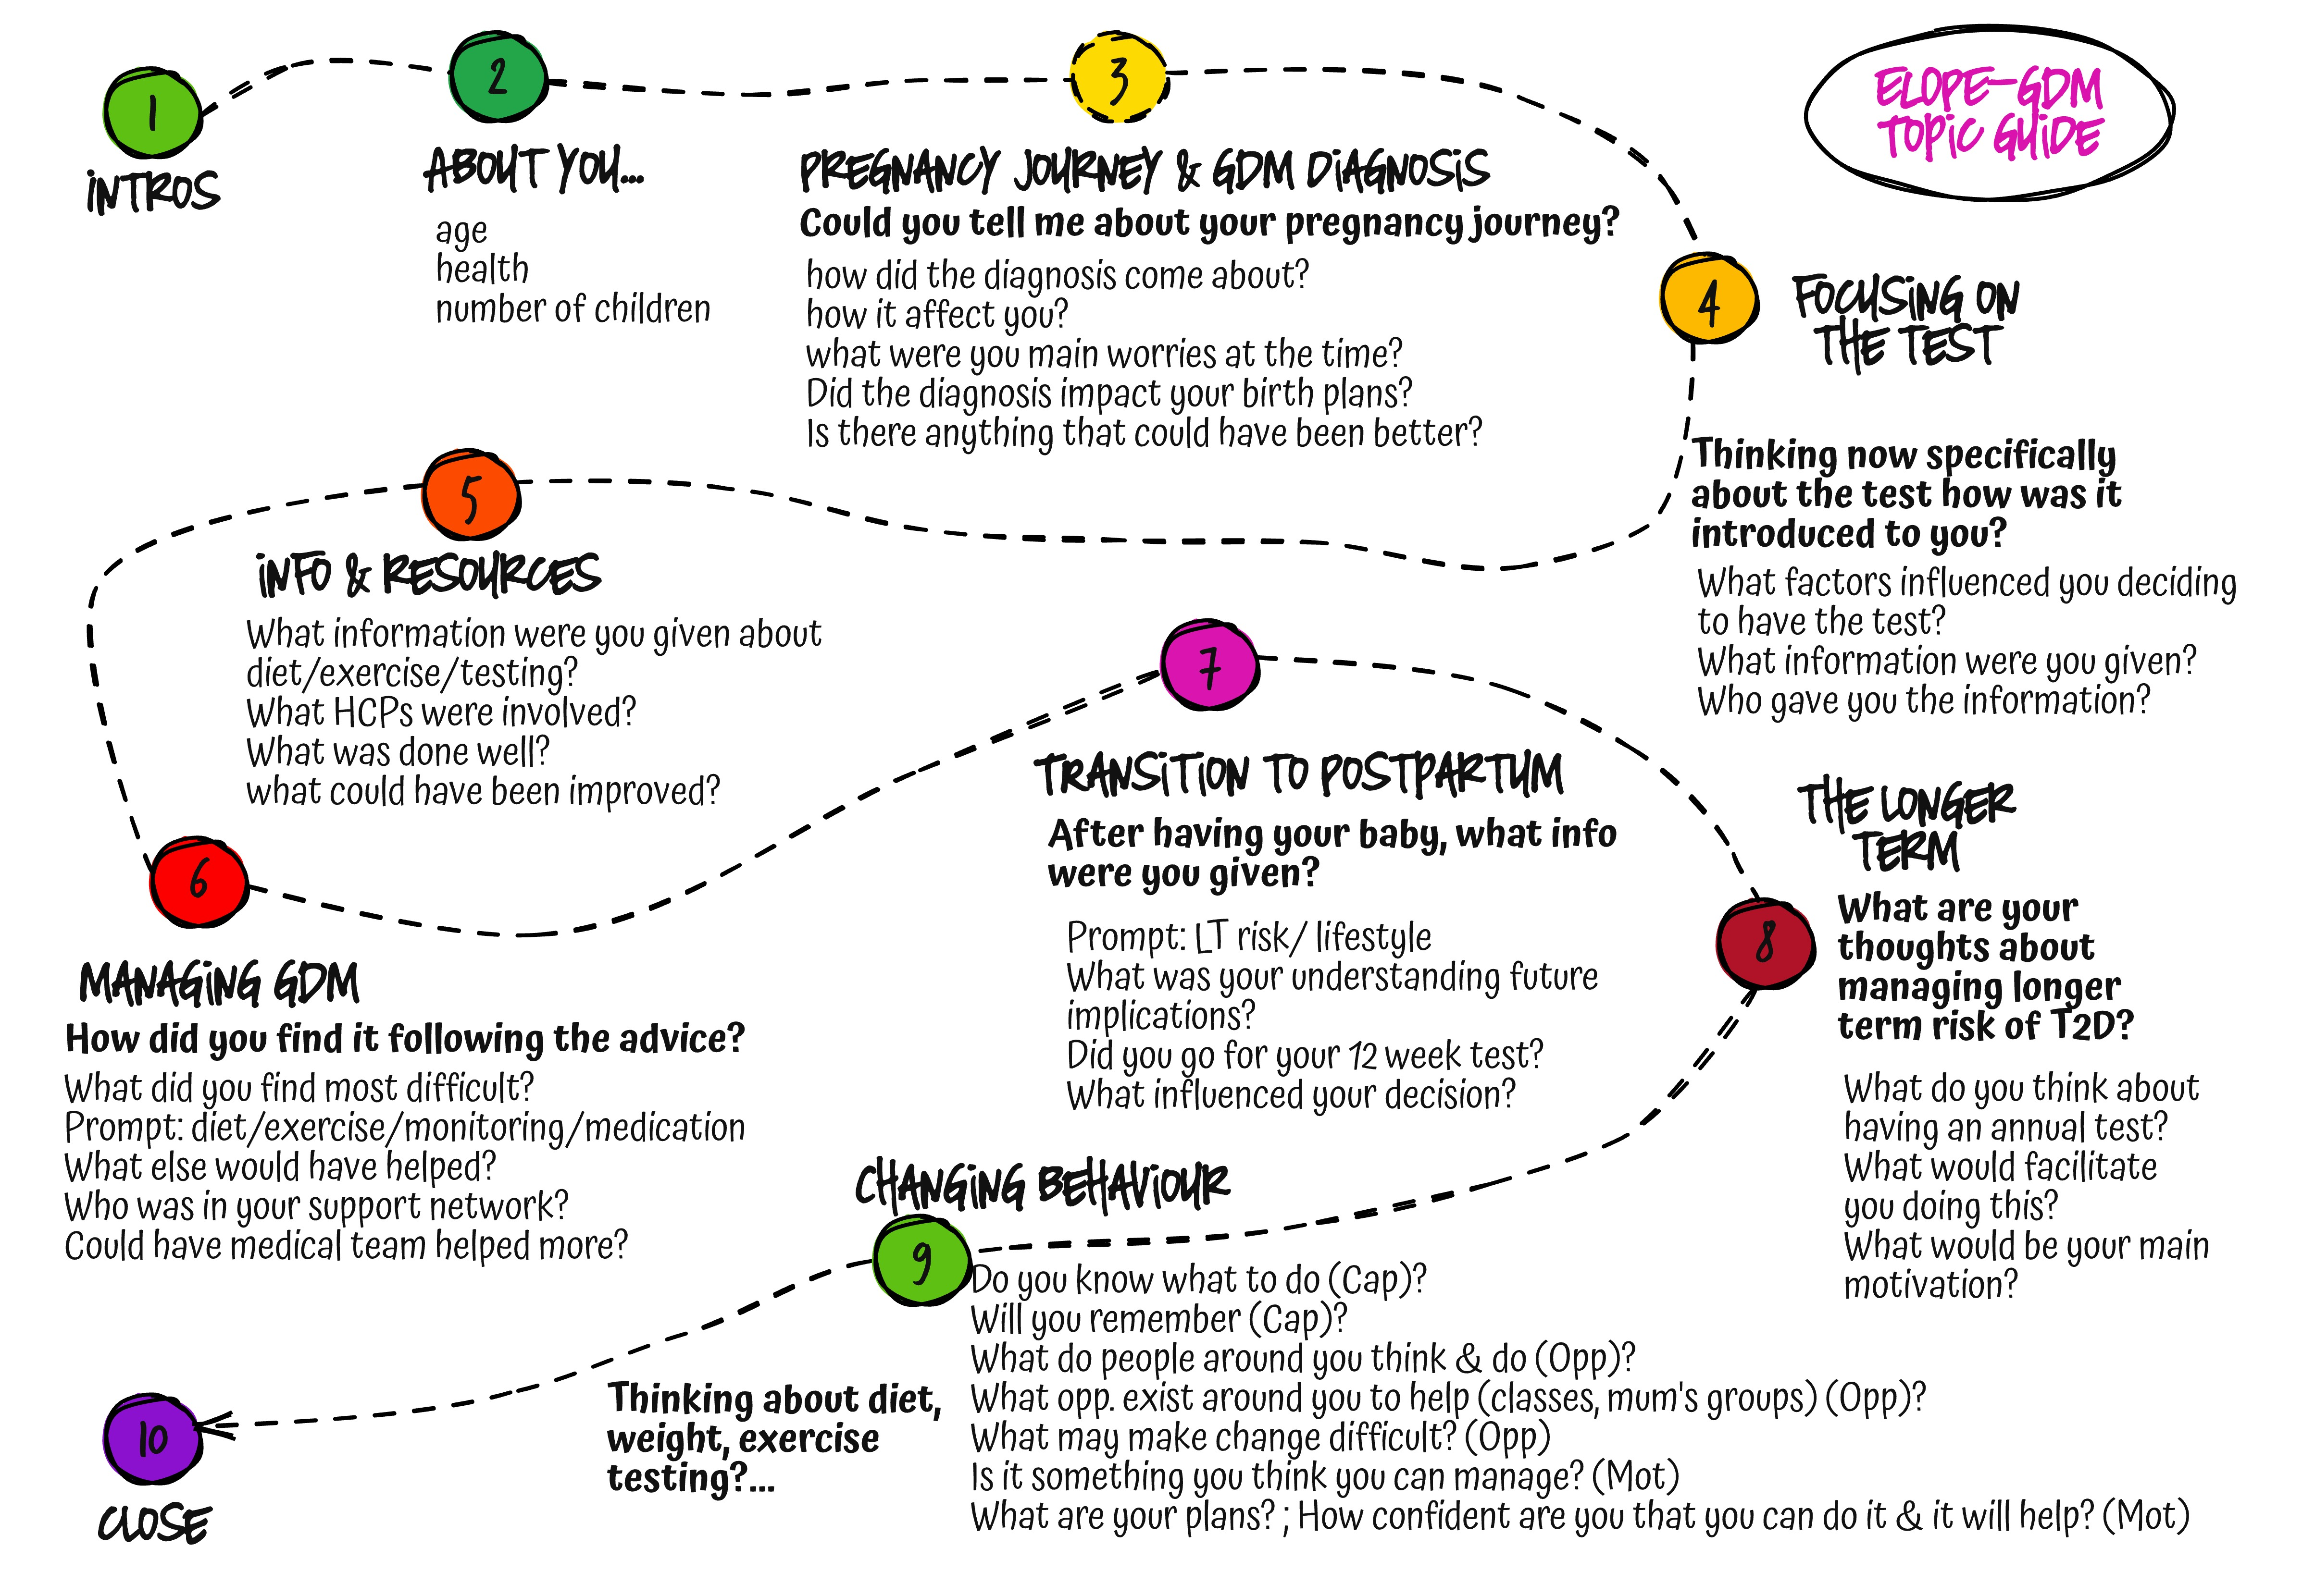
Figure 1: ELOPE Study Topic guide

Table 1: Illustrate COM-B and TDF framework
 |  | TDF Domain | Definition
Capability | Physical &  Psychological | Skills (Physical and psychological) | An ability or proficiency acquired through practice (skills, competence, ability, practice. Includes physical, cognitive and interpersonal skills)
Capability | Physical &  Psychological | Knowledge | An awareness of the existence of something (knowledge of the condition, scientific rationale), procedural knowledge, knowledge how to perform the task).
Capability | Physical &  Psychological | Attention processes (& memory & decision making) | The ability to retain information, focus selectively, chose between alternatives and competing behaviours (memory, attention, attention control, decision making, cognitive overload, tiredness).
Capability | Physical &  Psychological | Behavioural regulation | Managing or changing objectively observed or measured actions (self-monitoring, habit-breaking, action-planning).
Opportunity | Social | Social influences | Social influences and interpersonal processes that can cause individuals to change their thoughts, feelings or behaviours (social pressure, social norms, social support, power).
Opportunity | Physical | Environmental context and resources | Any circumstances of a person’s situation or environment that influences development of skills and abilities, competence or adaptive behaviour
Motivation | Reflective | Identity | A coherent set of behaviours/qualities of an individual in a social or work environment (identity, roles, group identity).
Motivation | Reflective | Beliefs about capabilities | Acceptance of the reality about an ability, talent or facility that a person can put to constructive use (Self-confidence, self-efficacy, perceived behavioural control, self-empowerment, beliefs).
Motivation | Reflective | Beliefs about consequences | Acceptance of the truth, reality, validity about outcomes of the behaviour in a given situation.
Motivation | Reflective | Intentions | A conscious decision to perform a behaviour or a resolve to act in a certain way (Stability of intention, stages of change).
Motivation | Reflective | Goals | Mental representations of outcomes or end states that an individual wants to achieve (Goals, targets, action-planning).
Motivation | Automatic | Emotions | A reaction pattern involving experiential, behavioural and physiological elements by which the individual attempts to deal with a personally significant matter (fear, anxiety, stress, positive/negative effect).
Motivation | Automatic | Habits and drive states | The impulse to engage in a behaviour with little or no sub-conscious thought¹; Evolved motivational mechanisms designed to ensure organisms take self-beneficial actions²
Motivation | Automatic | Reinforcement | Increasing probability of a response using rewards, incentives or other dependant relationship.

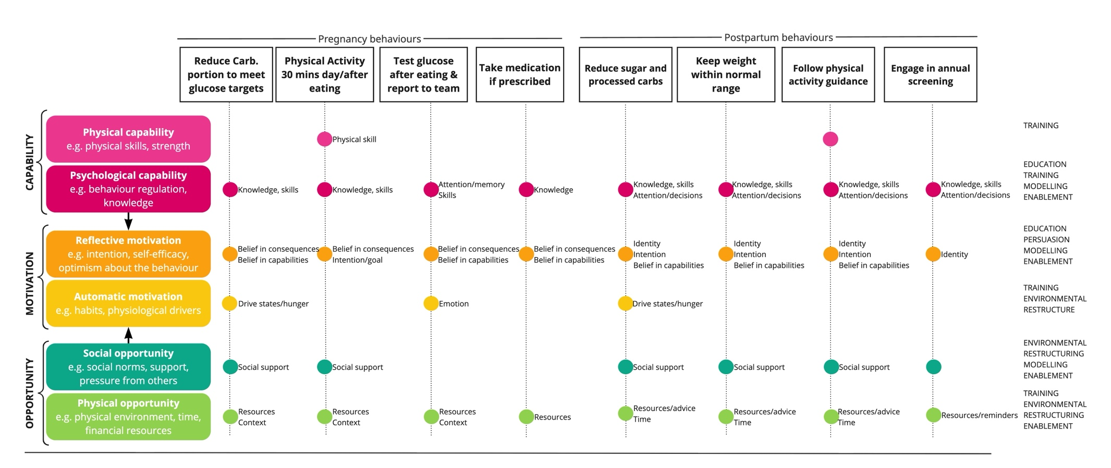
Figure 2: Schematic illustrating relevant COM-B & TDF Domains for each behaviour and appropriate intervention functions as indicated in the Behaviour Change Wheel Methodology ¹
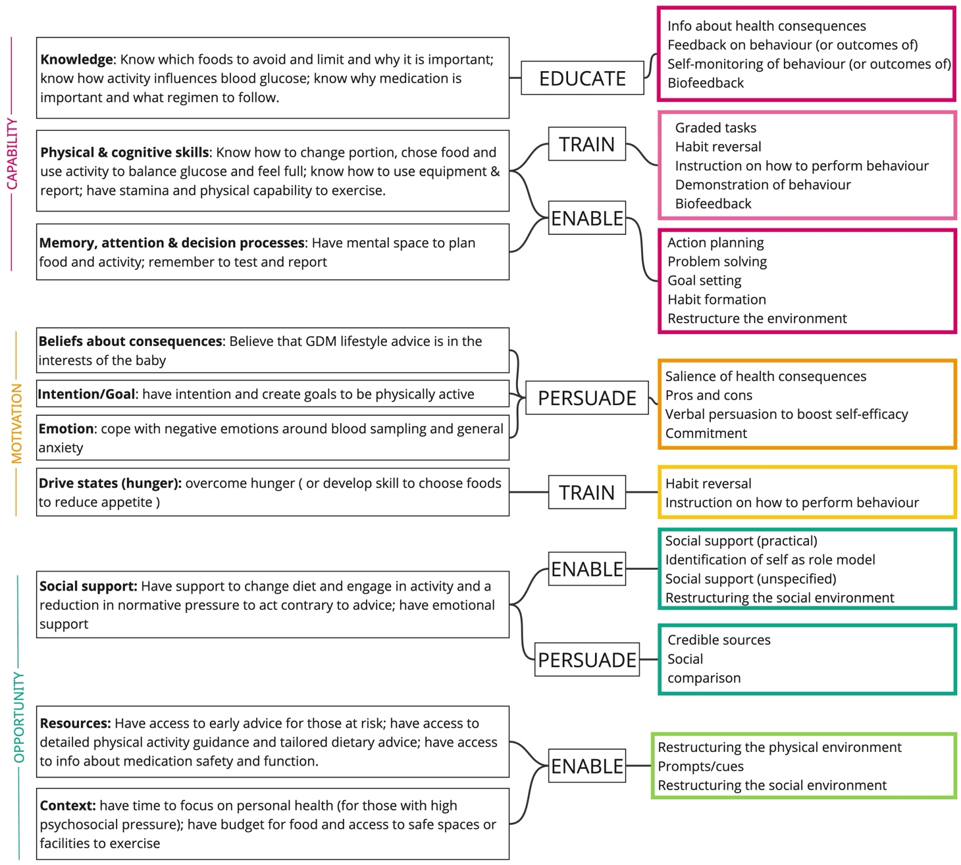
Figure 3: Mapping behavioural targets for GDM Self-management to intervention functions and potential strategies (BCTs)
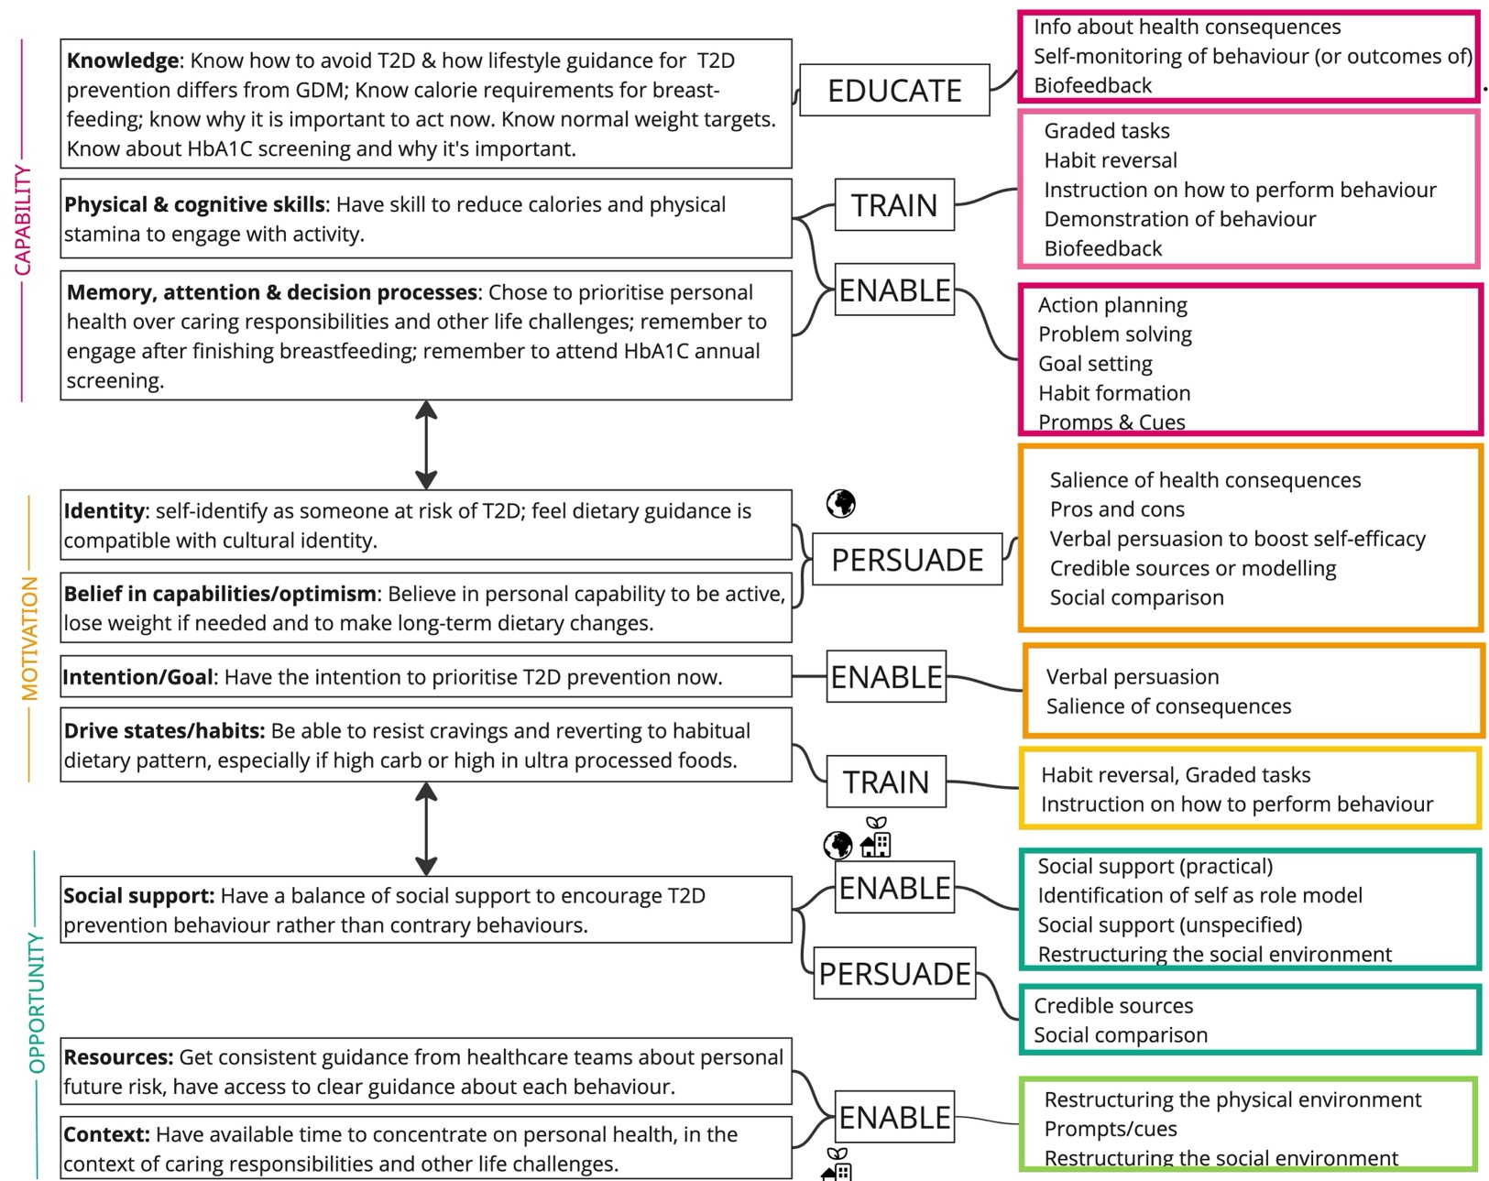
Figure 4: Mapping behavioural targets for T2D risk reduction to intervention functions and potential strategies (BCTs). Globe = ethnic minority, House = Socially disadvantaged
Table 2: Potential Behaviour Change Techniques by taxonomic grouping
Grouping | BCTs identified | GDM management |  |  |  | T2D risk-reduction
Grouping | BCTs identified | 1 | 2 | 3 | 4 | 1 | 2 | 3 | 4
Goals & planning | Action planning | 
Goals & planning | Goal setting
Feedback & monitoring | Feedback on behaviour
Feedback & monitoring | Self-monitoring of behaviour
Feedback & monitoring | Feedback on outcomes of behaviour
Feedback & monitoring | Self-monitoring of outcomes of behaviour
Feedback & monitoring | Biofeedback
Social support | Social support (unspecified)
Social support | Social support practical
Social support | Social support emotional
Shaping knowledge | Instruction on how to perform behaviour  Information about antecedents
Natural consequences | Information about health consequences  Salience of consequences
Comparison of behaviour | Demonstration of how to perform the behaviour  Social comparison
Associations | Prompts & cues
Repetition & substitution | Behavioural practice/rehearsal  Habit formation  Graded tasks
Comparison of outcomes | Credible sources  Pros & cons
Antecedents | Restructuring the physical environment  Restructuring the social environment  Adding objects (resources/guidance) to the environment
Identity | Identification of self as role model  Identity associated with changed behaviour
Self-belief | Verbal persuasion of capability  Focus on past success
Regulation | Reduce negative emotions

Table 3: COREQ Checklist
Topic | Item No. | Guide Questions/Description
Interviewer/facilitator | 1 | Which author/s conducted the interview or focus group?  AM
Credentials | 2 | What were the researcher’s credentials? E.g. PhD, MD  PhD
Occupation | 3 | What was their occupation at the time of the study?  Research Fellow
Gender | 4 | Was the researcher male or female?  Female
Experience and training | 5 | What experience or training did the researcher have?  Experienced qualitative researcher, particularly experienced working with minority ethnic groups.
Relationship established | 6 | Was a relationship established prior to study commencement?  A relationship was established via phone and text prior to the interview
Participant knowledge of  the interviewer | 7 | What did the participants know about the researcher? e.g. personal goals, reasons for doing the research  He participants were told the reasons the research was being conducted and the role of the researcher but no personal information.
Interviewer characteristics | 8 | What characteristics were reported about the inter viewer/facilitator?  e.g. Bias, assumptions, reasons and interests in the research topic  The researcher is a mother herself, though has not experienced GDM, she is particularly interested in diabetes prevention and management in people from minority ethnic groups who face health inequities.
Methodological orientation and Theory | 9 | What methodological orientation was stated to underpin the study? e.g. grounded theory, discourse analysis, ethnography, phenomenology,  content analysis  Deductive framework analysis informed by COM-B and TDF
Sampling | 10 | How were participants selected? e.g. purposive, convenience,  consecutive, snowball  Convenience sampling through community and healthcare channels.
Method of approach | 11 | How were participants approached? e.g. face-to-face, telephone, mail,  email  Email, text message and face-to-face via the Children’s centre.
Sample size | 12 | How many participants were in the study? 35
Non-participation | 13 | How many people refused to participate or dropped out? Reasons?  None. One person had to cancel the appointment as she had an emergency C section.
Setting of data collection | 14 | Where was the data collected? e.g. home, clinic, workplace At home and in the community or vis online technology.
Presence of non-  participants | 15 | Was anyone else present besides the participants and researchers?  Often the baby was present and sometimes other children. On one occasion the participant’s partner was present.
Description of sample | 16 | What are the important characteristics of the sample? e.g. demographic  data, date  The demographics are fully reported in the manuscript table 2.
Interview guide | 17 | Were questions, prompts, guides provided by the authors? Was it pilot tested?  The topic guide was developed in partnership with the PPI group, it was developed iteratively as the interviews proceeded.
Repeat interviews | 18 | Were repeat inter views carried out? If yes, how many? No repeat interviews were carried out.
Audio/visual recording | 19 | Did the research use audio or visual recording to collect the data?  Audio recording was used to capture the data.
Field notes | 20 | Were ﬁeld notes made during and/or after the inter view or focus group?  Field notes were made during and after the interviews.
Duration | 21 | What was the duration of the inter views or focus group? 60 minutes approximately
Data saturation | 22 | Was data saturation discussed? At 35 interviews no new data was emerging.
Transcripts returned | 23 | Were transcripts returned to participants for comment and/or correction?  No transcripts were not returned
Number of data coders | 24 | How many data coders coded the data?  One researcher (AM) coded the data
Description of the coding  tree | 25 | Did authors provide a description of the coding tree?  Yes description is provided in the manuscript and expanded in Supplementary data file 1 (Table S1-1)
Derivation of themes | 26 | Were themes identiﬁed in advance or derived from the data?  This was not a thematic analysis. The findings were generated deductively using the COM-B methodology.
Software | 27 | What software, if applicable, was used to manage the data? NVivo software was used to manage the data.
Participant checking | 28 | Did participants provide feedback on the ﬁndings? He participants had the opportunity to feed back on the thematic findings but not the behaviour analysis.
Quotations presented | 29 | Were participant quotations presented to illustrate the themes/ﬁndings?  Was each quotation identiﬁed? e.g. participant number  Yes two tables of participant quotes are used to illustrate the findings.
Clarity of minor themes | 32 | Is there a description of diverse cases or discussion of minor themes?  N/A not a thematic analysis
Data and ﬁndings consistent | 30 | Was there consistency between the data presented and the ﬁndings? Each finding is carefully illustrated as is the process of mapping the BCTs.
Clarity of major themes | 31 | Were major themes clearly presented in the ﬁndings? The major findings are clearly presented and discussed in the discussion section

1. Michie S, Van Stralen MM and West R. The behaviour change wheel: a new method for characterising and designing behaviour change interventions. Implementation science 2011; 6: 1-12.

