Sequence | Chemical Structure | Purity % | Ion | Calculated m/z | Observed m/z
NH₂-ACC-SFGTLRKQ-K(Dnp)-NH₂ | 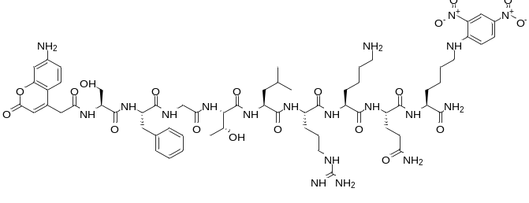 | 100 | [M+H]²⁺ | 715.9 | 716.2
NH₂-ACC-LQQLIRDS-K(Dnp)-NH₂ | 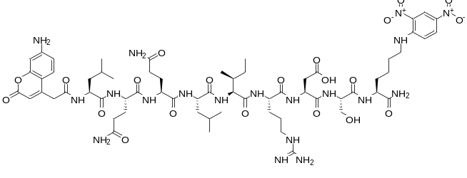 | 99.976 | [M+H]⁺ | 1466.7 | 1467.1
NH₂-ACC-RDSAERTI-K(Dnp)-NH₂ | 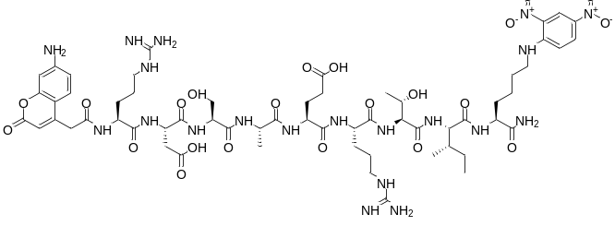 | 98.691 | [M+H]²⁺ | 721.3 | 721.4
NH₂-ACC-RTINLRNP-K(Dnp)-NH₂ | 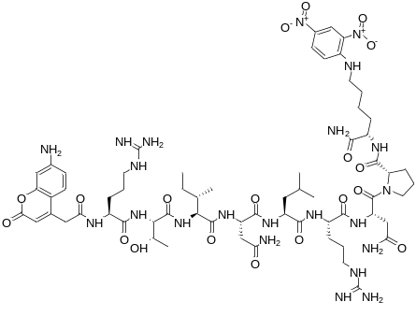 | 98.009 | [M+H]²⁺ | 739.4 | 739.8
NH₂-ACC-QVLEGRNE-K(Dnp)-NH₂ | 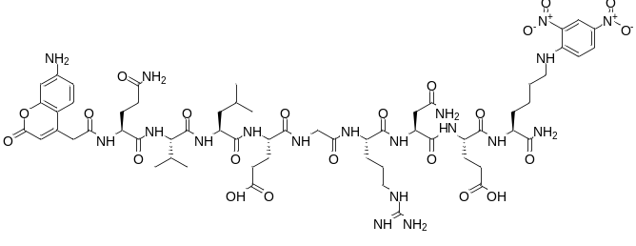 | 99.392 | [M+H]⁺ | 1438.6 | 1438.9
NH₂-ACC-EFSLLRGK-K(Dnp)-NH₂ | 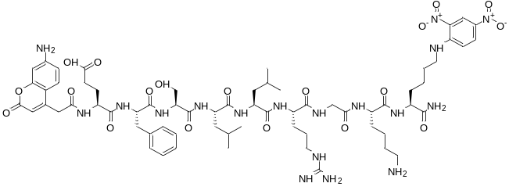 | 99.610 | [M+H]²⁺ | 722.4 | 722.7
NH₂-ACC-FENKKRID-K(Dnp)-NH₂ | 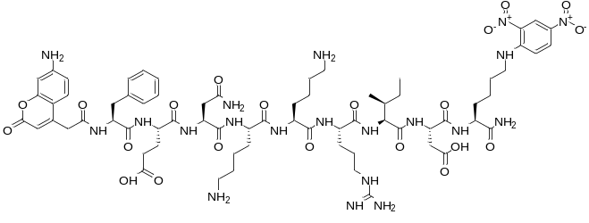 | 99.946 | [M+H]²⁺ | 772.4 | 772.7
NH₂-ACC-DPLVFREF-K(Dnp)-NH₂ | 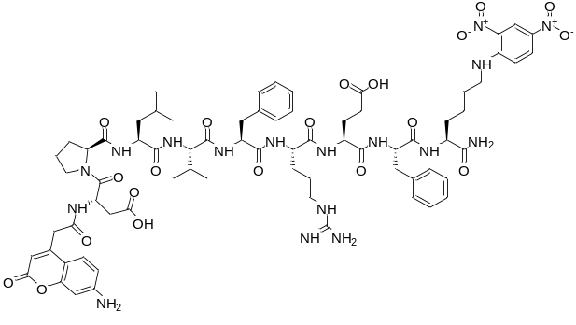 | 99.797 | [M+H]⁺ | 1516.7 | 1517.5
NH₂-ACC-TLLLERNF-K(Dnp)-NH₂ | 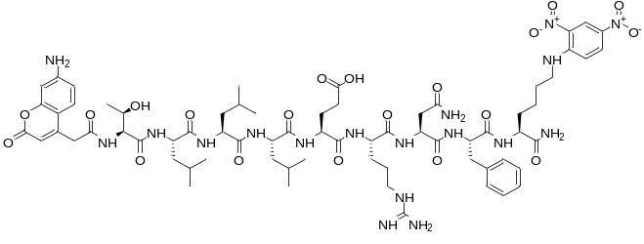 | 99.764 | [M+H]⁺ | 1499.7 | 1499.4
NH₂-ACC-DVQRGRSF-K(Dnp)-NH₂ | 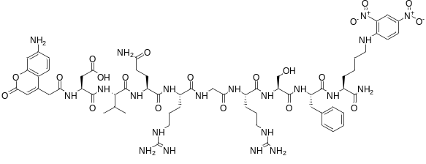 | 98.368 | [M+H]²⁺ | 729.8 | 730.0
NH₂-ACC-EPDVQRGR-K(Dnp)-NH₂ | 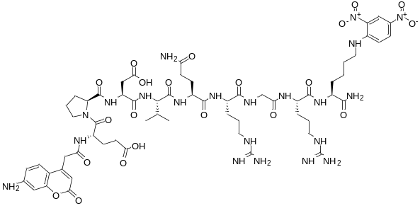 | 99.923 | [M+H]²⁺ | 725.8 | 726.0
NH₂-ACC-HERHLRQP-K(Dnp)-NH₂ | 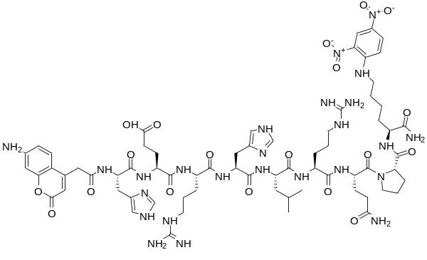 | 99.389 | [M+H]²⁺ | 783.9 | 784.2
NH₂-ACC-TLLHERHL-K(Dnp)-NH₂ | 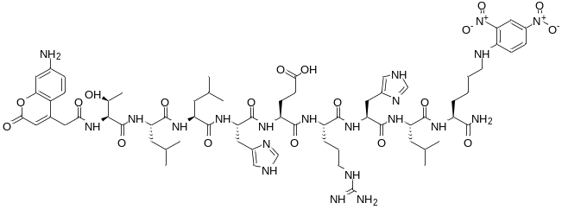 | 99.678 | [M+H]²⁺ | 756.9 | 757.1
NH₂-ACC-QQLRSRGD-K(Dnp)-NH₂ | 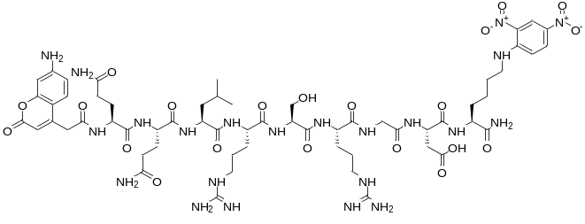 | 97.390 | [M+H]²⁺ | 727.3 | 727.6
NH₂-ACC-VLQQLRSR-K(Dnp)-NH₂ | 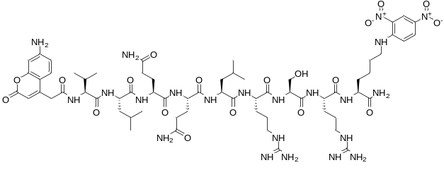 | 99.812 | [M+H]²⁺ | 747.4 | 748.0
NH₂-ACC-EVEVTRTH-K(Dnp)-NH₂ | 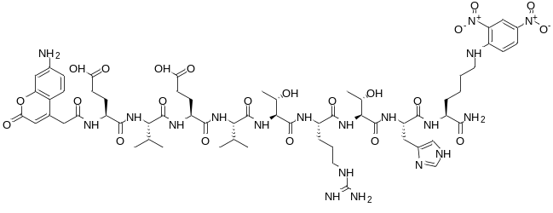 | 98.469 | [M+H]²⁺ | 732.8 | 733.2
NH₂-ACC-TRTHKREG-K(Dnp)-NH₂ | 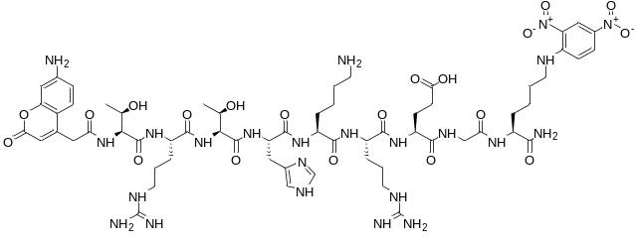 | 95.827 | [M+H]²⁺ | 739.9 | 739.8
NH₂-ACC-REGSGRFS-K(Dnp)-NH₂ | 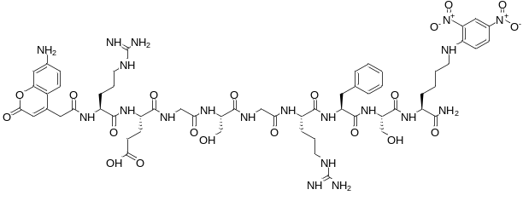 | 97.341 | [M+H]²⁺ | 695.3 | 695.3
NH₂-ACC-STLAFRVA-K(Dnp)-NH₂ | 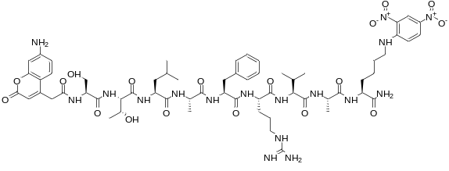 | 96.759 | [M+H]⁺ | 1358.7 | 1358.8
NH₂-ACC-PDKKQRTF-K(Dnp)-NH₂ | 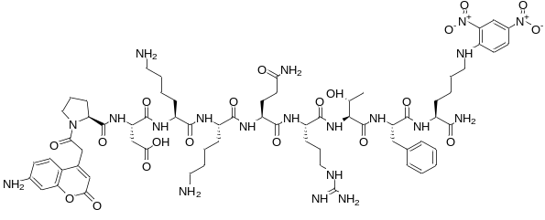 | 98.724 | [M+H]²⁺ | 757.4 | 757.6
NH₂-ACC-ATGHKRST-K(Dnp)-NH₂ | 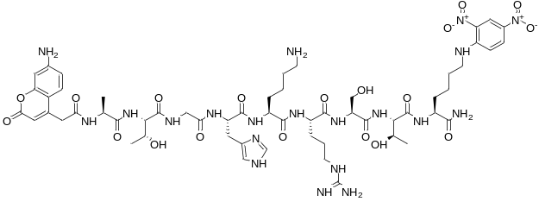 | 93.192 | [M+H]²⁺ | 676.3 | 676.4
NH₂-ACC-LELLDREL-K(Dnp)-NH₂ | 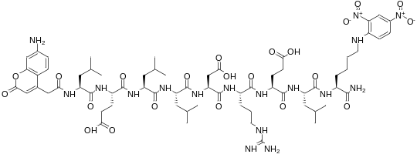 | 99.964 | [M+H]⁺ | 1494.7 | 1494.7
NH₂-ACC-GLSnnRSL-K(Dnp)-NH₂ | 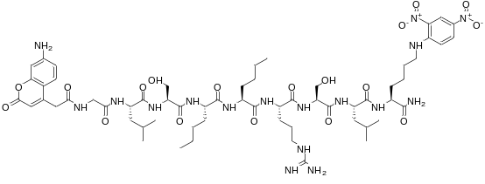 | 100 | [M+H]⁺ | 1352.7 | 1352.5
NH₂-ACC-LEGVLRDQ-K(Dnp)-NH₂ | 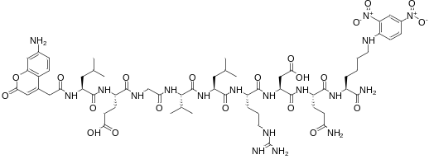 | 99.369 | [M+H]⁺ | 1423.7 | 1423.4
NH₂-ACC-DQLALRAL-K(Dnp)-NH₂ | 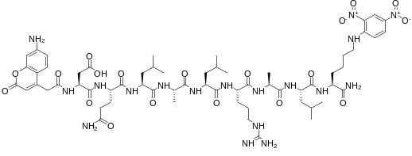 | 99.932 | [M+H]⁺ | 1393.7 | 1393.4
NH₂-ACC-APWQERST-K(Dnp)-NH₂ | 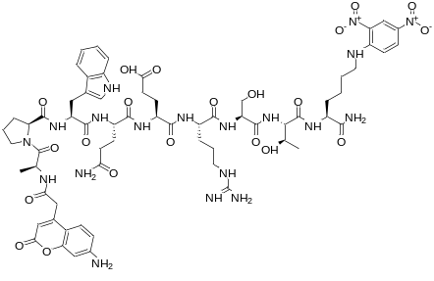 | 99.170 | [M+H]⁺ | 1468.6 | 1468.3
NH₂-ACC-PQAQGRnS-K(Dnp)- NH₂ | 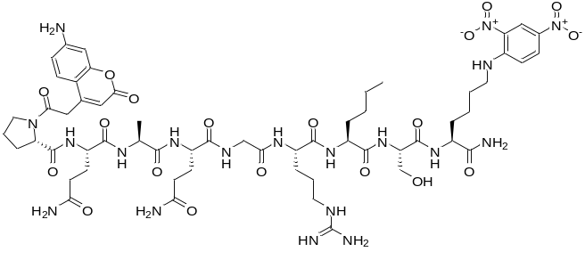 | 99.262 | [M+H]⁺ | 1350.6 | 1350.4
NH₂-ACC-DFQGLRAE-K(Dnp)- NH₂ | 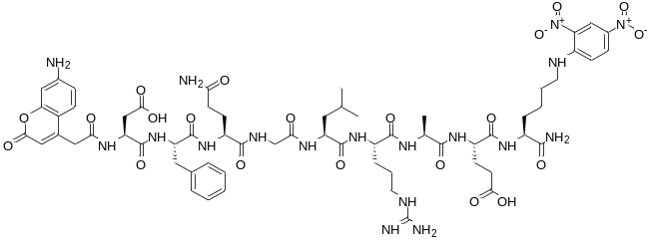 | 99.976 | [M+H]⁺ | 1429.6 | 1429.3
Supplementary Table 1. Analytical characterisation of synthesised IQF substrates. Table including compound name, chemical structure, molecular formula, purity, and mass confirmation (MS calculated and MS found), of IQF substrates synthesized for GSMD and GSDME.

