Supplementary material
Granzyme A amplifies human neutrophil pyroptosis
Aleksandra Korba-Mikołajczyk¹, Katarzyna Dominika Kotowska^{1#}, Edyta Bielec^{1#}, Kornelia Steindel¹, Ronald Piotrowski¹, Julia Miśkiewicz¹, Melanie Brügger^{2,3}, Nedim Kozarac^{2,3,4}, Scott Snipas⁵ Sonia Kołt¹, Stanisław Potoczek⁷, Jocelyn Wanjian-Tang⁸, Daniel Kirchhofer⁸, Guy Salvesen⁵, Charaf Benarafa^{2,3,6}, Paulina Kasperkiewicz^{1*}
¹Faculty of Chemistry, Wroclaw University of Science and Technology, Wroclaw, Poland
²Institute of Virology and Immunology IVI, Mittelhäusern, Switzerland
³Department of Infectious Diseases and Pathobiology, Vetsuisse Faculty, University of Bern, Bern, Switzerland
⁴Graduate School for Cellular and Biomedical Science, University of Bern, Bern, Switzerland
⁵NCI Designated Cancer Center, Sanford Burnham Prebys Medical Discovery Institute, 10901 North Torrey Pines Road, La Jolla, CA, 92037, United States of America
⁶Multidisciplinary Center for Infectious Diseases (MCID), University of Bern, Bern, Switzerland
⁷Clinical Department of Hematology, Cell Therapies and Internal Medicine, Wroclaw Medical University, Wrocław, Poland
⁸Dept. of Early Discovery Biochemistry, Genentech Inc., 1 DNA Way, South San Francisco, CA 94080, United States of America
#These authors contributed equally to this work.
*Corresponding Author: paulina.kasperkiewicz@pwr.edu.pl
Keywords: Granzyme A, Regulated Cell Death, Human Neutrophils, Gasdermins, Serine Protease, Pyroptosis

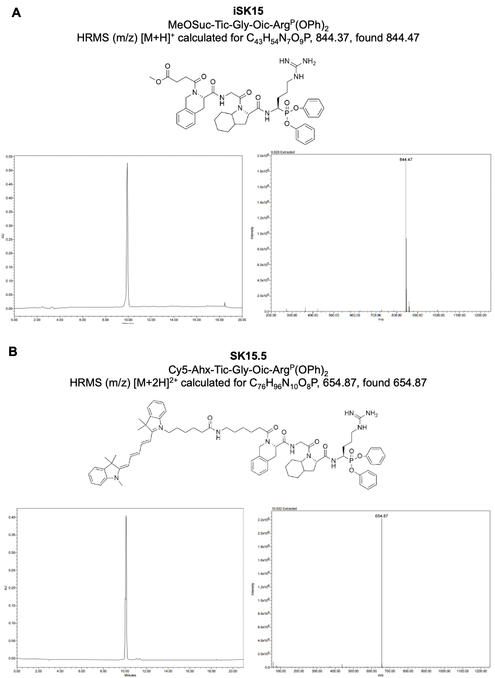
Supplementary Figure S1. Chemical analysis of iSK15 (A) and SK15.5 (B). Verified purity and calculated masses.
Supplementary Figure S2. Additional materials including iSK15 rescue of LPS pretreated cells and induced with nigericin, and gating strategies.
(A) qPCR-based quantification of gene expression. Ct values of GZMA and ACTB amplification. Neutrophils were isolated from peripheral blood of healthy patients, n=5. (B) Ct values for GZMA and ACTB in isolated neutrophils from healthy donors, along with the calculated ΔCt and relative expression (2^{−ΔCt}). (C) Nigericin-induced cell death timecourse. Neutrophils pre-treated for 1 hour with iSK15 and/or pretreated with LPS for 3 hours. Cell death is assessed at time points by flow cytometry as the percentage of SYTOX Green-positive cells. (D) Representative confocal images of naïve and nigericin-stimulated (10 µM, 15 and 30 minutes) human neutrophils co-stained with antibodies against GrA (AlexaFluor 488, green) and perforin (AlexaFluor 680, red). Nuclei counterstained with Hoechst (blue). Scale bar, 10 µm. (E) Representative gating strategy for neutrophil viability assay by flow cytometry. Granulocytes were identified by FSC/SSC profile, singlets selected by aspect ratio FSC, and dead cells defined as SYTOX Green-positive and representative gating strategy for CellROX ROS assay. Granulocytes and singlets gated as in flow cytometry gating; CellROX-positive cells identified by SYTOX Green channel fluorescence.
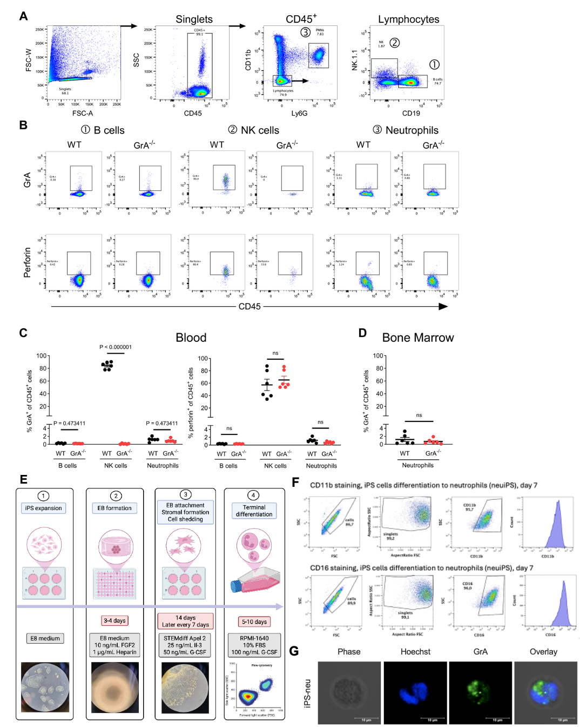
Supplementary Figure S3. Granzyme A and perforin expression in neutrophils from WT and GrA^{-/-} mice and characterization of iPSC-derived neutrophil-like cells.
(A) Flow cytometry gating strategy. Representative dot plots of mouse blood cell subpopulations within CD45⁺ singlets shown as (1) B cells (CD11b^{neg}, Ly6G^{neg}, NK1.1^{neg}, CD19⁺), (2) NK cells (CD11b^{neg}, Ly6G^{neg}, CD19^{neg}, NK1.1⁺), and (3) neutrophils (CD11b⁺, Ly6G⁺). (B) Representative flow cytometry plots of leukocyte subsets showing intracellular staining for GrA and perforin in B cells, NK cells, and neutrophils from WT and GrA^{-/-} mice. (C) Quantification of the percentage of GrA⁺ and perforin⁺ cells within B cell, NK cell, and neutrophil populations in blood from WT and GrA⁺mice. (D) Quantification of GrA expression in bone marrow neutrophils from WT and GrA^{-/-} mice. Data are from two experiments with 6 mice/genotype (3 females and 3 males) and were analyzed by multiple unpaired t tests. Each dot represents one individual mouse; bars indicate mean ± SEM. (E) Schematic of the iPSC-to-neutrophil differentiation protocol. iPSCs were expanded in E8 medium, formed into embryoid bodies (EBs) in E8 medium supplemented with 10 ng/mL FGF-basic over 3–4 days, then transferred to Geltrex-coated 6-well plates in STEMdiff Apel 2 medium supplemented with 25 ng/mL IL-3 and 50 ng/mL G-CSF. After 14 days of EB attachment and stromal formation, shed cells were collected every 7 days and subjected to terminal differentiation in RPMI 1640 supplemented with 10% FBS and 100 ng/mL G-CSF for 5–10 days. Representative brightfield images of each stage and Giemsa-stained cells at terminal differentiation are shown. (F) Flow cytometry analysis of CD11b and CD16 surface expression on iPSneu at day 7 of terminal differentiation. Gating strategy shown: cells → singlets → CD11b+ or CD16+ gate. (G) Representative confocal microscopy images of iPSneu stained with anti-GrA antibody (AlexaFluor 488, green) and Hoechst nuclear stain (blue). Scale bar, 10 µm.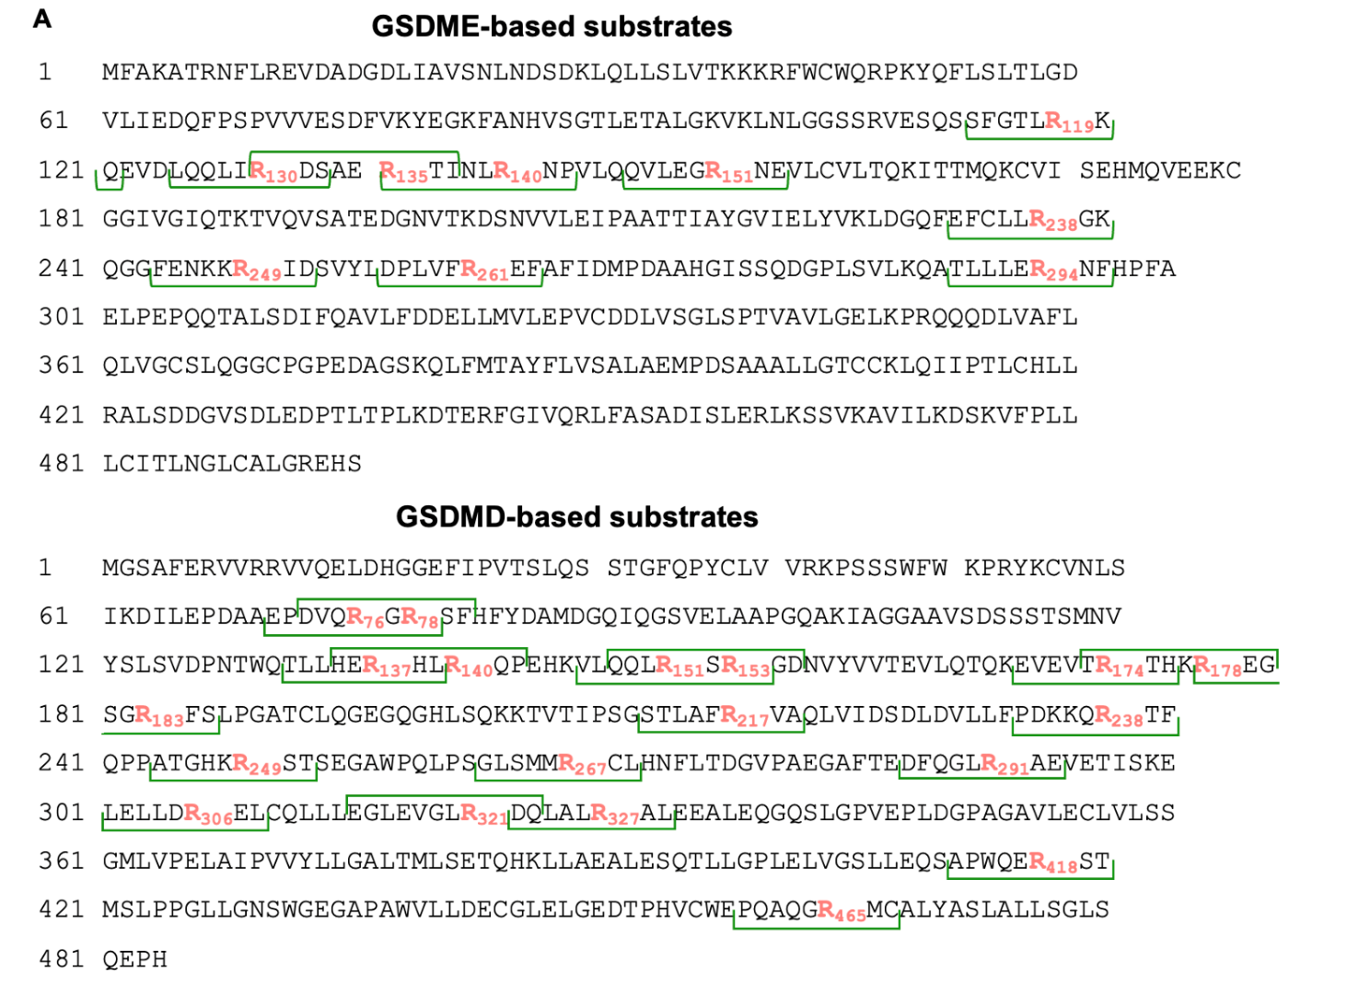
Supplementary Figure 4. Design of GSDMD and GSDME-based substrates.
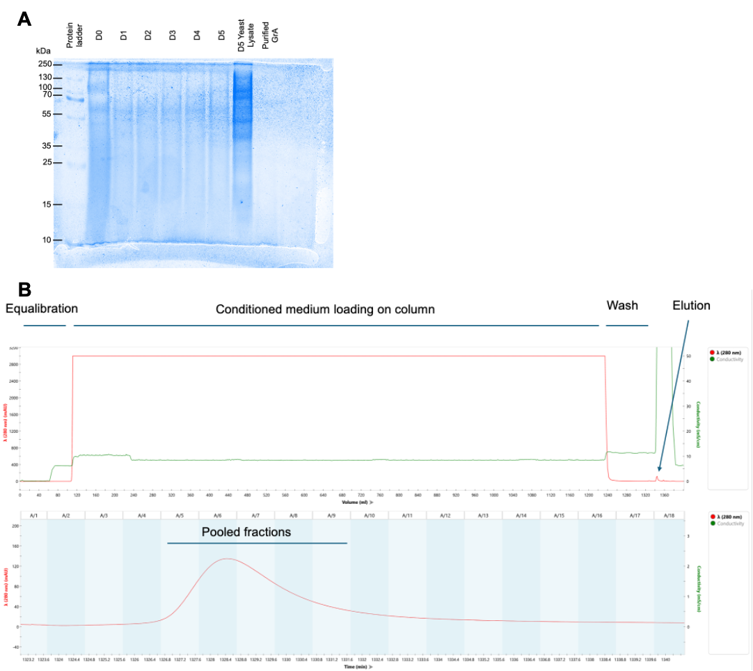
Supplementary Figure S5. Additional materials confirming the expression and purity of GrA. (A) Coomasie Blue staining from GrA expression in K. phaffii subjected to SDS-PAGE electrophoresis. (B) Chromatrographs of GrA purification, confirming the purity of the enzyme.

