A Monolithic Flexible Electromagnetic Interface for Simultaneous Sensing, Actuation, and Closed-Loop Haptic Interaction

Biyan Wang^{1,3}, Qing Su^{1,3}, Xiaoya Zhu¹, Wenbiao Zhou¹, Huikai Xie¹, Hong Su^{2*}, Xiaoyi Wang^{1*}

¹The School of Integrated Circuits and Electronics, Beijing Institute of Technology, Beijing 100081, China
²First Clinical Division, Peking University School and Hospital of Stomatology, National Center for Stomatology, National Clinical Research Center for Oral Diseases, National Engineering Research Center of Oral Biomaterials and Digital Medical Devices, Beijing 100081, China
³These authors contributed equally: Biyan Wang, Qing Su.
*Corresponding authonrs:
Hong Su (suhong0309@qq.com)
Xiaoyi Wang (xiaoyiwang@bit.edu.cn)

- The following is the supplementary material related to the fully flexible electromagnetic actuator.
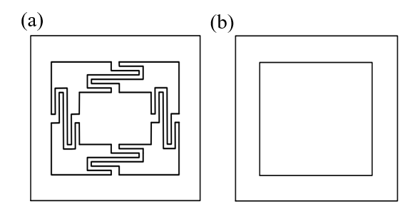

Supplementary Material Figure 1 (a) Flexible Suspension Frame; (b) Flexible Support Frame.
Supplementary Table 1 Comparison of properties of common flexible materials
Performance Index | PET | PDMS | PI | Selection Criterion
Young's Modulus | Medium | Low | Moderate | Provide structural stiffness
Thermal Stability | Poor | Excellent | High | Withstand Joule heat
Fatigue Resistance | Moderate | Moderate | Extremely high | functional under long-term driving
Process Compatibility | thermal shrinkage | stable chemical properties | Excellent | Compatible with MEMS processes

Supplementary Table 2 Simulation Frequency List
Mode | Mode shape | Frequency/Hz
1st | Translation along the Z-axis | 125
2st | Rotation about the X-axis | 224
3st | Rotation about the Y-axis | 255

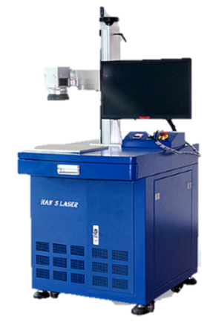
- (b)
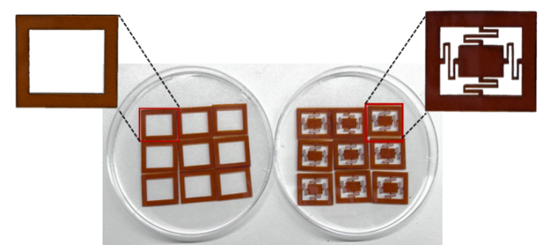

Supplementary Figure 2 (a) UV Laser Cutter; (b) Fabricated Frame After Cutting
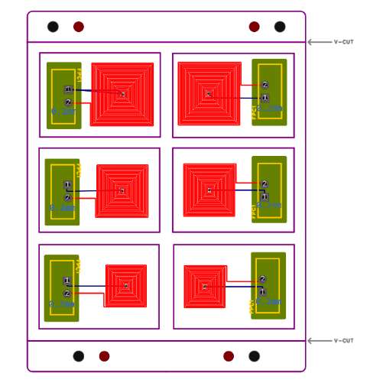

Supplementary Figure 3 Layout of the FPCB Coil
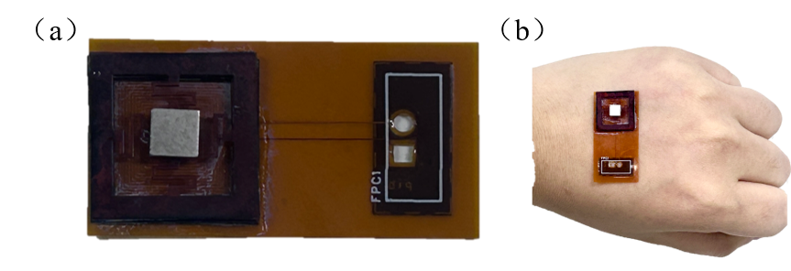

Supplementary Figure 4 Optical image of the fully flexible actuator
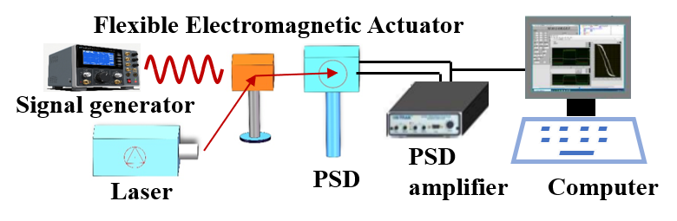

Supplementary Figure 5 Test System
Supplementary Table 3 Comparison with reported works
Reference | Actuation Type | Actuation | Displacement/𝜇m | Response Time
Hamdan N A | Piezoelectric | 300 V | 4 | N/A
Chirila | Shape Memory Alloy | 500 mA | 12000 | >1 s
Cheng J | Electromagnetic | 2.83 V | 250 | 18 ms
This work | Electromagnetic | 1 V(333 mA) | 912.53 | 29.6 ms
Compared with existing studies, this work achieves a favorable comprehensive performance in terms of driving voltage, vibration displacement, and response time.

- The following is the supplementary material related to the fully flexible electromagnetic sensor.
In the structural design of the sensor, the material of the flexible support pillars converts the external minute pressure into displacement. Therefore, elastic modulus and deformation recovery capability are the most critical factors. A comparison of the core parameters of commonly used polymer materials, including conventional silicone rubber, polydimethylsiloxane (PDMS), and the ultra-soft silicone elastomer Dragon Skin, is presented in the table.
Supplementary Table 4 Core Parameter Comparison of Flexible Materials
Type | Elastic Modulus Range (MPa) | Typical Hardness (Shore) | Hysteresis | Residual Deformation
Conventional Silicone Rubber | 0.5~2.0 | 40~60 A | Moderate | Significant
PDMS | 0.1~0.5 | 40~50 A | Low | Slight
Dragon Skin | 0.1~0.3 | 10 A | Low | Negligible
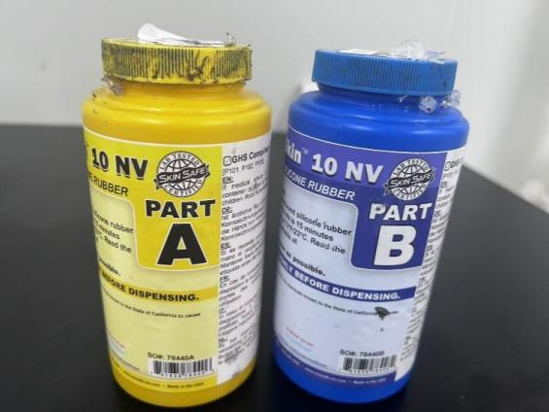

Supplementary Figure 6 Raw Dragon Skin Material
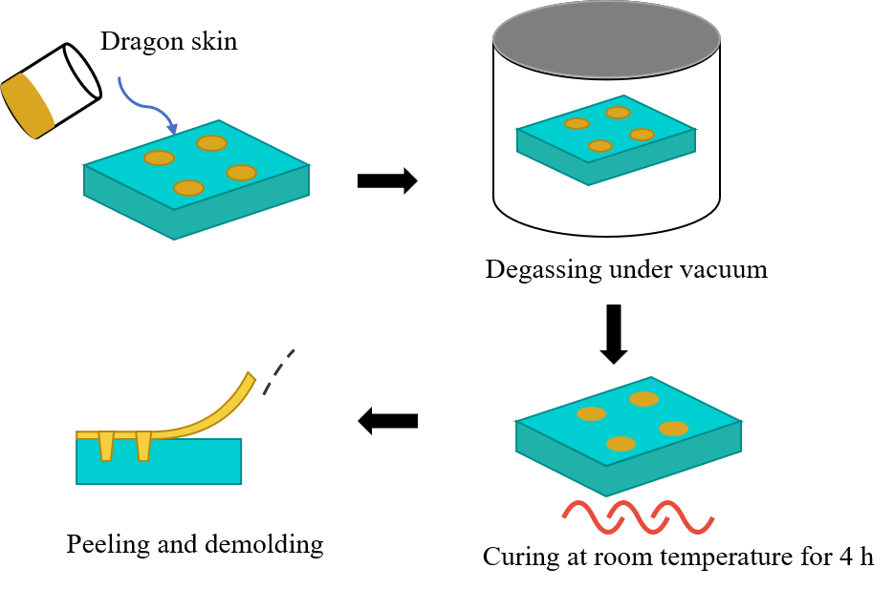

Supplementary Figure 7 Fabrication Schematic
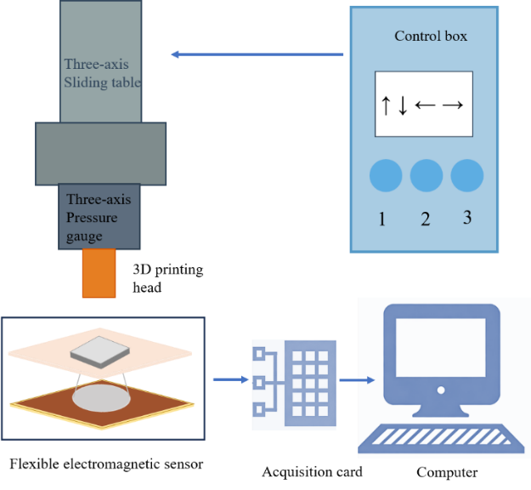

Supplementary Figure 8 Test System
Supplementary Table 5 Parameters of Flexible Support Pillars
Coil Size/mm | Upper/Lower Support Pillar Size/mm | Height/mm
10*10 | 2/3 | 3/5/7
8*8 | 3/4.5 | 3/5/7
6*6 | 4/6 | 3/5/7
4*4 | 5/7.5 | 3/5/7

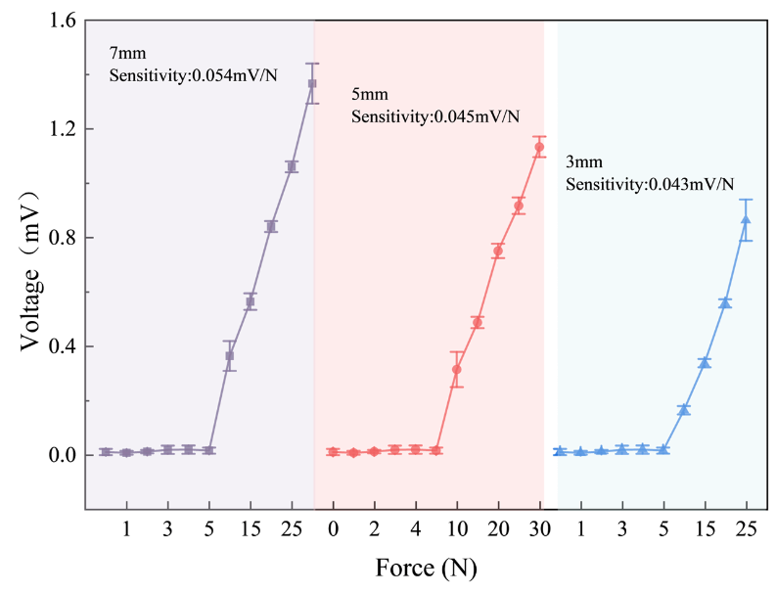

Supplementary Figure 9 Test images of 10 mm size with different support pillar heights
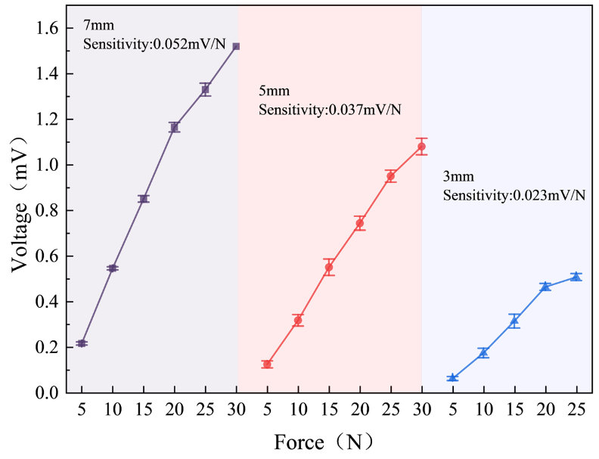

Supplementary Figure 10 Test images of 8 mm size with different support pillar heights
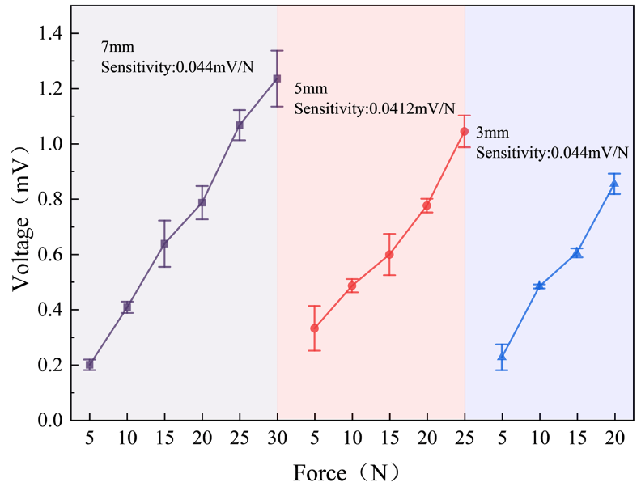

Supplementary Figure 11 Test images of 6 mm size with different support pillar heights
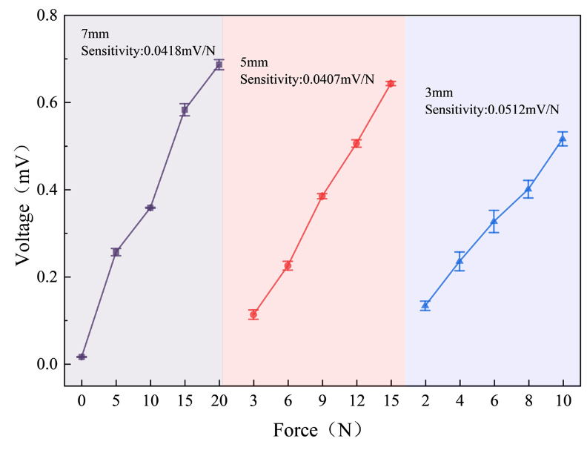

Supplementary Figure 12 Test images of 4 mm size with different support pillar heights
Compared with other groups of data, the 8 mm coil size combined with a 7 mm support height exhibits the optimal linearity and relatively high sensitivity (0.052 mV/N or 13 mV/kPa) over the full range of 0–30 N. This performance avoids problems such as undetectable signals under low pressure and pressure saturation under high pressure, achieving an optimal balance between sensitivity and pressure measurement range. The specific sensing performance of the flexible electromagnetic sensor fabricated with these parameters will be tested in the following sections.
- The following is the supplementary material related to the fully flexible electromagnetic actuation-sensing integration.
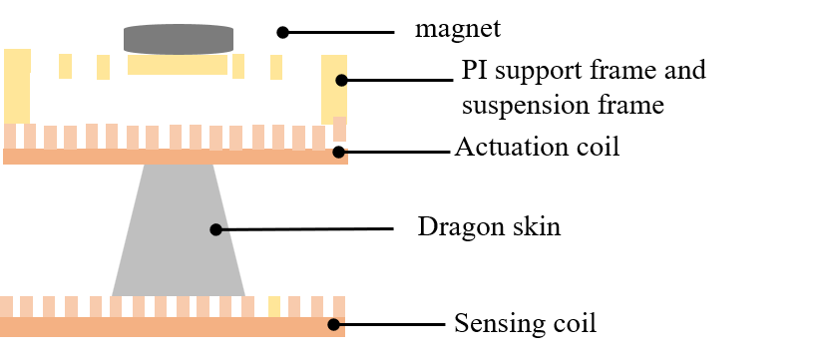

Supplementary Figure 13 Cross-sectional view of the integrated actuation-sensing single device

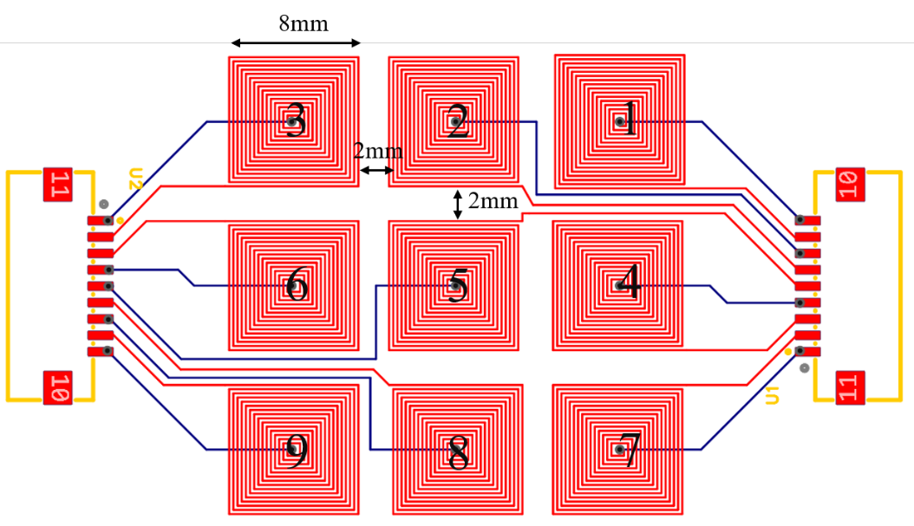

Supplementary Figure 14 Layout design of 3×3 FPCB coil wiring
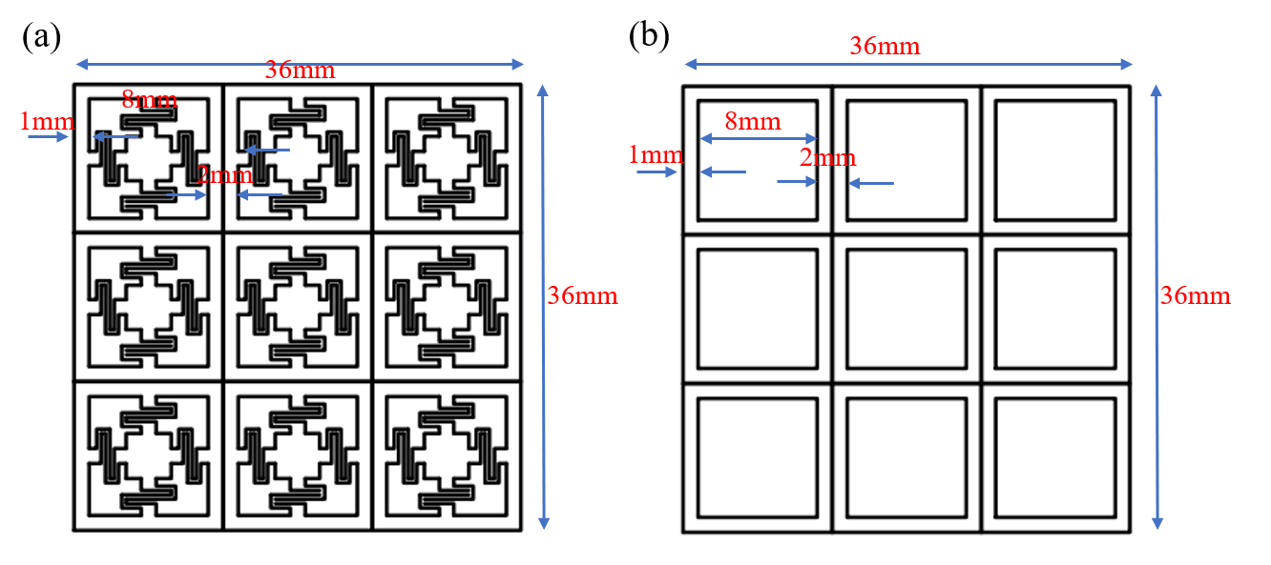

Supplementary Figure 15 Schematic diagram of the 3×3 flexible suspension and support frame
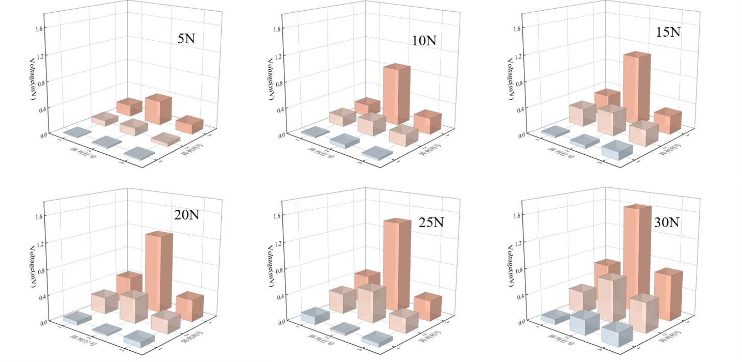
Supplementary Figure 16 Single-point pressure sensing at position S-2
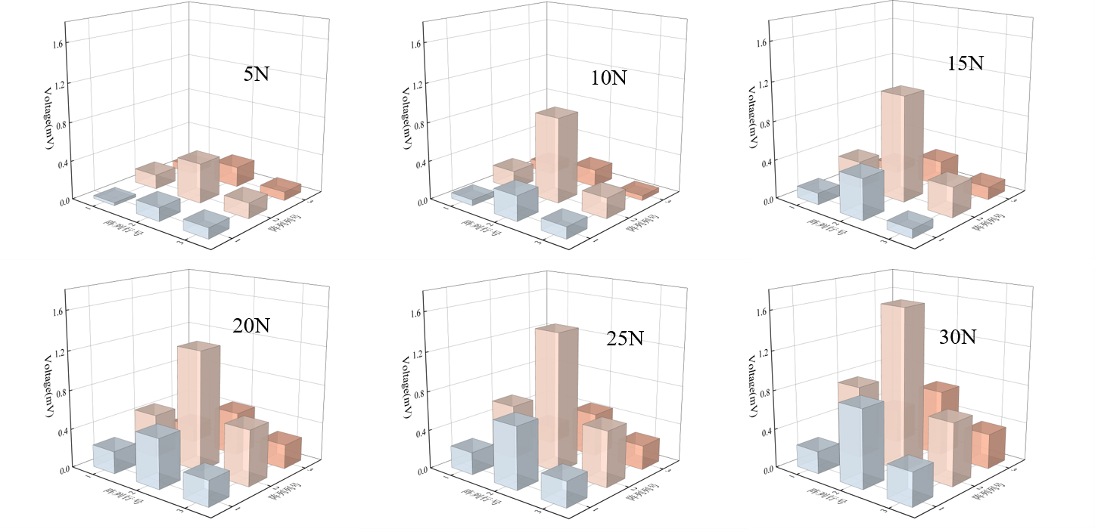

Supplementary Figure 17 Single-point pressure sensing at position S-5
- The following is the supplementary material related to the human tactile perception evaluation of the fully flexible electromagnetic actuator. To quantitatively evaluate the feedback performance of the electromagnetic actuator in a practical haptic system, a vibration perception experiment was conducted based on the physiological characteristics of human tactile sensation. According to the typical frequency range in which human skin is sensitive to vibrotactile stimuli, five representative driving frequencies of 20 Hz, 50 Hz, 120 Hz, 240 Hz, and 300 Hz were selected within the range of 20-300 Hz. By synchronously adjusting the driving voltage, three vibration intensity levels, namely weak, medium, and strong stimulation, were generated. As a result, a total of 15 vibrotactile stimulation conditions were obtained. During the experiment, the fingertip was naturally placed on the vibrating surface of the actuator. The perceived vibration intensity was subjectively rated using a five-level scale, where 1 represented almost imperceptible vibration and 5 represented very strong vibration. Each stimulation condition was repeated 10 times to reduce sensory deviation and improve the reliability of the evaluation. The measured vibration displacement values under different driving frequencies and voltages are summarized in Supplementary Table 5.
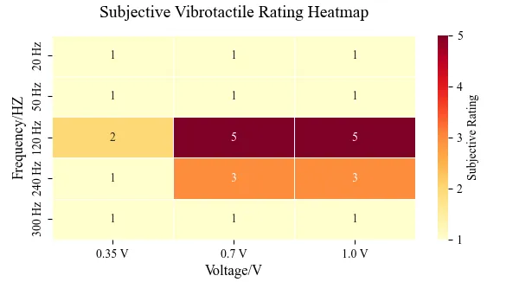
Supplementary Figure 18 Subjective vibrotactile rating heatmap under different frequencies (20–300 Hz) and driving voltages (0.35–1.0 V)

Supplementary Table 6 Vibration displacement of the electromagnetic actuator under different driving voltages and frequencies
Driving voltage | 20 HZ | 50 HZ | 120 HZ | 240 HZ | 300 HZ
0.35 V (weak) | 37.86 μm | 46.76 μm | 378.96 μm | 54.76 μm | 65.87 μm
0.7 V (medium) | 57.89 μm | 78.96 μm | 865.43 μm | 158.86 μm | 87.65 μm
1 V (strong) | 65.43 μm | 176.56 μm | 1423.46 μm | 187.86 μm | 106.63 μm
The subjective rating results showed that the perceived vibration intensity reached the highest level at 120 Hz under all three driving intensities. In tactile perception evaluation, a vibration amplitude of 0.25 mm is generally regarded as the minimum perceptible threshold for human skin. Under the excitation condition of 120 Hz and 1 V, the actuator generated a vibration displacement of 1423.46 μm, which was far above this perceptual threshold and therefore induced a strong vibrotactile sensation. In contrast, at lower frequency such as 20 Hz or higher frequency such as 300 Hz, the perceived vibration remained relatively weak even when the driving voltage was increased. These results indicate that frequency matching plays a more critical role than simply increasing vibration amplitude in enhancing human tactile feedback performance.

- The following is the supplementary material related to applications of the fully flexible electromagnetic actuation-sensing integration.
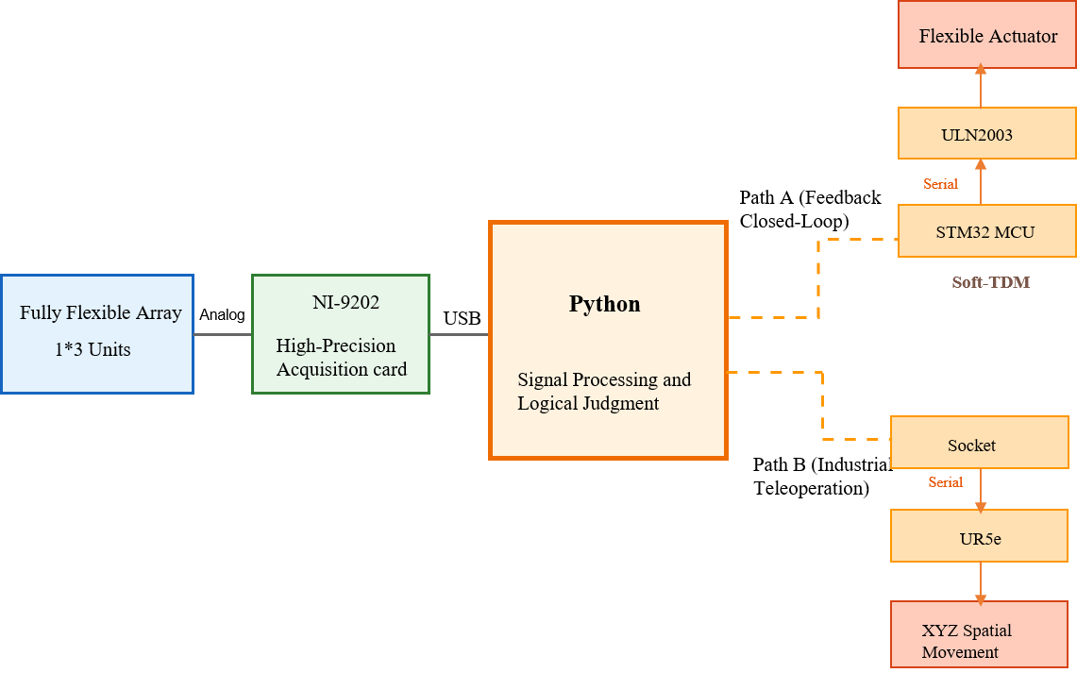
Supplementary Figure 19 System hardware-software co-architecture and dual-scenario application path diagram
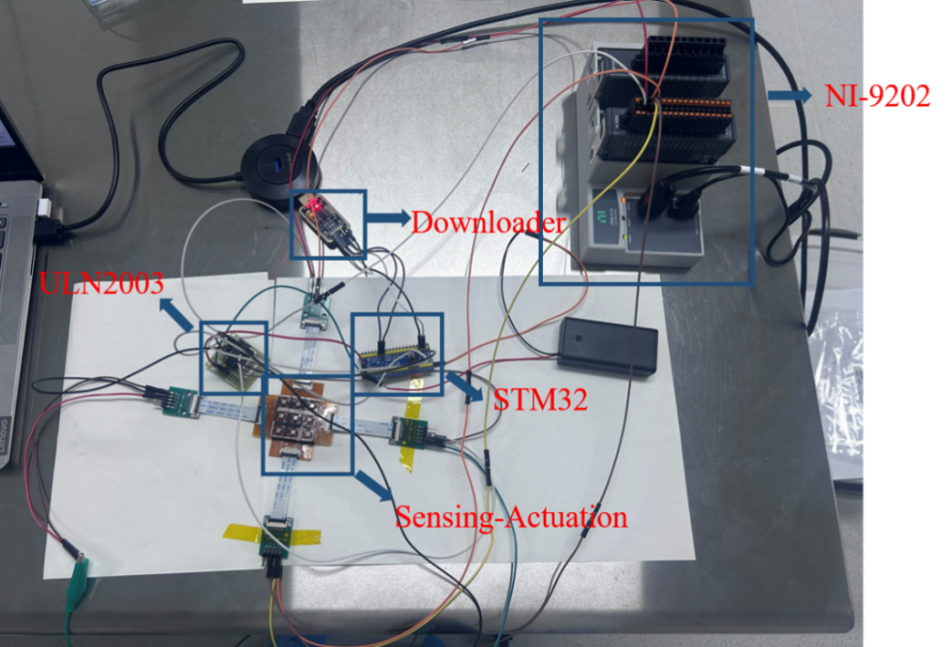

Supplementary Material Figure 20 Hardware Experimental Platform
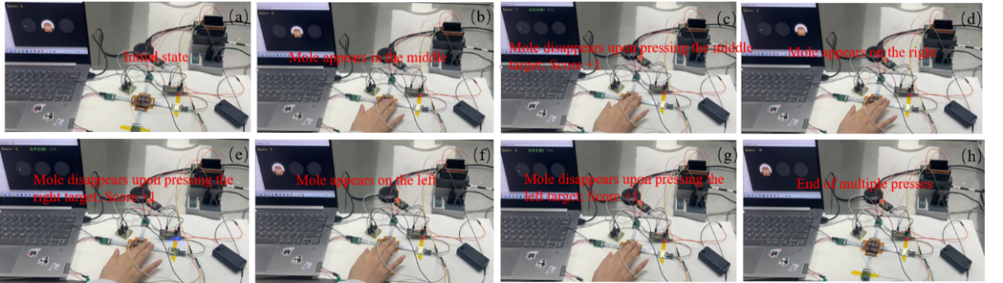

Supplementary Material Figure 21 The hardware experimental platform for the whack-a-mole tactile interaction game. (a) Initial state. (b) Mole appears in the middle. (c) Mole disappears upon pressing the middle target, with score +1. (d) Mole appears on the right. (e) Mole disappears upon pressing the right target, with score +1. (f) Mole appears on the left. (g) Mole disappears upon pressing the left target, with score +1. (h) End of multiple presses.
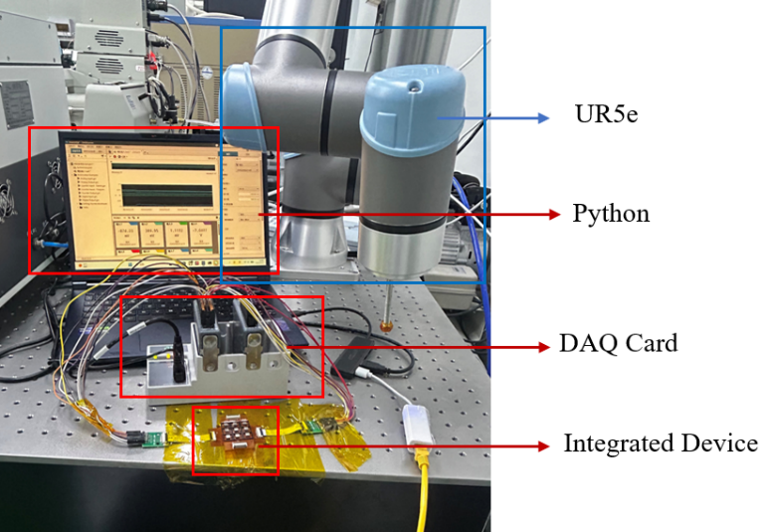

Supplementary Material Figure 22 Physical Photograph of the Robotic Arm Testing System
To suppress the electromagnetic interference caused by the robotic arm motor, data acquisition card, and surrounding equipment in the laboratory environment and ensure the acquisition of millivolt-level weak signals from the sensor, the integrated device is placed inside a customized magnetic shielding box during actual testing. Considering that the magnetic shielding box would block the device's working status and affect the demonstration effect, this component is not shown in the physical demonstration photograph.
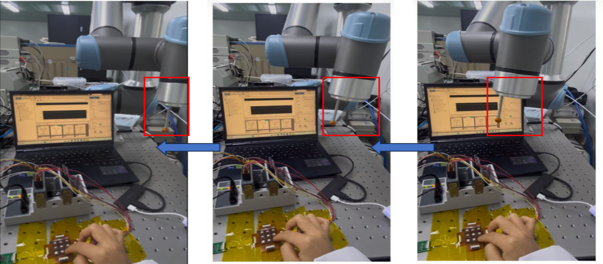

Supplementary Material Figure 23 Controlling the robotic arm to move leftward (X-direction) via pressing the device
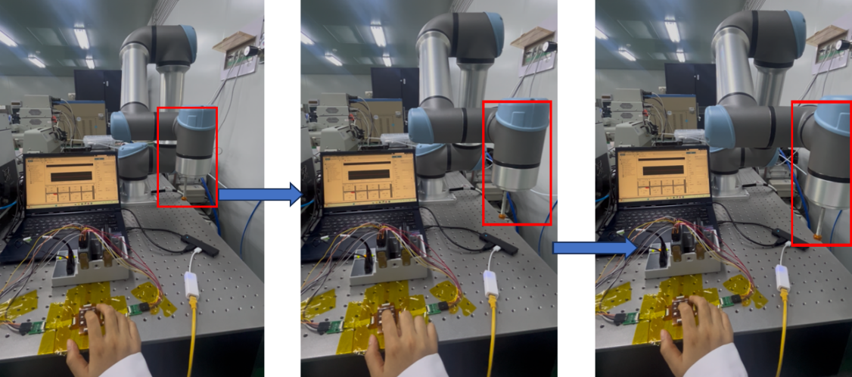

Supplementary Material Figure 24 Controlling the robotic arm to move forward (Y-direction) via pressing the device

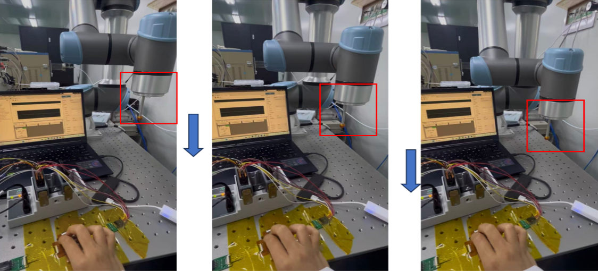

Supplementary Material Figure 25 Controlling the robotic arm to move downward (Z-direction) via pressing the device
The three groups of experimental figures demonstrate the control performance of the electromagnetic actuation-sensing integrated device on the UR5e collaborative robotic arm in the three-dimensional X, Y, and Z directions. As shown in Supplementary Material Figure 23, the complete process of controlling the robotic arm to move continuously leftward horizontally along the X-axis by pressing the device is presented. In the initial state, the end effector of the robotic arm is positioned directly above the device at its starting location. When a pressing stimulus is applied to the device by hand, the device outputs a sensing signal. After recognizing the signal via the Python upper computer, the robotic arm is driven and controlled to translate leftward along the X-axis, revealing the continuous motion trajectory of the robotic arm from the initial position to the target position. Similarly, Supplementary Material Figure 24 shows the forward motion along the Y-axis, and Supplementary Material Figure 25 illustrates the downward motion along the Z-axis.

Supplementary Movie 1. Immersive "Whack-A-Mole" game demonstration. This video demonstrates the closed-loop, bidirectional interaction capability of the monolithic flexible interface. A virtual target is generated on the host PC, and the user’s tactile input is captured by the integrated pressure sensor. Upon successful detection, the corresponding electromagnetic actuator provides localized vibration feedback to the user's fingertip, achieving a synchronized visual-tactile experience with low latency.
Supplementary Movie 2. Real-time teleoperation of a UR5e robotic arm. This video showcases the application of the 3×3flexible array as a high-sensitivity control interface for industrial robotics. By mapping the spatially-resolved pressure signals to XYZ coordinates via a socket communication protocol, the user achieves precise remote control of a UR5e collaborative robot arm. The demonstration highlights the system's high responsiveness and potential for complex remote manipulation tasks in medical or hazardous environments.

