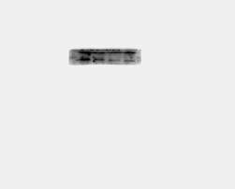
ADAM28
HIF1A
跑
β-actin
MTOR1
HIF1A
ADAM28
COL1A2
150kDa
110kDa
35kDa
42kDa
Figure S4
COL1A2
β-actin

