Supplementary Information
Temperature Regulates Global Freshwater Diazotrophy
Carla Villamarin^{1#}, Almog Gafni^{1#}, Eyal Geisler¹, Rafik Abdellatif², Mohamed Hatha Abdulla³, Adnan Abubakr⁴, Kofi Adu-Boahen⁵, Albin Alfreider⁶, Jonathan Anderson^{7,8}, Shai Arnon¹, Jose Luiz Attayde⁹, Roberto Bao Casal¹⁰, Silvia Britto Barreto^{11,12}, Luke Barrett¹³, Jiří Bárta¹⁴, Masengesho Barthazar¹⁵, Mar Benavides^{16,17}, Sara Benelli¹⁸, Jessica E. Beyer¹⁹, Lee Brown²⁰, Rafael Carballeira²¹, Arthur Coët^{17,22}, Sophie Comer-Warner²³, Edwin Cruz-Rivera^{24,25,26}, Davi Gasparini Fernandes Cunha²⁷, Julian Damashek²⁸, Ding He²⁹, Nandini Dixit³⁰, Lachlan Dow³¹, María Eugenia Fernández Pérez ¹⁰, David Fewer³², Spyros Gkelis³³, Christopher J. Gobler³⁴, Vítor Manuel Costa Gonçalves^{35,36,37}, Hans Peter Grossart^{38,39}, Dave Hambright¹⁹, John A. Harrison^{40,41}, Nicole Hayes⁴², Colin Hill⁴³, Gabriel Iketani⁴⁴, Tijs Joling⁴⁵, Philippe Juneau⁴⁶, Rand lander¹, Simon R. Law ^{47,48}, Antonio Machado⁴⁹, Jonathan D. Magasin⁵⁰, Monia Magri¹⁸, Benjamin Manirakiza⁵¹, Amy Marcarelli⁵², Frank O. Masese⁵³, Carina Menezes⁵⁴, Manuela Morais⁵⁵, Maria Moustaka-Gouni⁵⁶, Justin Murdock⁵⁷, Lawrence Tatanah Nanganoa⁵⁸, Joane Oakes⁴⁵, Valeria Ochoa-Herrera⁴⁹, Hans W. Paerl⁵⁹, Ada Pastor⁶⁰, Caio César Pires de Paula⁶¹, Adina Paytan⁶², Alexandra Penha⁵⁵, Solvig Pinnow⁶³, Martin Polz⁶⁴, James Powell^{24,25,26}, Eyal Rahav⁶⁵, Jean-Baptiste Ramond⁶⁶, Pedro M. Raposeiro^{35,36,37}, Nicholas E. Ray⁶⁷, Jonathan Ready⁶⁸, Alexander J. Reisinger⁶⁹, Lupita Renteria⁷⁰, Ute Risse-Buhl⁷¹, Anne Robertson⁷², Kaitlin Rommelfanger^{24,25,26}, Daniela Rosero-López^{73,74}, Jacqueline Rücker⁷¹, André Luís de Sá Salomão⁷⁵, Mathew Seymour⁷⁶, Martin A. Sieber⁷⁷, Hagar Siebner¹, Marcia da Silva Anjo^{11,12}, Gabriel Singer⁶, Swatantra Pratap Singh⁷⁸, Dagmara Sirova⁷⁹, Ruben Sommaruga⁶, Natassa Stefanidou⁸⁰, Robert Sterner⁸¹, Jabir Thajudeen⁸², Chidambaram Thamaraiselvan⁸³, Louise Thatcher⁸⁴, Tri Manh Tran⁸⁵, Abdulkareem Turaani¹, Kendra Turk-Kubo⁸⁶, Melany Ruiz Uriguen^{87,88}, Gupta Vadakattu⁸⁹, Lishani Wijewardene⁹⁰, Ciara Wirth⁴⁹, Adolphe Zézé⁹¹, Mindaugas Zilius⁹², Tuvia Turkeltraub¹ *; Edo Bar-Zeev¹ *
# Equally contributed to this research
* Corresponding authors: barzeeve@bgu.ac.il; tuviat@bgu.ac.il
¹ Zuckerberg Institute for Water Research, Jacob Blaustein Institutes for Desert Research, Ben-Gurion University of the Negev, Sde Boker Campus, 84990, Israel
² Mohammed VI Polytechnic University (UM6P), Benguerir, Morocco
³ Cochin University of Science and Technology, India
⁴ Division of Aquatic Environmental Management, Faculty of Fisheries, Sher-e-Kashmir University of Agricultural Sciences and Technology of Kashmir (SKUAST-K), Rangil, Ganderbal, Jammu & Kashmir, India.
⁵ Department of Geography Education, University of Education, Winneba, Ghana.
⁶ Department of Ecology, University of Innsbruck, Innsbruck, Austria.
⁷ CSIRO Agriculture and Food, Centre for Crop and Disease Management, Curtin University, Australia.
⁸ The UWA Institute of Agriculture, The University of Western Australia, Perth, Australia.
⁹ Departamento de Ecologia, Centro de Biociências, Universidade Federal do Rio Grande do Norte (UFRN), Natal, Rio Grande do Norte, Brazil
¹⁰ Universidade da Coruña, Grupo de Investigación en Cambio Ambiental e Paleobioloxía (GRICA-BIOpast), Centro Interdisciplinar de Química e Bioloxía (CICA), Spain
¹¹ Centre for Advanced Studies of Biodiversity - CEABIO, Guamá Science Park, Lot 11, Brazil
¹² Institute for Biological Sciences, Federal University of Pará - UFPA, R. Augusto Corrêa, Brazil
¹³ CSIRO Agriculture and Food, Canberra, Australian Capital Territory, Australia
¹⁴ Centre for Polar Ecology, Faculty of Science, University of South Bohemia in Ceske Budejovice, Ceske Budejovice, Czech Republic.
¹⁵ Rwanda Environment Management Authority, Rwanda.
¹⁶ National Oceanography Centre, European Way, Southampton, SO14 3ZH, United Kingdom
¹⁷ Aix Marseille Univ, Université de Toulon, CNRS, IRD, MIO, Marseille, France
¹⁸ Department of Chemistry, Life Sciences and Environmental Sustainability, University of Parma, Parma, Italy
¹⁹ School of Biological Sciences, University of Oklahoma, United States
²⁰ University of Leeds, Leeds, United Kingdom
²¹ Departamento de Ciencias Farmacéuticas y de la Salud, Facultad de Farmacia, Universidad San Pablo-CEU, CEU Universities, Urbanización de Montepríncipe, 28668 Boadilla del Monte, España
²² Aix-Marseille University, CNRS, CINAM, Turing Center for Living Systems, Marseille, France
²³ School of Geography, Earth and Environmental Sciences, University of Birmingham, United Kingdom
²⁴ Department of Biology, Morgan State University, United States
²⁵ Center for Urban and Coastal Climate Science Research, United States
²⁶ University of the Virgin Islands, United States
²⁷ Department of Hydraulic and Sanitation Engineering, São Carlos School of Engineering (EESC), University of São Paulo (USP), São Carlos, São Paulo, Brazil
²⁸ Riverkeeper, 20 Secor Road, Ossining, NY, United States
²⁹ Department of Ocean Science and Center for Ocean Research in Hong Kong and Macau, The Hong Kong University of Science and Technology, Hong Kong, China
³⁰ Indian Institute of Technology Bombay, Powai, India
³¹ Commonwealth Scientific and Industrial Research Organisation, Agriculture and Food, Acton, ACT, Australia
³² Department of Microbiology, University of Helsinki, FINN-00014, Finland.
³³ Department of Botany, School of Biology, Aristotle University of Thessaloniki, Thessaloniki 54124, Greece
³⁴ School of Marine and Atmospheric Sciences, Stony Brook University, Southampton, NY, 11968, United States
³⁵ Faculty of Sciences and Technology, University of the Azores, Ponta Delgada, Portugal
³⁶ Centro de Investigação em Biodiversidade e Recursos Genéticos & Laboratório Associado InBio, Portugal
³⁷ Biodiversity & Sustainability in Atlantic Islands, Ponta Delgada, Portugal
³⁸ Leibniz-Institute of Freshwater Ecology and Inland Fisheries, Germany
³⁹ Institute of Biochemistry and Biology, University of Potsdam, Potsdam 14469, Germany
⁴⁰ Washington State University, Vancouver, Canada.
⁴¹ School of the Environment, 14204 NE Salmon Creek Avenue, Vancouver, WA 98686, United States
⁴² Department of Biology, University of Wisconsin -Stout Polytechnic, Menomonie, United States.
⁴³ APC Microbiome Ireland, University College Cork, Cork, Ireland
⁴⁴ Institute of Educacional Sciences, Federal University of Western Pará, Santarém, 68040-255, Brazil
⁴⁵ Faculty of Science and Engineering, Southern Cross University, Lismore, NSW, Australia
⁴⁶ Ecotoxicology of Aquatic Microorganisms Laboratory, EcotoQ, TOXEN, GRIL, Department of Biological Sciences, Université du Québec à Montréal, Succ. Centre-Ville, Montréal, QC H3C 3P8, Canada.
⁴⁷ Agriculture and Food, Commonwealth Scientific and Industrial Research Organisation (CSIRO), Clunies Ross Street, Acton, ACT, Australia
⁴⁸ Cochin University of Science and Technology, India
⁴⁹ Universidad San Francisco de Quito USFQ, Quito, Ecuador.
⁵⁰ Ocean Sciences Department, University of California, Santa Cruz, Santa Cruz, 95064, United States
⁵¹ College of Science and Technology, School of Science, University of Rwanda, Kigali, Rwanda
⁵² Department of Biological Sciences, Michigan Technological University, MI 49931, United States
⁵³ Department of Fisheries and Aquatic Sciences, University of Eldoret, P.O. Box 1125, Eldoret, Kenya
⁵⁴ Laboratory of Biology and Ecotoxicology, Department of Environmental Health, Lisbon, Portugal
⁵⁵ Water Laboratory, University of Evora, 7005-345 Evora, Portugal
⁵⁶ School of Biology, Aristotle University of Thessaloniki, GR 54124, Thessaloniki, Greece
⁵⁷ Water Center, Technological University, Cookeville, Tennessee, United States
⁵⁸ Forest and Environment, Institute of Agricultural Research for Development, Cameroon
⁵⁹ Departments of Earth, Marine and Environmental Sciences, United States.
⁶⁰ Institute of Aquatic Ecology, University of Girona, Girona, Spain
⁶¹ Biology Centre of the Czech Academy of Sciences, České Budějovice, Czech Republic
⁶² Earth and Planetary Science, University of California Santa Cruz, United States
⁶³ Leibniz-Institute of Freshwater Ecology and Inland Fisheries, Stechlin 16775, Germany
⁶⁴ University of Vienna, Centre for Microbiology and Environmental Systems Science, Vienna, Austria
⁶⁵ Institute of Marine Science, University of California, Santa Cruz, CA, United States
⁶⁶ Extreme Ecosystem Microbiomics & Ecogenomics (E²ME) Lab., Facultad de Ciencias Biológicas, Pontificia Universidad Católica de Chile, Santiago, Chile
⁶⁷ School of Marine Science & Policy, University of Delaware, Lewes, DE, USA, United States
⁶⁸ Group for Integrated Biological Investigation, Universidade Federal do Pará, Belém, Brazil
⁶⁹ Department of Soil, Water, and Ecosystem Sciences, University of Florida Institute of Food and Agricultural Sciences (UF/IFAS), Gainesville, FL, United States
⁷⁰ Pacific Northwest National Lab, United States
⁷¹ Brandenburg University of Technology Cottbus-Senftenberg, Department of Aquatic Ecology, Germany
⁷² School of Life & Health Science, Roehampton University, London, United Kingdom
⁷³ Laboratorio de Ecología Acuática, Universidad San Francisco de Quito USFQ, Quito, Ecuador
⁷⁴ Global Research and Solutions Center, Universidad San Francisco de Quito USFQ, Quito, Ecuador
⁷⁵ Department of Sanitary and Environmental Engineering (DESMA), Faculty of Engineering (FEN), State University of Rio de Janeiro (UERJ), Rio de Janeiro, Brazil.
⁷⁶ School of Biological Sciences, The University of Hong Kong, Hong Kong SAR, China
⁷⁷ Department of Natural Sciences, University of Applied Sciences Bonn-Rhein-Sieg, Germany
⁷⁸ Gogri Hub for the Membrane Translational Research, Indian Institute of Technology Bombay, Powai, India
⁷⁹ Biology Centre of the Czech Academy of Sciences, České Budějovice, Czech Republic
⁸⁰ School of Biology, Aristotle University of Thessaloniki, GR 54124, Thessaloniki, Greece
⁸¹ Large Lakes Observatory, University of Minnesota Duluth, Duluth, Minnesota, United States
⁸² National Centre for Polar and Ocean Research (NCPOR), Ministry of Earth Sciences, Vasco-da-Gama, Goa, India; and CUSAT–NCPOR, Cochin University of Science and Technology, Kochi, Kerala, India.
⁸³ Ralph E. Martin Department of Chemical Engineering, University of Arkansas, United States
⁸⁴ Commonwealth Scientific and Industrial Research Organisation (CSIRO), Agriculture and Food, Australia
⁸⁵ University of Science, Vietnam National University, Hanoi.
⁸⁶ Ocean Sciences Department, University of California Santa Cruz, Santa Cruz, California, United States
⁸⁷ Colegio de Ciencias Biológicas y Ambientales, Universidad San Francisco de Quito USFQ, Quito, Ecuador.
⁸⁸ Core Lab de Ciencias Ambientales, Universidad San Francisco de Quito USFQ, Quito, Ecuador.
⁸⁹ CSIRO Ag & Food, Waite campus, Urrbrae, SA 5064, Australia.
⁹⁰ Department of Limnology and Water Technology, Faculty of Fisheries and Marine Sciences & Technology, University of Ruhuna, Matara 81000, Sri Lanka
⁹¹ Institut National Polytechnique Houphouet-Boigny, Yamoussoukro, Côte d’Ivoire.
⁹² Marine Research Institute, Klaipeda University, Lithuania

Results
Global bacterial abundance
Total bacterial abundance (BA) varied across the global freshwater sites, spanning several orders of magnitude (1.6x10⁹± 2.8 x10⁹, Figure S1). No latitudinal or regional patterns were apparent during the sampling period, consistent with the highly variable bacterial biomass in freshwater systems.
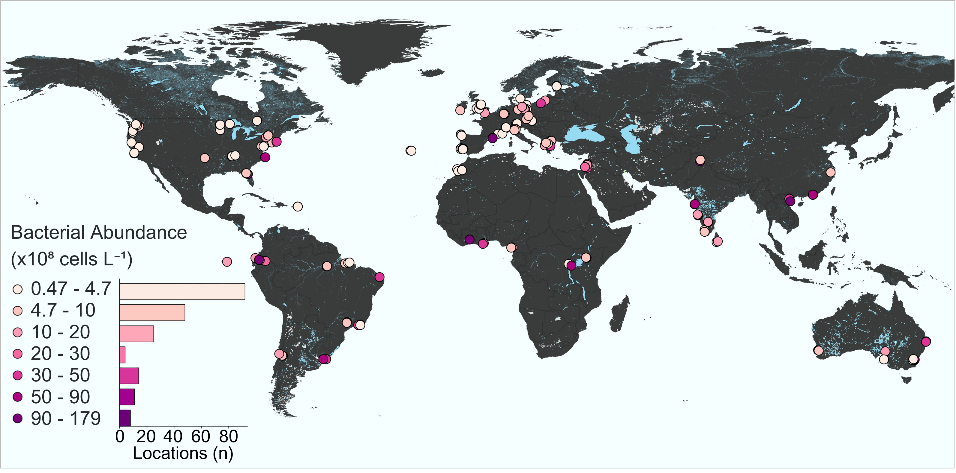Figure S1. Total bacterial abundance (BA) across the globe. Sites shades –from pale pink to magenta- increase as bacterial abundance increases. Histogram denotes sample size (number of locations) for each BA category

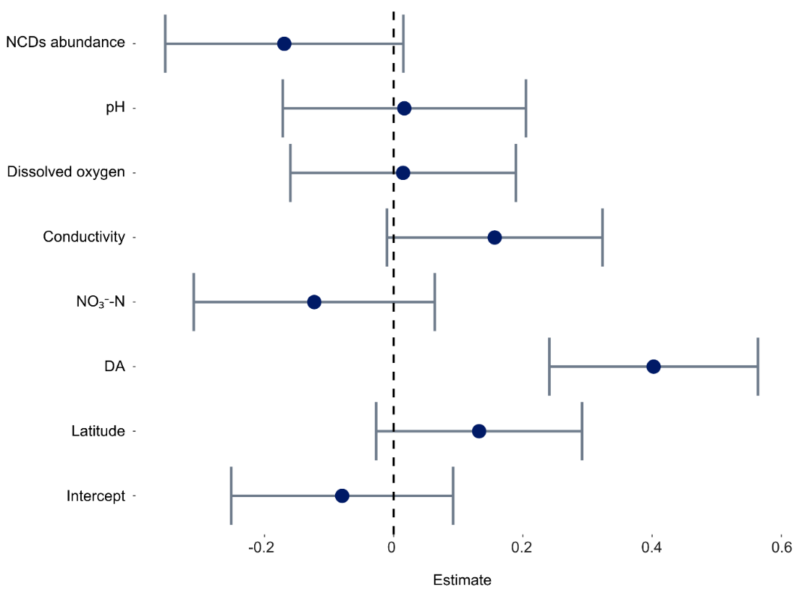
Figure S2. Regression plots for the drivers of N₂ fixation rates below 21°C.

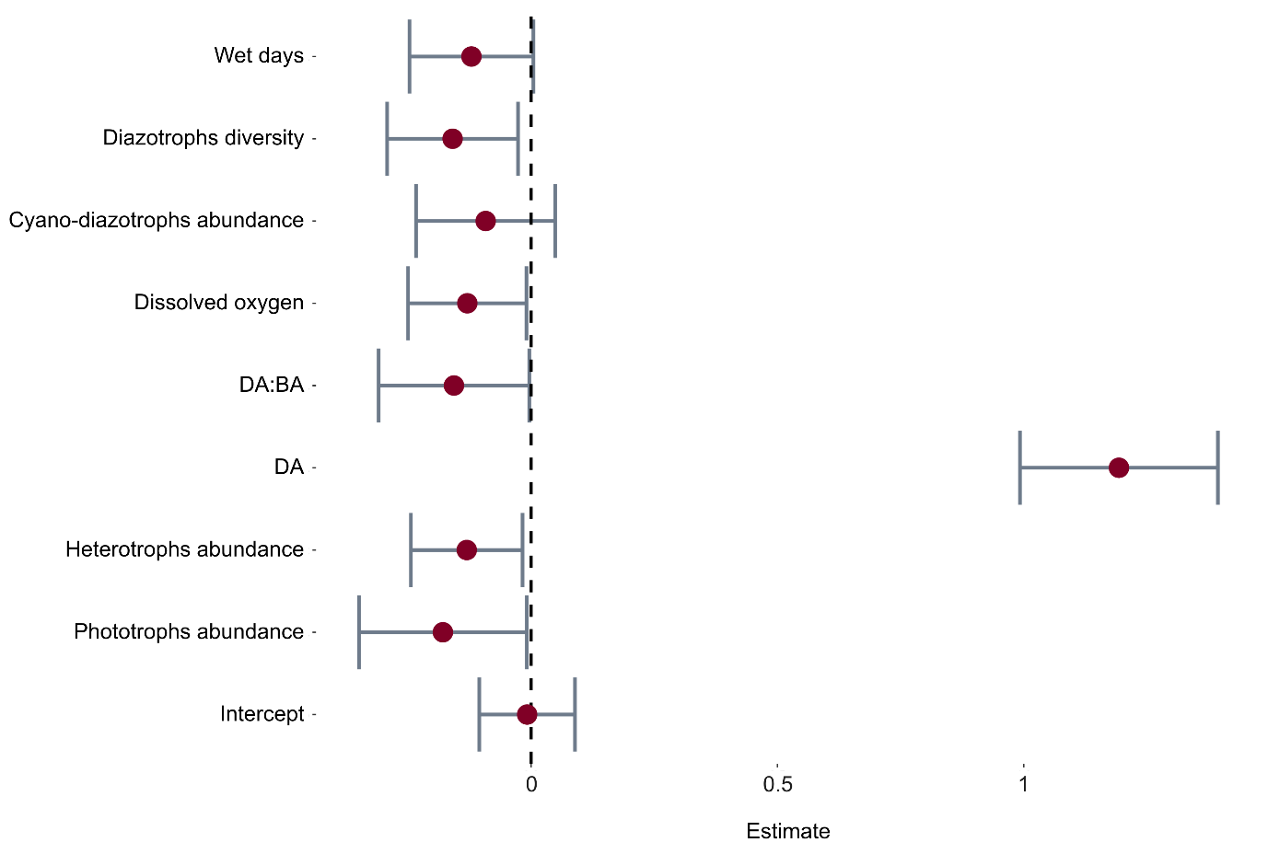
Figure S3. Regression plots for the drivers of N₂ fixation rates above 21°C.

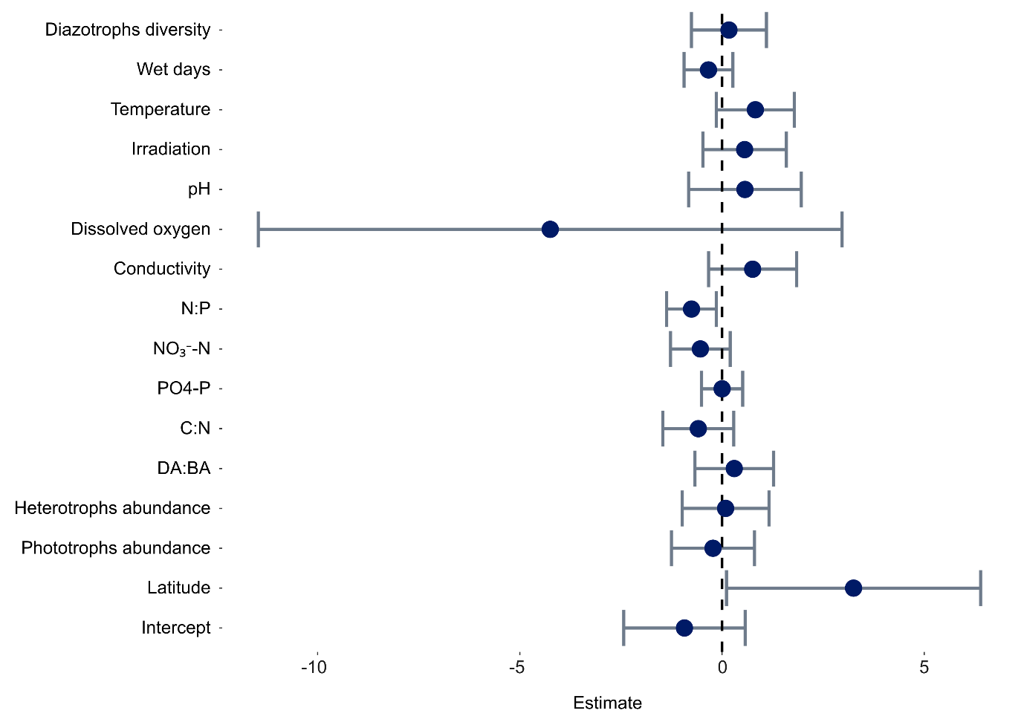
Figure S4. Regression plots for the drivers of N₂ fixation rates below 9°C.

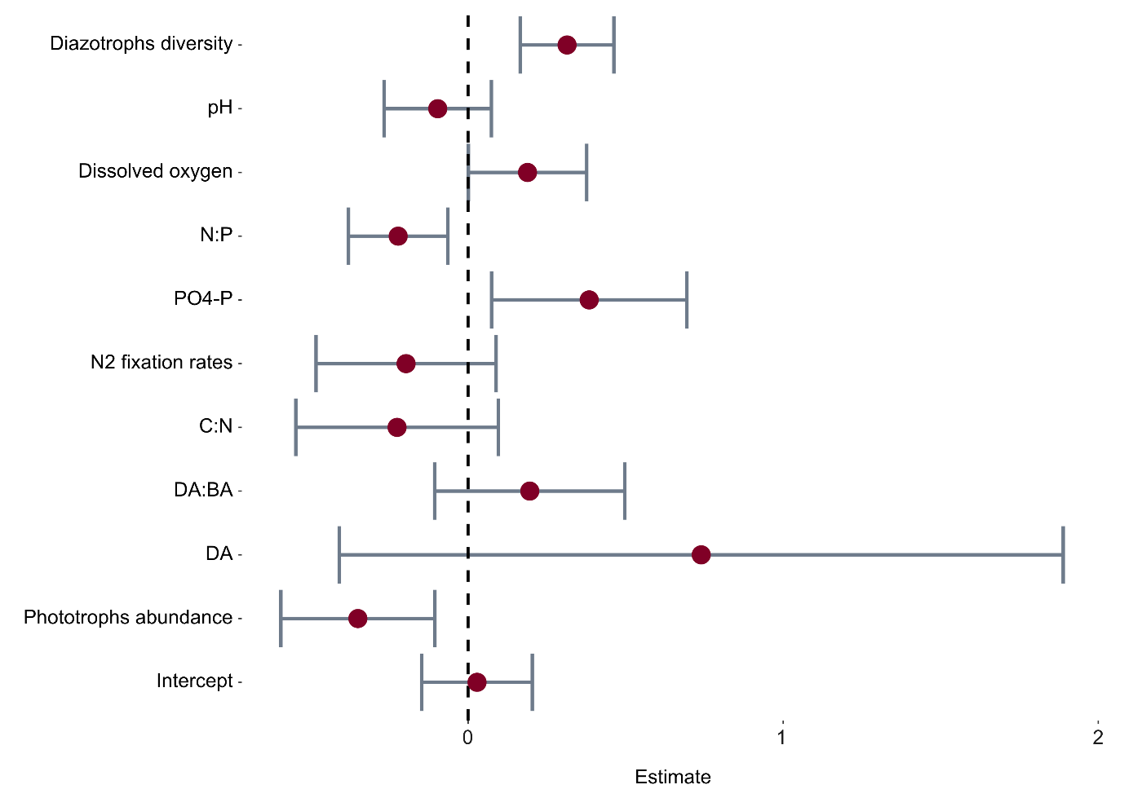
Figure S5. Regression plots for the drivers of N₂ fixation rates above 9°C.

Materials and methods
Research network and sampling locations
This global work included 80 research groups from 36 countries and six continents which constituted the network that sampled surface freshwater (< 1 m depth) from 206 locations across the world (Figure S6). These locations were divided into lotic (rivers and streams) and lentic (lakes and reservoirs) environments.
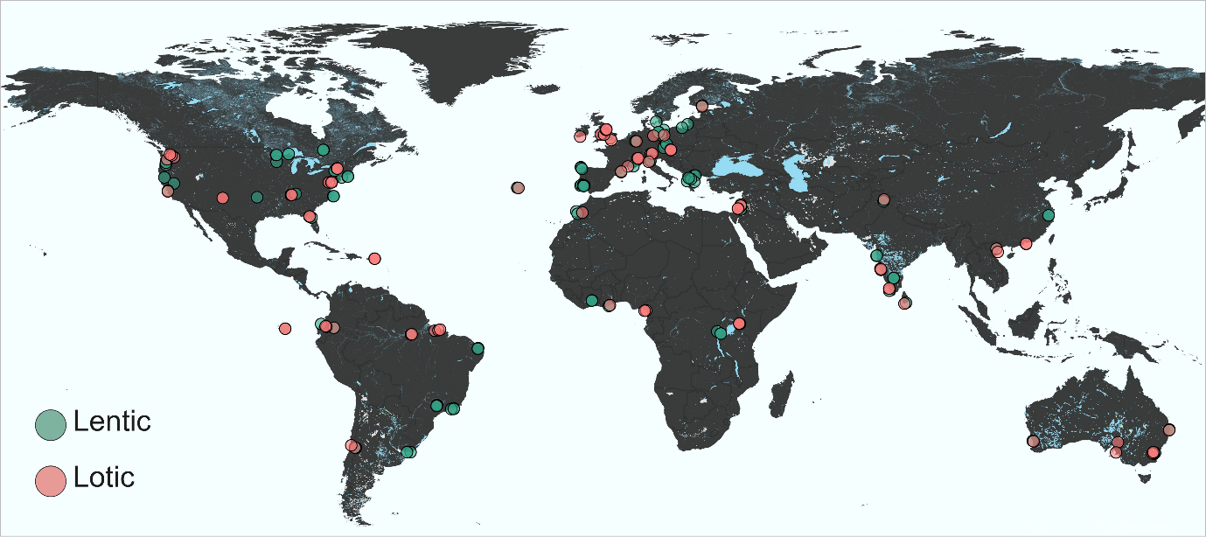
Figure S6. Global sampling sites across lotic and lentic freshwater ecospaces.
Pre-sampling stages
Design of the sampling kit
Kits were designed to endure international shipment after sampling freshwater environments across the globe. The kits were divided into basic and advanced options, according to the sampling capacity of each research partner. A basic kit was assembled with supplies to sample bacteria and diazotroph abundance as well as diversity and water chemistry (Table S1). An advanced kit included all the basic supplies, with the addition of materials to measure N₂ fixation rates (Table S1). Both kits included all the consumables needed to sample between 1-3 freshwater sites (determined by the partner).
Kits were packed in Styrofoam boxes (20 × 25 × 35 cm) containing two ice packs and a documentation bag. Each sampling tube in the kits was affixed with a printed label containing a dedicated code specifying the group number, sampling site, and analysis type, and was then placed in a pre-labeled analysis bag. Specific details related to the preparations of consumables assembled in the kits are provided below.
Table S1: per-site sampling components
 | Component | Catalog No. | Supplier | Quantity
Basic kit
General | Nitrile gloves (pairs) |  |  | 2
General | Plastic syringe, 60 mL (single use) | 16-0211 | SIMADA | 1
General | Parafilm strips |  |  | Several
Bacterial and diazotroph abundance | 15 mL polypropylene tube (A), pre-filled with 70 µL Glutaraldehyde (B) | 14-959-49B (A) / G7651 (B) | THERMOFISHER SCIENTIFIC (A) / SIGMA-ALDRICH (B) | 1
Bacterial and diazotroph abundance | Aluminum foil piece | – | – | 1
TOC and TN | Acid-washed glass VOC tube (A), pre-filled with 0.1% v:v 1 N HCl (B) | 140-40CDB (A) / – (B) | THERMOFISHER SCIENTIFIC (A) / BIO-LAB LTD. (B) | 2
NO₂+NO₃, NH₄ and PO₄ | 50 mL polypropylene tube | 14-432-22 | THERMOFISHER SCIENTIFIC | 3
Bacterial and diazotroph diversity | 5 mL luer-lock syringe (A), pre-filled with 3 mL RNAlater (B), sealed with cap | 16-020 (A) / R0901-100mL (B) | SIMADA (A) / SIGMA-ALDRICH (B) | 1
Bacterial and diazotroph diversity | Sterivex-GP pressure filter unit | SVGPB1010 | MILLIPORE® | 1
Bacterial and diazotroph diversity | Coded name sticker | – | – | 1
Bacterial and diazotroph diversity | Extra luer-lock caps | – | – | 2
Advanced kit
N₂ fixation rates | Polystyrene Petri dish (A), each with 1 pre-combusted glass-fiber filter wrapped in Parafilm (B) | P5481-500EA (A) / WHA1827025 (B) | MERCK® (A) / WHATMAN® (B) | 5
N₂ fixation rates | Glass VOC tube pre-filled with N₂-enriched water | 140-40CDB | THERMOFISHER SCIENTIFIC | 1
* TOC and TN (total organic carbon and total nitrogen, respectively)

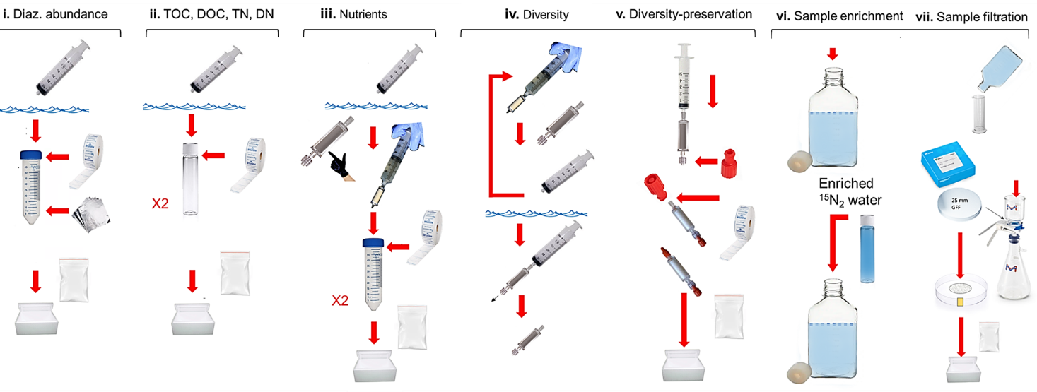
Figure S7. Schematic illustration of the sampling protocol. First, samples were collected from surface water for diazotroph abundance (i). Then partners collected collect water for total and dissolved organic carbon/nitrogen (ii) and nutrients (iii). The fourth sampling protocol focused on diazotroph diversity and function (iv). Nucleic acids were preserved on filters by fixing the samples with RNA later (v). For research partners measuring N₂ fixation rates, water samples were enriched with ¹⁵N₂ and incubated for 48 h under ambient conditions (vi). At the end of the incubation, samples were filtered and all samples were repacked for shipment (vii).
Preparation of ¹⁵N₂-enriched water
Enriched water with dissolved ¹⁵N₂ was prepared following ¹. Briefly, Milli-Q water was degassed in a sterile system that included a gastight Nalgene bottle (1L) with a custom-made cap (Figure S8). The system was degassed by passing the water via a membrane (3M Liqui-Cel MM 1X5.5 Series Membrane Contractor G543) under negative pressure for 24 h in a heated room (30ºC) to reduce gas solubility. The degassed water was enriched with 15 mL of ¹⁵N₂ gas (99%, Cambridge Isotopes, Lot # NLM-363-PK) at a ratio of 1.5% v:v. The enriched stock was continuously shaken (100 rpm), at 4 °C, for 48 hours to ensure complete dissolution of the ¹⁵N₂ gas bubble. The ¹⁵N₂-enriched water was aliquoted into 40 mL glass VOC vials, ensuring no air bubbles were trapped prior to sealing with Parafilm. Vials from different preparation batches were analyzed by membrane-introduction mass spectrometry (MIMS) to confirm the enrichment of the stock subsamples (Figure S9). The same method was applied to determine the shelf life of the stocks, confirming that no changes were apparent over 3 months.
Figure S8. Water degassing system. (A) Standard set up of the water degassing system used for all ¹⁵N₂-enriched water preparation batches. (B) Degassing membrane zoomed view. (C) Custom-made cap for degassing. (D) Schematic description of the system.

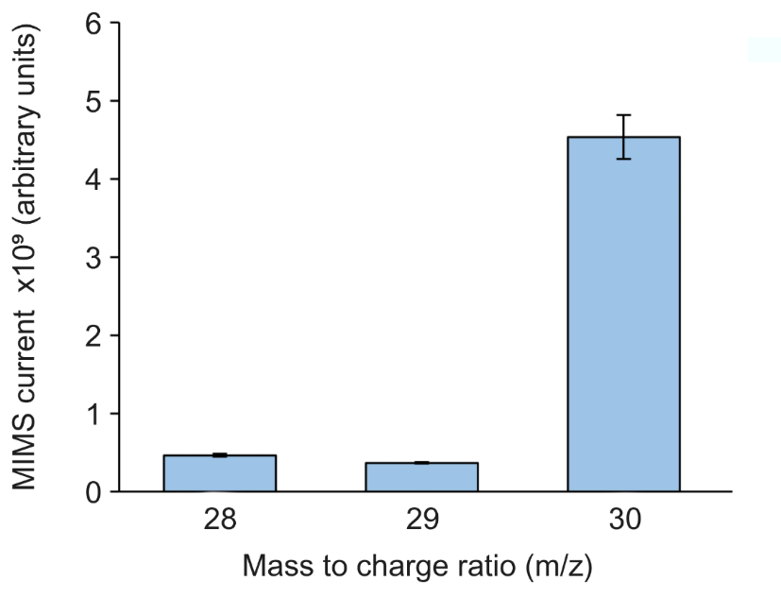
Figure S9. MIMS signal (arbitrary units) of nitrogen gas isotopologues (m/z 28, 29, and 30) in the ¹⁵N₂-enriched stock solution. The pronounced signal at m/z 30 confirms the dominance of ¹⁵N₂, while the lower signals at m/z 28 and 29 indicate minimal presence of ¹⁴N₂ and mixed ¹⁴N–¹⁵N species.
Sampling strategy and protocols
The freshwater ecospace was sampled according to three central pillars: (i) Each research group collected surface water (0.2-1 m deep) from one to three predetermined locations. These sites were chosen by the research partner according to ecological relevance of their region. The sampling was carried out using the custom made kit (Table S1) and associated specific handling protocol for all research partners to standardize the collection and analysis of diazotrophs across the freshwater ecospace (Figure S7, available also at https://youtu.be/8vK6IF98Ab8), (ii) The global sampling campaign was restricted to a dedicated timeframe (< one month) during late spring and early fall at the north and south hemispheres, respectively. (iii) All research partners collected samples for “basic analysis” (bacterial/diazotroph abundance and diversity as well as nutrient concentrations), while groups with advanced capacity also carried out incubation assays to measure N₂ fixation rates (detailed below). (iv) All samples were stored refrigerated (4 °C, dark, not frozen) and returned to BGU within five days of collection using a pre-paid courier service included in the kit.
Following the above, basic sampling was required from all partners and consisted of collecting surface water for the analysis of nutrient concentrations (NO₃, NO₂, NH₄ and PO₄), TOC and TN stoichiometric ratios (C:N:P), diazotrophic abundance, and molecular identification (Figure S7 i-v). At each site, a standardized set of auxiliary data was recorded (sampling date, time of sampling, electrical conductivity, water/air temperature, dissolved oxygen, pH, cloud coverage, annual precipitation, turbidity, land use, average stream depth, average stream width, catchment size, stream order, average slope, length of the flowing river upstream from the sampling point, river discharge, lake maximum depth, lake mixing regime, lake thermocline/nutricline depth, lake estimated volume) and is available in Appendix 1. In addition, 3–5 photographs of the sampling site were taken, including at least one image across the width of the system and additional images along the shoreline. Samples were collected > 2 m off the bank to minimize sediment disturbance. Collection of the samples was done in a clean bucket, rinsed three times with ambient surface water. The water samples were stirred every few minutes to ensure homogeneity before subsampling.
Advanced sampling included all procedures of the basic level, with the addition of N₂ fixation rate measurements (Figure S7 vi-vii). It should be noted that this procedure required dedicated equipment (i.e., vacuum system and gas tight bottles) that were not supplied in the kit. Prior to sampling, five gas-tight bottles (1L, Nalgene) were rinsed three times with surface water. Enriched bottles (x3) were filled with ~900 mL of surface water and spiked with 43 mL of ¹⁵N₂-enriched water (i.e., one vial from the kit). Surface water was then added to ensure the formation of a positive meniscus and the absence of air bubbles. Bottles were sealed without air bubbles and incubated for 24–48 h at close to ambient conditions. Incubations were ideally carried out in situ within the sampled river or lake. When this was not possible, incubations were conducted under laboratory conditions using an orbital shaker under a 12 h light / 12 h dark regime. In both cases, incubation temperature was maintained as close as possible to ambient conditions. For each incubation, metadata were recorded, including total incubation time, temperature, light intensity (if measured), and whether bottles were rotated. Samples were filtered through a pre-combusted (450°C) 25 mm GF/F filter at the end of the incubation. To avoid cross-contamination, bottles without ¹⁵N₂ enrichment were always filtered first, followed by the enriched samples. Filters were transferred into marked Petri dishes, sealed with tape, and placed in labeled zip-bags indicating treatment (with/without enrichment). All samples were stored in the Styrofoam box. Upon arrival at BGU, samples were transferred to a refrigerated room (4°C) until analysis.
Quantification of total bacterial and diazotroph abundance
Surface water (12 mL) was subsampled using a 60 mL syringe, which was prewashed three times with ambient water. The collected sample was transferred into a designated, pre-labeled 15 mL Falcon tube with glutaraldehyde (final concentration 0.02%; Sigma-Aldrich G7651) provided in the kit. Tubes were sealed with parafilm, wrapped in aluminum foil to protect from light, and placed in specifically labeled zip-bags before storage in the insulated Styrofoam box. Upon arrival at BGU, samples were subsampled in triplicate into 1.8 mL cryotubes (Cat. 377267, Nunc™, Thermo Scientific™), immediately flash-frozen in liquid nitrogen, and stored at –80 °C until analysis.
Analyzing the concentrations of total organic carbon and nitrogen
Surface water (30 mL) was subsampled using a 60 mL syringe into two pre-cleaned glass VOC vials provided in the kit. Prior to use, all vials were prewashed in a 1 N HCl acid bath overnight, rinsed three times with double-distilled water, and allowed to dry under clean conditions. To ensure immediate preservation upon sampling, 1 N HCl (0.1% v:v final concentration) was added in advance to each vial. This treatment was applied to halt bacterial activity and prevent biological alteration of the chemical composition of the water samples. Filled vials were placed in labeled zip-bags before storage in the insulated Styrofoam box. Upon arrival at BGU, samples were stored at –20 °C until analysis.
Analyzing the concentrations of dissolved nitrogen species and orthophosphate
Surface water (30 mL) was subsampled using a 60 mL syringe and filtered through a Sterivex 0.22 µm cartridge filter connected via luer lock to a sterile syringe. Care was taken to handle the Sterivex casing from the middle to avoid contamination. Filtrates were dispensed into two 50 mL Falcon tubes. Tubes were sealed with parafilm to prevent leakage and evaporation and placed in labeled zip-bags before storage in the insulated Styrofoam box. Upon arrival at the coordinating laboratory, samples were stored at –20 °C until analysis.
Diazotrophs community analysis
Up to 1 L of surface water was filtered through a Sterivex 0.22 µm cartridge filter using the same setup as detailed above with repeated cycles. Residual water was expelled by gently pushing air through the Sterivex with the sampling syringe. The Sterivex was then filled with RNAlater solution until the preservative overflowed, ensuring complete saturation and removal of air bubbles. Both ends of the Sterivex were sealed with designated caps and wrapped in parafilm. A pre-labeled sticker was affixed directly to the filter, which was then placed in a labeled zip-bag and stored in the Styrofoam shipping box with icepacks until return. Upon arrival at BGU, samples were stored at –80 °C until analysis.
Freshwater community analyses
Quantification of total bacterial and diazotroph abundance by flow cytometry
Samples were mixed with ethylenediaminetetraacetic acid (5 mM, pH 8) and probe-sonicated to dislodge aggregated cells (amplitude 55 mV, 10 s × 3). Cyanobacteria and pico- to micro-sized algae were counted using an unstained (300 µL) subsample. Total bacterial abundances quantified after subsamples (300 µL) were stained with LightCycler® 480 SYBR Green I Master (04707516001, Roche) for 15 min in the dark. Notably, despite the presence of micro and pico algae in the samples, their average contribution to total bacterial and archaeal abundance (BA) is negligible across samples (<0.1%, Figure S10), allowing our terminology to refer to bacteria and archaea only. Diazotrophs were identified and counted after the nitrogenase enzyme was immunolabeled according to Geisler et al ². Briefly, a subsample (1 mL) was centrifuged (4000 × g, 10 min) and washed three times with phosphate-buffered saline-Triton (PBST). Samples were tagged with a freshly made stock of primary antibody, anti-nifH (AS01 021A, Agrisera Antibodies, Vännäs, Sweden), incubated for 1 h at room temperature (Benchmark Scientific Roto-Therm Plus, H2024), and re-washed three times. A conjugated secondary antibody (A-11039, Thermo Fisher Scientific) with fluorescein isothiocyanate (FITC) was then added, incubated for 45 min at room temperature, and washed three times. The stained, unstained, and immunolabeled samples were analyzed along with a set of positive and negative controls (Table S2). In addition, the potential fixation capacity of the samples was tested using Vibrio natriegens (Vn). Specifically, Vn samples were fixed and stored in the dark at room temperature. The samples were then analyzed and quantified after two weeks and one month (Figure S11).

Table S2. Quality controls for diazotroph counts by flow cytometry
Control | Purpose | Representative density plots
Vn no stain | System cleanliness no autofluorescence
E.coli no stain | System cleanliness no autofluorescence | 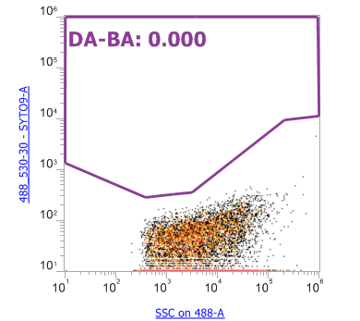
Vn total count | Total bacterial abundance stained using SYBR green | 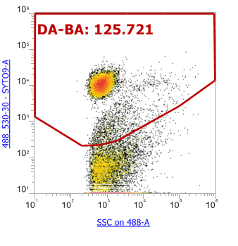
E.coli total count | Total bacterial abundance stained using SYBR green | 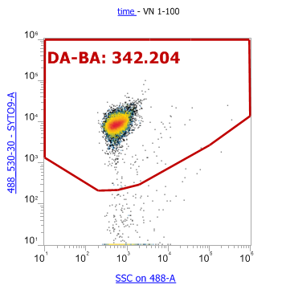
E. coli immunolabeled | Negative control of non-diazotroph | 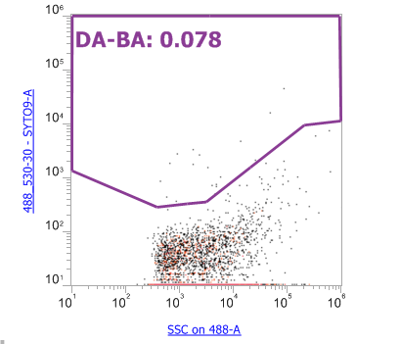
Vn immunolabeled | Positive control of diazotroph | 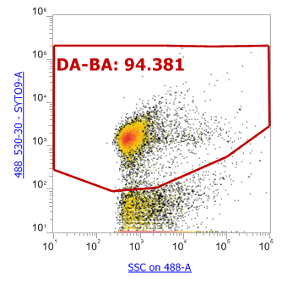

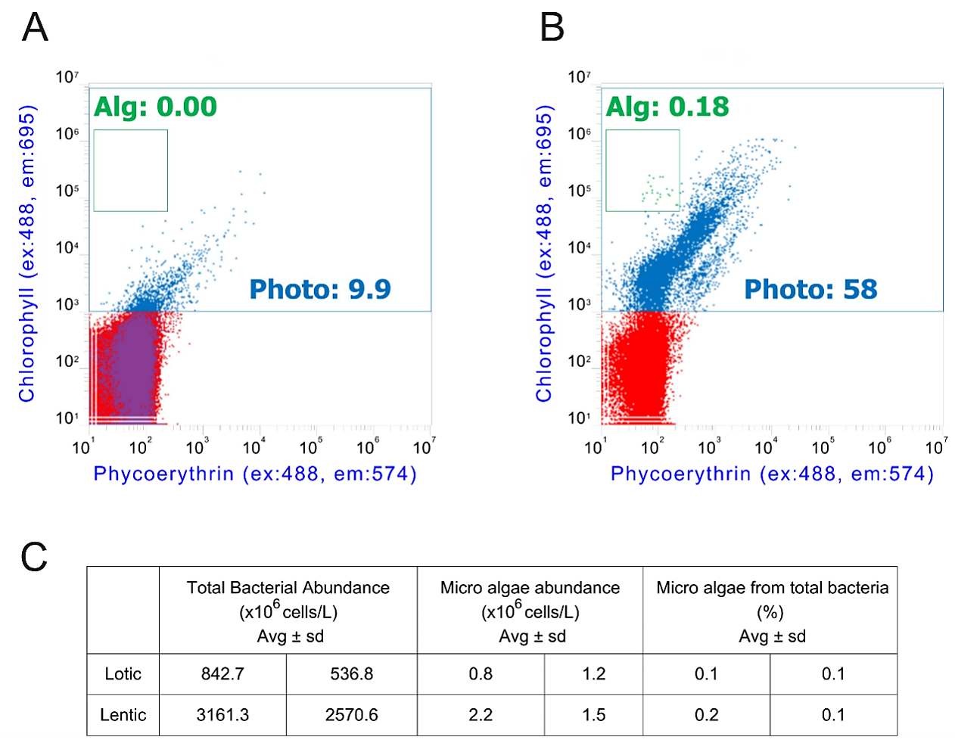
Figure S10. Micro and pico algae quantification by flow cytometry. Representative plots of total phototrophs and micro/pico algae in a lotic (A) and a lentic (B) study site. Average and standard deviation of total bacteria concentration, micro/pico algae concentration and its percentage. The units of the excitation (ex.) and emission (em.) spectrums are in nanometres. Numbers within the plots represent the concentrations of events measured directly by the flow cytometer.
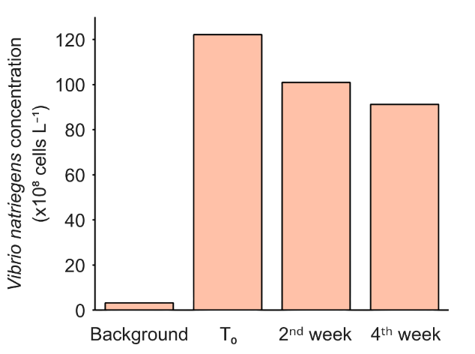
Figure S11. Monitoring of the cell fixation capacity of the kit’s glutaraldehyde for up to one month, using Vibrio natriegens (Vn) as a model organism. Bars represent the concentration of Vn nitrogenase after two and four weeks of storage.
Bacterial and diazotroph counts were done using a flow cytometer (Attune NxT, Thermo Fisher Scientific) equipped with a 450 nm laser (blue) detector of 520±30 nm for dye and 574±26 for non-dyed cells at 100 µL min⁻¹. Each run started with triplicate blanks, with sequential blanks every five samples to ensure system cleaning and that no carryover occurred. Cell-specific N₂ fixation was calculated by dividing the N₂ fixation rates by the number of diazotrophic cells.
Measuring N₂ fixation rates
Rates of N₂ fixation were determined using a ¹⁵N₂-enrichment approach according to Geisler et al. 2023 ². Briefly: Filters were dried overnight at 60°C and stored in a desiccator before being packed in tin capsules (Cat SSC1279, Silicol Scientific Equipment Ltd). Analysis was done in triplicate, using an elemental analyzer (EA; Flash 2000 HT, Thermo Fisher Scientific, Milan, Italy) coupled to an isotope ratio mass spectrometer (IRMS; Delta V Plus, Thermo Fisher Scientific, Bremen, Germany). Quartz crucibles were used and renewed every 15-20 samples to remove ash and maintain proper reactor operation over time. Accuracy was ensured by calibrating measured isotopic values against a set of secondary standards (Figure S12A), bracketing the range of isotopic compositions for both natural abundance and enriched samples. Nitrogen isotope ratios are reported in δ¹⁵N notation relative to air, determined using the following standards: Caffeine USGS62 (δ¹⁵N =+20.17‰), Glycine USGS64 (δ¹⁵N =+1.76 ‰), and L-Glutamic acid USGS40 (δ¹⁵N =-4.52 ± 0.06 ‰). A linearity test was performed, using USGS 64 (Figure S12B), at the beginning of the work to determine the nitrogen working range, during which the isotopic values remained stable. According to the results, a range of 10 to 52 µg N was determined. These values are in accordance with previous publications ^{2,3}. Standards were measured at the beginning and the end of each set. Also, a representative standard (Glycine, USGS64) was measured every 4-5 samples to verify proper system performance and to allow correction for potential instrumental drift. No significant drift or deviation was observed throughout the analytical sequence (Figure S12C, standard deviation = ±0.3‰). Finally, nitrogen content in the samples’ biomass was quantified using an external calibration curve (acetanilide), relating peak amplitude to a known amount of nitrogen in the standard. A linear response was obtained over a wide mass range, enabling reliable quantification from 1.8 to 52.4 µg N. (Figure S12D).
N₂ fixation rates were calculated from the ¹⁵N atom% excess measured in enriched samples, relative to natural abundance, normalized to the ¹⁵N enrichment of the dissolved N₂ pool at the start of the incubation. The fractional uptake was derived as N₂ fixation rate
$$=\frac{sample 15N atom\% - NA 15N atom\%}{15N enrichment - NA 15N atom\%} x incubation time$$
The fractional uptake was then multiplied by the particulate nitrogen concentration in the volume filtered, to yield volumetric N₂ fixation rates in nmol N L⁻¹ d⁻¹. Triplicate incubations were averaged per sample, and cell-specific rates were obtained by dividing bulk rates by diazotroph abundance.

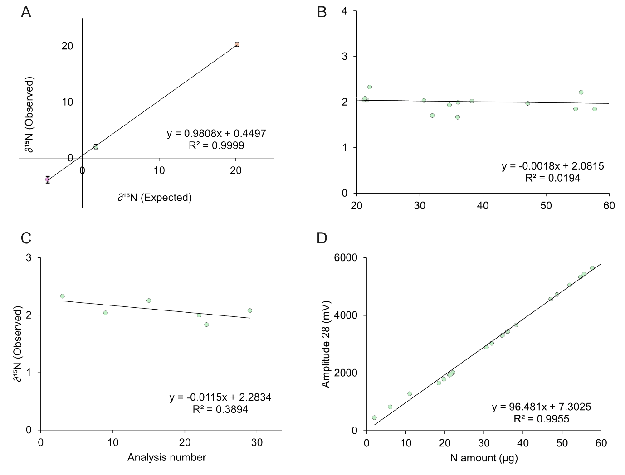
Figure S12. EA-IRMS quality control tests. A calibration curve comparing expected and measured δ¹⁵N for a range of known secondary standards, bracketing the isotopic composition of the samples (n=41) (A). A linearity test of δ¹⁵N in Glycine (USGS64) over a range of N amount (µg) in samples (standard deviation for the range of 1.8 to 57.7 µg N was 0.4) (B). A drift test of Glycine (USGS64) throughout the analysis showing no significant change (slope = -0.001, and standard deviation ±15) (C). A calibration curve relating N mass in Glycine (USGS64) to measured peak amplitude, used for quantification of the N in the sample’s biomass (D). Symbols: Glutamic acid (USGS40) was marked by pink, Glycine (USGS64) by green, Caffeine (USGS62) by orange.

Diazotroph community analysis: DNA extraction, nifH sequencing, and bioinformatics
DNA was extracted using the DNeasy PowerWater Sterivex Kit (Cat 14600-50-NF, QIAGEN), following the manufacturer’s protocol. Prior to extraction, filters were thawed at room temperature and RNAlater™ was removed by washing each cartridge with sterile 0.85% NaCl solution (5× the filter volume), as recommended by the kit provider. DNA was eluted in 40 µL of elution buffer and quantified using a NanoDrop™ spectrophotometer (NanoDrop One^{c}, Thermo Scientific).
To assess amplification efficiency and potential PCR inhibition, randomly selected samples were tested in-house for nifH gene amplification using nested PCR ⁴. Amplicons were visualized on a 2% agarose gel. Samples with DNA concentrations exceeding 100 ng/µL showed evidence of PCR inhibition and were therefore diluted at 1:10. Following dilution, inhibition was no longer observed.
DNA samples were dried using SpeedVac (Concentrator plus, Eppendorf) and transferred to sterile 0.5 mL tubes (GenTegra-DNA,) prior to shipment. DNA samples were sent to the RUSH Genomics and Microbiome Core Facility for nifH gene amplification using the same protocol. Finally, amplicons were sequenced using the Illumina NovaSeq 6000 platform (2 × 250 bp paired-end reads). Positive controls (VN strain) and negative controls (MQ water filter processed and extracted as any other sample) were included in the sequencing batch. Selected technical replicates (identical DNA extracts) were also submitted in duplicate to evaluate sequencing consistency.
The nifH sequences were analyzed following Morando et al. (2025), with few modifications. Briefly, prior to running the DADA2 nifH pipeline, the EstimateTrimLengths pre-pipeline stage was used to determine optimal read trimming parameters for the dataset (Table S3.). Raw Illumina paired-end reads were then processed through the DADA2 nifH pipeline (Magasin & Morando; github.com/jdmagasin/nifH_amplicons_DADA2), which includes primer trimming with cutadapt, identification of nifH-like reads for improved error model training, quality filtering and trimming, dereplication, denoising and ASV inference, merging of paired-end reads, construction of an ASV abundance table, and bimera removal. From the post-pipeline stages of the nifH-ASV-workflow (github.com/jdmagasin/nifH-ASV-workflow), only FilterAuids and AnnotateAuids were applied, which perform size- and abundance-based quality filtering and taxonomic annotation of ASVs against multiple nifH reference databases maintained by the Zehr and Turk-Kubo labs (UC Santa Cruz). The resulting output files, including a representative sequence FASTA file (auid.filtered.fasta), a sequence count table (auid.abundances.filtered.tsv), and a Genome879 taxonomy annotation file extracted from the main annotation table (auids.annot), were imported into R along with a sample metadata file for all subsequent post-processing and statistical analyses.
Alpha diversity was estimated on a rarefied ASV table (rarefied to the minimum sample depth using rarefy_even_depth; seed = 8012025), using the observed richness, Chao1, Shannon, Simpson, inverse Simpson, and dominance indices as implemented in the microbiome package. Taxonomic composition was summarized by agglomerating ASVs at Phylum, order and class levels using tax_glom, and relative abundances were calculated for each taxonomic group per sample. Taxa representing less than 5% relative abundance in all samples were grouped into an "Other" category for visualization purposes.
Table S3. Parameters controlling the DADA2 nifH pipeline
Stage | Parameter | Value
Cutadapt | allowMissingPrimers | FALSE
Pre-error model (nifH-like reads retention) | NifH_minLen | 33
Pre-error model (nifH-like reads retention) | NifH_minBits | 100
DADA2: filter and trim | truncLen.fwd | 172
DADA2: filter and trim | truncLen.rev | 202
DADA2: filter and trim | maxEE.fwd | 2
DADA2: filter and trim | maxEE.rev | 4
DADA2: merge reads | maxMismatch | 1

Carbon and nitrogen measurements.
Frozen samples were thawed overnight, each placed in an individual acid-cleaned 50 mL glass beaker. This step was done to salvage material in case the glass vials cracked during towing. Both total and dissolved fractions were analyzed. Dissolved organic carbon and nitrogen were measured after filtration through 0.45 µm PVDF filters (Millex®-GV). Analyses were performed using a Multi N/C analyzer (Analytik Jena, Jena, Germany; detection limit = 0.3 mg L⁻¹). Calibration curves were constructed using potassium hydrogen phthalate (Cat. #1 1090170100, Merck) and NH₄⁺ (Cat. #1198120500, Merck) standards, ranging from 0.5 to 100 mg L⁻¹. Additional Milli-Q water blanks were included to account for any carbon or nitrogen introduced from the PVDF filters which were later reduced from the DIC/TN results. The limit of detection (LOD), defined as three times the standard deviation of ten blank measurements, were 0.5 and 0.7 mg L⁻¹ for TOC and DOC respectively and 0.1 mg L⁻¹ for both TN and DN. In addition, blanks and qc samples were run every 7-10 samples to assure stability.
Quantifying the concentrations of dissolved nitrogen species and orthophosphate
Orthophosphate (PO₄³⁻), nitrate + nitrite (NO₃⁻ + NO₂⁻), and ammonium (NH₄⁺) were measured using a segmented flow autoanalyzer (AA-3, Seal Analytical, Wrexham, UK) with colorimetric detection. The level of detection of all nutrients LOD were above 8 nM, 80 nM, and 90 nM for PO₄³⁻, NO₃⁻ + NO₂⁻, and NH₄⁺, respectively. All concentrations were well above their respective detection limit. The reproducibility of the analyses was determined by using the following certified reference materials (CRM): MOOS 3 (PO₄³⁻, and NO₃⁻ + NO₂⁻), VKI 4.1 (NO₃⁻ + NO₂⁻), and VKI 4.2 (PO₄³⁻). Results were used when measured CRMs were within ±10% of the certified values. Organic nitrogen (N_{org}) was calculated by subtracting the sum of inorganic nitrogen species (NO₂⁻, NO₃⁻, and NH₄⁺) from the TN.
Using multi-linear modelling (MLR) to identify diazotrophy drivers
Predictor Variables Selection
Potential predictor variables for the initial full linear model (M0) were compiled from the GFREDIZ 2023 database, which integrated locally collected partner data, core analytical datasets, and publicly available climate data extracted for each sampling location based on their coordinates (Table S4). Data extraction was achieved using terra:extract ⁵ and RANN:nn2 ⁶ for raster and text format data, respectively.
Table S4. Climate data sources
Variable | Description | Unit | Source
Global horizontal irradiation | Global horizontal solar irradiation | kWh m⁻² | Global Solar Atlas (https://energydata.info/dataset/world-global-horizontal-irradiation-ghi-gis-data-global-solar-atlas)
Elevation (DEM) | Digital elevation model | m a.s.l. | EARTHDATA, NASA.  (https://www.earthdata.nasa.gov/topics/land-surface/digital-elevation-terrain-model-dem)
Air temperature | Long-term mean annual air temperature (1994–2023) | °C | Global Solar Atlas (https://energydata.info/dataset/world-air-temperature-2m-above-ground-level-temp-gis-data-global-solar-atlas)
Sunshine | Fraction of maximum possible sunshine (daylength) | % | New et al. (2002), Climate Research, 21: 1–25 (http://crudata.uea.ac.uk/cru/data/hrg/tmc/)
Precipitation | Monthly precipitation (and coefficient of variation) | mm month⁻¹ | New et al. (2002), Climate Research, 21: 1–25 (http://crudata.uea.ac.uk/cru/data/hrg/tmc/)
Wet days | Number of days with >0.1 mm precipitation per month | days month⁻¹ | New et al. (2002), Climate Research, 21: 1–25 (http://crudata.uea.ac.uk/cru/data/hrg/tmc/)
Ground frost | Number of ground-frost days per month | days month⁻¹ | New et al. (2002), Climate Research, 21: 1–25 (http://crudata.uea.ac.uk/cru/data/hrg/tmc/)
Minimum and maximum temperature | Monthly minimum and maximum temperature | °C | WorldClim database (https://www.reuters.com/article/us-amazon-biopiracy-genetics-feature/battling-biopiracy-scientists-catalog-the-amazons-genetic-wealth-idUSKCN1OJ02Z)

Variable selection followed a rigorous two-step screening process to minimize multicollinearity. First, pairwise correlations between variables were calculated to identify highly correlated predictors. Variables with correlation coefficients exceeding │0.8│ were carefully evaluated, and from each highly correlated pair, only the most relevant variable was retained ⁷. Subsequently, a multicollinearity assessment was performed using the Variance Inflation Factor (VIF) test ⁸. Variables with VIF values greater than 10 were screened, and where multiple variables provided similar information, only one was selected for the model.
Multi-linear model to identify the global drivers of freshwater N₂ fixation
In multiple linear regression and related modeling frameworks, adding predictors does not inherently improve model performance and may, in some cases, reduce predictive accuracy due to overfitting or multicollinearity. Consequently, a systematic evaluation of different predictor combinations was conducted to identify the optimal subset that maximizes predictive skill while maintaining model parsimony. Furthermore, the role of temperature as a controlling factor was studied by a threshold-based analysis. This analysis was conducted by iteratively applying temperature thresholds ranging from 1 to 25 °C. For each threshold, the data were divided into observations below and above the threshold, and separate MLR models were fitted to each subset. Note that herein the category defined as “above”, is inclusive if the values exactly at the threshold. Consequently, a comprehensive exploration of 1,048,555 potential model combinations was conducted for each temperature threshold.

Model selection relied on the Akaike Information Criterion (AIC) as the primary evaluation metric ^{9,10}.
$AIC=2k -2\ln{L}$ (Eq. 1)
Where:
k = The number of estimated parameters in the model
L = The maximum likelihood estimate (goodness-of-fit) of the model.
For each temperature group, the models with the lowest AIC score for the dataset above and below the threshold were identified as the best models. The final models were determined by selecting the temperature threshold with the highest R² and the lowest number of predictors for the “above threshold” model.
Following model selection, the optimal temperature threshold was used to partition the dataset within an ordination of all relevant predictor variables identified in the best models. Permutational multivariate analysis of variance (PERMANOVA) was applied in R, using the package “vegan”, to assess significant differences in multivariate composition between temperature range groups ^{11,12}.
Predictor variable importance was determined using the Lindeman, Merenda, and Gold (LMG) method, which decomposes the R-squared value to quantify the individual contribution of each predictor to the model's explanatory power ^{13,14}. This approach allowed us to rank predictors by their relative significance in explaining nitrogen fixation rate variability across the global freshwater ecospace.
Multi-linear model to identify the global drivers of non-cyanobacterial diazotrophs (NCDs) occurrence in freshwater
The global drivers of NCDs were assessed using a method similar to that described for nitrogen fixation rates (subsection “Multi-linear model to identify the global drivers of freshwater N₂ fixation”). In addition, the same predictors were employed, along with three additional variables: the abundance of NCDs and two variables related to nifH-based community structure, namely Evenness and the inverse of Simpson's diversity index.
In this case, the observed temperature-dependent variation in variable trends prompted a different set of thresholds to be used for data partitioning: 8°C to 12°C in 1°C increments. For each temperature threshold, multilinear models were independently fitted to observations below and above the threshold, resulting in X paired regime-specific model combinations.
Model validity was first ensured by excluding cases in which the sample size was insufficient relative to the model's complexity ¹⁰. Specifically, models were discarded when the number of observations did not satisfy the requirements for reliable estimation of information-theoretic metrics (n > k + 1).
Model selection based on the Akaike Information Criterion (AIC) (Eq. 1) was the primary evaluation metric ^{9,10}. Within each temperature group, the models with the lowest AIC score for the dataset above and below the threshold were identified as the best models. The final models were determined by selecting the temperature threshold with the highest R² and largest sample size for the “below threshold” model.
Detailed description of the figure production pipeline
Figure 1
Maps (Figures 1A, 1C, and 1E). Global distribution maps were produced in ArcGIS Pro (Esri Inc., Redlands, CA, USA). Sampling sites were symbolized as graduated-color circles, with fill color encoding the measured variable at each location using a single-hue magenta gradient (lighter pink to dark magenta). Category breaks were defined using the natural breaks (Jenks) classification method and subsequently rounded to ecologically or numerically meaningful values (e.g., class boundaries were adjusted from intermediate values such as 0.98 to 1, or 45.5–46 to 60) to improve legend readability. Each map includes an inset bar chart showing the number of sampling locations per category, produced in Microsoft Excel and incorporated into the final figure layout. All maps share a common cartographic base consisting of the “Dark Grey Base” and “Dark Grey Reference” vector tile layers provided by Esri. Water bodies were rendered using the “World Water Bodies” layer from the Esri ArcGIS Living Atlas of the World (Esri, DeLorme Publishing Company, Inc.; https://hub.arcgis.com/datasets/e750071279bf450cbd510454a80f2e63), which depicts inland perennial and intermittent water bodies, inundated areas, dry salt flats, and ocean or sea areas.
Bubble plots (Figures 1B and 1D). Georeferenced bubble plots were generated in R (v4.x) using the ggplot2 package. Each sampling site is represented as a circle positioned at its geographic coordinates (longitude on the x-axis, latitude on the y-axis), with circle area scaled proportionally to the measured variable (DA:BA ratio for Figure 1B; N₂ fixation rate per cell in femtomol N cell⁻¹ d⁻¹ for Figure 1D). Circle fill color distinguishes ecosystem type: lentic systems are shown in golden yellow (goldenrod1, #FFC125) and lotic systems in dark magenta (magenta4, #8B008B). All points use a semi-transparent fill (α = 0.25) with a solid black outline (stroke = 0.5 pt) rendered using shape 21 (filled circle with independent fill and border).
Boxplot insets (insets in Figures 1B, 1D, and 1E). Inset boxplots comparing lentic and lotic systems were produced in R using ggplot2 and the ggbreak package. Boxes display the interquartile range with the median line; individual data points are overlaid as a jitter strip (horizontal jitter width = 0.15, no vertical jitter) to show the full data distribution. Outliers are hidden from the box geometry (outlier.shape = NA) to avoid double-plotting with the jitter layer. Box and jitter colors follow the same lentic/lotic palette as the bubble plots. Axes are flipped horizontally (coord_flip()) so that ecosystem type appears on the y-axis. For the N₂ fixation per cell inset, the y-axis is interrupted with a scale break between 0.2 and 3.5 fmol N cell⁻¹ d⁻¹ (via scale_y_break()) to accommodate two high-value outlier sites without distorting the main distribution; the Shannon–Wiener diversity and DA:BA insets do not require an axis break.
Mirrored violin plot (Figure 1F).
The relative abundance of nifH sequence clusters (Clusters I–IV) across lentic and lotic ecosystems was visualized as a mirrored violin plot produced in R using ggplot2. Relative abundances were first computed per sample by dividing each amplicon sequence variant (ASV) read count by the total read count for that sample. Cluster-level relative abundances were then obtained by summing the per-sample relative abundances of all ASVs assigned to the same cluster. Lotic samples are displayed in the upper half of each violin (positive y-values; deep magenta, #6A0572) and lentic samples are mirrored in the lower half (negative y-values; warm amber, #D4A017). For each cluster×ecosystem combination, a half-violin kernel density estimate (geom_violin; trim = TRUE, scale = “width”, width = 0.7) is drawn with a hard boundary at zero (bounds parameter) to prevent density leakage across the midline. Individual sample points are overlaid as a jitter strip (α = 0.55, size = 1.5, horizontal jitter = 0.08). Per-cluster means ± standard error are shown as crossbars (width = 0.35, linewidth = 0.5). A horizontal line at y = 0 (grey30) delineates the two ecosystem halves. The y-axis is rendered on a pseudo-log₁₀ scale (pseudo_log_trans, σ = 0.01) to allow simultaneous visualization of the dominant clusters (I and III) and the low-abundance clusters (II and IV). Significant differences in relative abundance between lentic and lotic samples within each cluster were assessed with two-sided Wilcoxon rank-sum tests; p-values were corrected for multiple comparisons using the Benjamini–Hochberg false discovery rate (FDR) procedure.
Figure 2
Map (Figure 2A). The global distribution map of NCD prevalence was produced in ArcGIS Pro following the same cartographic approach and basemap layers as described for Figure 1. Sampling sites were symbolized as graduated-color circles, with fill color encoding the percentage of NCDs using a diverging green-to-red gradient (low NCD %: #2AA28C; high NCD %: #FF7F7F). Category breaks were again defined using the natural breaks (Jenks) method and rounded to even values. The inset bar chart showing the number of locations per NCD category was produced in Microsoft Excel.
Pie charts (Figures 2B and 2C-i). Pie charts summarizing the proportional contribution of cyanobacterial diazotrophs and non-cyanobacterial diazotrophs (NCDs) to the total diazotroph community were produced in R using ggplot2. For each grouping (lentic vs. lotic habitat type in Figure 2B; N₂ fixation rate categories in Figure 2C-i), the per-sample relative abundance of each ASV was first calculated by dividing its read count by the total diazotroph read count for that sample. ASVs were classified as cyanobacterial or NCD based on phylum-level taxonomy. Cyanobacterial and NCD proportions were summed per sample and group-level means were computed across all samples within each habitat type or fixation-rate category. These mean proportions were visualized as pie charts (geom_bar with coord_polar(“y”)). Fill colors were derived by computing the mean RGB value across all individual taxon colors within each phylum-level group (cyanobacteria palette: shades of green; NCD palette: shades of red), yielding a single representative color per slice. White borders separate slices, and all non-data elements were suppressed with theme_void.
Taxonomic composition boxplots (Figures 2C-ii and 2C-iii). Boxplots showing the relative abundance of the three most prevalent cyanobacterial orders (Figure 2C-ii) and the five most prevalent NCD orders (Figure 2C-iii) across N₂ fixation rate categories were produced in R using ggplot2. Taxon-level relative abundances were computed within each phylum group separately: for cyanobacteria, read counts per order were divided by the total cyanobacterial read count for that sample; for NCDs, read counts per order were divided by the total NCD read count. Unclassified entries were excluded prior to ranking. The top three cyanobacterial orders and top five NCD orders were identified by their mean relative abundance across all samples within each N₂ fixation rate category. Fixation-rate categories were defined by partitioning non-zero fixation rates into tertiles: low (0.001–0.2 nmol N L⁻¹ d⁻¹), medium (0.21–1.4 nmol N L⁻¹ d⁻¹), and high (1.5–133 nmol N L⁻¹ d⁻¹); sites with undetectable fixation were assigned to the zero category. Orders are sorted on the x-axis by descending mean relative abundance. Boxes display the interquartile range with the median line; individual data points are overlaid as jittered semi-transparent black filled circles (shape 21, fill = black at α = 0.4, width = 0.2, size = 8).
Figures 3 and 4
Figures 3 and 4 share an identical layout and were produced using the same code and approach; they differ only in the response variable modelled (N₂ fixation rates in Figure 3; NCD prevalence in Figure 4) and in which thermal regime is highlighted in panel A (above-threshold in Figure 3; below-threshold in Figure 4).
Temperature threshold selection plot (Figures 3A and 4A, main plot). To identify the optimal temperature threshold for partitioning the dataset into two thermal regimes prior to multiple linear regression (MLR) modelling, a series of candidate threshold temperatures were evaluated. For each candidate temperature, the dataset was divided into an “above” and a “below” subset and an MLR model was fitted to each. The resulting models were characterized by their Akaike Information Criterion (AIC) and adjusted R², plotted against each other in a scatter plot produced in R using ggplot2. Each point represents one candidate threshold temperature, labelled with its numeric value (geom_text, size = 15). Points are drawn as large filled circles (shape 21, size = 45, stroke = 1) with semi-transparent fill (α = 0.30): dark red (#800026) for the “above” regime and dark blue (#001a66) for the “below” regime. The x-axis includes a scale break (via scale_x_break()) to improve readability across the wide AIC range.
Temperature threshold selection; zoomed inset (Figures 3A and 4A). A zoomed inset highlighting the subset of candidate temperatures with the best combined AIC and adjusted R² performance was produced by overlaying three separate ggplot2 layers exported individually from R and composited in Canva. The first layer encodes p-value as a filled gradient (low p: light blue #B3D9FF; high p: dark blue #001a66; geom_point, shape 21, size = 45, stroke = 0, α = 0.8). The second layer encodes the number of predictors (k) as an outer ring using a grey-scale outline gradient (low k: light grey; high k: black; shape 21, stroke = 6, fill = NA). The third layer encodes sample size (n) as a further outer ring using a yellow gradient (low n: #fdefb2; high n: #edc001). Temperature labels are printed at the center of each point (geom_text, size = 15). The three exported PNG files were aligned and merged in Canva to produce the final composite inset.
Variable importance bar charts (Figures 3B and 4B). Relative variable importance for each MLR predictor was estimated using the LMG metric (variance partitioning averaged over all predictor orderings) via the calc.relimp function from the relaimpo package in R. Predictors were ranked in descending order of importance separately for the above- and below-threshold models. The resulting importance values were used to construct horizontal bar charts in which bar fill color encodes importance magnitude using a continuous single-hue gradient: a blue gradient for the below-threshold model and a red-brown gradient for the above-threshold model. The colour gradient was generated as a dummy plot in R, and the final bar chart layout (including colour mapping, variable labels, and significance annotations (*, **)) was assembled in Canva.
Principal component analysis biplot (Figures 3C and 4C). A principal component analysis (PCA) biplot was produced in R using the prcomp function (centered and scaled) applied to the subset of environmental and biological variables that contributed more than 2% of the adjusted R² in either the above- or below-threshold MLR model. Missing values were removed via na.omit() prior to analysis. Samples are displayed as semi-transparent points (α = 0.2, size = 4) colored by thermal group (above threshold: dark red #800026; below threshold: dark blue #001a66). Dashed 95% confidence ellipses (normal distribution, α = 0.04, linewidth = 0.36, linetype = 2) are drawn around each group using stat_ellipse(). Loading vectors (arrows) are scaled for visualization and colored by their association with each thermal regime: variables whose importance was primarily driven by the above-threshold model are shown in dark red, and those primarily driven by the below-threshold model in dark blue (geom_segment, open arrowheads, linewidth = 1.2). The association of the response variable with the PCA ordination space was assessed using the envfit function from the vegan package (999 permutations). PC axis labels include the percentage of variance explained.

REFERENCES
1. Mohr, W., Großkopf, T., Wallace, D. W. R. & LaRoche, J. Methodological underestimation of oceanic nitrogen fixation rates. PLoS ONE 5, e12583 (2010).
2. Geisler, E., Siebner, H., Rahav, E. & Bar-Zeev, E. Quantification of aquatic unicellular diazotrophs by immunolabeled flow cytometry. Biogeochemistry 164, 509–520 (2023).
3. White, A. E. et al. A critical review of the 15N2 tracer method to measure diazotrophic production in pelagic ecosystems. Limnol. Oceanogr. Methods 18, 129–147 (2020).
4. Zehr, J. P. & McReynolds, L. A. Use of degenerate oligonucleotides for amplification of the nifH gene from the marine cyanobacterium Trichodesmium thiebautii. Appl. Environ. Microbiol. 55, 2522–2526 (1989).
5. Hijmans, R. J., Brown, A. & Barbosa, M. terra: spatial data analysis. R package version 1.9-1. https://rspatial.org/ (2026).
6. Jefferis, G., Kemp, S. E., Arya, S. & Mount, D. RANN: fast nearest neighbour search (wraps ANN library) using L2 metric. R package version [not stated in source]. https://CRAN.R-project.org/package=RANN (2024).
7. Dormann, C. F. et al. Collinearity: a review of methods to deal with it and a simulation study evaluating their performance. Ecography 36, 27–46 (2013).
8. O'brien, R. M. A caution regarding rules of thumb for variance inflation factors. Qual. Quant. 41, 673–690 (2007).
9. Akaike, H. A new look at the statistical model identification. IEEE Trans. Autom. Control 19, 716–723 (1974).
10. Burnham, K. P. & Anderson, D. R. Model selection and multimodel inference: a practical information-theoretic approach 2nd edn (Springer, New York, 2002).
11. Anderson, M. J. A new method for non-parametric multivariate analysis of variance. Austral Ecol. 26, 32–46 (2001).
12. Oksanen, J. et al. vegan: community ecology package. R package version [not stated in source]. https://CRAN.R-project.org/package=vegan (2026).
13. Lindeman, R. H., Merenda, P. F. & Gold, R. Z. Introduction to Bivariate and Multivariate Analysis. (Scott, Foresman and Company, Glenview, IL, 1980).
14. Groemping, U. Relative importance for linear regression in R: the package relaimpo. J. Stat. Softw. 17, 1–27 (2006).

