Supplementary Material

**Title:** Associations of Depression and Sarcopenia with ADL Disability and All-Cause Mortality in Chinese Older Adults: A 7-Year Prospective Cohort Study

sTable 1. Sensitivity analysis with ADL disability defined as ≥2 difficulties (fully adjusted model, Model 3)

Exposure | HR (95% CI) | P
Depression | **1.45 (1.24–1.69)** | <0.001
Sarcopenia | 0.92 (0.74–1.15) | 0.47
Depression + Sarcopenia | **1.38 (1.05–1.82)** | 0.023
Model 3 (fully adjusted): adjusted for age, sex, marital status, education, residence, smoking, alcohol drinking, body mass index, chronic disease count, sleep duration, cognition, pain, and psychiatric disease. Multiple imputation by chained equations (10 datasets; Rubin's rules). ADL, activities of daily living; HR, hazard ratio; CI, confidence interval.

sTable 2. Sensitivity analysis using persistent depression (CESD-10 ≥10 at both 2011 and 2013 waves) as the exposure

Outcome | Exposure | Crude Model HR (95% CI) | Model 1 HR (95% CI) | Model 2 HR (95% CI) | Model 3 HR (95% CI)
ADL disability | Persistent depression | 2.11 (1.88–2.36) | 2.12 (1.89–2.38) | 2.03 (1.81–2.29) | **1.54 (1.35–1.76)**
ADL disability | Persistent depression + Sarcopenia | — | — | — | **1.61 (1.25–2.07)**
All-cause mortality | Persistent depression | 0.88 (0.68–1.13) | 1.03 (0.79–1.33) | 0.94 (0.73–1.22) | 0.83 (0.62–1.11)
All-cause mortality | Persistent depression + Sarcopenia | — | — | — | 1.11 (0.68–1.81)
Crude Model: crude; Model 1: adjusted for age and sex; Model 2: further adjusted for marital status, education, residence, smoking, alcohol drinking, and body mass index; Model 3: fully adjusted (Model 2 plus chronic disease count, sleep duration, cognition, pain, and psychiatric disease). Persistent depression was defined as CESD-10 score ≥10 at both the 2011 and 2013 waves (n = 596, 14.3%); participants with missing 2013 CESD-10 data (n = 471) were classified as non-persistent, representing a conservative approach. HR, hazard ratio; CI, confidence interval.

sTable 3. E-values for the primary and persistent-depression analyses (fully adjusted model, Model 3)

Analysis | Outcome | Exposure | HR (95% CI) | E-value (point estimate) | E-value (CI bound)
Main (multiple imputation) | ADL disability | Depression | 1.37 (1.23–1.53) | 2.09 | 1.77
Main (multiple imputation) | ADL disability | Depression + Sarcopenia | 1.40 (1.15–1.70) | 2.15 | 1.57
Persistent depression | ADL disability | Persistent depression | 1.54 (1.35–1.76) | 2.45 | 2.04
Persistent depression | ADL disability | Persistent depression + Sarcopenia | 1.61 (1.25–2.07) | 2.60 | 1.81
E-value indicates the minimum strength of association (on the risk ratio scale) that an unmeasured confounder would need to have with both the exposure and the outcome to fully explain away the observed association, conditional on the measured covariates (VanderWeele & Ding, Ann Intern Med 2017). HR, hazard ratio; CI, confidence interval.

sTable 4. Joint effects and interaction measures for the four exposure groups (adjusted for age and sex; multiple imputation)

Outcome | Group | HR (95% CI) | P
ADL disability | Sarcopenia only | 0.95 (0.79–1.13) | 0.55
ADL disability | Depression only | 1.82 (1.63–2.03) | <0.001
ADL disability | Depression + Sarcopenia | 1.73 (1.46–2.04) | <0.001
All-cause mortality | Sarcopenia only | 1.36 (1.06–1.74) | 0.015
All-cause mortality | Depression only | 1.14 (0.91–1.42) | 0.27
All-cause mortality | Depression + Sarcopenia | 1.66 (1.26–2.18) | <0.001
RERI (relative excess risk due to interaction) for ADL disability: −0.04 (95% CI −0.38 to 0.30); RERI for all-cause mortality: 0.17 (95% CI −0.37 to 0.70). Multiplicative interaction P = 0.98 (ADL) and P = 0.70 (mortality). Models were fitted in each of 10 multiply imputed datasets, and estimates were combined using Rubin's rules. RERI, relative excess risk due to interaction; HR, hazard ratio; CI, confidence interval.

sTable 5. Comparison of complete-case and multiple-imputation analyses (fully adjusted model, Model 3)

Outcome | Exposure | Complete-case (n=3,921) HR (95% CI) | MI (n=4,161) HR (95% CI)
ADL disability | Depression | 1.36 (1.21–1.52) | 1.37 (1.23–1.53)
ADL disability | Sarcopenia | 1.01 (0.86–1.18) | 1.01 (0.87–1.18)
ADL disability | Depression + Sarcopenia | 1.36 (1.11–1.67) | 1.40 (1.15–1.70)
All-cause mortality | Depression | 1.04 (0.84–1.28) | 1.03 (0.84–1.25)
All-cause mortality | Sarcopenia | 1.37 (1.05–1.78) | 1.19 (0.92–1.53)
All-cause mortality | Depression + Sarcopenia | 1.42 (1.00–2.03) | 1.27 (0.91–1.77)
MI, multiple imputation; HR, hazard ratio; CI, confidence interval.

sTable 6. Associations of sarcopenia components with ADL disability and all-cause mortality (fully adjusted model, Model 3)

Outcome | Component | HR (95% CI) | P
ADL disability | Low grip strength | **1.28 (1.12–1.47)** | <0.001
ADL disability | Low gait speed | **1.24 (1.09–1.40)** | <0.001
ADL disability | Low muscle mass | 0.96 (0.83–1.12) | 0.64
All-cause mortality | Low grip strength | **1.44 (1.15–1.79)** | 0.002
All-cause mortality | Low gait speed | 1.12 (0.90–1.39) | 0.30
All-cause mortality | Low muscle mass | 1.18 (0.91–1.53) | 0.21
Model 3 (fully adjusted): adjusted for age, sex, marital status, education, residence, smoking, alcohol drinking, body mass index, chronic disease count, sleep duration, cognition, pain, and psychiatric disease. Complete-case analyses (n = 3,921). Low gait speed was defined using sex-specific 20th-percentile cut-offs (0.49 m/s for men and 0.43 m/s for women; see Methods in the main text). HR, hazard ratio; CI, confidence interval.

sFigure 1. Flow diagram of participant selection in the China Health and Retirement Longitudinal Study (CHARLS), 2011–2018

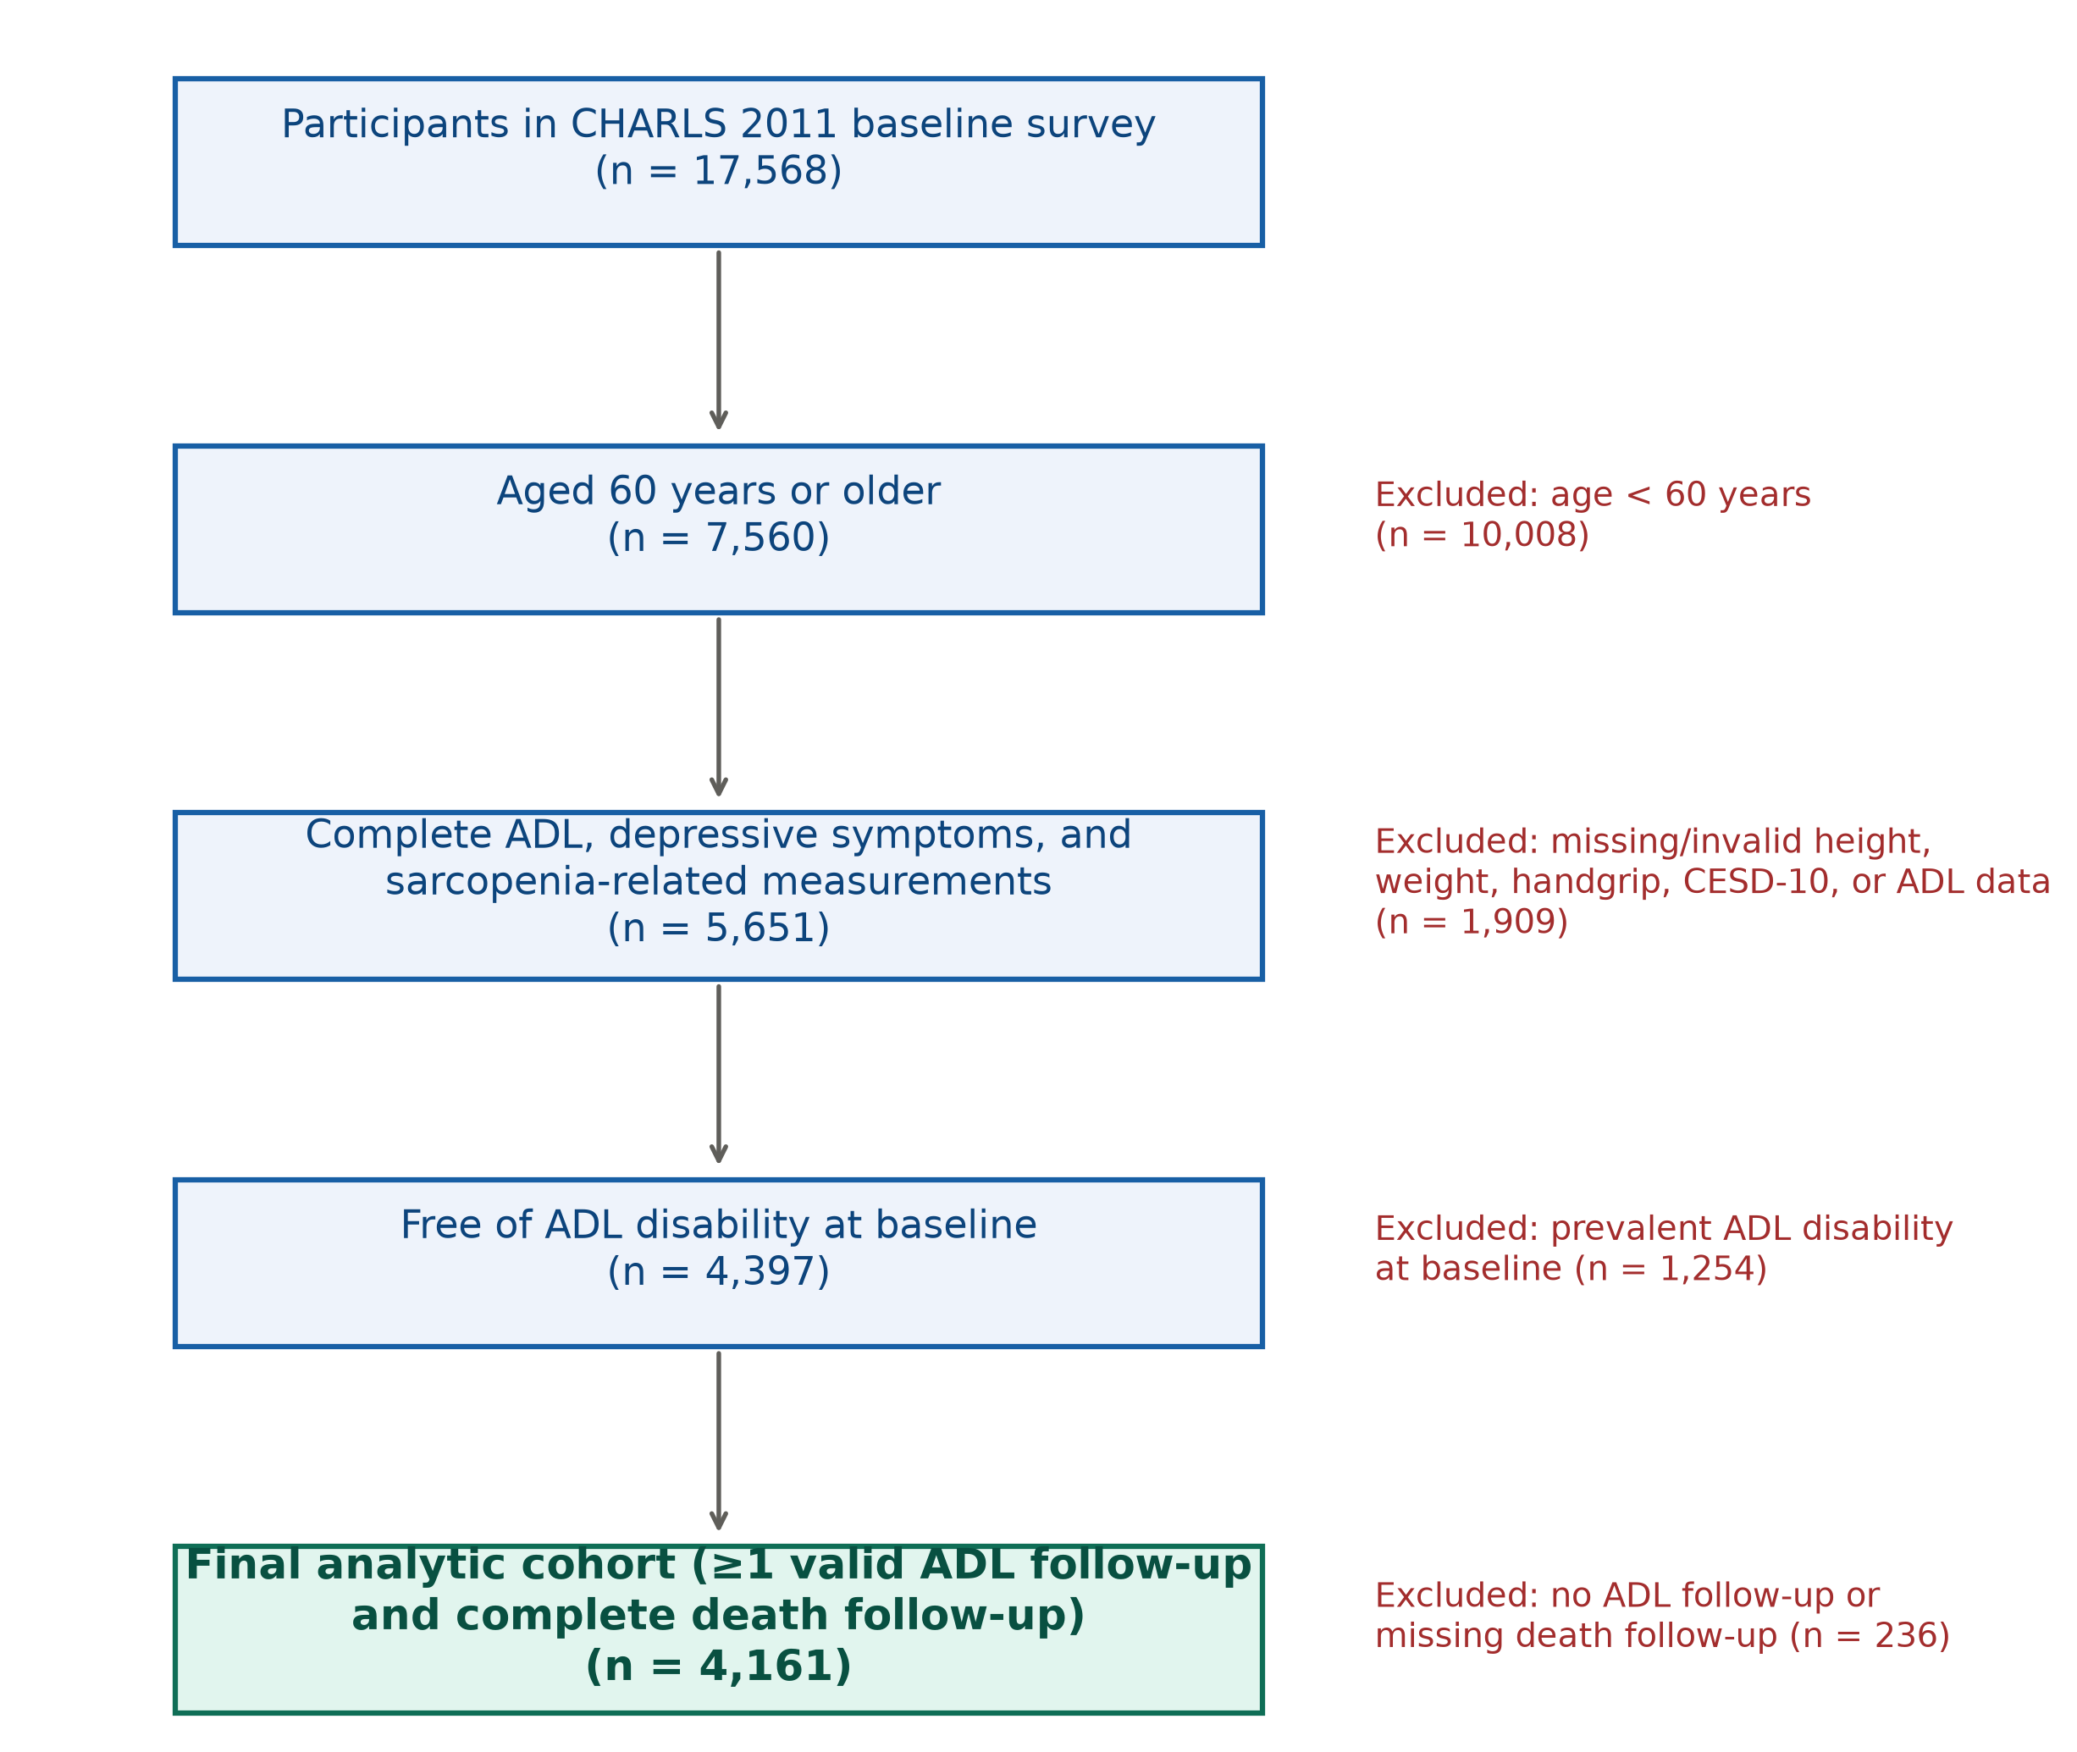

sFigure 2. Joint associations of depression with each sarcopenia component (low grip strength, low gait speed, low muscle mass) with (a–c) ADL disability and (d–f) all-cause mortality in fully adjusted models (Model 3)

Within each panel, hazard ratios (95% CIs) are shown for the component only, depression only, and their combination; the dashed vertical line indicates HR = 1.0. *P < 0.05, **P < 0.01, ***P < 0.001.

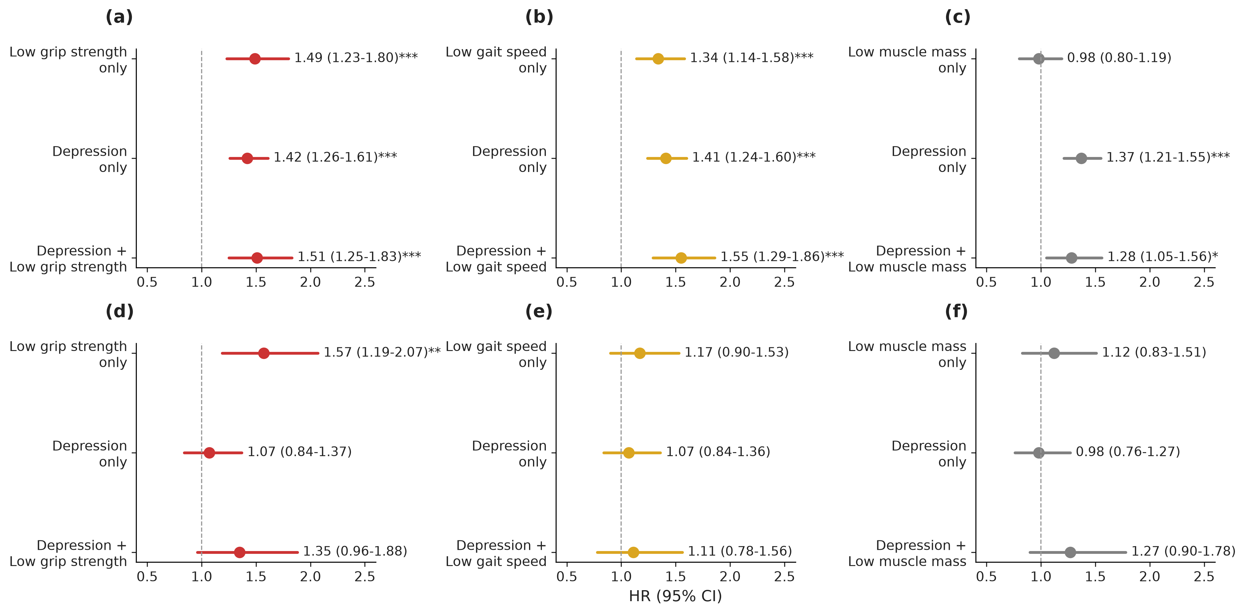

**Note:** The main-text Table 3 (joint effects and interaction measures) has been moved to this supplementary file (sTable 4) to streamline the main text. All sensitivity analyses confirm the robustness of the primary findings.

