Supplementary Material
Supplementary Table 1. Missing predictor information among screened patients
Cohort | Variable missing | N
Training cohort | DBV RNA | 2
Training cohort | Lymphocyte subsets | 5
Training cohort | Cytokines | 5
External validation cohort | Lymphocyte subsets | 4
External validation cohort | Cytokines | 2
Abbreviations: DBV, Bandavirus dabieense.
Supplementary Table 2. Baseline characteristics of the training and validation cohorts of SFTS patients
Characteristics | Total  (n = 530) | Training cohort (n=372) |  | Validation cohort  (n = 158) | P value
Age,year | 67.00 (60.00, 74.00) | 68.00 (61.00, 74.00) | 67.00 (59.00, 73.00) |  | 0.080
Gender, (male), n (%) | 239 (45.09) | 173 (46.51) | 66 (41.77) |  | 0.316
Comorbidities, n (%)
Hypertension | 147 (27.74) | 105 (28.23) | 42 (26.58) |  | 0.699
Diabetes | 100 (18.87) | 72 (19.35) | 28 (17.72) |  | 0.600
Cerebral diseases | 37 (6.98) | 27 (7.26) | 10 (6.33) |  | 0.701
Cardiac diseases | 38 (7.17) | 28 (7.53) | 10 (6.33) |  | 0.625
Symptoms, n (%)
Fever | 507 (95.66) | 361 (97.04) | 146 (92.41) |  | 0.017
Shiver | 226 (42.64) | 159 (42.74) | 67 (42.41) |  | 0.943
Fatigue | 464 (87.55) | 338 (90.86) | 126 (79.75) |  | <0.001
Headache | 66 (12.45) | 48 (12.90) | 18 (11.39) |  | 0.630
Myalgia | 206 (38.87) | 145 (38.98) | 61 (38.61) |  | 0.936
Nausea | 261 (49.25) | 187 (50.27) | 74 (46.84) |  | 0.470
Vomiting | 163 (30.75) | 110 (29.57) | 53 (33.54) |  | 0.364
Abdominal pain | 75 (14.15) | 60 (16.13) | 15 (9.49) |  | 0.045
Diarrhea | 219 (41.32) | 155 (41.67) | 64 (40.51) |  | 0.804
Signs, n (%)
Lymphadenectasis | 177 (33.40) | 133 (35.75) | 44 (27.85) |  | 0.078
Neurological signs | 261 (49.25) | 181 (48.66) | 80 (50.63) |  | 0.677
Hemorrhage | 91 (17.17) | 67 (18.01) | 24 (15.19) |  | 0.431
Laboratory parameters
WBC (10⁹/L) | 2.21 (1.57, 3.43) | 2.30 (1.64, 3.35) | 2.10 (1.42, 3.64) |  | 0.705
Neutrophils (10⁹/L) | 1.39 (0.90, 2.14) | 1.43 (0.95, 2.13) | 1.27 (0.82, 2.17) |  | 0.205
Lymphocytes (10⁹/L) | 0.49 (0.33, 0.79) | 0.46 (0.34, 0.76) | 0.56 (0.32, 0.86) |  | 0.178
HGB (g/L) | 141.00 (129.00, 151.00) | 140.00 (128.00, 151.00) | 142.00  (131.00, 151.50) |  | 0.317
PLT (10⁹/L) | 64.00 (47.00, 85.00) | 65.00 (49.00, 86.00) | 62.00 (44.00, 83.00) |  | 0.261
ALB (g/L) | 32.90 (29.90, 36.40) | 33.50 (30.25, 36.75) | 31.90 (28.90, 35.15) |  | <0.001
LDH (U/L) | 538.00 (343.00, 920.50) | 500.50 (327.00, 839.00) | 672.00 (403.50, 1120.50) |  | <0.001
PT (sec) | 13.10 (12.60, 13.80) | 13.20 (12.70, 13.80) | 12.80 (12.25, 13.40) |  | <0.001
APTT (sec) | 48.50 (41.85, 56.40) | 48.45 (41.90, 55.90) | 48.80 (41.75, 57.40) |  | 0.867
PCT (ng/ml) | 0.21 (0.10, 0.57) | 0.18 (0.09, 0.64) | 0.24 (0.11, 0.53) |  | 0.427
Hs-CRP (mg/L) | 3.45 (1.00, 10.17) | 3.31 (0.86, 9.22) | 4.26 (1.28, 13.71) |  | 0.031
IL-6 (pg/ml) | 21.70 (7.60, 65.65) | 22.05 (8.35, 60.45) | 21.00 (6.65, 86.66) |  | 0.625
IL-10 (pg/ml) | 13.70 (3.55, 42.80) | 14.87 (4.00, 45.90) | 11.10 (2.35, 35.23) |  | 0.026
CK (log10 U/L) | 2.54 (2.23, 3.00) | 2.51 (2.19, 2.94) | 2.62 (2.31, 3.08) |  | 0.019
DBV RNA (log10  TCID50/mL) | 3.49 (2.41, 4.57) | 3.25 (2.28, 4.34) | 4.12 (2.94, 5.24) |  | <0.001
CD3+ T cells (/uL) | 358.00 (214.00, 662.13) | 346.50 (213.00, 633.02) | 404.00 (214.00, 834.50) |  | 0.125
CD4+ T cells (/uL) | 163.00 (88.00, 299.00) | 163.00 (87.50, 295.57) | 166.00 (96.00, 313.00) |  | 0.318
CD8+ T cells (/uL) | 163.00 (91.50, 306.00) | 157.50 (88.00, 286.00) | 195.00 (97.00, 397.00) |  | 0.045
CD4/CD8 | 1.05 (0.63, 1.54) | 1.09 (0.66, 1.58) | 0.94 (0.55, 1.40) |  | 0.045
Abbreviations: SFTS, severe fever with thrombocytopenia syndrome; DBV, Bandavirus dabieense; WBC, white blood cell; HGB, hemoglobin; PLT, platelet; ALB, albumin; LDH, lactate dehydrogenase; PT, prothrombin time; APTT, activated partial thromboplastin time; Hs-CRP, high-sensitivity C-reactive protein; PCT, procalcitonin; IL-6, interleukin-6; IL-10, interleukin-10; CK, creatine phosphokinase; CD3/CD4/CD8, cluster of differentiation; CD3+ T cells, CD3-positive T lymphocytes; CD4+ T cells, CD4-positive T lymphocytes; CD8+ T cells, CD8-positive T lymphocytes; CD4/CD8, ratio of CD4+ to CD8+ T cells. Continuous variable data are presented as median (interquartile ranges, IQR). Classified variable data are presented as n (%). P values indicate differences between training cohort and external validation cohort. P<0.05 was considered statistically significant. Statistically significant values are shown in bold.
Supplementary Table 3. Clinical and laboratory characteristics of survivors and non-survivors in the validation cohort of SFTS patients
Characteristics | Total  (n = 158) | Survivors  (n=118) | Non-survivors  (n=40) | P value
Age,year | 67.00 (59.00, 73.00) | 64.50 (59.00, 72.50) | 71.00 (63.50, 73.50) | 0.027
Gender, (male), n (%) | 66 (41.77) | 50 (42.37) | 16 (40.00) | 0.793
Comorbidities, n (%)
Hypertension | 42 (26.58) | 27 (22.18) | 15 (37.50) | 0.071
Diabetes | 28 (17.72) | 19 (16.10) | 9 (22.50) | 0.360
Cerebral diseases | 10 (6.33) | 8 (6.78) | 2 (5.00) | 0.690
Cardiac diseases | 10 (6.33) | 7 (5.93) | 3 (7.50) | 0.725
Symptoms, n (%)
Fever | 146 (92.41) | 108 (91.53) | 38 (95.00) | 0.473
Shiver | 67 (42.41) | 54 (45.76) | 13 (32.50) | 0.142
Fatigue | 126 (79.75) | 98 (83.05) | 28 (70.00) | 0.076
Headache | 18 (11.39) | 16 (13.56) | 2 (5.00) | 0.141
Myalgia | 61 (38.61) | 45 (45.76) | 16 (40.00) | 0.834
Nausea | 74 (46.84) | 64 (54.24) | 10 (25.00) | 0.001
Vomiting | 53 (33.54) | 44 (37.29) | 9 (22.50) | 0.087
Abdominal pain | 15 (9.49) | 14 (11.86) | 1 (2.50) | 0.081
Diarrhea | 64 (40.51) | 51 (43.22) | 13 (32.50) | 0.233
Signs, n (%)
Lymphadenectasis | 44 (27.85) | 35 (29.66) | 9 (22.50) | 0.383
Neurological signs | 80 (50.63) | 54 (45.76) | 26 (65.00) | 0.035
Hemorrhage | 24 (15.19) | 13 (11.02) | 11 (27.50) | 0.012
Laboratory parameters
WBC (10⁹/L) | 2.10 (1.42, 3.64) | 2.17 (1.43, 3.69) | 1.88 (1.37, 3.14) | 0.171
Neutrophils (10⁹/L) | 1.27 (0.82, 2.17) | 1.27 (0.78, 2.17) | 1.24 (0.92, 2.03) | 0.823
Lymphocytes (10⁹/L) | 0.56 (0.32, 0.86) | 0.61 (0.34, 0.97) | 0.45 (0.26, 0.63) | 0.007
HGB (g/L) | 142.00 (131.00, 151.50) | 145.00 (132.50, 153.00) | 136.00 (119.00, 149.50) | 0.041
PLT (10⁹/L) | 62.00 (44.00, 83.00) | 67.00 (50.00, 88.00) | 46.00 (38.50, 64.50) | <0.001
ALB (g/L) | 31.81±4.45 | 32.59±4.17 | 29.49±4.48 | <0.001
LDH (U/L) | 672.00 (403.50, 1120.50) | 595.00 (377.50, 939.00) | 894.00  (463.50, 1912.50) | 0.005
PT (sec) | 12.80 (12.25, 13.40) | 12.65 (12.20, 13.30) | 13.20 (12.75, 13.95) | <0.001
APTT (sec) | 48.80 (41.75, 57.40) | 46.55 (40.25, 54.70) | 57.60 (46.90, 69.85) | <0.001
PCT (ng/ml) | 0.24 (0.11, 0.53) | 0.17 (0.10, 0.33) | 0.53 (0.34, 1.18) | <0.001
Hs-CRP (mg/L) | 4.26 (1.28, 13.71) | 2.64 (0.94, 8.44) | 12.80 (4.77, 39.22) | <0.001
IL-6 (pg/ml) | 21.00 (6.65, 86.66) | 13.72 (4.95, 33.80) | 141.39 (31.75, 422.35) | <0.001
IL-10 (pg/ml) | 11.10 (2.35, 35.23) | 6.00 (1.90, 25.40) | 49.90 (21.40, 103.25) | <0.001
CK (log10 U/L) | 2.62 (2.31, 3.08) | 2.61 (2.29, 3.03) | 2.85 (2.40, 3.21) | 0.348
DBV RNA (log10  TCID50/mL) | 4.12 (2.94, 5.24) | 3.77 (2.68, 4.57) | 5.59 (4.56, 6.59) | <0.001
CD3+ T cells (/uL) | 404.00 (214.00, 834.50) | 451.50 (262.00, 871.50) | 224.00 (155.50, 440.00) | <0.001
CD4+ T cells (/uL) | 166.00 (96.00, 313.00) | 221.50 (115.50, 338.50) | 101.00 (64.00, 162.50) | <0.001
CD8+ T cells (/uL) | 195.00 (97.00, 397.00) | 232.00 (105.00, 491.00) | 119.00 (62.00, 260.50) | 0.002
CD4/CD8 | 0.94 (0.55, 1.40) | 0.96 (0.57, 1.41) | 0.94 (0.52, 1.38) | 0.380
Abbreviations: SFTS, severe fever with thrombocytopenia syndrome; DBV, Bandavirus dabieense; WBC, white blood cell; HGB, hemoglobin; PLT, platelet; ALB, albumin; LDH, lactate dehydrogenase; PT, prothrombin time; APTT, activated partial thromboplastin time; Hs-CRP, high-sensitivity C-reactive protein; PCT, procalcitonin; IL-6, interleukin-6; IL-10, interleukin-10; CK, creatine phosphokinase; CD3/CD4/CD8, cluster of differentiation; CD3+ T cells, CD3-positive T lymphocytes; CD4+ T cells, CD4-positive T lymphocytes; CD8+ T cells, CD8-positive T lymphocytes; CD4/CD8, ratio of CD4+ to CD8+ T cells. Continuous variables are presented as mean ± SD or median (interquartile range, IQR), as appropriate. Classified variable data are presented as n (%). P values indicate differences between survivors and non- survivors in the external validation cohort. P<0.05 was considered statistically significant. Statistically significant values are shown in bold.
Supplementary Table 4. Collinearity diagnostics of variables
Parameters | Tolerance | VIF
CK | 0.856 | 1.169
IL-10 | 0.727 | 1.375
Hs-CRP | 0.850 | 1.177
DBV RNA | 0.804 | 1.244
CD4/CD8 | 0.953 | 1.049
Abbreviations: DBV, Bandavirus dabieense; CK, creatine phosphokinase; Hs-CRP, high-sensitivity C-reactive protein; IL-10, interleukin-10; CD4/CD8, ratio of CD4+ to CD8+ T cells.
Supplementary Table 5. Parameters of the logistic regression model
Predictor | Coefficient | Std.Error | z | P>|z| | Odds Ratio (per 0.1 unit) | Lower 95% CI | Upper 95%CI
const | -4.059 | 0.834 | -4.866 | 0.000 | 0.017 | 0.003 | 0.089
IL-10 | 0.001 | 0.000 | 2.932 | 0.003 | 1.001 | 1.000 | 1.001
Hs-CRP | 0.001 | 0.001 | 2.569 | 0.010 | 1.001 | 1.000 | 1.003
CD4/CD8 | -0.065 | 0.026 | -2.506 | 0.012 | 0.937 | 0.891 | 0.986
DBV RNA | 0.065 | 0.012 | 5.269 | 0.000 | 1.067 | 1.042 | 1.094
CK | 0.018 | 0.024 | 0.740 | 0.459 | 1.018 | 0.971 | 1.067
Abbreviations: DBV, Bandavirus dabieense; CK, creatine phosphokinase; Hs-CRP, high-sensitivity C-reactive protein; IL-10, interleukin-10; CD4/CD8, ratio of CD4+ to CD8+ T cells.
Supplementary Table 6. Hyperparameters and search space of the XGBoost model
Hyperparameter | Description | Search Space | Final Tuned Value
max_depth | Maximum depth of a tree | 1,2,3,4,5,6 | 2
n_estimators | Number of boosting rounds (trees) | 20,50,100,150,200,300 | 24
learning_rate | Step size shrinkage used in update | 0.01, 0.05, 0.1, 0.2 | 0.05
min_child_weight | Minimum sum of instance weight in a child | 1,3,5 | 1
subsample | Subsample ratio of the training instances | 0.6, 0.7, 0.8, 0.9 | 0.6
colsample_bytree | Subsample ratio of columns when constructing each tree | 0.6, 0.7, 0.8, 0.9 | 0.6
gamma | Minimum loss reduction required for a further partition | 0, 1, 2, 5 | 0
reg_alpha | L1 regularization term on weights | 0, 0.1, 1 | 0
reg_lambda | L2 regularization term on weights | 0.5, 1, 2, 5 | 5
scale_pos_weight | Balancing of positive and negative weights | Fixed at 3.48 | 3.48

Supplementary Table 7. Linearity assessment of continuous predictors using restricted cubic splines in the training cohort
Predictor | Nonlinearity P value | Overall P value
CK | 0.370 | <0.001
Hs-CRP | 0.623 | <0.001
IL-10 | 0.297 | <0.001
DBV RNA | 0.792 | <0.001
CD4/CD8 | 0.533 | <0.001
Abbreviations: DBV, Bandavirus dabieense; CK, creatine phosphokinase; Hs-CRP, high-sensitivity C-reactive protein; IL-10, interleukin-10; CD4/CD8, ratio of CD4+ to CD8+ T cells.
Supplementary Table 8. Discrimination and calibration in external validation
Model | External AUC AUC | Brier score | Calibration intercept | Calibration slope
Logistic regression | 0.815 | 0.116 | 0.125 | 0.951
XGBoost | 0.848 | 0.154 | 0.452 | 0.584
Platt-calibrated XGBoost | 0.848 | 0.145 | 0.213 | 0.822
Abbreviations: AUC, area under the receiver operating characteristic curve.
Supplementary Table 9. Threshold-based external validation performance
Model | Training-derived cutoff | Sensitivity (%) | Specificity (%) | PPV (%) | NPV (%)
Logistic regression | 0.313 | 75.00 | 77.12 | 52.63 | 90.10
XGBoost | 0.244 | 80.00 | 83.05 | 61.54 | 92.45
Platt-calibrated XGBoost | 0.314 | 77.50 | 81.36 | 58.49 | 91.43
Abbreviations: PPV, positive predictive value; NPV, negative predictive value.
Supplementary Table 10. External validation performance of logistic regression sensitivity analyses
Analysis | Cutoff | AUC | Brier score | Sensitivity (%) | Specificity (%) | PPV (%) | NPV (%)
Primary Youden | 0.313 | 0.815 | 0.116 | 75.00 | 77.12 | 52.63 | 90.10
Weighted LR | 0.607 | 0.815 | 0.163 | 75.00 | 77.12 | 52.63 | 90.10
Sensitivity-prioritized | 0.048 | 0.815 | 0.116 | 97.59 | 29.76 | 28.52 | 97.73
Abbreviations: AUC, area under the receiver operating characteristic curve; PPV, positive predictive value; NPV, negative predictive value; LR, logistic regression. Primary Youden indicates the optimal probability threshold determined by maximizing the Youden index. Weighted LR indicates the threshold selected using a weighted logistic regression criterion. Sensitivity-prioritized indicates a threshold selected to maximize sensitivity while maintaining acceptable specificity.

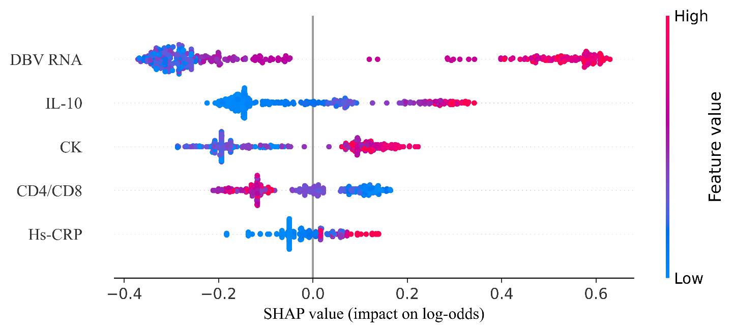
Supplementary Figure 1. SHAP summary plot illustrating the contribution of each predictor to the XGBoost model in the training cohort. The x-axis represents SHAP values on the log-odds scale, and color indicates relative feature values. Abbreviations: DBV, Dabie bandavirus; Hs-CRP, high-sensitivity C-reactive protein; CK, creatine phosphokinase; IL-10, interleukin-10; CD4/CD8, ratio of CD4⁺ T cells to CD8⁺ T cells.
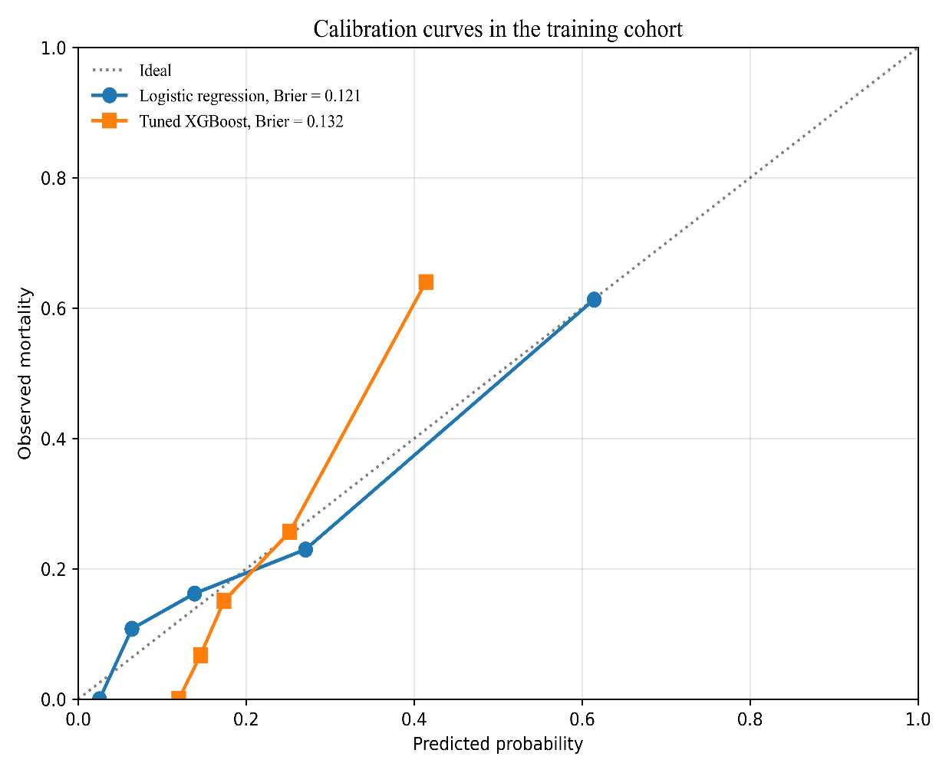
Supplementary Figure 2. Bootstrap bias-corrected calibration curves of logistic regression and tuned XGBoost models in the training cohort. The dashed line represents perfect calibration. Brier scores are shown in the figure legend.
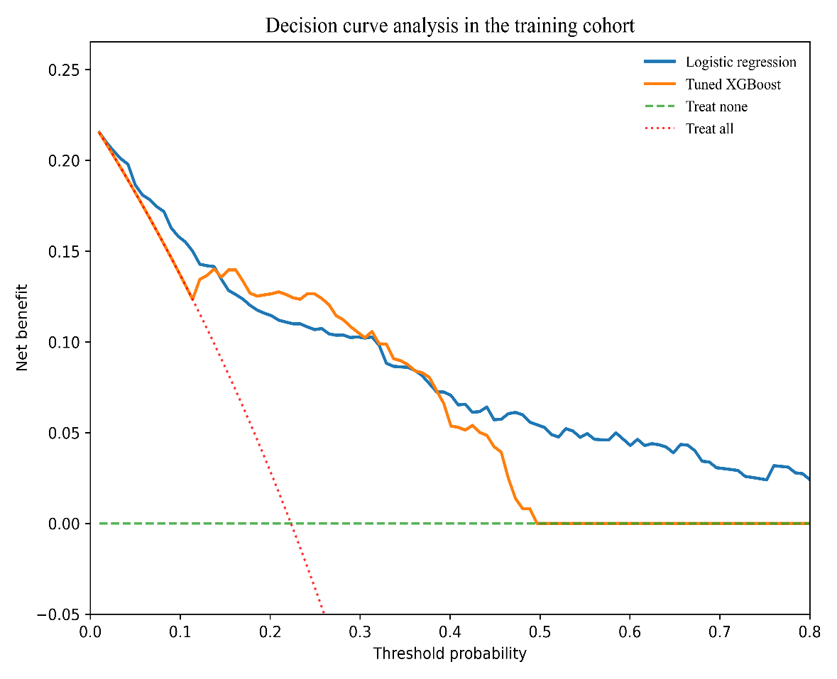
Supplementary Figure 3. Decision curve analysis of logistic regression and tuned XGBoost models in the training cohort. Abbreviations: DCA, decision curve analysis; SFTS, severe fever with thrombocytopenia syndrome.
Supplementary Figure 4. Decision curve analysis of logistic regression and tuned XGBoost models in the external validation cohort. Abbreviations: DCA, decision curve analysis; SFTS, severe fever with thrombocytopenia syndrome.

