Supplementary Information
AI-DRIVEN COFFEE TASTING: PREDICTING TASTE ATTRIBUTES FROM ELECTROCHEMICAL IMPRINTS

Rodion Golovinsky¹⁺, Ilya D. Ivanov¹⁺, Aleksandr S. Aglikov^{1*}, Timur A. Aliev¹, Ivan Timofeenko², Alexander S. Novikov¹, Mikhail F. Zayats³, Mariia S. Ashikhmina¹, Olga Yu. Orlova¹, Maria S. Masalovich¹* and Ekaterina V. Skorb¹
¹ Infochemistry Scientific Center, ITMO University
Lomonosova Str. 9, 191002 St. Petersburg, Russia
² Gastronomy Institute, Siberian Federal University
Svobodny Ave. 82 building 11, 660130 Krasnoyarsk, Russia
³ Belarusian State University
Nezavisimosti Avenue 4, 220030 Minsk, Belarus
⁺ These authors contributed equally to this work
* Corresponding author, e-mail: aglikov.aleksandr@gmail.com, msmasalovich@itmo.ru

Figure SI 1. GC chromatogram of a coffee sample 2
Table SI 1. GC results 3
Table SI 2. DFT-calculated enthalpies, entropies, and Gibbs free energies (in Hartree) for optimized equilibrium model structures (H, S, and G, respectively). 8
Table SI 3. DFT-calculated values of Gibbs free energies of reaction (ΔG) for various hypothetical coordination processes in model structures (in kcal/mol). 10

performance liquid chromatography (HPLC) result

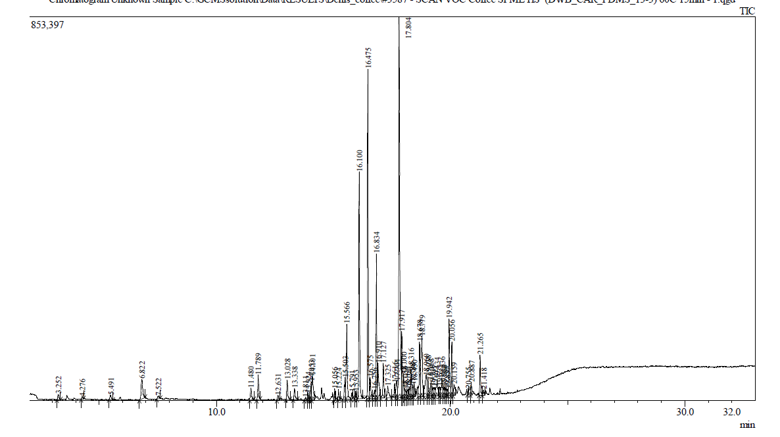
Figure SI 1. GC chromatogram of a coffee sample

Table SI 1. GC results
Peak# | R.Time | I.Time | F.Time | Area | Area % | Height | Height % | A/H | Name
1 | 3.252 | 3.192 | 3.35 | 44226 | 0.33 | 11977 | 0.25 | 3.69 | Furan
2 | 4.276 | 4.225 | 4.342 | 19258 | 0.14 | 5579 | 0.12 | 3.45 | Acetic acid, methyl ester
3 | 5.491 | 5.425 | 5.592 | 40828 | 0.3 | 9852 | 0.21 | 4.14 | Propanal, 2-methyl-
4 | 6.822 | 6.725 | 6.958 | 212229 | 1.56 | 43636 | 0.92 | 4.86 | Furan, 2-methyl-
5 | 7.522 | 7.458 | 7.617 | 26273 | 0.19 | 4969 | 0.1 | 5.29 | p-Dioxin, 2,3-dihydro-2,5,6-trimethyl-
6 | 11.48 | 11.433 | 11.608 | 96149 | 0.71 | 25835 | 0.54 | 3.72 | Butanal, 3-methyl-
7 | 11.789 | 11.717 | 11.875 | 168815 | 1.24 | 55094 | 1.16 | 3.06 | Butanal, 2-methyl-
8 | 12.631 | 12.583 | 12.708 | 32210 | 0.24 | 10503 | 0.22 | 3.07 | Furan, 2,5-dimethyl-
9 | 13.028 | 12.967 | 13.15 | 120597 | 0.89 | 43004 | 0.9 | 2.8 | 2,3-Pentanedione
10 | 13.338 | 13.283 | 13.467 | 81590 | 0.6 | 24843 | 0.52 | 3.28 | Carbamic acid, phenyl ester
11 | 13.811 | 13.758 | 13.875 | 20048 | 0.15 | 5368 | 0.11 | 3.73 | Pyrazine
12 | 13.924 | 13.875 | 13.975 | 42744 | 0.31 | 14264 | 0.3 | 3 | Disulfide, dimethyl
13 | 14.053 | 13.975 | 14.075 | 101711 | 0.75 | 39582 | 0.83 | 2.57 | 1H-Pyrrole, 1-methyl-
14 | 14.101 | 14.075 | 14.192 | 207328 | 1.53 | 52747 | 1.11 | 3.93 | Pyridine
15 | 15.056 | 15.017 | 15.1 | 55261 | 0.41 | 23866 | 0.5 | 2.32 | Pyrrole
16 | 15.224 | 15.175 | 15.283 | 52864 | 0.39 | 21946 | 0.46 | 2.41 | Hexen-1-ol, (E)-
17 | 15.503 | 15.375 | 15.533 | 172392 | 1.27 | 48456 | 1.02 | 3.56 | Hexanoic acid, 2-methylphenyl ester
18 | 15.566 | 15.533 | 15.9 | 472136 | 3.48 | 167584 | 3.53 | 2.82 | Pyrimidine, 2-methyl-
19 | 15.791 | 15.75 | 15.825 | 33247 | 0.24 | 13756 | 0.29 | 2.42 | 4-Methyl-2-oxopentanenitrile
20 | 15.953 | 15.9 | 16.008 | 39023 | 0.29 | 16944 | 0.36 | 2.3 | Furan, 2-(2-propenyl)-
21 | 16.1 | 16.008 | 16.25 | 1237584 | 9.11 | 504831 | 10.62 | 2.45 | Furfural
22 | 16.475 | 16.433 | 16.542 | 1466577 | 10.79 | 732690 | 15.41 | 2 | 2-Furanmethanol
23 | 16.575 | 16.542 | 16.667 | 143971 | 1.06 | 47211 | 0.99 | 3.05 | 1,2-Ethanediol, diacetate
24 | 16.756 | 16.667 | 16.792 | 63703 | 0.47 | 18551 | 0.39 | 3.43 | 3-Ethyl-2-pentanol
25 | 16.834 | 16.792 | 16.883 | 689241 | 5.07 | 321891 | 6.77 | 2.14 | Pyrazine, 2,6-dimethyl-
26 | 16.91 | 16.883 | 17.017 | 241730 | 1.78 | 77908 | 1.64 | 3.1 | Pyrrolidine, 2-(cyanomethylene)
27 | 17.127 | 17.017 | 17.183 | 230364 | 1.7 | 77370 | 1.63 | 2.98 | Ethanone, 1-(2-furanyl)-
28 | 17.325 | 17.258 | 17.475 | 121170 | 0.89 | 25096 | 0.53 | 4.83 | Oxepine, 2,7-dimethyl-
29 | 17.616 | 17.475 | 17.65 | 85995 | 0.63 | 31364 | 0.66 | 2.74 | 2-n-Butyl furan
30 | 17.704 | 17.65 | 17.742 | 141854 | 1.04 | 36520 | 0.77 | 3.88 | 3-Pentanone, 2-methyl-
31 | 17.804 | 17.742 | 17.892 | 2892653 | 21.29 | 846091 | 17.8 | 3.42 | 2-Furanmethanol, acetate
32 | 17.917 | 17.892 | 17.967 | 398078 | 2.93 | 146032 | 3.07 | 2.73 | Pyrazine, 2-ethyl-5-methyl-
33 | 18 | 17.967 | 18.033 | 133528 | 0.98 | 52223 | 1.1 | 2.56 | Furan, 2-[(methylthio)methyl]-
34 | 18.058 | 18.033 | 18.133 | 77393 | 0.57 | 18962 | 0.4 | 4.08 | 3-Hydroxyphenylacetylene
35 | 18.161 | 18.133 | 18.192 | 40633 | 0.3 | 16082 | 0.34 | 2.53 | Pyrazine, 2-ethenyl-6-methyl-
36 | 18.241 | 18.192 | 18.283 | 81637 | 0.6 | 21185 | 0.45 | 3.85 | 1-Propanone, 1-(2-furanyl)-
37 | 18.316 | 18.283 | 18.358 | 150169 | 1.11 | 60771 | 1.28 | 2.47 | 1H-Pyrrole-2-carboxaldehyde, 1-methyl-
38 | 18.388 | 18.358 | 18.417 | 72148 | 0.53 | 26402 | 0.56 | 2.73 | cis-1,2-Dihydrocatechol
39 | 18.45 | 18.417 | 18.5 | 88075 | 0.65 | 33014 | 0.69 | 2.67 | 2,2'-Bifuran
40 | 18.678 | 18.6 | 18.708 | 340520 | 2.51 | 121915 | 2.56 | 2.79 | Pyrazine, 3-ethyl-2,5-dimethyl-
41 | 18.779 | 18.708 | 18.825 | 531775 | 3.91 | 132375 | 2.78 | 4.02 | Furan, 2,2'-methylenebis-
42 | 18.96 | 18.875 | 19.008 | 263743 | 1.94 | 45865 | 0.96 | 5.75 | Bicyclo[2.2.1]heptane-2,5-diol, 1,7,7-trimethyl-, (2-endo,5-exo)-
43 | 19.038 | 19.008 | 19.092 | 122892 | 0.9 | 42581 | 0.9 | 2.89 | Nonanal
44 | 19.168 | 19.092 | 19.2 | 118057 | 0.87 | 34402 | 0.72 | 3.43 | 5-Ethyl-2-furaldehyde
45 | 19.219 | 19.2 | 19.25 | 53073 | 0.39 | 21478 | 0.45 | 2.47 | 2-Cyclopenten-1-one, 3-ethyl-2-hydroxy-
46 | 19.295 | 19.25 | 19.342 | 91498 | 0.67 | 19334 | 0.41 | 4.73 | 5H-Inden-5-one, 1,2,3,6,7,7a-hexahydro-7a-methyl-
47 | 19.434 | 19.342 | 19.467 | 163280 | 1.2 | 36306 | 0.76 | 4.5 | Pyrazine, 3,5-diethyl-2-methyl-
48 | 19.533 | 19.517 | 19.567 | 46647 | 0.34 | 20033 | 0.42 | 2.33 | Spiro[5.5]undeca-1,7-diene
49 | 19.636 | 19.567 | 19.675 | 142813 | 1.05 | 38863 | 0.82 | 3.67 | Furan, 2-(2-furanylmethyl)-5-methyl-
50 | 19.724 | 19.675 | 19.758 | 71481 | 0.53 | 20921 | 0.44 | 3.42 | Ethanone, 1-(2,6,6-trimethyl-1-cyclohexen-1-yl)-
51 | 19.784 | 19.758 | 19.825 | 47712 | 0.35 | 17589 | 0.37 | 2.71 | Benzofuran, octahydro-6-methyl-3-methylene-
52 | 19.857 | 19.825 | 19.892 | 42340 | 0.31 | 14927 | 0.31 | 2.84 | Cyclohexene, 1-acetyl-2-(1-hydroxyethyl)-
53 | 19.942 | 19.892 | 20.017 | 429695 | 3.16 | 170266 | 3.58 | 2.52 | 1H-Pyrrole, 1-(2-furanylmethyl)-
54 | 20.056 | 20.017 | 20.108 | 282640 | 2.08 | 118543 | 2.49 | 2.38 | Hepta-2,4-dienoic acid, methyl ester
55 | 20.159 | 20.108 | 20.192 | 76922 | 0.57 | 23579 | 0.5 | 3.26 | Methyl salicylate
56 | 20.755 | 20.717 | 20.783 | 35656 | 0.26 | 12662 | 0.27 | 2.82 | Bis(2-furfuryl)disulfide
57 | 20.887 | 20.85 | 20.925 | 72962 | 0.26 | 27753 | 0.58 | 2.63 | Cyclohexanone, 5-methyl-2-(1-methylethylidene)-
58 | 21.265 | 21.217 | 21.35 | 219660 | 0.26 | 88896 | 1.87 | 2.47 | 2-Methoxy-4-vinylphenol
59 | 21.418 | 21.35 | 21.467 | 37305 | 0.26 | 11207 | 0.24 | 3.33 | Benzene, 4-ethenyl-1,2-dimethoxy-

Table SI 2. DFT-calculated enthalpies, entropies, and Gibbs free energies (in Hartree) for optimized equilibrium model structures (H, S, and G, respectively).
Model structure | H | S | G
Au | -135.73985597 | 0.02048574 | -135.7603417
Cu | -1640.48500205 | 0.01888364 | -1640.50388569
Ni | -1508.26613232 | 0.01915404 | -1508.28528636
coronene(C) | -922.35299723 | 0.05454762 | -922.40754485
acetate | -228.62937964 | 0.03036617 | -228.65974582
acetate_Au | -364.40878605 | 0.04089615 | -364.44968219
acetate_Cu | -1869.16435197 | 0.03913557 | -1869.20348754
acetate_Ni | -1736.95955883 | 0.03688603 | -1736.99644486
acetic_acid | -229.18068925 | 0.03234574 | -229.21303498
acetic_acid_Au | -364.91931732 | 0.04224767 | -364.96156499
acetic_acid_C | -1151.53669663 | 0.06665743 | -1151.60335405
acetic_acid_Cu | -1869.6676652 | 0.04016051 | -1869.70782571
acetic_acid_Ni | -1737.4575443 | 0.04007513 | -1737.49761943
caffeine | -680.68085717 | 0.04931695 | -680.73017412
caffeine_Au | -816.43792946 | 0.05826509 | -816.49619455
caffeine_C | -1603.0676495 | 0.07518517 | -1603.14283467
caffeine_Cu | -2321.18663805 | 0.0569109 | -2321.24354895
caffeine_Ni | -2188.97688095 | 0.05697583 | -2189.03385678
2-furanmethanol | -344.69815286 | 0.03737819 | -344.73553105
2-furanmethanol_Au | -480.45232609 | 0.0458326 | -480.4981587
2-furanmethanol_Au_pi | -480.45231887 | 0.04583842 | -480.49815729
2-furanmethanol_Cu | -1985.19768333 | 0.04446085 | -1985.24214418
2-furanmethanol_Cu_pi | -1985.19767826 | 0.04440778 | -1985.24208604
2-furanmethanol_Ni | -1852.9906721 | 0.04328568 | -1853.03395777
2-furanmethanol_Ni_pi | -1852.99067919 | 0.0432427 | -1853.03392189
2-furanmethanol_O_Au | -480.45508413 | 0.04505609 | -480.50014022
2-furanmethanol_O_Cu | -1985.19493343 | 0.04457763 | -1985.23951106
2-furanmethanol_O_Ni | -1852.98547967 | 0.04381572 | -1853.02929539

Table SI 3. DFT-calculated values of Gibbs free energies of reaction (ΔG) for various hypothetical coordination processes in model structures (in kcal/mol).
 | Cu | Ni | Au | C
Acetic acid | 5.707173802 | 0.4404551932 | 7.411947686 | 10.80934059
Caffeine | -5.954525497 | -11.54385301 | -3.56345702 | -3.21015034
Furanmethanol_C | -1.711494511 | -8.245700733 | -1.43445534 | -
Acetate | -25.01003746 | -32.26194512 | -18.5709366 | -
Furanmethanol_O | -0.05918669605 | -5.320012991 | -2.67787797 | -

