Supplementary Information

A project-selection audit of public urinary-source Escherichia coli genomes from China distinguishes purpose-enriched NDM and mcr signals from CTX-M recurrence across projects
Botao Yu, Chunling Wang, Zhen Wang, and Min Yin

Supplementary Methods

Public-record eligibility and manual review
Candidate records were reconciled across NCBI and ENA identifiers. Inclusion required an Escherichia coli record, a China-associated geographic field, urinary-source evidence, and whole-genome reads or an assembly. Structured specimen-source fields supported 506 genomes. Six records required manual review of the associated BioSample, run, or BioProject context. The accession ledger preserves the source evidence and inclusion basis for each genome (Additional file 2).
City and province labels were retained when explicitly reported. Country-only records were coded as China without assigning a province. Regional metadata were used descriptively and were not used to impute missing geography or estimate regional prevalence.

Assembly-source harmonization
Raw reads were preferred when suitable public runs could be retrieved. One workflow generated 427 read-based assemblies. For 85 genomes without a suitable read set, we retained the corresponding NCBI assembly. Source type was recorded in the accession ledger. The main resistance summaries were repeated in the strict taxonomic quality-control set. Excluding the six Kraken2 caution records had little effect on headline genotype proportions.

BioProject source tracing and selection classification
Public-record searching began on 2 July 2026 during cohort construction. After cohort inclusion and accession-level genotype calls had been frozen, each of the 29 retained BioProject accessions was checked in Europe PMC and NCBI. The audit then followed links to the original article, BioProject record, BioSample, or accession-linked case report.
Evidence was recorded in four levels: original publication; original publication plus BioProject record; BioProject record plus case report; and BioProject record only. An original publication was identified for 19 projects containing 362 genomes. Ten projects containing 150 genomes had no accession-resolved original publication in the completed search. Nine of these, containing 149 genomes, were classified from BioProject records alone. One single-genome project was supported by its BioProject record and a case report.
Selection classes were based on the most explicit entry criterion. Syndrome-defined projects enrolled according to a clinical condition rather than a resistance marker. Representative clinical subsets intentionally sampled from a larger clinical collection to compare molecular or phenotypic groups. Resistance-targeted or enriched projects selected a resistance phenotype, gene, or multidrug-resistant organism. Lineage, case, or genome-report projects had no population denominator and were organized around a clone, paired isolate, individual genome, or technical purpose. The complete evidence text, source URL, and expected archive effect are given in Additional file 3.
The classes are broad and descriptive. A syndrome-defined collection can still differ from the general population because of its host or setting. A representative subset can still be selected rather than consecutive. We therefore report within-class archive composition and do not treat these strata as corrected prevalence samples.

BioProject-aware summaries
Five complementary summaries were calculated. The pooled archive proportion used all accession-level genomes. The strict-quality proportion excluded six Kraken2 caution records. The project-equalized value was the unweighted mean of the 29 BioProject-specific proportions. Dominant-project exclusion removed the project producing the largest absolute change for each outcome. Leave-one-BioProject-out analysis removed each project in turn.
These summaries assess robustness to archive composition. None reconstructs a probability sample. Project equalization can increase an estimate when a marker is common in several small targeted projects, as observed for NDM.

Broad-tree interpretation
The Panaroo-derived variable-site matrix was constructed without sequence type, BioProject, resistance genotype, selection class, or quality-control labels. These annotations were added after maximum-likelihood inference. The tree was unrooted. Circular rotation and a visual root were used only to improve layout.
The broad tree spans divergent phylogroups. It was used to display major lineage clustering and genotype distribution. It was not used to define transmission groups, test selection classes, or infer fine-scale ancestry. ST167 was analyzed separately with reference-based calling and recombination filtering.

ST167 duplicate-linked review
Pairs separated by no more than five Gubbins-filtered SNPs were reviewed using run, BioSample, BioProject, year, location, strain label, Mash similarity, and filtered distance. Four pairs were flagged. UPEC_CHN_0014 and UPEC_CHN_0206 differed by 0 SNPs and had identical whole-genome sketches, supporting a probable cross-project duplicate or resubmission. UPEC_CHN_0012 and UPEC_CHN_0202 differed by 1 SNP and had near-identical whole-genome sketches, supporting a probable linked isolate or resequencing event. UPEC_CHN_0226 and UPEC_CHN_0403 differed by 1 SNP, but their metadata were insufficient for exclusion. UPEC_CHN_0228 and UPEC_CHN_0229 differed by 0 SNPs within one project and could represent same-project near-clonal isolates or duplication.
The 28 accession-level genomes remained the primary analysis. A sensitivity analysis removed UPEC_CHN_0014 and UPEC_CHN_0012, one lower-contiguity representative from each of the two strongest probable duplicate-linked pairs. The other two pairs were retained because the available metadata could not resolve their status.

Selection of local-context representatives
NDM and mcr candidates were confirmed on the target contig with AMRFinderPlus. Replicon, insertion-sequence, IntegronFinder, and geNomad calls were joined by contig identifier. BLAST comparisons used cached NCBI plasmid references. A strict match required at least 99% nucleotide identity, 80% query coverage, and 80% reference coverage.
Representatives were selected after all strict-reference records had been audited. Selection retained distinct target alleles, replicon classes, reference backbones, Achtman sequence types, BioProjects, insertion-sequence patterns, and target orientations. Redundant rows with the same biological pattern were not plotted. The full audit is provided in Additional file 5.

Integron module grouping
Complete-integron and CALIN calls were processed separately before module grouping. Prokka coding sequences were matched to IntegronFinder coordinates. AMRFinderPlus supplied standardized resistance-gene names. Complete arrays were ordered outward from the integrase. CALINs lacked an integrase orientation anchor and were compared in both directions.
Candidate signatures were merged only when they shared the same core resistance-cassette organization. Frequent 3-prime conserved-region features remained in exact signatures but did not create separate core modules. A recurrent module required at least five genomes, two BioProjects, two component genes, two cassette features, an average mapped fraction of at least 0.80, and no hypothetical component. A single project could contribute no more than 80% of the module.

Supplementary Results

Selection-evidence coverage
Original publications were identified for 17 projects containing 353 genomes. Two more projects containing nine genomes were supported by an original publication together with the BioProject record. A BioProject record and case report supported one genome. BioProject records alone supported nine projects containing 149 genomes. The complete 29-project audit, selection-class assignment, and source links are reported in Additional file 3.

Strict taxonomic quality control
The strict-quality subset contained 506 genomes. CTX-M remained 67.2% (340/506), compared with 67.2% (344/512) in the full cohort. NDM changed from 28.1% (144/512) to 28.5% (144/506). mcr changed from 28.3% (145/512) to 27.9% (141/506). The fluoroquinolone resistance-associated genotype changed from 96.1% to 96.2%, and the MDR-like genotype changed from 86.3% to 86.4%.

Project-level sensitivity was marker specific
The maximum leave-one-project-out absolute change was 4.2 percentage points for CTX-M, 10.3 for NDM, and 21.9 for mcr. PRJNA1252346 was the most influential CTX-M project, but its removal increased the estimate to 71.4%. PRJNA931432 was the dominant NDM project. PRJNA604918 was the dominant mcr project. Full results for every BioProject are in Additional file 3.

Broad-tree model limitations
The broad alignment contained 512 genomes and 329,173 variable sites. Overall missingness was 0.29%, and the maximum per-genome value was 2.26%. IQ-TREE reported composition chi-square warnings for 349 sequences. These warnings were treated as a model-fit limitation for a divergent, variable-site alignment. The broad tree was not used for transmission inference.

ST167 sensitivity analyses
The median filtered distance was 89.5 SNPs for NDM-positive pairs and 243 for NDM-discordant pairs in the strict taxonomic subset. After one representative from each of the two strongest duplicate-linked pairs was removed, the corresponding medians were 90 and 210 SNPs. These descriptive results were not analyzed as independent pairwise observations because each genome contributes to multiple pairs.

Local-context reference matches
Ten NDM records met the strict reference criteria, and all were most similar to the IncX3 plasmid JN247852.1. Twenty mcr records met the same criteria. IncI2 representatives matched several reference backbones, while one strict IncX4 representative matched MH061196.1. Eighty-two of 100 exact mcr local-context records arose from PRJNA604918. This imbalance is retained in Additional file 5 and limits frequency interpretation.

Integron module sensitivity
The first three recurrent modules occurred across 9 to 19 BioProjects. The dfrA12-aadA2 module occurred in 46 ST410 and 51 non-ST410 genomes. Fifty-three of 97 occurrences were outside PRJNA931432. The two less frequent modules were dominated by CALIN calls. Their signatures describe recurrent cassette composition without assigning transcriptional direction or complete-integron structure.

Supplementary Figure
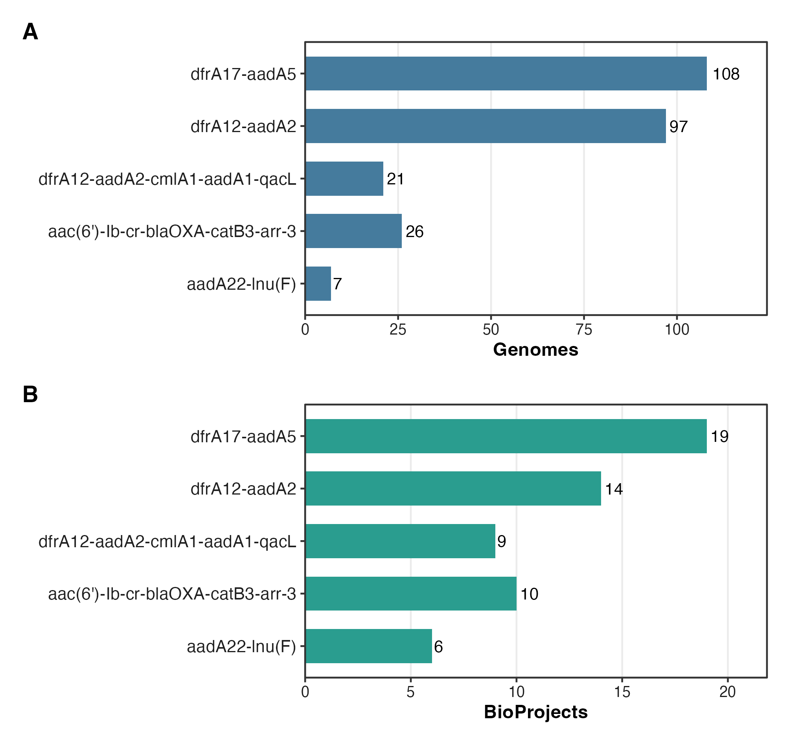
Supplementary Figure 1. Recurrent integron-associated cassette modules across BioProjects. A, Numbers of genomes carrying five recurrent cassette modules. B, Numbers of contributing BioProjects. Cassette compositions are shown on the y axis. CALIN organization was canonicalized without assigning transcriptional direction.

