Supplementary Material

Gaussian Process–Based Bayesian Optimization of Lower-Limb PNS–TMS Interstimulus Intervals in Adults and Children: A Proof-of-Concept Toward a Personalized Framework

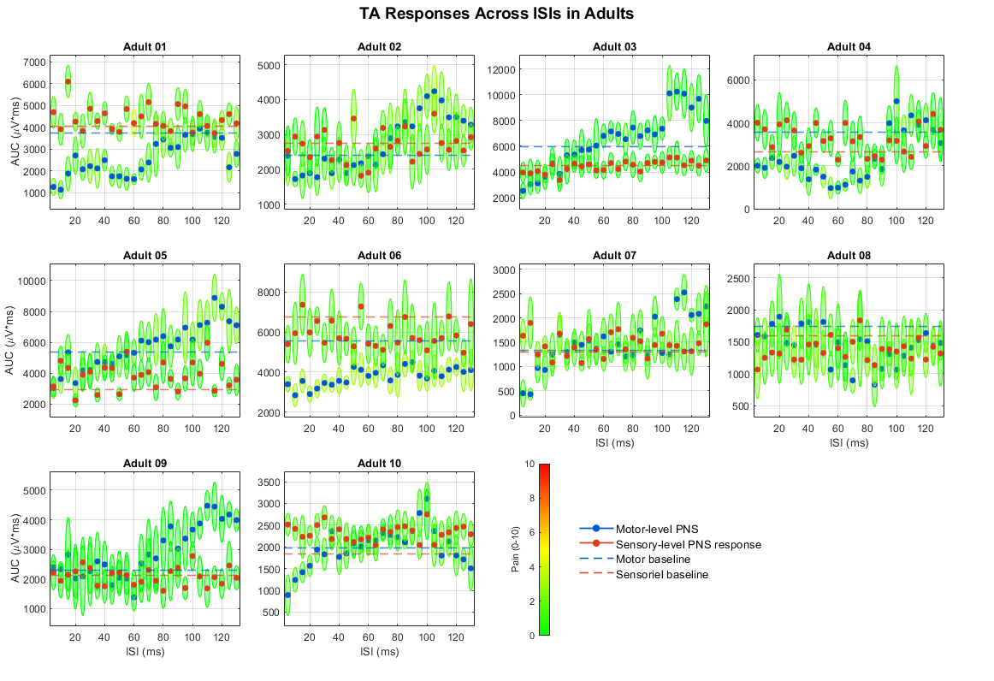
Supplementary Figure S1. Participant-specific TA responses across ISIs in adults. AUC responses are shown across the 26 latency-referenced ISIs for each adult participant. Motor-threshold and sensory-threshold PNS responses are shown in blue and red, respectively, with the corresponding baseline AUC indicated by dashed lines. Trial-level response distributions are shown around the per-ISI responses; color coding indicates the reported pain rating on a 0–10 scale.

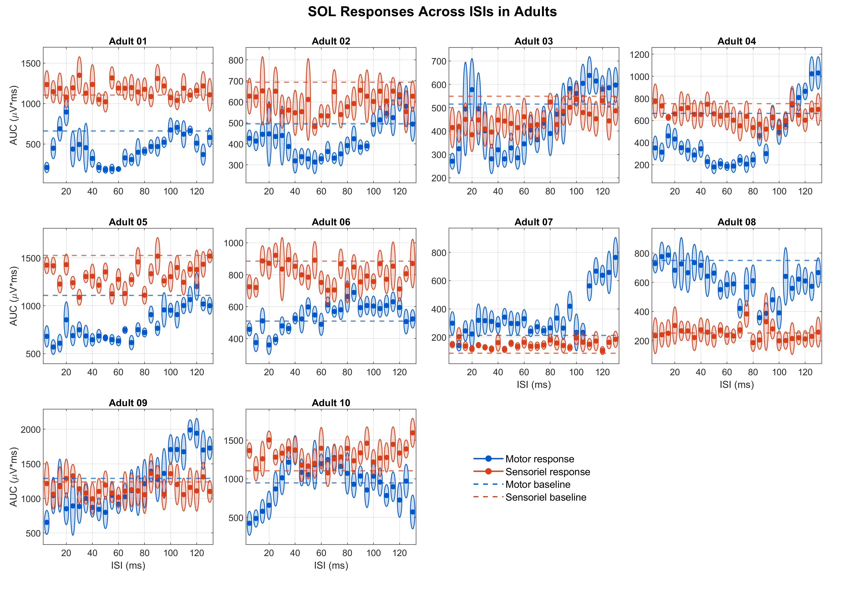
Supplementary Figure S2. Participant-specific SOL responses across ISIs in adults. AUC responses are shown across the 26 latency-referenced ISIs for each adult participant. Motor-threshold and sensory-threshold PNS responses are shown in blue and red, respectively. Points indicate the per-ISI responses, surrounding distributions illustrate trial-level variability, and dashed lines indicate the corresponding baseline AUC values.

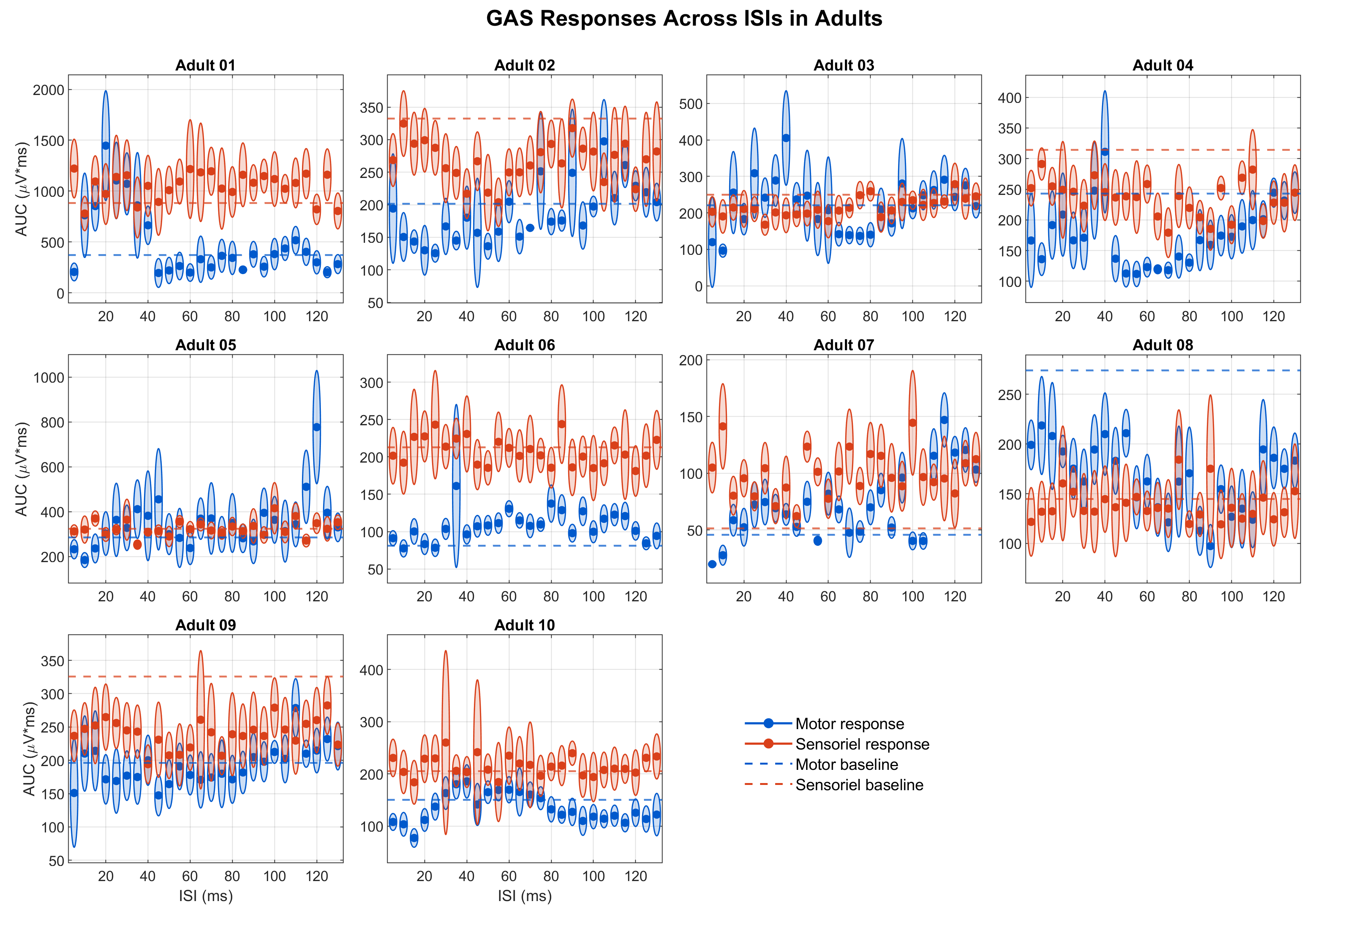
Supplementary Figure S3. Participant-specific GAS responses across ISIs in adults. AUC responses are shown across the 26 latency-referenced ISIs for each adult participant. Motor-threshold and sensory-threshold PNS responses are shown in blue and red, respectively. Points indicate the per-ISI responses, surrounding distributions illustrate trial-level variability, and dashed lines indicate the corresponding baseline AUC values.

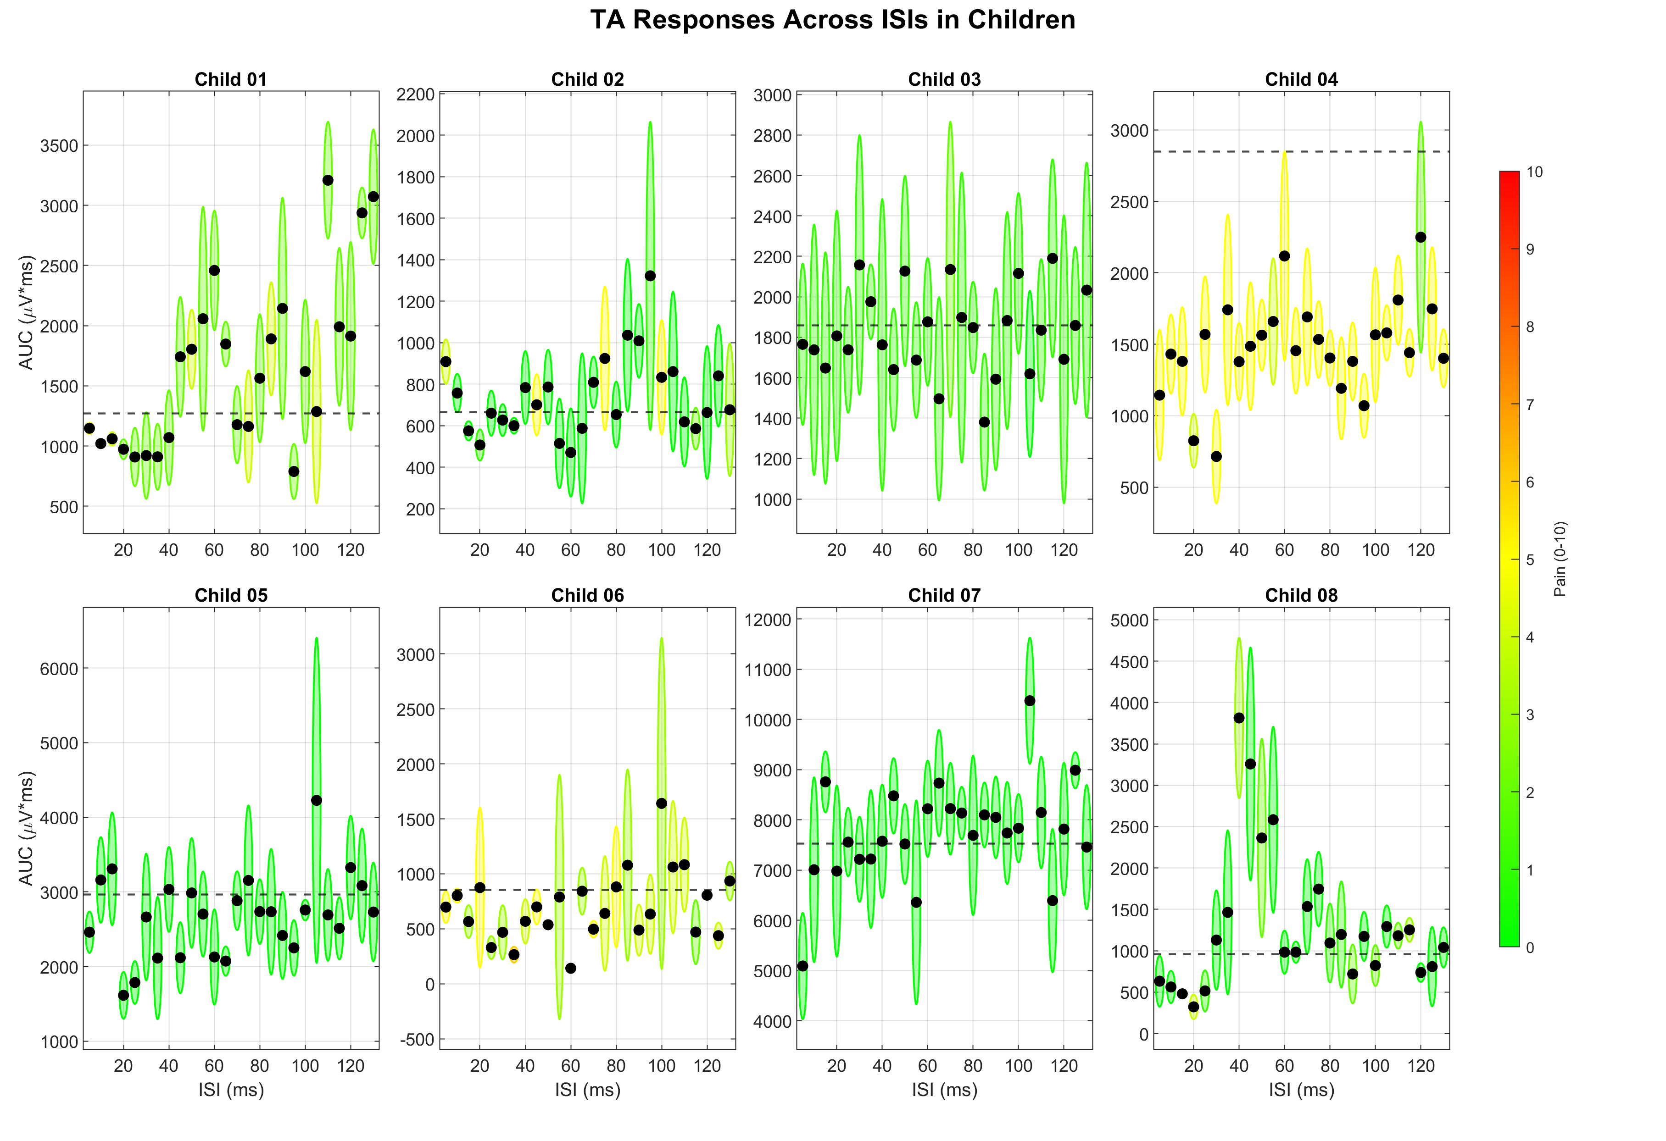
Supplementary Figure S4. Participant-specific TA responses across ISIs in children. AUC responses under motor-threshold PNS are shown across the 26 latency-referenced ISIs for each child. Black points indicate the per-ISI responses, surrounding distributions illustrate trial-level variability, and dashed lines indicate the baseline AUC. Color coding indicates the reported pain rating on a 0–10 scale.

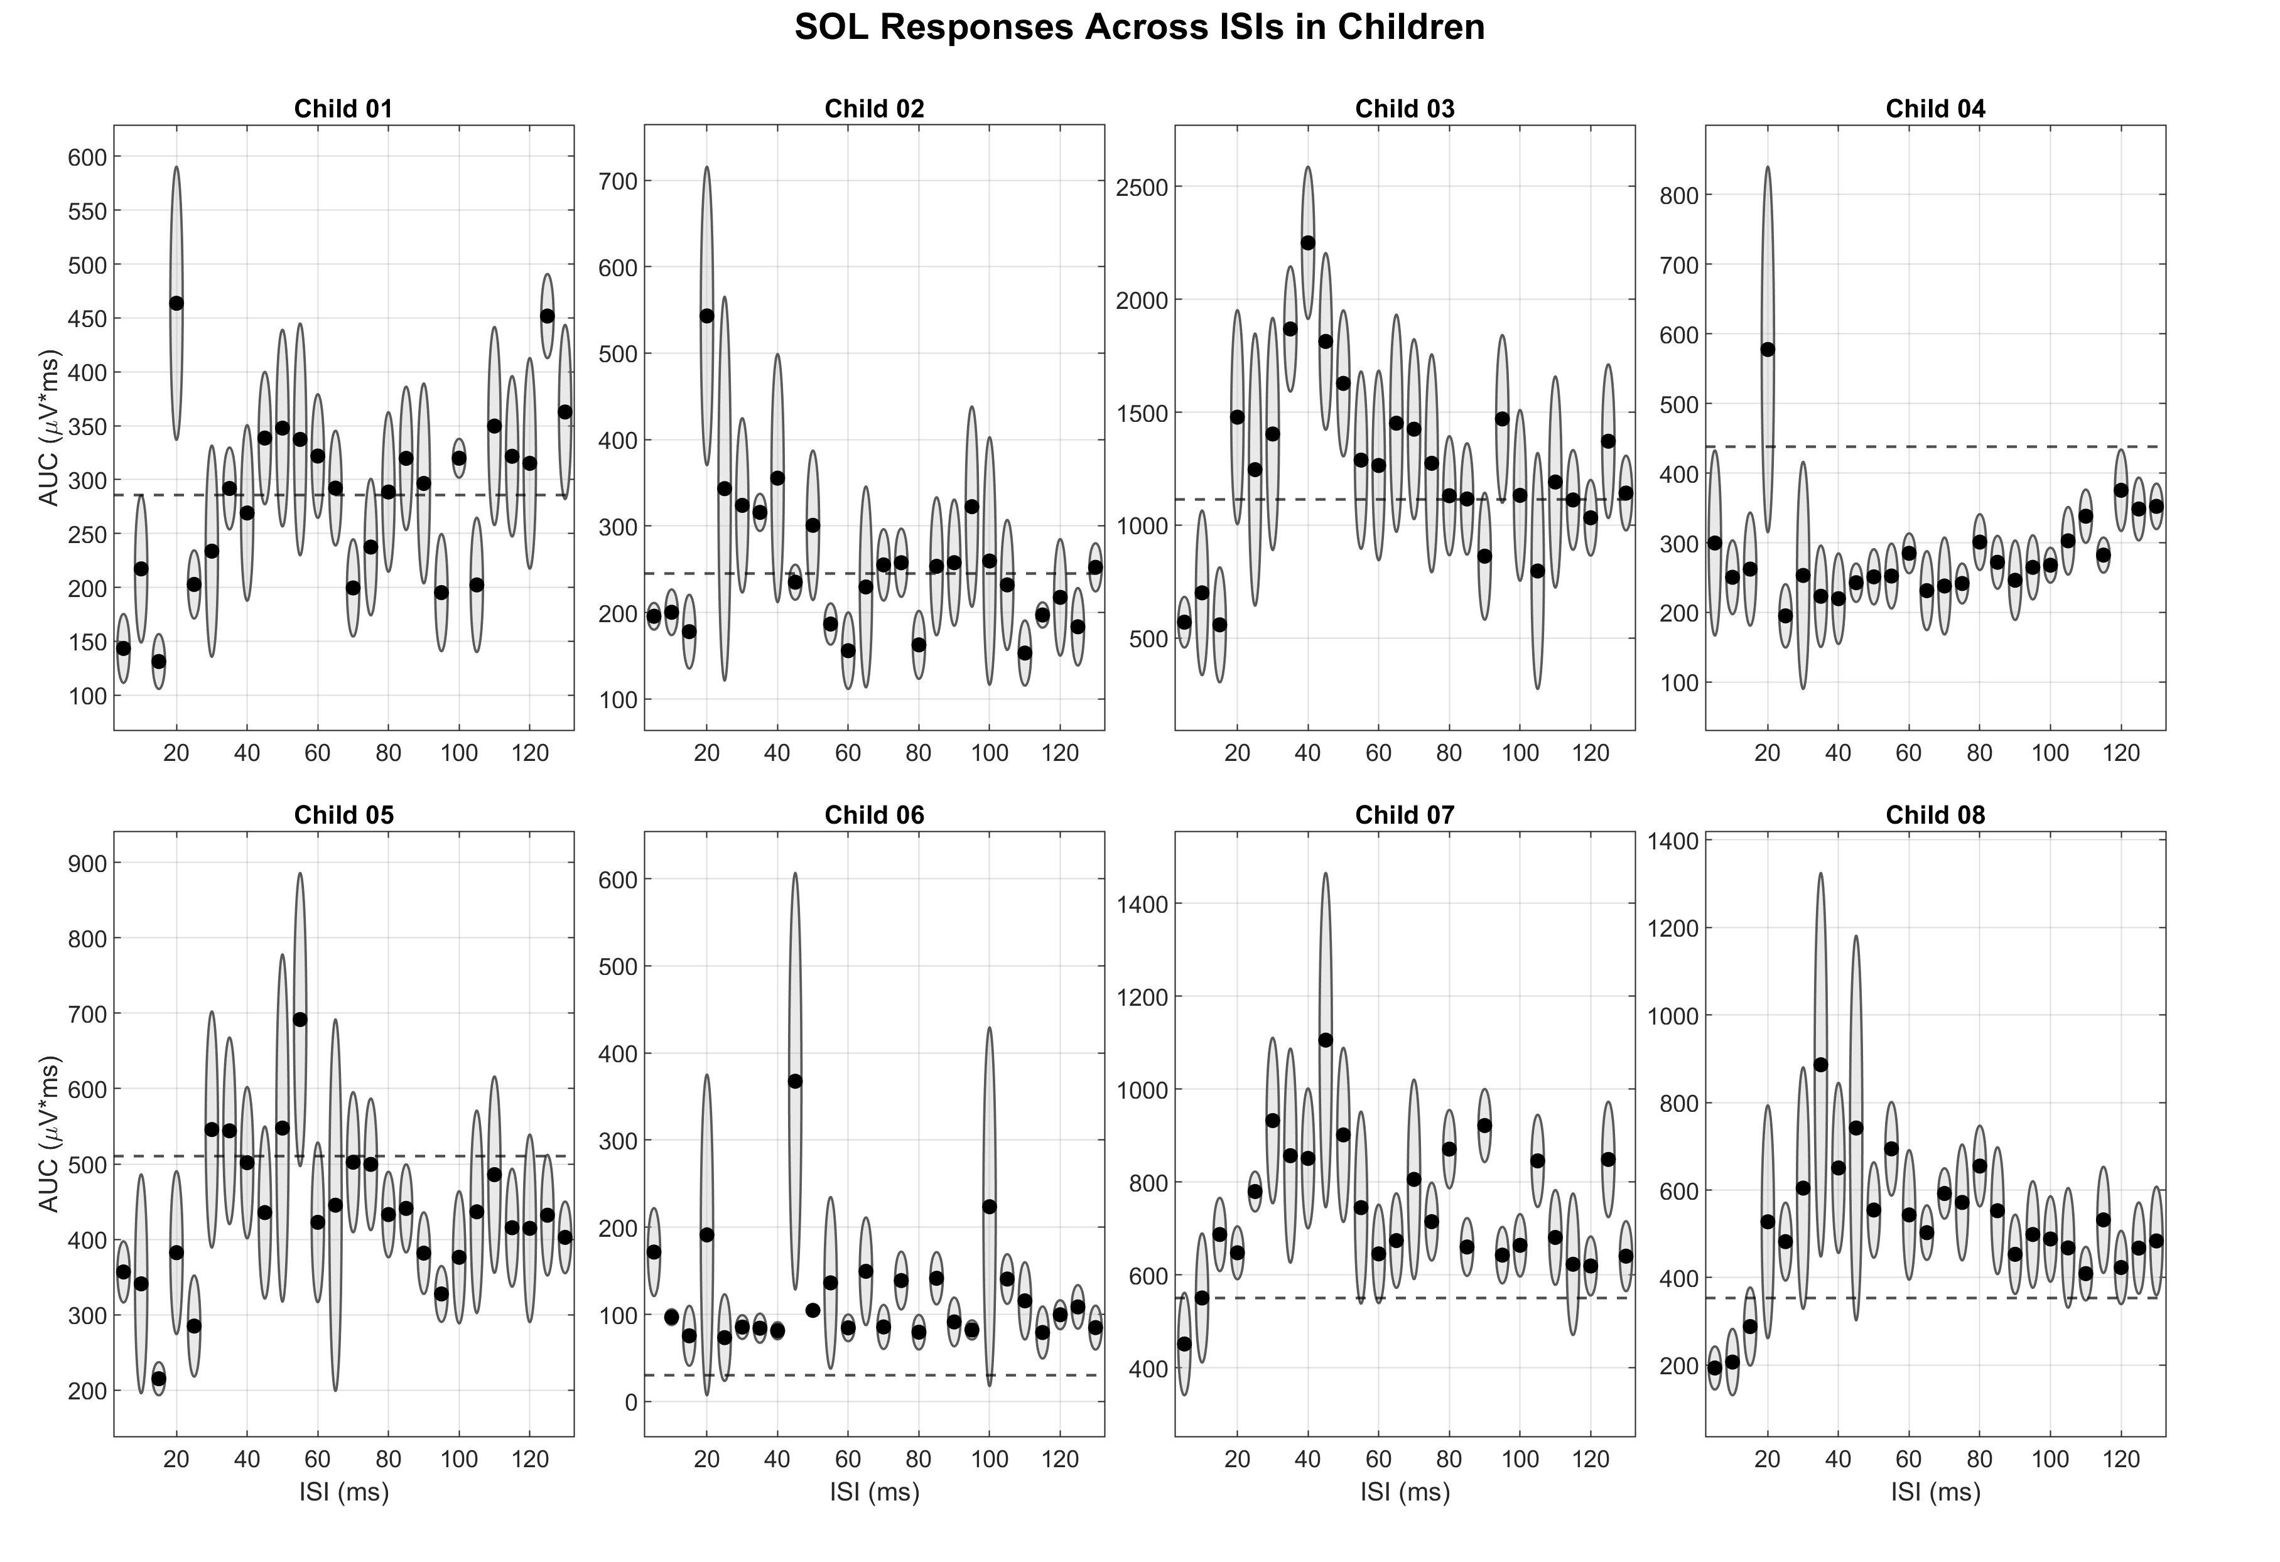
Supplementary Figure S5. Participant-specific SOL responses across ISIs in children. AUC responses under motor-threshold PNS are shown across the 26 latency-referenced ISIs for each child. Black points indicate the per-ISI responses, surrounding distributions illustrate trial-level variability, and dashed lines indicate the baseline AUC.

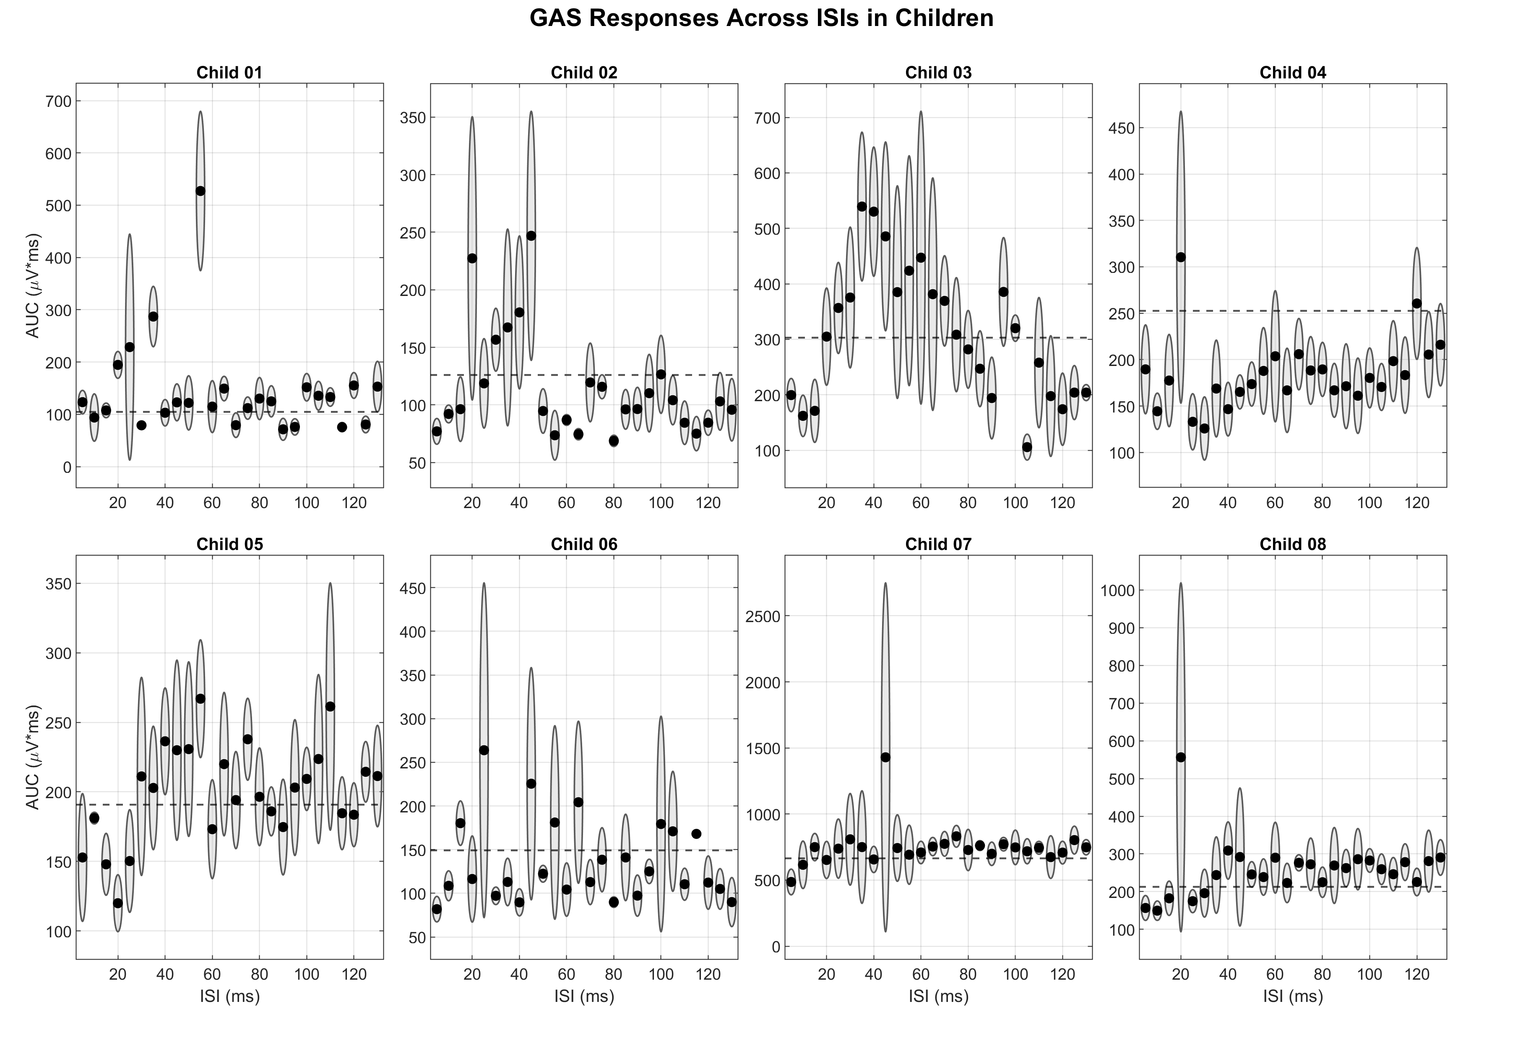
Supplementary Figure S6. Participant-specific GAS responses across ISIs in children. AUC responses under motor-threshold PNS are shown across the 26 latency-referenced ISIs for each child. Black points indicate the per-ISI responses, surrounding distributions illustrate trial-level variability, and dashed lines indicate the baseline AUC.

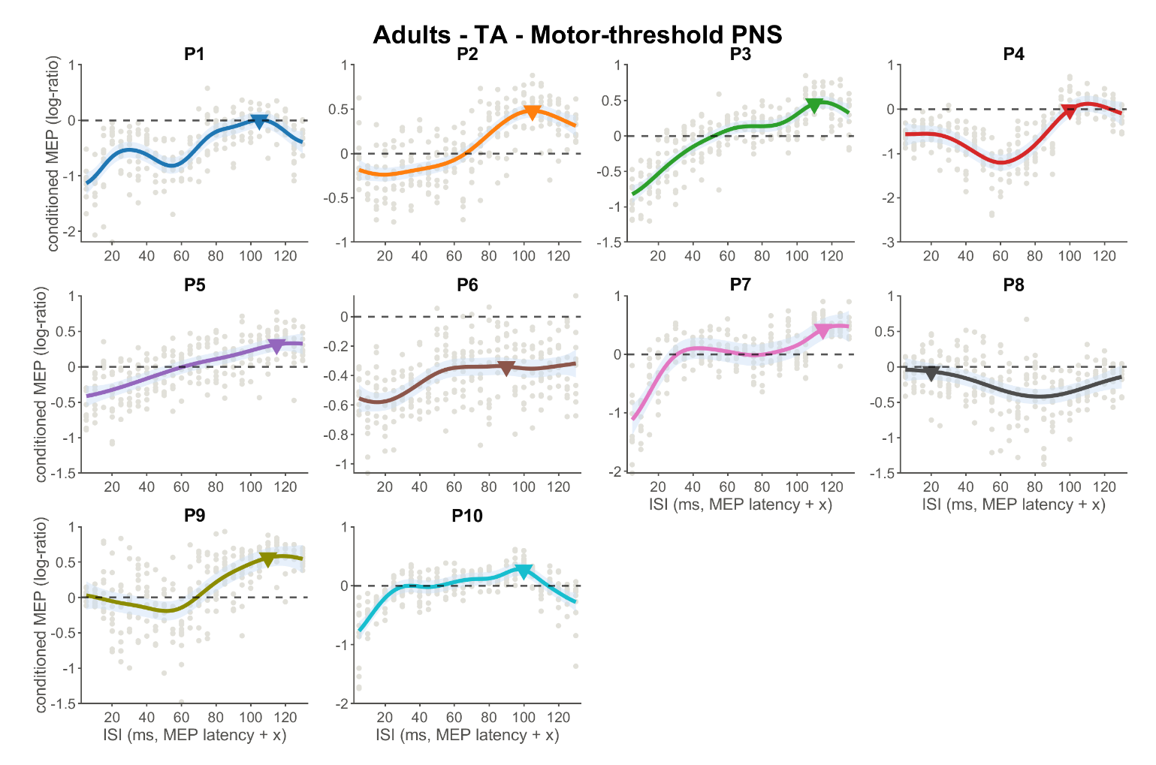
Supplementary Figure S7. Participant-specific GP ISI–response profiles for adult TA under motor-threshold PNS. Gray points represent trial-level baseline-referenced conditioned MEP responses for each participant. Colored curves show the participant-specific GP posterior mean, with shaded regions representing the approximate 95% credible interval. The horizontal dashed line indicates the unconditioned baseline (log-ratio = 0), and triangles indicate the ISI corresponding to the maximum GP posterior mean.

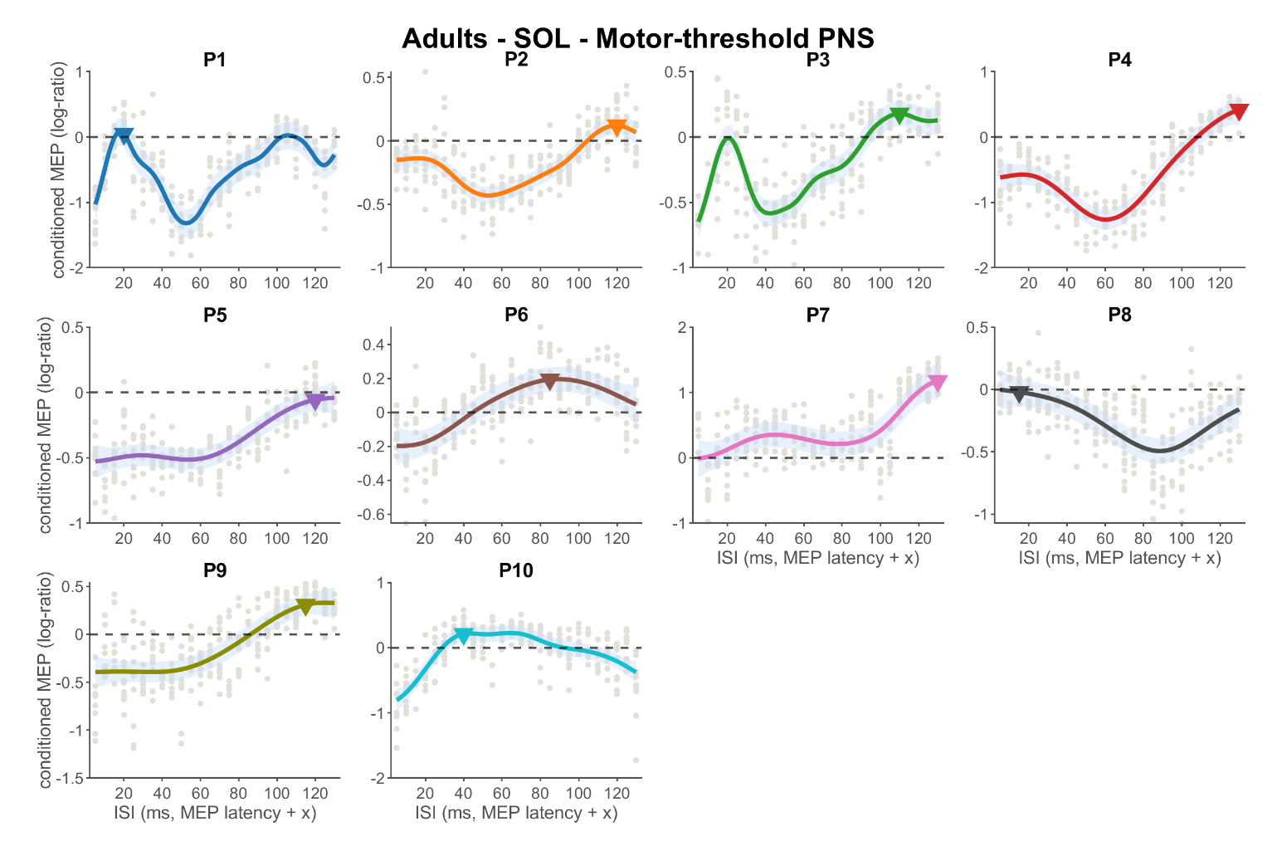
Supplementary Figure S8. Participant-specific GP ISI–response profiles for adult SOL under motor-threshold PNS. Gray points represent trial-level baseline-referenced conditioned MEP responses. Colored curves show the participant-specific GP posterior mean, with shaded regions representing the approximate 95% credible interval. The horizontal dashed line indicates the unconditioned baseline, and triangles indicate the ISI corresponding to the maximum GP posterior mean.

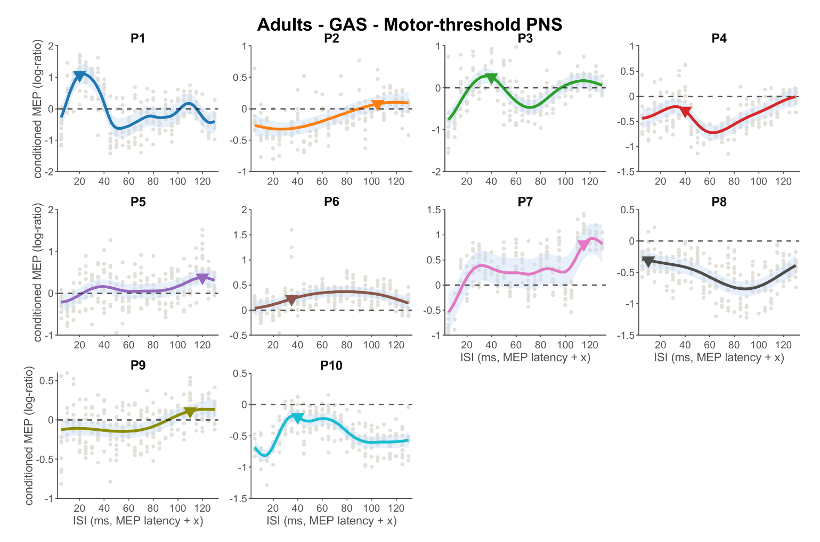
Supplementary Figure S9. Participant-specific GP ISI–response profiles for adult GAS under motor-threshold PNS. Gray points represent trial-level baseline-referenced conditioned MEP responses. Colored curves show the participant-specific GP posterior mean, with shaded regions representing the approximate 95% credible interval. The horizontal dashed line indicates the unconditioned baseline, and triangles indicate the ISI corresponding to the maximum GP posterior mean.

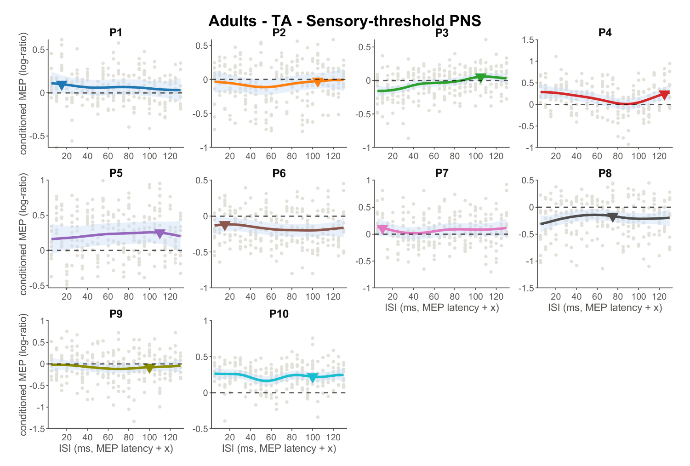
Supplementary Figure S10. Participant-specific GP ISI–response profiles for adult TA under sensory-threshold PNS. Gray points represent trial-level baseline-referenced conditioned MEP responses. Colored curves show the participant-specific GP posterior mean, with shaded regions representing the approximate 95% credible interval. The horizontal dashed line indicates the unconditioned baseline, and triangles indicate the ISI corresponding to the maximum GP posterior mean.

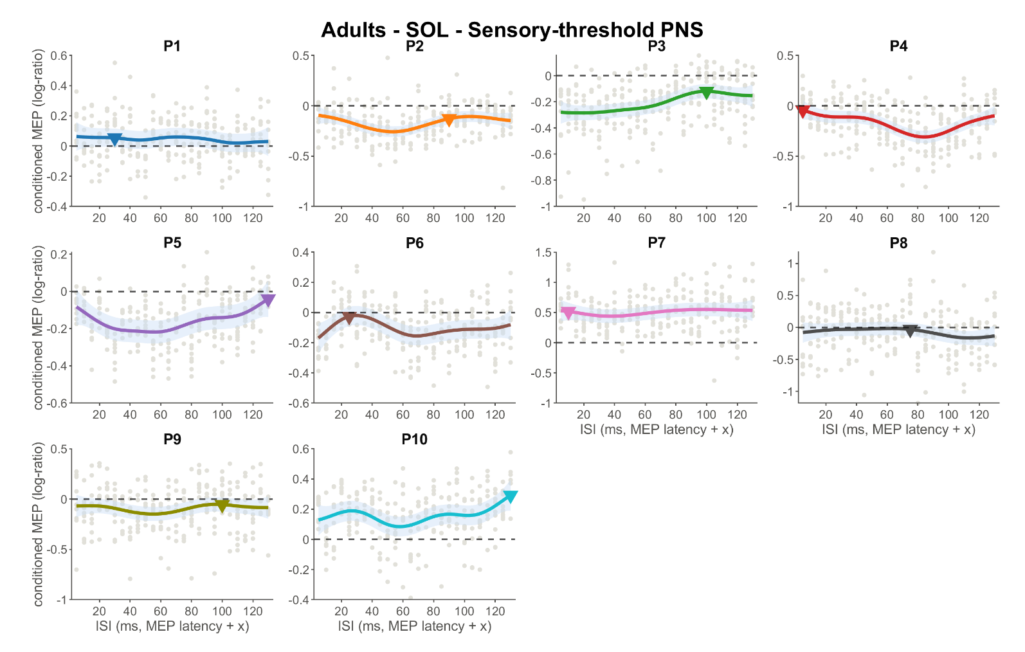
Supplementary Figure S11. Participant-specific GP ISI–response profiles for adult SOL under sensory-threshold PNS. Gray points represent trial-level baseline-referenced conditioned MEP responses. Colored curves show the participant-specific GP posterior mean, with shaded regions representing the approximate 95% credible interval. The horizontal dashed line indicates the unconditioned baseline, and triangles indicate the ISI corresponding to the maximum GP posterior mean.

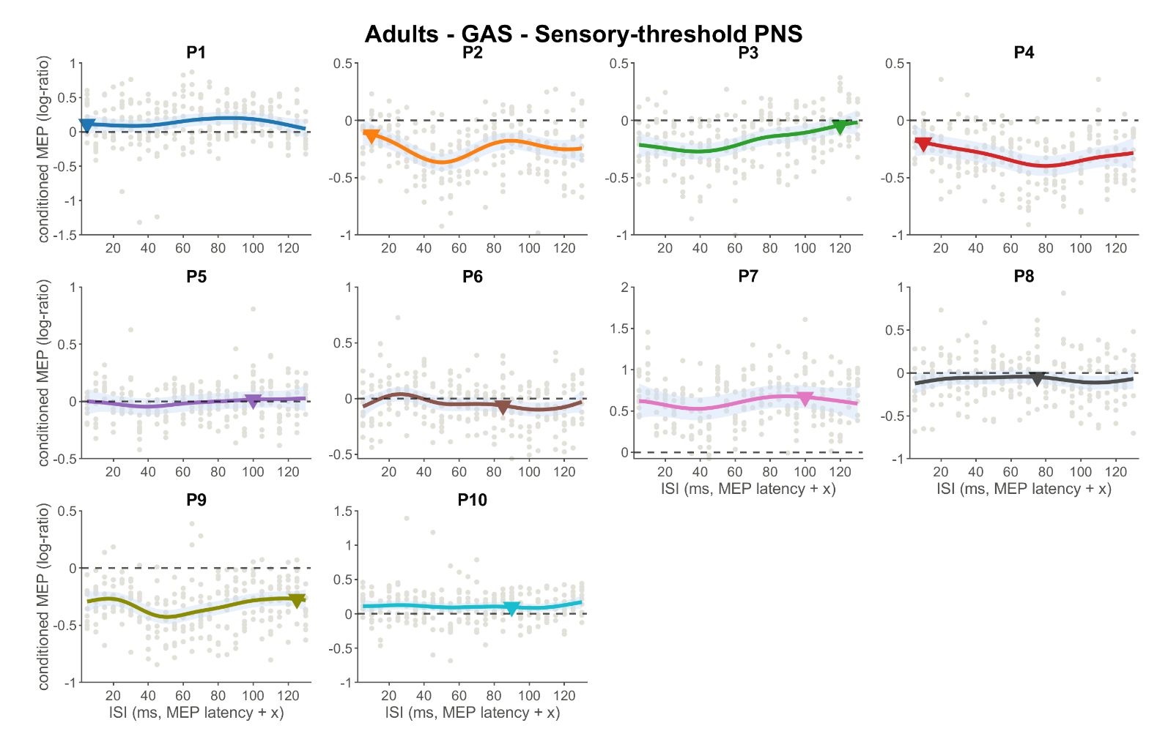
Supplementary Figure S12. Participant-specific GP ISI–response profiles for adult GAS under sensory-threshold PNS. Gray points represent trial-level baseline-referenced conditioned MEP responses. Colored curves show the participant-specific GP posterior mean, with shaded regions representing the approximate 95% credible interval. The horizontal dashed line indicates the unconditioned baseline, and triangles indicate the ISI corresponding to the maximum GP posterior mean.

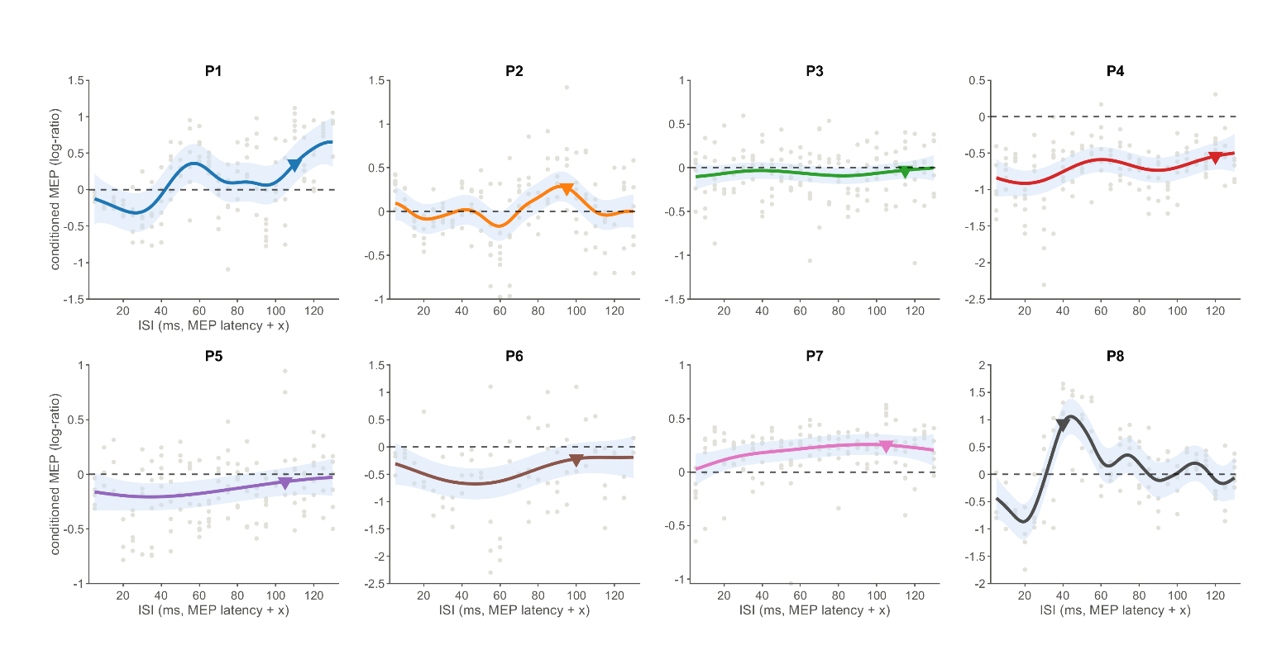
Supplementary Figure S13. Participant-specific GP ISI–response profiles for children TA under motor-threshold PNS. Gray points represent trial-level baseline-referenced conditioned MEP responses for each participant. Colored curves show the participant-specific GP posterior mean, with shaded regions representing the approximate 95% credible interval. The horizontal dashed line indicates the unconditioned baseline, and triangles indicate the ISI corresponding to the maximum GP posterior mean.
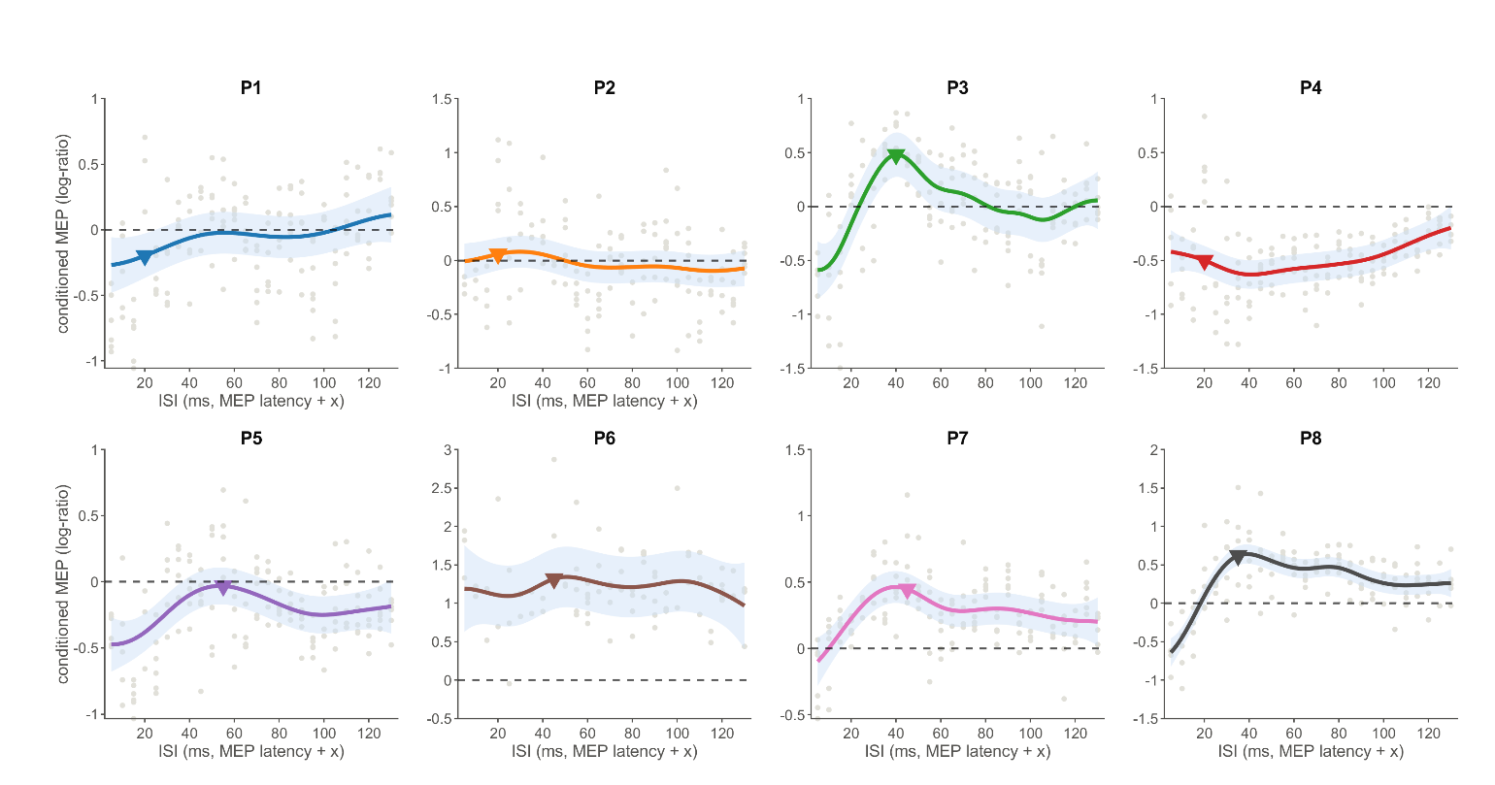
Supplementary Figure S14. Participant-specific GP ISI–response profiles for children SOL under motor-threshold PNS. Gray points represent trial-level baseline-referenced conditioned MEP responses for each participant. Colored curves show the participant-specific GP posterior mean, with shaded regions representing the approximate 95% credible interval. The horizontal dashed line indicates the unconditioned baseline, and triangles indicate the ISI corresponding to the maximum GP posterior mean.

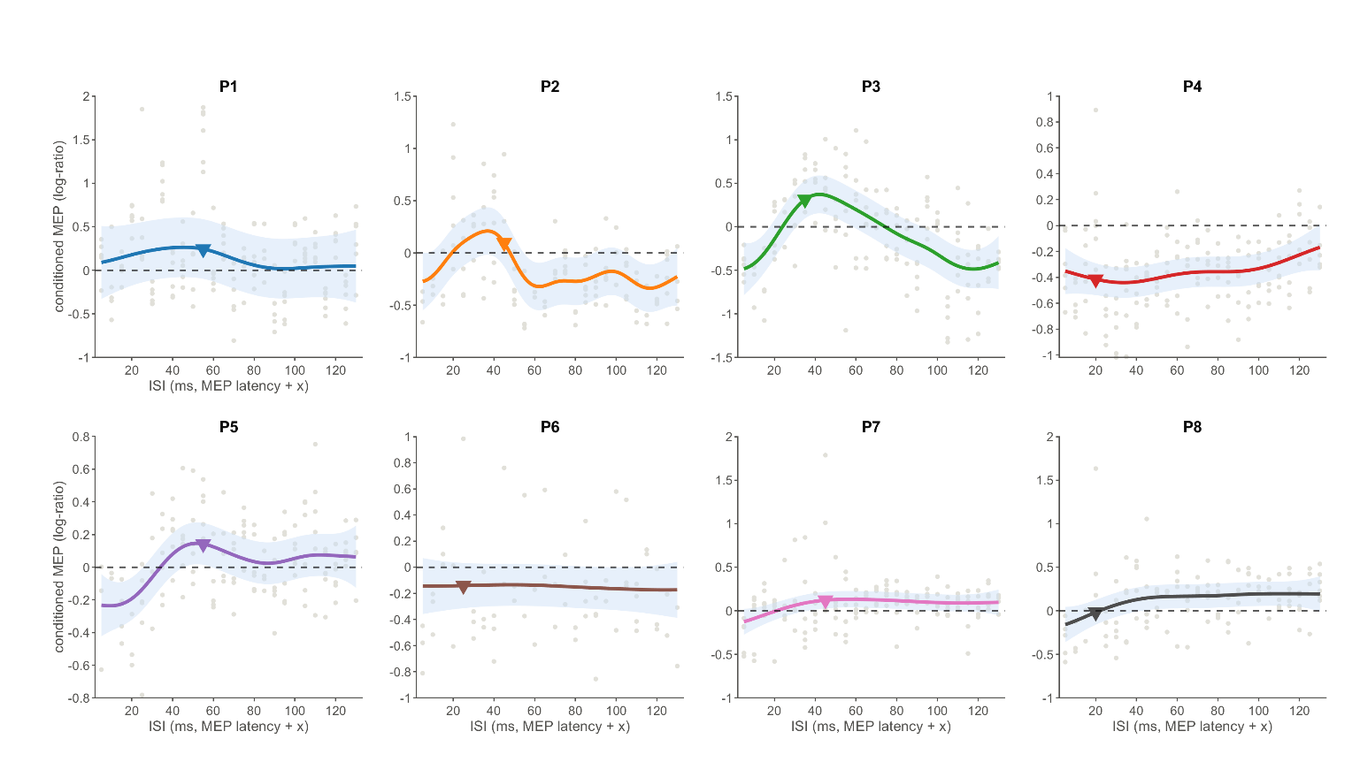
Supplementary Figure S15. Participant-specific GP ISI–response profiles for children GAS under motor-threshold PNS. Gray points represent trial-level baseline-referenced conditioned MEP responses for each participant. Colored curves show the participant-specific GP posterior mean, with shaded regions representing the approximate 95% credible interval. The horizontal dashed line indicates the unconditioned baseline, and triangles indicate the ISI corresponding to the maximum GP posterior mean.

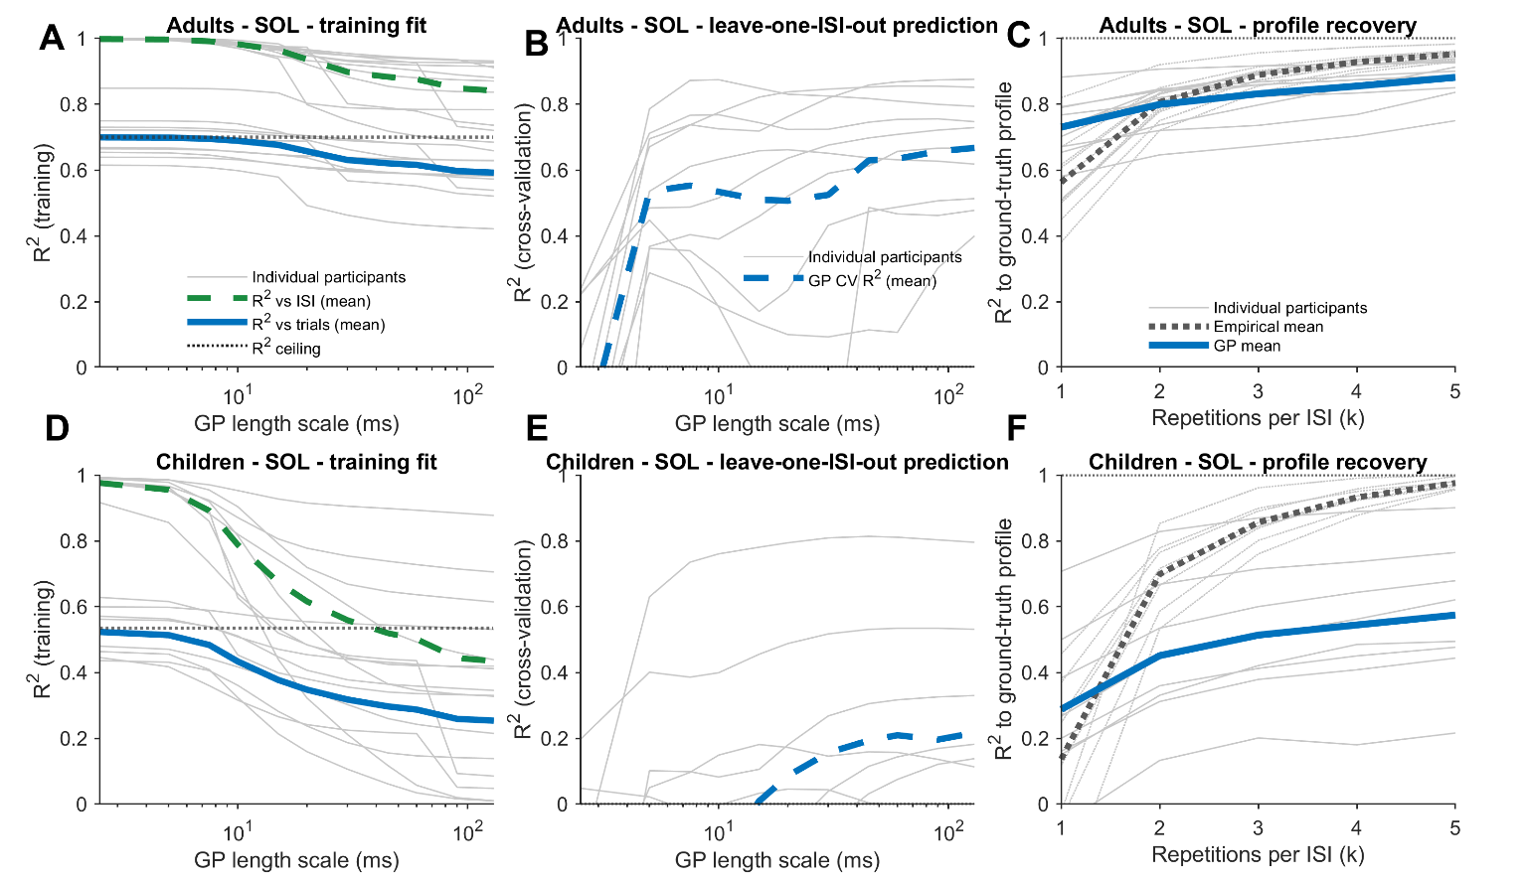
Supplementary Figure S16. GP model performance and data efficiency for SOL under motor-threshold PNS in adults and children. The top row shows adults and the bottom row shows children. (A,D) Training R² across GP length scales, evaluated relative to individual trial responses and the complete per-ISI mean profile, together with the empirical variance ceiling. (B,E) Leave-one-ISI-out cross-validation R² across GP length scales. Thin gray lines represent individual participants and dashed blue lines represent the group mean. (C,F) Recovery of the complete-repetition reference profile as a function of the number of repetitions per ISI. Thin gray lines represent individual participants; the dotted line represents empirical per-ISI averaging and the solid blue line represents GP regression.

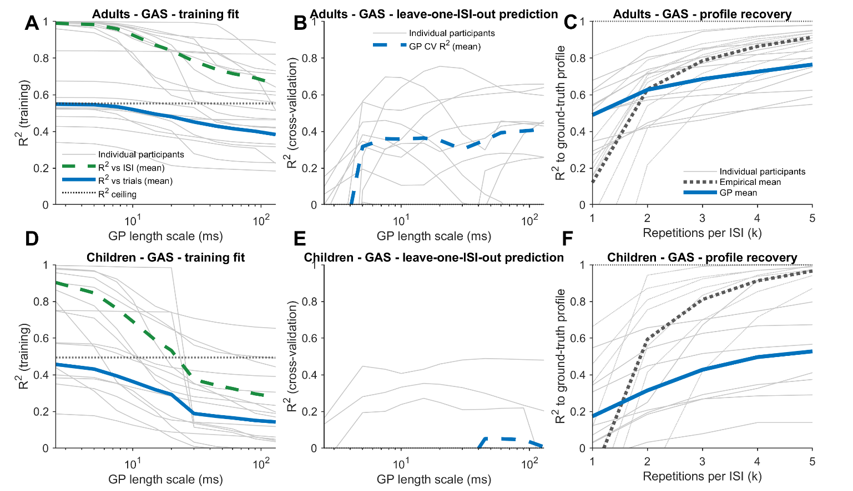
Supplementary Figure S17. GP model performance and data efficiency for GAS under motor-threshold PNS in adults and children. The top row shows adults and the bottom row shows children. (A,D) Training R² across GP length scales, evaluated relative to individual trial responses and the complete per-ISI mean profile, together with the empirical variance ceiling. (B,E) Leave-one-ISI-out cross-validation R² across GP length scales. Thin gray lines represent individual participants and dashed blue lines represent the group mean. (C,F) Recovery of the complete-repetition reference profile as a function of the number of repetitions per ISI. Thin gray lines represent individual participants; the dotted line represents empirical per-ISI averaging and the solid blue line represents GP regression.

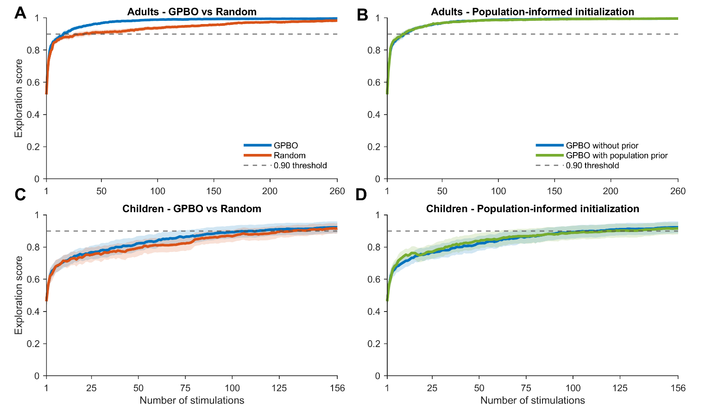
Supplementary Figure S18. Bayesian-optimization performance for SOL under motor-threshold PNS in adults and children. (A,C) Group exploration-score trajectories for GP-based Bayesian optimization (GPBO) and random ISI sampling in adults and children, respectively. (B,D) Exploration-score trajectories for GPBO with and without population-informed initialization in adults and children, respectively. Solid lines represent group means and shaded regions represent the standard error of the mean across participants. The horizontal dashed line indicates the exploration-score threshold of 0.90.

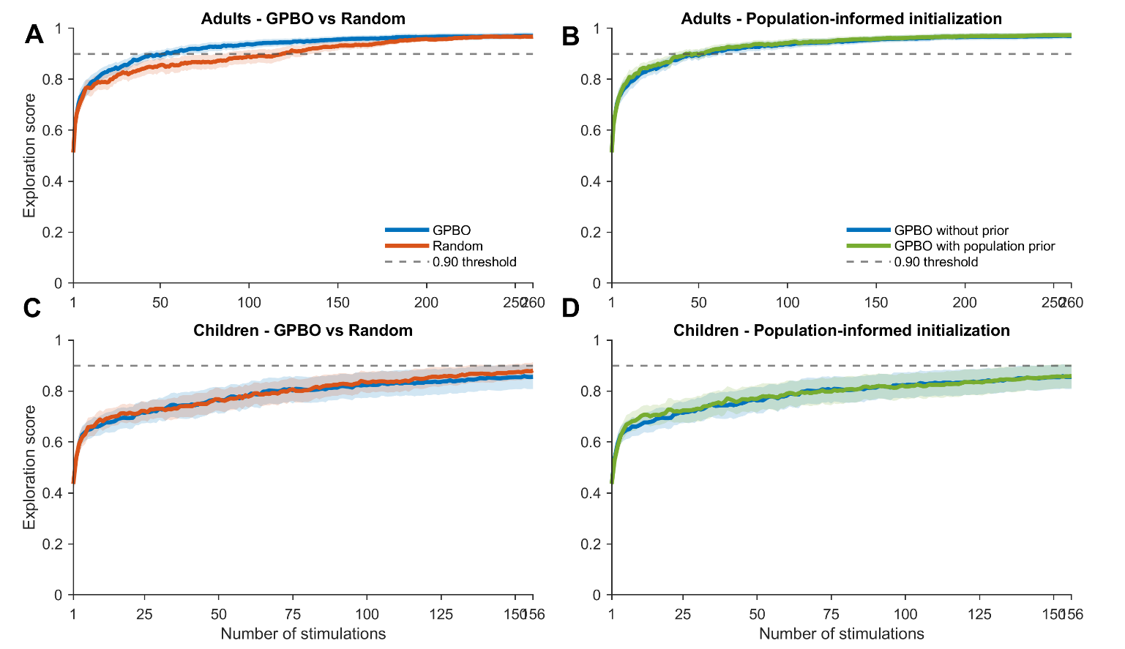
Supplementary Figure S19. Bayesian-optimization performance for GAS under motor-threshold PNS in adults and children. (A,C) Group exploration-score trajectories for GPBO and random ISI sampling in adults and children, respectively. (B,D) Exploration-score trajectories for GPBO with and without population-informed initialization in adults and children, respectively. Solid lines represent group means and shaded regions represent the standard error of the mean across participants. The horizontal dashed line indicates the exploration-score threshold of 0.90.

