Supplementary Information for:
Floating and fixed offshore wind intersect contrasting frontal and fishing seascapes in the Celtic Sea
Yang Yang^{1,2}, Peter I. Miller², Liam Langley³, Stephen Votier³, Michel Kaiser³ and Lilian Lieber¹
¹ School of Biological and Marine Sciences, University of Plymouth, Plymouth, UK
² Plymouth Marine Laboratory, Plymouth, UK
³ The Lyell Centre, Heriot-Watt University, Edinburgh, UK
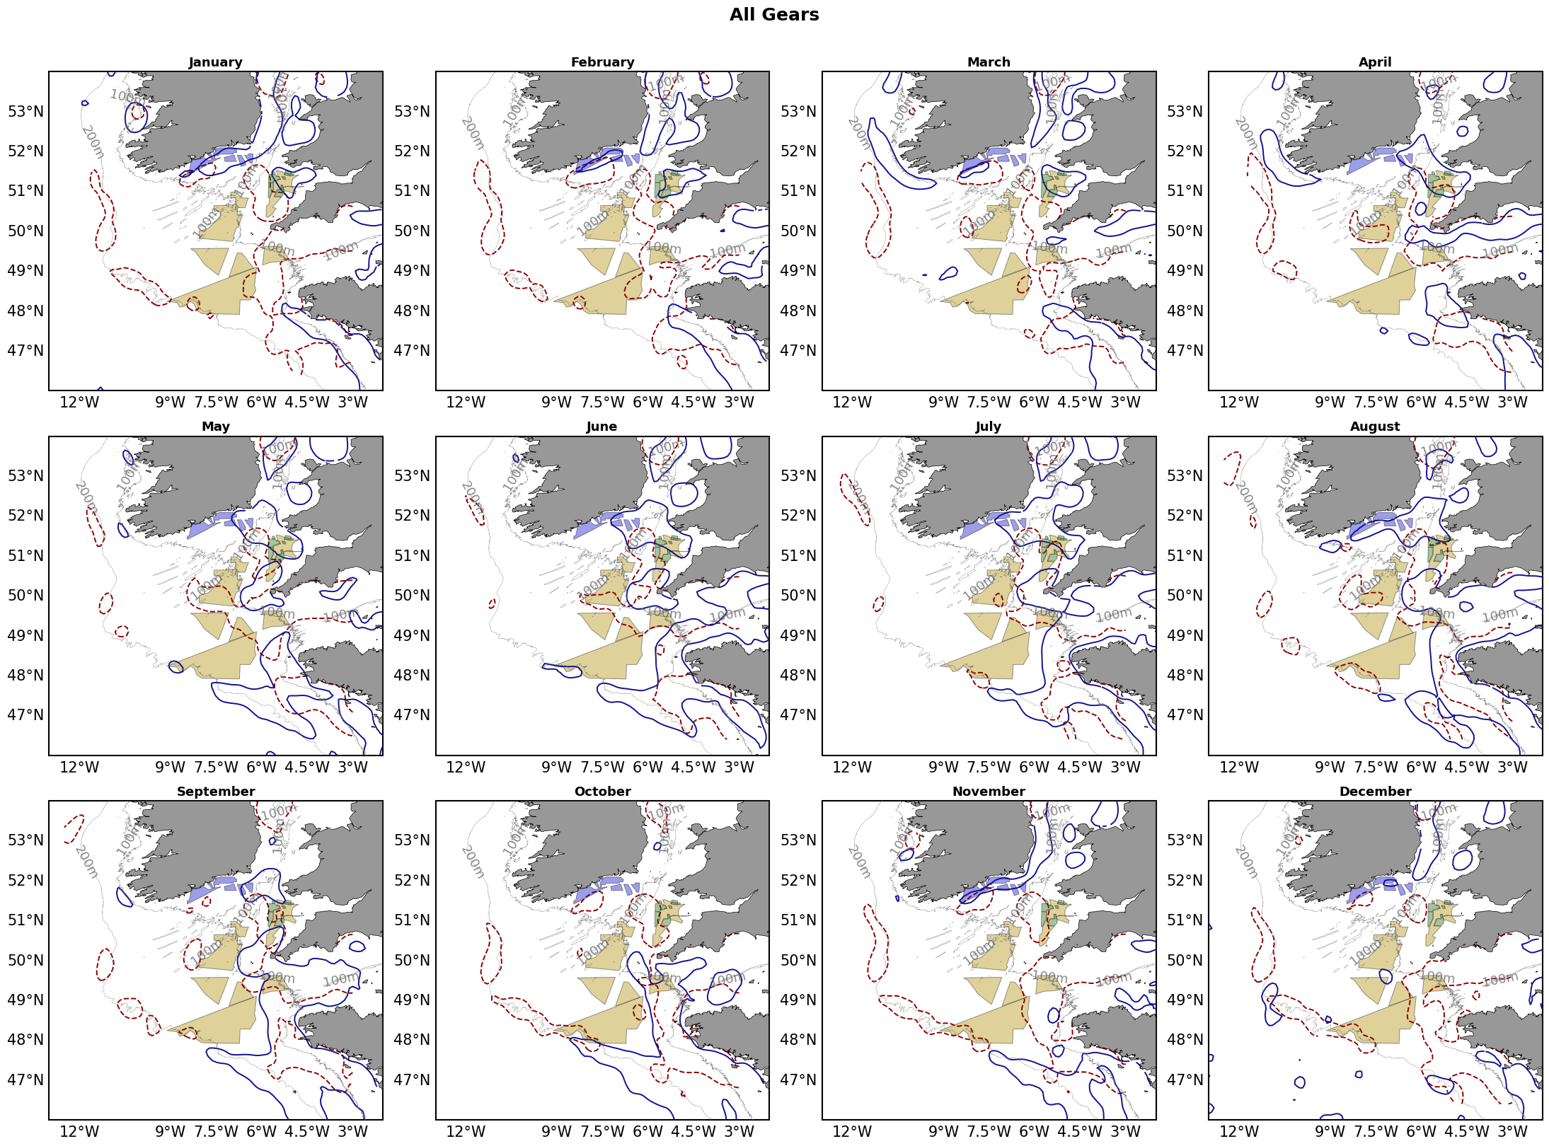
Supplementary Fig. 1 Monthly front and fishing hotspot distributions across 2012-2025. Panels show monthly composite hotspots for all gear types. Blue solid contours indicate thermal front hotspots, and red dashed contours indicate apparent fishing activity hotspots. Hotspots are defined as the top 20% of ranked monthly grid cells within the Celtic Sea analysis domain.
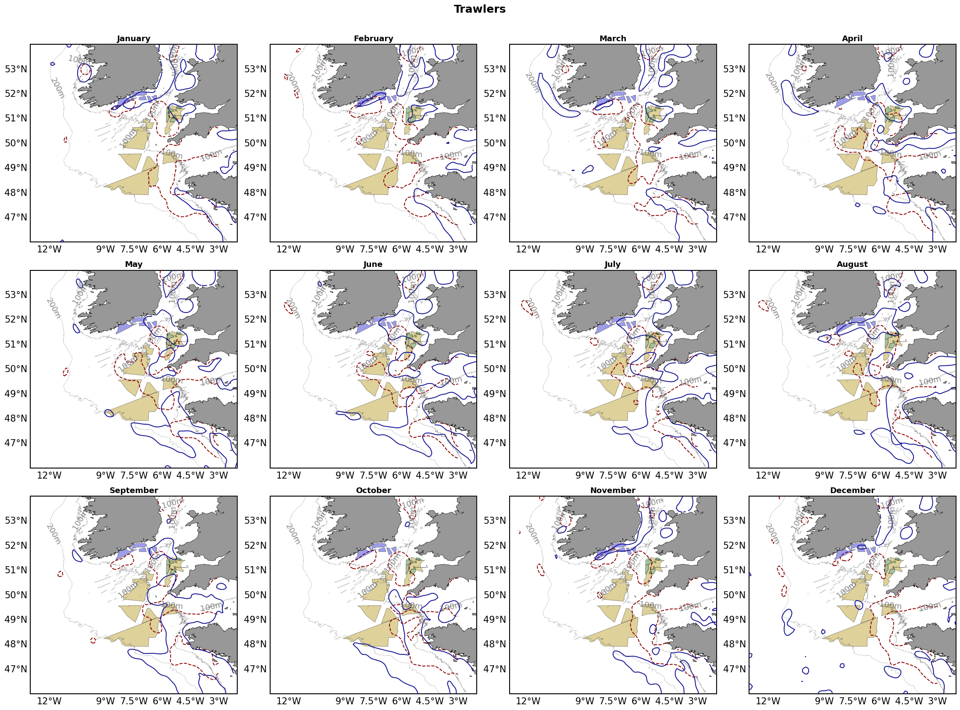
Supplementary Fig. 2 Monthly front and fishing hotspot distributions across 2012-2025. Panels show monthly composite fishing hotspots for trawlers. Blue solid contours indicate thermal front hotspots, and red dashed contours indicate apparent fishing activity hotspots.

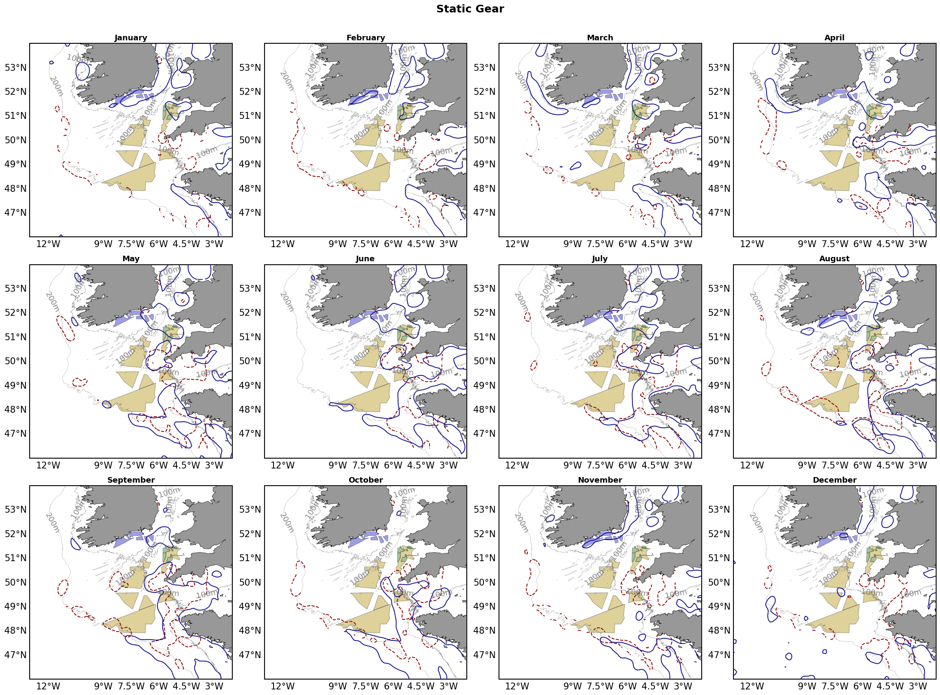
Supplementary Fig. 3 Monthly front and fishing hotspot distributions across 2012-2025. Panels show monthly composite fishing hotspots for static gears, including set longlines, set gillnets, pots and traps. Blue solid contours indicate thermal front hotspots, and red dashed contours indicate apparent fishing activity hotspots.

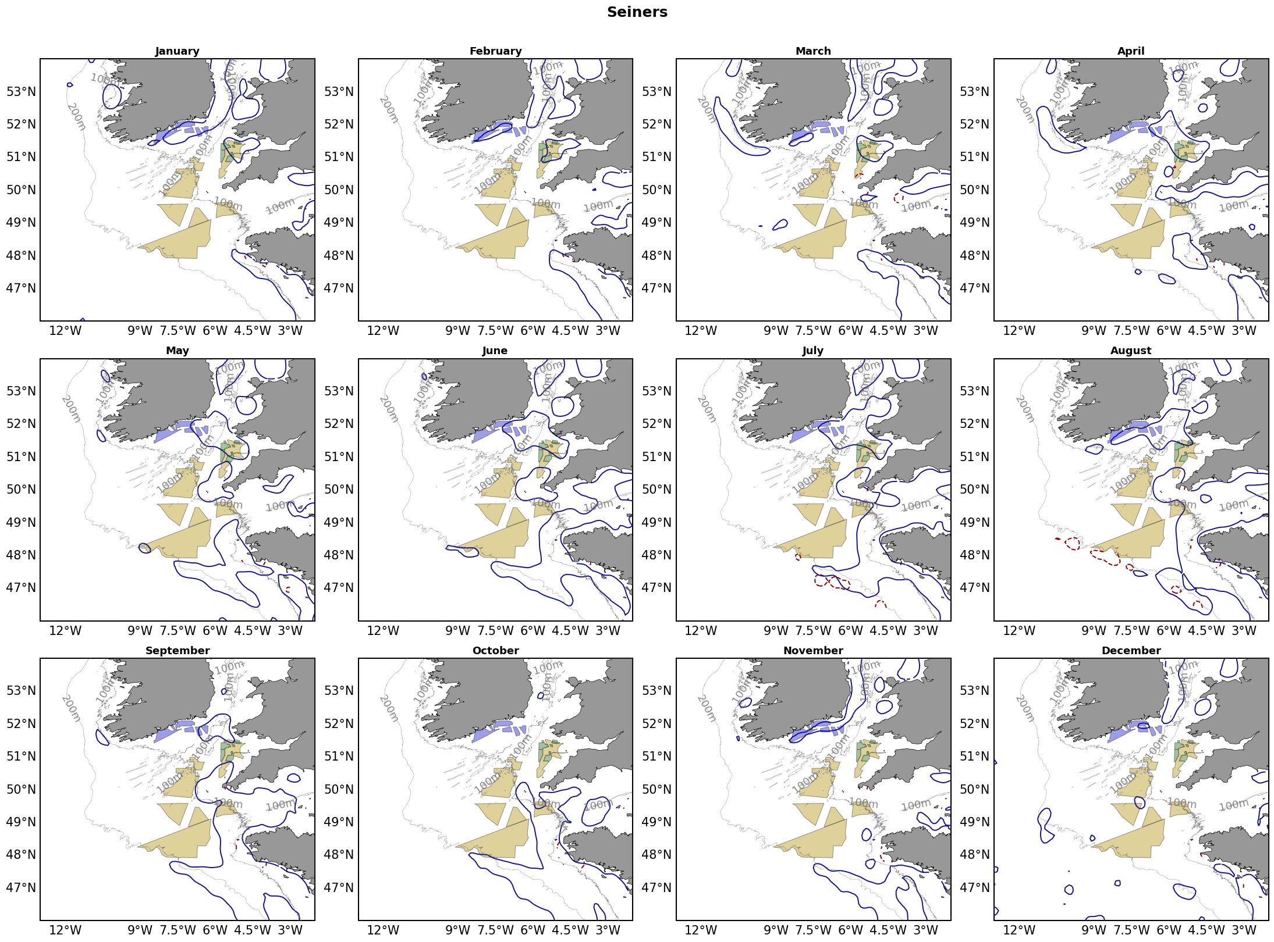
Supplementary Fig. 4 Monthly front and fishing hotspot distributions across 2012-2025. Panels show monthly composite fishing hotspots for seiners. Blue solid contours indicate thermal front hotspots, and red dashed contours indicate apparent fishing activity hotspots.

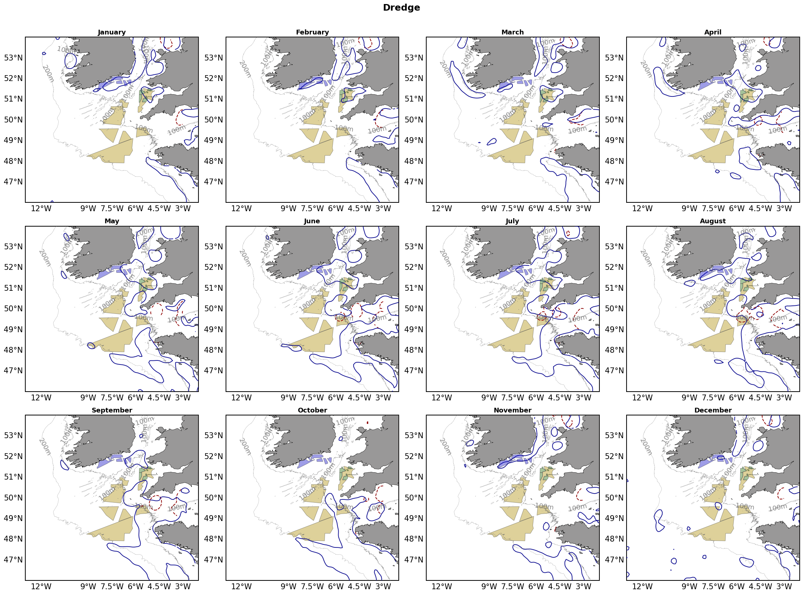
Supplementary Fig. 5 Monthly front and fishing hotspot distributions across 2012-2025. Panels show monthly composite fishing hotspots for dredge fishing. Blue solid contours indicate thermal front hotspots, and red dashed contours indicate apparent fishing activity hotspots.

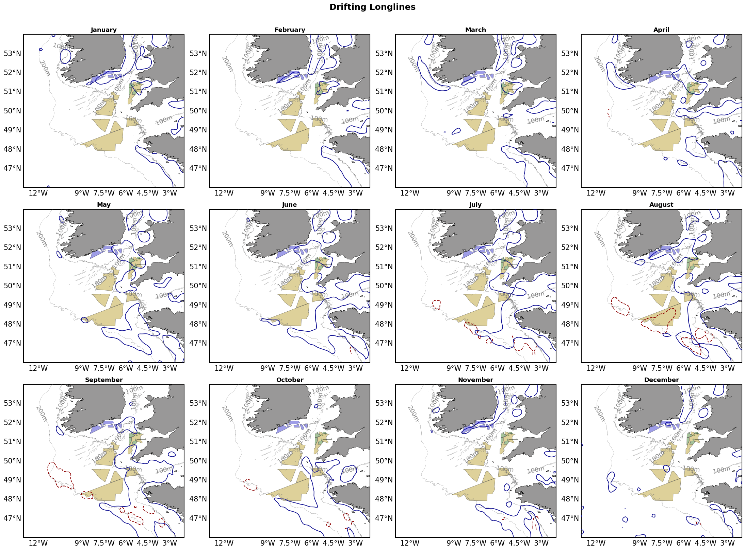
Supplementary Fig. 6 Monthly front and fishing hotspot distributions across 2012-2025. Panels show monthly composite fishing hotspots for drifting longlines. Blue solid contours indicate thermal front hotspots, and red dashed contours indicate apparent fishing activity hotspots.
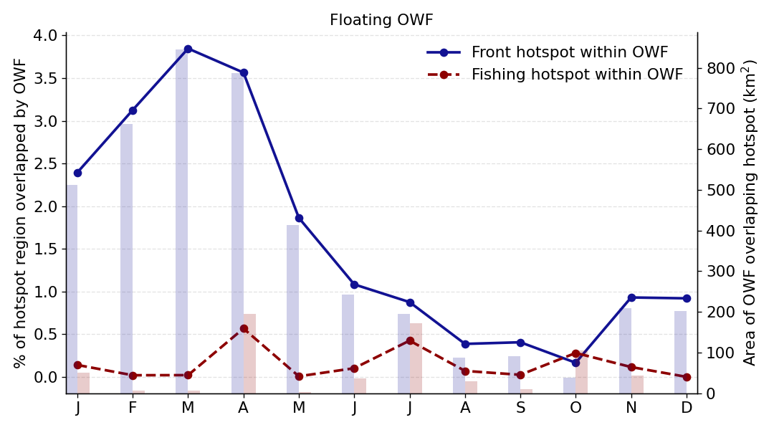
Supplementary Fig. 7 Monthly overlap between planned floating offshore wind (FLOW) footprints and Celtic Sea hotspot areas using the upper 10% hotspot threshold. Lines show the percentage of each monthly hotspot layer overlapped by FLOW, using the total monthly hotspot area in the Celtic Sea as the denominator. Shaded bars show the corresponding absolute overlap area in km². Front hotspots were defined from ranked monthly front strength, and fishing hotspots were defined from ranked monthly apparent fishing activity.
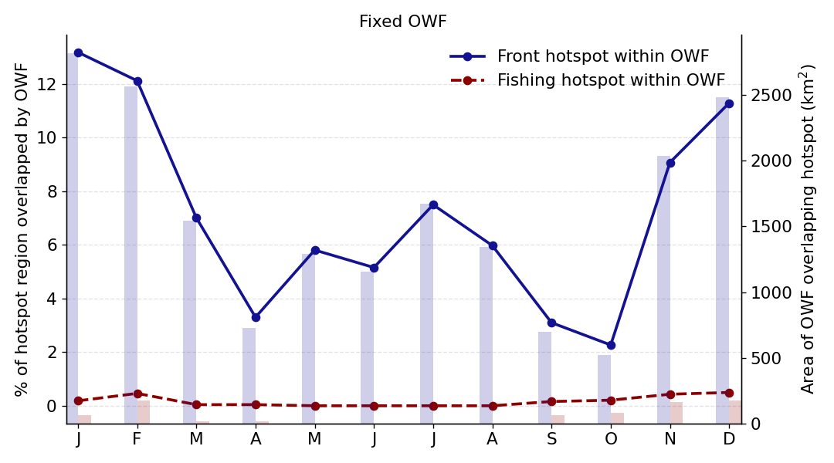
Supplementary Fig. 8 Monthly overlap between planned fixed-bottom offshore wind (FBOW) footprints and Celtic Sea hotspot areas using the upper 10% hotspot threshold. Lines show the percentage of each monthly hotspot layer overlapped by FLOW, using the total monthly hotspot area in the Celtic Sea as the denominator. Shaded bars show the corresponding absolute overlap area in km². Front hotspots were defined from ranked monthly front strength, and fishing hotspots were defined from ranked monthly apparent fishing activity.
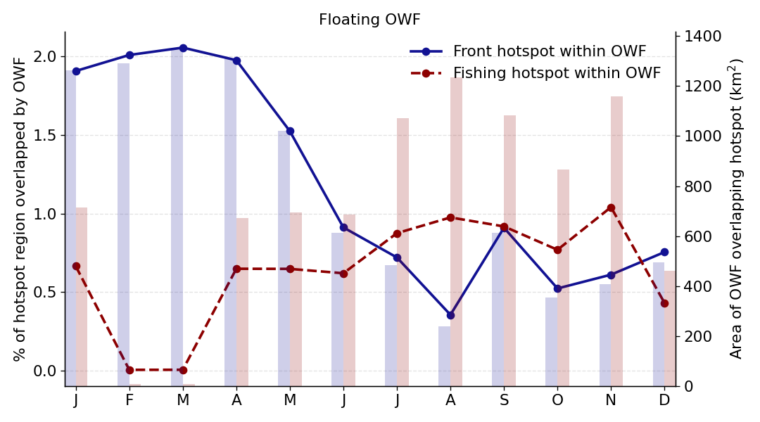
Supplementary Fig. 9 Monthly overlap between planned floating offshore wind (FLOW) footprints and Celtic Sea hotspot areas using the upper 30% hotspot threshold. Lines show the percentage of each monthly hotspot layer overlapped by FLOW, using the total monthly hotspot area in the Celtic Sea as the denominator. Shaded bars show the corresponding absolute overlap area in km². Front hotspots were defined from ranked monthly front strength, and fishing hotspots were defined from ranked monthly apparent fishing activity.
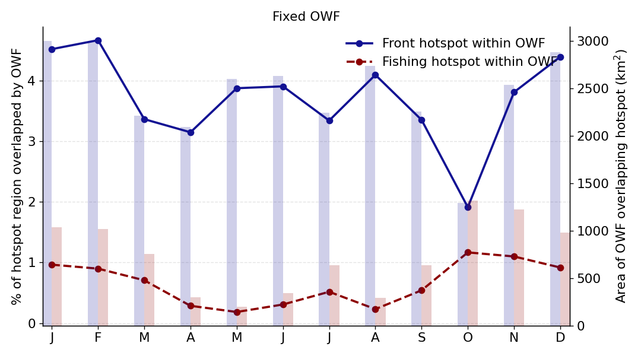
Supplementary Fig. 10 Monthly overlap between planned fixed-bottom offshore wind (FBOW) footprints and Celtic Sea hotspot areas using the upper 30% hotspot threshold. Lines show the percentage of each monthly hotspot layer overlapped by FLOW, using the total monthly hotspot area in the Celtic Sea as the denominator. Shaded bars show the corresponding absolute overlap area in km². Front hotspots were defined from ranked monthly front strength, and fishing hotspots were defined from ranked monthly apparent fishing activity.

