Supplementary Information
Lifecycle-dependent roles of mesoscale heat transport in marine heatwaves and cold-spells in the East Sea (Japan Sea)
Gyuchang Lim¹ and Jong-Jin Park^{1,2,*}
¹Kyungpook Institute of Oceanography, Kyungpook National University, Daegu, Korea
²School of Earth System Sciences, Kyungpook National University, Daegu, Korea
*Correspondence: jjpark@knu.ac.kr

Supplementary Methods
Data and event preprocessing. GLORYS12 daily potential temperature and horizontal velocity were analyzed on the native 1/12° grid for 1993–2022. ERA5 surface fluxes were converted to daily downward-positive values and linearly interpolated to the GLORYS12 grid. At each wet cell, the linear trend was removed while retaining the temporal mean; detrended SST and $T_{m,50}$ were used only for event detection. Day-of-year climatological means and 90th/10th percentiles were estimated with an 11-day sampling window and smoothed by 31 days [1]. Events lasted at least five days and gaps of at most two days were joined. Leap days were mapped to a 365-day calendar.
Spatiotemporal objects and catalogue overlap. Grid events were joined using eight-neighbor horizontal connectivity when their threshold intervals overlapped or were separated by no more than one day; transitive closure was obtained with union–find. Each connected component is one object. Jaccard and Dice overlap were calculated from SST and $T_{m,50}$ event cell-days:
J = |A ∩ B| / |A ∪ B|, D = 2|A ∩ B| / (|A| + |B|).
‘Matched-any’ requires at least one shared cell-day; object-pair scores use the maximum cell-day Jaccard value against all objects in the other catalogue. No minimum-area filter was imposed.
Exclusive regions. Candidate boxes were EKWC (128–132°E, 34–38.5°N), East Korea Bay (128–132°E, 38.5–41.5°N), Ulleung Basin (130–135°E, 35.5–39.5°N), SPF (130–138°E, 39.5–42°N), and Japan side (135–141.5°E, 35–42°N). For a cell contained in multiple boxes, the assigned region minimized
$$d_{r}^{2}={\left[\left(λ-λ_{r}\right)/Δλ_{r}\right]}^{2}+{\left[\left(ϕ-ϕ_{r}\right)/Δϕ_{r}\right]}^{2}$$
This normalized-distance rule produced zero final overlap; unassigned East Sea cells were kept as Other East Sea. Objects were regionally classified by their peak cell.
Deformation scale and filtering. Potential density was calculated from GLORYS12 temperature and salinity profiles. Negative $N^{2}$ values were set to zero. A WKB-based deformation-scale proxy was estimated as
$$N^{2}=-\left(\frac{g}{ρ_{0}}\right)\frac{∂ρ}{∂z} , c_{1}≈\frac{1}{π}\int{Ndz} , R_{d}=c_{1}/\left|f\right|$$
Thirty-day sampled profiles were averaged over the analysis period. The baseline low-pass half-width was L = clip (6$R_{d}$, 45, 120 km). Separate zonal and meridional metric cell counts were used in a NaN-aware rectangular filter, with weights renormalized over valid ocean cells. This is a stratification-based deformation-scale estimate, not a full-depth eigenvalue solution.
Fixed-layer heat budget. At every native depth, large-scale fields were obtained from the local low-pass filter and perturbations were defined as departures. Horizontal convergence was evaluated with the spherical divergence
$$∇_{h}∙\vec{F}=\frac{1}{a\cos{ϕ}}\frac{∂F_{λ}}{∂λ}+\frac{1}{a\cos{ϕ}}\frac{∂\left(F_{ϕ}\cos{ϕ}\right)}{∂ϕ}$$
Face-interpolated fluxes were used; wet–land faces had zero normal flux, and outer computational edges were excluded. Level-wise convergence was depth-averaged over 0–H, retaining partial cells and vertical shear–temperature covariance. The resolved terms were
${HFC}_{M}=-{〈∇_{h}∙\left(\overline{\vec{u}}\overline{T}\right)〉}_{H}$ ,
${HFC}_{E}=-{〈∇_{h}∙\left({\vec{u}}^{'}T^{'}\right)+∇_{h}∙\left(\overline{\vec{u}}T^{'}\right)+∇_{h}∙\left(\vec{u}'\overline{T}\right)〉}_{H}$.
The three ${HFC}_{E}$ components are the perturbation covariance, mean-current transport of temperature perturbations, and perturbation-velocity transport across the mean temperature field.
Surface forcing and closure. The retained surface contribution was $NHF=\left[Q_{net}-Q_{SW}(-H)\right]/\left(ρ_{0}c_{p}H\right)$, with $ρ_{0}=1026 kg/m^{3}$, $c_{p}=4000 J/kgK$. Downward flux is positive. Transmitted shortwave radiation followed
$Q_{SW}(-H)=Q_{SW}(0)\left[0.58 e^{-H/0.35}+0.42 e^{-H/23}\right]$.
For each object phase $P$, $RES$ was diagnosed after integration as $C_{RES}^{P}=∆T_{anom}^{P}-C_{{HFC}_{M}}^{P}-C_{{HFC}_{E}}^{P}-C_{NHF}^{P}$. Therefore, $RES$ combines unretained vertical advection, basal exchange, entrainment, mixing, assimilation, discretization/filter errors and cross-product mismatch; unresolved submesoscale motions may be included but cannot be isolated.
Lifecycle integration and object weighting. Threshold starts and ends were extended to the nearest anomaly extrema within ±20 days without crossing adjacent events. Daily term anomalies were summed over $t_{s}+1,⋯,t_{p}$ and $t_{p}+1,⋯,t_{e}$; at least 90% valid days were required. Values repeated within an object–cell pair were first averaged, then unique cells were weighted by spherical cell area:
$$C_{o}=\sum_{c}{A_{c}C_{(o,c)}}/\sum_{c}{A_{c}}$$
The object, rather than the grid cell, was the statistical unit.
Peak-year cluster bootstrap. Peak year is the calendar year containing an object’s peak anomaly and is not a high-activity-year subset. Annual sums, endpoint changes and object counts were formed for all 30 years. Each of 2,000 replicates sampled 30 whole years with replacement, retained all objects in each selected year, and recomputed the object-weighted mean and signed ratio $100×〈C_{X}〉/〈∆T_{anom}〉$. Percentile 95% intervals used the 2.5th and 97.5th percentiles. This pairs cluster bootstrap preserves arbitrary within-year dependence while treating years as independent clusters [2]. The descriptive $p_{boot}$ is the two-sided sign-tail fraction of bootstrap means; CI inclusion of zero is the primary criterion. Grid-wise maps instead use object means, require at least ten objects, and apply Benjamini–Hochberg FDR at q = 0.05 [3]
Quality assurance and sensitivity. A contribution was retained only when its phase-valid fraction was at least 0.90. Tests verified object-scale closure, closure of the three ${HFC}_{E}$ components, closure of the four $NHF$ components, exclusive regional membership, and configuration/cache signatures. The H = 30 m, $6×R_{d}$ experiment recomputed layer temperature, velocity–temperature products, level-wise convergence, penetrative shortwave, event detection and bootstrap. The H = 50 m, $9×R_{d}$experiment similarly reran the physical and statistical workflow; neither sensitivity result was obtained by scaling the 50 m baseline. The random seed was 20260731.

Supplementary Results
The SST–$T_{m,50}$ overlap quantifies event-selection sensitivity; no SST tendency is interpreted as a closed 0–50 m budget. Supplementary Figs. S2–S5 show gridded ${HFC}_{E}$ contributions for the primary $T_{m,50}$ catalogue, and Supplementary Figs. S6 and S7 show signed absolute-magnitude-normalized regional shares.

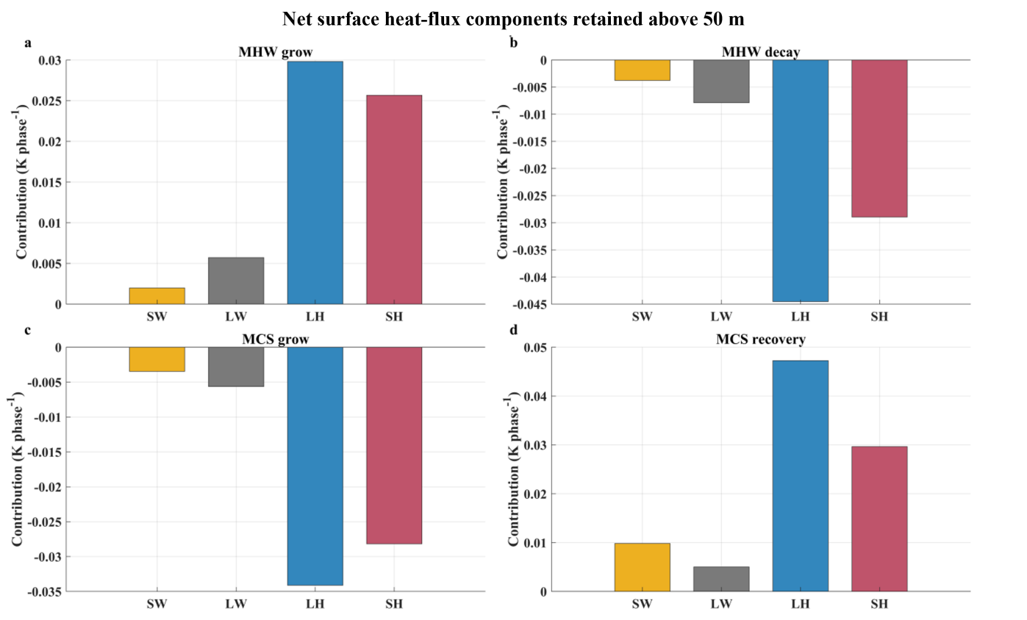
Supplementary Figure S1. Whole-domain $NHF$ component contributions for (a) MHW growth, (b) MHW decay, (c) MCS growth, and (d) MCS recovery. Downward heat flux is positive. Shortwave input is corrected for radiation transmitted below 50 m. Latent and sensible exchange provide most of the event-correlated $NHF$ signal.

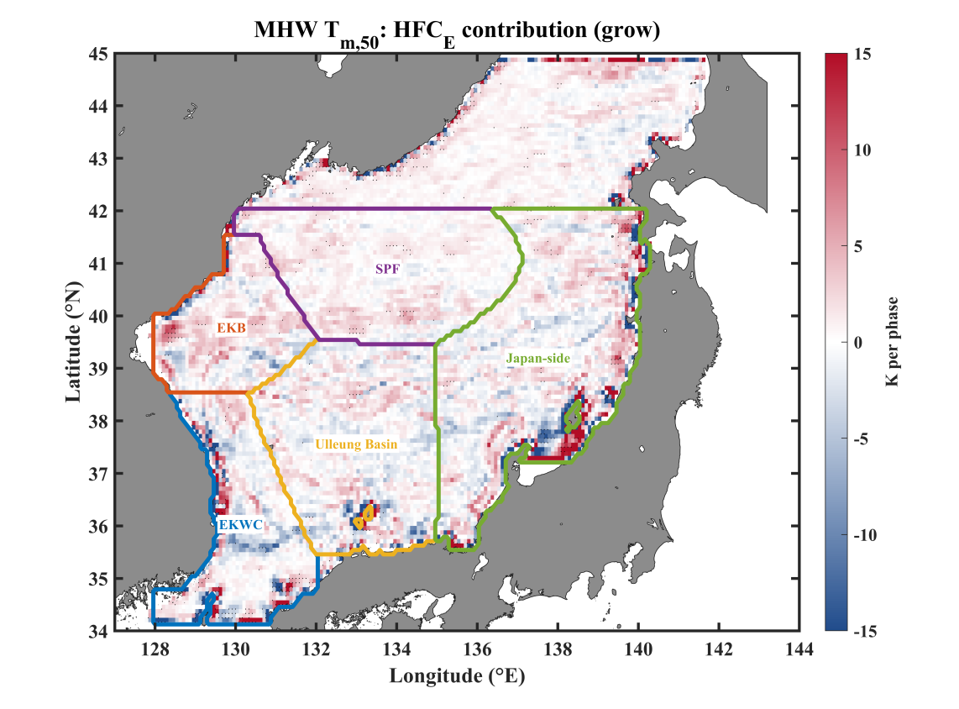
Supplementary Figure S2. Gridded ${HFC}_{E}$ contribution to $T_{m,50}$ MHW growth (K per event phase). Regional boundaries are shown for orientation. The common color range for Supplementary Figs. S2–S5 is -15 to +15 K; 2.91% of finite S2 cells outside this range are saturated, while the underlying values are unchanged.

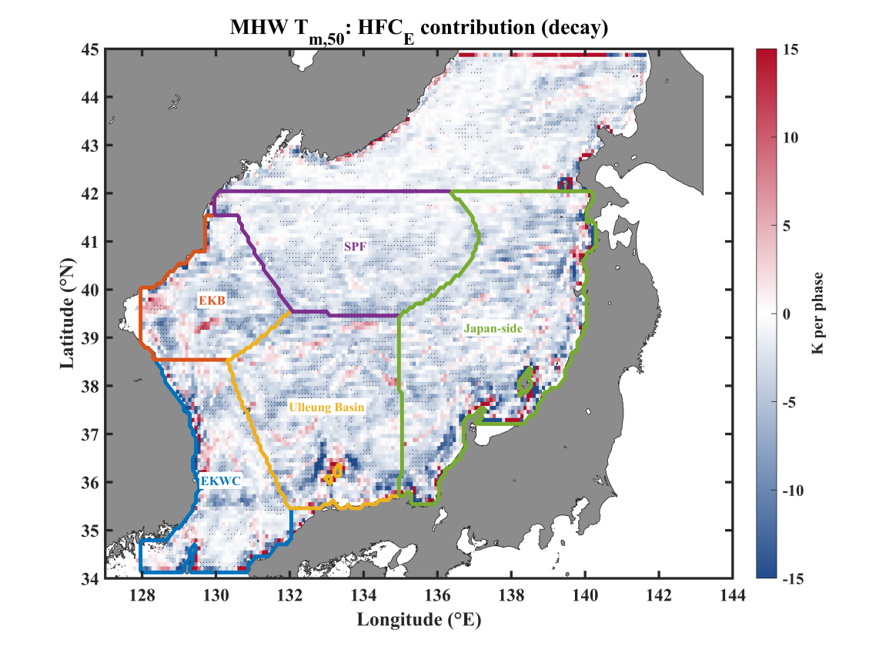
Supplementary Figure S3. Gridded ${HFC}_{E}$ contribution to $T_{m,50}$ MHW decay (K per event phase). Negative values denote mesoscale cooling. The common -15 to +15 K color range saturates 2.08% of finite cells.

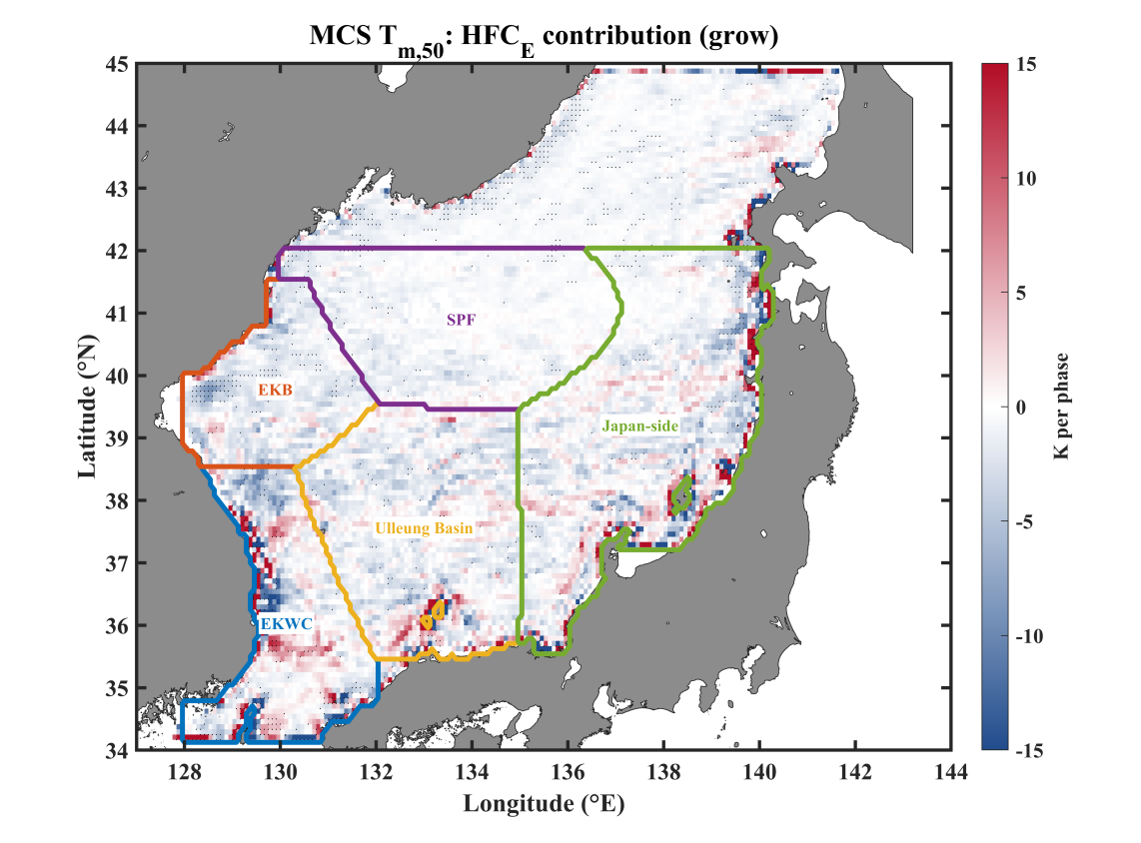
Supplementary Figure S4. Gridded ${HFC}_{E}$ contribution to $T_{m,50}$ MCS growth (K per event phase). Negative values enhance cold-event growth and positive values oppose it. The common -15 to +15 K color range saturates 2.28% of finite cells.

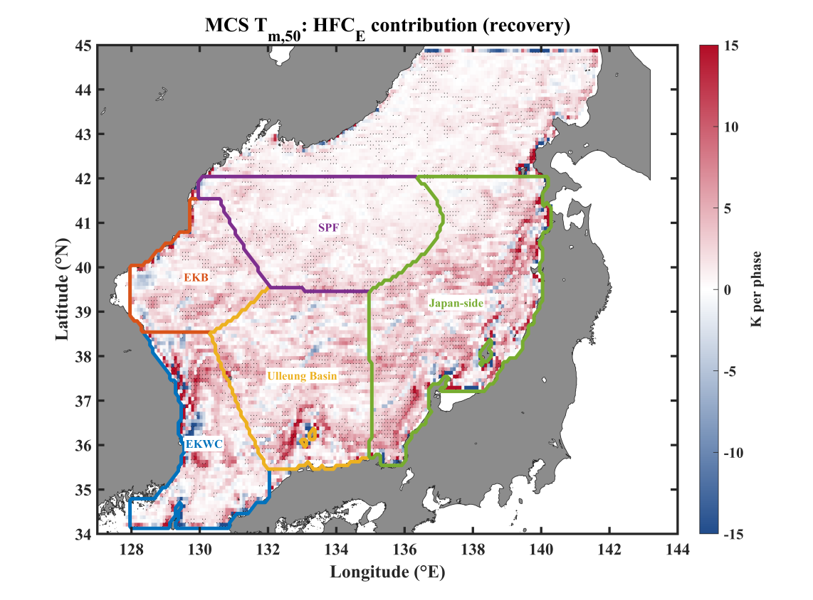
Supplementary Figure S5. Gridded ${HFC}_{E}$ contribution to $T_{m,50}$ MCS recovery (K per event phase). Positive values warm the upper layer toward climatological conditions. The common -15 to +15 K color range saturates 1.61% of finite cells.

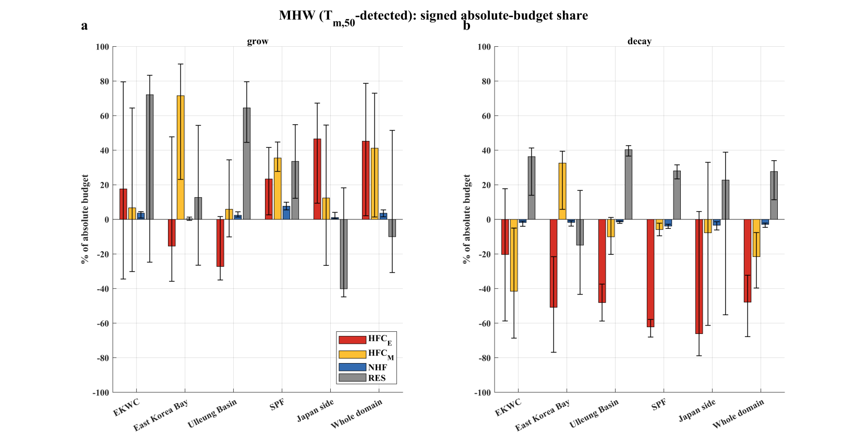
Supplementary Figure S6. Signed absolute-magnitude-normalized regional shares for $T_{m,50}$ MHW (a) growth and (b) decay. Each value is $100×C_{X}/\sum_{j}{\left|C_{j}\right|}$ and may therefore be negative; this diagnostic differs from the signed net-change ratios in the main text and is not compared directly with Bian et al [10].

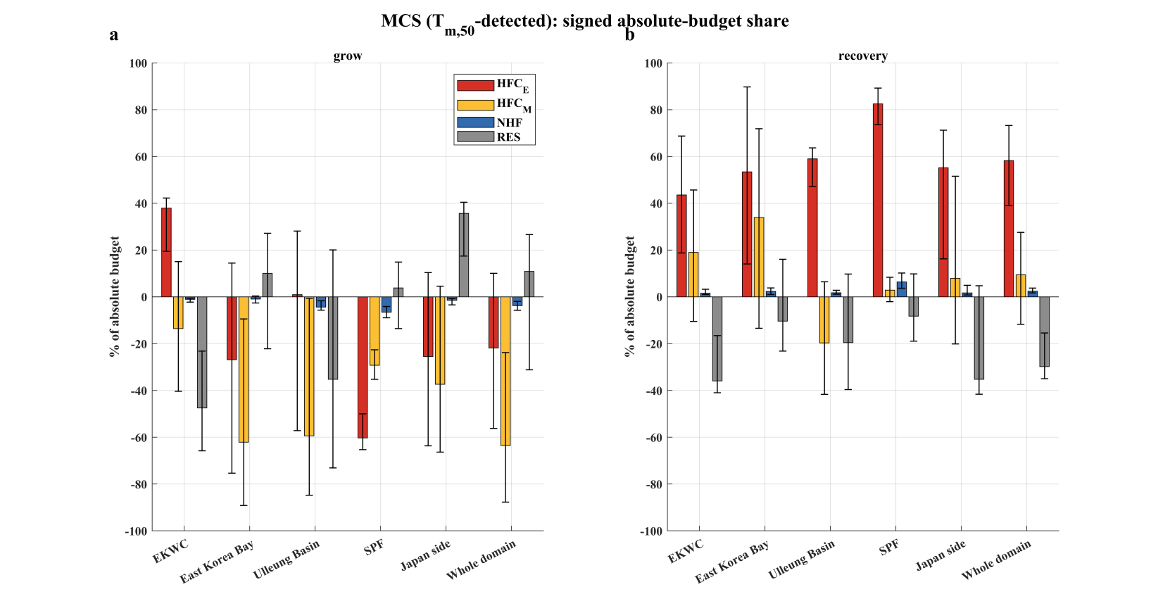
Supplementary Figure S7. As in Supplementary Fig. S6, but for $T_{m,50}$ MCS (a) growth and (b) recovery.

Supplementary Tables
Supplementary Table S1. Detrended event inventories. Grid-event counts are shown only to demonstrate the reduction obtained by independent space-time object linking.
Definition | Event | Grid events | Independent objects | Median duration (day) | Median cells
$$T_{m,50}$$ | MHW | 625508 | 4377 | 8 | 5
$$T_{m,50}$$ | MCS | 596721 | 4968 | 8 | 4
SST | MHW | 744287 | 4965 | 7 | 4
SST | MCS | 740285 | 5929 | 7 | 4

Supplementary Table S2. Complete regional ${HFC}_{E}$ results. The Whole-Domain row uses every independent object; the five dynamical regions are exclusive subsets assigned by object peak location.
Event | Region | Phase | N | $∆T_{anom}$(K) | ${HFC}_{E}$ (K) | % $∆T_{anom}$ | 95% CI | p-value
MHW | EKWC | grow | 922 | +1.273 | +0.224 | +17.6 | [-113.0, 165.1] | 0.810
MHW | EKWC | decay | 922 | -1.214 | -0.899 | +74.1 | [-71.9, 223.9] | 0.353
MHW | East Korea Bay | grow | 272 | +1.984 | -0.443 | -22.3 | [-126.4, 64.8] | 0.635
MHW | East Korea Bay | decay | 272 | -1.831 | -2.669 | +145.8 | [62.6, 245.7] | 0.001
MHW | Ulleung Basin | grow | 612 | +1.340 | -0.802 | -59.9 | [-120.0, 1.9] | 0.053
MHW | Ulleung Basin | decay | 612 | -1.334 | -3.319 | +248.8 | [178.4, 326.3] | <0.001
MHW | Subpolar Front | grow | 447 | +1.439 | +0.336 | +23.3 | [2.6, 41.6] | 0.023
MHW | Subpolar Front | decay | 447 | -1.281 | -1.816 | +141.8 | [123.9, 162.6] | <0.001
MHW | Japan Side | grow | 1072 | +1.274 | +2.993 | +234.8 | [22.0, 480.0] | 0.035
MHW | Japan Side | decay | 1072 | -1.207 | -1.464 | +121.3 | [-7.6, 242.7] | 0.066
MHW | Other East Sea | grow | 1052 | +1.543 | +0.509 | +33.0 | [-24.6, 86.2] | 0.246
MHW | Other East Sea | decay | 1051* | -1.385 | -0.192 | +13.8 | [-69.4, 95.7] | 0.736
MHW | Whole Domain | grow | 4377 | +1.409 | +0.797 | +56.6 | [2.1, 118.1] | 0.039
MHW | Whole Domain | decay | 4376* | -1.315 | -1.410 | +107.2 | [60.6, 151.3] | <0.001
MCS | EKWC | grow | 929 | -1.416 | +2.222 | -156.9 | [-272.7, -49.0] | 0.004
MCS | EKWC | recovery | 929 | +1.435 | +2.216 | +154.4 | [56.6, 252.6] | <0.001
MCS | East Korea Bay | grow | 383 | -2.231 | -0.751 | +33.7 | [-25.1, 86.3] | 0.251
MCS | East Korea Bay | recovery | 383 | +2.158 | +1.453 | +67.3 | [18.4, 120.3] | 0.006
MCS | Ulleung Basin | grow | 777 | -1.447 | +0.014 | -1.0 | [-64.1, 63.7] | 0.998
MCS | Ulleung Basin | recovery | 777 | +1.465 | +4.029 | +274.9 | [180.4, 366.9] | <0.001
MCS | Subpolar Front | grow | 421 | -1.342 | -0.877 | +65.3 | [50.1, 78.4] | <0.001
MCS | Subpolar Front | recovery | 421 | +1.380 | +1.364 | +98.8 | [76.0, 122.2] | <0.001
MCS | Japan Side | grow | 1406 | -1.433 | -1.278 | +89.2 | [-33.4, 242.9] | 0.180
MCS | Japan Side | recovery | 1406 | +1.474 | +2.751 | +186.6 | [28.7, 316.2] | 0.022
MCS | Other East Sea | grow | 1052 | -1.472 | -1.610 | +109.3 | [51.6, 171.8] | <0.001
MCS | Other East Sea | recovery | 1052 | +1.430 | +0.549 | +38.4 | [-17.4, 96.2] | 0.177
MCS | Whole Domain | grow | 4968 | -1.494 | -0.417 | +27.9 | [-14.0, 71.0] | 0.198
MCS | Whole Domain | recovery | 4968 | +1.501 | +2.167 | +144.4 | [96.1, 187.8] | <0.001
* one object excluded by the 90% valid-day criterion.

Supplementary References
1. Bian, C. et al. Oceanic mesoscale eddies as crucial drivers of global marine heatwaves. Nat. Commun. 14, 2970 (2023). https://doi.org/10.1038/s41467-023-38811-z.
2. Field, C. A. & Welsh, A. H. Bootstrapping clustered data. J. R. Stat. Soc. B 69, 369–390 (2007). https://doi.org/10.1111/j.1467-9868.2007.00593.x.
3. Benjamini, Y. & Hochberg, Y. Controlling the false discovery rate: a practical and powerful approach to multiple testing. J. R. Stat. Soc. B 57, 289–300 (1995). https://doi.org/10.1111/j.2517-6161.1995.tb02031.x

