Earth-abundant CZTS/MIL-125-NH₂ heterojunctions for enhanced visible-light Cr(VI) reduction: Interfacial charge dynamics and mechanistic insights

Supplementary Information

1. Structural Characterization
Fig S1 Raman spectra of MIL-125-NH₂ and CZTS nanoparticles. a) The CZTS spectrum shows the characteristic A₁ vibrational mode at ~336 cm⁻¹, confirming the kesterite phase and the absence of secondary phases [36]. b) The MIL-125-NH₂ spectrum displays the characteristic Ti–O framework vibrations (800, 825, 1250, 1414 cm⁻¹) and organic linker bands (1570, 1620 cm⁻¹) [37].

Fig S2 X-ray fluorescence (XRF) elemental analysis of MIL-125-NH₂/CZTS nanocomposites, showing the progressive increase in Cu, Zn, and Sn signals with increasing CZTS loading, confirming the successful incorporation of the kesterite nanoparticles.

Fig S3 SEM images of (a) MIL-125-NH₂ (hexagonal disk-like morphology), (b) CZTS nanoparticles, and (c–e) MIL-125-NH₂/CZTS nanocomposites with increasing CZTS content: c) 10%, d) 25% y e) 50%. The progressive change from disk-like to irregular/tetrahedral morphology suggests that CZTS nanoparticles decorate the external surface of the MOF crystals during growth.

2. Optical Properties – Band Gap Determination
Fig S4 Plot of $1/\sqrt{α_{exp}}$vs photon energy for the determination of the free carrier absorption contribution (α_{free} ) using a Drude-type model.

Fig S5 Deconvolution of the experimental absorbance into the contributions of free carrier absorption (α_{free}), CZTS absorption (α_{CZTS}), and MIL-125-NH₂ absorption (α_{MOF}), demonstrating the validity of the correction procedure. a) for NC5 and b) NC25 sample.

Fig S6 Band gap energy estimation using the first derivative of the diffuse reflectance spectra (dR/dλ), showing consistent values with those obtained from Tauc analysis.

3. Electronic Properties – Mott–Schottky Analysis
Fig S7 Mott–Schottky plot (1/C² vs applied potential) for a pristine CZTS film deposited on FTO/TiO₂, recorded at 1200 Hz in 0.2 M Na₂SO₄. The negative slope confirms the intrinsic p-type character of the kesterite semiconductor synthesized by the hot-injection method. The flat-band potential is indicated by the intercept with the potential axis.

Fig S8 Dependence of (a) carrier density (N_{D}) and (b) flat-band potential (V_{FB}) on CZTS loading, extracted from the Mott–Schottky analysis. The carrier density reaches a maximum for the NC25 composition, while the flat-band potential shifts monotonically toward positive values, indicating tunable electronic properties through controlled semiconductor incorporation.
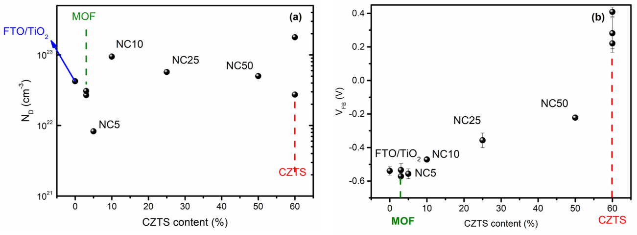

4. Photoelectrochemical Characterization
Figure S9. J–V curves for FTO//TiO₂//MOF//CZTS devices prepared with different numbers of MOF spin-coating deposition cycles (1(line), 2 (dash) 3 (dot)), used to optimize the film thickness.

Figure S10. Photocurrent density measured at 0 V vs Ag/AgCl for photoelectrodes based on individual semiconductors (MIL-125-NH₂ and CZTS), a layered MOF//CZTS structure, and the NC25 nanocomposite. The NC25 composite exhibits the highest photocurrent (73.3 µA cm⁻²), approximately 15 times higher than bare MOF and 2.5 times higher than the layered architecture, demonstrating the superior charge separation efficiency of the nanocomposite.

5. Photocatalytic Cr(VI) Reduction – Control Experiments

Figure S11. Control experiments for Cr(VI) reduction: in the dark (squares), without photocatalyst (circles) , and without TEA (triangles), confirming that no reduction occurs under these conditions.

6. Wavelength-dependent photocatalytic activity and Apparent Quantum Efficiency (AQE)
The wavelength-dependent photocatalytic activity of the NC25 nanocomposite was investigated between 333 and 568 nm. The apparent rate constants (k_{obs,λ}) were normalized by the incident photon flux (I_{0,λ}) to obtain the apparent quantum efficiency (Φ_{app,λ} = k_{obs,λ} / I_{0,λ}). The results are presented in Figure S13 and summarized in Table S1.

Table S1. Incident photon flux (I₀), observed rate constants (k_{obs,λ}), and apparent quantum efficiencies (Φ_{app}) for the NC25 nanocomposite at different irradiation wavelengths
λ (nm) | I₀ (photons s⁻¹) ª | k_{obs,λ} (s⁻¹) | Φ_{app}
333 | 6.39 × 10¹⁴ | 5.8 × 10⁻⁵ | 2.65 × 10⁻⁴
366 | 1.97 × 10¹⁵ | 8.12 × 10⁻⁵ | 1.21 × 10⁻⁴
405 | 3.45 × 10¹⁵ | 2.15 × 10⁻⁵ | 1.83 × 10⁻⁵
440 | 4.64 × 10¹⁵ | 5.8 × 10⁻⁻⁵ | 3.66 × 10⁻⁵
546 | 1.14 × 10¹⁶ | 3.4 × 10⁻⁵ | 8.70 × 10⁻⁶
568 | 7.41 × 10¹⁵ | 0.27 × 10⁻⁵ | 1.07 × 10⁻⁶
ª Calculated assuming a quartz cell volume of 3 cm³: I₀ (photons s⁻¹) = I₀ (M s⁻¹) × 0.003 L × 6.022 × 10²³ mol⁻¹.

Figure S12. Apparent quantum efficiency (Φ_{app}) for Cr(VI) photoreduction as a function of excitation wavelength for the NC25 nanocomposite. The maximum efficiency is observed at 333 nm (Φ_{app} ≈ 2.65 × 10⁻⁴), corresponding to dual excitation of both MIL-125-NH₂ and CZTS. A small shoulder is observed between 440 and 546 nm, where selective excitation of CZTS occurs. The wavelength-dependent behavior is consistent with the type-II heterojunction charge-transfer mechanism discussed in the main text. Error bars represent the standard deviation from three independent measurements.

