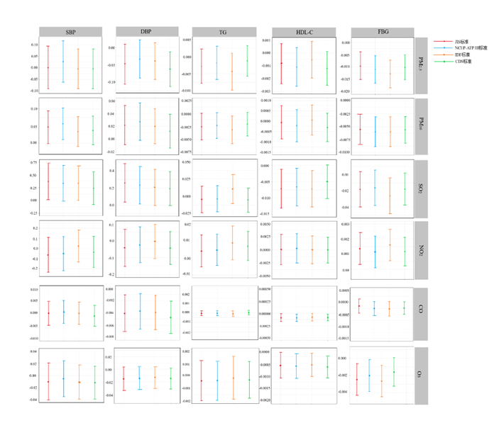
Figure S1 Sensitivity analysis of short-term exposure to air pollutants on biochemical indicators of MetS patients

