Single-Shot Phaseless Electromagnetic Source Imaging in EMC-Relevant Bands Using Frequency-Diverse Metamaterial Apertures
Hamidreza Karami^{1,*}, Farhad Rachidi², Karim Ashouri³

¹ School of Engineering and Management Vaud, HES-SO University of Applied Sciences and Arts Western, Switzerland;
² Ecole Polytechnique Fédérale de Lausanne (EPFL), Electromagnetic Compatibility Laboratory, CH-1015 Lausanne, Switzerland;
³ Institute of Electrical and Microengineering, École Polytechnique Fédérale de Lausanne, Laboratory for Advanced Electromagnetics and Photonics, Lausanne, Switzerland

*hamidreza.karami@heig-vd.ch

Corresponding author: Hamidreza Karami

Contents of this file
The supplementary information contains 8 figures and a subsection related to the influence of the number of excitation ports on frequency diversity.

1. Figures
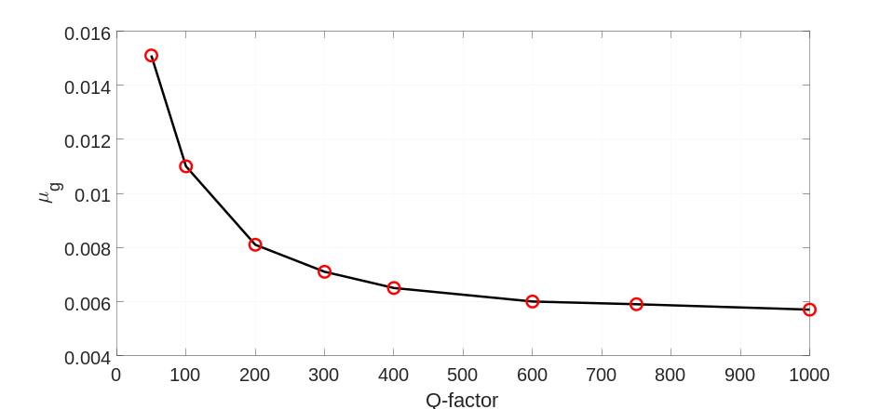
Fig. S1. Average mutual coherence (μg) versus Q-factor for the designed parallel-plate metaimager. Increasing Q-factor reduces μg, indicating lower measurement correlation and improved frequency diversity. Circles: simulated data points. Solid line: linear interpolation.

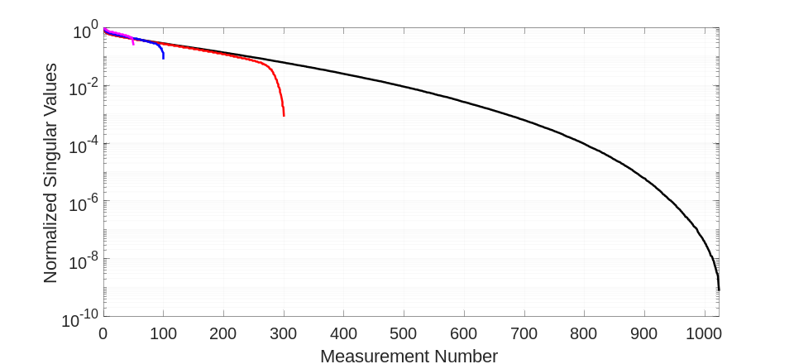
Fig. S2. Normalized singular values of the measurement matrix for different measurement frequencies in the range of 0.1–6 GHz. It can be observed that the measurement modes corresponding to the various frequency samples exhibit strong diversity, indicating that the sensing matrix possesses sufficient modal richness for effective source imaging. The relatively similar decay rates of the singular value spectra further indicate that the frequency-dependent measurement modes maintain comparable diversity across different numbers of measurement modes.

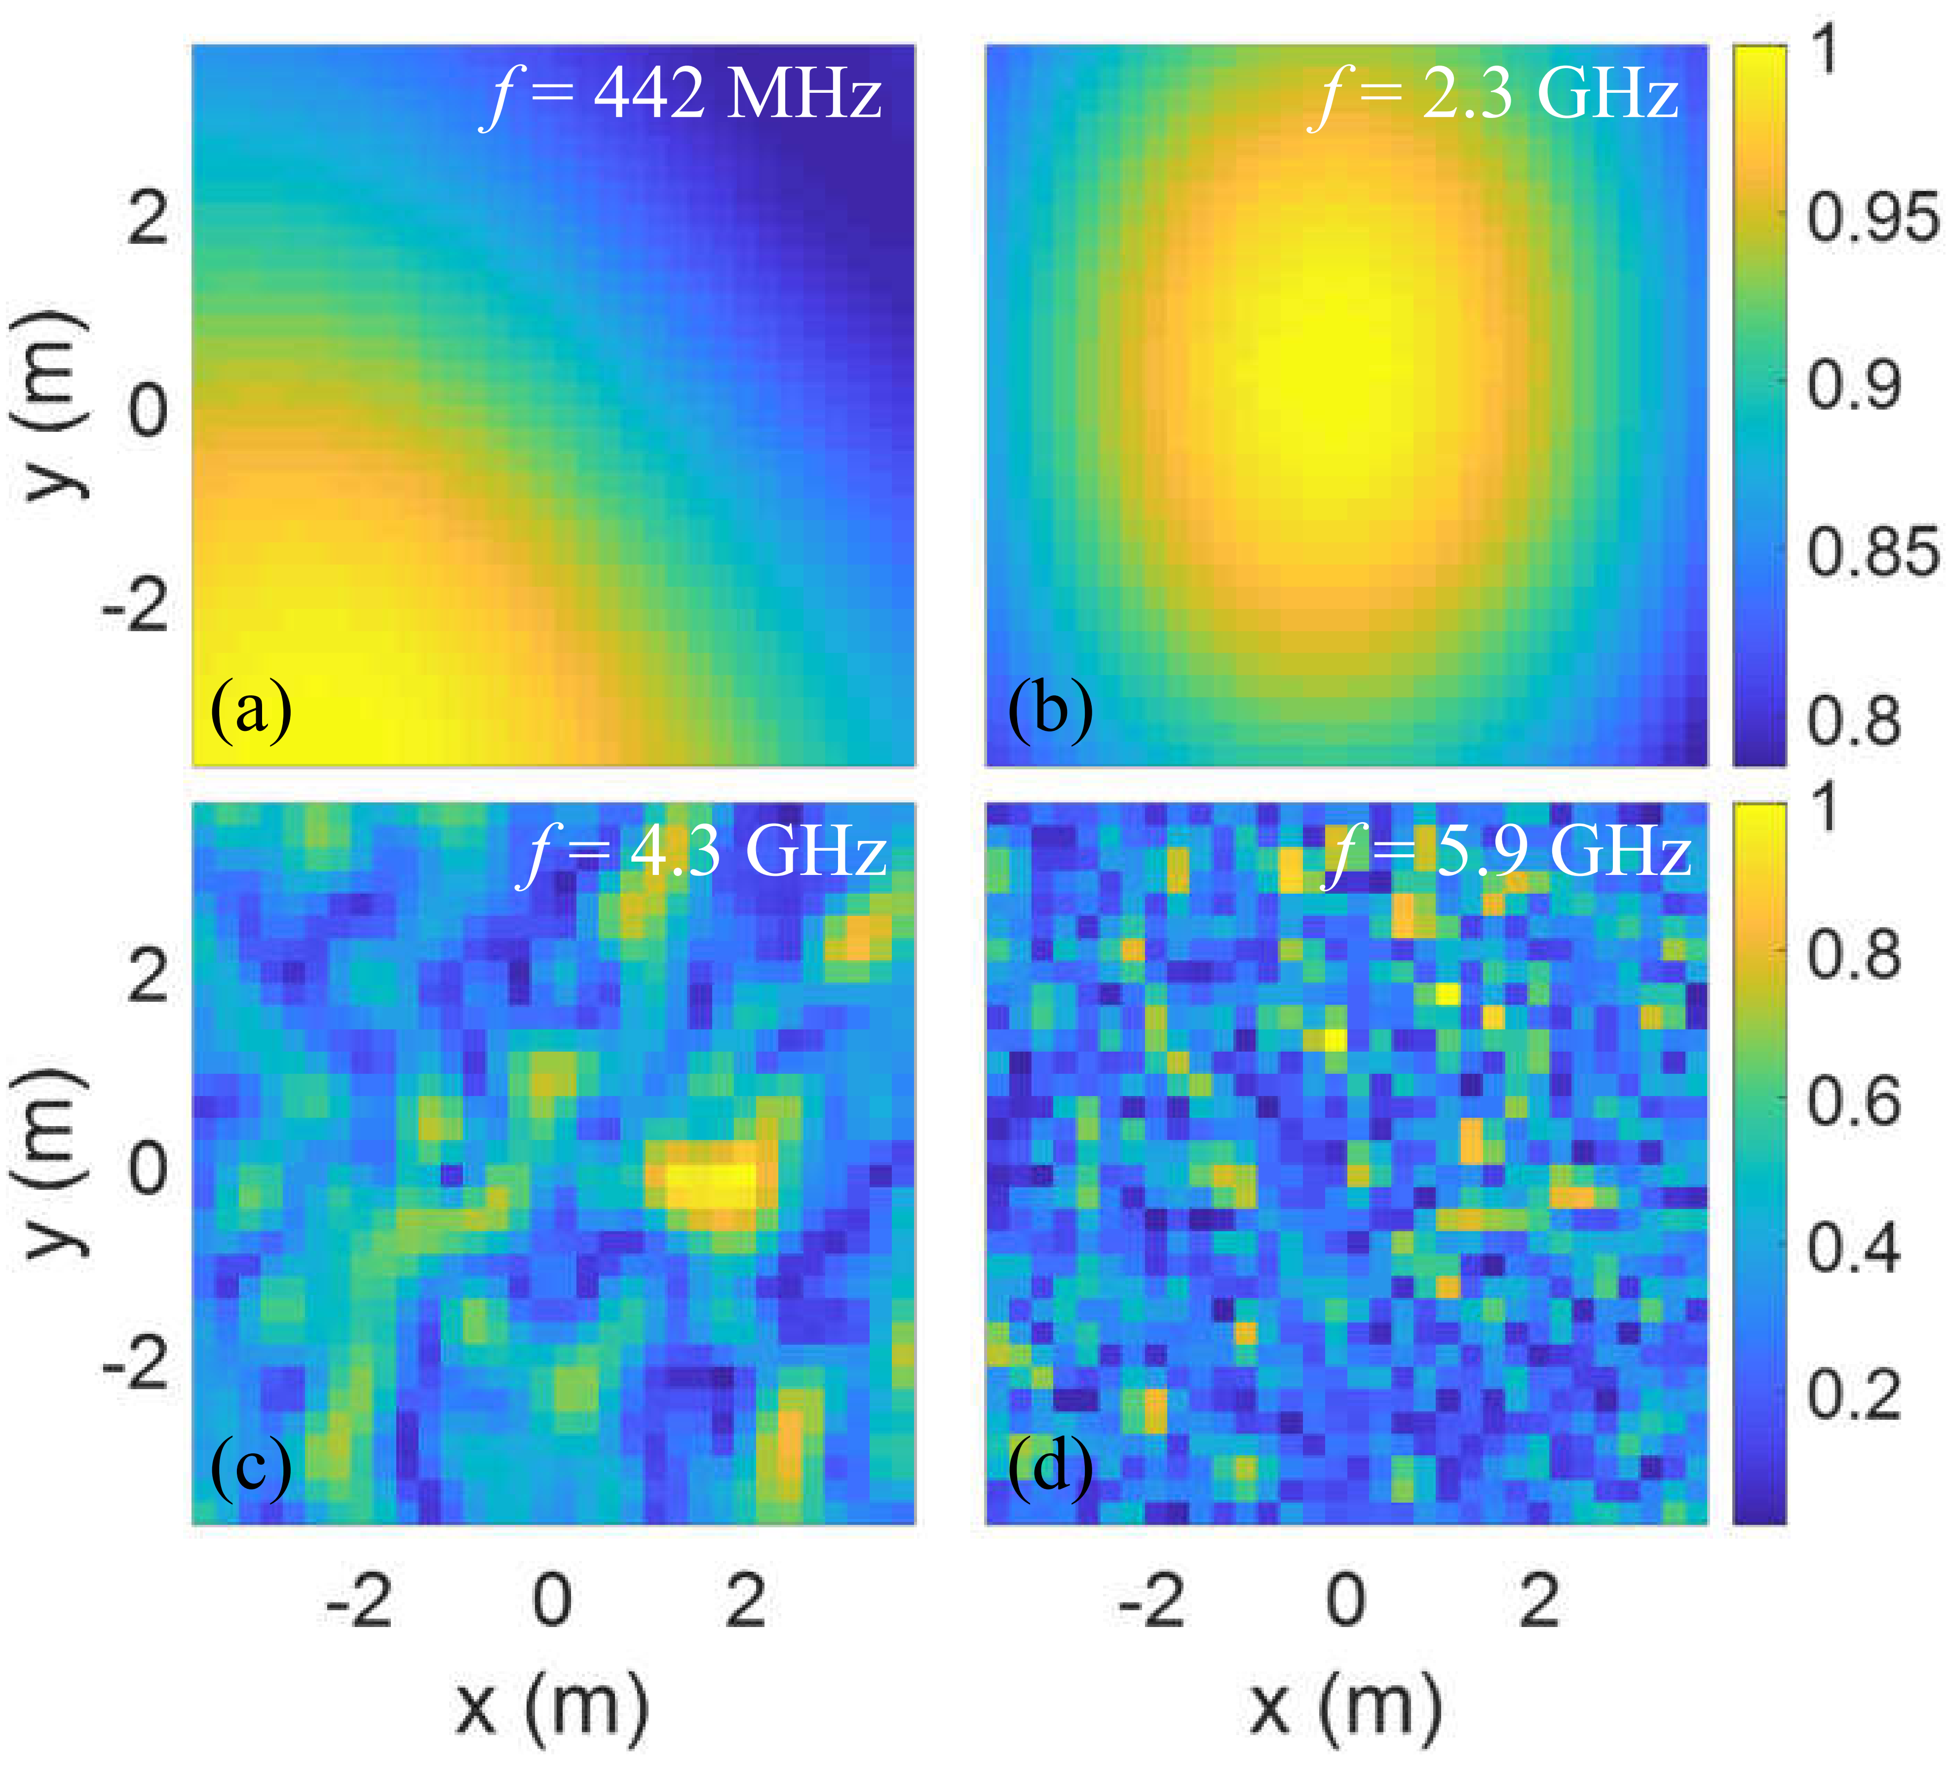
Fig. S3. Normalized magnitude of the electric-field distribution of the parallel-plate metaimager with complementary metamaterial apertures (Fig. 1), evaluated at different operating frequencies: (a) 𝑓=442 MHz, (b) 𝑓=2.3 GHz, (c) 𝑓=4.3 GHz, and (d) 𝑓=5.9 GHz.
At lower frequencies (442 MHz and 2.3 GHz), the field patterns exhibit limited variation, indicating a higher degree of correlation between the corresponding measurement modes. In contrast, at higher frequencies (4.3 GHz and 5.9 GHz), the radiation patterns differ more significantly, highlighting the increased diversity and uniqueness of the measurement modes enabled by frequency diversity.
The Q-factor of the metamaterial elements is 200. Additional design parameters and configuration details are provided in Section III.A.

Geometric dimensions and material parameters of the mode-mixing cavity shown in Fig.~3.
The mode-mixing cavity is designed to maximize field stochasticity through a combination of geometric asymmetry and non-uniform dielectric loading.

A. Cavity and Main Perturbation
The host structure is a rectangular Perfectly Electrical Conductor (PEC) cavity with the following specifications:
- External Dimensions (L_x, L_y, L_z): 650×650×180$ mm.
- Internal Filling: Rogers RO3010 ε_r = 11.2, tan$δ$=0.0022).
- Spherical Mixing Element: A metallic (PEC) sphere of radius R = 140 mm is subtracted from the cavity volume at corner (x, y, z) = (650, 650, 0) mm to break internal symmetries.

B. Dielectric Inclusions
Three dielectric blocks are embedded within the RO3010 filling to enhance frequency diversity. Their positions are defined relative to the cavity dimensions L_x, L_y, L_z:

Block | εr | Dimensions (w×h×d) [mm] | Center Coordinates (x,y,z) | Rotation
1 | 2.2 | 120 × 80 × 60 | (0.35L_x, 0.25L_y, 0.40L_z) | (15$°$)
2 | 6.0 | 100 × 100 × 80 | (0.60L_x, 0.55L_y, 0.30L_z) | (37$°$)
3 | 6.0 | 160 × 70 × 50 | (0.25L_x, 0.65L_y, 0.55L_z) | (62$°$)

C. Aperture Layer and Excitation
Radiating Face: The front PEC wall (z = L_z) is perforated with circular apertures.
Aperture Geometry: Diameter = $6$ mm.
Distribution: Randomized quasi-uniform distribution with an average center-to-center spacing of 20 mm.
Excitation Port: A single 50 $Ω$ coaxial probe.
Position: (0.15L_x, 0.15L_y, 0.5L_z) through the side wall.
Frequency Range: 0.1 GHz to 6 GHz.

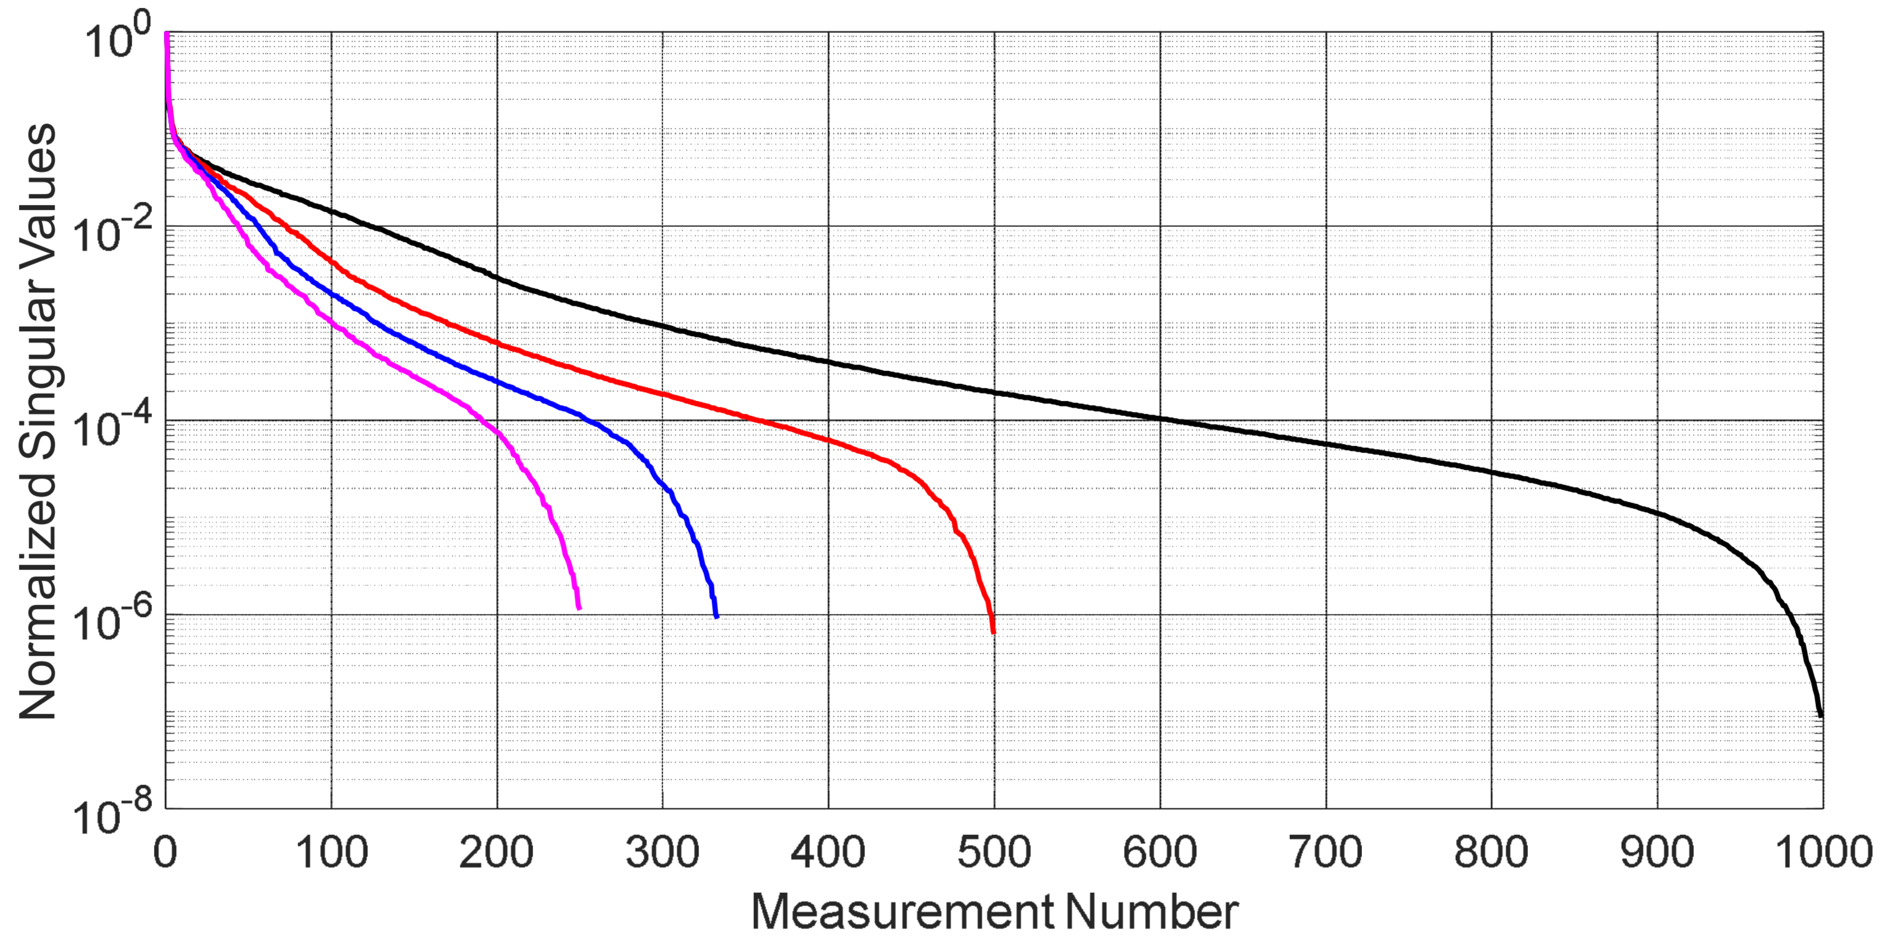
Fig. S4. Normalized singular values of the measurement matrix corresponding to different measurement frequencies uniformly distributed over the 1–6 GHz range. It can be observed that the measurement modes associated with the various frequency samples exhibit strong diversity, indicating that the sensing matrix possesses sufficient modal richness to enable effective source imaging. The slower decay of the singular-value spectrum for the higher measurement mode (1024, black line) indicates enhanced diversity of the frequency-dependent measurement modes compared to the lower measurement number (250, magenta line).
It should be noted that increasing the number of frequency samples enhances modal diversity and reduces mutual coherence of the sensing matrix. This improves conditioning and stabilizes the inverse problem, leading to improve reconstruction performance.

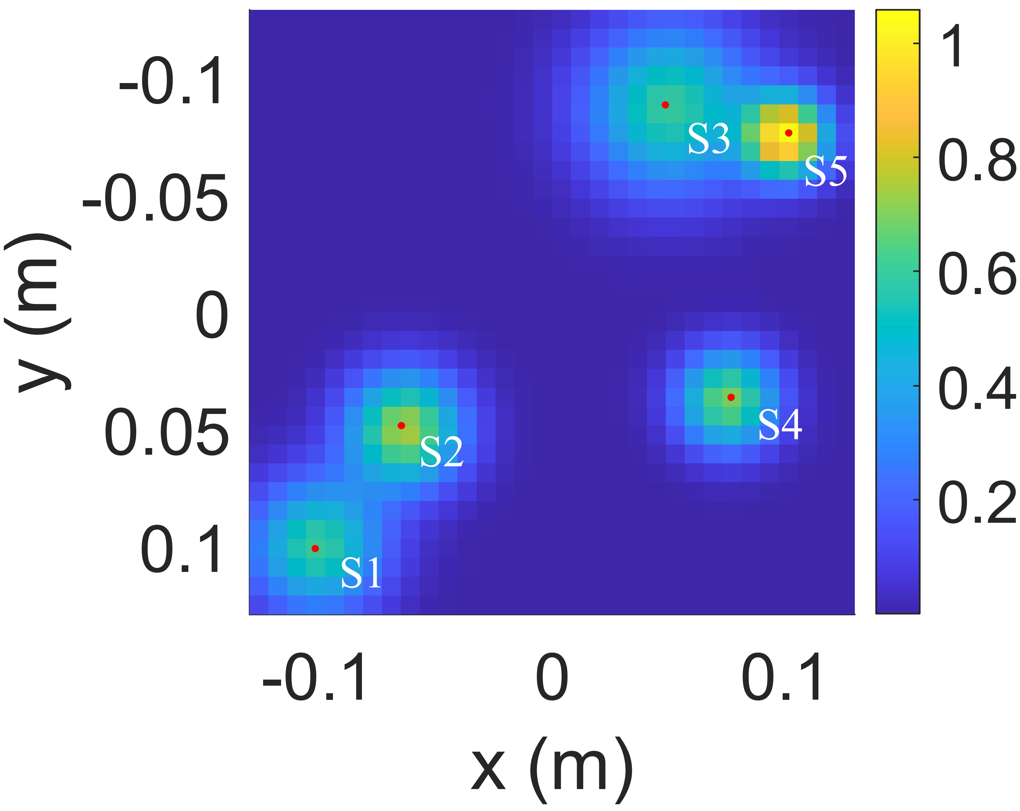
Fig. S5. Original overlapped Gaussian source distribution composed of five discrete Gaussian sources. The source locations are S₁: [−0.1, 0.1], S₂: [−0.0625, 0.05], S₃: [0.05, −0.087], S₄: [0.075, 0.0375], and S₅: [0.1, −0.075]. The corresponding standard deviations (σ) are 0.02, 0.0175, 0.025, 0.015, and 0.0125, respectively, with amplitudes of 0.6, 0.75, 0.6, 0.7, and 1.0.

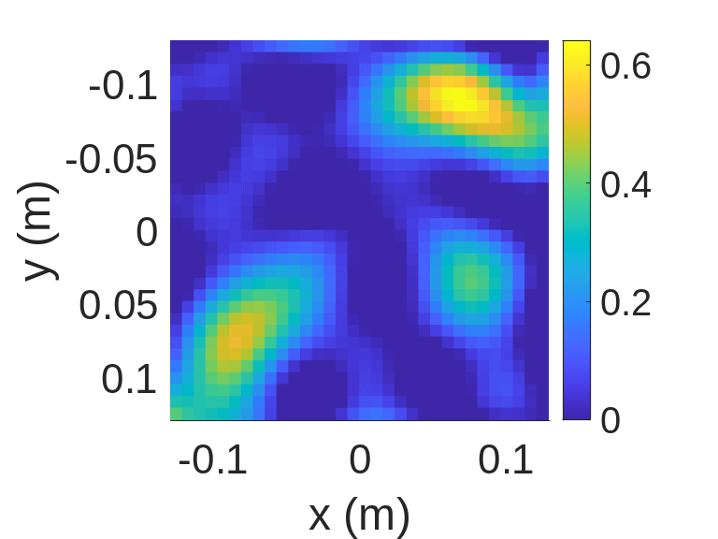
Fig. S6. Reconstruction performance of the proposed source imaging method for the discrete Gaussian PCB model at 15 dB SNR.

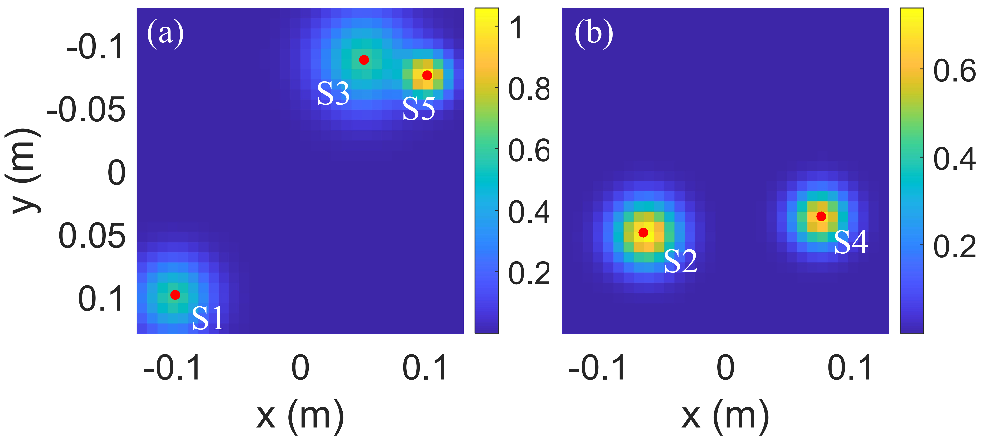
Fig. S7. Original overlapped Gaussian complex source distribution composed of five discrete Gaussian sources. The source locations are S₁: [−0.1, 0.1], S₂: [−0.0625, 0.05], S₃: [0.05, −0.087], S₄: [0.075, 0.0375], and S₅: [0.1, −0.075]. The corresponding standard deviations (σ) are 0.02, 0.0175, 0.025, 0.015, and 0.0125, respectively, with amplitudes of 0.6, 0.75j, 0.6, 0.7j, and 1.0.

2. Influence of the Number of Excitation Ports on Frequency Diversity
The frequency diversity of the parallel-plate metaimager is determined not only by the frequency-dependent response of the complementary metamaterial elements but also by the modal content excited within the parallel-plate waveguide. Because each feed port couples differently to the guided-wave spectrum supported by the structure, the number and arrangement of excitation ports influence the resulting spatial field patterns and, consequently, the diversity of the measurement modes.
To quantify this effect, the frequency diversity of the aperture was evaluated for different numbers of simultaneously active excitation ports. For each configuration, the sensing matrix was constructed over the operating bandwidth and characterized using the average mutual coherence. Increasing the number of ports introduces additional modal combinations that enrich the frequency-dependent aperture response and increase the number of effectively independent measurement modes.
Figure S4 shows the average mutual coherence of the sensing matrix for different numbers of excitation feeds. A clear reduction in $μ_{g}$ is observed as additional feeds are introduced, demonstrating that multi-feed excitation enhances the frequency diversity of the metaimager by generating a larger set of independent measurement modes. However, beyond a certain number of ports, the improvement becomes progressively smaller because many of the excited modes are already represented within the available modal space of the aperture. Consequently, the achievable frequency diversity exhibits a saturation behavior analogous to the Q-factor dependence discussed in the main text.
These observations confirm that the effective measurement diversity of the proposed metaimager is governed jointly by the resonant characteristics of the metamaterial elements and by the modal excitation strategy. Employing multiple excitation ports therefore provides an additional degree of freedom for enhancing sensing performance and improving the robustness of electromagnetic source reconstruction.

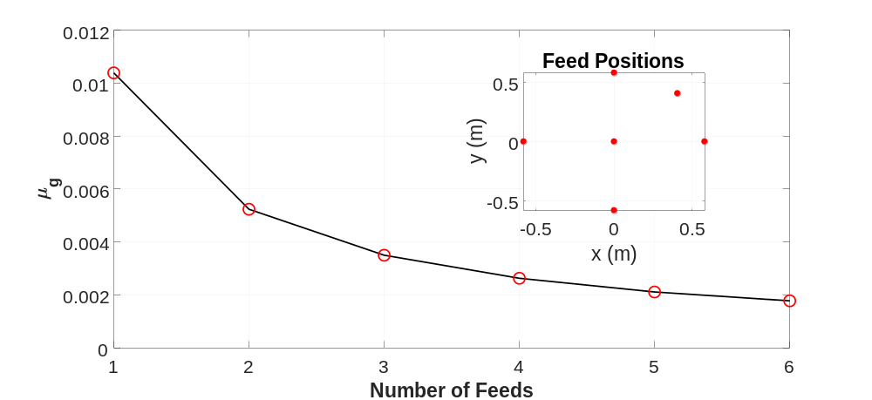
Fig. S8. Average mutual coherence ($μ_{g}$) of the parallel-plate metaimager versus the number of excitation feeds. The inset illustrates the locations of the six sources considered in the analysis. Overall, increasing the number of feeds leads to lower values of $μ_{g}$, indicating reduced inter-measurement correlation and improved frequency diversity. This behavior is attributed to the excitation of additional guided-wave modes and the resulting increase in the variety of frequency-dependent aperture field patterns.

