Assessment of the significance of urban vegetation in air phytoremediation: Quantitative analysis of particulate matter removal
Sombir Pannu¹, Rakesh Maity², Mayank Kumar², Vikram Singh^{1*}
¹Department of Chemical Engineering, Indian Institute of Technology Delhi, Hauz Khas, Delhi, 110016, New Delhi, India
²Department of Mechanical Engineering, Indian Institute of Technology Delhi, Hauz Khas, Delhi, 110016, New Delhi, India

List of supporting material
Section S1: PM mass quantification
Section S2: Wet and Dry removal

Figure S1: Monthly spatial distribution of PM₂.₅ emissions across the National Capital Territory (NCT) of Delhi during 2018. The image displays the gridded monthly PM₂.₅ emission flux (g m⁻² s⁻¹) from January to December 2018, highlighting the seasonal fluctuations in emission intensity across Delhi. Emissions peak near primary transportation routes and densely populated urban areas, while much lower emission intensities are noted in peripheral and less urbanised locations. A distinct seasonal pattern is evident, with significantly higher emissions during the post-monsoon and winter months (October–January), attributable to intensified residential heating, biomass burning, and vehicular emissions. Conversely, reduced emission fluxes are observed during the monsoon season (July–September), as precipitation, enhanced atmospheric mixing, and wet scavenging mitigate atmospheric particle concentration.

Figure S2: PM removal by the five selected plant species under wet and dry removal phenomenon conditions. Annual PM removal is partitioned into wet (precipitation occurred between successive sampling events) and dry (no precipitation between sampling events) removal scenarios for total PM (0.2-100 μm) and its three size fractions: large (11-100 μm), coarse (2.5-11 μm), and fine (0.2-2.5 μm). Bars represent the cumulative PM mass removed by Wedelia, Ailanthus altissima, Plumeria alba, Saraca asoca, and Cassia fistula during the study period.

Figure S3: Representative leaf morphology of the five selected plant species used for (PM) deposition measurements. The figure illustrates the variation in leaf size, shape, margin characteristics, and surface morphology among the studied species: (a) Cassia fistula, (b) Ailanthus altissima, (c) Saraca asoca, (d) Wedelia sp., and (e) Plumeria alba. These species were selected to represent a wide range of leaf morphologies that influence aerodynamic interactions, particle interception, and PM retention. Differences in leaf area, lamina shape, margin structure, and surface texture are expected to contribute to species-specific variation in the capture and accumulation of atmospheric particulate matter. Scale bars represent 2 cm.
Figure S4. Scanning electron micrographs (SEM) showing particulate matter deposition on the leaf surfaces of the five investigated plant species after ambient exposure. Representative micrographs illustrate differences in leaf surface morphology and particle retention among (a) Plumeria alba, (b) Saraca asoca, (c) Ailanthus altissima, (d) Cassia fistula, and (e) Sphagneticola trilobata (syn. Wedelia trilobata). Dust particles of varying sizes are visibly retained on the leaf surfaces.

Figure S5. Scanning electron micrographs (SEM) of cleaned leaf surfaces showing the inherent microstructural characteristics of the five investigated plant species after cleaning of surface-deposited PM. Representative images correspond to (i) Plumeria alba, (ii) Saraca asoca, (iii) Ailanthus altissima, (iv) Cassia fistula, and (v) Sphagneticola trilobata (syn. Wedelia trilobata).
Figure S6: Assessment of the spatial reproducibility of PM deposition on Saraca asoca leaves under different sampling strategies (Box[Right], Data[left]). The figure compares the deposited PM mass fractions (Total, 11-100 μm, 2.5-11 μm, and 0.2-2.5 μm) obtained from three independent sampling approaches: (left) leaves collected from all directions around a single tree, (centre) leaves collected from five consecutive Saraca asoca trees at the same location, and (right) leaves collected from five randomly distributed Saraca asoca trees across the IIT Delhi campus. Boxplots represent the distribution of deposited PM for each particle-size fraction, with individual points indicating biological replicates. Comparable PM deposition across the three sampling strategies demonstrates the reproducibility of the leaf-sampling methodology and indicates that variation due to sampling direction, adjacent trees, and campus location was relatively small.

Table S1: Mass fraction obtained from the dust/PM removed from plant leaves (XRF).
Table S2: Mass fraction of the source profile obtained from Xact instrument.
Table S3: PM2.5 concentrations (µg/m3) 2022-2023 obtained from all CPCB stations.
Table S4: Table S5: PM10 concentrations (µg/m³) 2022-2023 obtained from all CPCB stations.
Table S5: Deposition velocity (V_{d}) estimated through various methods

S1: PM mass quantification:
The deposition of particulate matter (PM) on plant leaves was measured gravimetrically using pre-conditioned filter sheets. Before weighing, the filter papers were acclimated under controlled climatic conditions to minimise mass fluctuations associated with changes in moisture levels. The original mass of each filter was documented before particle collection, and the final mass was assessed after sampling and reconditioning. The PM mass was determined by subtracting the starting filter mass from the final filter mass and normalising the difference to the tested leaf surface area used for deposition (cm²), yielding the PM concentration per unit area (equation S1).
$Mass deposition on filter paper\left(\frac{µg}{cm^{2}}\right)=\frac{\left(Initial mass-Final mass\right)µg}{leaf area\left(cm^{2}\right)}$ S1
For instance, wedelia sampling (assuming 20% of the green area for each species):
Obtained mass deposition on leaves:
On 27th May 2022 deposition was (11-100 µm): 261.99 µg/cm²
On 31th May 2022 deposition was(11-100 µm): 71.42 µg/cm²
$PM removed\left(tons\right)=Mass deposition on filter paper\left(\frac{µg}{cm^{2}}\right)*species fraction*LAI* green area \left(km^{2}\right)$ S2
The calculated area-normalised deposition was then projected to the city level by integrating the leaf area index (LAI) with relevant urban green spaces, thereby yielding an estimate of the total PM mass associated with vegetative surfaces across the city (equation S2).
LAI = 0.1 (May month)
City green area = 342 km²
Using equation S1 and S2:
$$Unit area mass deposition obtained= 261.99\frac{µg}{cm^{2}}- 71.42\frac{µg}{cm^{2}}$$
$=190.57\frac{µg}{cm^{2}}$
$$City wide mass removal=190.57\frac{µg}{cm^{2}}*species fraction*LAI*city green area$$
$=190.57\frac{µg}{cm^{2}}*0.2*0.1*342 km^{2}$
$=13.05 tons$

S2: Wet and Dry removal:
To estimate PM removal, distinct correction factors were used for wet and dry conditions to address variations in particle retention and resuspension. In wet removal, a correction factor of 1.0 was used, which implies that deposited particles were efficiently eliminated from the environment by precipitation and associated wash-off processes. Therefore, the whole removed PM percentage was concluded to be part of atmospheric removal. Conversely, under dry removal, a correction factor of 0.5 was used to compensate for the possible resuspension of particles settled on leaf surfaces. This methodology aligns with the premise used in the deposition-velocity technique, whereby just 50% of the initially deposited PM is considered to be effectively removed under dry conditions.
Accordingly, PM removal estimated as:
$${PM removed}_{wet}=PM reduction on leaves after precipitation$$
$${PM removed}_{dry}=PM reduction on leaves*0.5$$
Under dry conditions, a correction coefficient of 0.5 was used to account for possible particle resuspension. This assumption acknowledges that accumulated PM may not be permanently removed to ground, since a portion of the deposited particles may be re-suspended into the atmosphere by wind or other disruptions. Consequently, 50% of the deposited PM was considered to represent effective atmospheric removal, while the remaining fraction was assumed to be susceptible to resuspension.

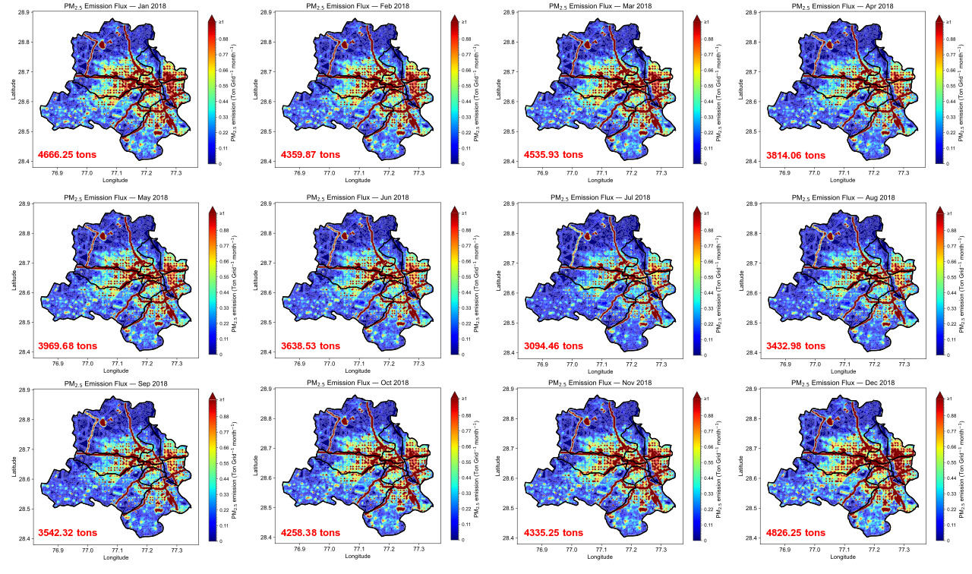
Figure S1: Monthly spatial distribution of PM₂.₅ emissions across the National Capital Territory (NCT) of Delhi during 2018. The image displays the gridded monthly PM₂.₅ emission flux (g m⁻² s⁻¹) from January to December 2018, highlighting the seasonal fluctuations in emission intensity across Delhi. Emissions peak near primary transportation routes and densely populated urban areas, while much lower emission intensities are noted in peripheral and less urbanised locations. A distinct seasonal pattern is evident, with significantly higher emissions during the post-monsoon and winter months (October–January), attributable to intensified residential heating, biomass burning, and vehicular emissions. Conversely, reduced emission fluxes are observed during the monsoon season (July–September), as precipitation, enhanced atmospheric mixing, and wet scavenging mitigate atmospheric particle concentration.
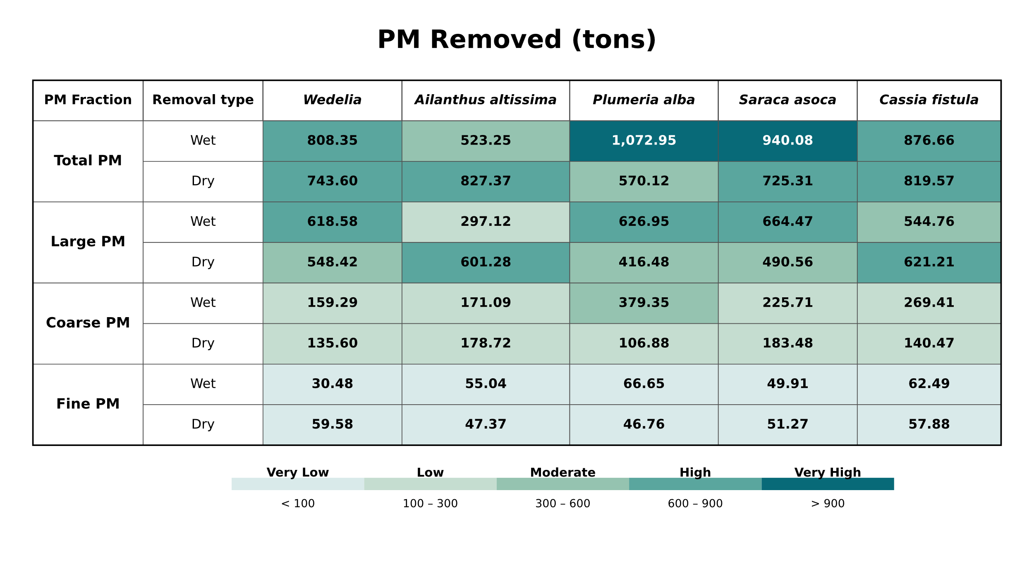
Figure S2: PM removal by the five selected plant species under wet and dry removal phenomenon conditions. Annual PM removal is partitioned into wet (precipitation occurred between successive sampling events) and dry (no precipitation between sampling events) removal scenarios for total PM (0.2-100 μm) and its three size fractions: large (11-100 μm), coarse (2.5-11 μm), and fine (0.2-2.5 μm). Numbers represent the cumulative PM mass removed (tons) by Wedelia, Ailanthus altissima, Plumeria alba, Saraca asoca, and Cassia fistula during the study period.
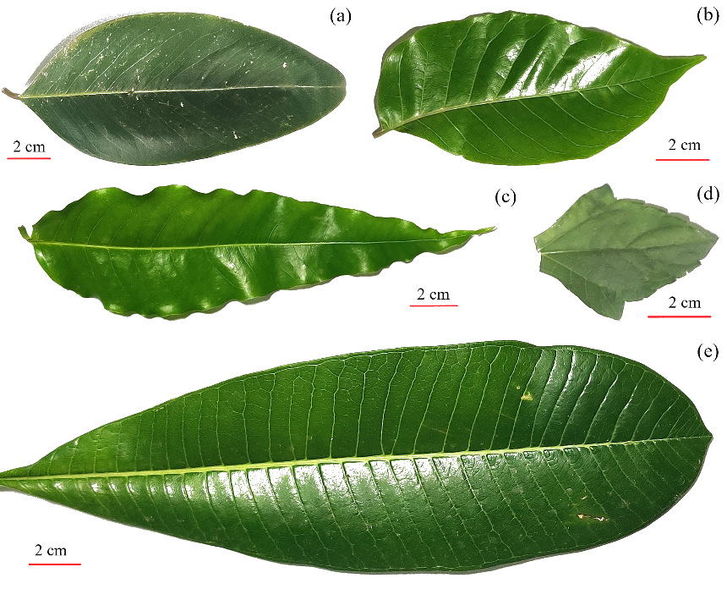

Figure S3: Representative leaf morphology of the five selected plant species used for (PM) deposition measurements. The figure illustrates the variation in leaf size, shape, margin characteristics, and surface morphology among the studied species: (a) Cassia fistula, (b) Ailanthus altissima, (c) Saraca asoca, (d) Wedelia sp., and (e) Plumeria alba. These species were selected to represent a wide range of leaf morphologies that influence aerodynamic interactions, particle interception, and PM retention. Differences in leaf area, lamina shape, margin structure, and surface texture are expected to contribute to species-specific variation in the capture and accumulation of atmospheric particulate matter. Scale bars represent 2 cm.

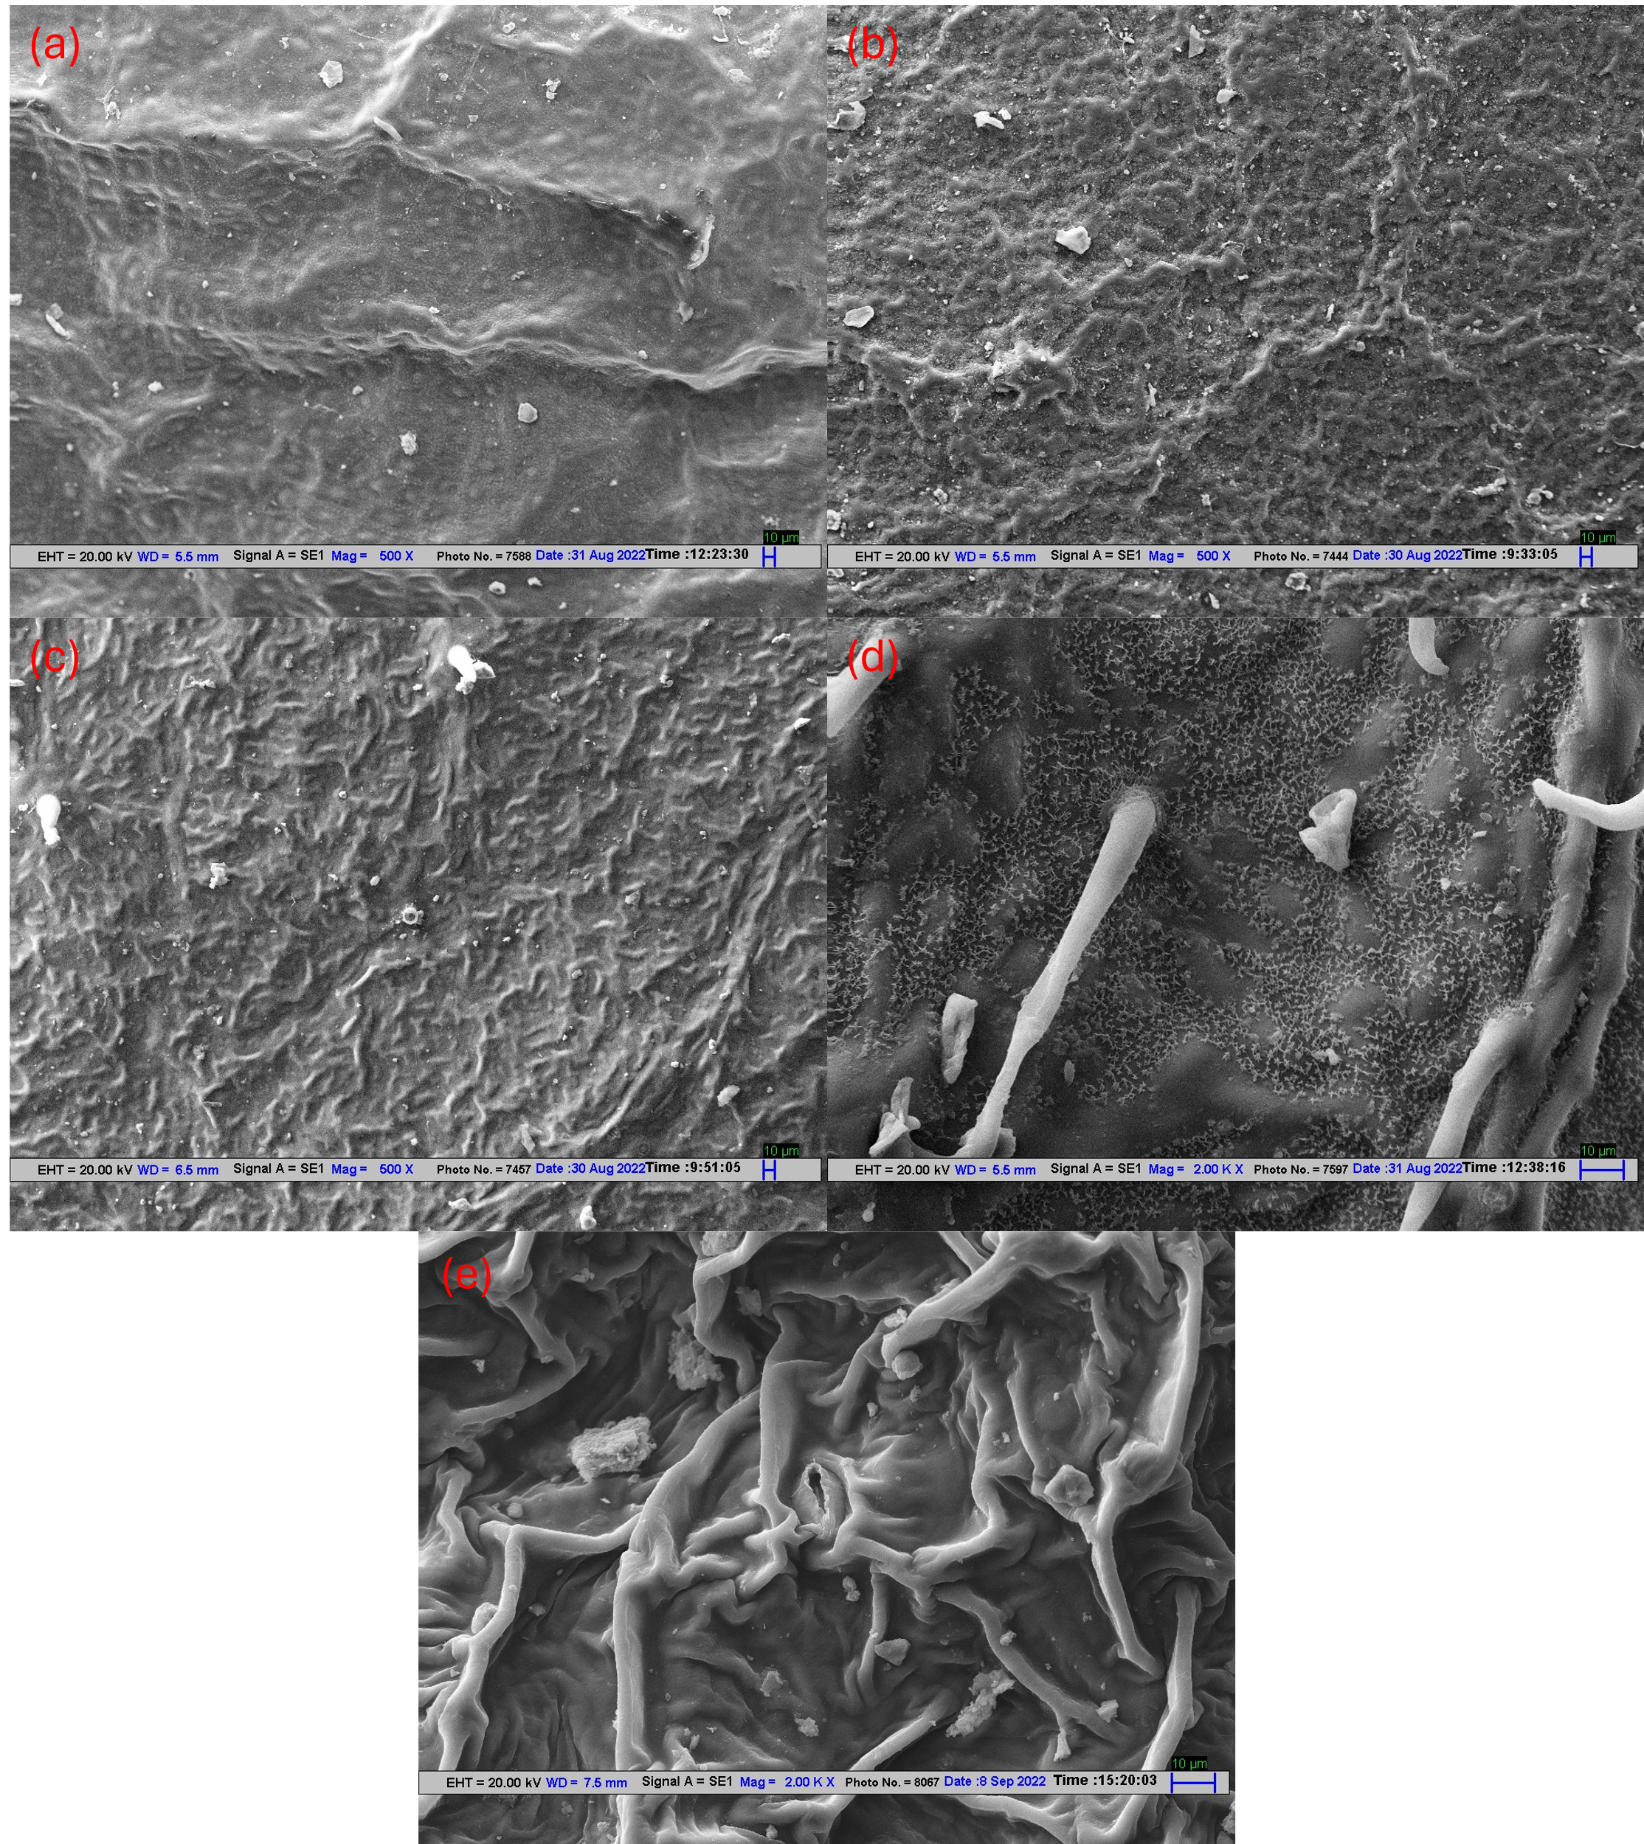Figure S4. Scanning electron micrographs (SEM) showing particulate matter deposition on the leaf surfaces of the five investigated plant species after ambient exposure. Representative micrographs illustrate differences in leaf surface morphology and particle retention among (a) Plumeria alba, (b) Saraca asoca, (c) Ailanthus altissima, (d) Cassia fistula, and (e) Sphagneticola trilobata (syn. Wedelia trilobata). Dust particles of varying sizes are visibly retained on the leaf surfaces. Some deposited dust particles are highlighted in images for visual identification. Red circles are deposited PM obtained on the leaf surfaces.

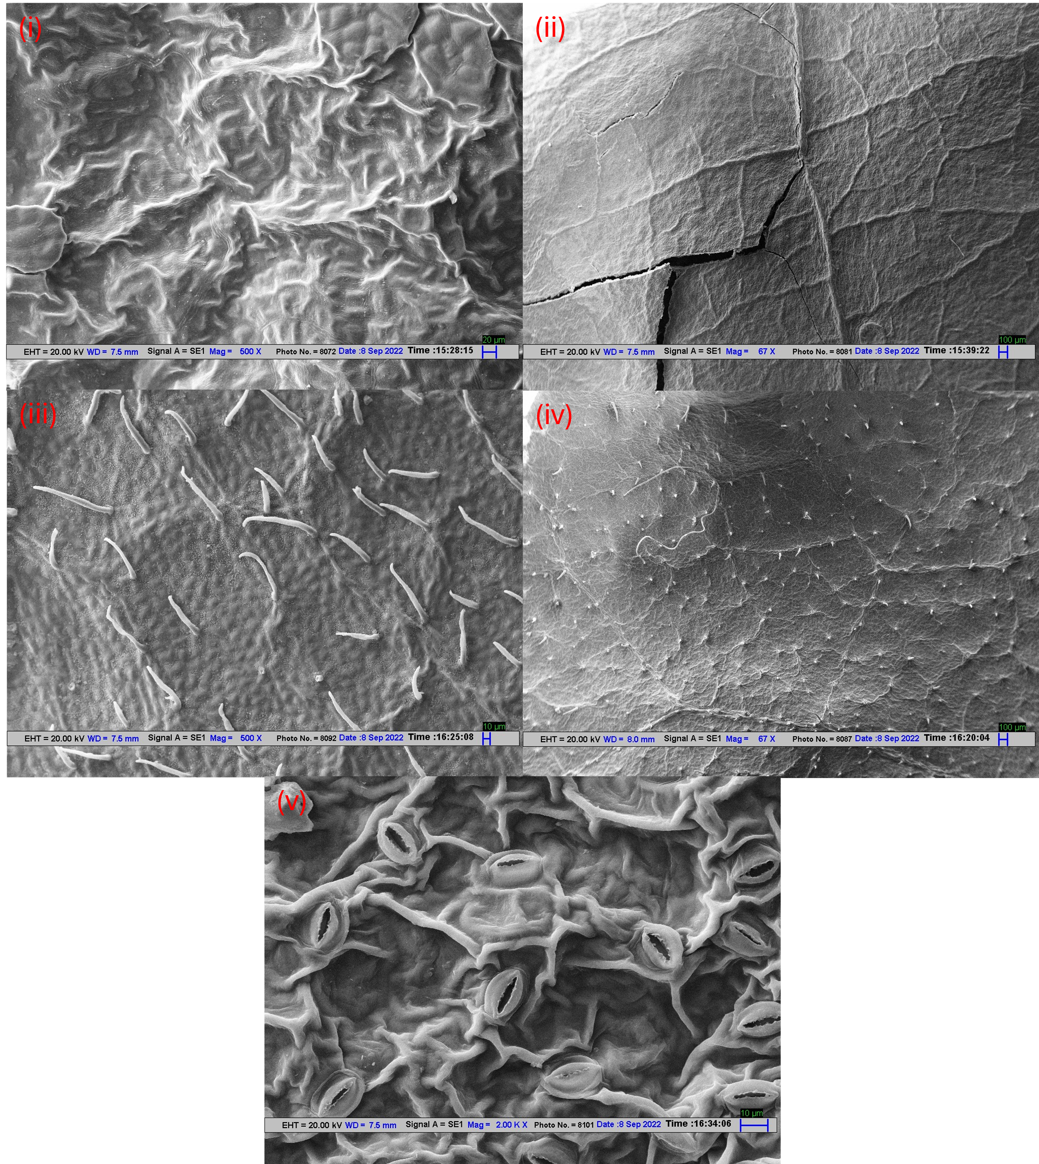Figure S5. SEM of cleaned leaf surfaces showing the inherent microstructural characteristics of the five investigated plant species after cleaning of surface-deposited PM. Representative images correspond to (i) Plumeria alba, (ii) Saraca asoca, (iii) Ailanthus altissima, (iv) Cassia fistula, and (v) Sphagneticola trilobata (syn. Wedelia trilobata).

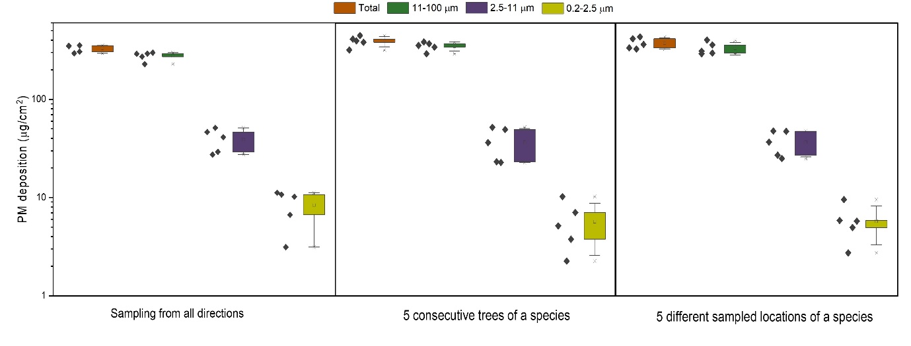
Figure S6: Assessment of the spatial reproducibility of PM deposition on Saraca asoca leaves under different sampling strategies (Box[Right], Data[left]). The figure compares the deposited PM mass fractions (Total, 11-100 μm, 2.5-11 μm, and 0.2-2.5 μm) obtained from three independent sampling approaches: (left) leaves collected from all directions around a single tree, (centre) leaves collected from five consecutive Saraca asoca trees at the same location, and (right) leaves collected from five randomly distributed Saraca asoca trees across the IIT Delhi campus. Boxplots represent the distribution of deposited PM for each particle-size fraction, with individual points indicating biological replicates. Comparable PM deposition across the three sampling strategies demonstrates the reproducibility of the leaf-sampling methodology and indicates that variation due to sampling direction, adjacent trees, and campus location was relatively small.
S3: Five samples were taken from all directions around a single Saraca asoca tree to evaluate variation in sampled mass. Sampling from five different locations was conducted for a single species to estimate location effects, and five different trees of the same species from a single location were used to evaluate variation in tree deposition. PM quantification among single-species planted consecutively exhibited standard deviations of 12.23% for total PM, 10.29% for large PM, 42.72% for coarse PM, and 70.71% for fine PM. Similarly, for location, standard deviations of 12.91%, 14.59%, 31.42%, and 49.88% were associated with total, large, coarse, and fine PM, respectively. Among samples from a single tree taken from various directions, the standard deviations were 8.57%, 10.42%, 28.55%, and 51.50% for total PM, large PM, coarse PM, and fine PM, respectively. It was therefore assumed that the effect of sampling direction, arrangement, and location on deposition mass was negligible (Coarse particles (11-100 µm) exhibited consistently low variability (CV ~10-14%). However, finer particles (2.5-11 µm and 0.2-2.5 µm) exhibited much more variability (CV up to ~54%) without substantial variations across datasets (p > 0.05), indicating the predominance of regional stochastic processes. The total deposited mass displayed a relative stability (CV ~12%) and showed no significant variation across spatial scales (p > 0.05)).

Table S1: Mass fraction obtained from the dust/PM removed from plant leaves (XRF).
Elemental | Wedelia | Ailanthus altissima | Cassia fistula | Saraca asoca | Avg. mass fraction
Al | 15.493 | 14.876 | 13.779 | 15.083 | 14.80775
Si | 44.004 | 44.809 | 44.459 | 43.616 | 44.222
P | 0.209 | 0.26 | 0.178 | 0.255 | 0.2255
S | 0.274 | 0.429 | 0.554 | 0.602 | 0.46475
Cl | 0.03279 | 0.05819 | 0.305 | 0.05593 | 0.1129775
K | 5.164 | 5.412 | 5.412 | 6.347 | 5.58375
Ca | 10.705 | 9.739 | 10.642 | 7.491 | 9.64425
Ti | 1.82 | 2.034 | 1.886 | 2.205 | 1.98625
Cr | 0.08181 | 0.09011 | 0.19 | 0.143 | 0.12623
Mn | 0.211 | 0.193 | 0.16 | 0.19 | 0.1885
Fe | 19.011 | 19.667 | 19.47 | 21.687 | 19.95875
Ni | 0.06323 | 0.09394 | 0.253 | 0.122 | 0.1330425
Cu | 0.05577 | 0.09131 | 0.22 | 0.08657 | 0.1134125
Zn | 0.205 | 0.214 | 0.959 | 0.264 | 0.4105
Rb | 0.05386 | 0 | 0 | 0 | 0.013465
Sr | 0.07482 | 0 | 0 | 0 | 0.018705
Pb | 0.03997 | 0 | 0 | 0.05569 | 0.023915

Table S2: Mass fraction of the source profile obtained from Xact instrument.
 | Power Plant | Dust Related | Vehicular Emission | Secondary Chloride | Biomass burning | Waste Incineration | Industria | Pb-rich
Al 13 (ng/m3) | 0 | 4.346745 | 32.4822 | 2.893032 | 0 | 0 | 0 | 0
Si 14 (ng/m3) | 10.04703109 | 58.92095 | 11.88183 | 1.869175 | 17.81382 | 12.57641 | 5.965212 | 15.75946
P | 0 | 0 | 0 | 0 | 0 | 0 | 0 | 0
S 16 (ng/m3) | 81.60451128 | 0 | 24.31705 | 1.64246 | 7.521237 | 0 | 26.2721 | 22.94532
Cl 17 (ng/m3) | 0 | 0 | 0.815154 | 91.808 | 11.51174 | 39.0057 | 16.13821 | 0
K 19 (ng/m3) | 0 | 0 | 5.73E-08 | 0.221102 | 52.35449 | 14.54238 | 0 | 29.55447
Ca 20 (ng/m3) | 3.89844718 | 19.16338 | 22.16725 | 1.061111 | 2.209159 | 1.358427 | 2.622839 | 0.481161
Ti 22 (ng/m3) | 0.373646866 | 1.288256 | 1.003748 | 0 | 0.543991 | 0.431848 | 0.296399 | 0.419121
Cr 24 (ng/m3) | 0.04581878 | 0 | 0.172975 | 0 | 0 | 0.010712 | 0.070469 | 0
Mn 25 (ng/m3) | 0.3221896 | 0.169249 | 0.681899 | 0 | 0.073673 | 0.18772 | 0.028084 | 0.113851
Fe 26 (ng/m3) | 3.067580138 | 15.84541 | 6.449029 | 0.193154 | 6.894407 | 11.59074 | 3.494335 | 6.098527
Ni 28 (ng/m3) | 0.00320053 | 0.013203 | 0.028353 | 0.001067 | 0 | 0.022673 | 0 | 0.000546
Cu 29 (ng/m3) | 1.05555E-08 | 0.008932 | 0 | 0.029703 | 0.110066 | 0.21439 | 22.00281 | 0.268119
Zn 30 (ng/m3) | 0 | 0 | 0 | 0 | 0.858351 | 19.84645 | 10.47809 | 6.665719
Rb | 0 | 0 | 0 | 0 | 0 | 0 | 0 | 0
As 33 (ng/m3) | 0.094295439 | 0.012427 | 0 | 0 | 0.069002 | 0.125902 | 0 | 0
Se 34 (ng/m3) | 0.048584608 | 0 | 0 | 0.003346 | 0 | 0 | 0 | 0.010345
Sr 38 (ng/m3) | 0 | 0.188399 | 0.000509 | 0.0087 | 0.040065 | 0.086644 | 0 | 0.042157
Pb 82 (ng/m3) | 0.49469449 | 0.043054 | 0 | 0.269155 | 0 | 0 | 12.63146 | 17.6412

Table S3: PM_{2.5} concentrations (µg/m³) 2022-2023 obtained from all CPCB stations.
 | May | June | July | Aug. | Sept. | Oct. | Nov. | Dec. | Jan. | Feb. | March | April | May
Alipur Delhi - DPCC | 81.2 | 62.9 | 33.6 | 31.5 | 36.3 | 111.3 | 211.4 | 182.4 | 155.3 | 122.1 | 79.6 | 76.7 | 67.8
Anand Vihar Delhi - DPCC | 88.3 | 80.1 | 42.4 | 41.4 | 52.8 | 131.5 | 204.6 | 220.8 | 226.0 | 138.0 | 100.0 | 91.6 | 82.4
Ashok Vihar Delhi - DPCC | 63.3 | 52.5 | 38.0 | 32.4 | 40.5 | 116.4 | 199.0 | 185.7 | 175.4 | 112.8 | 68.1 | 62.0 | 54.3
Dr. Karni Singh Shooting Range Delhi - DPCC | 70.7 | 48.4 | 28.6 | 25.6 | 33.3 | 92.2 | 174.3 | 174.1 | 184.4 | 106.4 | 68.1 | 57.2 | 55.7
Dwarka-Sector 8 Delhi - DPCC | 67.2 | 55.6 | 30.0 | 28.6 | 34.8 | 104.1 | 190.1 | 194.9 | 205.9 | 120.5 | 72.6 | 72.9 | 65.9
IGI Airport (T3) Delhi - IMD | 72.6 | 57.1 | 30.9 | 29.4 | 34.9 | 91.3 | 154.3 | 139.7 | 141.6 | 88.1 | 60.6 | 56.0 | 51.6
IHBAS Dilshad Garden Delhi - CPCB | 69.8 | 60.1 | 44.6 | 42.4 | 42.1 | 94.3 | 128.3 | 115.3 | 109.4 | 99.0 | 68.1 | 65.8 | 56.4
ITO Delhi - CPCB | 93.3 | 64.7 | 42.2 | 37.5 | 49.8 | 116.4 | 166.6 | 166.3 | 228.2 | 153.3 | 74.7 | 52.5 | 76.6
Aya Nagar Delhi - IMD | 63.5 | 43.5 | 36.0 | 28.6 | 33.5 | 77.8 | 140.1 | 122.7 | 132.1 | 68.5 | 63.5 | 53.4 | 54.0
Bawana Delhi - DPCC | 88.2 | 72.7 | 43.6 | 38.0 | 46.4 | 121.0 | 218.5 | 188.8 | 177.9 | 133.5 | 95.9 | 93.4 | 82.3
Burari Crossing Delhi - IMD | 71.5 | 87.3 |  | 45.0 | 64.3 | 190.5 | 194.2 | 192.3 | 156.6 | 110.2 | 68.2 | 70.9 | 52.5
Jahangirpuri Delhi - DPCC | 75.1 | 59.8 | 45.0 | 45.8 | 49.7 | 134.5 | 233.7 | 229.3 | 203.8 | 137.9 | 95.2 | 89.9 | 77.8
Jawaharlal Nehru Stadium Delhi - DPCC | 70.5 | 51.9 | 29.1 | 30.0 | 36.9 | 98.8 | 176.2 | 182.6 | 181.7 | 105.9 | 65.1 | 52.4 | 51.3
Lodhi Road Delhi - IITM | 95.5 | 74.5 | 31.0 | 28.9 |  |  |  | 235.3 | 213.2 | 125.2 | 87.0 | 54.8 | 71.7
CRRI Mathura Road Delhi - IMD | 71.3 | 58.1 | 30.7 | 31.4 | 37.9 | 99.1 | 153.6 | 150.6 | 166.6 | 112.2 | 70.5 | 65.9 | 65.3
Chandni Chowk Delhi - IITM | 95.0 | 95.4 | 35.7 | 40.3 |  |  |  | 122.6 | 101.8 | 75.7 | 55.1 | 27.6 | 27.2
DTU Delhi - CPCB | 118.4 | 85.2 | 39.7 | 37.0 | 34.3 | 87.7 | 93.7 | 112.2 | 157.7 | 70.7 | 48.4 | 54.8 | 58.3
Lodhi Road Delhi - IMD | 59.0 | 44.6 | 31.2 | 32.2 | 32.4 | 77.2 | 126.8 | 120.3 | 126.1 | 77.6 | 54.8 | 47.0 | 49.9
Major Dhyan Chand National Stadium Delhi - DPCC | 79.6 | 59.1 | 37.1 | 33.5 | 39.4 | 100.2 | 181.5 | 183.9 | 184.0 | 111.1 | 70.3 | 58.8 | 59.0
Mandir Marg Delhi - DPCC | 79.7 | 71.1 | 31.7 | 21.7 | 28.7 | 53.1 | 145.9 | 166.3 | 173.4 | 102.9 | 67.6 | 57.0 | 57.7
Mundka Delhi - DPCC | 82.8 | 71.2 | 34.9 | 33.3 | 42.0 | 115.3 | 209.3 | 208.0 | 193.7 | 131.4 | 93.7 | 92.6 | 80.2
NSIT Dwarka Delhi - CPCB | 118.4 | 88.6 | 43.9 | 48.3 | 51.1 | 130.5 | 196.2 | 194.0 | 175.9 | 153.6 | 98.0 | 109.1 | 109.6
Najafgarh Delhi - DPCC | 66.3 | 50.6 | 28.7 | 24.9 | 29.6 | 78.9 | 156.2 | 132.9 | 129.8 | 86.0 | 63.6 | 57.2 | 56.4
Narela Delhi - DPCC | 84.8 | 67.3 | 34.1 | 30.7 | 40.1 | 111.8 | 219.2 | 181.9 | 181.0 | 133.9 | 94.6 | 82.1 | 78.3
Nehru Nagar Delhi - DPCC | 80.6 | 53.8 | 38.6 | 31.7 | 41.9 | 118.3 | 218.5 | 237.6 | 236.8 | 135.5 | 84.1 | 71.5 | 65.3
North Campus DU Delhi - IMD | 70.3 | 53.3 | 37.4 | 33.1 | 38.7 | 114.6 | 180.2 | 160.2 | 152.1 | 100.5 | 66.7 | 58.5 | 59.2
Okhla Phase-2 Delhi - DPCC | 68.3 | 48.1 | 29.9 | 26.8 | 35.5 | 101.8 | 174.4 | 174.9 | 190.5 | 109.9 | 71.7 | 62.7 | 59.2
Patparganj Delhi - DPCC | 81.3 | 65.9 | 42.6 | 32.2 | 41.8 | 112.8 | 204.9 | 206.0 | 204.2 | 124.1 | 81.3 | 66.2 | 69.4
Punjabi Bagh Delhi - DPCC | 94.0 | 74.0 | 46.2 | 39.9 | 47.7 | 115.0 | 181.6 | 195.1 | 194.6 | 125.7 | 85.4 | 77.4 | 74.1
Pusa Delhi - DPCC | 64.0 | 48.9 | 28.1 | 26.9 | 32.9 | 95.4 | 170.9 | 178.8 | 189.4 | 108.1 | 70.8 | 58.7 | 57.7
Pusa Delhi - IMD | 69.7 | 58.2 | 35.8 | 30.5 | 34.9 | 89.2 | 146.0 | 136.8 | 135.1 | 84.5 | 57.2 | 49.5 | 56.5
R K Puram Delhi - DPCC | 83.9 | 61.3 | 38.4 | 36.0 | 42.9 | 112.6 | 188.4 | 194.8 | 208.1 | 123.7 | 79.0 | 92.6 | 87.6
Rohini Delhi - DPCC | 73.4 | 60.3 | 34.4 | 29.6 | 38.8 | 112.7 | 211.4 | 202.4 | 195.8 | 130.4 | 88.9 | 79.5 | 76.2
Shadipur Delhi - CPCB | 78.3 | 54.9 | 29.9 | 31.6 | 50.1 | 119.1 | 184.8 | 189.0 | 187.5 | 166.6 | 121.9 | 91.4 | 92.2
Sirifort Delhi - CPCB | 72.3 | 52.2 | 30.9 | 28.7 | 35.5 | 95.3 | 175.1 | 166.0 | 177.8 | 108.3 | 71.7 | 68.5 | 63.9
Sonia Vihar Delhi - DPCC | 90.5 | 63.1 | 44.9 | 34.7 | 40.3 | 114.9 | 215.5 | 187.7 | 181.8 | 120.6 | 79.8 | 70.1 | 73.6
Sri Aurobindo Marg Delhi - DPCC | 66.7 | 48.4 | 29.5 | 26.8 | 32.5 | 83.2 | 160.1 | 158.7 | 171.5 | 98.3 | 58.9 | 48.9 | 49.2
Vivek Vihar Delhi - DPCC | 97.8 | 60.0 | 36.9 | 31.8 | 42.6 | 121.5 | 208.2 | 203.2 | 200.8 | 124.4 | 86.1 | 74.5 | 72.3
Wazirpur Delhi - DPCC | 79.4 | 64.2 | 46.1 | 41.5 | 45.1 | 122.7 | 209.5 | 201.1 | 201.7 | 139.6 | 89.7 | 81.7 | 77.1
Average PM2.5 | 79.4 | 62.3 | 36.1 | 33.3 | 40.3 | 107.1 | 181.2 | 176.8 | 177.2 | 114.8 | 76.3 | 68.0 | 66.1

Table S4: PM₁₀ concentrations (µg/m³) 2022-2023 obtained from all CPCB stations.
 | May | June | July | Aug. | Sept. | Oct. | Nov. | Dec. | Jan. | Feb. | March | April | May
Alipur Delhi - DPCC | 237.9 | 227.7 | 74.7 | 81.6 | 90.7 | 211.7 | 346.5 | 285.5 | 216.3 | 201.6 | 156.9 | 216.9 | 190.4
Anand Vihar Delhi - DPCC | 284.7 | 297.9 | 127.8 | 179.9 | 239.8 | 427.6 | 424.2 | 368.2 | 389.7 | 369.0 | 263.1 | 248.5 | 244.3
Ashok Vihar Delhi - DPCC | 225.6 | 208.1 | 85.3 | 91.9 | 112.9 | 243.5 | 340.3 | 317.6 | 297.9 | 256.6 | 171.1 | 203.7 | 187.9
Dr. Karni Singh Shooting Range Delhi - DPCC | 205.6 | 170.1 | 58.6 | 65.9 | 83.4 | 173.7 | 270.2 | 266.2 | 276.5 | 205.6 | 143.4 | 166.5 | 157.6
Dwarka-Sector 8 Delhi - DPCC | 266.9 | 259.5 | 91.0 | 93.9 | 110.2 | 246.4 | 335.8 | 327.8 | 311.2 | 278.7 | 178.8 | 238.3 | 223.1
IGI Airport (T3) Delhi - IMD | 184.3 | 194.5 | 80.6 | 84.3 | 93.1 | 195.4 | 271.5 | 227.8 | 231.4 | 188.9 | 144.3 | 174.4 | 149.3
IHBAS Dilshad Garden Delhi - CPCB | 236.5 | 203.1 | 89.0 | 95.9 | 108.3 | 223.8 | 265.2 | 273.8 | 225.2 | 241.7 | 182.5 | 139.2 | 167.9
ITO Delhi - CPCB | 228.0 | 178.4 | 84.3 | 72.5 | 89.8 | 189.9 | 227.1 | 218.8 | 303.8 | 247.0 | 147.8 | 101.2 | 122.7
Aya Nagar Delhi - IMD | 189.9 | 185.6 | 64.8 | 66.7 | 82.5 | 171.7 | 259.4 | 236.1 | 239.3 | 175.8 | 120.7 | 134.8 | 141.5
Bawana Delhi - DPCC | 292.9 | 250.2 | 90.7 | 94.3 | 102.3 | 244.5 | 377.8 | 328.6 | 299.0 | 275.4 | 210.6 | 267.0 | 224.6
Burari Crossing Delhi - IMD | 208.7 | 287.0 |  | 132.1 | 114.1 | 349.5 | 408.5 | 329.2 | 241.1 | 215.0 | 150.0 | 200.8 | 181.9
Jahangirpuri Delhi - DPCC | 223.8 | 217.2 | 87.7 | 115.9 | 128.8 | 287.8 | 418.6 | 396.4 | 360.7 | 310.7 | 226.2 | 270.5 | 234.8
Jawaharlal Nehru Stadium Delhi - DPCC | 214.7 | 203.4 | 72.7 | 75.0 | 93.8 | 186.1 | 297.0 | 298.3 | 280.1 | 188.8 | 123.1 | 160.9 | 149.0
Lodhi Road Delhi - IITM | 167.0 | 126.9 | 51.3 | 48.1 |  |  |  | 311.9 | 219.7 | 153.0 | 123.6 | 84.0 | 86.3
CRRI Mathura Road Delhi - IMD | 246.4 | 215.7 | 65.5 | 67.0 | 76.4 | 216.8 | 287.2 | 282.0 | 340.7 | 211.2 | 161.1 | 183.1 | 128.1
Chandni Chowk Delhi - IITM | 273.3 | 262.2 | 102.5 | 66.4 |  |  |  | 246.6 | 290.3 | 248.6 | 165.7 | 204.7 | 208.6
DTU Delhi - CPCB | 251.0 | 219.5 | 79.0 | 90.3 | 85.5 | 206.0 | 367.1 | 323.2 | 315.5 | 245.7 | 177.6 | 204.7 | 196.9
Lodhi Road Delhi - IMD | 219.6 | 179.5 | 64.9 | 69.4 | 72.9 | 154.9 | 220.1 | 217.8 | 224.5 | 168.1 | 115.2 | 136.0 | 143.7
Major Dhyan Chand National Stadium Delhi - DPCC | 269.7 | 232.3 | 89.5 | 92.3 | 97.2 | 192.6 | 281.1 | 269.1 | 264.0 | 215.8 | 155.5 | 189.9 | 188.7
Mandir Marg Delhi - DPCC | 234.8 | 198.5 | 79.3 | 72.2 | 83.6 | 161.6 | 254.3 | 253.9 | 249.9 | 196.2 | 143.9 | 166.5 | 162.0
Mundka Delhi - DPCC | 302.7 | 283.9 | 95.7 | 119.6 | 135.0 | 245.5 | 341.4 | 338.5 | 348.1 | 306.5 | 229.9 | 296.0 | 270.9
NSIT Dwarka Delhi - CPCB | 266.6 | 181.1 | 82.3 | 107.6 | 120.1 | 260.8 | 395.2 | 384.1 | 298.3 | 283.4 | 196.1 | 234.8 | 203.7
Najafgarh Delhi - DPCC | 233.2 | 200.0 | 60.4 | 59.9 | 69.9 | 141.1 | 234.9 | 195.3 | 178.9 | 150.6 | 127.0 | 162.0 | 146.0
Narela Delhi - DPCC | 288.7 | 236.3 | 97.0 | 95.2 | 113.4 | 220.8 | 341.0 | 282.9 | 278.4 | 259.6 | 200.4 | 221.9 | 221.3
Nehru Nagar Delhi - DPCC | 237.9 | 187.0 | 75.7 | 82.6 | 92.2 | 198.3 | 315.0 | 331.5 | 330.1 | 231.2 | 159.5 | 191.3 | 174.5
North Campus DU Delhi - IMD | 222.6 | 189.9 | 79.3 | 76.7 | 82.9 | 187.0 | 267.5 | 238.2 | 228.4 | 187.0 | 135.6 | 157.8 | 152.2
Okhla Phase-2 Delhi - DPCC | 252.8 | 206.2 | 83.4 | 90.4 | 98.0 | 221.5 | 318.3 | 303.6 | 306.3 | 251.6 | 191.3 | 209.4 | 194.3
Patparganj Delhi - DPCC | 226.7 | 197.7 | 77.0 | 80.3 | 98.2 | 218.4 | 318.7 | 319.9 | 310.6 | 248.5 | 190.1 | 205.1 | 187.3
Punjabi Bagh Delhi - DPCC | 255.0 | 223.9 | 108.3 | 99.3 | 111.5 | 240.1 | 325.2 | 312.1 | 302.8 | 256.9 | 179.6 | 216.5 | 199.5
Pusa Delhi - DPCC | 240.9 | 219.8 | 86.8 | 95.3 | 118.5 | 226.3 | 302.7 | 323.2 | 320.6 | 256.0 | 187.7 | 213.8 | 205.2
Pusa Delhi - IMD | 201.4 | 191.3 | 66.1 | 67.1 | 77.0 | 158.1 | 236.7 | 226.4 | 221.3 | 172.5 | 121.0 | 132.6 | 152.0
R K Puram Delhi - DPCC | 234.5 | 193.3 | 77.3 | 79.7 | 95.7 | 184.7 | 293.8 | 280.4 | 280.3 | 218.7 | 161.4 | 189.4 | 171.8
Rohini Delhi - DPCC | 249.0 | 229.8 | 85.3 | 88.9 | 104.2 | 237.1 | 354.0 | 323.5 | 297.8 | 254.4 | 187.2 | 213.3 | 215.5
Shadipur Delhi - CPCB | 220.6 | 202.6 | 93.8 | 106.0 | 118.0 | 257.1 | 352.5 | 361.4 | 357.4 | 284.2 | 216.0 | 215.2 | 205.6
Sirifort Delhi - CPCB | 247.0 | 194.5 | 82.4 | 87.1 | 97.2 | 204.6 | 336.7 | 321.2 | 313.1 | 235.7 | 175.2 | 201.3 | 182.4
Sonia Vihar Delhi - DPCC | 275.9 | 234.0 | 94.2 | 96.9 | 113.6 | 235.5 | 353.8 | 318.0 | 294.6 | 261.9 | 179.7 | 216.0 | 214.3
Sri Aurobindo Marg Delhi - DPCC | 222.2 | 185.3 | 64.5 | 68.3 | 73.2 | 135.6 | 225.4 | 223.6 | 239.5 | 170.4 | 126.1 | 138.8 | 136.1
Vivek Vihar Delhi - DPCC | 266.7 | 237.3 | 90.1 | 95.5 | 114.8 | 247.8 | 356.2 | 346.4 | 326.2 | 278.8 | 196.2 | 218.4 | 203.4
Wazirpur Delhi - DPCC | 207.3 | 235.9 | 130.4 | 113.5 | 120.1 | 279.2 | 352.4 | 349.5 | 331.4 | 303.4 | 217.1 | 261.2 | 224.7
Average PM10 | 238.8 | 214.0 | 83.4 | 88.9 | 103.2 | 221.2 | 315.5 | 296.4 | 285.7 | 236.0 | 170.2 | 194.5 | 183.3
PM concentrations were obtained from the daily mean values recorded by 40 monitoring stations of the Central Pollution Control Board (CPCB) located across the National Capital Territory (NCT) of Delhi. The daily measurements from each station were aggregated to illustrate the spatial distribution of ambient PM levels across the research area. The daily average concentrations were then compiled on a monthly scale to derive indicative monthly mean PM concentrations for each analytical period. The derived monthly average PM concentrations were then used as input for the $V_{d}$ technique to assess PM deposition and removal over the selected region.
Table S5: Deposition velocity estimated through various methods.
Literature | Method | Particle size | Tracer | Detection method | Wind speed | Exposure duration | Tree species | $V_{d}$(cm/s)
Freer-Smith et al. (2004) | wind tunnel | 0.8 (observed by scanning electron microscope) | NaCl | total mass of Na+ | 3.0 | 10 | Acer pseudo-platanus#  Alnus glutinosa#  Eucalyptus globulus#  Ficus nitida#  Fraxinus excelsior#  Pseudotsuga menziesii*  Quercus petraea# | 0.042  0.125  0.018  0.004  0.178  1.167  0.956
Beckett et al. (2000) | wind tunnel | 1.28 (observed by scanning electron microscope) | NaCl | total mass of Na+ | 3.0 | 10 | Acer campestre#  Cupressocyparis leylandii*  Pinus nigra var. maritima*  Populus deltoides x  Trichocarpa Beaupré’#  Sorbus intermedia# | 0.08  0.76  1.15  0.12  0.39
Pullman (2009) | wind tunnel | 2.5  (milled but the size is not observed or verified) | KNO3 | electrical conductivity | 6.5 | 30 | Picea abies*  Pinus strobus*  Tsuga canadensis* Tsuga japonica* | 0.0189  0.0108  0.0193  0.0058
S. Yin et al. (2019) | Smog chamber | 1.8-2.5  (Verfied by spectrometer) | Diamond powder | indirect | 2 | 50 | Cedrus deodara*  Cinnamomum camphora#  Elaeocarpus decipiens#  Firmiana simplex#  Ginkgo biloba#  Ligustrum lucidum# Magnolia grandiflora#  Metasequoia glyptostroboides*  Podocarpus macrophyllus#  Prunus cerasifera f. Atropurpurea#  Salix babylonica# Sabina chinensis*  Sapindus saponaria# Sophora japonica# | 0.319  0.239  0.334  0.064  0.263  0.317  0.305  0.380  0.237  0.374  0.277  0.216  0.291  0.435
Notes: * stands for coniferous trees; # stands for broadleaved trees.

