Supplementary material

Early risk stratification for in-hospital mortality after acute diquat poisoning: a retrospective cohort study with external validation
Supplementary methods: Fine-Gray competing-risks analysis
For the secondary hospital-course analysis, admission was the time origin and hospital stay was the time scale. Discharge alive was the event of interest and in-hospital death was the competing event. Cumulative incidence functions were used to describe both outcomes. Univariable Fine-Gray models were fit for baseline candidate variables, followed by a prespecified multivariable model including age, estimated ingested volume, bicarbonate, lactate, white blood cell count, creatinine, and alanine aminotransferase. Effects were reported as subdistribution hazard ratios (sHRs) with 95% confidence intervals. Proportional subdistribution hazards were assessed using covariate-by-log-time interactions, with Holm correction for multiple testing. The analysis was associational and was not intended as a causal analysis of recovery time or length of stay.
Supplementary Table S1. Univariable and multivariable Fine-Gray competing-risks regression analyses of discharge alive during hospitalization
Variable | Effect unit | Univariable sHR (95% CI) | P value | Multivariable sHR (95% CI) | P value
Male | Male vs female | 0.825（0.613–1.111） | 0.204 | — | —
Age | Per 10-year increase | 1.002（0.850–1.181） | 0.986 | 0.985（0.868–1.117） | 0.814
Estimated ingested volume | Per 10-mL increase | 0.842（0.814–0.871） | <0.001 | 0.895（0.863–0.930） | <0.001
pH | Per 0.1-unit increase | 1.311（1.079–1.592） | 0.007 | — | —
PO₂ | Per 10-kPa increase | 0.623（0.420–0.923） | 0.018 | — | —
HCO₃⁻ | Per 5-mmol/L increase | 1.743（1.464–2.075） | <0.001 | 1.352（1.118–1.635） | 0.002
Lactate | Per 1-mmol/L increase | 0.572（0.456–0.718） | <0.001 | 0.752（0.578–0.979） | 0.034
White blood cell count | Per 5 × 10⁹/L increase | 0.618（0.543–0.703） | <0.001 | 0.903（0.770–1.059） | 0.211
ALT | Per 100-U/L increase | 0.568（0.414–0.777） | <0.001 | 0.822（0.640–1.057） | 0.126
α-Amylase | Per 100-U/L increase | 0.759（0.610–0.944） | 0.013 | — | —
Creatinine | Per 100-μmol/L increase | 0.867（0.797–0.945） | 0.001 | 0.902（0.832–0.979） | 0.013
Note: sHR, subdistribution hazard ratio; CI, confidence interval; PO₂, partial pressure of oxygen; HCO₃⁻, bicarbonate; ALT, alanine aminotransferase. Discharge alive was the event of interest, and in-hospital death was the competing event. The multivariable Fine-Gray model prespecified seven variables: age, estimated ingested volume, HCO₃⁻, lactate, white blood cell count, creatinine, and ALT. An sHR >1 indicates a higher subdistribution hazard of discharge alive, whereas an sHR <1 indicates a lower subdistribution hazard.
Supplementary Figure S1. Forest plot of the prespecified multivariable Fine-Gray model
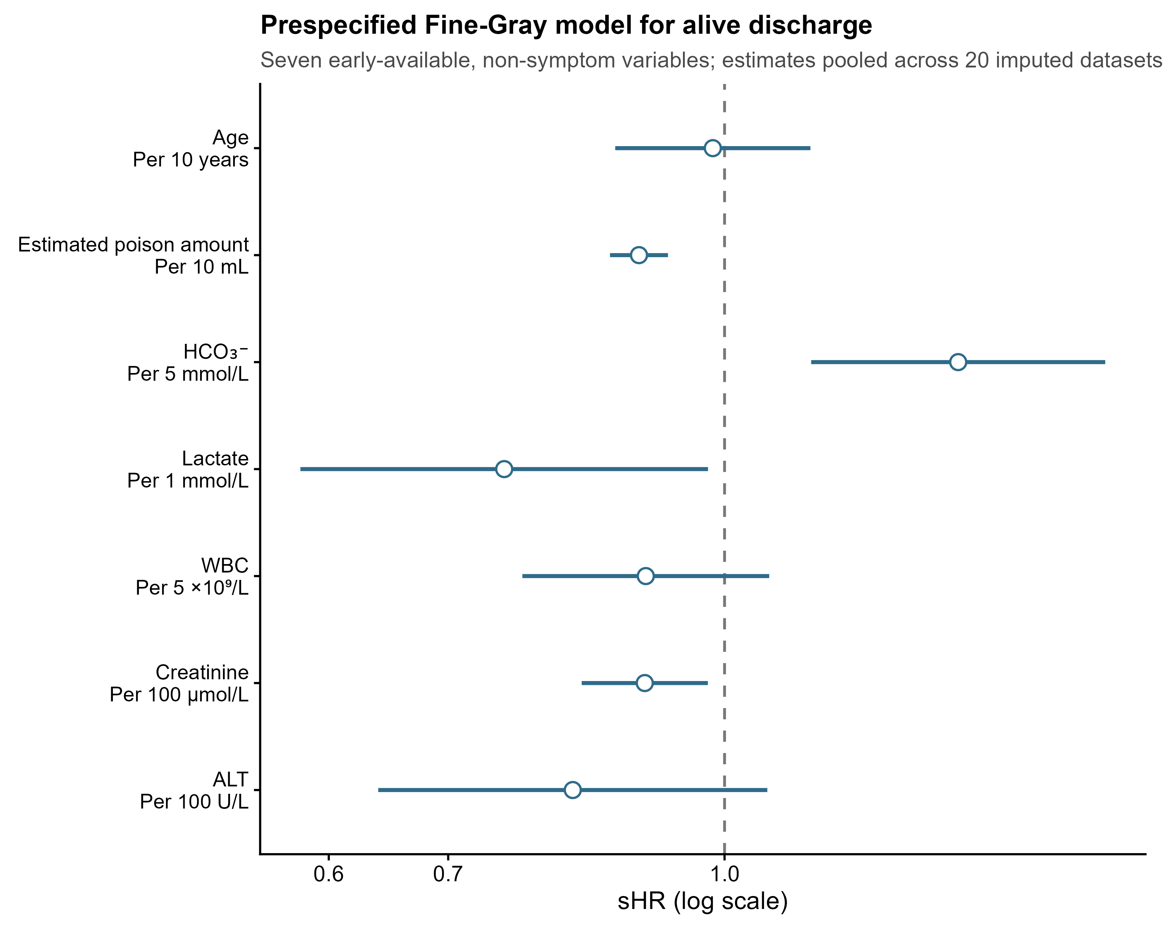
Note:Points and horizontal lines represent sHRs and 95% CIs, respectively.

Supplementary Table S2. Test of the proportional subdistribution hazards assumption for the multivariable Fine-Gray model
Variable | Time-interaction β | Standard error | Unadjusted P value | Holm-adjusted P value
Age | 0.127 | 0.108 | 0.238 | 1.000
Estimated ingested volume | −0.018 | 0.018 | 0.320 | 1.000
HCO₃⁻ | 0.044 | 0.114 | 0.700 | 1.000
Lactate | −0.106 | 0.058 | 0.068 | 0.410
White blood cell count | −0.032 | 0.063 | 0.607 | 1.000
Creatinine | 0.208 | 0.079 | 0.008 | 0.058
ALT | 0.020 | 0.287 | 0.944 | 1.000
Note: The proportional subdistribution hazards assumption was tested using interactions between each covariate and standardized log(time), with the Holm method used to adjust for multiple comparisons. All Holm-adjusted P values were >0.05; the smallest adjusted P value was 0.058. Thus, there was no clear statistical evidence that the proportional subdistribution hazards assumption was violated.

