Supplementary Information for “Tropical Volcanism Enhanced the East Asian Summer Monsoon during the Last Millennium”
Fei Liu¹, Chaochao Gao^{2*}, Jing Chai³, Alan Robock⁴, Bin Wang^{5*}, Jinbao Li⁶, Xu Zhang⁷, Gang Huang⁸ and Wenjie Dong¹
¹School of Atmospheric Sciences Sun Yat-Sen University, Key Laboratory of Tropical Atmosphere-Ocean System Ministry of Education, and Southern Marine Science and Engineering Guangdong Laboratory, Zhuhai 519082, China
²College of Environmental and Resource Sciences, Zhejiang University, Hangzhou 310058, China
³School of Atmospheric Sciences, Chengdu University of Information Technology, Chengdu 610225, China
⁴Department of Environmental Sciences, Rutgers University, New Brunswick, NJ 08901, USA.
⁵Department of Atmospheric Sciences and International Pacific Research Center, University of Hawaii at Manoa, Honolulu, HI 96822, USA
⁶Department of Geography, University of Hong Kong, Hong Kong SAR, China
⁷Group of Alpine Paleoecology and Human Adaptation (ALPHA), State Key Laboratory of Tibetan Plateau Earth System, Resources and Environment (TPESRE), Institute of Tibetan Plateau Research, Chinese Academy of Sciences, Beijing, China
⁸State Key Laboratory of Numerical Modeling for Atmospheric Sciences and Geophysical Fluid Dynamics, Institute of Atmospheric Physics, Chinese Academy of Sciences, Beijing 100029, China

Submitted to Nature Climate Change

*To whom correspondence should be addressed. Chaochao Gao, gaocc@zju.edu.cn and Bin Wang, wangbin@hawaii.edu

Figure S1. East Asian summer monsoon (EASM) response to tropical eruptions based on reconstructions of Shi et al. 2017 and 2018. a Superposed epoch analysis results of East China precipitation anomalies (shading; Shi et al. (2017) in the first boreal summer after 22 tropical eruptions (Sigl et al. 2015) from 1470 to 1999 AD). Stippling indicates precipitation anomalies not significant at the 90% confidence level. The red curve is the Yangtze River. b Same as a, except for East Asian precipitation anomalies in Shi et al. (2018). The data of Shi et al. (2018)were linearly interpolated to a 0.5°×0.5° grid.

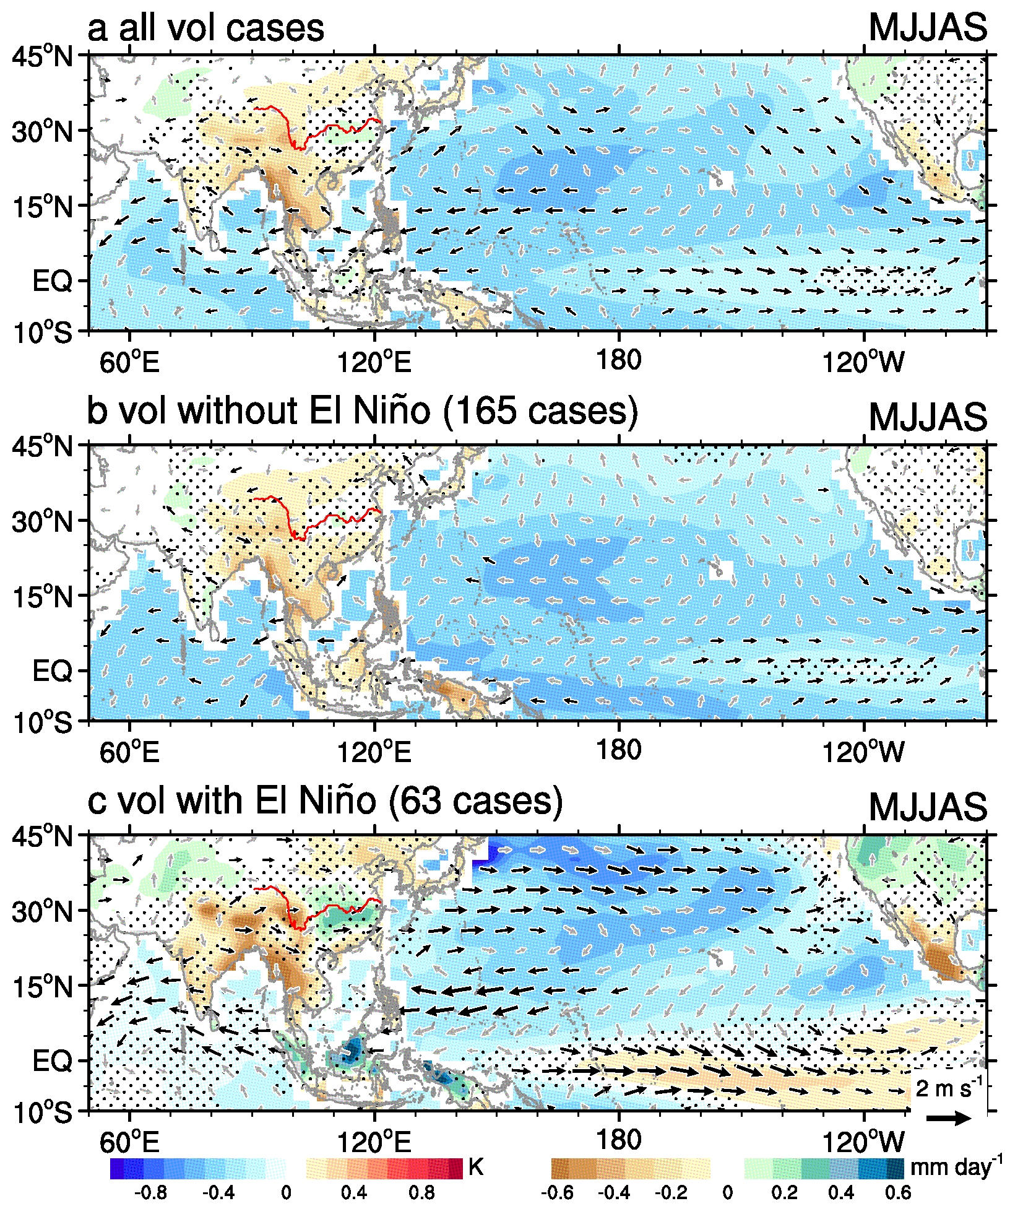

Figure S2. Simulated EASM-ocean responses to tropical eruptions during last millennium in PMIP models. a Composite SST anomalies (shading over ocean), precipitation anomalies (shading over land), and 850 hPa wind anomalies (vectors) in the first boreal summer after all 228 simulated tropical eruptions in 13 PMIP last millennium simulations from 850 to 1849 AD. Stippling and grey vectors indicate precipitation and temperature anomalies and wind anomalies not significant at the 90% confidence level, respectively. b and c Same as a except for composites of 165 eruptions without and 63 eruptions with an El Niño response in the first boreal winter after the eruption, respectively.

Figure S3. El Niño response to tropical eruptions based on reconstructions. Response of individual ENSO reconstruction (Supplementary Table S1), as well as their ensemble mean, to 22 tropical eruptions (Supplementary Table S2) during 1470 to 1999 AD. Confidence limits (90, 95, 99%) are marked by horizontal lines. Blue and red colors mark the pre-eruption and post-eruption composites, respectively. “0” denotes the first cold season following the eruptions. The number of eruptions available for each ENSO reconstruction analysis is also presented.

Table S1. ENSO reconstructions used in this paper.
Index | Variable/Proxy | Source | Period
EN1 | ENSO Proxy | North American tree rings (Li et al. 2011) | 900–2002
EN2 | ENSO Proxy (Niño3) | Tree rings data from Mexico and Texas (Cook 2008) | 1300–1979
EN3 | ENSO Proxy | Tree rings “TEX-MEX” region North America (D'Arrigo et al. 2005) | 1408–1978
EN4 | ENSO Proxy | Network of tropical records from the circumPacific (Emile-Geay et al. 2013) | 1000–2000
EN5 | ENSO Proxy | Tree rings Asia, New Zealand, North & South America (Li et al. 2013) | 1301–2005
EN6 | ENSO Proxy | Corals, tree rings, and ice cores from the western Pacific, New Zealand, central Pacific and subtropical North America (Braganza et al. 2009) | 1525–1982
EN7 | ENSO Proxy | Corals from the central Pacific, tree rings from the TexMex region and USA, and corals and ice cores from other tropical regions (Wilson et al. 2010) | 1607–1998
EN8 | ENSO Proxy | Tree rings, corals and ice cores from the Pacific Basin (McGregor et al. 2010) | 1650–1977
EN9 | ENSO Proxy (Niño3) | Tree rings, corals and ice cores from tropical Pacific region (Mann et al. 2000) | 1650–2000
EN10 | ENSO Proxy (SOI) | Tree rings from North America and Indonesia (Stahle et al. 1998) | 1706–1977
EN11 | ENSO Proxy | Fossil corals from the central tropical Pacific (Dee et al. 2020) | 1147–1465 1637–1705  1887–2007

Table S2. Dates of 22 tropical volcanic eruptions (represented by the peak aerosol loading year) during 1470–1999 AD obtained from Sigl et al. (2015). Nine eruptions followed by an El Niño based on the ensemble mean of 11 ENSO reconstructions (see Methods) are shown in boldface.

Year
1512
1554
1585
1595
1601
1641
1673
1693
1695
1762
1809
1815
1832
1836
1862
1884
1903
1943
1964
1968
1982
1991

Table S3. Last-millennium simulations in PMIP3 (Braconnot et al. 2011; 2012) and PMIP4 (Jungclaus et al. 2017), and in CESM-Last millennium ensembles (LME) (Otto-Bliesner et al. 2016).

Model | Volcanic forcingª | Resolution  (lat×lon×lev) | Project  (ensembles) | Period  (A.D.) | References
BCC-CSM-1.1 | GRA | 128×64×26 | PMIP3 (1) | 850-1850 | Wu et al. (2013)
CCSM4 | GRA | 288×192×26 | PMIP3 (1) | 850-1850 | Gent et al. (2011); (Landrum et al. 2013)
FGOALS-s2 | GRA | 128×60×26 | PMIP3 (1) | 850-1850 | Bao et al. (2013)
MRI-CGCM3 | GRA | 320 ×160×48 | PMIP3 (1) | 850-1850 | Yukimoto et al. (2012)
IPSL-CM5A-LR | Ammann | 96×95×39 | PMIP3 (1) | 850-1850 | Dufresne et al. (2013)
CSIRO-Mk3L-1.2 | CEA | 64×56×18 | PMIP3 (1) | 851-1850 | Phipps et al. (2012)
GISS-E2-R | CEA | 144×90×40 | PMIP3 (1) | 850-1850 | Schmidt et al. (2006)
HadCM3 | CEA | 96×73×19 | PMIP3 (1) | 850-1850 | Collins et al. (2001); (Pope et al. 2000; Schurer et al. 2013)
MIROC-ESM | CEA | 128×64×80 | PMIP3 (1) | 850-1849 | Watanabe et al. (2011)
MPI-ESM-P | CEA | 196×98×47 | PMIP3 (1) | 850-1849 | Jungclaus et al. (2014)
EC-Earth3-Veg-LR | Toohey | 320×160×62 | PMIP4 (1) | 850-1849 | Consortium (2020)
MIROC-ES2L | Toohey | 128×64×40 | PMIP4 (1) | 850-1849 | Ohgaito et al. (2021)
MRI-ESM2-0 | Toohey | 360×160×80 | PMIP4 (1) | 850-1849 | Yukimoto et al. (2019)
CESM-LME | GRA | 144×90×26 | LME-full forcing (10) | 850-1850 | Otto-Bliesner et al. (2016)
ªGRA: Gao et al. (2008); Ammann: Ammann et al. (2007); CEA: Crowley et al. (2008); Toohey: Toohey and Sigl (2017).

Table S4. Dates for tropical volcanic eruptions used in PMIP3, PMIP4 and CESM during last millennium. Eruptions during 1470-1850 AD are shown in boldface.

CEAª | CEAª | Tooheyª
year | year | year
870(872^{b}) | 971 | 1028
901(900^{b}) | 991 | 1108
961(958^{b}) | 1041 | 1171
1001(no^{b}) | 1113 | 1191
1081(1082^{b}) | 1229 | 1230
1213 | 1258 | 1257
1258 | 1286 | 1276
1275(1278^{b}) | 1331 | 1286
1284(1286^{b}) | 1456 | 1345
1341(no^{b}) | 1576 | 1453
1416(1417^{b}) | 1594 | 1458
1452 | 1674 | 1585
1600 | 1696 | 1595
1641 | 1809 | 1600
1673 | 1816 | 1640
1809 | 1835 | 1695
1815 |  | 1809
1835 |  | 1815
1883 |  | 1831
1963 |  | 1835
1991

ªGRA=Gao et al. (2008); CEA=Crowley et al. (2008); Toohey=Toohey and Sigl (2017). ^{b}The dates are chosen based on the-top-of-the-atmosphere shortwave radiation in the IPSL model that is forced by volcanic forcing of Ammann et al. (2007).
References
Ammann, C. M., F. Joos, D. S. Schimel, B. L. Otto-Bliesner, and R. A. Tomas, 2007: Solar influence on climate during the past millennium: Results from transient simulations with the NCAR Climate System Model. Proc. Natl. Acad. Sci. USA, 104, 3713-3718, https://doi.org/10.1073/pnas.0605064103
Bao, Q., and Coauthors, 2013: The flexible global ocean-atmosphere-land system model, Spectral version 2: FGOALS-s2. Adv. Atmos. Sci., 30, 561-576, http://doi.org/10.1007/s00376-012-2113-9
Braconnot, P., S. Harrison, B. Otto-Bliesner, A. Abe-Ouchi, J. Jungclaus, and J. Y. Peterschmitt, 2011: The paleoclimate modeling intercomparison project contribution to CMIP5. CLIVAR Exchanges, 56, 15-19
Braconnot, P., and Coauthors, 2012: Evaluation of climate models using palaeoclimatic data. Nat. Climate Change, 2, 417-424, https://doi.org/10.1038/nclimate1456
Braganza, K., J. L. Gergis, S. B. Power, J. S. Risbey, and A. M. Fowler, 2009: A multiproxy index of the El Niño–Southern Oscillation, A.D. 1525–1982. J. Geophys. Res. Atmos., 114, https://doi.org/10.1029/2008JD010896
Collins, M., S. F. B. Tett, and C. Cooper, 2001: The internal climate variability of HadCM3, a version of the Hadley Centre coupled model without flux adjustments. Climate Dyn., 17, 61-81, http://doi.org/10.1007/s003820000094
Consortium, E. C.-E., 2020: EC-Earth-Consortium EC-Earth3-Veg model output prepared for CMIP6 ScenarioMIP, http://doi.org/10.22033/ESGF/CMIP6.727
Cook, E., R. D’Arrigo, and K. Anchukaitis, 2008: ENSO reconstructions from long tree-ring chronologies: Unifying the differences. Talk presented at a special workshop on Reconciling ENSO Chronologies for the Past, 15
Crowley, T., Z. Ga, B. Vinther, R. Udisti, K. Kreutzs, J. Cole-Dai, and E. Castellano, 2008: Volcanism and the Little Ice Age. PAGES Newslett., 16, 22-23, http://doi.org/10.1029/2002GL0166335
D'Arrigo, R., E. R. Cook, R. J. Wilson, R. Allan, and M. E. Mann, 2005: On the variability of ENSO over the past six centuries. Geophys. Res. Lett., 32, L03711 https://doi.org/10.1029/2004GL022055
Dee, S., K. Cobb, J. Emile-Geay, T. Ault, R. Edwards, H. Cheng, and C. Charles, 2020: No consistent ENSO response to volcanic forcing over the last millennium. Science, 367, 1477-1481, http://doi.org/10.1126/science.aax2000
Dufresne, J. L., and Coauthors, 2013: Climate change projections using the IPSL-CM5 Earth System Model: from CMIP3 to CMIP5. Climate Dyn., 40, 2123-2165, http://doi.org/10.1007/s00382-012-1636-1
Emile-Geay, J., K. M. Cobb, M. E. Mann, and A. T. Wittenberg, 2013: Estimating central equatorial Pacific SST variability over the past millennium. Part I: Methodology and validation J. Climate, 26, 2302-2328, http://doi.org/10.1175/jcli-d-11-00510.1
Feng, S., Q. Hu, Q. Wu, and M. E. Mann, 2013: A gridded reconstruction of warm season precipitation for Asia spanning the past half millennium. J. Climate, 26, 2192-2204, http://doi.org/10.1175/jcli-d-12-00099.1
Gao, C., A. Robock, and C. Ammann, 2008: Volcanic forcing of climate over the past 1500 years: An improved ice core-based index for climate models. J. Geophys. Res. Atmos., 113, D23111, https://doi.org/10.1029/2008JD010239
Gent, P. R., and Coauthors, 2011: The Community Climate System Model version 4. J. Climate, 24, 4973-4991, http://doi.org/10.1175/2011jcli4083.1
Jungclaus, J. H., K. Lohmann, and D. Zanchettin, 2014: Enhanced 20th-century heat transfer to the Arctic simulated in the context of climate variations over the last millennium. Clim. Past, 10, 2201-2213, http://doi.org/10.5194/cp-10-2201-2014
Jungclaus, J. H., and Coauthors, 2017: The PMIP4 contribution to CMIP6 – Part 3: The last millennium, scientific objective, and experimental design for the PMIP4 past1000 simulations. Geosci. Model Dev., 10, 4005-4033, http://doi.org/10.5194/gmd-10-4005-2017
Landrum, L., B. L. Otto-Bliesner, E. R. Wahl, A. Conley, P. J. Lawrence, N. Rosenbloom, and H. Teng, 2013: Last millennium climate and its variability in CCSM4. J. Climate, 26, 1085-1111, http://doi.org/10.1175/jcli-d-11-00326.1
Li, J., and Coauthors, 2011: Interdecadal modulation of El Niño amplitude during the past millennium. Nat. Climate Change, 1, 114-118, http://doi.org/10.1038/nclimate1086
Li, J., and Coauthors, 2013: El Niño modulations over the past seven centuries. Nat. Climate Change, 3, 822-826, http://doi.org/10.1038/nclimate1936
Mann, M. E., E. Gille, J. Overpeck, W. Gross, R. S. Bradley, F. T. Keimig, and M. K. Hughes, 2000: Global temperature patterns in past centuries: An interactive presentation. Earth Interact., 4, 1-1, http://doi.org/10.1175/1087-3562(2000)004<0001:Gtpipc>2.3.Co;2
McGregor, S., A. Timmermann, and O. J. C. o. t. P. Timm, 2010: A unified proxy for ENSO and PDO variability since 1650. Climate of the Past, 6, 1-17, https://doi.org/10.5194/cp-6-1-2010
Ohgaito, R., and Coauthors, 2021: PMIP4 experiments using MIROC-ES2L Earth system model. Geosci. Model Dev., 14, 1195-1217, http://doi.org/10.5194/gmd-14-1195-2021
Otto-Bliesner, B. L., and Coauthors, 2016: Climate variability and change since 850 CE: An ensemble approach with the Community Earth System Model. Bull. Amer. Meteor. Soc., 97, 735-754, http://doi.org/10.1175/bams-d-14-00233.1
Phipps, S. J., L. D. Rotstayn, H. B. Gordon, J. L. Roberts, A. C. Hirst, and W. F. Budd, 2012: The CSIRO Mk3L climate system model version 1.0 – Part 2: Response to external forcings. Geosci. Model Dev., 5, 649-682, http://doi.org/10.5194/gmd-5-649-2012
Pope, V. D., M. L. Gallani, P. R. Rowntree, and R. A. Stratton, 2000: The impact of new physical parametrizations in the Hadley Centre climate model: HadAM3. Climate Dyn., 16, 123-146, http://doi.org/10.1007/s003820050009
Schmidt, G. A., and Coauthors, 2006: Present-day atmospheric simulations using GISS ModelE: Comparison to in situ, satellite, and reanalysis data. J. Climate, 19, 153-192, http://doi.org/10.1175/jcli3612.1
Schurer, A. P., G. C. Hegerl, M. E. Mann, S. F. B. Tett, and S. J. Phipps, 2013: Separating forced from chaotic climate variability over the past millennium. J. Climate, 26, 6954-6973, http://doi.org/10.1175/jcli-d-12-00826.1
Shi, F., S. Zhao, Z. Guo, H. Goosse, and Q. Yin, 2017: Multi-proxy reconstructions of May–September precipitation field in China over the past 500 years. Clim. Past, 13, 1919-1938, http://doi.org/10.5194/cp-13-1919-2017
Shi, H., B. Wang, E. R. Cook, J. Liu, and F. Liu, 2018: Asian summer precipitation over the past 544 years reconstructed by merging tree rings and historical documentary records J. Climate, 31, 7845-7861, http://doi.org/10.1175/jcli-d-18-0003.1
Sigl, M., and Coauthors, 2015: Timing and climate forcing of volcanic eruptions for the past 2,500 years. Nature, 523, 543-549, http://doi.org/10.1038/nature14565
Stahle, D. W., and Coauthors, 1998: Experimental dendroclimatic reconstruction of the Southern Oscillation. Bull. Amer. Meteor. Soc., 79, 2137-2152, http://doi.org/10.1175/1520-0477(1998)079<2137:Edrots>2.0.Co;2
Toohey, M., and M. Sigl, 2017: Volcanic stratospheric sulfur injections and aerosol optical depth from 500 BCE to 1900 CE. Earth Syst. Sci. Data, 9, 809-831, http://doi.org/10.5194/essd-9-809-2017
Watanabe, S., and Coauthors, 2011: MIROC-ESM 2010: model description and basic results of CMIP5-20c3m experiments. Geosci. Model Dev., 4, 845-872, http://doi.org/10.5194/gmd-4-845-2011
Wilson, R., E. Cook, R. D'Arrigo, N. Riedwyl, M. N. Evans, A. Tudhope, and R. Allan, 2010: Reconstructing ENSO: the influence of method, proxy data, climate forcing and teleconnections. J Quat Sci, 25, 62-78, https://doi.org/10.1002/jqs.1297
Wu, T., and Coauthors, 2013: Global carbon budgets simulated by the Beijing Climate Center Climate System Model for the last century. J. Geophys. Res. Atmos., 118, 4326-4347, https://doi.org/10.1002/jgrd.50320
Yukimoto, S., and Coauthors, 2019: MRI MRI-ESM2.0 model output prepared for CMIP6 PMIP. Earth System Grid Federation, http://doi,org/10.22033/ESGF/CMIP6.636
Yukimoto, S., and Coauthors, 2012: A new global climate model of the Meteorological Research Institute: MRI-CGCM3-Model description and basic performance-. J. Meteorol. Soc. Japan. Ser. II, 90A, 23-64, http://doi.org/10.2151/jmsj.2012-A02

