Childhood feeding difficulties perceived by mothers and fathers: a cross-sectional study conducted in Family Pediatrician offices.
SUPPLEMENTARY MATERIAL

BOX S1. Items used to construct each variable related to childhood feeding and eating disorders.
Childhood Feeding and Eating Disorders
Rumination Disorder | - Does the child bring food back into the mouth after swallowing, showing signs of pleasure?  - Does the child tend to regurgitate food for rechewing and reswallowing after ingestion (for at least one month and following a period of adequate feeding of at least equal duration)?  - During meals, does the child assume postures such as arching the back, tilting the head backward, or contracting the abdominal muscles?  - Have recurrent regurgitation episodes been observed for at least one month following a period of adequate feeding of at least equal duration?
Infantile Anorexia | - After 6 months of age, did your child show a sudden and prolonged lack of appetite without any apparent reason?  - Is the child easily distracted during meals?  - Does the child eat willingly?  - Has the child experienced weight loss or failure to thrive during the last 4 to 6 months?  - Does the child refuse, or has the child refused, food for at least one month?  - After 6 months of age, has the child shown a lack of interest in food?
Sensory Food Aversion | - Have qualitative reductions in the child's diet occurred for at least one month?  - Does the child refuse, spit out, or vomit certain types of food?  - Does the child eat without difficulty when offered preferred foods?  - For at least one month, has the child eaten only specific foods (not due to food intolerance, celiac disease, or other medical conditions)?  - Have quantitative reductions in food intake occurred for at least one month?  - Does the child refuse new foods because of their taste, smell, color, texture, or temperature?  - Does the child show disgust or gagging responses when introduced to a new type of food?
Post-Traumatic Feeding Disorder | - Did the child begin refusing food following a feeding-related traumatic event (e.g., choking, repeated episodes of vomiting, food poisoning)?  - Does the child systematically refuse, or has the child systematically refused, bottle feeding while accepting other feeding methods (e.g., spoon feeding)?  - Does the child show intense resistance when approaching the bottle or food?  - Does the child readily accept solid foods?  - Does the child refuse to open his/her mouth?  - Does the child hold food in the mouth?  - Did the child begin refusing food following traumatic events not directly related to feeding?  - Does the child show anxiety when meals are being prepared?
Oral-Motor Feeding Disorder | - Does the child have difficulties with sucking?  - Does the child have difficulty drinking milk from a cup?  - Does the child have difficulty chewing?  - Does the child show difficulty swallowing?  - Does the child spit out food during meals?  - Does the child retain food in the cheeks?  - Does the child tend to choke or gag during feeding?
Food Approach | - Does the child cry when food is offered?  - Does the child show aggressive or angry reactions when being fed?  - Does the child leave the table, interrupting the meal or failing to complete it?  - Is it necessary to restrain or immobilize the child in order to make him/her eat?  - Does the child play with food or other objects during meals, becoming distracted?  - Does the child push food away or throw it?  - Does the child spit out food?  - Does the child eat only when prompted and encouraged?  - Does the child hold food in his/her hand without eating it?  - Are vomiting episodes observed after meals?  - Does the child move away from food by arching his/her back?

BOX S2. Items used to construct each variable related to parental psychopathology.
Parental Psychopathology
Phobias | - Are you worried about your child's eating or feeding behavior?  - Recently, have you experienced intense fears or excessive distress regarding the situation?  - Recently, have you felt excessively tense, nervous, or anxious without any apparent reason?
Mood Disorder | - Is mealtime with your child a source of discomfort for you?  - Does your child's behavior during meals make you angry?  - Recently, have you experienced profound sadness, unhappiness, hopelessness, or frequent crying?
Obsessive-Compulsive Disorder | - Does it bother you when your child gets dirty with food while eating?  - Do you currently have, or have you previously had, the urge to repeatedly check actions you have already performed?  - According to you or your family members, do you spend excessive time on personal hygiene or household cleaning, neglecting other commitments and duties?  - Do you experience recurrent thoughts that interfere with your daily life and that you cannot get rid of?  - Does it bother you when your child does not behave during meals as you would like?
Parental Mealtime Practices | - Do you force your child to eat?  - Do you distract the child, or allow the child to become distracted (e.g., toys, television) during meals in order to make him/her eat?  - Are the strategies you use to make your child eat effective?  - Do you consider mealtimes with your child to be satisfactory?
Eating Disorders | - Has food been, or is food currently, a source of distress for you?  - Have you followed highly restrictive diets, or conversely experienced periods of uncontrolled binge eating?  - Has your body weight and/or body shape been, or is it currently, a source of distress or concern for you?

Figure S1. Scatterplots of children's rumination scores in relation to parental psychopathology scores. Maternal scores are shown in green and paternal scores in blue. The estimated regression line is shown in red. The x- and y-axes represent the hypothetical range of variation for each variable. For each scatterplot, Pearson's correlation coefficient and the corresponding p-value are reported.

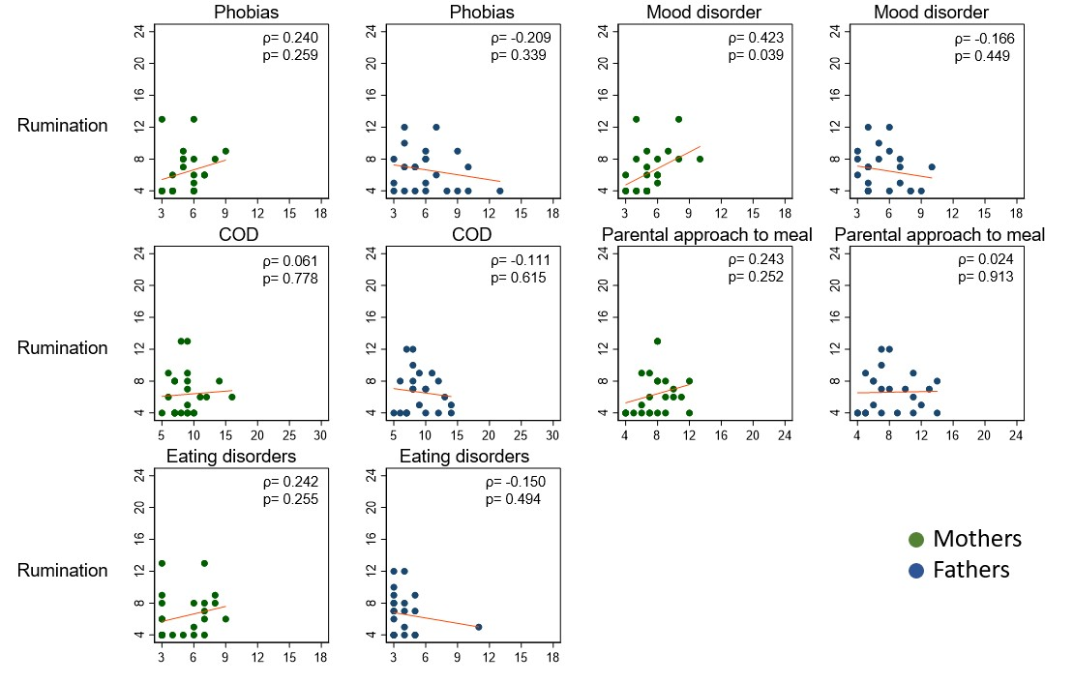
Figure S2. Scatterplots of children's infantile anorexia scores in relation to parental psychopathology scores. Maternal scores are shown in green and paternal scores in blue. The estimated regression line is shown in red. The x- and y-axes represent the hypothetical range of variation for each variable. For each scatterplot, Pearson's correlation coefficient and the corresponding p-value are reported.

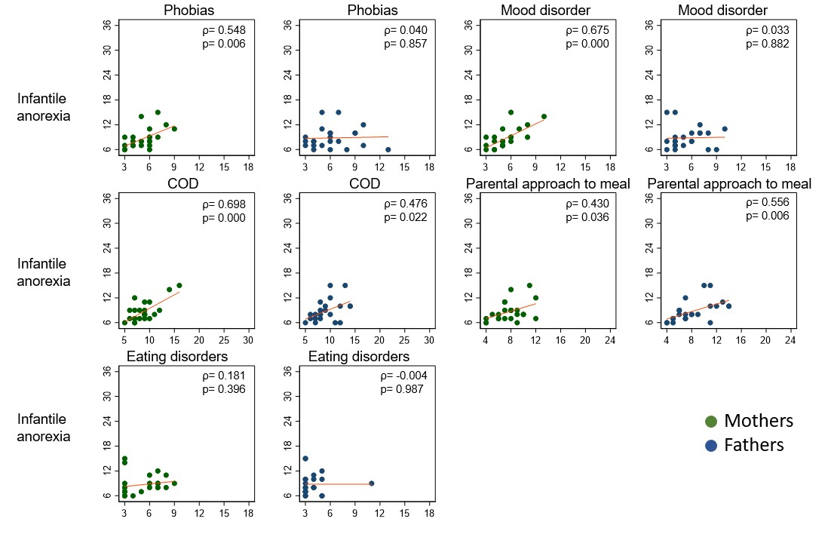
Figure S3. Scatterplots of children's sensory food aversion scores in relation to parental psychopathology scores. Maternal scores are shown in green and paternal scores in blue. The estimated regression line is shown in red. The x- and y-axes represent the hypothetical range of variation for each variable. For each scatterplot, Pearson's correlation coefficient and the corresponding p-value are reported.

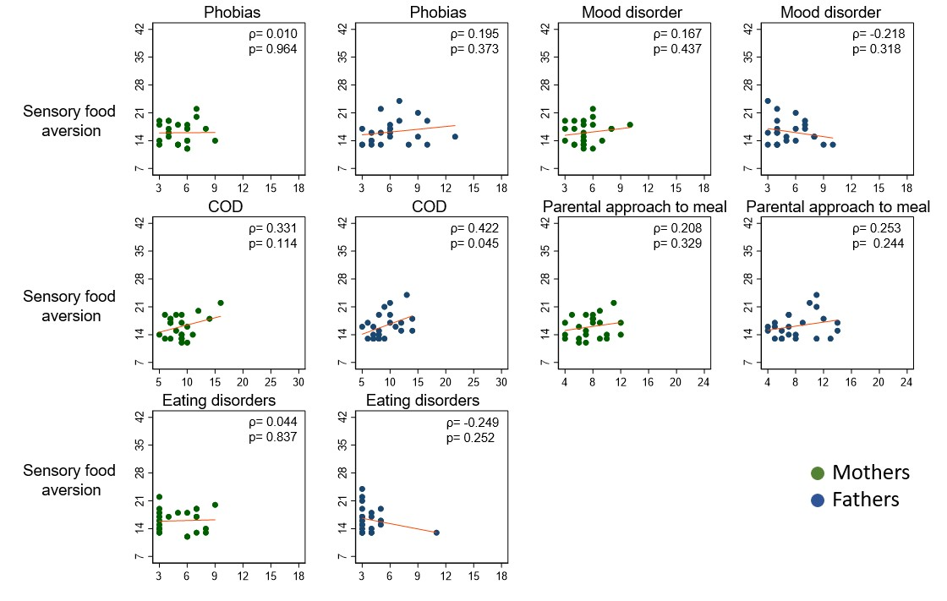
Figure S4. Scatterplots of children's post-traumatic feeding disorder scores in relation to parental psychopathology scores. Maternal scores are shown in green and paternal scores in blue. The estimated regression line is shown in red. The x- and y-axes represent the hypothetical range of variation for each variable. For each scatterplot, Pearson's correlation coefficient and the corresponding p-value are reported.

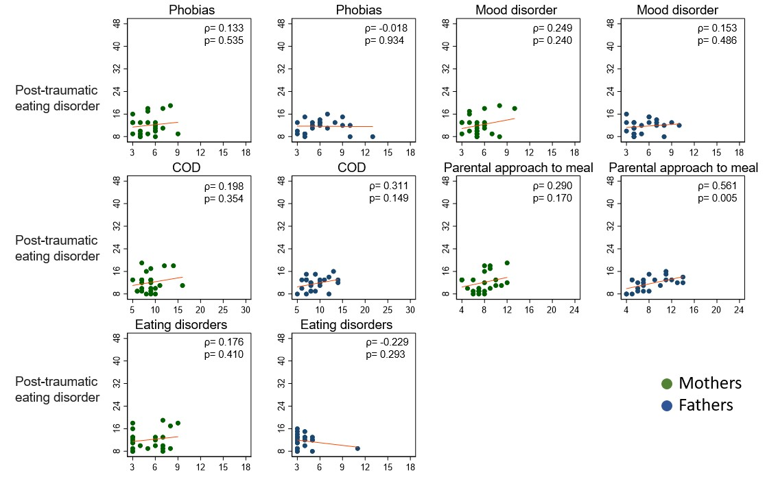
Figure S5. Scatterplots of children's oral-motor feeding disorder scores in relation to parental psychopathology scores. Maternal scores are shown in green and paternal scores in blue. The estimated regression line is shown in red. The x- and y-axes represent the hypothetical range of variation for each variable. For each scatterplot, Pearson's correlation coefficient and the corresponding p-value are reported.

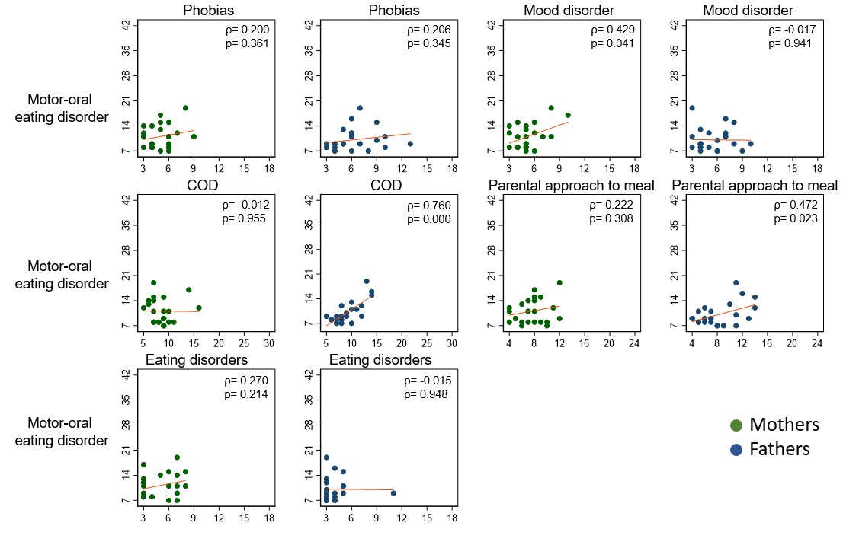
Figure S6. Scatterplots of children's food approach scores in relation to parental psychopathology scores. Maternal scores are shown in green and paternal scores in blue. The estimated regression line is shown in red. The x- and y-axes represent the hypothetical range of variation for each variable. For each scatterplot, Pearson's correlation coefficient and the corresponding p-value are reported.

