Table S1 The optimal hyper-parameters of each ML models obtained through grid search for trait of TNB and NBA.
Method | Optimal hyper-parametersª
SVR | kernel = ‘rbf’, C=7, gamma=0.0001
KRR | kernel= ‘rbf’, α=0.1, gamma=0.0001
RF | n_estimators=250, max_depth=None
Adaboost.R2_(SVR) | kernel=’rbf’, C=7, gamma=0.0001
Adaboost.R2_(KRR) | kernel=’rbf’, α=0.01, gamma=0.0001
ª Optimal hyper-parameters: The optimal hyper-parameters of each machine learning method found by using grid search

Table S2 Prediction performance for TNB and NBA performed with ML methods using the default hyper-parameters as assessed with 20 replicates of 5-fold CV
Method | TNB^{c} |  | NBA^{d}
Method | Accuracyª | Unbiasedness^{b} | Accuracyª | Unbiasedness^{b}
SVR | 0.255±0.027 | 1.275±0.147 | 0.224±0.023 | 1.098±0.126
KRR | 0.264±0.025 | 1.007±0.108 | 0.222±0.024 | 0.879±0.101
RF | 0.246±0.028 | 1.064±0.142 | 0.225±0.027 | 1.002±0.128
Adaboost.R2_(KRR) | 0.254±0.024 | 0.759±0.085 | 0.209±0.027 | 0.636±0.085
ª Accuracy: the correlation between corrected phenotypes and GEBVs of the validation population;
^{b} Unbiasedness: the regression of corrected phenotypes onto the GEBVs
^{c} TNB: total number of piglets born
^{d} NBA: number of piglets born alive

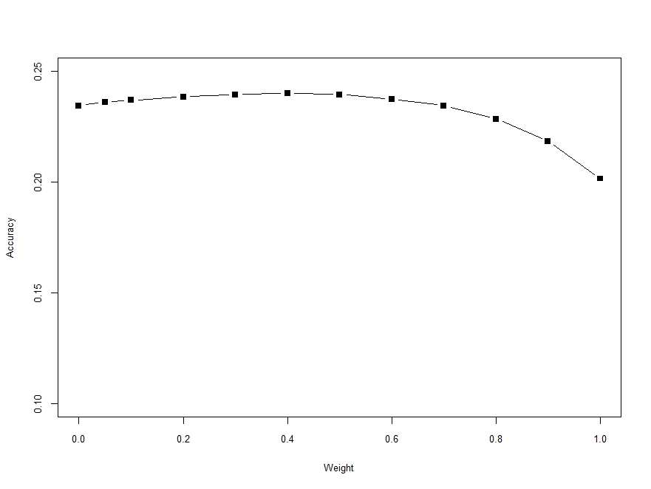
Figure S1 Accuracy of genomic prediction obtained from the ssGBLUP method with different weighting factors, averaged by TNB and NBA and assessed by 20 replicates of 5-fold CV.

