Supplementary Materials

Effects of modification and co-aging with soils on Cd(II) adsorption behaviors and quantitative mechanisms by biochar
Zhuowen Meng¹, Shuang Huang^{1*}, Zhongbing Lin¹
¹ State Key Laboratory of Water Resources and Hydropower Engineering Sciences, Wuhan University, Wuhan 430072, China (First author: 2018202060124@whu.edu.cn; Corresponding author: hsh5527@whu.edu.cn.)

Number of pages = 5
Number of table = 2
Number of figures = 1
The isotherm data of Cd(II) adsorption on biochars were fitted by the Langmuir (LM, Eq (1)) and Freundlich model (FM, Eq (2)):
(1)
(2)
Where C_{e} (mg·L⁻¹) is the concentration of Cd(II) in the solution after equilibration, Q_{e} (mg·g⁻¹) is the adsorbed amount of Cd(II) on the biochar after equilibration, Q_{m} (mg·g⁻¹) is the maximum Cd(II) adsorption capacity for the biochar, K_{L} (L·mg⁻¹) and K_{F} (mg·g⁻¹) (mg·L⁻¹)^{−n} are the adsorption coefficients of the LM and FM, respectively, and n (dimensionless) is a constant fitted by the FM relevant to the adsorption heterogeneity of biochar surface.
Table S1 Parameters of Cd(II) adsorption on biochars obtained from Langmuir and Freundlich isotherm models.
Biochar | Langmuir model |  |  | Freundlich model
Biochar | Q_{mL}  (mg·g⁻¹) | K_{L}  (L·mg⁻¹) | R² | K_{F}  (mg·g⁻¹)·(mg·L⁻¹)^{-n} | n | R²
BC | 54.26 | 1.68 | 0.996 | 26.82 | 0.17 | 0.835
MBC | 117.33 | 2.79 | 0.969 | 59.72 | 0.19 | 0.821
OBC | 60.52 | 4.15 | 0.965 | 35.39 | 0.14 | 0.920
PBC | 48.16 | 0.56 | 0.916 | 21.50 | 0.19 | 0.943
PMBC | 105.27 | 0.10 | 0.927 | 21.14 | 0.35 | 0.992
ABC | 47.28 | 0.01 | 0.978 | 2.01 | 0.55 | 0.941
AMBC | 210.81 | 0.01 | 0.954 | 2.96 | 0.70 | 0.972
BBC | 65.78 | 0.01 | 0.964 | 1.72 | 0.61 | 0.960
BMBC | 503.62 | 0.01 | 0.970 | 1.41 | 0.85 | 0.976
CBC | 88.79 | 0.02 | 0.887 | 7.54 | 0.44 | 0.944
CMBC | 82.38 | 0.09 | 0.893 | 19.10 | 0.31 | 0.988
Q_{mL} (mg·g⁻¹) is the maximum adsorption capacity of Cd(II) by biochars fitted by Langmuir isotherm model;
K_{L} (L·mg⁻¹) and K_{F} (mg·g⁻¹) (mg·L⁻¹)^{−n} are the adsorption coefficients of the LM and FM;
n (dimensionless) is a constant fitted by the FM relevant to the adsorption heterogeneity of biochar surface.
Table S2 Major cations released from and metals adsorbed on biochars during adsorption
Element (mg·L⁻¹) | K | Na | Ca | Mg | Sum
BC | 0.315 | 0 | 4.345 | 1.388 | 6.05
MBC | 0.502 | 0 | 3.104 | 2.864 | 6.48
PBC | 0 | 0 | 5.61 | 3.607 | 9.22
PMBC | 0 | 0 | 2.32 | 2.239 | 4.56
ABC | 0 | 0 | 0.644 | 0 | 0.64
AMBC | 0 | 0 | 3.51 | 0.125 | 3.63
BBC | 0 | 0 | 2.138 | 0.083 | 2.22
BMBC | 0 | 0 | 4.844 | 0.092 | 4.94
CBC | 0 | 0 | 0 | 0 | 0
CMBC | 0 | 0 | 0.819 | 1.005 | 1.82

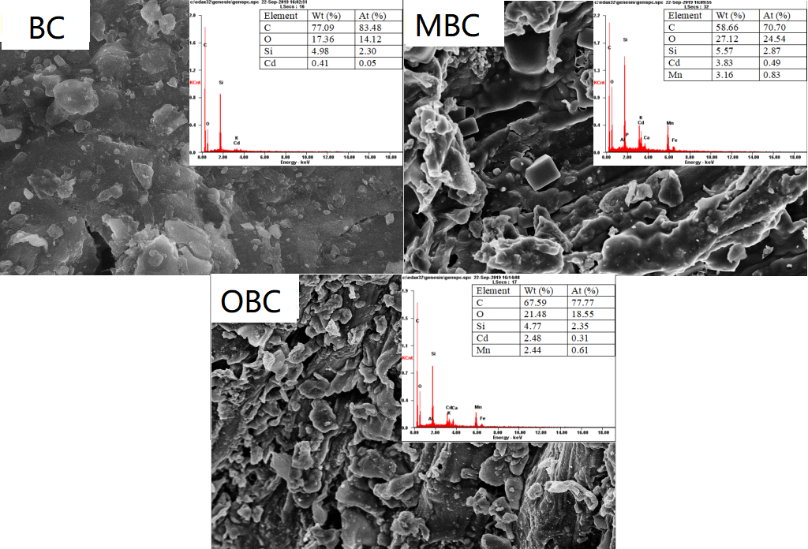
Fig. S1 SEM-EDS images of the biochars (BC, MBC, OBC) after the adsorption of Cd(II)

