Architecting Diabolo-Shaped Ln₉ (Ln = Tb, Dy, Ho, Er) Homonuclear Clusters: Structural Topology, Magnetic Relaxation, and Theoretical Elucidation.
Vipanchi,ª Keiichi Katoh,^{b} Nobuto Funakoshi,^{c} Nabanita Deb,^{d} Arun Kumar Bar,^{d*} Masahiro Yamashita,^{c,e*} Kuduva R. Vignesh^{a*}
ª Department of Chemical Sciences, Indian Institute of Science Education and Research (IISER) Mohali, Sector-81, Knowledge city, S.A.S. Nagar, Mohali-140306, Punjab, India.
Email: vigneshkuduvar@iisermohali.ac.in
^{b}Department of Chemistry, Graduate School of Science, Josai University, 1-1 Keyakidai, Sakado, Saitama 350-0295, Japan
^{c} Institute of Materials Research, Tohoku University, 2-1-1 Katahira, Aoba-Ku, Sendai 980-8577, Japan. E-mail: masahiro.yamashita.c5@tohoku.ac.jp
^{d} Department of Chemistry, Indian Institute of Science Education and Research Tirupati, Tirupati – 517619, Andhra Pradesh, India. E-mail: a.bar@iisertirupati.ac.in

^{e} School of Chemical Science and Engineering, Tongji University, Siping Road 1239, Shanghai 200092, P. R. China

Table of Contents:

Figures S1-S8, Tables S1-S10….……….……….…….………… Crystallographic details
Figures S9-S12…………………………..…….…………………….…………….…PXRD
Figures S13-S17……………………..……...…………………………..……... Magnetism
Figures S18-S19, Tables S11-S19…………..……………………….... Theoretical Studies

Materials and Characterisation Studies.
Experimental Section
All the reactions were performed at room temperature. Starting materials such as Lanthanide nitrate hydrated salts (Ln = Tb, Dy, Ho, Er) were obtained from Sigma Aldrich (~ 99.9% purity). HBzAc (1-Phenyl-1,3-butanedione) and triethylamine were procured from commercial sources materials and the products were found to be stable toward moisture and air. HPLC-grade Methanol and Acetonitrile were commercially also purchased. The compounds were prepared using the synthesis procedure reported earlier.⁵⁸

Preparation of [Tb₉(µ₄-OH)₂(µ₃-OH)₈(µ-BzAc)₈(BzAc)₈].NO₃ (1-Tb). To the mixture of Tb(NO₃)₃.5H₂O (0.5 mmol) in MeOH (10 mL) and MeCN (10 mL), HBzAc (1.0 mmol) was added, followed by the dropwise addition of triethylamine (1.0 mmol) to the reaction mixture. After 24 h stirring, the clear colorless mixture was filtered, and the filtrate was left undisturbed at room temperature. Colorless block-shaped single-crystals were obtained through slow evaporation after 12 days, suitable for X-ray diffraction analysis. These crystals were washed with diethyl ether and dried overnight and collected for magnetic measurements with the yield through slow evaporation of (65%, crystalline product); IR (KBr diluted, cm^{‒1}) ν_{max}: 3340 (br), 3057 (s), 1615 (m), 1526 (m), 1455 (s), 1399 (w), 1281 (w), 1208(s), 1179 (s), 1105 (w), 1069 (s), 1003 (s), 963 (w), 844 (s), 767 (s), 718 (s)

Preparation of [Dy₉(µ₄-OH)₂(µ₃-OH)₈(µ-BzAc)₈(BzAc)₈]NO₃.2MeOH.MeCN (2-Dy). The synthetic procedure was the same as that in the case of 1-Tb; only the mole ratio of metal precursors was varied. Dy(NO₃)₃.6H₂O (0.5 mmol) was used in the synthesis to yield the title complex 2-Dy. Colorless block-shaped single crystals were obtained through slow evaporation after 12 days, suitable for X-ray diffraction analysis. These crystals were washed with diethyl ether and dried for overnight and collected for magnetic measurements with the yield of (58%, crystalline product); FT-IR (KBr diluted, cm^{‒1}) ν_{max}: 3340 (br), 3057 (s), 1615 (m), 1526 (m), 1455 (s), 1405 (w), 1278 (w), 1216(s), 1183 (s), 1105 (w), 1073 (s), 997 (s), 962 (w), 842 (s), 733 (s), 715 (s)

Preparation of [Ho₉(µ₄-O)(µ₄-OH)(µ₃-OH)₈(µ-BzAc)₈(BzAc)₈] (3-Ho). The synthetic procedure was the same as that in the case of 1-Tb, replacing the metal precursors to Ho(NO₃)₃.5H₂O (0.5 mmol) in the synthesis to yield the title compound 3-Ho. Colorless block-shaped single crystals were obtained through slow evaporation after 12 days, suitable for X-ray diffraction analysis. These crystals were washed with diethyl ether and dried for overnight and collected for magnetic measurements with the yield of (70%, crystalline product); FT-IR (KBr diluted, cm^{‒1}) ν_{max}: 3342 (br), 2966 (s), 1636 (m), 1383 (m), 1260 (s), 1097 (s), 1024 (s), 969.8 (s), 853 (s), 803 (s), 755 (s)

Preparation of [Er₉(µ₄-O)(µ₄-OH)(µ₃-OH)₈(µ-BzAc)₈(BzAc)₈] (4-Er). The synthetic procedure was the same as that in the case of 1-Tb, by using Er(NO₃)₃.5H₂O (0.5 mmol) instead of Tb salt, and yielded the title compound 4-Er. Colorless block-shaped single crystals were obtained through slow evaporation in the majority after 12 days, suitable for X-ray diffraction analysis. These crystals were washed with diethyl ether and dried for overnight and collected for magnetic measurements with the yield of (63%, crystalline product); FT-IR (KBr diluted, cm^{‒1}) ν_{max}: 3338 (br), 3062 (s), 1607 (m), 1530 (m), 1452 (s), 1399 (w), 1281 (w), 1208(s), 1179 (s), 1105 (w), 1069 (s), 1003 (s), 963 (w), 844 (s), 767 (s), 718 (s).

Single-crystal X-ray crystallography
Single-Crystal XRD Details: Single crystals suitable for diffraction were coated with Paratone oil and mounted on a goniometer. Diffraction data were recorded on a Bruker D8 Advance (Da Vinci) diffractometer equipped with an Oxford Cryosystems cooling unit and operated with Mo-Kα radiation. Structure solutions were obtained via direct methods using SIR92 or Superflip, followed by full-matrix least-quares refinement on F implemented in the Olex2 software package. Atomic scattering factors were taken from the International Tables for X-ray Crystallography. Absorption effects were collected using a multi-scan technique. Hydrogen atoms were introduced at geometrically predicted positions. In the initial stages of refinement, soft restraints were applied to X-H distances and H-X-H angles to standardize geometry and U iso(H) values (1.2-1.5 x Ueq of the carrier atom). Final refinement employed riding models. All non-hydrogen atoms were refined with anisotropic displacement parameters. A summary of crystallographic measurements and results is provided in Table S1, while key bond metrics are listed in Tables S2-S9. CIF files for complexes have been deposited with the CCDC under deposition numbers.
The bulk purity was characterized using experimental Powder X-ray diffraction (PXRD) data for the four powder samples, which were collected on a Rigaku Ultima IV fully automatic high-resolution X-ray diffractometer system with a Theta-Theta (θ-θ) Goniometer, used for routine characterization of powder samples. Scans were performed at room temperature in the 2θ range 5-50° and compared with the predicted patterns based on low-temperature single-crystal X-ray data.

Table S1. Crystal data and structure refinement parameters for complexes 1-Tb − 4-Er.
 | 1-Tb | 2-Dy | 3-Ho | 4-Er
Empirical formula | C₁₈₄H₂₁₀N₉O₅₃Tb₉ | C₁₆₅H₁₆₇Dy₉N₂O₄₈ | C₁₆₃H₁₆₂Ho₉NO₄₄ | C₁₆₆H₁₇₂Er₉NO₄₆
CCDC No. | 2583387 | 2583386 | 2583385 | 2583384
Formula weight | 4825.88 | 4408.50 | 4323.30 | 4422.38
Temperature/K | 100 | 150 | 150 | 100
Crystal system | cubic | triclinic | triclinic | triclinic
Space group | P_{n}/3_{n} | P$\overline{1}$ | P$\overline{1}$ | P$\overline{1}$
a/Å | 33.8291(5) | 17.4787(6) | 17.234(16) | 17.2523(6)
b/Å | 33.8291(5) | 17.5178(5) | 17.656(16) | 17.4403(7)
c/Å | 33.8291(5) | 30.8654(10) | 29.36(6) | 30.7749(11)
α/° | 90 | 85.1490(10) | 94.26(3) | 85.0790(10)
β/° | 90 | 81.1980(10) | 91.82(3) | 81.4070(10)
γ/° | 90 | 85.3250(10) | 94.529(17) | 85.2650(10)
Volume/Å³ | 38714.3(17) | 9283.3(5) | 8876(15) | 9099.1(6)
Z | 6 | 2 | 2 | 2
ρ_{calc}g/cm³ | 1.242 | 1.577 | 1.618 | 1.617
μ/mm⁻¹ | 2.491 | 3.645 | 4.032 | 4.172
F(000) | 14316.0 | 4298.0 | 4204.0 | 4318
Crystal size/mm³ | 0.04 × 0.04 × 0.01 | 0.02 × 0.01 × 0.01 | 0.03 × 0.02 × 0.01 | 0.02 × 0.02 × 0.01
Radiation | MoKα (λ = 0.71073) | MoKα (λ = 0.71073) | MoKα (λ = 0.71073) | MoKα (λ = 0.71073)
2Θ range for data collection/° | 5.108 to 52.758 | 3.626 to 50.054 | 3.484 to 50.352 | 3.434 to 50.054
Index ranges | -42 ≤ h ≤ 42, -42 ≤ k ≤ 42, -41 ≤ l ≤ 42 | -20 ≤ h ≤ 20, -20 ≤ k ≤ 20, -36 ≤ l ≤ 36 | -20 ≤ h ≤ 18, -21 ≤ k ≤ 21, -35 ≤ l ≤ 35 | -20 ≤ h ≤ 18, -20 ≤ k ≤ 20, -36 ≤ l ≤ 36
Reflections collected | 486437 | 230233 | 195657 | 124713
Independent reflections | 6617  [R_{int} = 0.0720, R_{sigma} = 0.0119] | 32670 [R_{int} = 0.0652, R_{sigma} = 0.0368] | 31574  [R_{int} = 0.1796, R_{sigma} =0.1228] | 37236  [R_{int} = 0.0427, R_{sigma} = 0.0388]
Data/restraints/parameters | 6617/26/272 | 32670/703/2110 | 31574/1129/2022 | 37236/336/1993
Goodness-of-fit on F² | 1.146 | 1.032 | 1.003 | 1.087
Final R indexes [I>=2σ (I)] | R1 = 0.0550, wR2 = 0.1420 | R1 = 0.0376, wR2 = 0.1084 | R₁ = 0.0587, wR₂ = 0.1289 | R₁ = 0.0511, wR₂ = 0.1424
Final R indexes [all data] | R₁ = 0.0720, wR₂ = 0.1641 | R₁ = 0.0450, wR₂ = 0.1142 | R₁ = 0.1213, wR₂ = 0.1570 | R₁ = 0.0636, wR₂ = 0.1546
Largest diff. peak/hole / e Å⁻³ | 0.92/-0.68 | 4.11/-1.20 | 1.24/-1.10 | 3.35/-1.32

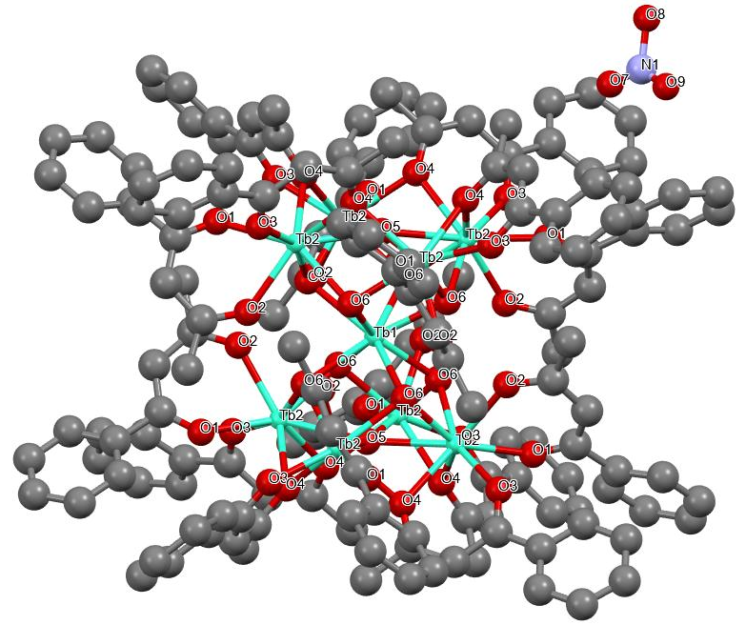
Figure S1. Labeled representation of compound 1-Tb. Color scheme: Dy, yellow; green, C, black. H atoms are omitted for the sake of clarity. ¹1-X,+Y,1/2-Z; ²2-X,+Y,1/2-Z
Figure S2. Packing diagram of compound 1-Tb.
Table S2. Measured bond distances for compound 1-Tb.
Tb1 Tb2¹ 3.7066(3) O4 C19 1.313(10)
Tb1 Tb2² 3.7066(3) Tb1 Tb2³ 3.7066(3)
Tb1 Tb2⁴ 3.7066(3) Tb1 O6¹ 2.412(5)
Tb1 O6³ 2.412(5) Tb1 O6⁵ 2.412(5)
Tb1 O6⁶ 2.412(5) Tb1 O6 2.412(5)
Tb1 O6⁷ 2.412(5) Tb1 O6⁴ 2.412(5)
Tb1 O6² 2.412(5) Tb2 Tb2² 3.6272(5)
Tb2 Tb2³ 3.6272(5) Tb2 O2 2.323(5)
Tb2 O1 2.315(5) Tb2 O5 2.5789(11)
Tb2 O3 2.326(5) Tb2 O6 2.315(5)
Tb2 O6³ 2.301(5) Tb2 O4 2.410(5)
Tb2 O4² 2.426(5) O2 C2 1.289(9)
O1 C4 1.261(9) O3 C17 1.261(9)
¹3/2-X,1/2-Y,+Z; ²3/2-Z,+Y,+X; ³+Z,+Y,3/2-X; ⁴3/2-Z,1/2-Y,3/2-X; ⁵+Z,1/2-Y,+X; ⁶+X,1/2-Y,3/2-Z; ⁷3/2-X,+Y,3/2-Z
Table S3. Measured bond angles for compound 1-Tb.
Tb2¹ Tb1 Tb2² 58.587(6) O5 Tb2 Tb1 52.2(2) Tb2³ Tb1 Tb2⁴ 87.570(11)
O5 Tb2 Tb2⁴ 45.31(2) Tb2¹ Tb1 Tb2⁴ 101.155(11) O5 Tb2 Tb2³ 45.31(2)
Tb2² Tb1 Tb2³ 99.913(11) O3 Tb2 Tb1 140.63(14) Tb2¹ Tb1 Tb2³ 148.096(10)
O3 Tb2 Tb2³ 157.91(14) Tb2² Tb1 Tb2⁴ 150.488(10) O3 Tb2 Tb2⁴ 97.83(14)
O61 Tb1 Tb2³ 111.01(12) O3 Tb2 O5 135.31(19) O6 Tb1 Tb2² 111.01(12)
O3 Tb2 O4³ 116.66(18) O6² Tb1 Tb2⁴ 165.43(13) O3 Tb2 O4 70.68(18)
O6⁴ Tb1 Tb2¹ 113.63(12) O6 Tb2 Tb1 39.30(12) O6⁴ Tb1 Tb2⁴ 37.44(12)
O6⁴ Tb2 Tb1 39.21(13) O6⁵ Tb1 Tb24 37.09(12) O6 Tb2 Tb2⁴ 95.89(13)
O6⁵ Tb1 Tb2¹ 77.97(13) O6 Tb2 Tb2³ 38.06(13) O6⁶ Tb1 Tb2⁴ 77.97(13)
O6⁴ Tb2 Tb2⁴ 38.35(13) O6³ Tb1 Tb2³ 37.44(12) O6⁴ Tb2 Tb2³ 95.93(13)
O6 Tb1 Tb2³ 37.09(12) O6 Tb2 O2 79.91(18) O6 Tb1 Tb2⁴ 92.19(13)
O6⁴ Tb2 O2 76.05(17) O6⁴ Tb1 Tb2³ 91.98(13) O6⁴ Tb2 O1 148.52(19)
O6⁷ Tb1 Tb2¹ 91.98(13) O6 Tb O5 65.3(2) O6³ Tb1 Tb2⁴ 91.98(13)
O6⁴ Tb2 O5 65.5(2) O6⁶ Tb1 Tb2² 91.98(13) O6 Tb2 O3 158.23(19)
O6⁷ Tb1 Tb2³ 113.63(12) O6⁴ Tb2 O3 103.04(19) O6⁶ Tb1 Tb2³ 165.43(13)
O6⁴ Tb2 O6 77.9(2) O6⁵ Tb1 Tb2² 113.63(12) O6 Tb2 O4 129.59(18)
O6⁴ Tb1 Tb2² 165.43(13) O6 Tb2 O4³ 76.11(17) O6² Tb1 Tb2¹ 92.20(13)
O6⁴ Tb2 O4 76.68(18) O61 Tb1 Tb2¹ 37.44(12) O6⁴ Tb2 O4³ 129.52(18)
O6³ Tb1 Tb2¹ 111.01(12) O4 Tb2 Tb1 101.31(12) O6⁷ Tb1 Tb2² 92.20(13)
O4³ Tb2 Tb1 101.00(12) O6² Tb1 Tb2³ 77.97(13) O4³ Tb2 Tb2³ 41.25(12)
O6² Tb1 Tb2² 37.44(12) O4³ Tb2 Tb2⁴ 103.32(11) O6¹ Tb1 Tb2⁴ 113.63(12)
O4 Tb2 Tb2⁴ 41.57(12) O6¹ Tb1 Tb2² 37.09(12) O4 Tb2 Tb2³ 103.41(12)
O6 Tb1 Tb2¹ 165.43(13) O4 Tb2 O5 64.67(18) O6⁷ Tb1 Tb2⁴ 111.01(12)
O4³ Tb2 O5 64.47(18) O6⁵ Tb1 Tb2³ 92.20(13) O4 Tb2 O4³ 87.9(2)
O6⁶ Tb1 Tb2¹ 37.09(12) C2 O2 Tb2 135.5(5) O6³ Tb1 Tb2² 77.97(13)
C4 O1 Tb2 133.5(5) O6⁷ Tb1 O6⁵ 140.1(2) Tb2⁵ O5 Tb2³ 89.38(5)
O6¹ Tb1 O6⁴ 143.9(2) Tb2⁴ O5 Tb2³ 168.0(4) O6³ Tb1 O6 73.94(12)
Tb2⁴ O5 Tb2 89.38(5) O6⁷ Tb1 O6³ 143.9(2) Tb2⁵ O5 Tb2 168.0(4)
O6⁶ Tb1 O6³ 140.1(2) Tb2⁵ O5 Tb2⁴ 89.38(5) O6⁷ Tb1 O6 77.7(3)
Tb2³ O5 Tb2 89.38(5) O6⁴ Tb1 O6² 140.1(2) C17 O3 Tb2 138.3(5)
O6⁷ Tb1 O6² 73.94(12) Tb2 O6 Tb1 103.26(19) O6¹ Tb1 O6⁷ 116.5(3)
Tb2³ O6 Tb1 103.7(2) O6⁵ Tb1 O6³ 73.94(12) Tb2³ O6 Tb2 103.6(2)
O6¹ Tb1 O6 140.1(2) Tb2 O4 Tb2⁴ 97.19(18) O6⁵ Tb1 O6 116.5(3)
C19 O4 Tb2 131.8(5) O6⁶ Tb1 O6⁴ 77.7(3) C19 O4 Tb2⁴ 125.9(4)
O6⁴ Tb1 O6⁵ 73.94(12) O6¹ Tb1 O6⁵ 77.7(3) O2 C2 C3 121.4(8)
O6² Tb1 O6 75.2(2) O2 C2 C1 117.8(7) O6⁶ Tb1 O6 143.9(2)
O6⁵ Tb1 O6² 143.9(2) O3 C17 C18 122.5(7) O6¹ Tb1 O6² 73.94(12)
O3 C17 C16 117.2(7) O6³ Tb1 O6² 77.7(3) O6⁴ Tb1 O6 73.94(12)
O1 C4 C3 125.1(7) O6⁴ Tb1 O6⁷ 75.2(2) O1 C4 C5 116.3(7)
O6⁶ Tb1 O6² 116.5(3) O6⁶ Tb1 O6⁵ 75.2(2) O6⁴ Tb1 O6³ 116.5(3)
O6¹ Tb1 O6⁶ 73.94(12) O6¹ Tb1 O6³ 75.2(2) O6⁶ Tb1 O6⁷ 73.94(12)
Tb2³ Tb2 Tb1 60.705(3) Tb2⁴ Tb2 Tb1 60.705(3) Tb2³ Tb2 Tb2⁴ 89.999(1)
O4 C19 C18 124.9(7) O2 Tb2 Tb1 79.89(12) O4 C19 C20 114.5(7)
O2 Tb2 Tb2⁴ 112.43(12) O2 Tb2 Tb2³ 116.77(12) O2 Tb2 O5 132.0(3)
O2 Tb2 O3 79.25(18) O2 Tb2 O4 133.06(17) O2 Tb2 O4³ 138.54(17)
O1 Tb2 Tb1 128.18(13) O1 Tb2 Tb2³ 93.99(13) O1 Tb2 Tb2⁴ 171.03(14)
O1 Tb2 O2 72.80(17) O1 Tb2 O5 136.81(14) O1 Tb2 O3 75.64(19)
O7 N1 O8 113(4) O1 Tb2 O6 92.19(18) O9 N1 O7 130(5)
O1 Tb2 O4 129.51(18) O9 N1 O8 117(4) O1 Tb2 O4³ 74.85(17)
¹3/2-Z,1/2-Y,3/2-X; ²3/2-X,1/2-Y,+Z; ³3/2-Z,+Y,+X; ⁴+Z,+Y,3/2-X; ⁵3/2-X,+Y,3/2-Z; ⁶+X,1/2-Y,3/2-Z; ⁷+Z,1/2-Y,+X
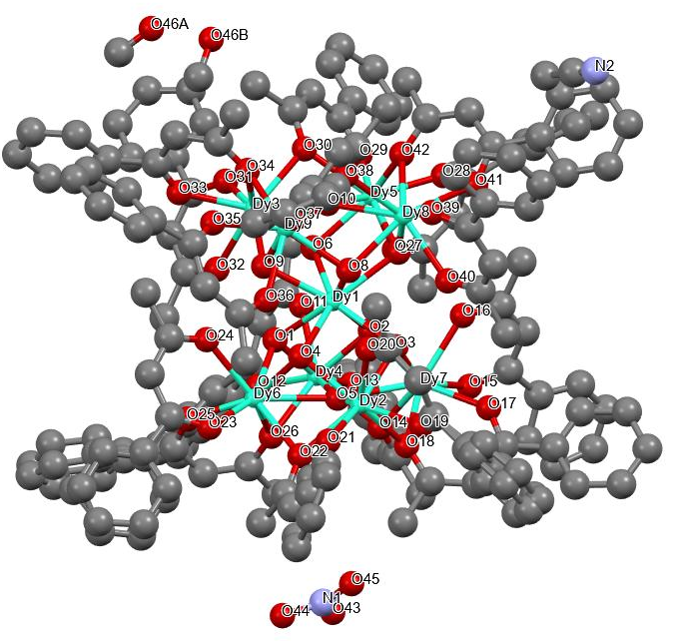
Figure S3. Labeled representation of compound 2-Dy. Color scheme: Dy, yellow; green, C, black. H atoms are omitted for the sake of clarity. ¹1-X,+Y,1/2-Z; ²2-X,+Y,1/2-Z
Figure S4. Packing diagram of compound 2-Dy.

Table S4. Measured bond distances for compound 2-Dy.
Dy1 Dy6 3.6854(4) Dy1 Dy4 3.6879(4)
Dy1 Dy2 3.6871(4) Dy1 O9 2.410(4)
Dy1 O7 2.419(4) Dy1 O6 2.415(4)
Dy1 O2 2.417(4) Dy1 O8 2.419(4)
Dy1 O5 2.908(4) Dy1 O1 2.418(4)
Dy1 O3 2.417(4) Dy1 O4 2.410(4)
Dy5 Dy8 3.6035(4) Dy5 Dy3 3.5931(4)
Dy5 O7 2.314(4) Dy5 O6 2.289(4)
Dy5 O28 2.309(4) Dy5 O10 2.568(4)
Dy5 O29 2.311(5) Dy5 O30 2.413(4)
Dy5 O27 2.334(4) Dy5 O42 2.405(4)
Dy6 Dy4 3.6044(4) Dy6 Dy2 3.6003(4)
Dy6 O5 2.542(4) Dy6 O1 2.293(4)
Dy6 O26 2.423(4) Dy6 O4 2.304(4)
Dy6 O22 2.410(4) Dy6 O23 2.297(5)
Dy6 O24 2.326(4) Dy6 O25 2.314(5)
Dy4 Dy7 3.5793(4) Dy4 O2 2.287(4)
Dy4 O5 2.529(4) Dy4 O11 2.333(4)
Dy4 O1 2.310(4) Dy4 O26 2.408(4)
Dy4 O14 2.415(4) Dy4 O13 2.328(5)
Dy4 O12 2.290(4) Dy2 Dy7 3.5830(4)
Dy2 O5 2.572(4) Dy2 O20 2.332(4)
Dy2 O3 2.314(4) Dy2 O4 2.287(4)
Dy2 O22 2.433(4) Dy2 O18 2.399(4)
Dy2 O19 2.301(4) Dy2 O21 2.293(4)
Dy8 Dy9 3.6112(4) Dy8 O7 2.292(4)
Dy8 O8 2.318(4) Dy8 O40 2.340(4)
Dy8 O41 2.337(4) Dy8 O38 2.427(4)
Dy8 O39 2.299(4) Dy8 O10 2.561(4)
Dy8 O42 2.406(4) Dy3 Dy9 3.5989(4)
Dy3 O9 2.293(4) Dy3 O6 2.305(4)
Dy3 O10 2.568(4) Dy3 O32 2.333(4)
Dy3 O31 2.307(5) Dy3 O30 2.406(4)
Dy3 O34 2.416(4) Dy3 O33 2.287(5)
Dy9 O9 2.310(4) Dy9 O8 2.292(4)
Dy9 O38 2.423(4) Dy9 O10 2.545(4)
Dy9 O34 2.411(5) Dy9 O36 2.341(5)
Dy9 O37 2.315(5) Dy9 O35 2.316(5)
Dy7 O2 2.307(4) Dy7 O5 2.560(4)
Dy7 O3 2.284(4) Dy7 O16 2.333(4)
Dy7 O14 2.405(4) Dy7 O18 2.413(4)
Dy7 O15 2.289(4) Dy7 O17 2.326(4)
O11 C2 1.269(8) O20 C49 1.269(8)
O26 C79 1.305(7) O40 C149 1.272(8)
O41 C157 1.269(8) O38 C139 1.311(8)
O28 C84 1.274(8) O39 C147 1.281(8)
O22 C59 1.298(7) O23 C67 1.283(9)
O16 C29 1.260(8) O24 C69 1.266(8)
O14 C19 1.300(8) O32 C109 1.267(8)
O18 C39 1.290(8) O31 C107 1.285(8)
O29 C97 1.275(8) O30 C99 1.309(8)
O19 C47 1.281(8) O27 C82 1.265(8)
O13 C17 1.252(9) O34 C119 1.288(8)
O36 C129 1.258(8) O15 C27 1.263(8)
O12 C4 1.275(9) O37 C137 1.270(8)
O25 C77 1.243(8) O17 C37 1.261(8)
O21 C57 1.252(8) O35 C127 1.275(9)
O33 C117 1.278(8) O44 N1 1.311(15)
C77 C76A 1.506(14) N1 O43 1.310(16)
N1 O45 1.342(16) O46B C163 1.28(3)

Table S5. Measured bond angles for compound 2-Dy.
Dy6 Dy1 Dy4 58.529(7) O35 Dy9 Dy1 131.52(12) Dy6 Dy1 Dy2 58.463(7)
O35 Dy9 Dy8 167.50(12) Dy2 Dy1 Dy4 87.057(8) O35 Dy9 Dy3 96.21(14)
O9 Dy1 Dy6 77.69(9) O35 Dy9 O38 125.71(16) O9 Dy1 Dy4 112.45(9)
O35 Dy9 O10 138.19(17) O9 Dy1 Dy2 112.18(10) O35 Dy9 O34 74.21(18)
O9 Dy1 O7 116.60(13) O35 Dy9 O36 73.03(18) O9 Dy1 O6 73.99(14)
Dy4 Dy7 Dy1 60.949(7) O9 Dy1 O2 141.88(13) Dy4 Dy7 Dy2 90.334(9)
O9 Dy1 O8 74.01(14) Dy2 Dy7 Dy1 60.901(8) O9 Dy1 O5 121.07(12)
O2 Dy7 Dy1 39.71(9) O9 Dy1 O1 75.98(13) O2 Dy7 Dy4 38.63(9)
O9 Dy1 O3 142.31(14) O2 Dy7 Dy2 96.71(9) O9 Dy1 O4 76.27(14)
O2 Dy7 O5 65.29(13) O7 Dy1 Dy6 165.70(9) O2 Dy7 O16 77.24(14)
O7 Dy1 Dy4 112.31(9) O2 Dy7 O14 77.65(14) O7 Dy1 Dy2 112.63(9)
O2 Dy7 O18 129.26(14) O7 Dy1 O8 73.87(13) O2 Dy7 O17 156.49(15)
O7 Dy1 O5 122.32(12) O5 Dy7 Dy1 51.68(8) O6 Dy1 Dy6 112.11(9)
O5 Dy7 Dy4 44.96(9) O6 Dy1 Dy4 78.16(9) O5 Dy7 Dy2 45.85(8)
O6 Dy1 Dy2 165.21(9) O3 Dy7 Dy1 39.59(10) O6 Dy1 O7 73.94(13)
O3 Dy7 Dy4 96.86(10) O6 Dy1 O2 76.28(13) O3 Dy7 Dy2 39.12(10)
O6 Dy1 O8 116.52(13) O3 Dy7 O2 78.43(14) O6 Dy1 O5 121.26(12)
O3 Dy7 O5 66.31(13) O6 Dy1 O1 76.07(13) O3 Dy7 O16 76.53(14)
O6 Dy1 O3 141.66(13) O3 Dy7 O14 130.64(14) O2 Dy1 Dy6 92.15(9)
O3 Dy7 O18 77.98(14) O2 Dy1 Dy4 37.14(9) O3 Dy7 O15 149.85(15)
O2 Dy1 Dy2 92.10(9) O3 Dy7 O17 95.55(16) O2 Dy1 O7 76.43(13)
O16 Dy7 Dy1 79.35(10) O2 Dy1 O8 142.05(13) O16 Dy7 Dy4 114.47(11)
O2 Dy1 O5 58.43(12) O16 Dy7 Dy2 114.21(11) O2 Dy1 O1 74.12(13)
O16 Dy7 O5 131.03(13) O2 Dy1 O3 73.80(13) O16 Dy7 O14 137.07(16)
O8 Dy1 Dy6 112.45(9) O16 Dy7 O18 137.56(15) O8 Dy1 Dy4 165.33(9)
O14 Dy7 Dy1 101.92(10) O8 Dy1 Dy2 78.27(9) O14 Dy7 Dy4 42.15(10)
O8 Dy1 O5 122.23(12) O14 Dy7 Dy2 102.84(10) O5 Dy1 Dy6 43.38(7)
O14 Dy7 O5 64.54(13) O5 Dy1 Dy4 43.10(7) O14 Dy7 O18 84.88(15)
O5 Dy1 Dy2 43.96(7) O18 Dy7 Dy1 101.21(10) O1 Dy1 Dy6 37.34(9)
O18 Dy7 Dy4 101.77(10) O1 Dy1 Dy4 37.69(9) O18 Dy7 Dy2 41.72(10)
O1 Dy1 Dy2 92.11(9) O18 Dy7 O5 64.16(13) O1 Dy1 O7 141.95(13)
O15 Dy7 Dy1 134.61(13) O1 Dy1 O8 141.95(13) O15 Dy7 Dy4 98.63(13)
O1 Dy1 O5 57.99(12) O15 Dy7 Dy2 164.48(14) O3 Dy1 Dy6 92.53(9)
O15 Dy7 O2 98.20(17) O3 Dy1 Dy4 91.73(9) O15 Dy7 O5 139.63(14)
O3 Dy1 Dy2 37.81(9) O15 Dy7 O16 73.54(16) O3 Dy1 O7 76.17(13)
O15 Dy7 O14 76.28(15) O3 Dy1 O8 76.57(13) O15 Dy7 O18 123.37(16)
O3 Dy1 O5 59.06(12) O15 Dy7 O17 75.55(19) O3 Dy1 O1 117.05(13)
O17 Dy7 Dy1 133.84(13) O4 Dy1 Dy6 37.57(9) O17 Dy7 Dy4 163.35(12)
O4 Dy1 Dy4 92.18(9) O17 Dy7 Dy2 92.31(13) O4 Dy1 Dy2 37.12(9)
O17 Dy7 O5 133.17(15) O4 Dy1 O7 141.88(13) O17 Dy7 O16 79.26(15)
O4 Dy1 O6 142.07(13) O17 Dy7 O14 121.38(15) O4 Dy1 O2 116.79(13)
O17 Dy7 O18 70.07(15) O4 Dy1 O8 76.28(13) Dy3 O9 Dy1 103.43(15)
O4 Dy1 O5 58.37(12) Dy3 O9 Dy9 102.87(15) O4 Dy1 O1 74.29(13)
Dy9 O9 Dy1 103.01(15) O4 Dy1 O3 74.27(13) Dy5 O7 Dy1 102.74(14)
Dy8 Dy5 Dy1 60.987(8) Dy8 O7 Dy1 103.72(15) Dy3 Dy5 Dy1 60.831(7)
Dy8 O7 Dy5 102.93(15) Dy3 Dy5 Dy8 90.276(9) Dy5 O6 Dy1 103.63(14)
O7 Dy5 Dy1 39.64(9) Dy5 O6 Dy3 102.91(15) O7 Dy5 Dy8 38.31(9)
Dy3 O6 Dy1 102.93(15) O7 Dy5 Dy3 96.41(9) Dy4 O2 Dy1 103.22(14)
O7 Dy5 O10 65.61(13) Dy4 O2 Dy7 102.36(15) O7 Dy5 O30 129.47(14)
Dy7 O2 Dy1 102.73(15) O7 Dy5 O27 79.62(14) Dy8 O8 Dy1 102.91(15)
O7 Dy5 O42 76.65(13) Dy9 O8 Dy1 103.25(15) O6 Dy5 Dy1 39.39(10)
Dy9 O8 Dy8 103.12(15) O6 Dy5 Dy8 96.52(10) Dy6 O5 Dy1 84.83(11)
O6 Dy5 Dy3 38.70(9) Dy6 O5 Dy2 89.51(12) O6 Dy5 O7 78.31(13)
Dy6 O5 Dy7 169.43(16) O6 Dy5 O28 148.87(14) Dy4 O5 Dy1 85.12(11)
O6 Dy5 O10 66.12(13) Dy4 O5 Dy6 90.60(12) O6 Dy5 O29 103.25(16)
Dy4 O5 Dy2 169.41(16) O6 Dy5 O30 77.39(14) Dy4 O5 Dy7 89.39(12)
O6 Dy5 O27 75.70(14) Dy2 O5 Dy1 84.34(10) O6 Dy5 O42 130.05(14)
Dy7 O5 Dy1 84.64(11) O28 Dy5 Dy1 128.50(11) Dy7 O5 Dy2 88.57(12)
O28 Dy5 Dy8 93.47(11) C2 O11 Dy4 133.2(4) O28 Dy5 Dy3 170.49(11)
C49 O20 Dy2 133.9(4) O28 Dy5 O7 91.93(14) Dy6 O1 Dy1 102.89(14)
O28 Dy5 O10 136.10(14) Dy6 O1 Dy4 103.08(15) O28 Dy5 O29 75.88(16)
Dy4 O1 Dy1 102.50(14) O28 Dy5 O30 128.81(15) Dy2 O3 Dy1 102.37(15)
O28 Dy5 O27 73.47(15) Dy7 O3 Dy1 103.39(15) O28 Dy5 O42 74.34(15)
Dy7 O3 Dy2 102.37(15) O10 Dy5 Dy1 52.37(9) Dy4 O26 Dy6 96.49(14)
O10 Dy5 Dy8 45.29(9) C79 O26 Dy6 131.5(4) O10 Dy5 Dy3 45.60(9)
C79 O26 Dy4 125.1(4) O29 Dy5 Dy1 141.32(12) C149 O40 Dy8 133.0(4)
O29 Dy5 Dy8 156.70(13) C157 O41 Dy8 136.7(4) O29 Dy5 Dy3 97.43(12)
Dy9 O38 Dy8 96.24(14) O29 Dy5 O7 158.99(16) C139 O38 Dy8 124.2(4)
O29 Dy5 O10 134.56(15) C139 O38 Dy9 132.8(4) O29 Dy5 O30 70.45(16)
Dy6 O4 Dy1 102.82(15) O29 Dy5 O27 80.51(17) Dy2 O4 Dy1 103.40(15)
O29 Dy5 O42 115.19(16) Dy2 O4 Dy6 103.27(15) O30 Dy5 Dy1 101.35(11)
C84 O28 Dy5 132.7(4) O30 Dy5 Dy8 102.56(11) C147 O39 Dy8 132.0(4)
O30 Dy5 Dy3 41.71(10) Dy6 O22 Dy2 96.04(14) O30 Dy5 O10 64.13(14)
C59 O22 Dy6 126.3(4) O27 Dy5 Dy1 79.80(10) C59 O22 Dy2 131.2(4)
O27 Dy5 Dy8 116.76(11) Dy8 O10 Dy5 89.27(12) O27 Dy5 Dy3 112.49(11)
Dy8 O10 Dy3 168.09(17) O27 Dy5 O10 132.11(13) Dy3 O10 Dy5 88.81(12)
O27 Dy5 O30 134.15(15) Dy9 O10 Dy5 168.20(17) O27 Dy5 O42 138.92(15)
Dy9 O10 Dy8 90.01(13) O42 Dy5 Dy1 101.44(10) Dy9 O10 Dy3 89.47(12)
O42 Dy5 Dy8 41.51(10) C67 O23 Dy6 133.0(5) O42 Dy5 Dy3 103.13(10)
C29 O16 Dy7 132.2(4) O42 Dy5 O10 64.27(13) C69 O24 Dy6 134.2(4)
O42 Dy5 O30 86.36(14) Dy7 O14 Dy4 95.91(14) Dy4 Dy6 Dy1 60.770(7)
C19 O14 Dy4 130.6(4) Dy2 Dy6 Dy1 60.792(7) C19 O14 Dy7 127.6(4)
Dy2 Dy6 Dy4 89.658(9) C109 O32 Dy3 133.7(4) O5 Dy6 Dy1 51.79(8)
Dy2 O18 Dy7 96.27(14) O5 Dy6 Dy4 44.56(9) C39 O18 Dy2 128.0(5)
O5 Dy6 Dy2 45.59(9) C39 O18 Dy7 130.4(4) O1 Dy6 Dy1 39.77(9)
C107 O31 Dy3 132.2(5) O1 Dy6 Dy4 38.62(9) C97 O29 Dy5 137.4(5)
O1 Dy6 Dy2 96.53(9) Dy3 O30 Dy5 96.44(15) O1 Dy6 O5 65.30(13)
C99 O30 Dy5 132.3(5) O1 Dy6 O26 76.65(14) C99 O30 Dy3 125.7(4)
O1 Dy6 O4 78.71(13) C47 O19 Dy2 133.8(5) O1 Dy6 O22 130.00(14)
C82 O27 Dy5 133.5(4) O1 Dy6 O23 150.99(16) C17 O13 Dy4 135.4(5)
O1 Dy6 O24 77.39(15) Dy9 O34 Dy3 96.42(15) O1 Dy6 O25 99.00(17)
C119 O34 Dy3 131.5(5) O26 Dy6 Dy1 101.46(10) C119 O34 Dy9 125.9(5)
O26 Dy6 Dy4 41.59(10) C129 O36 Dy9 134.0(5) O26 Dy6 Dy2 103.21(10)
C27 O15 Dy7 132.6(5) O26 Dy6 O5 64.65(13) C4 O12 Dy4 130.9(5)
O4 Dy6 Dy1 39.62(9) C137 O37 Dy9 138.5(5) O4 Dy6 Dy4 96.16(10)
C77 O25 Dy6 138.4(5) O4 Dy6 Dy2 38.20(10) C37 O17 Dy7 135.8(4)
O4 Dy6 O5 65.50(13) C57 O21 Dy2 137.2(4) O4 Dy6 O26 129.90(14)
C127 O35 Dy9 132.1(5) O4 Dy6 O22 77.34(14) C117 O33 Dy3 137.7(5)
O4 Dy6 O24 77.56(15) O4 Dy6 O25 156.65(15) O42 C159 C158 124.9(6)
O22 Dy6 Dy1 101.83(10) O42 C159 C160 115.6(6) O22 Dy6 Dy4 102.19(10)
O41 C157 C158 123.7(6) O22 Dy6 Dy2 42.22(10) O41 C157 C156 116.3(6)
O22 Dy6 O5 64.90(13) O22 Dy6 O26 86.28(14) O40 C149 C148 124.3(6)
O23 Dy6 Dy1 132.55(13) O40 C149 C150 115.6(6) O23 Dy6 Dy4 166.56(13)
O23 Dy6 Dy2 96.36(13) O23 Dy6 O5 138.32(15) O20 C49 C50 115.3(6)
O23 Dy6 O26 125.04(16) O20 C49 C48 124.4(7) O23 Dy6 O4 95.99(16)
O23 Dy6 O22 74.96(16) O27 C82 C81 116.6(6) O23 Dy6 O24 73.63(17)
O27 C82 C83 124.2(6) O23 Dy6 O25 74.63(19) O24 Dy6 Dy1 79.35(11)
O24 Dy6 Dy4 114.73(12) O16 C29 C28 124.8(6) O24 Dy6 Dy2 114.35(11)
O16 C29 C30 115.1(6) O24 Dy6 O5 131.14(13) O24 Dy6 O26 136.16(16)
O26 C79 C78 124.2(6) O24 Dy6 O22 137.02(16) O26 C79 C80 115.3(6)
O25 Dy6 Dy1 136.98(14) O25 Dy6 Dy4 96.06(14) O25 Dy6 Dy2 161.36(14)
O36 C129 C130 116.5(7) O25 Dy6 O5 134.90(15) O36 C129 C128 123.3(7)
O25 Dy6 O26 70.71(16) O25 Dy6 O22 119.14(16) O39 C147 C146 115.2(6)
O25 Dy6 O24 79.27(17) O39 C147 C148 124.6(6) Dy6 Dy4 Dy1 60.701(7)
Dy7 Dy4 Dy1 61.008(7) O38 C139 C138 123.7(6) Dy7 Dy4 Dy6 90.000(9)
O38 C139 C140 115.8(6) O2 Dy4 Dy1 39.64(9) O2 Dy4 Dy6 96.50(10)
O22 C59 C58 123.9(6) O2 Dy4 Dy7 39.01(10) O22 C59 C60 114.5(6)
O2 Dy4 O5 66.07(13) O2 Dy4 O11 77.01(14) O2 Dy4 O1 78.67(13)
O2 Dy4 O26 130.83(14) O2 Dy4 O14 77.80(13) O11 C2 C1 116.7(6)
O2 Dy4 O13 96.94(17) O11 C2 C3 123.5(7) O2 Dy4 O12 150.07(16)
O5 Dy4 Dy1 51.78(8) O5 Dy4 Dy6 44.84(8) O5 Dy4 Dy7 45.65(8)
O28 C84 C85 116.0(6) O11 Dy4 Dy1 79.33(10) O28 C84 C83 125.4(6)
O11 Dy4 Dy6 114.23(11) O11 Dy4 Dy7 114.63(11) O25 C77 C78 123.6(6)
O11 Dy4 O5 131.10(13) O25 C77 C76A 117.3(12) O11 Dy4 O26 135.65(15)
O25 C77 C76B 115.9(11) O11 Dy4 O14 137.19(15) O1 Dy4 Dy1 39.81(9)
O1 Dy4 Dy6 38.30(9) O1 Dy4 Dy7 96.75(9) O1 Dy4 O5 65.29(13)
O1 Dy4 O11 77.26(14) O24 C69 C70 116.0(6) O1 Dy4 O26 76.65(14)
O24 C69 C68 124.3(7) O1 Dy4 O14 129.97(14) O1 Dy4 O13 156.49(15)
O26 Dy4 Dy1 101.71(10) O19 C47 C48 124.9(7) O26 Dy4 Dy6 41.92(10)
O19 C47 C46A 116.4(15) O26 Dy4 Dy7 103.55(10) O19 C47 C46B 115.7(14)
O26 Dy4 O5 65.06(13) O26 Dy4 O14 86.59(14) O14 Dy4 Dy1 101.76(10)
O32 C109 C108 123.0(7) O14 Dy4 Dy6 102.53(10) O32 C109 C110 116.2(7)
O14 Dy4 Dy7 41.93(10) O14 Dy4 O5 64.87(13) O13 Dy4 Dy1 135.06(13)
O13 Dy4 Dy6 162.86(13) O12 C4 C3 124.4(6) O13 Dy4 Dy7 93.78(14)
O12 C4 C5A 117.9(9) O13 Dy4 O5 134.19(16) O12 C4 C5B 112.1(9)
O13 Dy4 O11 79.24(16) O13 Dy4 O26 121.06(16) O13 Dy4 O14 70.13(17)
O12 Dy4 Dy1 133.61(14) O12 Dy4 Dy6 97.98(14) O12 Dy4 Dy7 165.39(14)
O12 Dy4 O5 139.05(16) O15 C27 C28 124.4(6) O12 Dy4 O11 73.18(16)
O15 C27 C26 117.0(6) O12 Dy4 O1 97.09(17) O12 Dy4 O26 75.21(16)
O12 Dy4 O14 123.82(17) O12 Dy4 O13 75.1(2) Dy6 Dy2 Dy1 60.745(7)
O37 C137 C138 124.0(7) Dy7 Dy2 Dy1 60.983(7) O37 C137 C136 115.4(7)
Dy7 Dy2 Dy6 90.007(9) O5 Dy2 Dy1 51.70(8) O5 Dy2 Dy6 44.90(8)
O18 C39 C38 123.9(6) O5 Dy2 Dy7 45.58(8) O18 C39 C40 115.1(6)
O20 Dy2 Dy1 79.36(11) O20 Dy2 Dy6 113.99(11) O29 C97 C96 115.5(7)
O20 Dy2 Dy7 114.92(11) O29 C97 C98 124.6(7) O20 Dy2 O5 131.05(13)
O20 Dy2 O22 136.44(15) O14 C19 C18 124.4(7) O20 Dy2 O18 138.50(15)
O14 C19 C20 115.1(7) O3 Dy2 Dy1 39.82(10) O3 Dy2 Dy6 96.52(10)
O3 Dy2 Dy7 38.51(10) O23 C67 C66A 113.1(10) O3 Dy2 O5 65.69(13)
O23 C67 C68 124.6(6) O3 Dy2 O20 77.71(15) O23 C67 C66B 118.5(10)
O3 Dy2 O22 129.64(14) O3 Dy2 O18 77.69(14) O4 Dy2 Dy1 39.48(10)
O4 Dy2 Dy6 38.53(9) O4 Dy2 Dy7 96.48(10) O4 Dy2 O5 65.21(13)
O4 Dy2 O20 76.93(14) O4 Dy2 O3 78.58(14) O13 C17 C18 123.7(7)
O4 Dy2 O22 77.21(14) O13 C17 C16A 119.3(9) O4 Dy2 O18 129.21(14)
O13 C17 C16B 114.7(9) O4 Dy2 O19 150.40(15) O4 Dy2 O21 97.62(17)
O22 Dy2 Dy1 101.32(10) O22 Dy2 Dy6 41.74(10) O22 Dy2 Dy7 102.34(10)
O22 Dy2 O5 64.13(13) O18 Dy2 Dy1 101.58(10) O18 Dy2 Dy6 101.59(10)
O18 Dy2 Dy7 42.02(10) O18 Dy2 O5 64.16(13) O18 Dy2 O22 84.60(14)
O19 Dy2 Dy1 132.64(12) O19 Dy2 Dy6 166.59(12) O19 Dy2 Dy7 96.82(13)
O19 Dy2 O5 138.95(15) O19 Dy2 O20 73.49(16) O19 Dy2 O3 96.00(15)
O19 Dy2 O22 125.09(15) O19 Dy2 O18 76.46(16) O21 Dy2 Dy1 135.62(14)
O21 Dy2 Dy6 93.98(12) O21 Dy2 Dy7 161.89(13) O21 C57 C58 123.3(6)
O21 Dy2 O5 133.39(14) O21 C57 C56 116.6(6) O21 Dy2 O20 79.45(16)
O21 Dy2 O3 157.12(15) O35 C127 C128 125.0(7) O21 Dy2 O22 69.98(15)
O35 C127 C126 115.5(8) O21 Dy2 O18 119.92(17) O21 Dy2 O19 76.07(18)
Dy5 Dy8 Dy1 60.768(7) O34 C119 C118 125.5(7) Dy5 Dy8 Dy9 89.652(9)
O34 C119 C120 114.7(7) Dy9 Dy8 Dy1 60.631(7) O7 Dy8 Dy1 39.35(10)
O7 Dy8 Dy5 38.75(10) O7 Dy8 Dy9 96.04(9) O7 Dy8 O8 78.18(14)
O7 Dy8 O40 76.56(14) O7 Dy8 O41 100.10(15) O7 Dy8 O38 130.43(14)
O33 C117 C116 115.5(7) O7 Dy8 O39 149.72(15) O33 C117 C118 123.6(7)
O7 Dy8 O10 66.02(13) O7 Dy8 O42 77.04(14) O8 Dy8 Dy1 39.52(9)
O8 Dy8 Dy5 96.13(10) O8 Dy8 Dy9 38.18(10) O8 Dy8 O40 78.22(15)
O30 C99 C98 125.2(7) O8 Dy8 O41 157.91(15) O30 C99 C100 114.4(7)
O8 Dy8 O38 76.49(14) O8 Dy8 O10 65.32(13) O8 Dy8 O42 129.36(14)
O40 Dy8 Dy1 79.35(10) O40 Dy8 Dy5 113.77(11) O40 Dy8 Dy9 115.15(11)
O40 Dy8 O38 136.60(16) O40 Dy8 O10 131.60(13) O40 Dy8 O42 135.60(15)
O17 C37 C38 123.6(6) O41 Dy8 Dy1 137.96(11) O17 C37 C36 116.3(6)
O41 Dy8 Dy5 95.78(11) O41 Dy8 Dy9 160.22(11) O41 Dy8 O40 79.96(15)
O41 Dy8 O38 118.43(15) O41 Dy8 O10 134.46(14) O41 Dy8 O42 70.35(14)
O38 Dy8 Dy1 101.62(10) O38 Dy8 Dy5 103.54(11) O38 Dy8 Dy9 41.84(10)
O38 Dy8 O10 64.80(13) O39 Dy8 Dy1 132.49(11) O39 Dy8 Dy5 166.74(11)
O39 Dy8 Dy9 97.55(12) O39 Dy8 O8 96.40(15) O39 Dy8 O40 73.17(16)
O39 Dy8 O41 73.83(16) O39 Dy8 O38 75.30(16) O39 Dy8 O10 138.75(15)
O39 Dy8 O42 125.56(15) O10 Dy8 Dy1 52.26(9) O10 Dy8 Dy5 45.44(9)
O10 Dy8 Dy9 44.82(9) O42 Dy8 Dy1 101.19(9) O42 Dy8 Dy5 41.48(9)
O42 Dy8 Dy9 102.58(10) O42 Dy8 O38 87.30(14) O42 Dy8 O10 64.35(13)
Dy5 Dy3 Dy1 60.990(7) Dy5 Dy3 Dy9 90.013(9) Dy9 Dy3 Dy1 60.870(8)
O9 Dy3 Dy1 39.41(9) O9 Dy3 Dy5 96.43(10) O9 Dy3 Dy9 38.73(10)
O9 Dy3 O6 78.32(14) O9 Dy3 O10 65.78(13) O9 Dy3 O32 77.64(15)
O9 Dy3 O31 151.14(15) O9 Dy3 O30 129.73(14) O9 Dy3 O34 76.88(15)
O6 Dy3 Dy1 39.60(10) O6 Dy3 Dy5 38.39(9) O6 Dy3 Dy9 96.33(10)
O6 Dy3 O10 65.91(13) O6 Dy3 O32 77.53(14) O6 Dy3 O31 95.25(15)
O6 Dy3 O30 77.23(14) O6 Dy3 O34 130.56(14) O10 Dy3 Dy1 52.46(9)
O10 Dy3 Dy5 45.60(9) O10 Dy3 Dy9 45.01(9) O32 Dy3 Dy1 79.60(11)
O32 Dy3 Dy5 114.40(11) O32 Dy3 Dy9 114.95(12) O32 Dy3 O10 132.06(14)
O32 Dy3 O30 136.70(16) O32 Dy3 O34 135.74(16) O31 Dy3 Dy1 131.97(11)
O31 Dy3 Dy5 95.36(12) O31 Dy3 Dy9 166.96(11) O31 Dy3 O10 137.16(15)
O31 Dy3 O32 73.50(16) O31 Dy3 O30 74.45(16) O31 Dy3 O34 125.25(16)
O30 Dy3 Dy1 101.65(10) O30 Dy3 Dy5 41.85(10) O30 Dy3 Dy9 102.34(10)
O30 Dy3 O10 64.22(13) O30 Dy3 O34 86.93(15) O34 Dy3 Dy1 101.79(11)
O34 Dy3 Dy5 103.94(11) O34 Dy3 Dy9 41.73(11) O34 Dy3 O10 65.00(14)
O33 Dy3 Dy1 136.26(13) O33 Dy3 Dy5 161.99(13) O33 Dy3 Dy9 95.76(14)
O33 Dy3 O9 98.73(17) O33 Dy3 O6 155.93(15) O33 Dy3 O10 134.96(16)
O33 Dy3 O32 78.50(16) O33 Dy3 O31 75.71(18) O33 Dy3 O30 120.14(16)
O33 Dy3 O34 70.40(17) Dy8 Dy9 Dy1 60.953(7) Dy3 Dy9 Dy1 60.816(7)
Dy3 Dy9 Dy8 90.060(9) O9 Dy9 Dy1 39.46(9) O9 Dy9 Dy8 96.37(10)
O9 Dy9 Dy3 38.40(10) O9 Dy9 O38 130.68(14) O9 Dy9 O10 65.94(13)
O9 Dy9 O34 76.68(15) O9 Dy9 O36 78.11(15) O9 Dy9 O37 155.84(16)
O9 Dy9 O35 95.25(16) O8 Dy9 Dy1 39.60(10) O8 Dy9 Dy8 38.70(10)
O8 Dy9 Dy3 96.47(10) O8 Dy9 O9 78.35(14) O31 C107 C108 123.9(7)
O8 Dy9 O38 77.06(14) O31 C107 C106 115.8(7) O8 Dy9 O10 65.95(13)
O8 Dy9 O34 130.94(15) O8 Dy9 O36 76.81(15) O8 Dy9 O37 99.34(17)
O8 Dy9 O35 149.85(17) O38 Dy9 Dy1 102.01(10) O38 Dy9 Dy8 41.92(10)
O38 Dy9 Dy3 103.94(10) O38 Dy9 O10 65.09(13) O10 Dy9 Dy1 52.48(9)
O10 Dy9 Dy8 45.17(9) O10 Dy9 Dy3 45.51(9) O34 Dy9 Dy1 101.84(10)
O34 Dy9 Dy8 104.07(11) O34 Dy9 Dy3 41.84(10) O34 Dy9 O38 88.40(15)
O34 Dy9 O10 65.42(14) O36 Dy9 Dy1 79.54(11) O44 N1 O45 121(2)
O36 Dy9 Dy8 113.96(12) O43 N1 O44 113(2) O36 Dy9 Dy3 115.16(12)
O43 N1 O45 126(2) O36 Dy9 O38 134.76(16) Dy5 O42 Dy8 97.02(14)
O36 Dy9 O10 132.01(14) O36 Dy9 O34 136.13(17) O37 Dy9 Dy1 137.02(14)
O37 Dy9 Dy8 96.32(13) O37 Dy9 Dy3 161.54(14) O37 Dy9 O38 70.69(16)
O37 Dy9 O10 135.41(15) O37 Dy9 O34 119.70(17) O37 Dy9 O36 77.95(17)
O37 Dy9 O35 74.55(19)
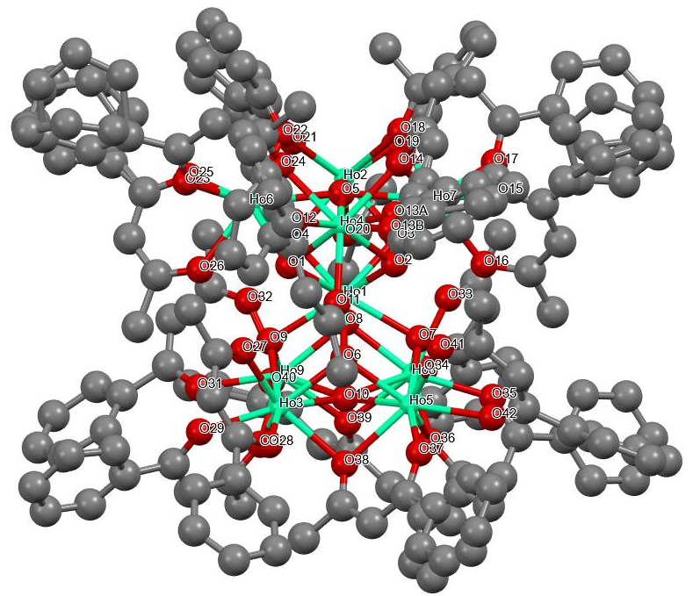
Figure S5. Labeled representation of compound 3-Ho. Color scheme: Dy, yellow; green, C, black. H atoms are omitted for the sake of clarity. ¹1-X,+Y,1/2-Z; ²2-X,+Y,1/2-Z
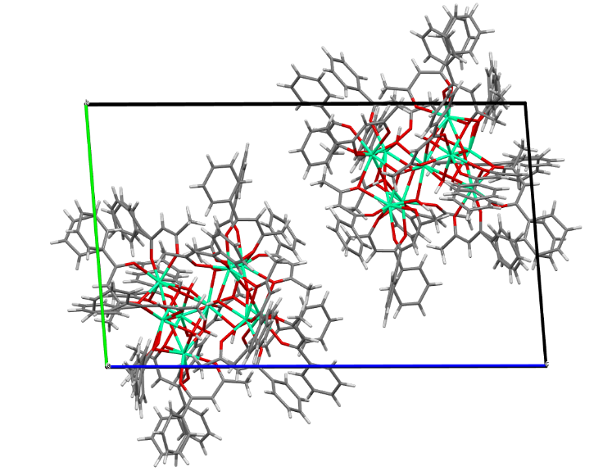
Figure S6. Packing diagram of compound 3-Ho.
Table S6. Measured bond distances for compound 3-Ho.
Ho8 Ho1 3.681(4) Ho8 Ho9 3.592(3)
Ho8 Ho5 3.567(3) Ho8 O8 2.291(7)
Ho8 O36 2.385(9) Ho8 O10 2.536(8)
Ho8 O7 2.283(7) Ho8 O34 2.281(8)
Ho8 O39 2.410(7) Ho8 O33 2.331(8)
Ho8 O35 2.333(8) Ho1 Ho5 3.669(3)
Ho1 Ho2 3.665(3) Ho1 Ho6 3.660(3)
Ho1 Ho4 3.660(3) Ho1 O8 2.398(8)
Ho1 O7 2.399(7) Ho1 O1 2.403(7)
Ho1 O6 2.382(9) Ho1 O2 2.402(7)
Ho1 O3 2.408(8) Ho1 O4 2.387(9)
Ho1 O9 2.405(7) Ho7 Ho2 3.544(3)
Ho7 Ho4 3.576(2) Ho7 O2 2.314(8)
Ho7 O3 2.285(7) Ho7 O16 2.294(8)
Ho7 O15 2.307(8) Ho7 O14 2.389(9)
Ho7 O17 2.313(9) Ho7 O18 2.396(9)
Ho7 O5 2.530(7) Ho9 Ho3 3.553(3)
Ho9 O8 2.291(7) Ho9 O10 2.516(9)
Ho9 O39 2.413(8) Ho9 O32 2.277(9)
Ho9 O9 2.304(8) Ho9 O31 2.314(8)
Ho9 O30 2.403(9) Ho9 O40 2.301(9)
Ho5 Ho3 3.564(3) Ho5 O36 2.389(8)
Ho5 O10 2.561(9) Ho5 O7 2.295(8)
Ho5 O6 2.259(8) Ho5 O42 2.290(8)
Ho5 O37 2.272(10) Ho5 O38 2.414(8)
Ho5 O41 2.318(8) Ho2 Ho6 3.577(2)
Ho2 O3 2.286(8) Ho2 O4 2.284(8)
Ho2 O22 2.403(8) Ho2 O20 2.317(8)
Ho2 O19 2.278(10) Ho2 O21 2.285(10)
Ho2 O18 2.395(8) Ho2 O5 2.535(9)
Ho6 Ho4 3.579(3) Ho6 O1 2.287(9)
Ho6 O4 2.293(8) Ho6 O24 2.392(8)
Ho6 O22 2.388(9) Ho6 O25 2.280(10)
Ho6 O26 2.325(9) Ho6 O23 2.313(8)
Ho6 O5 2.527(7) Ho3 O10 2.524(8)
Ho3 O6 2.303(8) Ho3 O9 2.273(10)
Ho3 O29 2.292(8) Ho3 O30 2.388(9)
Ho3 O38 2.382(10) Ho3 O28 2.296(11)
Ho3 O27 2.305(10) Ho4 O1 2.293(7)
Ho4 O2 2.262(7) Ho4 O14 2.387(9)
Ho4 O24 2.361(9) Ho4 O11 2.300(11)
Ho4 O12 2.301(11) Ho4 O13B 2.37(4)
Ho4 O13A 2.26(3) Ho4 O5 2.550(10)
O36 C129 1.284(14) O34 C114 1.286(13)
O39 C142 1.305(14) O16 C29 1.279(13)
O42 C154 1.256(15) O33 C112 1.283(13)
O35 C127 1.262(14) O15 C27 1.260(13)
O14 C19 1.336(15) O32 C109 1.280(16)
O24 C69 1.305(13) O31 C107 1.276(18)
O29 C97 1.246(14) O22 C59 1.298(18)
O20 C49 1.254(16) O30 C99 1.308(14)
O40 C144 1.253(15) O17 C37 1.232(15)
O37 C137 1.292(17) O25 C77 1.301(14)
O38 C139 1.267(17) O11 C2 1.264(19)
O41 C152 1.275(15) O28 C84 1.300(18)
O19 C47 1.294(17) O26 C79 1.265(14)
O23 C67 1.258(16) O21 C57 1.265(16)
O27 C82 1.270(17) O18 C39 1.310(15)
O12 C4 1.20(2)

Table S7. Measured bond angles for compound 3-Ho.
Ho9 Ho8 Ho1 60.77(3) O1 Ho4 Ho1 39.90(18) Ho5 Ho8 Ho1 60.79(3)
O1 Ho4 Ho7 96.7(2) Ho5 Ho8 Ho9 89.82(3) O1 Ho4 Ho6 38.5(2)
O8 Ho8 Ho1 39.33(19) O1 Ho4 O14 129.8(3) O8 Ho8 Ho9 38.39(17)
O1 Ho4 O24 76.7(3) O8 Ho8 Ho5 96.0(2) O1 Ho4 O11 76.6(3)
O8 Ho8 O36 129.5(3) O1 Ho4 O12 100.2(3) O8 Ho8 O10 64.7(3)
O1 Ho4 O13B 147.5(8) O8 Ho8 O39 76.8(3) O1 Ho4 O5 65.8(3)
O8 Ho8 O33 78.5(3) O2 Ho4 Ho1 39.69(19) O8 Ho8 O35 158.0(3)
O2 Ho4 Ho7 39.1(2) O36 Ho8 Ho1 101.4(2) O2 Ho4 Ho6 96.4(2)
O36 Ho8 Ho9 102.66(19) O2 Ho4 O1 78.8(3) O36 Ho8 Ho5 41.7(2)
O2 Ho4 O14 77.3(3) O36 Ho8 O10 65.1(3) O2 Ho4 O24 129.6(3)
O36 Ho8 O39 87.2(3) O2 Ho4 O11 79.8(3) O10 Ho8 Ho1 51.9(2)
O2 Ho4 O12 152.3(4) O10 Ho8 Ho9 44.5(2) O2 Ho4 O13B 94.7(10)
O10 Ho8 Ho5 45.9(2) O2 Ho4 O5 66.0(3) O7 Ho8 Ho1 39.29(18)
O14 Ho4 Ho1 101.4(2) O7 Ho8 Ho9 96.21(18) O14 Ho4 Ho7 41.5(2)
O7 Ho8 Ho5 38.94(19) O14 Ho4 Ho6 102.2(2) O7 Ho8 O8 77.9(3)
O14 Ho4 O5 64.3(3) O7 Ho8 O36 77.5(3) O24 Ho4 Ho1 101.1(2)
O7 Ho8 O10 66.2(3) O24 Ho4 Ho7 101.9(2) O7 Ho8 O39 130.7(3)
O24 Ho4 Ho6 41.5(2) O7 Ho8 O33 76.5(3) O24 Ho4 O14 85.7(3)
O7 Ho8 O35 99.6(3) O24 Ho4 O13B 127.8(10) O34 Ho8 Ho1 132.5(2)
O24 Ho4 O5 63.9(3) O34 Ho8 Ho9 97.43(19) O11 Ho4 Ho1 80.7(2)
O34 Ho8 Ho5 166.7(2) O11 Ho4 Ho7 117.8(2) O34 Ho8 O8 96.5(3)
O11 Ho4 Ho6 113.3(2) O34 Ho8 O36 125.3(3) O11 Ho4 O14 139.4(3)
O34 Ho8 O10 138.5(3) O11 Ho4 O24 134.1(3) O34 Ho8 O7 149.5(3)
O11 Ho4 O12 73.2(4) O34 Ho8 O39 75.2(3) O11 Ho4 O13B 71.0(8)
O34 Ho8 O33 73.0(3) O11 Ho4 O5 132.7(3) O34 Ho8 O35 74.4(3)
O12 Ho4 Ho1 137.2(3) O39 Ho8 Ho1 101.80(19) O12 Ho4 Ho7 161.8(3)
O39 Ho8 Ho9 41.89(19) O12 Ho4 Ho6 99.6(3) O39 Ho8 Ho5 103.7(2)
O12 Ho4 O14 120.5(3) O39 Ho8 O10 64.9(3) O12 Ho4 O24 75.7(4)
O33 Ho8 Ho1 79.7(2) O12 Ho4 O13B 71.2(10) O33 Ho8 Ho9 115.5(2)
O12 Ho4 O5 139.1(4) O33 Ho8 Ho5 113.9(2) O13B Ho4 Ho1 130.5(10)
O33 Ho8 O36 135.5(3) O13B Ho4 Ho7 97.8(9) O33 Ho8 O10 131.5(3)
O13B Ho4 Ho6 168.7(10) O33 Ho8 O39 136.7(3) O13B Ho4 O14 78.0(8)
O33 Ho8 O35 79.7(3) O13B Ho4 O5 140.2(8) O35 Ho8 Ho1 137.5(2)
O13A Ho4 Ho1 133.0(8) O35 Ho8 Ho9 160.40(19) O13A Ho4 Ho7 90.1(7)
O35 Ho8 Ho5 95.2(2) O13A Ho4 Ho6 162.4(7) O35 Ho8 O36 69.9(3)
O13A Ho4 O1 158.6(6) O35 Ho8 O10 134.7(3) O13A Ho4 O2 94.2(8)
O35 Ho8 O39 118.6(3) O13A Ho4 O14 66.6(6) Ho2 Ho1 Ho5 149.41(3)
O13A Ho4 O24 121.8(8) Ho6 Ho1 Ho5 149.12(3) O13A Ho4 O11 82.3(6)
Ho6 Ho1 Ho2 58.48(4) O13A Ho4 O12 76.6(8) Ho4 Ho1 Ho5 100.32(8)
O13A Ho4 O5 129.9(6) Ho4 Ho1 Ho2 87.40(8) O5 Ho4 Ho1 52.05(18)
Ho4 Ho1 Ho6 58.55(6) O5 Ho4 Ho7 45.04(16) O8 Ho1 Ho5 91.6(2)
O5 Ho4 Ho6 44.90(15) O8 Ho1 Ho2 79.0(2) Ho8 O8 Ho1 103.4(3)
O8 Ho1 Ho6 112.83(19) Ho9 O8 Ho8 103.2(3) O8 Ho1 Ho4 166.41(18)
Ho9 O8 Ho1 103.3(3) O8 Ho1 O7 73.7(3) Ho8 O36 Ho5 96.7(3)
O8 Ho1 O1 141.8(2) C129 O36 Ho8 133.1(8) O8 Ho1 O2 142.7(2)
C129 O36 Ho5 123.2(8) O8 Ho1 O3 76.8(2) Ho8 O10 Ho5 88.8(3)
O8 Ho1 O9 74.4(2) Ho9 O10 Ho8 90.6(3) O7 Ho1 Ho5 37.60(18)
Ho9 O10 Ho5 169.2(4) O7 Ho1 Ho2 112.14(18) Ho9 O10 Ho3 89.6(3)
O7 Ho1 Ho6 165.24(17) Ho3 O10 Ho8 169.9(4) O7 Ho1 Ho4 112.25(18)
Ho3 O10 Ho5 89.0(3) O7 Ho1 O1 142.0(3) Ho8 O7 Ho1 103.6(3)
O7 Ho1 O2 76.5(3) Ho8 O7 Ho5 102.4(3) O7 Ho1 O3 75.9(3)
Ho5 O7 Ho1 102.8(3) O7 Ho1 O9 116.7(3) C114 O34 Ho8 132.8(7)
O1 Ho1 Ho5 111.8(2) Ho6 O1 Ho1 102.5(3) O1 Ho1 Ho2 92.5(2)
Ho6 O1 Ho4 102.8(3) O1 Ho1 Ho6 37.6(2) Ho4 O1 Ho1 102.4(3)
O1 Ho1 Ho4 37.74(17) Ho5 O6 Ho1 104.4(3) O1 Ho1 O3 117.6(3)
Ho5 O6 Ho3 102.7(3) O1 Ho1 O9 75.2(3) Ho3 O6 Ho1 103.7(3)
O6 Ho1 Ho5 36.62(19) Ho7 O2 Ho1 102.2(3) O6 Ho1 Ho2 165.35(19)
Ho4 O2 Ho1 103.3(3) O6 Ho1 Ho6 112.78(19) Ho4 O2 Ho7 102.8(3)
O6 Ho1 Ho4 78.0(2) Ho8 O39 Ho9 96.3(3) O6 Ho1 O8 115.6(3)
C142 O39 Ho8 125.3(7) O6 Ho1 O7 73.6(3) C142 O39 Ho9 132.4(7)
O6 Ho1 O1 76.3(3) Ho7 O3 Ho1 102.9(3) O6 Ho1 O2 75.8(3)
Ho7 O3 Ho2 101.7(3) O6 Ho1 O3 141.4(3) Ho2 O3 Ho1 102.6(3)
O6 Ho1 O4 142.7(3) C29 O16 Ho7 133.8(8) O6 Ho1 O9 73.5(3)
C154 O42 Ho5 133.8(9) O2 Ho1 Ho5 77.7(2) Ho2 O4 Ho1 103.3(3)
O2 Ho1 Ho2 92.2(2) Ho2 O4 Ho6 102.8(3) O2 Ho1 Ho6 91.90(19)
Ho6 O4 Ho1 102.8(3) O2 Ho1 Ho4 36.98(17) C112 O33 Ho8 132.3(8)
O2 Ho1 O1 74.0(2) C127 O35 Ho8 137.3(7) O2 Ho1 O3 74.6(3)
C27 O15 Ho7 131.2(8) O2 Ho1 O9 140.5(3) Ho4 O14 Ho7 97.0(3)
O3 Ho1 Ho5 112.14(18) C19 O14 Ho7 124.5(7) O3 Ho1 Ho2 37.49(18)
C19 O14 Ho4 131.8(9) O3 Ho1 Ho6 92.41(18) C109 O32 Ho9 134.4(9)
O3 Ho1 Ho4 92.50(18) Ho9 O9 Ho1 102.7(3) O4 Ho1 Ho5 165.31(17)
Ho3 O9 Ho1 103.8(3) O4 Ho1 Ho2 37.33(18) Ho3 O9 Ho9 101.8(3)
O4 Ho1 Ho6 37.66(19) Ho4 O24 Ho6 97.7(3) O4 Ho1 Ho4 92.50(19)
C69 O24 Ho6 132.1(8) O4 Ho1 O8 76.6(3) C69 O24 Ho4 125.7(9)
O4 Ho1 O7 141.6(3) C107 O31 Ho9 130.8(10) O4 Ho1 O1 74.5(3)
C97 O29 Ho3 138.8(9) O4 Ho1 O2 117.0(3) Ho6 O22 Ho2 96.6(3)
O4 Ho1 O3 74.1(3) C59 O22 Ho2 130.2(9) O4 Ho1 O9 77.0(3)
C59 O22 Ho6 127.4(8) O9 Ho1 Ho5 91.6(2) C49 O20 Ho2 134.8(9)
O9 Ho1 Ho2 113.2(2) Ho3 O30 Ho9 95.7(3) O9 Ho1 Ho6 78.0(2)
C99 O30 Ho9 127.7(10) O9 Ho1 Ho4 111.51(18) C99 O30 Ho3 130.7(9)
O9 Ho1 O3 142.9(3) C144 O40 Ho9 137.2(10) Ho2 Ho7 Ho1 61.03(5)
C37 O17 Ho7 136.8(8) Ho2 Ho7 Ho4 90.58(7) C137 O37 Ho5 138.9(11)
Ho4 Ho7 Ho1 60.65(6) C77 O25 Ho6 130.1(10) O2 Ho7 Ho1 39.76(19)
Ho3 O38 Ho5 96.0(3) O2 Ho7 Ho2 96.9(2) C139 O38 Ho5 131.3(9)
O2 Ho7 Ho4 38.09(18) C139 O38 Ho3 125.4(9) O2 Ho7 O14 76.3(3)
C2 O11 Ho4 134.9(11) O2 Ho7 O18 129.9(3) C152 O41 Ho5 135.3(8)
O2 Ho7 O5 65.7(3) C84 O28 Ho3 130.5(12) O3 Ho7 Ho1 39.7(2)
C47 O19 Ho2 134.6(8) O3 Ho7 Ho2 39.17(19) C79 O26 Ho6 135.0(10)
O3 Ho7 Ho4 96.85(19) C67 O23 Ho6 134.7(8) O3 Ho7 O2 78.6(3)
C57 O21 Ho2 136.3(9) O3 Ho7 O16 76.2(3) C82 O27 Ho3 133.6(11)
O3 Ho7 O15 150.1(3) Ho2 O18 Ho7 95.4(3) O3 Ho7 O14 130.6(3)
C39 O18 Ho7 129.6(8) O3 Ho7 O17 95.4(3) C39 O18 Ho2 129.6(9)
O3 Ho7 O18 78.5(3) C4 O12 Ho4 131.5(12) O3 Ho7 O5 66.4(3)
O16 Ho7 Ho1 79.2(2) O16 Ho7 Ho2 114.0(2) O16 Ho7 Ho4 114.0(2)
O16 Ho7 O2 77.3(3) O34 C114 C115 116.8(11) O16 Ho7 O15 74.1(3)
O34 C114 C113 122.5(11) O16 Ho7 O14 136.2(3) O16 Ho7 O17 78.7(3)
O16 Ho7 O18 137.4(3) O33 C112 C111 115.6(11) O16 Ho7 O5 131.1(3)
O33 C112 C113 124.5(11) O15 Ho7 Ho1 134.6(2) O15 Ho7 Ho2 164.3(2)
O24 C69 C68 127.4(11) O15 Ho7 Ho4 98.3(2) O24 C69 C70 113.5(10)
O15 Ho7 O2 98.1(3) O15 Ho7 O14 75.8(3) O15 Ho7 O17 75.4(3)
O15 C27 C28 125.0(12) O15 Ho7 O18 122.6(3) O15 C27 C26 117.4(11)
O15 Ho7 O5 139.5(3) O14 Ho7 Ho1 101.08(19) O20 C49 C50 118.0(13)
O14 Ho7 Ho2 103.4(2) O20 C49 C48 123.7(13) O14 Ho7 Ho4 41.5(2)
O14 Ho7 O18 86.0(3) O14 Ho7 O5 64.6(3) O17 Ho7 Ho1 133.7(2)
O17 Ho7 Ho2 92.6(2) O17 Ho7 Ho4 164.2(2) O17 Ho7 O2 155.9(3)
O17 Ho7 O14 122.8(3) O16 C29 C28 122.2(12) O17 Ho7 O18 70.2(3)
O16 C29 C30 118.6(11) O17 Ho7 O5 133.4(3) O18 Ho7 Ho1 101.94(19)
O42 C154 C153 125.2(13) O18 Ho7 Ho2 42.29(19) O42 C154 C155 117.3(12)
O18 Ho7 Ho4 102.6(2) O18 Ho7 O5 64.4(3) O5 Ho7 Ho1 51.91(19)
O5 Ho7 Ho2 45.7(2) O5 Ho7 Ho4 45.5(2) Ho8 Ho9 Ho1 60.81(6)
Ho3 Ho9 Ho8 89.73(3) Ho3 Ho9 Ho1 61.21(3) O8 Ho9 Ho8 38.40(19)
O41 C152 C153 122.5(12) O8 Ho9 Ho1 39.36(19) O41 C152 C151 117.7(13)
O8 Ho9 Ho3 96.3(2) O8 Ho9 O10 65.1(3) O32 C109 C110 117.7(12)
O8 Ho9 O39 76.8(3) O32 C109 C108 122.5(15) O8 Ho9 O9 78.4(3)
O8 Ho9 O31 149.7(3) O8 Ho9 O30 130.5(3) O8 Ho9 O40 101.0(3)
O10 Ho9 Ho8 44.90(17) O10 Ho9 Ho1 51.9(2) O10 Ho9 Ho3 45.27(18)
O39 Ho9 Ho8 41.84(16) O17 C37 C36 119.0(12) O39 Ho9 Ho1 101.79(18)
O17 C37 C38 123.8(12) O39 Ho9 Ho3 103.3(2) O39 Ho9 O10 65.2(3)
O36 C129 C130 113.9(11) O32 Ho9 Ho8 113.00(19) O36 C129 C128 126.3(12)
O32 Ho9 Ho1 79.2(2) O32 Ho9 Ho3 116.3(2) O32 Ho9 O8 76.3(3)
O32 Ho9 O10 131.1(3) O32 Ho9 O39 133.9(3) O32 Ho9 O9 78.7(3)
O32 Ho9 O31 73.5(3) O32 Ho9 O30 137.9(3) O32 Ho9 O40 78.1(3)
O9 Ho9 Ho8 96.26(18) O9 Ho9 Ho1 39.62(17) O19 C47 C46 118.2(13)
O9 Ho9 Ho3 38.8(2) O19 C47 C48 123.4(14) O9 Ho9 O10 65.5(3)
O9 Ho9 O39 130.4(3) O35 C127 C126 116.9(11) O9 Ho9 O31 93.8(3)
O35 C127 C128 123.0(11) O9 Ho9 O30 77.2(3) O31 Ho9 Ho8 169.0(2)
O31 Ho9 Ho1 130.1(2) O31 Ho9 Ho3 95.3(2) O31 Ho9 O10 137.8(3)
O40 C144 C143 124.6(13) O31 Ho9 O39 127.2(3) O40 C144 C145 115.5(13)
O31 Ho9 O30 74.3(3) O30 Ho9 Ho8 103.5(2) O25 C77 C78 125.6(14)
O30 Ho9 Ho1 102.3(2) O25 C77 C76A 118(3) O30 Ho9 Ho3 42.0(2)
O25 C77 C76B 110(2) O30 Ho9 O10 65.7(3) O30 Ho9 O39 87.5(3)
O40 Ho9 Ho8 97.5(2) O40 Ho9 Ho1 138.4(2) O40 Ho9 Ho3 159.8(2)
O26 C79 C80 114.8(15) O40 Ho9 O10 136.2(3) O26 C79 C78 122.7(14)
O40 Ho9 O39 71.3(3) O40 Ho9 O9 156.2(3) O40 Ho9 O31 74.7(3)
O37 C137 C138 120.9(16) O40 Ho9 O30 117.9(3) O37 C137 C136 109.7(19)
Ho8 Ho5 Ho1 61.13(6) O37 C137 C11 125(2) Ho3 Ho5 Ho8 89.95(3)
Ho3 Ho5 Ho1 61.22(3) O36 Ho5 Ho8 41.6(2) O36 Ho5 Ho1 101.7(2)
O21 C57 C58 123.5(15) O36 Ho5 Ho3 102.36(19) O21 C57 C56A 119.4(15)
O36 Ho5 O10 64.6(3) O21 C57 C56B 112.5(15) O36 Ho5 O38 85.2(3)
O10 Ho5 Ho8 45.29(17) O10 Ho5 Ho1 52.0(2) O31 C107 C108 125.6(13)
O10 Ho5 Ho3 45.09(17) O31 C107 C106 113.1(15) O7 Ho5 Ho8 38.70(18)
O7 Ho5 Ho1 39.61(17) O7 Ho5 Ho3 96.64(18) O7 Ho5 O36 77.1(3)
O7 Ho5 O10 65.5(3) O30 C99 C100 113.8(12) O7 Ho5 O38 129.5(3)
O30 C99 C98 124.6(13) O7 Ho5 O41 79.8(3) O6 Ho5 Ho8 96.0(2)
O6 Ho5 Ho1 39.0(2) O6 Ho5 Ho3 39.07(19) O6 Ho5 O36 129.5(3)
O6 Ho5 O10 65.2(3) O6 Ho5 O7 77.9(3) O11 C2 C1 116.6(15)
O6 Ho5 O42 149.0(3) O11 C2 C3 121.3(18) O6 Ho5 O37 103.7(3)
O6 Ho5 O38 77.9(3) O39 C142 C143 122.4(12) O6 Ho5 O41 76.2(3)
O39 C142 C141 115.5(12) O42 Ho5 Ho8 93.7(2) O42 Ho5 Ho1 128.5(2)
O42 Ho5 Ho3 170.1(2) O12 C4 C3 127.1(18) O42 Ho5 O36 74.7(3)
O12 C4 C5A 107.3(19) O42 Ho5 O10 136.6(3) O12 C4 C5B 136(2)
O42 Ho5 O7 92.0(3) O42 Ho5 O38 128.4(3) O42 Ho5 O41 73.2(3)
O37 Ho5 Ho8 156.5(2) O22 C59 C58 123.7(12) O37 Ho5 Ho1 141.3(2)
O22 C59 C60 115.6(16) O37 Ho5 Ho3 97.4(2) O37 Ho5 O36 114.9(3)
O37 Ho5 O10 134.7(3) O37 Ho5 O7 158.8(3) O18 C39 C38 123.4(12)
O37 Ho5 O42 75.7(3) O18 C39 C40 114.9(12) O37 Ho5 O38 70.7(3)
O37 Ho5 O41 80.1(3) O38 Ho5 Ho8 101.9(2) O27 C82 C81 116.8(17)
O38 Ho5 Ho1 101.7(2) O27 C82 C83 123.1(16) O38 Ho5 Ho3 41.7(2)
O38 Ho5 O10 64.1(3) O38 C139 C138 126.7(14) O41 Ho5 Ho8 117.3(2)
O38 C139 C140 113.3(15) O41 Ho5 Ho1 80.1(2) O41 Ho5 Ho3 113.2(2)
O41 Ho5 O36 139.4(3) O29 C97 C96 119.3(12) O41 Ho5 O10 132.0(3)
O29 C97 C98 122.0(12) O41 Ho5 O38 134.6(3) Ho7 Ho2 Ho1 61.20(5)
Ho7 Ho2 Ho6 89.98(7) Ho6 Ho2 Ho1 60.69(6) O3 Ho2 Ho1 39.87(18)
O3 Ho2 Ho7 39.16(19) O3 Ho2 Ho6 96.7(2) O3 Ho2 O22 129.6(3)
O3 Ho2 O20 76.7(3) O28 C84 C83 126.6(19) O3 Ho2 O18 78.5(3)
O28 C84 C85 110.5(17) O3 Ho2 O5 66.3(3) O4 Ho2 Ho1 39.3(2)
O4 Ho2 Ho7 96.6(2) O4 Ho2 Ho6 38.69(19) O4 Ho2 O3 78.4(3)
O4 Ho2 O22 77.3(3) O4 Ho2 O20 76.2(3) O4 Ho2 O21 96.7(3)
O4 Ho2 O18 129.7(3) O4 Ho2 O5 65.5(3) O22 Ho2 Ho1 101.0(2)
O22 Ho2 Ho7 101.7(2) O22 Ho2 Ho6 41.5(2) O22 Ho2 O5 63.5(3)
O20 Ho2 Ho1 78.6(2) O20 Ho2 Ho7 114.7(2) O20 Ho2 Ho6 113.5(2)
O23 C67 C68 126.8(12) O20 Ho2 O22 136.8(3) O23 C67 C66 115.8(13)
O20 Ho2 O18 138.7(3) O20 Ho2 O5 130.6(3) O19 Ho2 Ho1 133.3(2)
O19 Ho2 Ho7 97.2(2) O19 Ho2 Ho6 166.0(2) O19 Ho2 O3 96.5(3)
O19 Ho2 O4 150.5(3) O19 Ho2 O22 124.8(3) O19 Ho2 O20 74.3(3)
O19 Ho2 O21 75.9(3) O19 Ho2 O18 76.2(3) O19 Ho2 O5 139.1(3)
O21 Ho2 Ho1 134.4(2) O21 Ho2 Ho7 163.0(2) O21 Ho2 Ho6 93.8(2)
O21 Ho2 O3 155.5(3) O21 Ho2 O22 71.1(3) O21 Ho2 O20 78.8(3)
O21 Ho2 O18 120.8(3) O21 Ho2 O5 133.6(3) O18 Ho2 Ho1 102.1(2)
O18 Ho2 Ho7 42.3(2) O18 Ho2 Ho6 101.8(2) O18 Ho2 O22 84.2(3)
O18 Ho2 O5 64.3(3) O5 Ho2 Ho1 52.00(19) O5 Ho2 Ho7 45.55(16)
O5 Ho2 Ho6 44.93(15) Ho2 Ho6 Ho1 60.83(5) Ho2 Ho6 Ho4 89.99(7)
Ho4 Ho6 Ho1 60.72(4) O1 Ho6 Ho1 39.86(19) O1 Ho6 Ho2 96.8(2)
O1 Ho6 Ho4 38.66(18) O1 Ho6 O4 78.6(3) O1 Ho6 O24 76.2(3)
O1 Ho6 O22 129.9(3) O1 Ho6 O26 76.3(3) O1 Ho6 O23 105.1(3)
O14 C19 C20 116.4(15) O1 Ho6 O5 66.3(3) O14 C19 C18 121.3(14)
O4 Ho6 Ho1 39.5(2) O4 Ho6 Ho2 38.50(19) O4 Ho6 Ho4 96.2(2)
O4 Ho6 O24 129.0(3) O13B C5 C18 123(4) O4 Ho6 O22 77.4(3)
O13B C5 C16B 118(4) O4 Ho6 O26 80.3(3) O4 Ho6 O23 159.7(3)
O4 Ho6 O5 65.5(3) O24 Ho6 Ho1 100.5(2) O24 Ho6 Ho2 102.4(2)
O24 Ho6 Ho4 40.8(2) O24 Ho6 O5 63.9(3) O22 Ho6 Ho1 101.4(2)
O22 Ho6 Ho2 41.8(2) O22 Ho6 Ho4 102.1(2) O22 Ho6 O24 85.9(3)
O22 Ho6 O5 63.8(3) O25 Ho6 Ho1 129.5(2) O25 Ho6 Ho2 94.0(2)
O25 Ho6 Ho4 169.5(2) O13A C17A C16A 120(3) O25 Ho6 O1 149.6(3)
O25 Ho6 O4 92.9(3) O25 Ho6 O24 128.7(3) O25 Ho6 O22 74.9(3)
O25 Ho6 O26 73.4(4) O25 Ho6 O23 73.7(3) O25 Ho6 O5 136.3(3)
O26 Ho6 Ho1 80.9(2) O26 Ho6 Ho2 117.6(2) O26 Ho6 Ho4 113.1(3)
O26 Ho6 O24 133.4(4) O26 Ho6 O22 139.9(3) O26 Ho6 O5 132.9(3)
O23 Ho6 Ho1 143.8(3) O23 Ho6 Ho2 154.3(3) O23 Ho6 Ho4 98.7(2)
O23 Ho6 O24 70.7(3) O23 Ho6 O22 112.5(3) O23 Ho6 O26 81.2(3)
O23 Ho6 O5 134.5(3) O5 Ho6 Ho1 52.10(18) O5 Ho6 Ho2 45.1(2)
O5 Ho6 Ho4 45.4(2) Ho9 Ho3 Ho1 61.09(5) Ho9 Ho3 Ho5 90.50(3)
Ho5 Ho3 Ho1 60.80(5) O10 Ho3 Ho1 51.8(2) O10 Ho3 Ho9 45.1(2)
O10 Ho3 Ho5 45.9(2) O6 Ho3 Ho1 38.9(2) O6 Ho3 Ho9 96.0(2)
O6 Ho3 Ho5 38.2(2) O6 Ho3 O10 65.2(3) O6 Ho3 O30 130.7(3)
O6 Ho3 O38 77.8(3) O6 Ho3 O27 77.4(3) O9 Ho3 Ho1 39.35(18)
O9 Ho3 Ho9 39.4(2) O9 Ho3 Ho5 96.59(18) O9 Ho3 O10 65.8(3)
O9 Ho3 O6 77.5(3) O9 Ho3 O29 97.3(3) O9 Ho3 O30 78.1(3)
O9 Ho3 O38 130.6(3) O9 Ho3 O28 150.3(3) O9 Ho3 O27 77.1(3)
O29 Ho3 Ho1 134.8(3) O29 Ho3 Ho9 95.0(2) O29 Ho3 Ho5 163.8(2)
O29 Ho3 O10 135.3(3) O29 Ho3 O6 154.9(3) O29 Ho3 O30 70.4(3)
O29 Ho3 O38 121.4(3) O29 Ho3 O28 75.6(3) O29 Ho3 O27 77.5(3)
O30 Ho3 Ho1 102.5(2) O30 Ho3 Ho9 42.3(2) O30 Ho3 Ho5 104.6(2)
O30 Ho3 O10 65.8(3) O38 Ho3 Ho1 101.9(2) O38 Ho3 Ho9 102.8(2)
O38 Ho3 Ho5 42.36(19) O38 Ho3 O10 65.1(3) O38 Ho3 O30 86.8(3)
O28 Ho3 Ho1 132.6(3) O28 Ho3 Ho9 166.2(3) O28 Ho3 Ho5 96.1(2)
O28 Ho3 O10 138.3(3) O28 Ho3 O6 96.6(3) O28 Ho3 O30 124.0(3)
O28 Ho3 O38 74.7(3) O28 Ho3 O27 73.2(4) O27 Ho3 Ho1 79.6(2)
O27 Ho3 Ho9 115.0(3) O27 Ho3 Ho5 113.8(2) Ho7 O5 Ho2 88.8(2)
O27 Ho3 O10 131.4(3) Ho7 O5 Ho4 89.5(3) O27 Ho3 O30 136.1(3)
Ho2 O5 Ho4 168.5(4) O27 Ho3 O38 136.3(4) Ho6 O5 Ho7 169.2(4)
Ho7 Ho4 Ho1 60.96(5) Ho6 O5 Ho2 89.9(3) Ho7 Ho4 Ho6 89.44(7)
Ho6 O5 Ho4 89.7(3) Ho6 Ho4 Ho1 60.72(5)
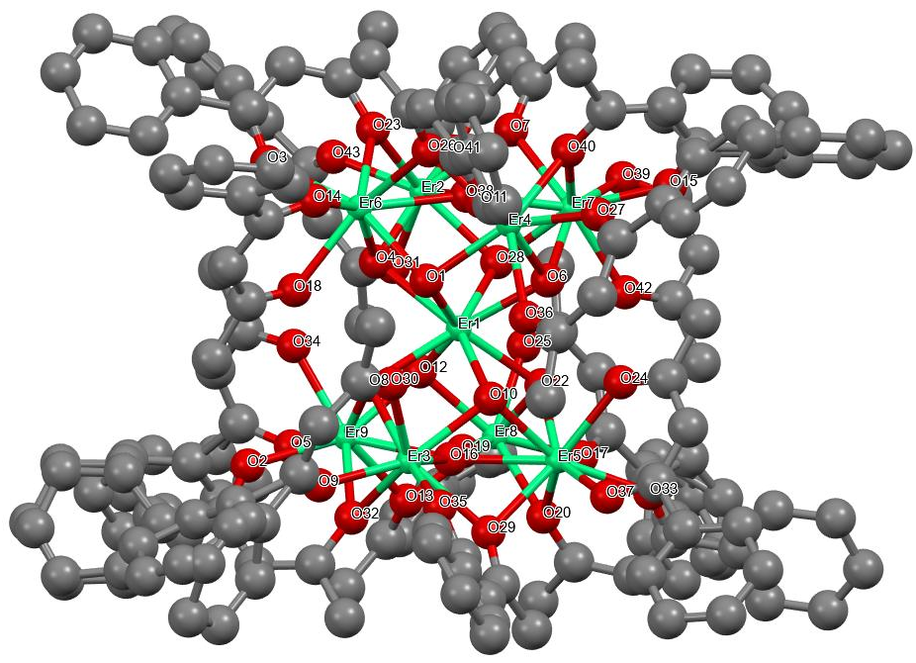
Figure S7. Labelled representation of compound 4-Er. Color scheme: Dy, yellow; green, C, black. H atoms are omitted for the sake of clarity. ¹1-X,+Y,1/2-Z; ²2-X,+Y,1/2-Z
Figure S8. Packing diagram of compound 4-Er.
Table S8. Measured bond distances for compound 4-Er.
Er1 Er4 3.6486(4) Er1 Er6 3.6511(4)
Er1 Er7 3.6491(4) Er1 O7 2.406(4)
Er1 O6 2.390(4) Er1 O8 2.396(4)
C97A O41 1.200(18) Er1 O4 2.392(4)
Er1 O3 2.392(4) Er1 O1 2.388(4)
Er1 O5 2.885(4) Er1 O2 2.391(4)
Er1 O9 2.386(4) Er8 Er5 3.5522(4)
Er8 Er9 3.5706(4) Er8 O7 2.265(4)
Er8 O8 2.287(4) Er8 O38 2.375(4)
Er8 O36 2.308(4) Er8 O10 2.535(4)
Er8 O34 2.395(4) Er8 O37 2.325(4)
Er8 O35 2.281(4) Er5 Er3 3.5496(4)
Er5 O7 2.293(4) Er5 O6 2.256(4)
Er5 O39 2.297(4) Er5 O40 2.302(4)
Er5 O38 2.378(4) Er5 O10 2.533(4)
Er5 O42 2.395(4) Er5 O41 2.282(4)
Er4 Er6 3.5509(4) Er4 Er7 3.5585(4)
Er4 O1 2.260(4) Er4 O5 2.517(4)
Er4 O26 2.367(4) Er4 O2 2.286(4)
Er4 O11 2.303(5) Er4 O14 2.384(4)
Er4 O12A 2.270(13) Er4 O12B 2.267(12)
Er4 O13 2.299(5) Er6 Er2 3.5324(4)
Er6 O4 2.263(4) Er6 O1 2.293(4)
Er6 O5 2.490(4) Er6 O18 2.383(4)
Er6 O16 2.298(4) Er6 O14 2.378(4)
Er6 O17 2.313(11) Er6 O15A 2.291(11)
Er6 O15B 2.285(11) Er6 O2A 2.313(12)
Er7 Er2 3.5419(4) Er7 O3 2.296(4)
Er7 O5 2.544(4) Er7 O26 2.408(4)
Er7 O2 2.266(4) Er7 O24 2.307(4)
Er7 O22 2.367(4) Er7 O25A 2.289(10)
Er7 O23 2.274(5) Er7 O25B 2.283(10)
Er2 O4 2.293(4) Er2 O3 2.260(4)
Er2 O5 2.522(4) Er2 O20 2.305(4)
Er2 O18 2.375(4) Er2 O22 2.379(4)
Er2 O21 2.302(5) Er2 O19 2.283(5)
Er9 Er3 3.5486(5) Er9 O8 2.275(4)
Er9 O9 2.289(4) Er9 O10 2.516(4)
Er9 O34 2.404(4) Er9 O30 2.375(5)
Er9 O33 2.296(5) Er9 O31 2.298(5)
Er9 O32 2.299(5) Er3 O6 2.289(4)
Er3 O9 2.264(4) Er3 O10 2.529(4)
Er3 O28 2.289(4) Er3 O42 2.373(5)
Er3 O30 2.387(5) Er3 O27 2.303(4)
Er3 O29 2.285(5) O39 C137 1.263(8)
O40 C139 1.280(8) O26 C79A 1.316(14)
O26 C79B 1.314(14) O24 C69 1.274(8)
O38 C129 1.308(7) O20 C49 1.272(8)
O18 C39 1.322(8) O16 C29 1.286(8)
O36 C119 1.276(7) O34 C109 1.318(7)
O28 C147 1.307(8) O37 C127 1.257(7)
O42 C99 1.312(8) O11 C2A 1.285(13)
O11 C2B 1.275(13) O14 C19 1.308(7)
O35 C117 1.270(8) O30 C159 1.301(8)
O22 C59 1.290(8) O33 C107 1.260(8)
O27 C149 1.279(8) O17 C37A 1.265(14)
O2A C37B 1.273(15) O25A C77A 1.26(3)
O12B C4B 1.35(13) O12A C4A 1.23(10)
O21 C57 1.268(8) O19 C47 1.278(8)
O23 C67 1.270(8) O15A C27A 1.29(3)
O29 C157 1.251(8) C77B O25B 1.28(3)
O13 C17 1.245(9) O31 C87 1.267(10)
Table S9. Measured bond angles for compound 4-Er.
Er4 Er1 Er6 58.215(8) O6 Er3 Er9 96.39(10) Er4 Er1 Er7 58.369(8)
O6 Er3 O10 65.97(13) Er7 Er1 Er6 86.728(8) O6 Er3 O28 95.61(15)
O7 Er1 Er4 165.35(9) O6 Er3 O42 77.32(15) O7 Er1 Er6 112.26(9)
O6 Er3 O30 130.42(15) O7 Er1 Er7 112.59(9) O6 Er3 O27 77.62(15)
O7 Er1 O5 121.97(12) O9 Er3 Er1 39.33(10) O6 Er1 Er4 112.23(9)
O9 Er3 Er5 96.41(10) O6 Er1 Er6 78.47(9) O9 Er3 Er9 39.04(10)
O6 Er1 Er7 165.20(9) O9 Er3 O6 78.21(15) O6 Er1 O7 73.85(13)
O9 Er3 O10 66.16(14) O6 Er1 O8 116.10(13) O9 Er3 O28 152.09(14)
O6 Er1 O4 76.06(14) O9 Er3 O42 130.24(15) O6 Er1 O3 141.45(13)
O9 Er3 O30 77.22(16) O6 Er1 O5 121.28(12) O9 Er3 O27 77.43(16)
O6 Er1 O2 142.14(14) O9 Er3 O29 98.01(18) O8 Er1 Er4 113.10(9)
O10 Er3 Er1 52.78(9) O8 Er1 Er6 165.42(9) O10 Er3 Er5 45.51(9)
O8 Er1 Er7 78.70(9) O10 Er3 Er9 45.15(10) O8 Er1 O7 73.49(13)
O28 Er3 Er1 132.56(10) O8 Er1 O5 122.62(13) O28 Er3 Er5 94.98(11)
O4 Er1 Er4 91.97(9) O28 Er3 Er9 166.02(10) O4 Er1 Er6 37.10(9)
O28 Er3 O10 136.19(15) O4 Er1 Er7 92.23(10) O28 Er3 O42 73.09(15)
O4 Er1 O7 76.29(13) O28 Er3 O30 124.32(15) O4 Er1 O8 141.90(13)
O28 Er3 O27 74.66(17) O4 Er1 O3 73.91(13) O42 Er3 Er1 102.01(10)
O4 Er1 O5 58.38(12) O42 Er3 Er5 42.14(10) O3 Er1 Er4 92.51(9)
O42 Er3 Er9 102.66(11) O3 Er1 Er6 91.49(9) O42 Er3 O10 64.39(14)
O3 Er1 Er7 37.94(9) O42 Er3 O30 86.89(16) O3 Er1 O7 75.97(13)
O30 Er3 Er1 101.88(11) O3 Er1 O8 76.66(13) O30 Er3 Er5 103.76(11)
O3 Er1 O5 58.99(12) O30 Er3 Er9 41.70(12) O1 Er1 Er4 37.06(10)
O30 Er3 O10 64.81(14) O1 Er1 Er6 37.81(9) O27 Er3 Er1 79.54(11)
O1 Er1 Er7 91.84(10) O27 Er3 Er5 114.42(12) O1 Er1 O7 142.08(13)
O27 Er3 Er9 115.00(13) O1 Er1 O6 76.40(13) O27 Er3 O10 132.31(14)
O1 Er1 O8 142.22(13) O27 Er3 O42 136.50(17) O1 Er1 O4 74.13(13)
O27 Er3 O30 135.92(18) O1 Er1 O3 116.95(13) O29 Er3 Er1 135.43(14)
O1 Er1 O5 57.96(12) O29 Er3 Er5 162.84(13) O1 Er1 O2 74.08(14)
O29 Er3 Er9 95.32(14) O5 Er1 Er4 43.38(8) O29 Er3 O6 155.54(15)
O5 Er1 Er6 42.81(8) O29 Er3 O10 134.89(16) O5 Er1 Er7 43.92(8)
O29 Er3 O28 76.32(18) O2 Er1 Er4 37.70(10) O29 Er3 O42 120.70(17)
O2 Er1 Er6 92.05(9) O29 Er3 O30 70.63(17) O2 Er1 Er7 37.21(10)
O29 Er3 O27 77.97(17) O2 Er1 O7 141.90(14) Er8 O7 Er1 103.57(15)
O2 Er1 O8 76.73(13) Er8 O7 Er5 102.42(15) O2 Er1 O4 117.00(13)
Er5 O7 Er1 102.22(14) O2 Er1 O3 74.45(14) Er5 O6 Er1 103.86(15)
O2 Er1 O5 58.62(12) Er5 O6 Er3 102.73(15) O9 Er1 Er4 78.06(10)
Er3 O6 Er1 102.82(16) O9 Er1 Er6 112.62(10) Er8 O8 Er1 103.22(15)
O9 Er1 Er7 112.37(10) Er9 O8 Er1 103.16(15) O9 Er1 O7 116.60(13)
Er9 O8 Er8 103.01(15) O9 Er1 O6 73.92(15) Er6 O4 Er1 103.29(15)
O9 Er1 O8 74.16(14) Er6 O4 Er2 101.66(15) O9 Er1 O4 141.66(14)
Er2 O4 Er1 102.49(15) O9 Er1 O3 142.52(14) Er7 O3 Er1 102.23(15)
O9 Er1 O1 76.05(14) Er2 O3 Er1 103.51(15) O9 Er1 O5 121.43(12)
Er2 O3 Er7 102.05(15) O9 Er1 O2 76.36(14) Er4 O1 Er1 103.39(16)
Er5 Er8 Er1 60.827(7) Er4 O1 Er6 102.50(15) Er5 Er8 Er9 89.627(9)
Er6 O1 Er1 102.50(15) Er9 Er8 Er1 60.694(7) C137 O39 Er5 132.7(4)
O7 Er8 Er1 39.58(10) Er4 O5 Er1 84.70(11) O7 Er8 Er5 39.07(10)
Er4 O5 Er7 89.36(13) O7 Er8 Er9 96.42(10) Er4 O5 Er2 169.44(18)
O7 Er8 O8 78.26(14) Er6 O5 Er1 85.25(12) O7 Er8 O38 77.50(14)
Er6 O5 Er4 90.36(13) O7 Er8 O36 76.27(14) Er6 O5 Er7 169.46(18)
O7 Er8 O10 66.62(13) Er6 O5 Er2 89.64(13) O7 Er8 O34 131.02(14)
Er7 O5 Er1 84.22(11) O7 Er8 O37 99.35(14) Er2 O5 Er1 84.77(11)
O7 Er8 O35 149.91(15) Er2 O5 Er7 88.72(13) O8 Er8 Er1 39.44(10)
C139 O40 Er5 134.6(4) O8 Er8 Er5 96.13(10) Er4 O26 Er7 96.37(14)
O8 Er8 Er9 38.37(10) C79A O26 Er4 122(2) O8 Er8 O38 129.35(14)
C79A O26 Er7 132.5(15) O8 Er8 O36 78.19(14) C79B O26 Er4 131.4(19)
O8 Er8 O10 65.55(14) C79B O26 Er7 128.5(16) O8 Er8 O34 76.85(14)
Er4 O2 Er1 102.53(16) O8 Er8 O37 157.50(14) Er7 O2 Er1 103.15(16)
O38 Er8 Er1 101.37(9) Er7 O2 Er4 102.86(15) O38 Er8 Er5 41.66(9)
C69 O24 Er7 135.1(5) O38 Er8 Er9 102.28(10) Er8 O38 Er5 96.74(14)
O38 Er8 O10 64.10(13) C129 O38 Er8 133.2(4) O38 Er8 O34 86.82(14)
C129 O38 Er5 123.0(4) O36 Er8 Er1 79.40(10) Er9 O9 Er1 103.03(16)
O36 Er8 Er5 113.86(11) Er3 O9 Er1 103.71(16) O36 Er8 Er9 115.28(11)
Er3 O9 Er9 102.43(15) O36 Er8 O38 135.94(15) C49 O20 Er2 133.0(4)
O36 Er8 O10 131.93(13) Er2 O18 Er6 95.87(14) O36 Er8 O34 136.68(15)
C39 O18 Er6 131.1(5) O36 Er8 O37 79.52(15) C39 O18 Er2 127.0(4)
O10 Er8 Er1 52.53(9) C29 O16 Er6 133.4(4) O10 Er8 Er5 45.47(9)
C119 O36 Er8 133.0(4) O10 Er8 Er9 44.80(9) Er5 O10 Er8 89.00(13)
O34 Er8 Er1 101.87(10) Er9 O10 Er8 89.96(13) O34 Er8 Er5 103.56(10)
Er9 O10 Er5 167.85(17) O34 Er8 Er9 42.03(10) Er9 O10 Er3 89.41(13)
O34 Er8 O10 64.77(13) Er3 O10 Er8 167.87(17) O37 Er8 Er1 137.47(11)
Er3 O10 Er5 89.07(13) O37 Er8 Er5 95.59(11) Er8 O34 Er9 96.13(14)
O37 Er8 Er9 160.66(10) C109 O34 Er8 125.3(4) O37 Er8 O38 70.59(14)
C109 O34 Er9 132.1(4) O37 Er8 O10 134.40(14) C147 O28 Er3 131.1(5)
O37 Er8 O34 118.69(14) C127 O37 Er8 136.5(4) O35 Er8 Er1 133.30(11)
Er3 O42 Er5 96.21(15) O35 Er8 Er5 165.87(11) C99 O42 Er5 131.3(5)
O35 Er8 Er9 97.88(11) C99 O42 Er3 127.0(4) O35 Er8 O8 97.17(15)
C2A O11 Er4 131.6(8) O35 Er8 O38 124.51(14) C2B O11 Er4 136.4(9)
O35 Er8 O36 73.69(15) Er6 O14 Er4 96.42(14) O35 Er8 O10 138.64(15)
C19 O14 Er4 131.1(4) O35 Er8 O34 74.99(15) C19 O14 Er6 126.0(4)
O35 Er8 O37 73.53(15) C117 O35 Er8 132.7(4) Er8 Er5 Er1 61.192(7)
Er9 O30 Er3 96.35(15) Er3 Er5 Er1 60.962(8) C159 O30 Er9 125.8(5)
Er3 Er5 Er8 90.317(9) C159 O30 Er3 132.0(5) O7 Er5 Er1 40.01(9)
Er7 O22 Er2 96.54(15) O7 Er5 Er8 38.51(9) C59 O22 Er7 128.9(5)
O7 Er5 Er3 96.88(10) C59 O22 Er2 129.5(5) O7 Er5 O39 91.50(15)
C107 O33 Er9 137.6(5) O7 Er5 O40 79.65(15) C149 O27 Er3 133.5(5)
O7 Er5 O38 76.91(13) C37A O17 Er6 134.2(19) O7 Er5 O10 66.29(13)
C77A O25A Er7 138.0(16) O7 Er5 O42 130.05(15) C4A O12A Er4 139(10)
O6 Er5 Er1 39.37(11) C57 O21 Er2 136.1(4) O6 Er5 Er8 96.71(11)
C47 O19 Er2 132.0(5) O6 Er5 Er3 38.97(10) C67 O23 Er7 134.1(5)
O6 Er5 O7 78.61(14) C27A O15A Er6 129(3) O6 Er5 O39 149.00(15)
C157 O29 Er3 136.6(5) O6 Er5 O40 75.81(15) O39 C137 C138 125.3(6)
O6 Er5 O38 130.12(15) O39 C137 C136 116.9(6) O6 Er5 O10 66.35(14)
C138 C137 C136 117.4(6) O6 Er5 O42 77.49(15) O40 C139 C138 122.8(6)
O6 Er5 O41 102.03(16) O40 C139 C140 116.8(6) O39 Er5 Er1 128.52(11)
C138 C139 C140 120.3(6) O39 Er5 Er8 93.17(11) O36 C119 C118 124.5(6)
O39 Er5 Er3 170.25(11) O36 C119 C120 115.8(6) O39 Er5 O40 73.52(15)
O39 Er5 O38 74.21(15) O39 Er5 O10 135.88(14) O37 C127 C126 117.5(6)
O39 Er5 O42 128.60(15) O37 C127 C128 123.6(6) O40 Er5 Er1 80.02(11)
O40 Er5 Er8 117.01(11) O40 Er5 Er3 112.83(11) O40 Er5 O38 139.21(15)
O40 Er5 O10 132.71(14) O26 C79A C78A 124(2) O40 Er5 O42 133.95(16)
O26 C79A C80A 117(3) O38 Er5 Er1 101.67(10) O38 Er5 Er8 41.60(10)
O20 C49 C48 124.2(6) O38 Er5 Er3 102.80(10) O20 C49 C50 115.6(6)
O38 Er5 O10 64.11(13) O38 Er5 O42 86.18(14) O10 Er5 Er1 52.75(9)
O10 Er5 Er8 45.53(9) O10 Er5 Er3 45.42(9) O42 Er5 Er1 101.52(11)
O35 C117 C116 116.5(6) O42 Er5 Er8 102.77(11) O35 C117 C118 123.9(6)
O42 Er5 Er3 41.66(11) O42 Er5 O10 64.03(14) O41 Er5 Er1 139.97(12)
O41 Er5 Er8 157.90(12) O41 Er5 Er3 96.88(12) O24 C69 C70 116.6(7)
O41 Er5 O7 158.08(15) O24 C69 C68 123.1(7) O41 Er5 O39 76.67(16)
O41 Er5 O40 79.31(16) O41 Er5 O38 116.30(15) O41 Er5 O10 134.41(15)
O41 Er5 O42 70.46(17) Er6 Er4 Er1 60.927(8) O38 C129 C128 124.6(6)
Er6 Er4 Er7 89.667(9) O38 C129 C130 115.6(6) Er7 Er4 Er1 60.822(7)
O1 Er4 Er1 39.55(10) O1 Er4 Er6 39.08(10) O11 C2A C3A 126.8(14)
O1 Er4 Er7 96.45(10) O11 C2A C1A 113.6(14) O1 Er4 O5 65.45(14)
O1 Er4 O26 130.09(14) O1 Er4 O2 78.58(14) O14 C19 C20 114.8(6)
O1 Er4 O11 77.60(16) O14 C19 C18 124.2(6) O1 Er4 O14 77.38(14)
O1 Er4 O12A 150(4) O18 C39 C38 123.6(7) O1 Er4 O12B 152(4)
O18 C39 C40 114.9(7) O1 Er4 O13 97.98(19) O5 Er4 Er1 51.92(9)
O34 C109 C108 123.8(6) O5 Er4 Er6 44.51(9) O34 C109 C110 114.4(6)
O5 Er4 Er7 45.64(9) O26 Er4 Er1 101.89(10) O26 Er4 Er6 102.07(10)
O25A C77A C78A 120.9(17) O26 Er4 Er7 42.26(10) O25A C77A C76A 118.0(19)
O26 Er4 O5 64.87(14) O26 Er4 O14 85.75(15) O19 C47 C48 124.4(6)
O2 Er4 Er1 39.77(10) O19 C47 C46A 118.3(9) O2 Er4 Er6 96.50(10)
O19 C47 C46B 113.4(9) O2 Er4 Er7 38.37(11) O2 Er4 O5 65.87(13)
O2 Er4 O26 77.48(15) O16 C29 C30 119.2(6) O2 Er4 O11 77.42(16)
O16 C29 C28 122.5(7) O2 Er4 O14 130.10(14) O2 Er4 O13 155.82(17)
O11 Er4 Er1 79.67(11) O11 Er4 Er6 115.33(13) O11 Er4 Er7 114.35(12)
O33 C107 C108 124.5(7) O11 Er4 O5 131.60(14) O33 C107 C106 115.6(7)
O11 Er4 O26 136.72(17) O11 Er4 O14 136.89(17) O14 Er4 Er1 101.68(10)
O14 Er4 Er6 41.72(10) O14 Er4 Er7 102.89(11) O14 Er4 O5 64.44(14)
O12A Er4 Er1 130(2) O12A Er4 Er6 169(2) O12A Er4 Er7 94(3)
O42 C99 C98 125.6(7) O12A Er4 O5 137(4) O42 C99 C100 113.5(8)
O12A Er4 O26 74(4) O12A Er4 O2 93(2) O12A Er4 O11 72(4)
O17 C37A C38 125.8(15) O12A Er4 O14 127(2) O17 C37A C36A 117.4(15)
O12A Er4 O13 78(3) O12B Er4 Er1 137(2) O12B Er4 Er6 162(2)
O12B Er4 Er7 99(3) O12B Er4 O5 139(4) O12B Er4 O26 75(4)
O30 C159 C158 124.0(7) O12B Er4 O2 100(2) O30 C159 C160 114.9(6)
O12B Er4 O11 75(4) O12B Er4 O14 121(2) O12B Er4 O13 72(3)
O41 C97A C96A 123.3(16) O13 Er4 Er1 135.73(16) O41 C97A C98 114.0(11)
O13 Er4 Er6 95.37(16) O13 Er4 Er7 162.55(15) O27 C149 C150 115.4(7)
O13 Er4 O5 134.68(17) O27 C149 C148 124.1(7) O13 Er4 O26 120.30(18)
O13 Er4 O11 78.47(17) O13 Er4 O14 70.96(17) O23 C67 C68 124.9(7)
Er2 Er6 Er4 90.188(9) O23 C67 C66 116.8(7) O4 Er6 Er4 96.80(10)
O4 Er6 Er2 39.48(10) O4 Er6 O1 78.46(14) O4 Er6 O5 66.39(14)
O4 Er6 O18 78.28(14) O4 Er6 O16 76.46(15) O12A C4A C3A 119(5)
O4 Er6 O14 131.01(14) O12A C4A C5A 123(5) O4 Er6 O17 97(2)
O4 Er6 O15A 150.2(9) O4 Er6 O15B 150.0(9) O4 Er6 O2A 96(2)
O1 Er6 Er4 38.42(10) O1 Er6 Er2 96.76(10) O1 Er6 O5 65.47(14)
O28 C147 C148 123.7(7) O1 Er6 O18 130.06(15) O28 C147 C146 115.9(7)
O1 Er6 O16 76.80(15) O1 Er6 O14 76.89(14) O1 Er6 O17 155.6(5)
O1 Er6 O2A 156.1(5) O5 Er6 Er4 45.13(9) O5 Er6 Er2 45.55(9)
O18 Er6 Er4 102.64(11) O18 Er6 Er2 41.99(10) O21 C57 C58 122.7(7)
O18 Er6 O5 64.78(14) O21 C57 C56 116.0(6) O16 Er6 Er4 113.84(11)
O16 Er6 Er2 114.61(11) O16 Er6 O5 130.86(14) O16 Er6 O18 137.46(16)
O16 Er6 O14 135.73(16) O16 Er6 O17 78.8(5) O16 Er6 O2A 79.3(5)
O14 Er6 Er4 41.85(10) O14 Er6 Er2 103.32(11) O14 Er6 O5 64.95(14)
O14 Er6 O18 86.30(15) O17 Er6 Er4 163.2(15) O17 Er6 Er2 94.3(19)
O17 Er6 O5 134.8(14) O17 Er6 O18 70.9(10) O22 C59 C58 124.8(7)
O17 Er6 O14 121.4(16) O22 C59 C60 114.4(7) O15A Er6 Er4 103.2(6)
O15A Er6 Er2 158.7(4) O29 C157 C158 124.8(7) O15A Er6 O1 104.1(4)
O29 C157 C156 115.5(7) O15A Er6 O5 142.2(8) O15A Er6 O18 117.7(6)
O15A Er6 O16 75.3(8) O15A Er6 O14 77.4(8) O15A Er6 O17 68(2)
O15B Er6 Er4 93.3(6) O15B Er6 Er2 168.7(6) O15B Er6 O1 92.6(4)
O15B Er6 O5 135.4(7) O15B Er6 O18 126.7(6) O15B Er6 O16 73.7(9)
O15A C27A C28 129(9) O15B Er6 O14 72.7(8) O15A C27A C26A 112(9)
O15B Er6 O2A 81(2) O2A Er6 Er4 163.6(14) O2A Er6 Er2 93.1(19)
O2A Er6 O5 133.7(14) O2A Er6 O18 69.9(10) O2A Er6 O14 121.9(16)
Er4 Er7 Er1 60.809(8) Er2 Er7 Er1 61.062(8) Er2 Er7 Er4 89.911(9)
O3 Er7 Er1 39.83(10) O3 Er7 Er4 96.55(10) O3 Er7 Er2 38.61(9)
O3 Er7 O5 65.68(13) O3 Er7 O26 129.35(14) O3 Er7 O24 77.83(14)
O3 Er7 O22 77.55(14) O5 Er7 Er1 51.86(9) O5 Er7 Er4 45.00(9)
O5 Er7 Er2 45.38(9) O26 Er7 Er1 101.03(10) O26 Er7 Er4 41.38(10)
O26 Er7 Er2 102.05(10) O26 Er7 O5 63.88(13) O2 Er7 Er1 39.65(10)
O2 Er7 Er4 38.77(10) O2 Er7 Er2 96.75(10) O2 Er7 O3 78.73(14)
O2 Er7 O5 65.66(14) O2 Er7 O26 77.02(14) O2 Er7 O24 76.66(15)
O2 Er7 O22 129.58(15) O2 Er7 O25A 92.0(3) O2 Er7 O23 150.46(16)
O2 Er7 O25B 103.5(3) O24 Er7 Er1 79.35(11) O24 Er7 Er4 114.00(12)
O24 Er7 Er2 115.16(11) O24 Er7 O5 131.20(14) O24 Er7 O26 136.32(15)
O24 Er7 O22 138.42(15) O22 Er7 Er1 101.60(11) O22 Er7 Er4 101.69(11)
O22 Er7 Er2 41.87(10) O22 Er7 O5 64.09(14) O22 Er7 O26 84.84(14)
O25A Er7 Er1 130.3(3) O25A Er7 Er4 89.9(4) O25A Er7 Er2 165.7(5)
O25A Er7 O3 155.4(6) O25A Er7 O5 130.9(5) O25A Er7 O26 68.9(6)
O25A Er7 O24 77.9(6) O25A Er7 O22 124.4(5) O23 Er7 Er1 132.76(12)
O23 Er7 Er4 166.39(12) O23 Er7 Er2 96.73(13) O23 Er7 O3 96.04(16)
O23 Er7 O5 138.57(16) O23 Er7 O26 125.21(16) O23 Er7 O24 73.82(17)
O23 Er7 O22 76.06(17) O23 Er7 O25A 80.8(4) O23 Er7 O25B 70.6(4)
O25B Er7 Er1 141.5(3) O25B Er7 Er4 98.9(4) O25B Er7 Er2 156.9(4)
O25B Er7 O3 157.3(6) O25B Er7 O26 72.4(6) O25B Er7 O24 80.7(6)
O25B Er7 O22 115.1(4) Er6 Er2 Er1 61.038(8) O15B C27B C28 122(8)
Er6 Er2 Er7 90.235(9) O15B C27B C26B 115(5) Er7 Er2 Er1 60.917(8)
C27B O15B Er6 129(3) O4 Er2 Er1 39.72(10) O4 Er2 Er6 38.86(9)
O4 Er2 Er7 96.76(10) O4 Er2 O5 65.42(13) O4 Er2 O20 77.68(14)
O4 Er2 O18 77.85(14) O4 Er2 O22 129.46(14) O4 Er2 O21 156.39(15)
O3 Er2 Er1 39.52(10) C37B O2A Er6 135(2) O3 Er2 Er6 96.91(10)
O3 Er2 Er7 39.34(10) O2A C37B C38 121.9(19) O3 Er2 O4 78.34(14)
O2A C37B C36B 115.0(19) O3 Er2 O5 66.56(13) C4B O12B Er4 127(8)
O3 Er2 O20 76.25(14) O3 Er2 O18 130.73(14) O3 Er2 O22 77.97(14)
O3 Er2 O21 96.68(16) O3 Er2 O19 150.11(15) O5 Er2 Er1 51.82(9)
O5 Er2 Er6 44.81(9) O5 Er2 Er7 45.90(9) O20 Er2 Er1 79.61(10)
O20 Er2 Er6 115.19(11) O20 Er2 Er7 114.05(10) O20 Er2 O5 131.43(13)
O20 Er2 O18 137.66(16) O20 Er2 O22 136.75(15) O18 Er2 Er1 102.01(10)
O18 Er2 Er6 42.15(10) O18 Er2 Er7 102.71(11) O18 Er2 O5 64.38(14)
O18 Er2 O22 85.02(15) O22 Er2 Er1 101.19(10) O22 Er2 Er6 101.87(10)
O22 Er2 Er7 41.59(10) O22 Er2 O5 64.28(14) O21 Er2 Er1 134.85(12)
O21 Er2 Er6 162.58(12) O21 Er2 Er7 93.39(13) O25B C77B C76B 113.9(18)
O21 Er2 O5 133.97(16) O25B C77B C78B 124.4(18) O21 Er2 O20 78.71(15)
O21 Er2 O22 70.49(16) O19 Er2 Er1 133.20(15) O19 Er2 Er6 96.85(14)
O19 Er2 Er7 165.85(15) C77B O25B Er7 135.2(16) O19 Er2 O4 96.43(18)
O19 Er2 O5 138.02(16) O26 C79B C78B 124(2) O19 Er2 O20 73.89(16)
O26 C79B C80B 112(3) O19 Er2 O18 75.16(16) O19 Er2 O22 124.53(17)
C17 O13 Er4 137.6(5) O19 Er2 O21 76.3(2) Er8 Er9 Er1 61.010(8)
Er3 Er9 Er1 60.955(8) O13 C17 C18 123.3(7) Er3 Er9 Er8 90.035(9)
O21 Er2 O18 120.52(16) O8 Er9 Er1 39.60(10) O13 C17 C16B 115.9(10)
O8 Er9 Er8 38.62(10) O8 Er9 Er3 96.49(10) O13 C17 C16A 116.6(10)
O8 Er9 O9 78.35(14) O8 Er9 O10 66.05(13) O8 Er9 O34 76.91(14)
O8 Er9 O30 130.84(16) O8 Er9 O33 99.43(16) O8 Er9 O31 150.54(18)
O8 Er9 O32 77.13(15) O9 Er9 Er1 39.43(10) O9 Er9 Er8 96.35(10)
O9 Er9 Er3 38.53(11) O9 Er9 O10 66.03(14) O9 Er9 O34 130.61(15)
O9 Er9 O30 76.98(15) O9 Er9 O33 155.67(17) O9 Er9 O31 95.36(16)
O9 Er9 O32 77.94(16) C98 C97B O41 133.0(12) O10 Er9 Er1 52.77(9)
O41 C97B C96B 110.6(13) O10 Er9 Er8 45.24(9) O10 Er9 Er3 45.44(9)
O34 Er9 Er1 102.00(10) O34 Er9 Er8 41.84(10) O34 Er9 Er3 103.83(10)
O34 Er9 O10 64.96(13) O30 Er9 Er1 102.06(11) O30 Er9 Er8 103.84(12)
O30 Er9 Er3 41.95(11) O30 Er9 O10 65.17(15) O30 Er9 O34 88.09(15)
O33 Er9 Er1 137.00(13) O33 Er9 Er8 96.49(12) O33 Er9 Er3 161.47(13)
O33 Er9 O10 135.55(15) O33 Er9 O34 70.93(16) O33 Er9 O30 119.52(17)
O12B C4B C5B 110(4) O33 Er9 O31 74.53(19) O12B C4B C3B 131(4)
O33 Er9 O32 77.96(17) O31 Er9 Er1 131.73(12) O31 Er9 Er8 167.18(12)
O11 C2B C3B 120.5(13) O31 Er9 Er3 95.90(15) O11 C2B C1B 118.2(16)
O31 Er9 O10 137.59(18) O31 Er9 O34 125.41(16) O31 Er9 O30 73.8(2)
O32 C89 C90 117.0(7) O31 Er9 O32 73.41(19) O32 C89 C88 123.4(8)
O32 Er9 Er1 79.48(11) O32 Er9 Er8 114.23(12) C87 O31 Er9 131.0(6)
O32 Er9 Er3 115.06(12) O32 Er9 O10 132.25(14) O32 Er9 O34 135.04(17)
O31 C87 C86A 105.3(10) O32 Er9 O30 136.14(17) O31 C87 C86B 124.0(11)
Er5 Er3 Er1 60.984(8) O31 C87 C88 125.7(7) Er9 Er3 Er1 61.023(8)
C89 O32 Er9 134.5(5) Er9 Er3 Er5 90.021(9) C97A O41 Er5 145.3(11)
O6 Er3 Er1 39.58(11) C97B O41 Er5 129.8(8) O6 Er3 Er5 38.30(10)

Table S10. Shape measures of the eight coordinated Ln(III) ions in complexes 1-Tb−4-Er.
 | 1-Tb |  | 2-Dy |  | 3-Ho |  | 4-Er
 | Tb(C) | Tb(P) | Dy(C) | Dy(P) | Ho(C) | Ho(P) | Er(C) | Er(P)
OP-8 | 27.616 | 31.590 | 27.421 | 31.869 | 27.496 | 32.366 | 27.561 | 31.565
HPY-8 | 24.265 | 21.889 | 24.222 | 21.894 | 24.078 | 21.735 | 24.161 | 22.084
HBPY-8 | 17.239 | 16.304 | 18.114 | 16.152 | 17.716 | 16.106 | 18.059 | 16.433
CU-8 | 9.657 | 13.816 | 10.657 | 13.737 | 10.357 | 13.623 | 10.611 | 13.619
SAPR-8 | 0.058 | 4.152 | 0.022 | 4.068 | 0.033 | 4.278 | 0.028 | 3.980
TDD-8 | 2.485 | 2.597 | 2.710 | 2.467 | 2.618 | 2.397 | 2.683 | 2.433
JGBF-8 | 16.904 | 11.742 | 17.211 | 11.543 | 16.927 | 11.422 | 17.197 | 11.739
JBTPR-8 | 28.908 | 26.018 | 28.737 | 26.103 | 28.762 | 26.116 | 28.768 | 26.199
JBTPR-8 | 2.898 | 2.182 | 2.850 | 2.142 | 2.738 | 2.394 | 2.813 | 2.057
BTPR-8 | 2.319 | 1.610 | 2.248 | 1.623 | 2.148 | 1.889 | 2.230 | 1.497
JSD-8 | 5.327 | 3.825 | 5.369 | 3.634 | 5.221 | 3.695 | 5.339 | 3.592
TT-8 | 10.518 | 14.259 | 11.505 | 14.139 | 11.201 | 14.103 | 11.459 | 14.018
ETBPY8 | 24.213 | 22.624 | 24.250 | 22.750 | 24.223 | 22.785 | 24.323 | 22.653
C = central Ln(III); and P = peripheral Ln(III) (all the peripheral Ln(III) have same geometry)
OP-8: Octagon; HPY-8: Heptagonal pyramid; HBPY-8: Hexagonal bipyramid;CU-8: Cube; SAPR-8: Square antiprism; TDD-8: Triangular dodecahedron; JGBF-8: Johnson gyrobifastigium J26; JETBPY-8: Johnson elongated triangular bipyramid J14; JBTPR-8: Biaugmented trigonal prism J50; BTPR-8: Biaugmented trigonal prism; JSD-8: Snub diphenoid J84; TT-8: Triakis tetrahedron; ETBPY-8: Elongated trigonal bipyramid.
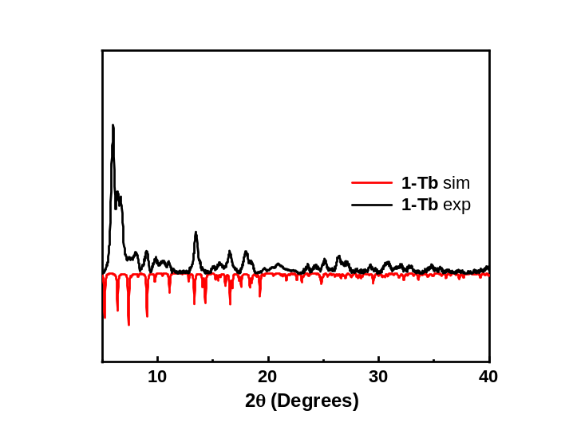
Figure S9. Powder XRD pattern for complex 1-Tb.

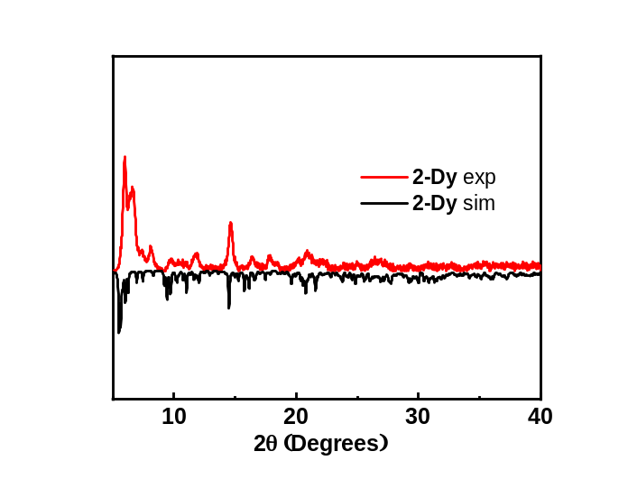
Figure S10. Powder XRD pattern for complex 2-Dy.

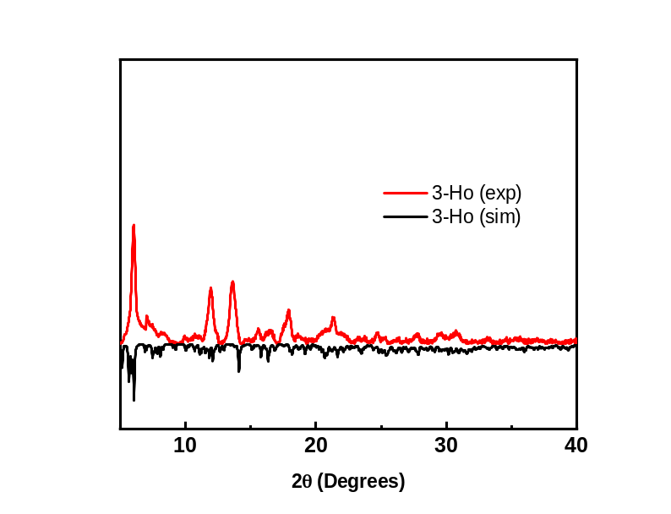
Figure S11. Powder XRD pattern for complex 3-Ho.

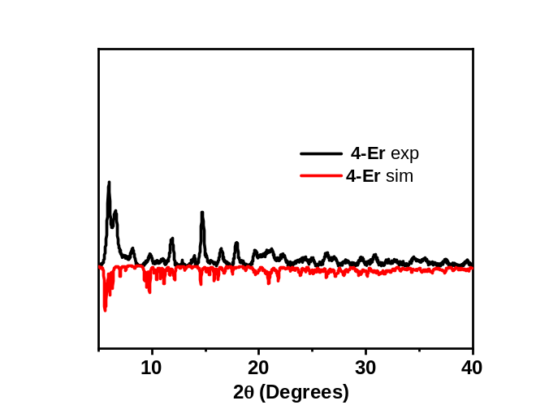
Figure S12. Powder XRD pattern for complex 4-Er.
Magnetism
Magnetic Details: Magnetic susceptibility measurements were performed on a Quantum Design SQUID magnetometer MPMS-3 and PPMS, operating between 1.8 and 300K for DC-applied fields ranging from 0 to 70 kOe and 0 to 90 kOe, respectively, to evaluate magnetic susceptibility. Microcrystalline samples were dispersed in Vaseline to stop the crystallites from torquing. The sample mulls were contained in a calibrated gelatin capsule that was held in the center of a drinking straw and fixed at the end of the sample rod. Alternating current (AC) magnetic measurements were performed in an oscillating field of 5 Oe with frequencies ranging from 0.1 Hz to 750Hz (MPMS-3) and 10 Hz to 10 kHz (PPMS).
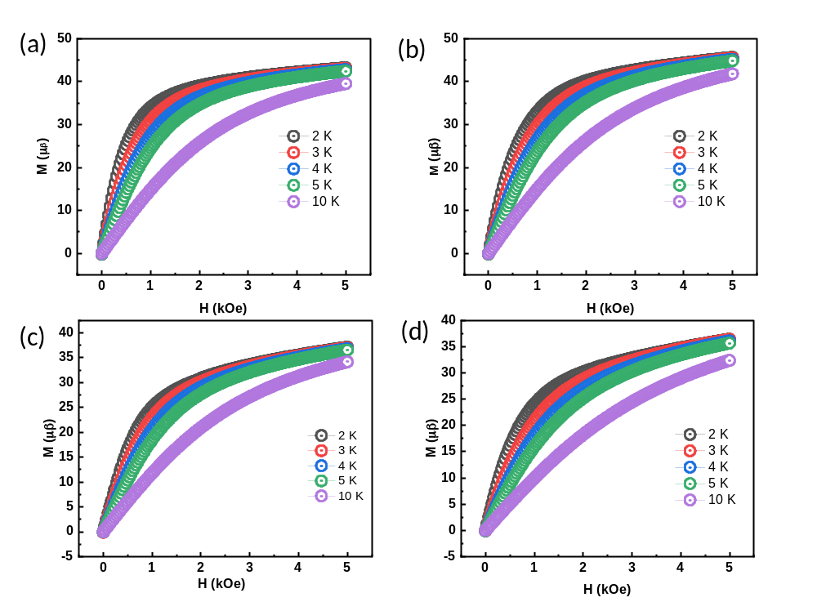
Figure S13. M vs. H plots for 1-Tb (a), 2-Dy (b), 3-Ho (c), and 4-Er (d) at different low temperatures and magnetic fields.
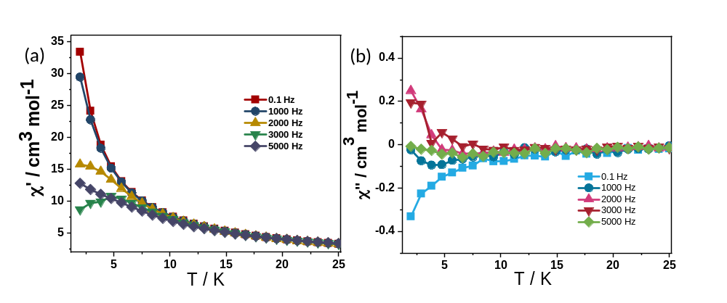
Figure S14. Plots of (a) χ_{M}″ and (b) χ_{M}″ versus T at various dc field for 1-Tb to predict the optimum dc field.
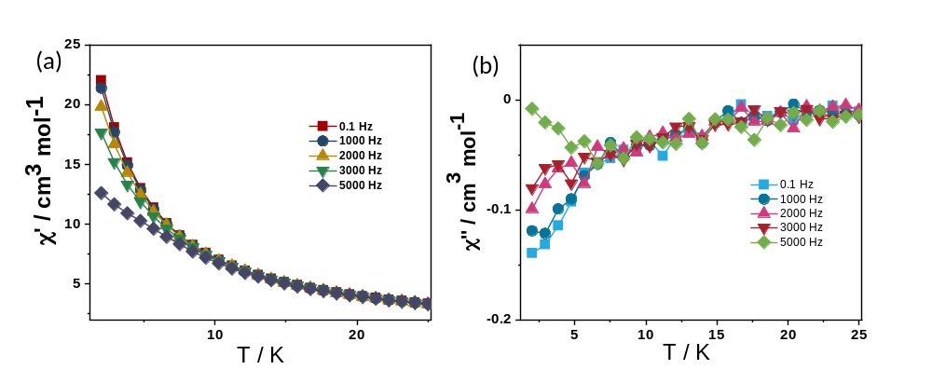Figure S15. Plots of (a) χ_{M}″ and (b) χ_{M}″ versus T at various dc fields for 3-Ho to predict the optimum dc field.
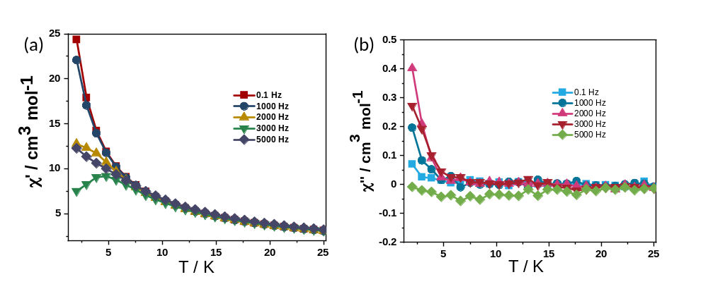Figure S16. Plots of (a) χ_{M}″ and (b) χ_{M}″ versus T at various dc fields for 4-Er to predict the optimum dc field.
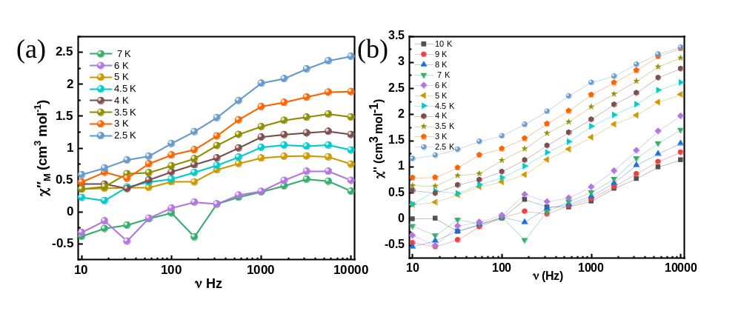
Figure S17. χ_{M}′′ vs. frequency plots for (a) 2-Dy and (b) 4-Er at an applied H_{dc} = 2000 Oe, respectively.

Computational Details. The MOLCAS 8.2¹ program was used, and ab initio CASSCF/RASSI-SO/SINGLE_ANISO calculations were carried out on the single-crystal XRD structures without any further geometry optimizations. A diamagnetic Lu(III) ion has been used to replace the other metal ions in calculating the magnetic characteristics of a single paramagnetic Ln(III) ion. The Douglas-Kroll Hamiltonian was preferred to take the relativistic effect of Ln (III) ions into consideration.² Cholesky decomposition of two-electron integrals has been used consistently throughout the calculations.³ ANO-RCC basis sets were used in this work.⁴ In particular, for Tb, Dy, Ho, Er, and Lu atoms, the [ANO-RCC…8s7p5d3f2g1h] basis set was used, and for Lu atoms, the [ANO-RCC…8s7p5d3f2g1h]. For C, [ANO-RCC…3s2p] and for O atoms [ANO-RCC…4s3p2d], and H atom [ANO-RCC…2s] to perform the GUESSORB calculations to determine the active space for the complete active space self-consistent field (CASSCF) calculations. To calculate CASSCF, eight electrons across seven 4f orbitals were used for Tb(III) ions. In the CI procedure,⁵ 7 septet excited states, 140 quintet excited states, and 195 triplet roots were computed. Nine electrons across seven 4f orbitals were used for Dy(III), there were 21 sextet excited states, 224 quartet excited states, and 480 doublet excited states computed to calculate the anisotropy. In Ho(III) ions, ten electrons across seven 4f orbitals were used. For CI roots, 35 quintets, 210 triplets, and 196 singlets, excited states were computed. In Er(III) ions, eleven electrons across seven 4f orbitals were used. For CI roots, 35 quartets, and 112 doublets, excited states were computed. We computed excited states based on spin-orbit coupling within spin-free eigenstates and mixed them using the RASSI-SO technique.⁶ The SINGLE_ANISO program considered the mixed SO states of each Ln(III) ion when calculating its anisotropic g-tensors for the doublets of Ln(III). The LoProp charge⁷ analysis was conducted on the metal centers and the atoms of the first coordination sphere, including the halide bridges, to analyze the orientation of anisotropic axes. Crystal-field parameters were computed using the SINGLE_ANISO algorithm to understand the relaxation mechanism thoroughly^{8, 9} The Hamiltonian used for the CF parameters is shown in the equation:
$$\hat{H}CF=\sum{1}\sum_{k=-q}^{q}{B_{k}^{q}Õ_{k}^{q}} (1)$$
Given as eq. 2, the related crystal field Hamiltonian contains the Stevens operator, $Õ_{k}^{q}$ , and the crystal field parameter, $B_{k}^{q}$. When a metal ion possesses a large nonaxial $B_{k}^{q}$ terms (where q ≠ 0 and k = 2, 4, and 6), compared to the axial terms (where q = 0 and k = 2, 4, and 6),¹¹ the QTM effects are predominant.
POLY_ANISO program calculated the exchange/dipolar interactions between the Dy^{III}-Dy^{III} by fitting with the experimental data.¹⁰ The exchange Hamiltonian employed for the complexes 1-4 is shown in the equation J_{i}
$$\hat{H}ex=-\sum_{i=1}^{3}{J_{i}}S_{i}S_{i+1} (2)$$
(Here $J_{i}=J_{i}^{dipolar}+J_{i}^{exch}$ ${; J}_{i}$ are the total magnetic interactions, $J_{i}^{dipolar}$ is the dipolar magnetic interaction and $J_{i}^{exch}$ is the exchange interaction between all the neighboring metal centres.
Table S11. The g-tensor of the lowest multiplets of all Tb(III) centers in 1-Tb complexes.
 | g-tensor
 |  | Tb1 | Tb2 | Tb3 | Tb4 | Tb5 | Tb6 | Tb7 | Tb8 | Tb9
1 | g_{x} | 0.0000 | 0.0000 | 0.0000 | 0.0000 | 0.0000 | 0.0000 | 0.0000 | 0.0000 | 0.0000
 | g_{y} | 0.0000 | 0.0000 | 0.0000 | 0.0000 | 0.0000 | 0.0000 | 0.0000 | 0.0000 | 0.0000
 | g_{z} | 13.8035 | 15.3900 | 16.0329 | 15.3720 | 16.0425 | 15.9399 | 15.9526 | 15.2836 | 15.2848
2 | g_{x} | 0.0000 | 0.0000 | 0.0000 | 0.0000 | 0.0000 | 0.0000 | 0.0000 | 0.0000 | 0.0000
 | g_{y} | 0.0000 | 0.0000 | 0.0000 | 0.0000 | 0.0000 | 0.0000 | 0.0000 | 0.0000 | 0.0000
 | g_{z} | 9.8763 | 12.5714 | 13.6583 | 12.5676 | 13.6487 | 13.5374 | 13.5382 | 12.4603 | 12.4627
7 | g_{x} | 0.0000 | 0.0000 | 0.0000 | 0.0000 | 0.0000 | 0.0000 | 0.0000 | 0.0000 | 0.0000
 | g_{y} | 0.0000 | 0.0000 | 0.0000 | 0.0000 | 0.0000 | 0.0000 | 0.0000 | 0.0000 | 0.0000
 | g_{z} | 6.7779 | 4.8557 | 4.8207 | 4.8586 | 4.8338 | 4.8022 | 4.7905 | 4.8218 | 4.8285
9 | g_{x} | 0.0000 | 0.0000 | 0.0000 | 0.0000 | 0.0000 | 0.0000 | 0.0000 | 0.0000 | 0.0000
 | g_{y} | 0.0000 | 0.0000 | 0.0000 | 0.0000 | 0.0000 | 0.0000 | 0.0000 | 0.0000 | 0.0000
 | g_{z} | 17.9060 | 17.3093 | 17.2652 | 17.2801 | 17.2587 | 17.2051 | 17.2327 | 17.2554 | 17.2464

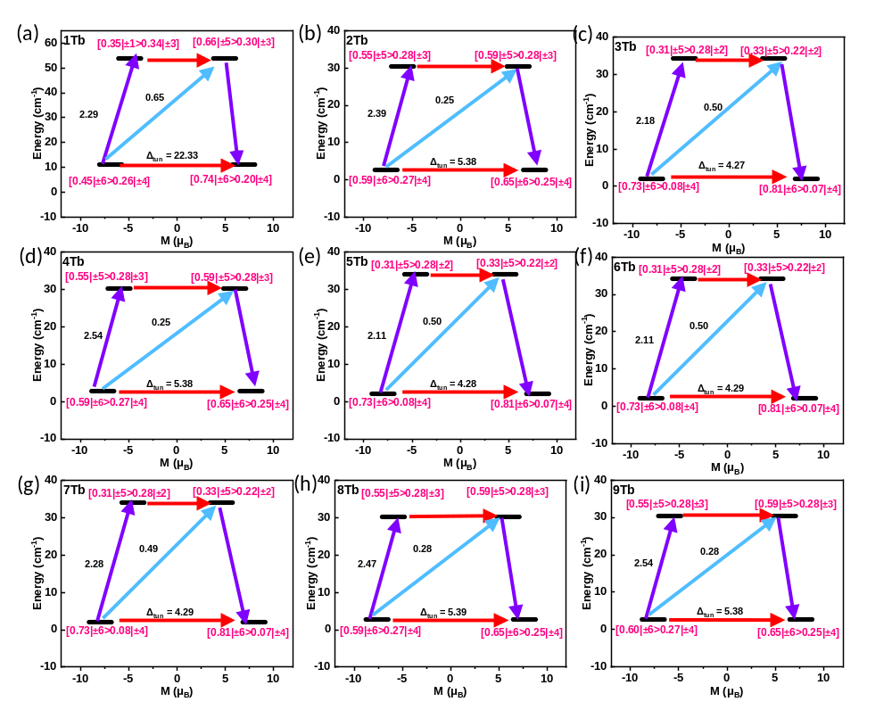
Figure S18. SINGLE_ANISO computed relaxation mechanism for all nine Tb(III) centres for complex 1-Tb. The black dash represents the energy levels. Red arrows, tunnelling gap; purple and blue arrows, spin-phonon transitions. The percentage-pure states are mentioned below each energy level.

Table S12. The g-tensor of the lowest multiplets of all Dy(III) centers in 2-Dy complexes.
 | g-tensor
 |  | Dy1 | Dy2 | Dy3 | Dy4 | Dy5 | Dy6 | Dy7 | Dy8 | Dy9
1 | g_{x} | 0.3909 | 0.2580 | 0.4088 | 0.6279 | 0.5245 | 0.31304 | 0.6337 | 0.2291 | 0.5072
 | g_{y} | 1.6733 | 0.9447 | 1.5064 | 3.6955 | 2.6147 | 1.1394 | 3.5794 | 0.7457 | 2.2873
 | g_{z} | 17.1996 | 18.3317 | 17.9583 | 15.2152 | 15.6753 | 18.1442 | 15.0608 | 18.7465 | 6.5888
2 | g_{x} | 0.7616 | 0.1014 | 0.2696 | 1.3037 | 1.1170 | 0.4573 | 1.2310 | 0.1952 | 1.0936
 | g_{y} | 1.0202 | 1.0500 | 1.2664 | 2.6287 | 1.7040 | 0.8788 | 2.6036 | 0.7089 | 1.4549
 | g_{z} | 15.4543 | 17.2110 | 16.9476 | 13.6731 | 13.6336 | 16.7977 | 12.6791 | 17.6132 | 14.6206
3 | g_{x} | 0.1759 | 0.1509 | 0.3320 | 0.4522 | 0.3020 | 0.1444 | 0.0172 | 0.6147 | 0.5486
 | g_{y} | 1.1972 | 1.6385 | 1.9223 | 1.4803 | 1.2561 | 1.0236 | 1.1017 | 1.2185 | 1.4530
 | g_{z} | 13.9572 | 13.3032 | 13.4436 | 13.4337 | 13.9783 | 14.1439 | 14.2311 | 14.0491 | 14.0794
4 | g_{x} | 0.7467 | 0.0219 | 0.6397 | 0.1814 | 0.5224 | 1.2320 | 0.0345 | 0.5391 | 0.3342
 | g_{y} | 2.4315 | 2.2292 | 1.9746 | 2.2056 | 2.3612 | 2.3777 | 1.5260 | 2.4133 | 2.4342
 | g_{z} | 10.6182 | 10.7037 | 11.0324 | 10.1835 | 10.5374 | 10.2418 | 10.9005 | 10.1587 | 10.7549
5 | g_{x} | 8.4687 | 2.2621 | 2.5086 | 2.8956 | 8.0342 | 4.7303 | 7.8073 | 8.3451 | 2.5944
 | g_{y} | 6.7880 | 3.0438 | 2.9606 | 4.0904 | 6.6786 | 6.3123 | 7.2053 | 7.0088 | 5.6671
 | g_{z} | 3.3483 | 12.0996 | 12.0919 | 10.7787 | 3.6631 | 9.0933 | 4.7255 | 4.3273 | 9.6149
6 | g_{x} | 2.5467 | 3.8774 | 3.9419 | 3.3454 | 2.1640 | 1.5049 | 2.1910 | 1.8542 | 3.1458
 | g_{y} | 3.7759 | 6.3374 | 6.0469 | 5.5906 | 3.4485 | 1.6420 | 2.5473 | 2.3797 | 4.5054
 | g_{z} | 14.4757 | 11.1036 | 11.1132 | 11.4919 | 14.3136 | 16.4386 | 14.8967 | 15.6161 | 13.2051
7 | g_{x} | 0.0424 | 0.0782 | 0.3448 | 0.0205 | 0.0155 | 0.1751 | 0.2672 | 0.0390 | 0.1417
 | g_{y} | 1.6164 | 0.8685 | 0.7086 | 0.9043 | 1.5731 | 1.0008 | 1.1624 | 1.6874 | 2.0256
 | g_{z} | 16.2122 | 17.5040 | 18.1799 | 17.5692 | 17.0681 | 18.4299 | 17.6052 | 15.7499 | 15.6514
8 | g_{x} | 0.2739 | 0.1710 | 0.0930 | 0.1835 | 0.2372 | 0.1419 | 0.1677 | 0.2951 | 0.3750
 | g_{y} | 1.4226 | 0.7625 | 0.3315 | 0.7858 | 1.2232 | 0.4919 | 0.6216 | 1.5012 | 1.9118
 | g_{z} | 17.6394 | 18.7797 | 19.3807 | 18.8849 | 17.9242 | 18.9326 | 18.6565 | 17.4451 | 17.3273

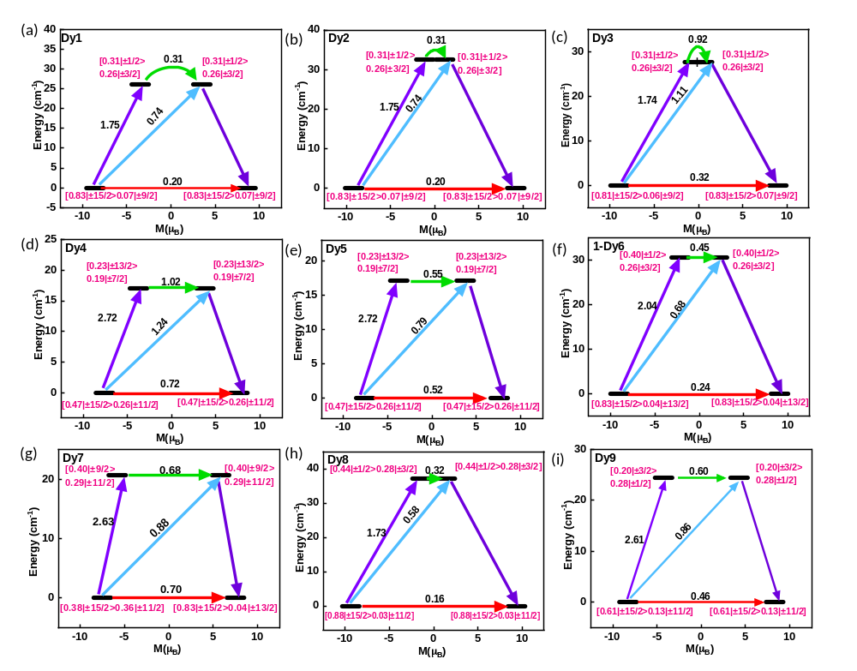
Figure S19. SINGLE_ANISO computed relaxation mechanism diagram for all nine Er(III) centres for complex 2-Dy. The black dash represents the energy levels. Red and green arrows, tunnelling gap; purple and blue arrows, spin-phonon transitions. The percentage-pure states are mentioned below each energy level.

Table S13. Ab initio computed spin-orbit states (cm⁻¹) of all Ho(III) centers in 3-Ho complexes.
KDs |  | Energy (cm⁻¹)
 | Ho1 | Ho2 | Ho3 | Ho4 | Ho5 | Ho6 | Ho7 | Ho8 | Ho9
1 | 1.8 | 0.8 | 0.8 | 0.6 | 0.6 | 0.7 | 0.8 | 0.8 | 0.9
2 | 8.15 | 40.6 | 39.3 | 42 | 39.8 | 43.6 | 39.9 | 42.8 | 41.5
3 | 54.6 | 119.5 | 116.1 | 120.1 | 112.3 | 123.6 | 117.2 | 123.6 | 125.3
4 | 96.3 | 176.57 | 173.6 | 177.6 | 175.3 | 177.4 | 177.6 | 178.4 | 177.6
5 | 151.7 | 194.1 | 187.9 | 197.1 | 189.6 | 201.8 | 194.9 | 200.2 | 195.1
6 | 156.0 | 216.7 | 212.3 | 218.2 | 214.5 | 222.4 | 219.3 | 223.2 | 218.0
7 | 201.0 | 235.7 | 232.4 | 237.6 | 234.2 | 237.1 | 235.8 | 241.0 | 236.3
8 | 231.8 | 253 | 248 | 254.2 | 249.0 | 259.2 | 252 | 259.9 | 254.8
9 | 328.7 | 278.9 | 277.5 | 281.3 | 276.4 | 280.5 | 276.7 | 282.7 | 283.8
10 | 381.3 | 307.3 | 301.9 | 309.2 | 305.0 | 313.3 | 309.5 | 310.7 | 308.8
 | g-tensors
g_{x} | 0.0000 | 0.0000 | 0.0000 | 0.0000 | 0.0000 | 0.0000 | 0.0000 | 0.0000 | 0.0000
g_{y} | 0.0000 | 0.0000 | 0.0000 | 0.0000 | 0.0000 | 0.0000 | 0.0000 | 0.0000 | 0.0000
g_{z} | 10.7393 | 16.1864 | 16.1030 | 16.6563 | 16.3220 | 17.0168 | 16.8930 | 16.8930 | 16.5417
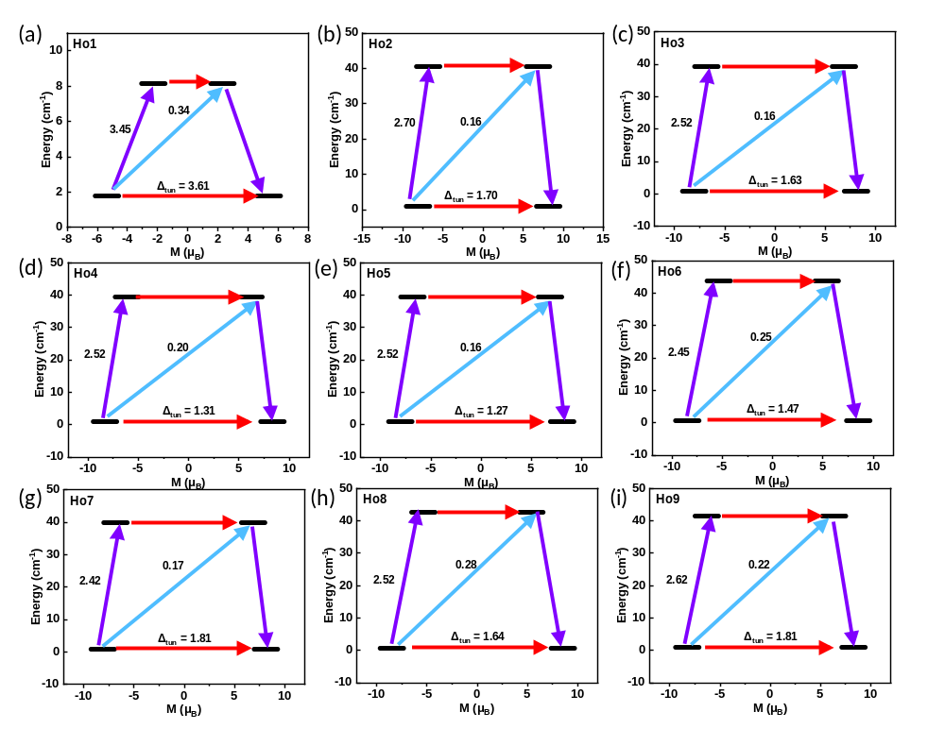
Figure S20. SINGLE_ANISO computed relaxation mechanism for all nine Ho(III) centres for complex 3-Ho. The black dash represents the energy levels. Red arrows, tunnelling gap; purple and blue arrows, spin-phonon transitions. The percentage-pure states are mentioned below each energy level.
Table S14. The g-tensor of the lowest multiplets of all Ho(III) centers in 3-Ho complexes.
 | g-tensor
 |  | Ho1 | Ho2 | Ho3 | Ho4 | Ho5 | Ho6 | Ho7 | Ho8 | Ho9
1 | g_{x} | 0.0000 | 0.0000 | 0.0000 | 0.0000 | 0.0000 | 0.0000 | 0.0000 | 0.0000 | 0.0000
 | g_{y} | 0.0000 | 0.0000 | 0.0000 | 0.0000 | 0.0000 | 0.0000 | 0.0000 | 0.0000 | 0.0000
 | g_{z} | 10.7393 | 16.1864 | 16.1030 | 16.6563 | 16.3220 | 17.0168 | 16.8930 | 16.8930 | 16.5417
2 | g_{x} | 0.0000 | 0.0000 | 0.0000 | 0.0000 | 0.0000 | 0.0000 | 0.0000 | 0.0000 | 0.0000
 | g_{y} | 0.0000 | 0.0000 | 0.0000 | 0.0000 | 0.0000 | 0.0000 | 0.0000 | 0.0000 | 0.0000
 | g_{z} | 7.9713 | 13.7831 | 13.6957 | 14.3930 | 13.9277 | 14.8641 | 13.9306 | 14.6792 | 14.2544
3 | g_{x} | 0.0000 | 0.0000 | 0.0000 | 0.0000 | 0.0000 | 0.0000 | 0.0000 | 0.0000 | 0.0000
 | g_{y} | 0.0000 | 0.0000 | 0.0000 | 0.0000 | 0.0000 | 0.0000 | 0.0000 | 0.0000 | 0.0000
 | g_{z} | 1.7547 | 15.0318 | 15.1194 | 15.1287 | 15.5322 | 14.6095 | 15.4168 | 14.9871 | 14.5384
4 | g_{x} | 0.0000 | 0.0000 | 0.0000 | 0.0000 | 0.0000 | 0.0000 | 0.0000 | 0.0000 | 0.0000
 | g_{y} | 0.0000 | 0.0000 | 0.0000 | 0.0000 | 0.0000 | 0.0000 | 0.0000 | 0.0000 | 0.0000
 | g_{z} | 3.1517 | 10.6688 | 9.9420 | 10.3667 | 9.8753 | 11.3690 | 10.7683 | 11.1713 | 10.9031
5 | g_{x} | 0.0000 | 0.0000 | 0.0000 | 0.0000 | 0.0000 | 0.0000 | 0.0000 | 0.0000 | 0.0000
 | g_{y} | 0.0000 | 0.0000 | 0.0000 | 0.0000 | 0.0000 | 0.0000 | 0.0000 | 0.0000 | 0.0000
 | g_{z} | 0.5739 | 11.2745 | 11.2882 | 11.4258 | 11.3084 | 11.2314 | 11.3537 | 11.5201 | 11.1357
6 | g_{x} | 0.0000 | 0.0000 | 0.0000 | 0.0000 | 0.0000 | 0.0000 | 0.0000 | 0.0000 | 0.0000
 | g_{y} | 0.0000 | 0.0000 | 0.0000 | 0.0000 | 0.0000 | 0.0000 | 0.0000 | 0.0000 | 0.0000
 | g_{z} | 19.7441 | 15.5360 | 15.2896 | 16.2379 | 15.8123 | 15.2495 | 15.4873 | 14.9951 | 14.9739
7 | g_{x} | 0.0000 | 0.0000 | 0.0000 | 0.0000 | 0.0000 | 0.0000 | 0.0000 | 0.0000 | 0.0000
 | g_{y} | 0.0000 | 0.0000 | 0.0000 | 0.0000 | 0.0000 | 0.0000 | 0.0000 | 0.0000 | 0.0000
 | g_{z} | 17.2329 | 16.6845 | 16.2062 | 16.8919 | 16.7774 | 16.9491 | 16.9893 | 16.3279 | 16.1469

Table S15. Ab initio computed spin-orbit states (cm⁻¹) of all Er(III) centers in 4-Er complexes.
 | Energy (cm⁻¹)
KDs | Er1 | Er2 | Er3 | Er4 | Er5 | Er6 | Er7 | Er8 | Er9
1 | 0 | 0 | 0 | 0 | 0 | 0 | 0 | 0 | 0
2 | 103.7 | 31.2 | 34.8 | 29.2 | 30.0 | 28.9 | 34.0 | 35.1 | 34.6
3 | 150.4 | 73.5 | 79.9 | 71.2 | 69.4 | 69.6 | 71.1 | 77.6 | 72.7
4 | 158.3 | 112.8 | 117.8 | 113.3 | 109.5 | 109.0 | 111.5 | 112.0 | 112.3
5 | 218.3 | 165.5 | 161.9 | 166.5 | 155.8 | 160.7 | 164.3 | 163.4 | 161.3
6 | 318.7 | 220.4 | 220.5 | 213.2 | 210.0 | 213.3 | 217.5 | 218.9 | 217.9
7 | 321.8 | 288.8 | 293.7 | 296.0 | 285.8 | 284.2 | 293.5 | 296.5 | 299.8
8 | 369.0 | 371.3 | 377.5 | 368.4 | 354.3 | 357.1 | 352.8 | 369.0 | 368.2
 | g-tensors
g_{x} | 0.0494 | 1.0146 | 0.8976 | 0.7479 | 0.8254 | 10.3682 | 0.6350 | 0.9316 | 1.0233
g_{y} | 0.0505 | 6.2399 | 5.6068 | 5.5048 | 6.0601 | 7.6441 | 3.9342 | 5.6098 | 6.0740
g_{z} | 15.4500 | 11.5463 | 12.4022 | 12.3953 | 11.9523 | 1.0541 | 13.4558 | 12.2637 | 11.8349

Table S16. The g-tensor of the lowest multiplets of all Er(III) centers in 4-Er complexes.
 | g-tensor
 |  | Er1 | Er2 | Er3 | Er4 | Er5 | Er6 | Er7 | Er8 | Er9
1 | g_{x} | 0.0494 | 1.0146 | 0.8976 | 0.7479 | 0.8254 | 10.3682 | 0.6350 | 0.9316 | 1.0233
 | g_{y} | 0.0505 | 6.2399 | 5.6068 | 5.5048 | 6.0601 | 7.6441 | 3.9342 | 5.6098 | 6.0740
 | g_{z} | 15.4500 | 11.5463 | 12.4022 | 12.3953 | 11.9523 | 1.0541 | 13.4558 | 12.2637 | 11.8349
2 | g_{x} | 0.0119 | 8.9702 | 9.6046 | 0.3831 | 9.3638 | 8.4626 | 0.9513 | 9.6541 | 9.0069
 | g_{y} | 0.0181 | 6.1920 | 5.2801 | 5.2842 | 6.1337 | 6.5886 | 4.0935 | 5.0040 | 5.8724
 | g_{z} | 17.7664 | 0.0275 | 0.1696 | 10.5172 | 0.3650 | 0.0510 | 10.9983 | 0.0774 | 0.0040
3 | g_{x} | 9.5518 | 1.0203 | 0.8927 | 0.3603 | 1.0424 | 0.7422 | 8.4715 | 0.8543 | 0.4291
 | g_{y} | 7.9791 | 2.9029 | 2.9440 | 4.1549 | 2.5902 | 3.9970 | 4.3832 | 3.5821 | 3.1691
 | g_{z} | 1.9242 | 9.2451 | 9.6376 | 9.2093 | 9.2870 | 8.5608 | 0.2182 | 9.3183 | 9.5094
4 | g_{x} | 0.1698 | 2.9748 | 3.1090 | 6.3630 | 3.3590 | 6.1423 | 6.9589 | 7.1152 | 2.6216
 | g_{y} | 0.7048 | 4.7366 | 4.8910 | 5.6563 | 4.7526 | 5.8552 | 4.8968 | 4.9757 | 4.4385
 | g_{z} | 11.0033 | 7.2503 | 7.1508 | 2.1940 | 6.8688 | 3.0764 | 2.2707 | 2.6732 | 8.0428
5 | g_{x} | 4.0885 | 0.8527 | 1.4066 | 0.5900 | 1.1064 | 0.6514 | 0.9547 | 1.2013 | 0.9255
 | g_{y} | 4.2830 | 2.7122 | 2.5574 | 1.9672 | 2.5594 | 2.5036 | 2.2543 | 2.7325 | 2.4768
 | g_{z} | 4.9744 | 13.1846 | 13.3229 | 14.2347 | 13.5686 | 13.6487 | 14.6954 | 13.9226 | 14.0238
6 | g_{x} | 0.1251 | 0.0725 | 0.0823 | 0.4953 | 0.3893 | 0.3098 | 0.3072 | 0.1189 | 0.3692
 | g_{y} | 0.3599 | 1.8247 | 1.6369 | 1.5067 | 1.8535 | 1.9264 | 1.9055 | 1.3646 | 1.5878
 | g_{z} | 10.0580 | 11.6210 | 11.8586 | 12.2131 | 11.9562 | 11.9851 | 11.5331 | 11.9788 | 11.8778
7 | g_{x} | 5.0620 | 1.2712 | 1.0584 | 0.8119 | 0.9712 | 1.1831 | 0.8581 | 0.9585 | 0.9028
 | g_{y} | 4.8020 | 1.5245 | 1.2568 | 1.1708 | 1.3144 | 1.4048 | 1.6996 | 1.2622 | 1.3151
 | g_{z} | 4.2826 | 13.2476 | 13.5055 | 13.4250 | 13.1281 | 13.4491 | 12.2303 | 13.1555 | 13.0970
8 | g_{x} | 0.2379 | 0.1394 | 0.1073 | 0.1701 | 0.1739 | 0.1870 | 0.3122 | 0.1853 | 0.1875
 | g_{y} | 0.3426 | 0.3405 | 0.2737 | 0.4259 | 0.4433 | 0.4654 | 0.7953 | 0.4852 | 0.4994
 | g_{z} | 8.4534 | 15.7470 | 15.8326 | 15.3920 | 15.3341 | 15.6675 | 14.8721 | 15.5434 | 15.2934

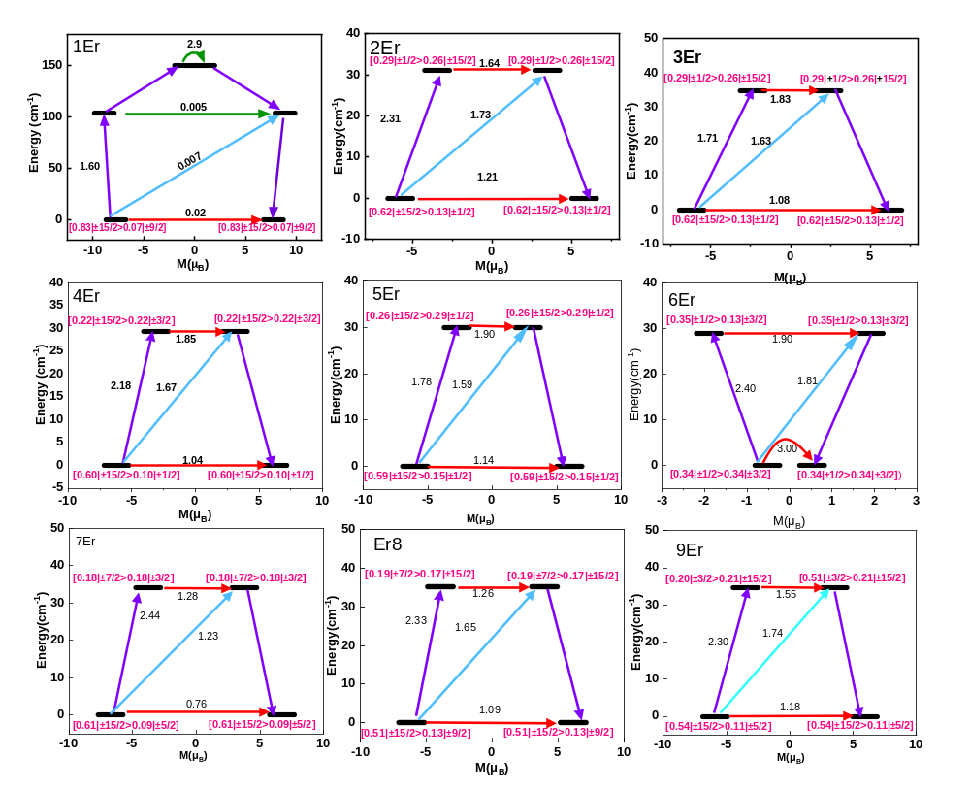
Figure S21. SINGLE_ANISO computed relaxation mechanism for all nine Er(III) centres for complex 4-Er.

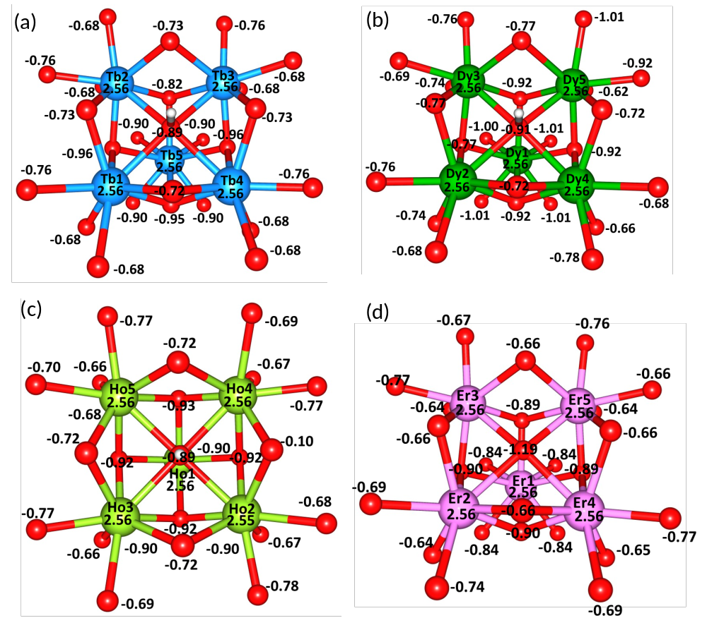
Figure S22. LoProp charges on complex (a) 1-Tb, (b) 2-Dy, (b) 3-Ho and (d) 4-Er.
Table S17. Computed exchange couplings (cm^{‒1}) values for complexes 1-Tb to 4-Er.
Complex | J₁ | J₂ | J₃ | zJ
1-Tb | -0.002 | -0.001 | -0.001 | -0.005
2-Dy | -0.12 | -0.07 | -0.13 | -0.005
3-Ho | -0.18 | -0.17 | -0.16 | -0.01
4-Er | -0.12 | -0.12 | -0.12 | -0.01

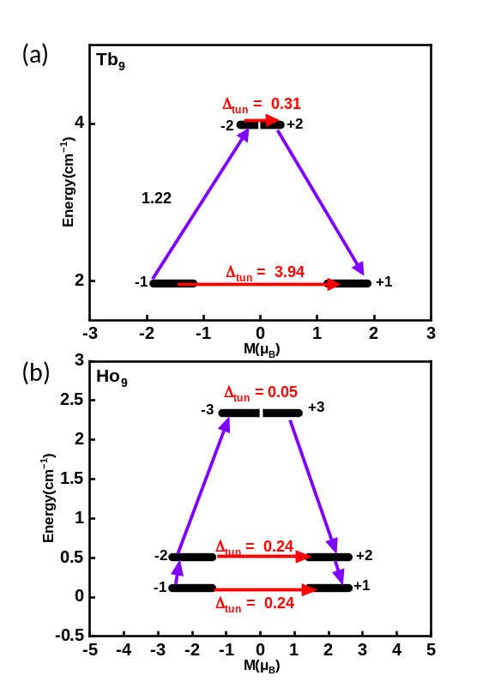
Figure S23. Low-lying exchange spectra in (a) 1-Tb and (b) 3-Ho. The exchange states are placed on the diagram according to their magnetic moments (bold block lines). The red arrows show the tunnelling gaps (Δ_{tun}) between each doublet state, while the purple arrows show the possible pathway through spin-phonon transitions.
Table S18: Lowest exchange-coupled doublets (cm^{‒1}) arising from the dipolar coupling, the corresponding tunnel splitting (Δ_{tun}, cm^{‒1}), and the g_{z} value of each doublet (g_{x} and g_{y} ≠ 0) for complex 1-Tb.
No. | E (cm^{‒1}) | Δ_{tun} | g_{z}
1 | 0.000000000000  3.937113927941 | 3.94 | 3.061094750
2 | 3.942147729850  4.018685906371 | 0.31 | 0.000004607

Table S19: Lowest exchange-coupled doublets (cm^{‒1}) arising from the dipolar coupling, the corresponding tunnel splitting (Δ_{tun}, cm^{‒1}), and the g_{z} value of each doublet (g_{x} and g_{y} ≠ 0) for complex 3-Ho.
No. | E (cm^{‒1}) | Δ_{tun} | g_{z}
1 | 0.000000000000  0.238748432237 | 0.24 | 4.016518000
2 | 0.402716077716  0.641415418828 | 0.24 | 4.015874669
3 | 2.298302094488  2.346571185608 | 0.05 | 2.514008276

References:
1. F. Aquilante, J. Autschbach, R. K. Carlson, L. F. Chibotaru, M. G. Delcey, L. De Vico, I. Fdez. Galván, N. Ferré, L. M. Frutos, L. Gagliardi, M. Garavelli, A. Giussani, C. E. Hoyer, G. Li Manni, H. Lischka, D. Ma, P. Å. Malmqvist, T. Müller, A. Nenov, M. Olivucci, T. B. Pedersen, D. Peng, F. Plasser, B. Pritchard, M. Reiher, I. Rivalta, I. Schapiro, J. Segarra-Martí, M. Stenrup, D. G. Truhlar, L. Ungur, A. Valentini, S. Vancoillie, V. Veryazov, V. P. Vysotskiy, O. Weingart, F. Zapata and R. Lindh, Molcas 8: New capabilities for multiconfigurational quantum chemical calculations across the periodic table, J. Comput. Chem., 2016, 37, 506-541.
2. B. A. Hess, C. M. Marian, U. Wahlgren and O. Gropen, A mean-field spin-orbit method applicable to correlated wavefunctions, Chem. Phys. Lett., 1996, 251, 365-371.
3. B. O. Roos and P.-A. Malmqvist, Relativistic quantum chemistry: the multiconfigurational approach, Phys. Chem. Chem. Phys., 2004, 6, 2919-2927.
4. B. O. Roos, R. Lindh, P.-A. Malmqvist, V. Veryazov, P.-O. Widmark and A. C. Borin, New Relativistic Atomic Natural Orbital Basis Sets for Lanthanide Atoms with Applications to the Ce Diatom and LuF₃, J. Phys. Chem. A., 2008, 112, 11431-11435.
5. K. R. Vignesh, S. K. Langley, K. S. Murray and G. Rajaraman, Exploring the Influence of Diamagnetic Ions on the Mechanism of Magnetization Relaxation in {Co₂^{III}Ln₂^{III}} (Ln = Dy, Tb, Ho) “Butterfly” Complexes, Inorg. Chem., 2017, 56, 2518-2532.
6. P. A. Malmqvist, B. O. Roos and B. Schimmelpfennig, The restricted active space (RAS) state interaction approach with spin-orbit coupling, Chem. Phys. Lett., 2002, 357, 230-240.
7. L. Gagliardi, R. Lindh and G. Karlström, Local properties of quantum chemical systems: The LoProp approach, J. Chem. Phys., 2004, 121, 4494-4500.
8. A. S. Armenis, V. Vipanchi, K. N. Pantelis, L. Cunha-Silva, K. R. Vignesh, D. I. Alexandropoulos and T. C. Stamatatos, Slow Magnetization Relaxation in a Family of Triangular {Co₂^{III}Ln₂^{III}} Clusters: The Effect of Diamagnetic Co^{III} Ions on the Ln^{III} Magnetic Dynamics, Chem. Eur. J., 2023, 29, e202302337.
9. L. F. Chibotaru and L. Ungur, Ab initio calculation of anisotropic magnetic properties of complexes. I. Unique definition of pseudospin Hamiltonians and their derivation, J. Chem. Phys., 2012, 137, 064112-064122.
10. M. E. Lines, Orbital Angular Momentum in the Theory of Paramagnetic Clusters, J. Chem. Phys., 1971, 55, 2977-2984.
11. S. K. Langley, L. Ungur, N. F. Chilton, B. Moubaraki, L. F. Chibotaru and K. S. Murray, Single-Molecule Magnetism in a Family of {Co₂^{III}Dy₂^{III}} Butterfly Complexes: Effects of Ligand Replacement on the Dynamics of Magnetic Relaxation, Inorg. Chem., 2014, 53, 4303-4315.

