Supplementary information
for
A 0.5 cm³ Ingestible Capsule Sensor with Synchronized Sensing and Tracking for Active Gastrointestinal Event Identification and Localization

Zijian An ^{1,2,3,4#}, Fengrong Liu ^{1,2,4#}, Ang Li ¹, Yuxi Li ^{1,2}, Yunrui Cao ¹, Zhenghan Shi ¹, Xin Li¹, Hao Wen ¹, Rujing Sun ¹, Qingjun Liu ^{1,2,4}*

¹Zhejiang Key Laboratory of Intelligent Sensing Technology and Advanced Medical Instrument, Key Laboratory for Biomedical Engineering of Ministry of Education, College of Biomedical Engineering & Instrument Science, Zhejiang University, Hangzhou 310027, PR China

²Taizhou Key Laboratory of Medical Devices and Advanced Materials, Zhejiang Key Laboratory of Intelligent Medical Decision Support, Taizhou Institute of Zhejiang University, 318000, PR China

³Faculty of Materials Science and Energy Engineering, Shenzhen University of Advanced Technology, Shenzhen, 518107, P.R. China

⁴Innovation Center for Smart Medical Technologies & Devices, Binjiang Institute of Zhejiang University, Hangzhou, 310053,P.R. China

#These co-first authors contribute equally to this work.

E-mail address: qjliu@zju.edu.cn (Q. Liu).

Table of Content

Supplementary Note 1 Theoretical calculation of the communication model.
Supplementary Note 2 Finite element electromagnetic simulation.
Supplementary Fig. 1 Equivalent transmitting circuit.
Supplementary Fig. 2 Coupling impedance calculation.
Supplementary Fig. 3 Replace the cylindrical electrode with a spherical electrode to simplify the calculation.
Supplementary Fig. 4 Relationship between the load impedance and the frequency.
Supplementary Fig. 5 Schematic diagram of the far-field electric potential of an infinitesimal dipole.
Supplementary Fig. 6 Model composition.
Supplementary Fig. 7 Multilayer perceptron network structure and its training process.
Supplementary Fig. 8 Image of the positioning experimental setup.
Supplementary Fig. 9 Devices form that excreted by rabbits normally.
Supplementary Fig. 10 Gastric motility data processing and annotation under normal conditions.
Supplementary Fig. 11 Gastric motility data processing and annotation under drug conditions.
Supplementary Fig. 12 Comparison between reconstructed localization coordinates and X-ray images, including ventral-dorsal position and lateral position views.
Supplementary Fig. 13 Intestinal motility data processing and annotation under normal conditions.
Supplementary Fig. 14 Circuit schematic diagram.
Supplementary Fig. 15 Assembly and testing details.
Supplementary Fig. 16 External-to-internal pressure transmission ratio.
Supplementary Fig. 17 Communication test within body tissues
Supplementary Fig. 18 Spectral data.
Supplementary Fig. 19 Safety experiment.
Supplementary Fig. 20 Surgical details.
Supplementary Table 1 Comparison of recent advanced ingestible sensor and commercial wireless technologies.
Supplementary Table 2 Physical parameters of the model.
Supplementary Table 3 Electrical parameters.
Supplementary Table 4 Predicted coordinates and actual coordinates.
Supplementary Movie 1 Real-time communication demonstration.
Supplementary Movie 2 Functional verfication of the Pill-Scanner from ingestion to excretion (In the stomach, during the eating process).
Supplementary Movie 3 Functional verfication of the Pill-Scanner from ingestion to excretion (In the stomach, the process of drinking water).
Supplementary Movie 4 Functional verfication of the Pill-Scanner from ingestion to excretion (In the small intestine).
Supplementary Movie 5 Functional verfication of the Pill-Scanner from ingestion to excretion (After excretion).
Supplementary Movie 6 The rhythmic differences between the stomach, small intestine, and large intestine.
Supplementary Note 1. Theoretical calculation of the communication model
According to Fig. 2b and 2c, the equivalent transmitting circuit of our in vivo communication can be simplified to Supplementary Fig. 1. This circuit can be divided into three parts: the excitation source (considered as an ideal voltage source), the coupling impedance (the coupling electrode and the encapsulation layer), and the load impedance (body tissue). Using this circuit model, the output current and the energy coupled to the body tissue can be estimated, and then the transmission loss and the communication distance can be calculated.
1. Estimation of coupling impedance
The coupling impedance originates from the capacitance formed between the electrode and the body tissue. This capacitor can be calculated using the parallel plate capacitor formula (1):
$C=\frac{εS}{4πkd}=\frac{εrw}{2kd}$ (1)
Where $r$ is the radius of capsule, $w$ is the width of coupling electrode, $k$ is the electrostatic constant, $d$ and $ε$ represent the thickness and dielectric constant of the encapsulation material respectively. Therefore, the capacitance reactance $Z_{C}$ can be calculated as formula (2):
$Z_{C}=−\frac{1}{jωC}$ (2)
The Supplementary Fig. 2. shows the relationship between the coupling impedance and the frequency.
2. Estimation of load impedance
The conductance $G$ of a spherical electrode with radius $a$ in an infinite dielectric medium can be calculated as formula (3):
$G=σ4πa$ (3)
Where $σ$ is the conductivity of the medium.
Using the method of images (takes care of the effect that each sphere has on the other), the conductance of two spheres immersed in an infinite homogeneous medium can be calculated as formula (4)¹:
$G=σ2πa\left(1+\frac{a}{L}+{\left(\frac{a}{L}\right)}^{2}+{\left(\frac{a}{L}\right)}^{3}+{2\left(\frac{a}{L}\right)}^{4}+{3\left(\frac{a}{L}\right)}^{5}…\right)$ (4)
$$\left(L>2a\right)$$
This formula is used to calculate the conductance when the values of $L$ and $a$ are close. When $L$ is much greater than $a$, formula (4) becomes equivalent to formula (3). Under such conditions, the conductance is proportional to the radius of the electrode's contact with the medium and independent of the separation distance. However, practical coupling electrodes are cylindrical in shape. Due to boundary effects (where the surface potential no longer distributes uniformly as in the case of a sphere), there is no general analytical expression for conductors of this shape as there is for spherical electrodes.
A reasonable assumption is that this cylindrical coupling surface can be equivalently treated as a sphere with radius $a$ (Supplementary Fig. 3), leading to the expression for $a$:
$4πa^{2}=2πrw$ (5)
$a=\sqrt{\frac{rw}{2}}$ (6)
Where the $r$ is the radius of the capsule and the $w$is the width of the coupling electrode. In this design, since the electrode configuration does not meet the condition that $L$ ≫ $a$, the conductance $G_{T}$ between the coupling electrodes must be estimated using formula (7). Taking the first five terms as an approximation, the estimated conductance of the human tissue load is approximately:
$G_{T}=σ^{∗}2π\sqrt{\frac{rw}{2}}\left(1+\frac{\sqrt{\frac{rw}{2}} }{L}+{\left(\frac{\sqrt{\frac{rw}{2}} }{L}\right)}^{2}+{\left(\frac{\sqrt{\frac{rw}{2}} }{L}\right)}^{3}+{2\left(\frac{\sqrt{\frac{rw}{2}} }{L}\right)}^{4}+{3\left(\frac{\sqrt{\frac{rw}{2}} }{L}\right)}^{5}\right)$ (7)
Where the $σ^{∗}$ is a complex number, The real part is the conductance $σ$, and the imaginary part is the susceptance $iωε$：
$σ^{∗}=σ+iωε$ (8)
Biological tissues are typical dispersive dielectric media, which means their permittivity and conductivity change with frequency. The variation in the permittivity and conductivity of body tissues was based on previous research². The Supplementary Fig. 4. shows the relationship between the load impedance and the frequency.
Therefore, the total current coupled to the body tissue is:
$I_{0}=\frac{U_{0}}{\frac{1}{G_{T}}+Z_{C}}$ (9)
3. Estimation of communication distance
Considering the tiny size of the sensor compared to the wavelength, the infinitesimal dipole model was used to calculate the attenuation and transmission distance (Supplementary Fig. 5).
For infinitesimal dipoles, the electric potential distribution (the maximum electric potential along the dipole moment direction) can be calculated as:
$φ=\frac{p}{4πε}\left(\frac{1}{d^{2}}+\frac{jωμ}{kdε}\right)e^{−jkd}$ (10)
Where $p$ is the dipole moment:
$p=q∙L=\frac{I_{0}L}{jω}$ (11)
The input current $I_{0}$ can be calculated using formula (9), and $d$ is the distance between the the observation point and the infinitesimal dipole, $μ$ is the vacuum permeability, $k$ is the complex wavenumber:
$k=ω\sqrt{με^{∗}}$ (12)
Where $ε^{∗}$ is the complex permittivity of body tissues:
$ε^{∗}=ε−i\frac{σ}{ω}$ (13)
The imaginary part of the complex wavenumber $α$ represents the attenuation constant, which indicates the attenuation of electromagnetic waves through a lossy medium.
$α=Im\left(k\right)$ (14)

Note S2. Finite element electromagnetic simulation
Finite element analysis (FEA) was utilized to analyze the electrical signal transmission mechanism. All the calculations were conducted in COMSOL Multiphysics. The AC/DC module was used to quantitatively analyze the surface potential distribution and power consumption of the system during operation, as well as the performance of the system under different parameter conditions. The model consists of a homogeneous cylinder and a randomly placed Pill-Scanner (Supplementary Fig. 6a and b). The 3D structure of the device is shown in Supplementary Fig. 6c-e. The geometric parameters of the model are shown in Supplementary Table 2. The simulation frequency was set to 6MHz, and the electrical conductivity and dielectric constant values of the relevant human tissues at this frequency were calculated according to the Cole-Cole formula. The material settings were shown in Supplementary Table 3. The entire model adhered to the principle of current conservation, and the electrical insulation was used for boundaries. The initial potential of the electric potential was set at 0V, and working potentials of the transmitting electrodes were respectively set at ±2V to simulate the actual working conditions. In terms of mesh division, a free mesh divider was used to refine the mesh near the electrode and boundary layer to enhance the accuracy of the simulation in key areas. In the far-field region, a lower grid density was adopted to reduce the computing time.

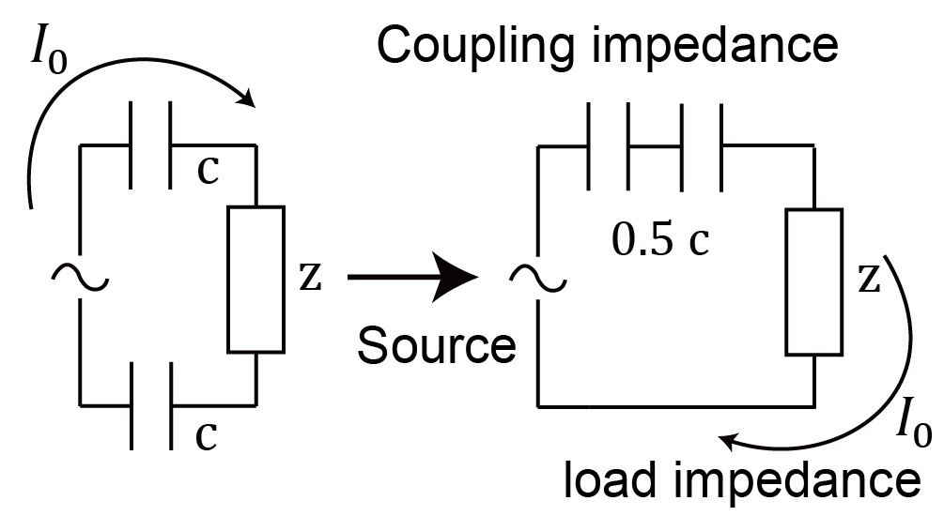
Supplementary Fig. 1 Equivalent transmitting circuit.

Supplementary Fig. 2 Coupling impedance calculation.

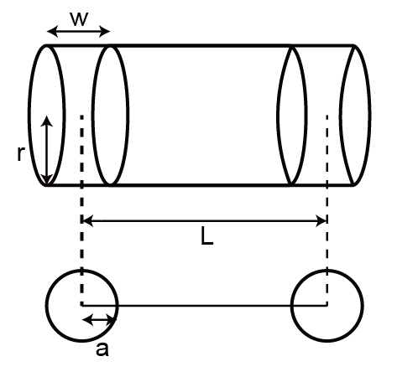
Supplementary Fig. 3 Replace the cylindrical electrode with a spherical electrode to simplify the calculation.

Supplementary Fig. 4 Relationship between the load impedance and the frequency.

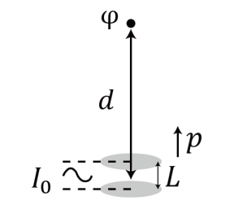
Supplementary Fig. 5 Schematic diagram of the far-field electric potential of an infinitesimal dipole.

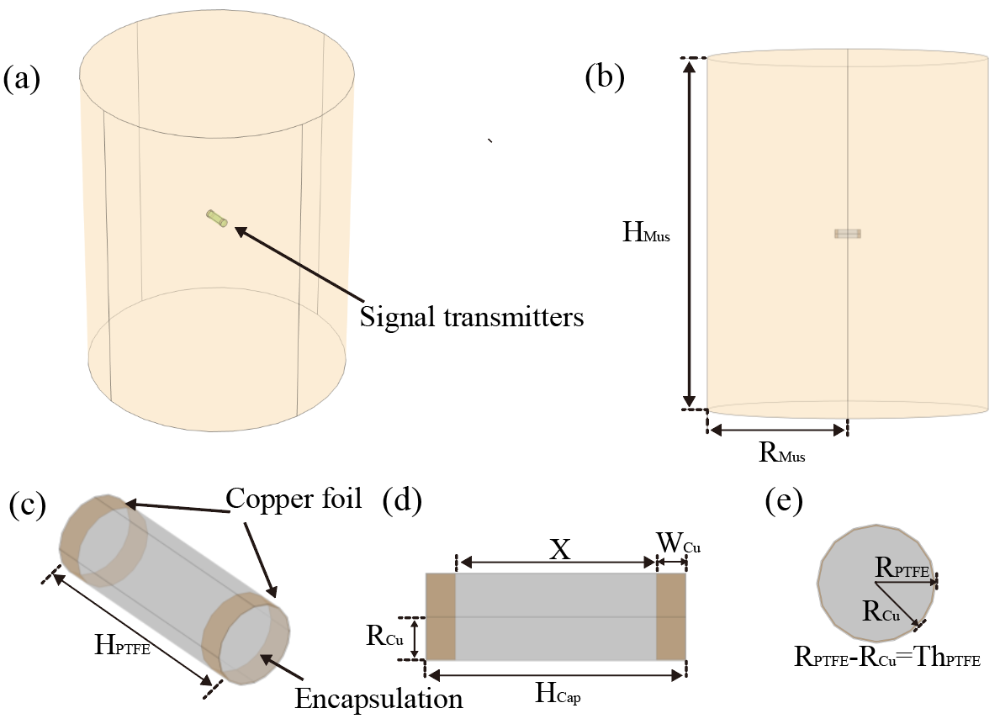
Supplementary Fig. 6 Model composition.

Supplementary Fig. 7 Multilayer perceptron network structure and its training process. During the training process, the model employed an adaptive learning rate decay strategy and an early stopping mechanism to optimize training effectiveness and prevent overfitting. The learning rate decay strategy was implemented via the ReduceLROnPlateau callback function, with specific parameter settings as follows: monitoring the validation loss (val_loss), and automatically reducing the current learning rate to 60% of its original value when the validation performance showed no improvement for 10 consecutive epochs. The lower bound for the learning rate was set to 1e-7. This dynamic adjustment mechanism helps the model approach the optimal solution more finely in the later stages of training, avoiding oscillations caused by an excessively high learning rate. The early stopping strategy utilized the EarlyStopping callback function, also monitoring the validation loss. Training was automatically terminated, and the model weights were restored to the state with the lowest validation loss when no decrease in validation loss was observed for 20 consecutive epochs. This approach effectively prevents overfitting on the training set while conserving computational resources.

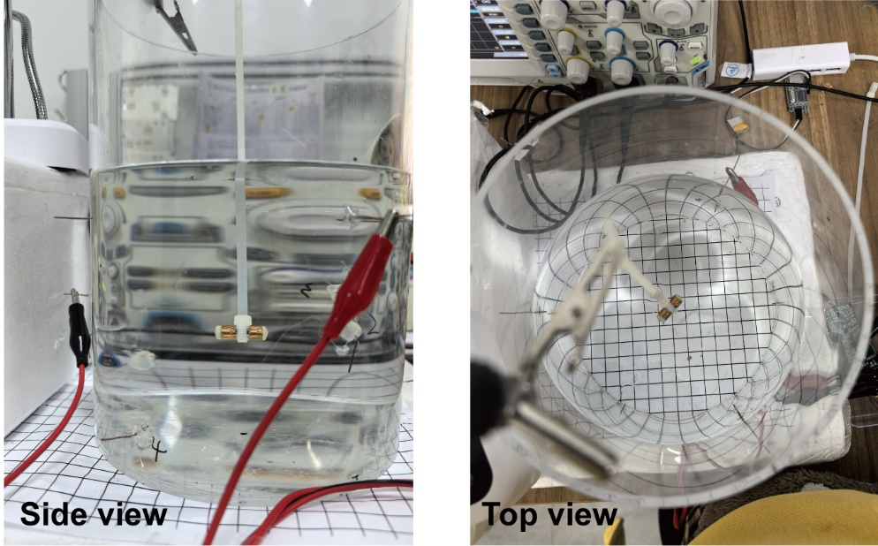
Supplementary Fig. 8 Image of the positioning experimental setup. The unit distance on the coordinate paper in the picture is one centimeter. The position where the device is suspended was confirmed visually. The coordinates shown in the image are (0, 0, -1, 90, 45) (X, Y, Z, Pitch, Yaw)

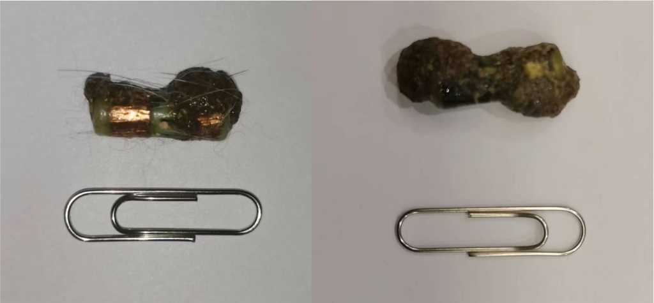
Supplementary Fig. 9 Devices form that excreted by rabbits normally.

Supplementary Fig. 10 Gastric motility data processing and annotation under normal conditions. The waveforms of gastrointestinal peristalsis are very different from sine waves. Therefore, using traditional frequency domain analysis may introduce harmonic errors. We adopted the method of peak annotation and counting to reduce statistical errors.

Supplementary Fig. 11 Gastric motility data processing and annotation under drug conditions. Under the influence of the drug, the gastric motility pattern underwent significant changes, with the peak value increasing markedly.

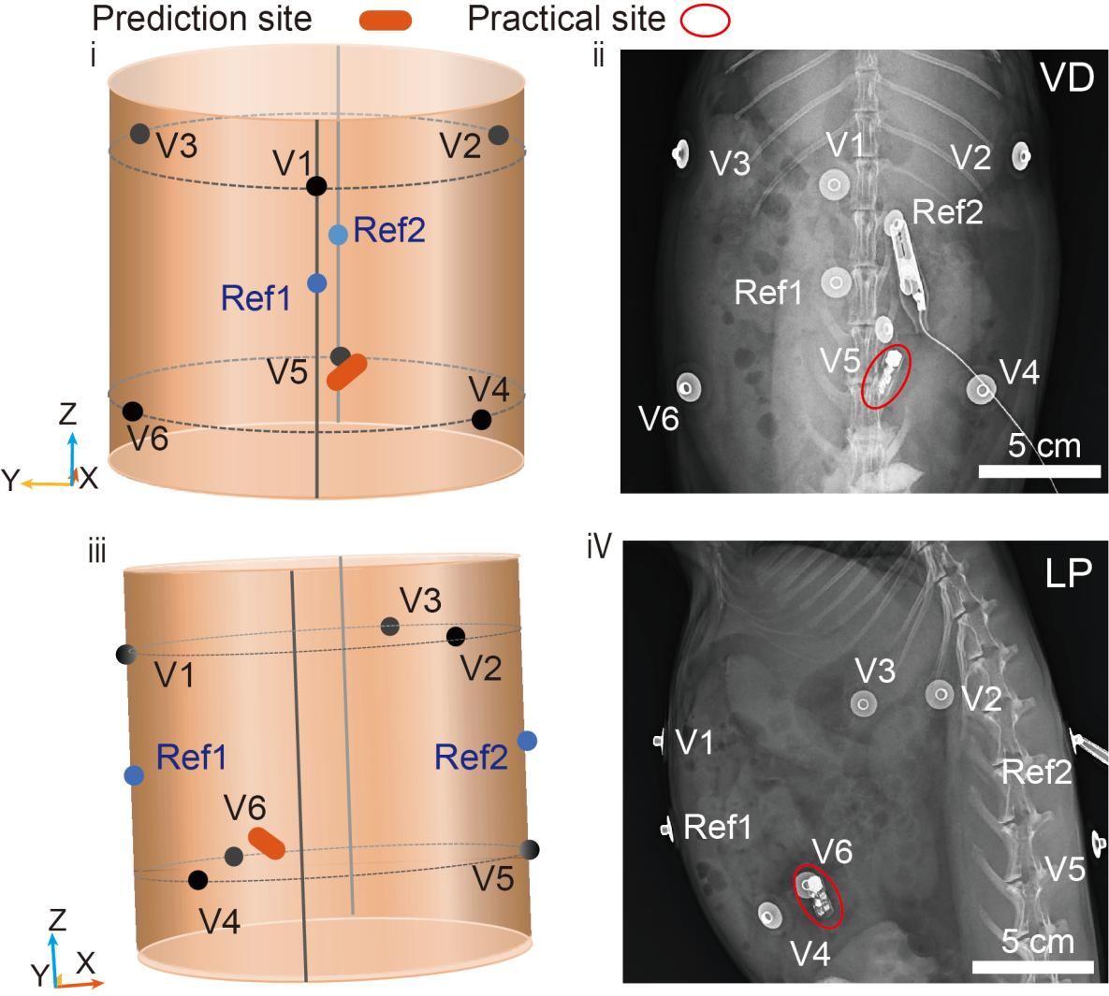
Supplementary Fig. 12 Comparison between reconstructed localization coordinates and X-ray images, including ventral-dorsal position and lateral position views. A 3D model with digital coordinates was built for reconstructing the predicted positions of the capsules. As shown in the X-ray image, two reference points were set on the spine, and the abdominal midline. The rib edge (stomach position) was set as plane 1, and the symmetrical position with the reference point was set as plane 2. These two planes were 8 cm apart, and the origin of the coordinate system was located at the midpoint of the line connecting the two reference points. The coordinates output by the positioning algorithm were manually entered into the model to provide a 3D image, and the position was verified immediately by X-ray inspection (ventral-dorsal position and lateral position). The result shows that the in vivo localization was still reliable even when a simple cylinder model was used as the training set, which might be related to the relative homogeneity of the abdominal tissue and the robustness of the electro-quasistatic dipole field distribution in low dielectric contrast materials.

Supplementary Fig. 13 Intestinal motility data processing and annotation under normal conditions. The peristaltic frequency of the small intestine is significantly higher than that of the stomach and the large intestine, and it is also more regular.

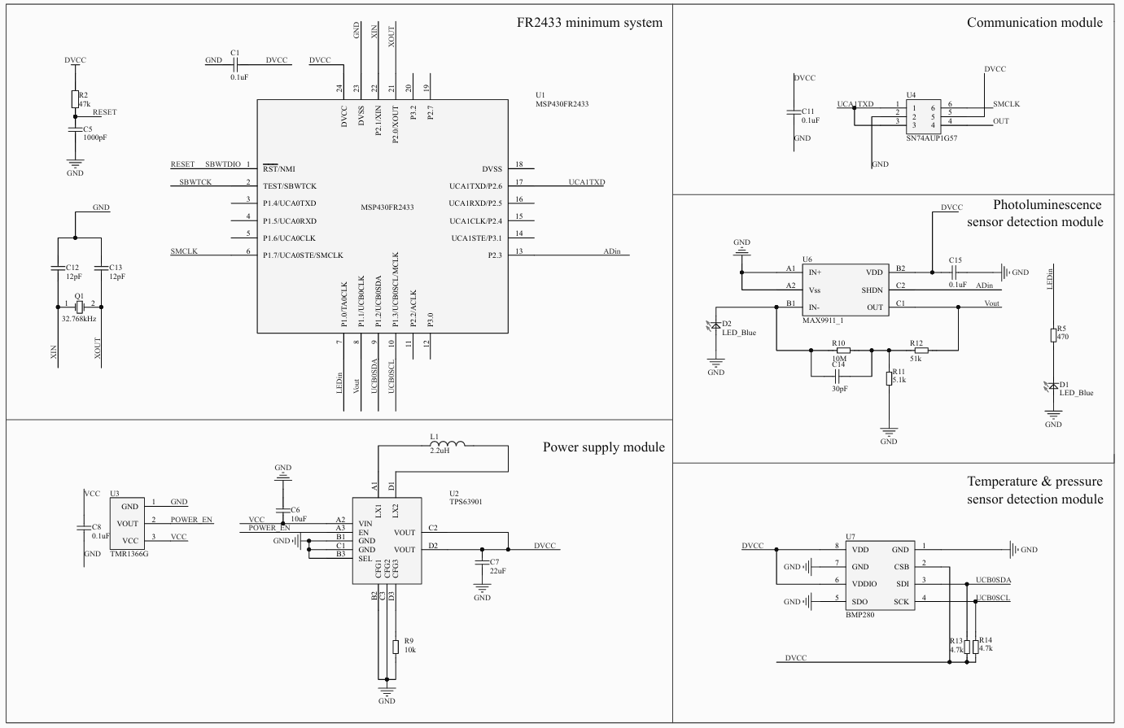
Supplementary Fig. 14 Circuit schematic diagram.

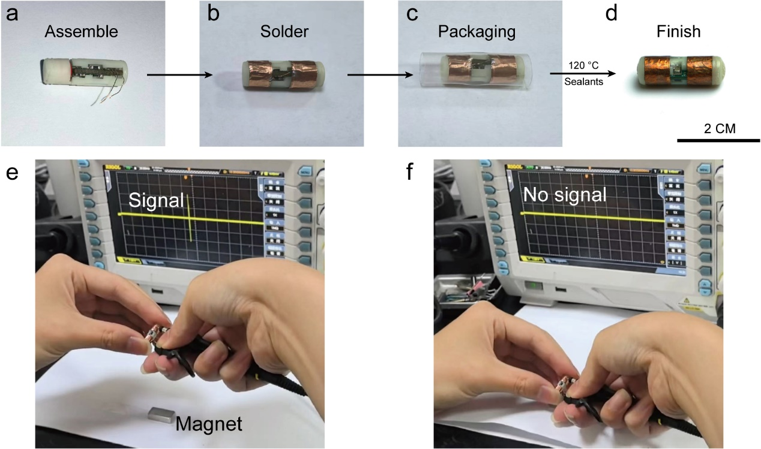

Supplementary Fig. 15 Assembly and testing details. (a) Structural assembly. (b) Coupling electrode welding. (c) Heat shrink tube packaging. (d) Seal both end faces with sealants after heating. (e) The differential signal for communication in normal operating conditions. (f) Once the device gets close to the magnet, the system shuts down.

Supplementary Fig. 16 External-to-internal pressure transmission ratio. The calibration was carried out using a sealed container with adjustable pressure and a standard pressure gauge. The readings of the standard pressure gauge inside the sealed container were compared with the measurement results of the device. Using hydraulic transmission, this ratio was increased from 2.3% to 63.8%.

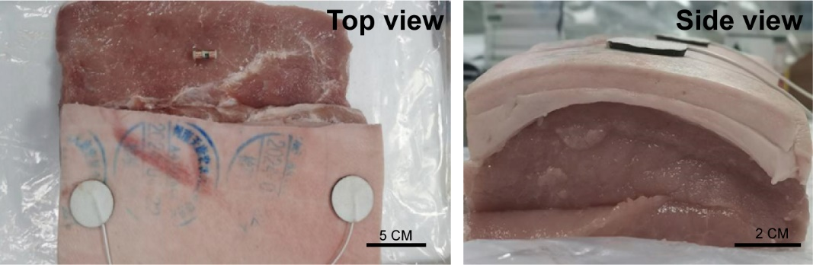
Supplementary Fig. 17 Communication test within body tissues.

Supplementary Fig. 18 Spectral data. (a) ICG sensor, and (b) oxygen sensor

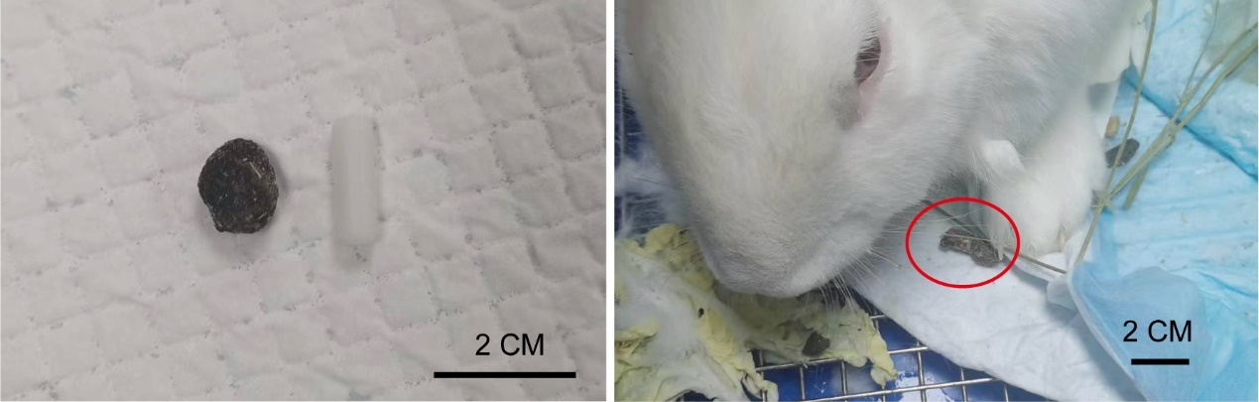
Supplementary Fig. 19 Safety experiment. (left) Comparison of normal feces and the patency capsule, and (right) excreted capsule.

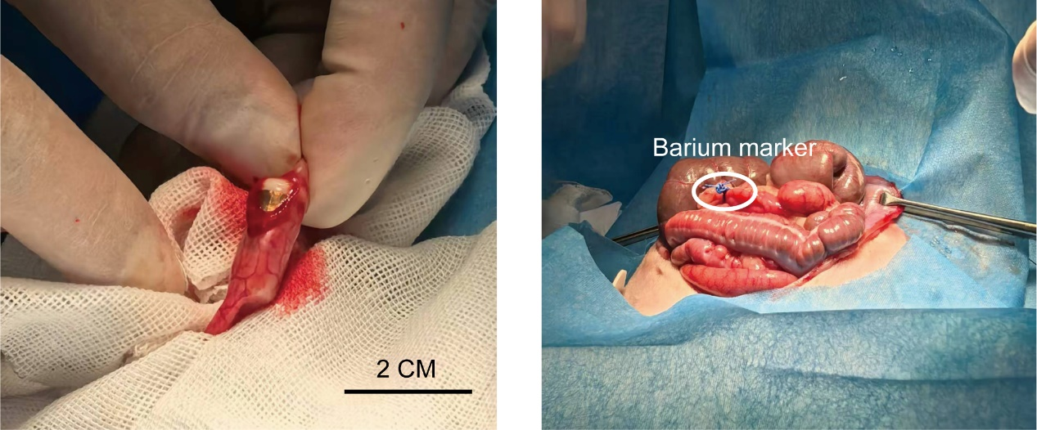
Supplementary Fig. 20 Surgical details. (left) intestinal incision and implantation process, and (right) mechanical damage model on the jejunum of rabbit. The Fig. marks the X-ray detectable suture.

Supplementary Table 1. Comparison of recent advanced ingestible sensor and commercial wireless technologies.
Subject | Size  (L×D mm) | Volume  (cm³) | Sensors | Positioning | Communication type | communication current  (mA) | Battery life @  sampling rate
Our | 18×6 | 0.5 | Fluorescence & mechanical | 5D*  ~1 cm | 6 MHz  Body coupled | ~0.8 | >10 days  @ 4 Hz
Medtronic  PillCam | 26×11 | 2.47 | Camera | 2D  ~3-5 cm | 433 MHz Wireless | - | >8 h  @ 2-6 Hz
Olympus  EndoCapsule | 26×11 | 2.47 | Camera | 3D  - | -  Wireless | - | 12 h  @ 2 Hz
IntroMedic  MiroCam | 24.5×10.8 | 2.24 | Camera | - | -  Body coupled | - | 12 h  @ 3 Hz
Ovesco  HemoPill | 26.3×7 | 1.01 | Fluorescence | - | -  Wireless | - | 9 h  -
PillTrek³ | 25×7 | 0.96 | Electrochemistry | No | 2.4 GHz  BLE | ~15 | @1 Hz
GISMO⁴ | 21×7.5 | 0.93 | Electrochemistry | No | 868 MHz  Wireless | ~13 | 5 days  @ 0.05 Hz
Bacterial-electronic sensor pill⁵ | 8.5×14.25 | 1.35 | Engineered bacteria fluorescence | No | 915 MHz  Wireless | - | -  @ 0.03 Hz
iMAG⁶ | 20×7.8 | 0.96 | Magnetic  (for positioning) | 3D  1.5 mm | 2.4 GHz  BLE | ~15  With 11 mF capacitor ~8 | 2 weeks  @ 0.4 Hz
Biofuel cell powered capsule⁷ | 26×9 | 1.65 | Electrochemistry | No | 40–200 MHz energy-efficient magnetic | - | Self-powered  @ 0.2 Hz
Nordic  nRF5340 | - | - | - | - | 2.4 GHz  BLE | 3.2 | -
SILICON LABS  EFR32BG22 | - | - | - | - | 2.4 GHz  BLE | 4.1 | -
TI  CC2640R2F |  |  |  |  | 2.4 GHz  BLE | 6.1 | -
* 3D means (X, Y, Z) 5D means (X, Y, Z, Pitch, Yaw); - means no data.
Color code: Red: commercial device; Green: recent developments; Blue: advanced low-power Bluetooth

Supplementary Table 2. Physical parameters of the model.
Parameter | Size(mm) | Description
R_{Cap} | 3 | Capsule radius
H_{Cap} | 18 | Capsule length
R_{Cu} | 3 | Copper foil radius
W_{Cu} | 2-8 | Copper foil width
X | 2-14 | Electrode distance
R_{PTFE} | 3.01 | Encapsulation layer radius
H_{PTFE} | 18.02 | Encapsulation layer length
Th_{PTFE} | 0.01 | Encapsulation layer thickness
R_{Mus} | 50-100 | Abdominal cavity radius
H_{Mus} | 100-250 | Abdominal cavity height

Supplementary Table 3. Electrical parameters.
Material | Electrical conductivity (S/m) | Dielectric constant
Copper | 5.998×10⁷ | 1
Encapsulation | 5×10⁻¹⁴ | 4
Filling | 5×10⁻¹⁷ | 2
Muscle | 0.5527 | 850

Supplementary Table 4. Predicted coordinates and actual coordinates.
Actual coordinates  （X, Y, Z, Pitch, Yaw） | Predicted coordinates  （X, Y, Z, Pitch, Yaw） | Mean Squared Error (cm)
(0, 0, -1.5, 90, 0) | (-0.196, 0.291, -0.914, 95.4, 0.18) | 0.502
(-3.2, 2.8, 1, 90, 10) | (-4.19, 3.23, -0.01, 93.2, 25.1) | 0.502
(3, 1.6, 0, 90, 170) | (2.31, 1.92, 0.4, 83.7, 158.8) | 0.502
(3.3, -2.4, -1, 90, 35) | (3.68, -2.88, 0.56, 76.5, 50.8) | 0.502
(-3.4, -2.7, -3, 160, 90) | (-3.05, -1.87, -1.93, 134.2, 97) | 0.502
(-2, -2, 2.5, 0, 75) | (-2.3, -3.3, 3, 9.4, 76) | 0.502

Actual coordinates  （X, Y, Z, Pitch, Yaw） | Predicted coordinates  （X, Y, Z, Pitch, Yaw） | Mean Squared Error (cm)
(0, 0, 0, 90, 0) | (0.621, -1.39, -0.09, 102.9, -3.9) | 0.8723
(-3, 0, 0, 90, 135) | (-2.21, -1.51, -0.07, 79.4, 144) | 0.8723
(-5, 0, 0, 90, 90) | (-4.07, -1.69, 0.3, 97.8, 87.7) | 0.8723
(3, 0, 0, 90, 135) | (2.96, 1.39, 0.97, 97.6, 138.6) | 0.8723
(5, 0, 0, 90, 0) | (4.94, 1.02, 1.03, 85, 5.2) | 0.8723

Actual coordinates  （X, Y, Z, Pitch, Yaw） | Predicted coordinates  （X, Y, Z, Pitch, Yaw） | Mean Squared Error (cm)
(-2.5, -1, -3.7, 160, 45) | (-1.77, -1.05, -2.14, 100, 66) | 0.746
(-6, 0, -0.5, 80, 45) | (-5.22, -0.24, -1.27, 86.9, 27.1) | 0.746
(-6, 0.6, 3.7, 190, 45) | (-5.4, 0.61, 2.31, 100, 95) | 0.746

Supplementary Reference
1 Grimnes, S. & Martinsen, Ø. G. in Bioimpedance and Bioelectricity Basics (Third Edition) (eds Sverre Grimnes & Ørjan G. Martinsen)\ 141-178 (Academic Press, 2015).
2 Baumgartner, C. et al. “IT’IS Database for thermal and electromagnetic parameters of biological tissues,” Version 5.0. (2025).
3 Min, J. et al. Continuous biochemical profiling of the gastrointestinal tract using an integrated smart capsule. Nat. Electron. 8, 844–855 (2025).
4 Even, A. et al. Measurements of redox balance along the gut using a miniaturized ingestible sensor. Nat. Electron. 8, 856–870 (2025).
5 Inda-Webb, M. E. et al. Sub-1.4 cm3 capsule for detecting labile inflammatory biomarkers in situ. Nature. 620, 386-392 (2023).
6 Sharma, S. et al. Location-aware ingestible microdevices for wireless monitoring of gastrointestinal dynamics. Nat. Electron. 6, 242-256 (2023).
7 De la Paz, E. et al. A self-powered ingestible wireless biosensing system for real-time in situ monitoring of gastrointestinal tract metabolites. Nat. Commun. 13, 7405 (2022).

