SUPPORTING INFORMATION

Exploring circulatory microRNA as biomarkers for detection of spontaneously occurring mammary tumors in canines
Rajeshwar Khandare¹, Sonal Saxena^{*1}, Vinay Kumar¹, Pradeep Kumar¹, Mani Saminathan², Sameer Shrivastava^{*1}
¹Division of Veterinary Biotechnology, Indian Veterinary Research Institute Izatnagar, Bareilly –243122, Uttar Pradesh, India
²Centre of Animal Disease Research and Diagnosis, Indian Veterinary Research Institute Izatnagar, Bareilly –243122, Uttar Pradesh, India
*Corresponding author Email: sonalvet@gmail.com , sameer_vet@rediffmail.com

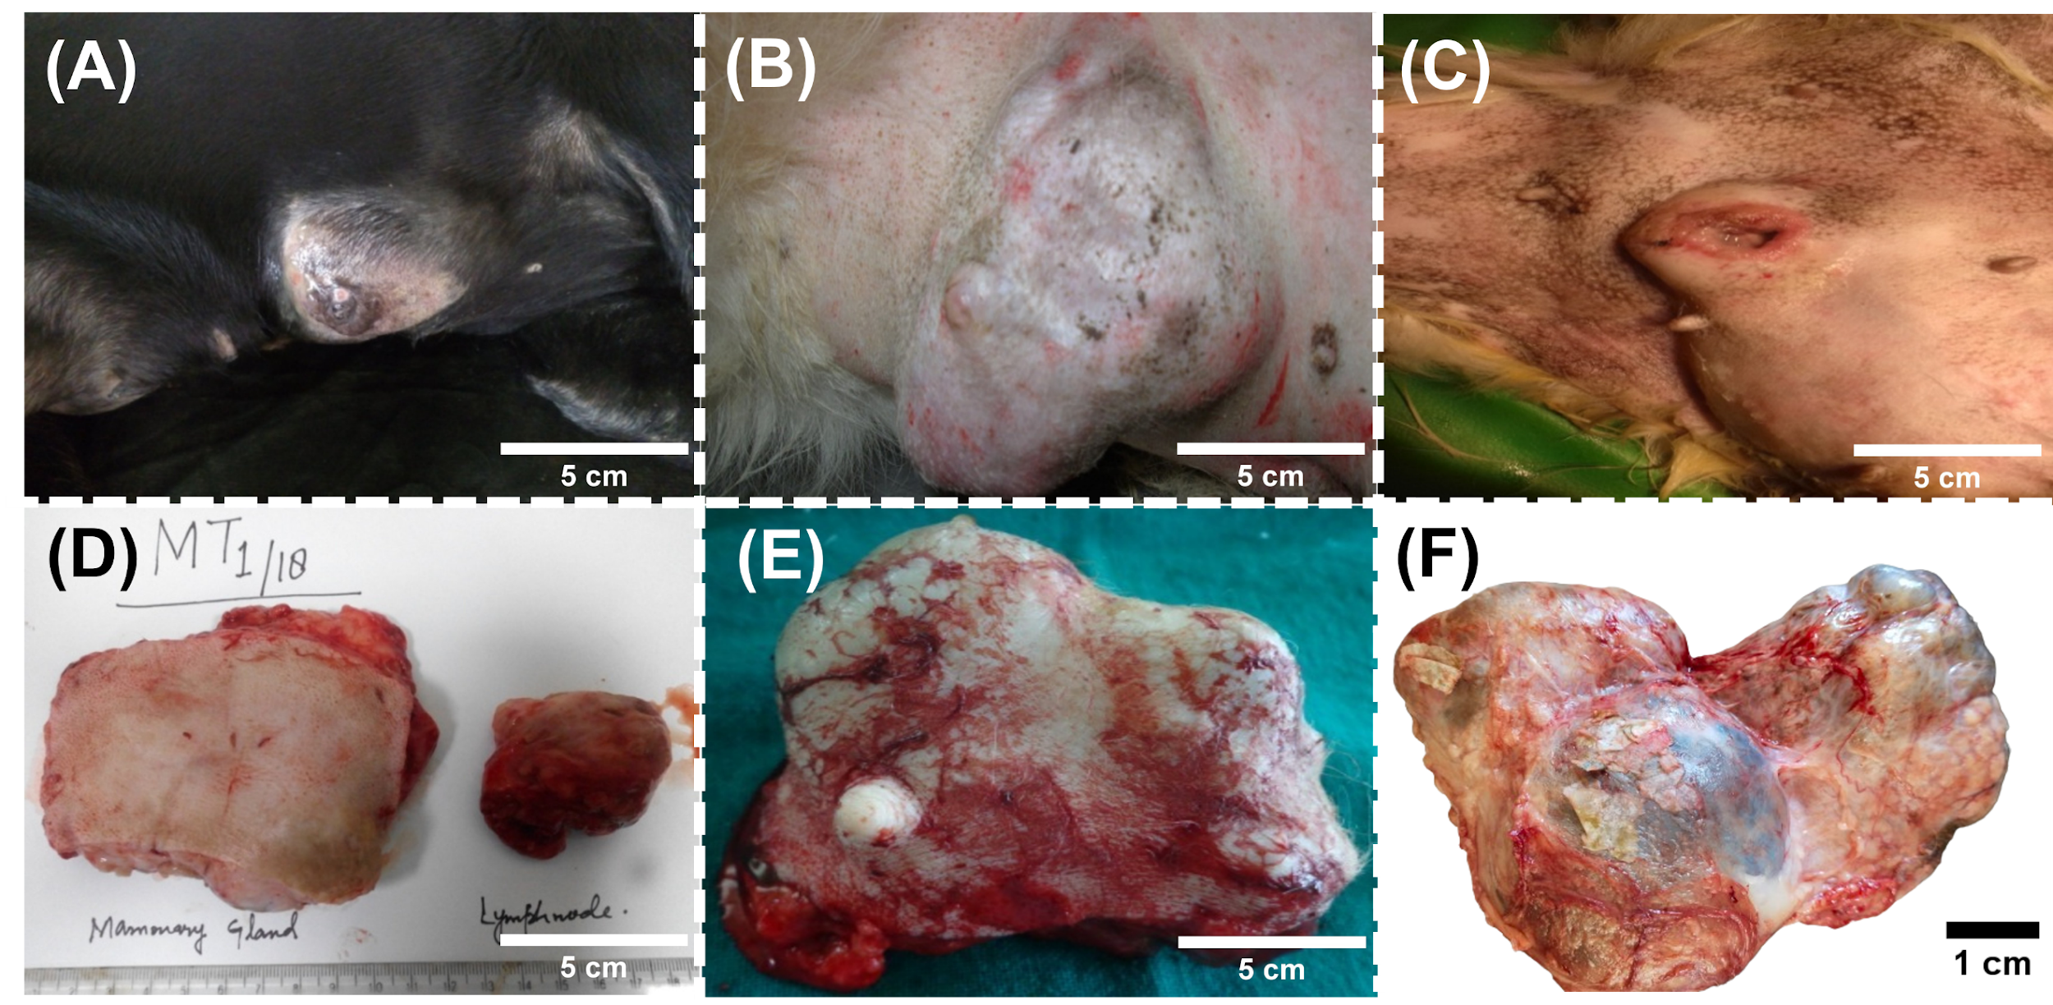
Fig. S1. Gross appearance of some representative tumor masses from CMT cases (A), (B) and (C) Gross appearance of tumor growth in mammary gland. (D), (E) and (F) Surgical removal of canine tumor masses. Scale bar: 5 cm & 1 cm.

Table S1: miRNA sequences for qRT PCR analysis
miRNA | miRbase accession number | Sequence
Cfa-miR-199-1 | ﷟HYPERLINK "https://www.mirbase.org/mature/MIMAT0006642"MIMAT0006642 | ACAGUAGUCUGCACAUUGGUU
Cfa-miR-451 | MIMAT0009870 | AAACCGUUACCAUUACUGAGUU
Cfa-miR-145 | MIMAT0009863 | GUCCAGUUUUCCCAGGAAUCCCU
cel-miR-39 | MIMAT0020306 | AGCUGAUUUCGUCUUGGUAAUA
cfa-miR-16 | MIMAT0006648 | UAGCAGCACGUAAAUAUUGGCG

 | CMT |  | CONTROL
miRNA biomarker | AVG | STDEV | AVG | STDEV
miRNA-145 | 11.93643 | 30.26681 | 1.194046 | 1.065339
miRNA-451 | 1.115167 | 1.084431 | 2.018396 | 2.388416
miRNA-199 | 8.767696 | 26.05522 | 1.038222 | 1.037715
Table S2. The average fold change (± SD) of miRNA-145, miRNA-451 and miRNA-199in CMT and control sera samples.

Table S3. Biomarker panel of different combination of miRNAs
Biomarker panel | AUC | SE ª | 95% CI ^{b}
miRNA-451 | 0.607 | 0.0877 | 0.458 to 0.742
miRNA-451 +miRNA-199 | 0.697 | 0.0743 | 0.550 to 0.819
miRNA-451 +miRNA-199 +miRNA-145 | 0.852 | 0.0550 | 0.723 to 0.936

