Identification of studies via databases and registers

Records removed before screening:
Duplicate records removed (n = 342)
Records marked as ineligible by automation tools (n = 229)
Records removed for other reasons (n =13)
Records identified from:
Databases (n = 932)
Registers (n = 11)

Identification

Records screened
(n = 359)
Records excluded
(n = 186)

Reports sought for retrieval
(n = 173)
Reports not retrieved
(n = 0)

Screening

Reports assessed for eligibility
(n =173)
Reports excluded:
Case reports (n = 11)
Duplicated data (n =16)
Incomplete or inaccurate data (n =38)
etc.

Studies included:
For meta-analyses = 91
For Systematic review = 17

Included

Figures S1. Literature search, inclusion and exclusion process for S. Typhi

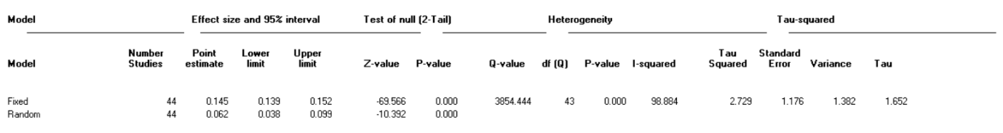
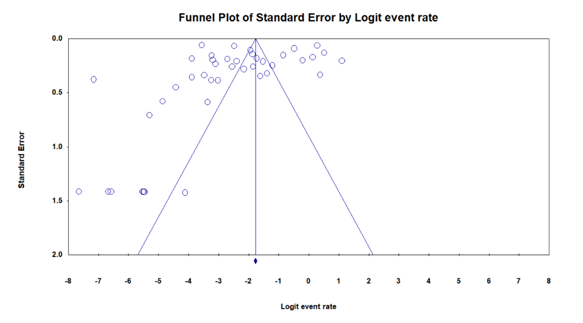
- Human

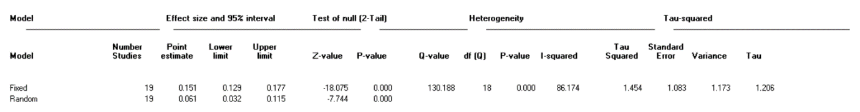
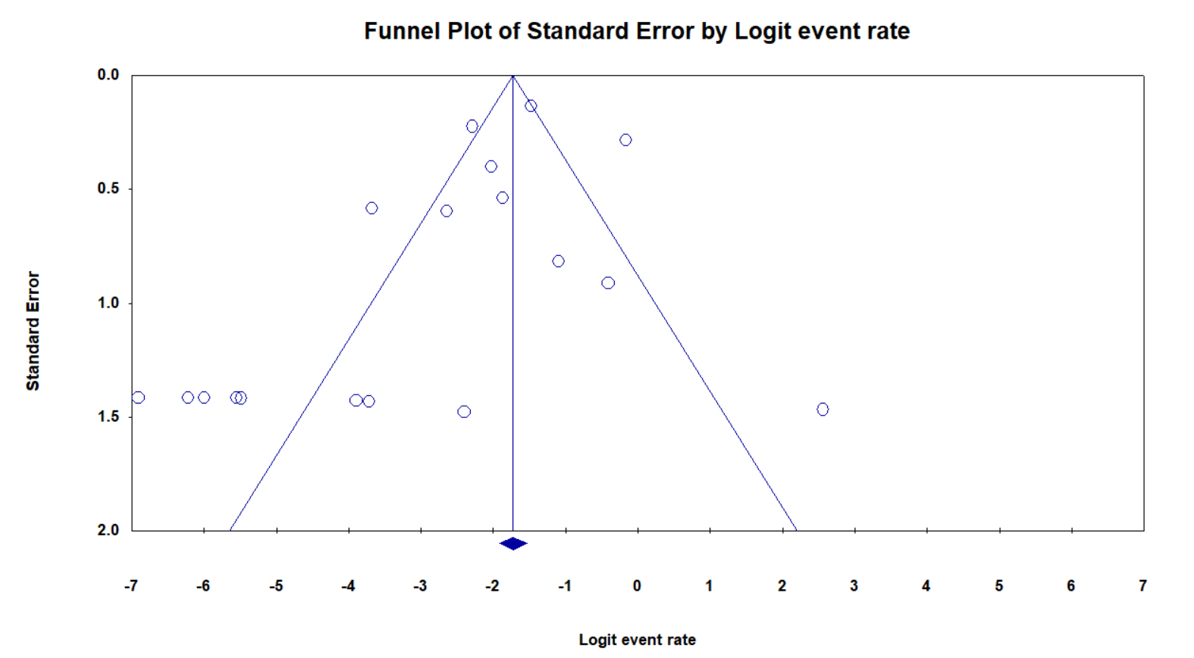
- Food

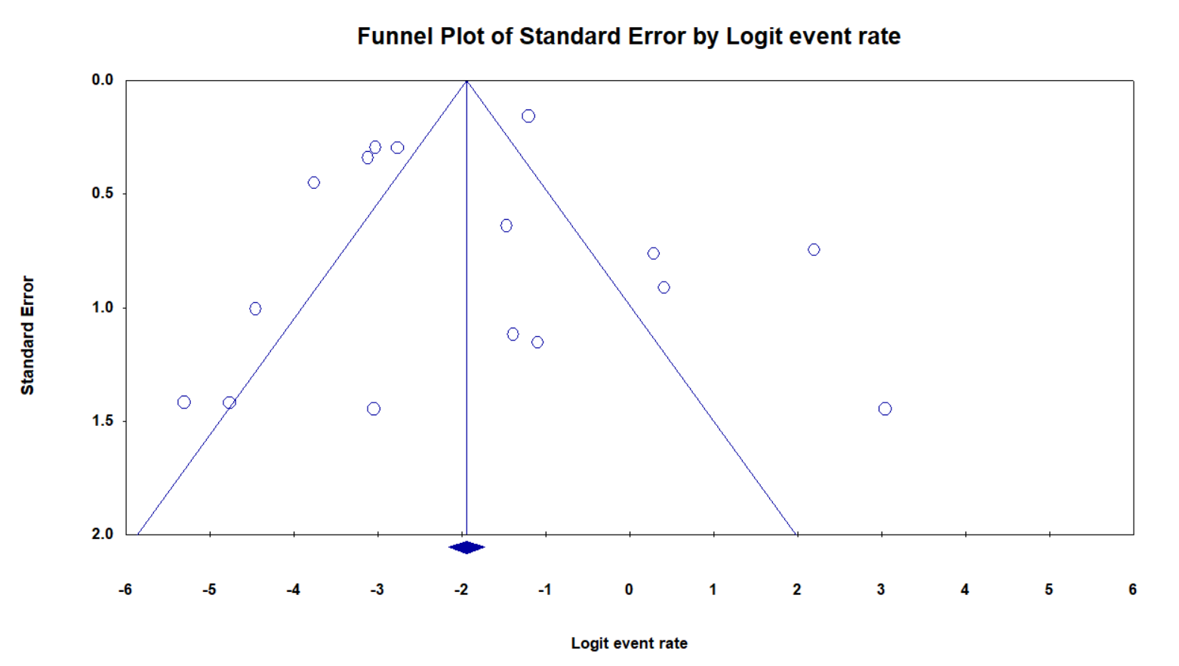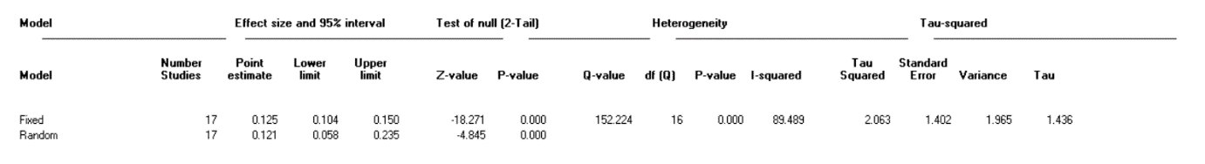
- Environmental samples

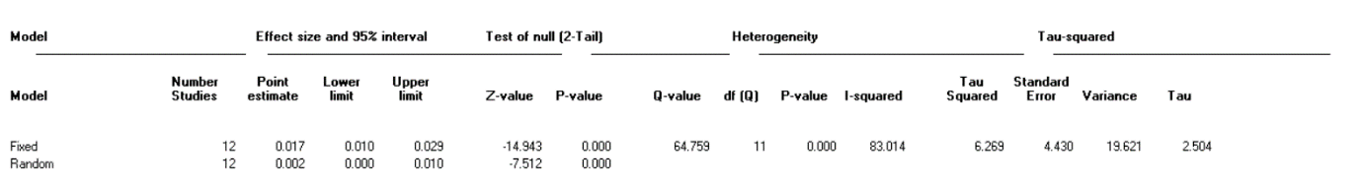
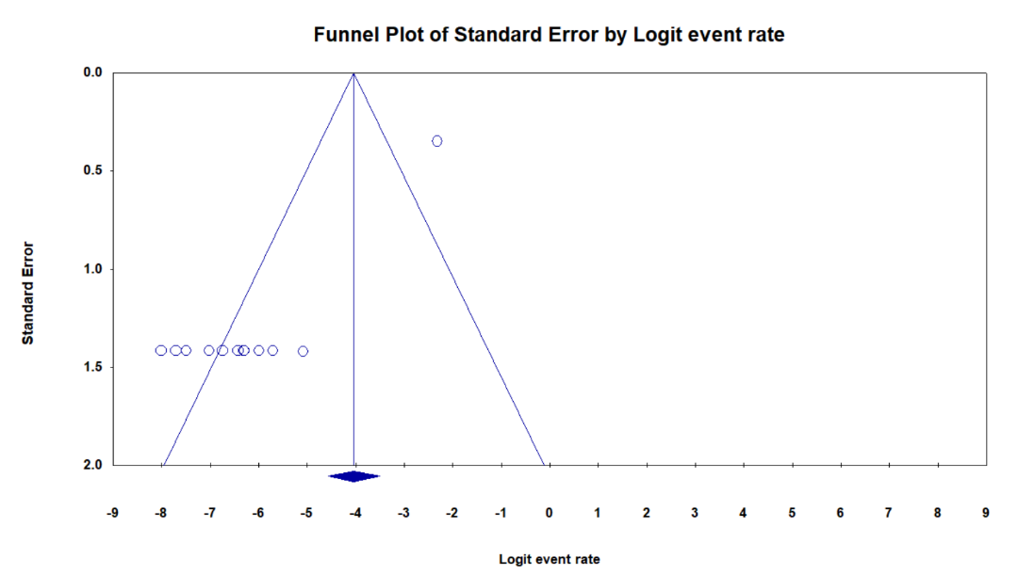
- Livestock
Figure S2: Heterogeneity and funnel plot analyses of eligible S. Typhi studies in Nigeria

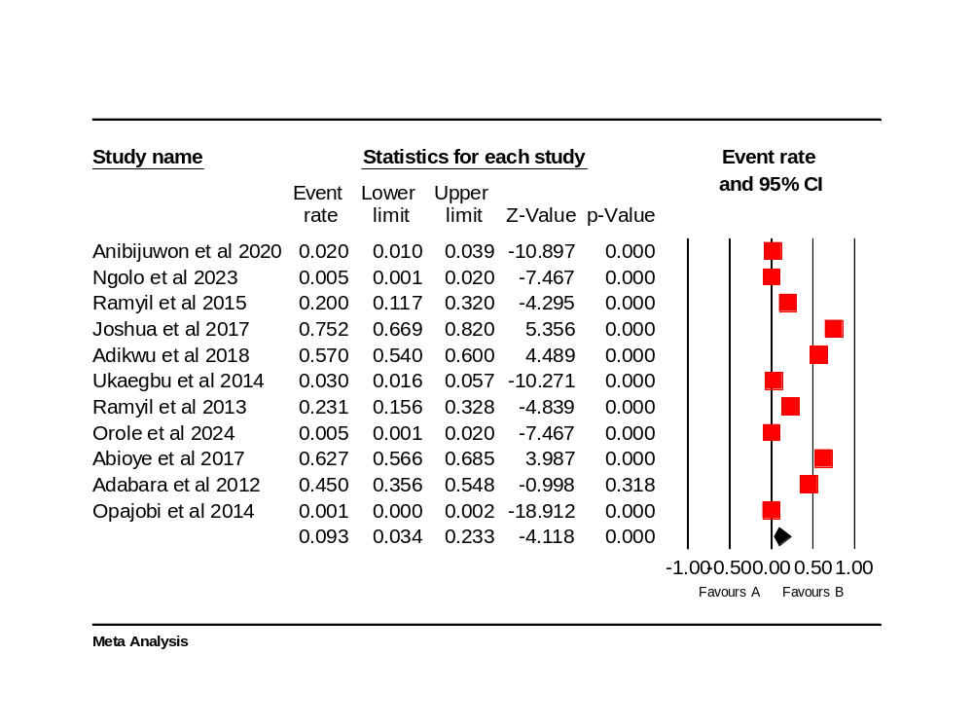
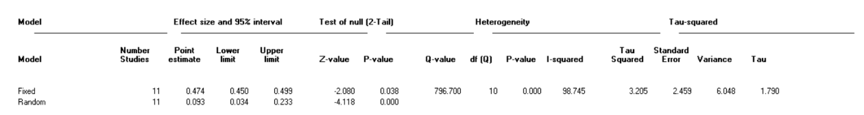
- North-central

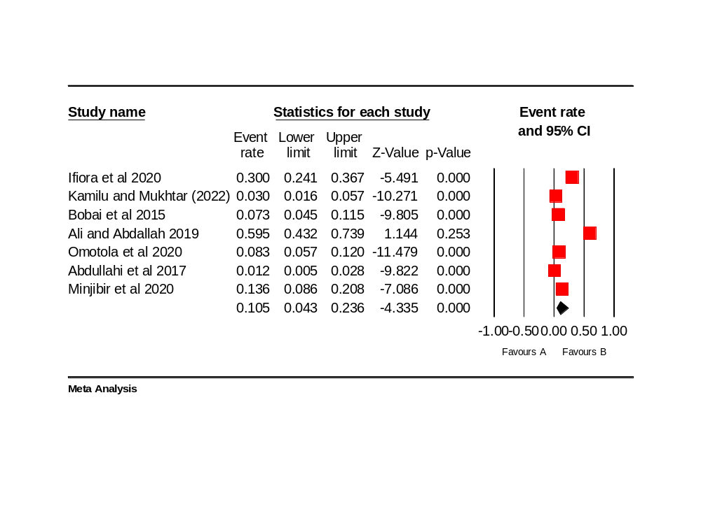
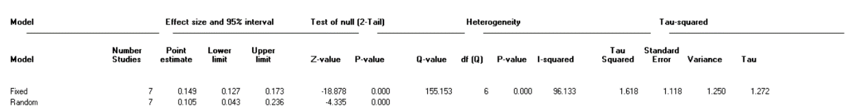
- Northwest

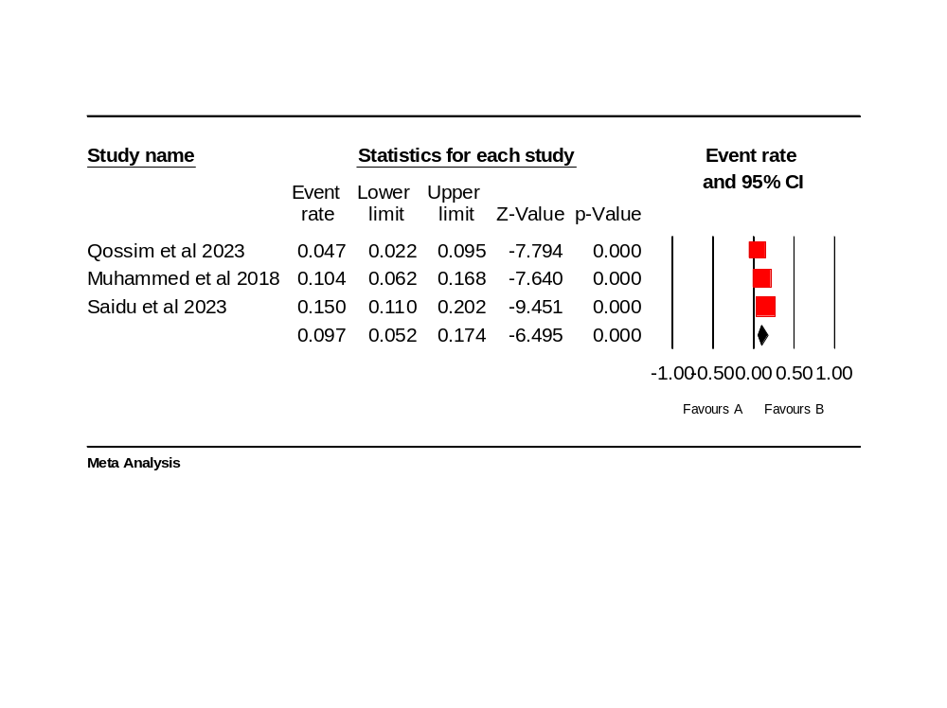
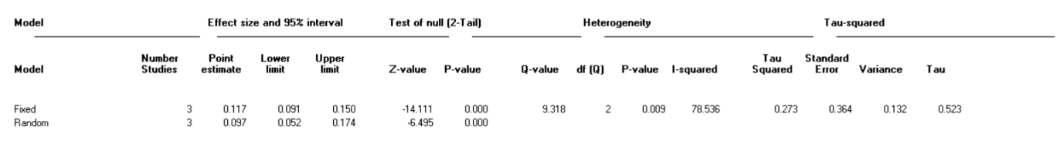
- North-east

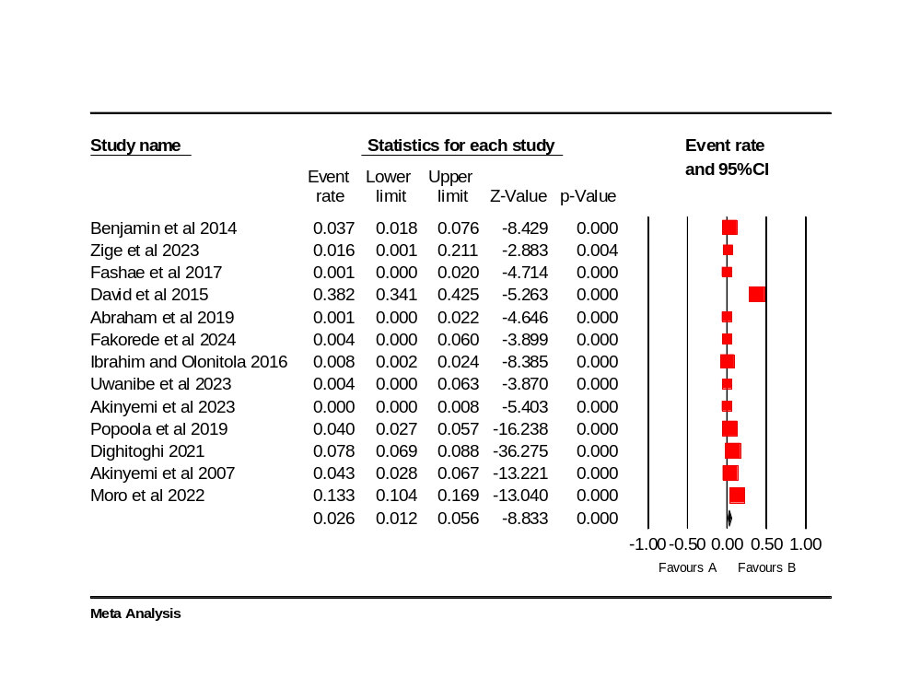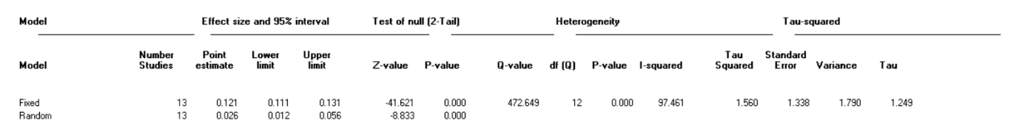
- Southwest

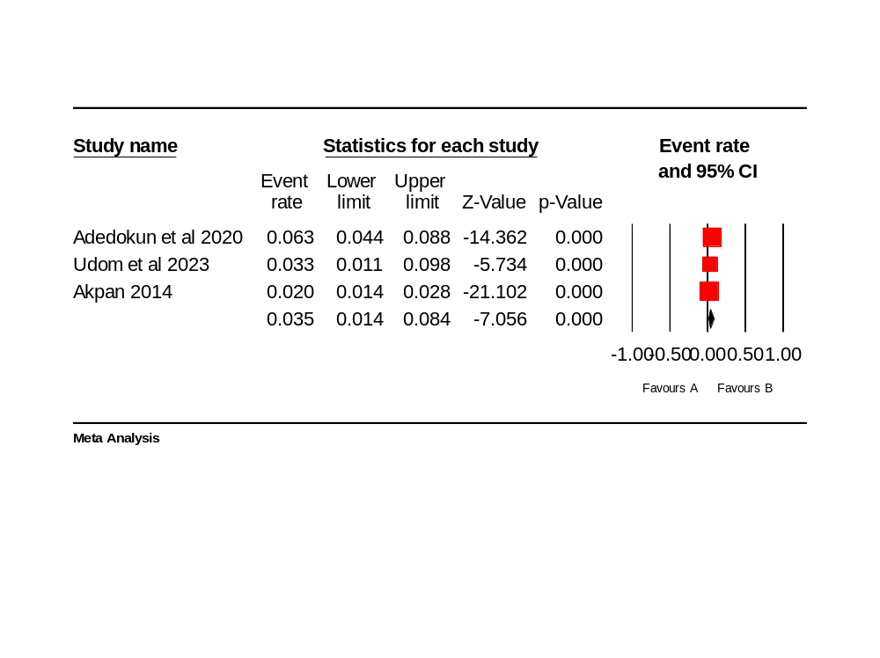
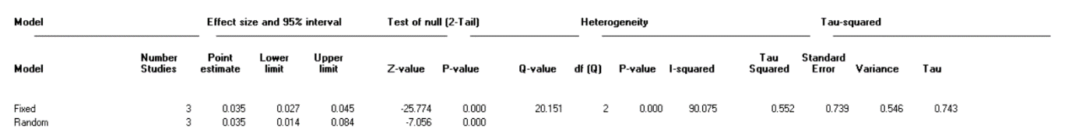
- South-south

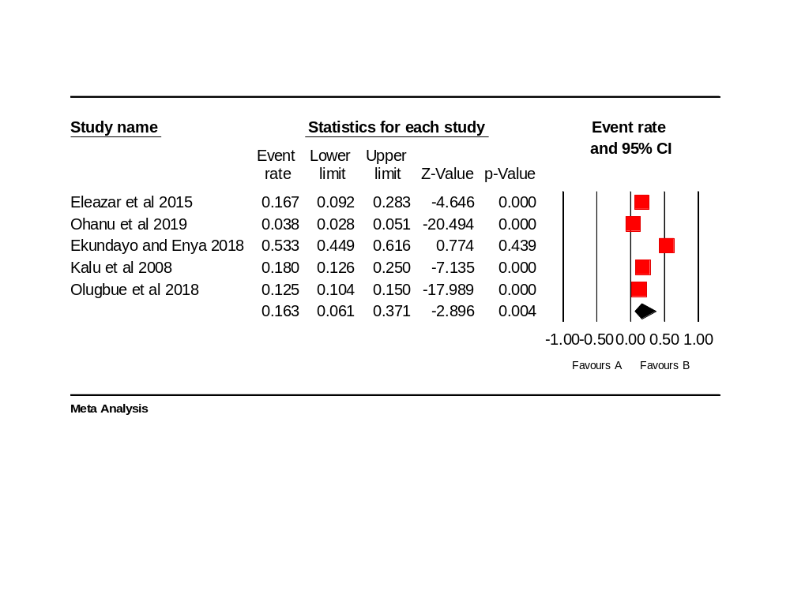
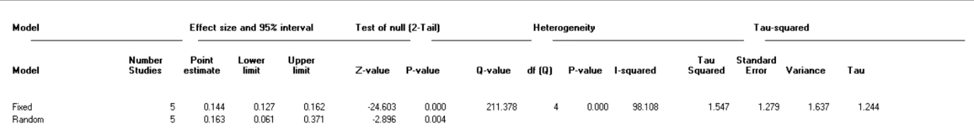
- South-east

Figure S3: Pooled prevalence and heterogeneity analysis of S. Typhi in humans by six geopolitical zones of Nigeria

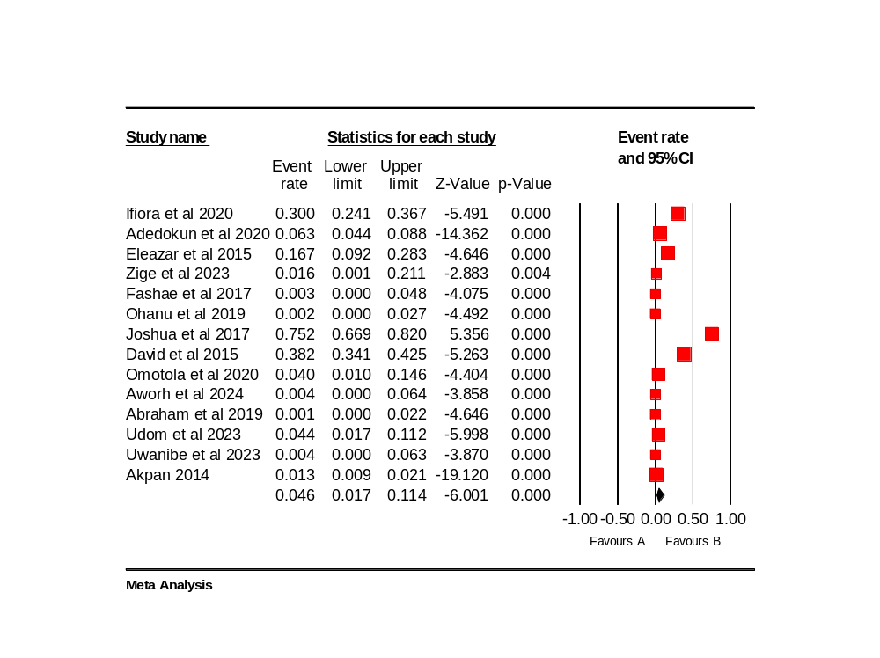

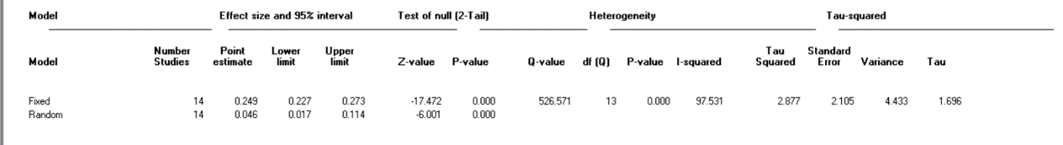
- Healthy or asymptomatic humans

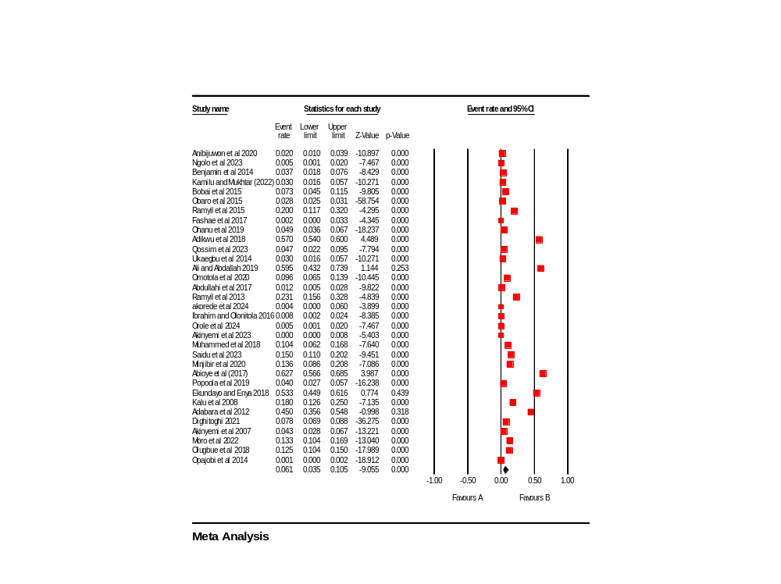
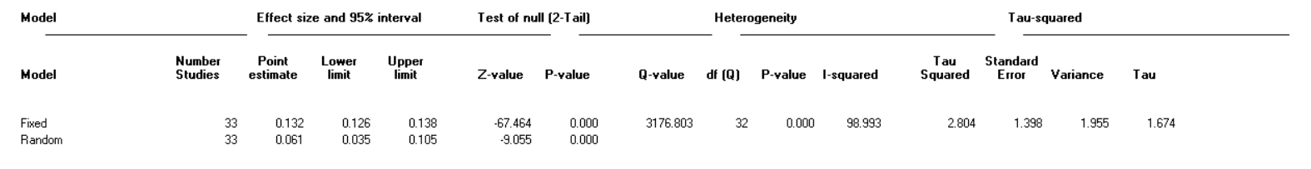
- Sick or symptomatic humans
Figure S4: Pooled prevalence of S. Typhi and heterogeneity of eligible studies by health status of humans

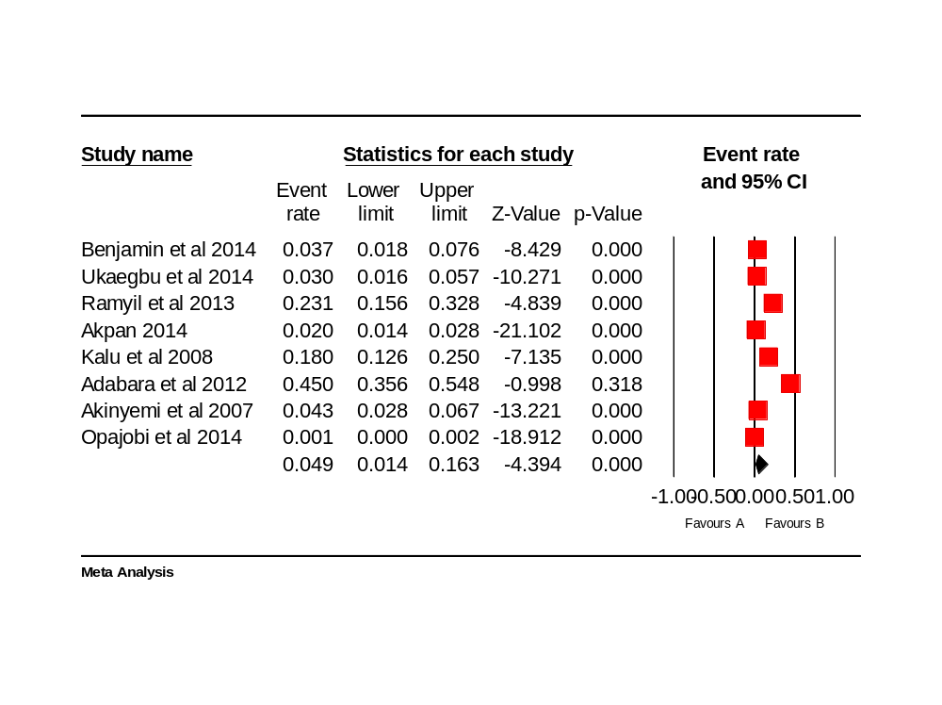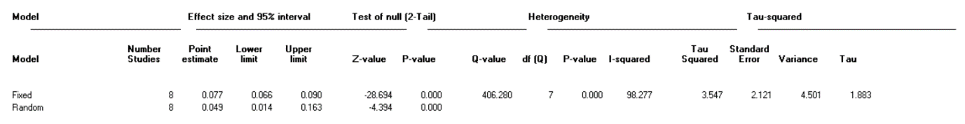
- ≤ 2014

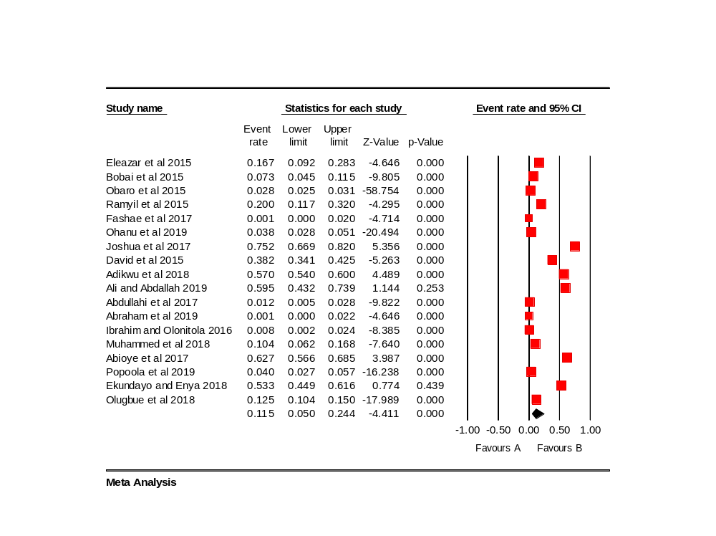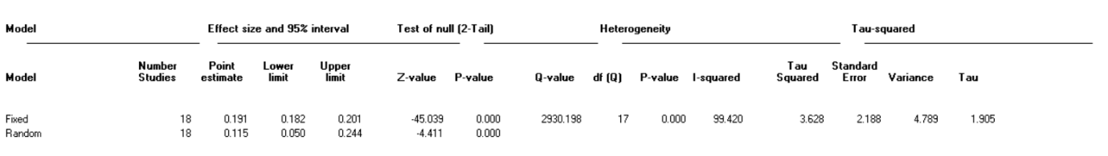
- 2015-2019

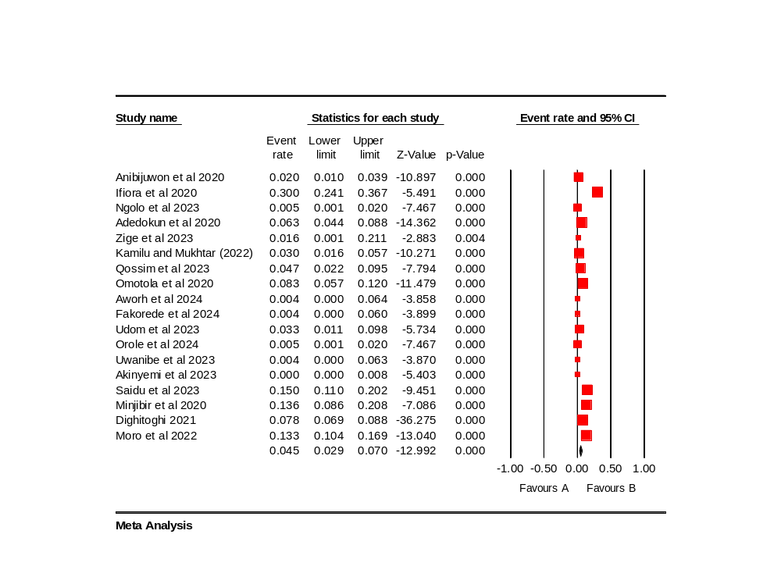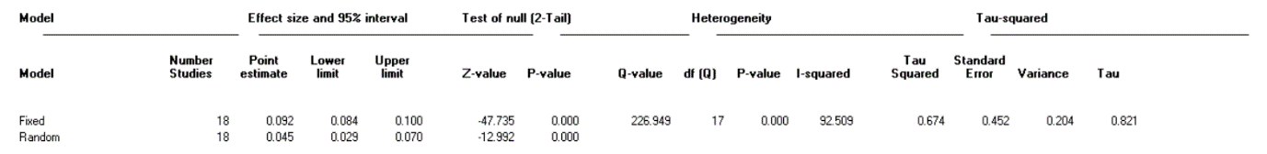
- 2020-2024
Figure S5: Pooled prevalence of S. Typhi and heterogeneity of eligible studies by year of studies on humans

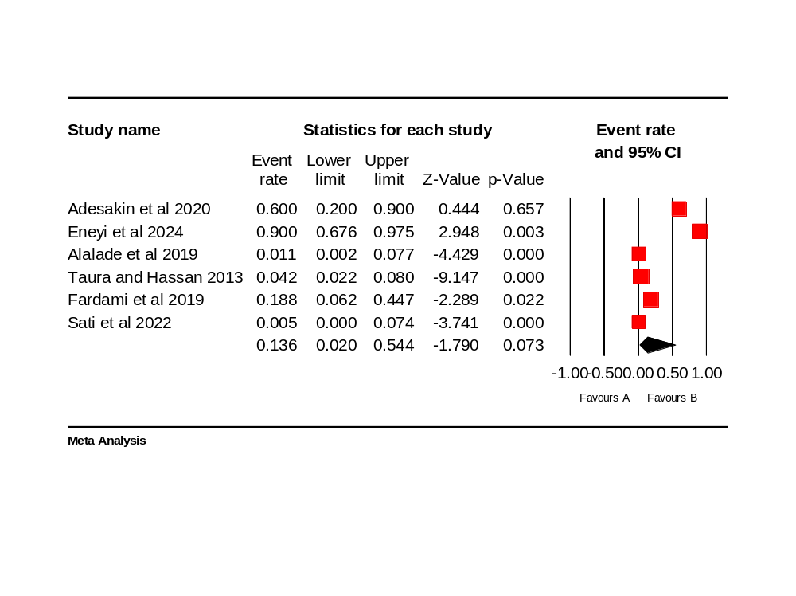
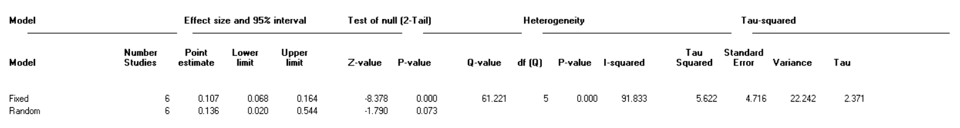
- Drinking water
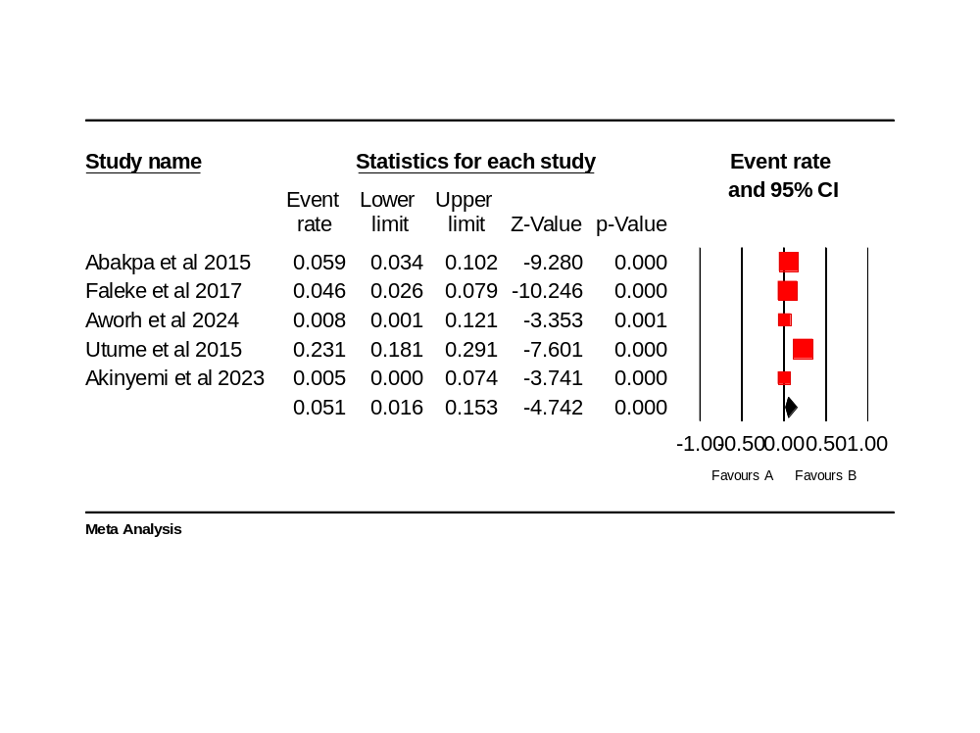
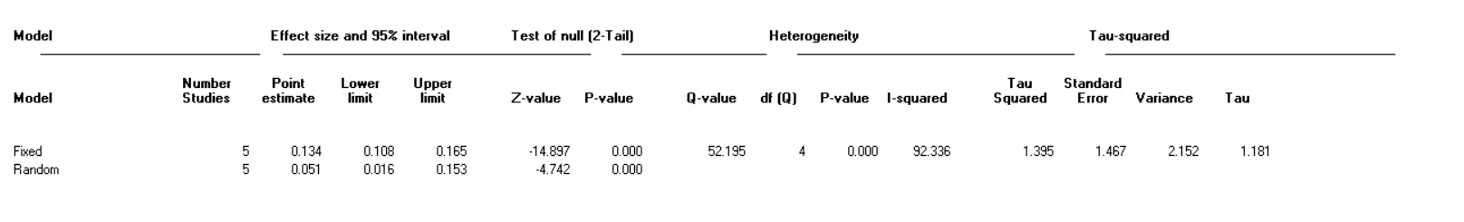
- Surface swab, soil, effluent, and sewage
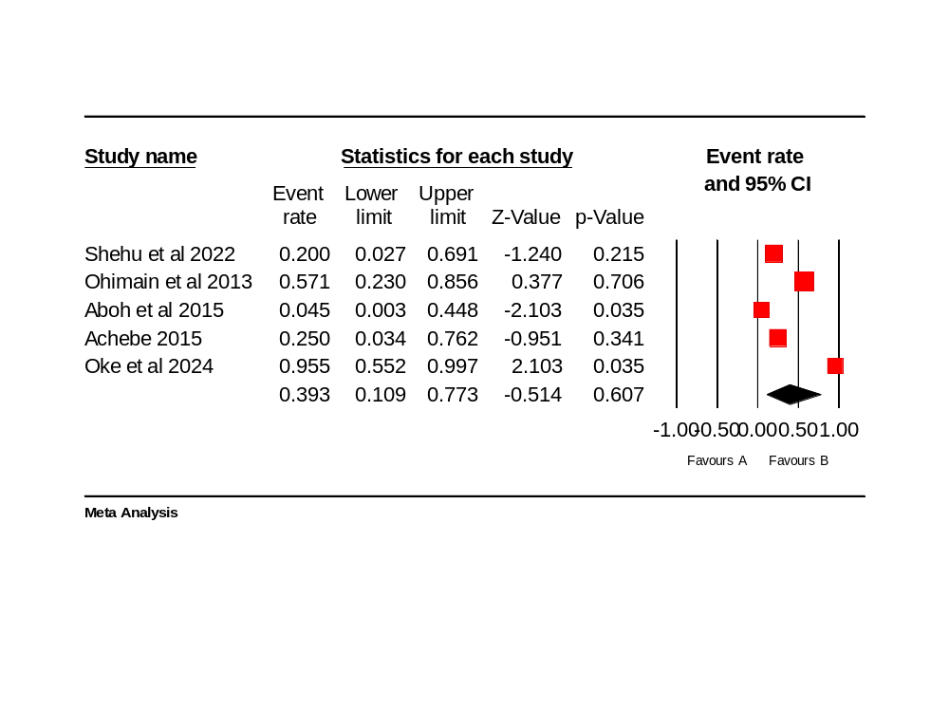
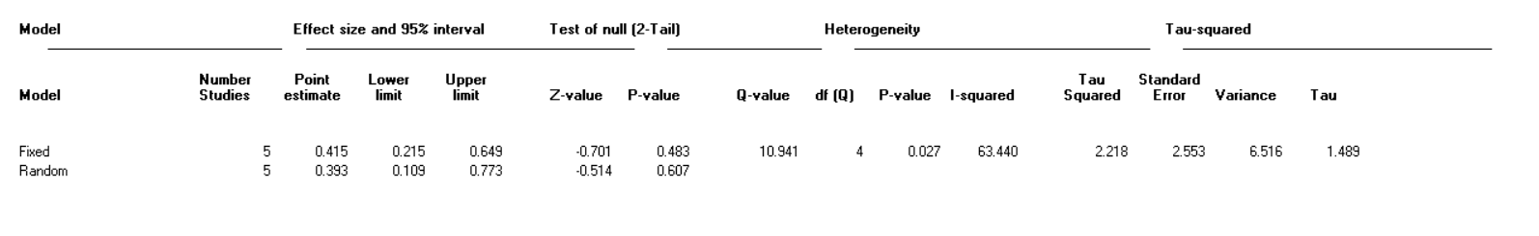
- Non-drinking water from tap, well, river, and pond
Figure S6: Pooled prevalence of S. Typhi and heterogeneity of eligible studies by types of environmental samples

