Supplemental materials.
RNA sequencing. Paired-end RNA-sequencing libraries were prepared as described (38).
Raw-sequencing reads were mapped to the reference genome (NC_000913.3) of E. coli K-12 MG1655 using bowtie (v1.1.2) with the following options “-X 1000 -n 2 -3 3”. Transcript abundance was quantified using summarizeOverlaps from the R GenomicAlignments package (v1.18.0) with the following options: “mode = “IntersectionStrict”, singleEnd = FALSE, ignore.strand = FALSE, preprocess.reads = invertStrand”. To ensure the quality of the compendium, genes shorter than 100 nucleotides and genes with under 10 fragments per million-mapped reads across all samples were removed before further analysis. Transcripts per million (TPM) were calculated by DESeq2 (v1.22.1). The final expression values were log-transformed log²(TPM + 1), referred to as log-TPM.
ChIP-Exo experiments. Chip-exo experiments were performed following the procedures previously described. To identify PtrR binding sites for each strain, the DNA bound to PtrR from formaldehyde cross-linked cells, collected after growth in M9, was isolated by chromatin immunoprecipitation (ChIP) with the antibodies that specifically recognize the myc tag (9E10, Santa Cruz Biotechnology), and Dynabeads Pan Mouse IgG magnetic beads (Invitrogen) were added, followed by stringent washings as described previously ². ChIP materials (chromatin-beads) were used to perform on-bead enzymatic reactions of the ChIP-exo method. Briefly, the sheared DNA of the chromatin-beads was repaired by the NEBNext End Repair Module (New England Biolabs), followed by the addition of a single dA overhang and ligation of the first adaptor (5’-phosphorylated) using a dA-Tailing Module (New England Biolabs) and NEBNext Quick Ligation Module (New England Biolabs), respectively. Nick repair was performed by using the PreCR Repair Mix (New England Biolabs). Lambda exonuclease- and RecJf exonuclease-treated chromatin was eluted from the beads, and overnight incubation at 65 degrees reversed the protein-DNA cross-links. RNA- and protein-free DNA samples were used to perform primer extension and second adaptor ligation with the following modifications. The DNA samples, incubated for primer extension as described previously (38), were treated with the dA-Tailing Module and NEBNext Quick Ligation Module (New England Biolabs) for second adaptor ligation. The DNA sample, purified using the GeneRead Size Selection Kit (Qiagen), was enriched by polymerase chain reaction (PCR) using Phusion High-Fidelity DNA Polymerase (New England Biolabs). The amplified DNA samples were purified again with a GeneRead Size Selection Kit (Qiagen) and quantified using Qubit dsDNA HS Assay Kit (Life Technologies). The quality of the DNA sample was checked by running the Agilent High Sensitivity DNA Kit using an Agilent 2100 Bioanalyzer before sequencing using HiSeq 2500 (Illumina) following the manufacturer’s instructions. Each modified step was also performed following the manufacturer’s instructions. ChIP-exo experiments were performed in duplicate.

FIGURES
Fig. S1 Alignment of the LTTR transcription factors in Escherichia coli K-12 MG1655. Sequence profiles of the proteins were aligned in Clustal Omega. One of the most common regulator families in prokaryotes is lysR-type transcriptional regulators (LTTR). The lysR-type HTH domain is a DNA-binding, winged-turn-helix (wHTH) domain of about 60 residues present in the N-terminal part. LTTRs are present in diverse bacterial genera, archaea and algal chloroplasts. All LTTRs contain the DNA-binding lysR-type HTH domain.
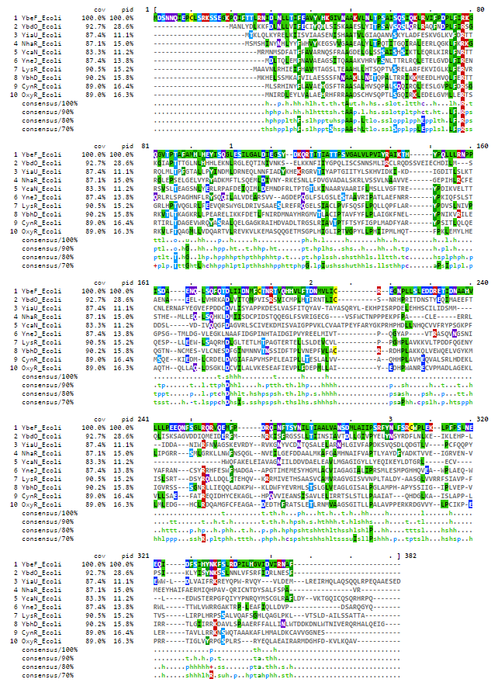

Fig. S2 The predicted YbdO binding site (yellow backgrond) upstream of ybdO gene, suggesting that ybdO is autoregulator as supported by ChiP-exo DNA-binding and RNA-seq data (Table 2), the ybdO start of the gene is marked by red font.
display items per page

T | displaying 1 - 10 of 11 | next» last»

ID | Organism | Annotation
fig|83333.1.peg.604 | Escherichia coli K12 | LysR-family transcriptional regulator YbdO
fig|1068608.3.peg.3106 | Escherichia coli XH140A | LysR-family transcriptional regulator YbdO
fig|457401.3.peg.1903 | Escherichia sp. 4_1_40B | Putative LysR-family transcriptional regulator YbdO
fig|556266.3.peg.3380 | Shigella sp. D9 | Putative LysR-family transcriptional regulator YbdO
fig|766158.3.peg.679 | Shigella flexneri 2850-71 | Putative LysR-family transcriptional regulator YbdO
fig|216599.1.peg.581 | Shigella sonnei 53G | Putative LysR-family transcriptional regulator YbdO
fig|621.8.peg.5123 | Shigella boydii ATCC 9905 | Putative LysR-family transcriptional regulator YbdO
fig|358708.5.peg.2095 | Shigella dysenteriae 1012 | Putative LysR-family transcriptional regulator YbdO
fig|754333.3.peg.2625 | Escherichia albertii TW11588 | Putative LysR-family transcriptional regulator YbdO
fig|585054.5.peg.2409 | Escherichia fergusonii ATCC 35469 | Putative LysR-family transcriptional regulator YbdO

fig|83333.1.peg.604 Escherichia coli K12
fig|1110693.3.peg.466 Escherichia coli str. K-12 substr. MDS42
fig|457401.3.peg.1903 Escherichia sp. 4_1_40B
fig|556266.3.peg.3380 Shigella sp. D9
fig|624.753.peg.3857 Shigella sonnei strain NLAE-zl-G496
fig|373384.11.peg.637 Shigella flexneri 5 str. 8401
fig|621.221.peg.5428 Shigella boydii strain ATCC 35964
fig|564.14.peg.4142 Escherichia fergusonii strain FDAARGOS_170
fig|622.435.peg.3171 Shigella dysenteriae strain ATCC 12039
fig|208962.68.peg.595 Escherichia albertii strain 1551-2
fig|1499973.6.peg.1976 Escherichia marmotae strain HT073016
fig|67829.4.peg.1024 Citrobacter murliniae strain P080C CL
fig|67827.10.peg.3160 Citrobacter werkmanii strain FDAARGOS_364
fig|1006003.3.peg.132 Citrobacter freundii ATCC 8090 = MTCC 1658
fig|545.11.peg.827 Citrobacter koseri strain FDAARGOS_86
fig|133448.4.peg.3409 Citrobacter youngae strain L6
fig|469595.3.peg.1261 Citrobacter sp. 30_2
fig|1218086.3.peg.1181 Citrobacter sedlakii NBRC 105722
fig|57706.65.peg.4328 Citrobacter braakii strain MiY-A
fig|1218085.3.peg.3193 Citrobacter rodentium NBRC 105723
fig|1064551.5.peg.662 Salmonella enterica subsp. enterica serovar Thompson str. RM6836
fig|208962.68.peg.595 t-agaaaaaCTTAAcgataaaTTAAGtaaagaa-a-----------ataa
fig|1499973.6.peg.1976 t-agaaaaaCTTAAtcgtgaaTTAAGtaaaata-acataatatataaaaa
fig|564.14.peg.4142 t-agaaaatCTTAAtccaaagTTAAGcagaaaa-acataat----acata
fig|622.435.peg.3171 t-agaaaaaCTTAAtcctgagTTAAGtaaaaaa-acataat----ataaa
fig|373384.11.peg.637 t-agaaaaaCTTAAtcctgagTTAAGcaaaaaa-acataatcaataaaaa
fig|621.221.peg.5428 t-agaaaaaCTTAAtcctgagTTAAGcaaaaaa-acataatcaataaaaa
fig|556266.3.peg.3380 t-agaaaaaCTTAAtcctgagTTAAGcaaaaaa-atataatcaataaaaa
fig|624.753.peg.3857 t-agaaaaaCTTAAtcctgagTTAAGcaaaaaa-atataatcaataaaaa
fig|83333.1.peg.604 t-agaaaaaCTTAAtcctgagTTAAGcaaaaaa-acataatcaataaaaa
fig|1110693.3.peg.466 t-agaaaaaCTTAAtcctgagTTAAGcaaaaaa-acataatcaataaaaa
fig|457401.3.peg.1903 t-agaaaaaCTTAAtcctgagTTAAGcaaaaaa--cataatcaataaaaa
fig|67829.4.peg.1024 t-agttttagTTAActgttcaTTAAGatttaaatggatatgtgctaagaa
fig|67827.10.peg.3160 t-agtttaagTTAActattcaTTAAGcgtataaaagattcttaaaagaaa
fig|1006003.3.peg.132 t-agctaaagTTAAttattcaTTAAGcacacaa-acataaatttcaagaa
fig|57706.65.peg.4328 ttagtttaaaTTAAtaattcaTTAAGcacacaa-acataaatcacaagaa
fig|133448.4.peg.3409 t-agtttaagTTAAttattcaTTAAGc-cataa-acataaactctaagaa
fig|469595.3.peg.1261 t-agtttaagTTAAttattcaTTAAGc-cataa-acataaactctaagaa
fig|545.11.peg.827 t-agtattatTgAAagagaatTTAAGcttagcaaacatcactattgtaaa
fig|1218086.3.peg.1181 t-agccataCTaAAtgtcactTTAAGtttg-cattgaaaaattttattca
fig|1218085.3.peg.3193 t-agccataCTaAAactaactTTAAGtcaggcattgatttctttagctta
fig|1064551.5.peg.662 t-agtttaaaTaAActctacaTTAAGtttaataaacataactctggtaaa
* ** * ** ***** * *

fig|1499973.6.peg.1976 tacataaagcca-tatcattgacttgatgaata--ttatgagaacaagca
fig|564.14.peg.4142 taaatacaacaa-cattattgaacaagtgaatgatttatggaagagacaa
fig|622.435.peg.3171 taca-acagcag-cattattgaacaaatgaatgatttatagaagagataa
fig|373384.11.peg.637 tacatacgcaaa-aaacattgattaagtgaatataccatggaagaaa-aa
fig|621.221.peg.5428 tacatacgcaaa-aaacattgattaagtgaatataccatggaagaaa-aa
fig|556266.3.peg.3380 tatatacgcaaa-aaacattgattaagtgaatataccatggaagaaa-aa
fig|624.753.peg.3857 tatatacgcaaa-aaacattgattaagtgaatataccatggaagaaa-aa
fig|83333.1.peg.604 tatatacgcaaa-aaacattgattaagtgaatatatcatggaagaaa-aa
fig|1110693.3.peg.466 tatatacgcaaa-aaacattgattaagtgaatatatcatggaagaaa-aa
fig|457401.3.peg.1903 tatatacgcaaa-aaacattgattaagtgaatatatcatggaagaaa-aa
fig|67829.4.peg.1024 tgattaataac--ttagaca--taatgaaacggaatatttcagagcaaag
fig|67827.10.peg.3160 taatttgcaat--tcaaata--tataaaaatgaaatatttccacataaaa
fig|1006003.3.peg.132 taactaccatt--taaacta--ttccacaattgaatttttcactacatta
fig|57706.65.peg.4328 tattcacaact--taaaata--tttcagaattaaatttttcaaaacatga
fig|133448.4.peg.3409 tgattagaatt--taaatta--ttcaacaattgaattatcctatacatta
fig|469595.3.peg.1261 tgattagaatt--taaatta--ttcaacaattgaattatcctatacatta
fig|545.11.peg.827 gcattggatgtg-ttgcataactataacaaatatagttatgacaatagtc
fig|208962.68.peg.595 tacataaagcca-tactattgacttgatgaata--ttatgataa-aagca
fig|1218086.3.peg.1181 gtgacaacacctaaaacattcatgcaacagataatttcatcttagaaa-t
fig|1218085.3.peg.3193 a-gatgacacggaaagcattaatgatacggatgatttcatatcaaaaagt
fig|1064551.5.peg.662 ttattgagatt--aagtcataat--catggaagataccatgataatgc--

fig|1499973.6.peg.1976 t-----atga-atggagtgcatcATGGCTAATCTTTACGACTTAAAAAAA
fig|564.14.peg.4142 t-----acaa--cggagtatgttATGGCTAATCTTTATGATCTAAAAAAA
fig|622.435.peg.3171 t-----atga--cggagtatgttATGGCGAATCTTTATGGCCTAAAAAAA
fig|373384.11.peg.637 t-----ataaaccggagtagtgtATGGCCAATCTCTACGACTTGAAAAAG
fig|621.221.peg.5428 t-----ataaaccggagtagtgtATGGCCAATCTCTACGACTTGAAAAAG
fig|556266.3.peg.3380 t-----ataa-ccggagtagtgtATGGCCAATCTCTACGACTTGAAAAAG
fig|624.753.peg.3857 t-----ataa-ccggagtagtgtATGGCCAATCTCTACGACTTGAAAAAG
fig|83333.1.peg.604 t-----ataa-ccggagtagtgtATGGCCAATCTCTACGACTTGAAAAAG
fig|1110693.3.peg.466 t-----ataa-ccggagtagtgtATGGCCAATCTCTACGACTTGAAAAAG
fig|457401.3.peg.1903 t-----ataa-ccggagtagtgtATGGCCAATCTCTACGACTTGAAAAAG
fig|67829.4.peg.1024 c-taagacaggaatggata---tATGGCTAACCTTTACGACCTCAAAAAA
fig|67827.10.peg.3160 t-aacaatgagaatataca---tATGGCTAACCTCTATGACCTTAAAAAA
fig|1006003.3.peg.132 c-catcacaggaaggtacg---cATGGCTAACCTCTATGACCTCAAAAAG
fig|57706.65.peg.4328 c-catcacaggaaggtatg---tATGGCTAACCTCTATGACCTTAAAAAG
fig|133448.4.peg.3409 c-catcacaggaaggtatg---cATGGCTAACCTCTATGACCTCAAAAAA
fig|469595.3.peg.1261 c-catcacaggaaggtatg---cATGGCTAACCTCTATGACCTCAAAAAA
fig|545.11.peg.827 a-caaaacaggaagaaaaaaa-cATGGCTAATCTCTACGATCTCAAAAAA
fig|208962.68.peg.595 tgaatcatga-atggagtgcgtcATGGCTAATCTGTATGATTTAAAGAAA
fig|1218086.3.peg.1181 g------gaaacaggaaaaaaacATGGCTAACCTTTACGATCTCAAAAAA
fig|1218085.3.peg.3193 g------agaaaaggaaaaacacATGGCTAACCTTTACGATCTCAAAAAG
fig|1064551.5.peg.662 -----------cgggaacatactATGGCTAACCTTTACGACCTTAAAAAA
***** ** ** ** * * ** **

Fig S3 YbeF and ybdO gene clustering with citCDEFXGT (citrate lyase) and citAB(transcriptional regulator)in E. coli, Salmonella, Citrobacter sp.

Fig. S4 FlhDC regulon and additional flagella related genes form “FlhDC” iModulon (iModulonDB), transcriptional activity for yTF mutant strains in mid-exponential (WT, ybdO, ybeF, ygfI and late exponential (WT_LL, ycaN_LL, yiaU_LL) growth phase.

Fig. S5A YbhJ (red) genome context with the ybhD (dark purple), ybhI (dark blue), Gnl-2-oxoglutarate/malate translocator precursor and ybhH (dark salad green).
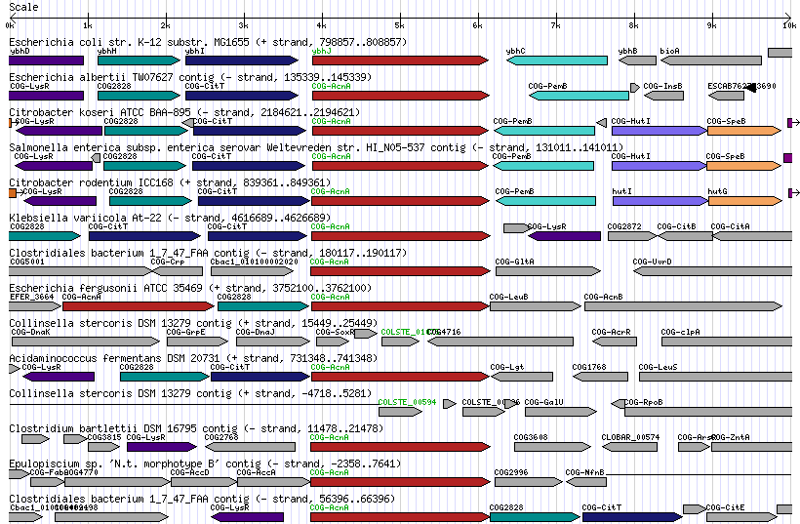
Fig S5B YbhI alignment with the Gnl-2-oxoglutarate/malate translocator precursor from Spinach (TCDB).
>gnl|BL_ORD_ID|13007 gnl|TC-DB|Q41364|2.A.47.3.1 2-OXOGLUTARATE/MALATE
TRANSLOCATOR PRECURSOR - Spinacia oleracea (Spinach). Length = 569

Score = 810, Bits(316), Expect = 9.11157e-101
Identities=35.7%, Positives=56.4%

Query: 5SLWKLILILAIPCIIGFMPAPAGLSELAWVLFGIYLAAIVGLVIKPFPEPVVLLIAVAAS 64
S+ L+ + I I F+ P P G+S AW L I+ L+ IVG++ +P P V L+ + AS
Sbjct:103SIKPLLASILTGVIIWFIPTPEGVSRNAWQLLAIFLSTIVGIITQPLPLGAVALMGLGAS162

Query: 65 MVVVGNLSDGAFKTTAVLSGYSSGTTWLVFSAFTLSAAFVTTGLGKRIAYLLIGKIGNTT 124
++ AF S + WL+ AF + F+ TGLG RIAY + G+++
Sbjct: 163 VLTKTLTFSAAF------SAFGDPIPWLIALAFFFARGFIKTGLGNRIAYQFVKLFGSSS 216

Query: 125 LGLGYVTVFLDLVLAPATPSNTARAGGIVLPIINSVAVALGSE-PEKSPRRVGHYLMMSI 183
LGLGY VF + +. LAPA PS +. ARAGGI LP++ S+ +. A GS + + R++G +. LM++
Sbjct: 217 LGLGYSLVFSEALLAPAIPSVSARAGGIFLPLVKSLCIACGSNVGDGTERKLGAWLMLTC 276

Query: 184 YMVTKTTSYMFFTAMAGNILALKMINDILHLQISWGGWALAAGLPGIIMLLVTPLVIYTM 243
+ + +. S MF TAMA N L+ + + + I W WA AA +. PG++ L+ V PL++ Y +
Sbjct: 277 FQTSVISSSMFLTAMAANPLSATLTFNTIGKAIGWMDWAKAAFVPGLVSLIVVPLLLYVV 336

Query: 244 YPPEIK-KVDNKTIAKAGLAELGPMKIREKMLLGVFVLALLGWIFSKSLGVDESTVAIVV 302
YPPEIK D + AK L ++. GPM E ++ +. L + W+F LGVD T AI+
Sbjct: 337 YPPEIKSSPDAPRLAKEKLDKMGPMTKNESIMAVTLLLTVGLWVFGGKLGVDAVTAAILG 396

Query: 303 MATMLLLGIVTWEDVVKNKGGWNTLIWYGGIIGLSSLLSKVKFFEWLAE-VFKNNLAFDG 361
++ +L+ G+VTW++ + W+TL W+ +I ++ L+K W +E V K
Sbjct: 397 LSVLLITGVVTWKECLAESVAWDTLTWFAALIAMAGYLNKYGLITWFSENVVKVVGGLGL 456

Query: 362 HGNVAFFVIIFLSIIVRYFFASGSAYIVAMLPVFAMLANVSGAPLMLTALALLFSNSYGG 421
++F V++ L YFFASG+A+I AM F +A+ G P L A+ L F ++ G
Sbjct: 457 SWQMSFGVLVLLYFYSHYFFASGAAHIGAMFTAFLSVASALGTPPFLAAIVLSFLSNLMG 516

Query: 422 MVTHYGGAAGPVIFGVGYNDIKSWWLVGAVLTILTFLVHITLGVWWWNMLIGW 474
+THYG + PV. +G Y + WW G +++I+ ++ + +G WW + W
Sbjct: 517 GLTHYGIGSAPVFYGANYVPLPQWWGYGFLISIVNLIIWLGVGGLWWKAIGLW 569

Fig. S6 The growth measurement of the ybhD mutant (orange and grey line) compared to the wild type BW25113 strain of E. coli (blue and yellow line). Growth was measured in 96-well plates with glucose or glycerol as the carbon source (in the presence and the absence of 10 mM malate).

M9 medium, 0.4% glycerol carbon source, L-malate 10 mM

Fig. S7 The microaerobic growth for the ygfI deletion mutant (blue,orange) and E. coli BW25113 (red, yellow) in M9 glucose medium (A) and the same medium supplemented with 7 mM L-threonine.

Fig. S8 The predicted YneJ DNA-binding site (red font) upstream of yneJ gene, ChIP-Exo detected DNA is marked with green background.
yneI<-
fig|457401.3.peg.516 CCGGAGTAATGGTCATcgggg----tatctcctttatgagtcatggtatgaagatacgcagatttactct
fig|1050617.5.peg.1967 CCGGAGTAATGGTCATcgggg----tatctcctttatgagtcatggtatgaagatacgcagatttactct
fig|83333.1.peg.1513 CCGGAGTAATGGTCATcgggg----tatctcctttatgagtcatggtatgaagatacgcagatttactct
fig|556266.3.peg.269 CCGGAGTAATGGTCATcgggg----tatctcctttatgagtcatggtatgaagatacgcagatttactct
fig|344609.11.peg.1857 CCGGAGTAATGGTCATcgggg----tatctcctttatgagtcatggtatgaagatacgcagatttactct
fig|216599.12.peg.1800 CCGGAGTAATGGTCATcgggg----tatctcctttatgagtcatggtatgaagatacgcagatttactct
fig|300267.13.peg.1966 CCGGAGTAATGGTCATcgggg----tatctcctttatgagtcatggtatgaagatacgcagatttactct
fig|564.14.peg.3012 CCGGAGTAATGGTCATcgggg----tatctcctttatgagtcatggtatgaagatacgcagatttactct
fig|1499973.6.peg.993 CCGGAGTGATGGTCATcgggg----tatctccttcatgagtcagggtaaaaagatacgcagatttactct
fig|208962.36.peg.1540 CCGGAGTGATGGACATcagga----tatctccattgtgagtgatatctccaggatacgcagatttactcc
fig|1006003.3.peg.577 CTGCTGTGATAGTCATtaagtgc-ctctctttatcgcagggtatggttatatcatgagcatatttactct
fig|1173691.3.peg.4273 CTGCTGTGATAGTCATtaagtgc-ctctctttatcgcagggtatggttatatcatgagcatatttactct
fig|67829.4.peg.3175 CTGCTGTGATGGTCATaggtcttactctctttatcgcaggatatggttatatcatgagcgtatttactct
fig|545.23.peg.4274 CAGGTGTCATCGTCATcggtttgtctctctacgttgcggga-atgcctgcataatgggcgcatttactct
fig|35703.30.peg.4088 CCGGTGAAATCGTCATacag-----tctctccgtcgttcttgatgtcatcatcatggacgcgtttactct
* * * ** * *** * *** * * * ** * *******
YneJ binding area YneJ binding site -> yneJ
fig|457401.3.peg.516 tgctttaaaatgaataatattaagccacttattcacgaatcgagaatgctATGGATCTGACCCAACTGGAGATGTT
fig|1050617.5.peg1967tgctttaaaatgaataatattaagccacttattcacgaatcgagaatgctATGGATCTGACCCAACTGGAGATGTT
fig|83333.1.peg.1513 tgctttaaaatgaataatattaagccacttattcacgaatcgagaatgctATGGATCTGACCCAACTGGAGATGTT
fig|556266.3.peg.269 tgctttaaaatgaataatattaagccacttattcacgaatcgagaatattATGGATCTGACCCAACTGGAGATGTT
fig|344609.11peg.1857tgctttaaaatgaataatattaagccacttattcacgaatcgagaatattATGGATCTGACCCAACTGGAGATGTT
fig|216599.12peg.1800tgctttaaaatgaataatattaagccacttattcacgaatcgagaatgttATGGATCTGACCCAACTGGAGATGTT
fig|300267.13.peg1966tgctttaaaatgaataatattaagccacttattcacaaatcgagaatattATGGATCTGACCCAACTGGAGATGTT
fig|564.14.peg.3012 tgctttaaaatgaataatattaagccacttattcacgaatcgagaatgttATGGATCTGACCCAACTGGAGATGTT
fig|1499973.6.peg.993tactttaaaatgaataatattaagccacttattcacgaattgagaatactATGGATCTAACCCAACTGGAGATGTT
fig|208962.36.peg1540ttcgtaaaaatgaataatattaagtcacttattcacaaatcgagaatgccATGGACCTGACCCAGTTAGAGATGTT
fig|1006003.3.peg.577ttctgaaaaatgaataatattaaccataccattcacgaatagagaaaattATGGATCTGACGCAGCTGGAAATGTT
fig|1173691.3.peg4273ttctgaaaaatgaataatattaaccataccattcacgaatagagaaaattATGGATCTGACGCAGCTGGAAATGTT
fig|67829.4.peg.3175 ttatgaaaaatgaataatattaaccacaccattcacgaatagagaaaacaATGGATCTGACGCAACTGGAAATGTT
fig|545.23.peg.4274 ttctgaaaaatgaataatattaagcactgcgttcacaaaaagagaaaatcATGGATCTGACTCAGCTGGAAATGTT
fig|35703.30.peg.4088ttccgaaaaatgaataatattaaccaaaccattcacgaagagagaaaaccATGGATCTGACCCAACTGGAGATGTT
* ***************** ***** ** ***** **** ** ** ** * ** ****

2nd branch of YneJ in Serratia / Yersinia / Erwinia

fig|1206776.4.peg.1570catgccgcagtattaaa-ctcacaaaaaatgaataatactcatcaagttcatcacgaaaagagaagac-cATGGA
fig|399741.3.peg.1566 catgccgcagtattaaa-ctcacaaaaactgaataatactcaccaagttcatcacgaaaagagaagac-aATGGA
fig|615.1.peg.4875 catgccgcagtattaaa-ctcacaaaaactgaataatagttatcaagttcatcacgaaacgagaatat-tATGGA
fig|349967.3.peg.2685 catgcctgagcattaga-atcacaaaaaatgaataatagtcactaagttcatcacaaaaagagaacacttATGGA
fig|349968.3.peg.1236 catgcctgagcattaga-atcacaaaaaatgaataatactcattaagttcatcacaaaaagagaatacatATGGA
fig|349966.3.peg.2345 catgcctgagcattaga-atcacaaaaaatgaataattctcactaagttcatcacaaaaagagaacgattATGGA
fig|349965.3.peg.1395 catgcctgagcattaga-atcacaaaaaatgaataatgctcattaagttcatcacaaaaagagaacacctATGGA
fig|630.2.peg.2749 catgcctgagcattaga-atcacaaaaaatgaataatactcactaagttcatcacggaaagagaATGCTTATGGA
fig|187410.1.peg.2620 catgcctgagtattaga-atcacaaaaaatgaataatagtcattaagttcatcacaaaaagagaacatctATGGA
fig|273123.1.peg.1629 catgcctgagtattaga-atcacaaaaaatgaataatagtcattaagttcatcacaaaaagagaacatctATGGA
fig|218491.3.peg.2039 cacagcttgccgctacacttcacaaaaaatgaataatcaaacaccagttcattacgaaaagagaaaac-cATGGA
** * ** * ********* ******** ******* ** ** **** *****
-> yneJ

Fig.S9 A. The aerobic growth for the ptrR (yneJ) (dark blue line) deletion mutant and E. coli BW25113 (orange line) in modified M9 medium glycerol (0.1%) as carbon source and 20 mM L-Glutamate (nitrogen source), and in 96-well plates and the same medium (with glycerol 0.4%) in culture tubes.
B. The phenotype in plates PM2 for the ptrR (yneJ) deletion mutant and E. coli BW25113 in M9 medium without carbon source, supplemented by L-glutamate (20mM)

Fig. S10 The antibiotic resistance phenotype for the ptrR (yneJ) deletion mutant and E. coli BW25113 wild type (blue line) for the plate PM11C, Biolog for two different concentrations of tetracycline is A. 1X and B. 8X. 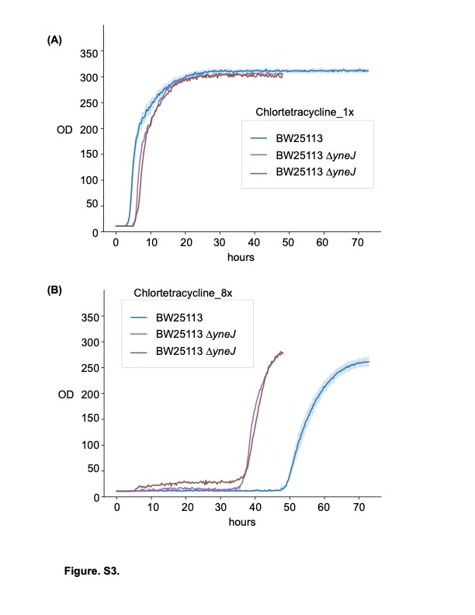
TABLES

Table S1
b-number | gene |  | Sequence | Position | Score | Log² fold change
b2724 | hycB |  | GccGGACAAAGAACTC | -447 | 5.65 | -9.0
 | pflB |  | GATGGACAAAGCGTTC | -356 | 7.26 | -5.39
  b0903
b1200 | dhaK |  | GATGCACAAtGGATTC | -92 | 6.22 | -1.39
b1241 | adhB |  | GATGCtgAAAGGTGTC | -274 | 5.16 | -5.70
b2503 | pdeF | GActCACAAAaGGTTC |  | -365 | 5.16 | -
b4076 | nrfA | GATGaAtAAAGGGCTt |  | -390 | 5.37 | -
b4020 | yjbB | GATtCACAAAtCTGTC |  | -230 | 5.36 | -
b4028 | yjbG | GcTGGACgAAGAAGTC |  | -153 | 4.80 | -
b1468 | narZ | GATGtACAAccGTGTC |  | -75 | 5.87 | -2.28
Table S2

