Manuscript: Estimating relative abundance of two SARS-CoV-2 variants through wastewater surveillance at two large metropolitan sites

Supplementary Information

Supplementary Methods:

Parameters used with primer design software.
- Product size ranges: 60-200
- Primer size: min 15, opt 20, max 36
- Primer melting temperature: min 50°C, optimal 60°C, max 65°C
- GC% content: min 40%, optimal 50%, high 60%
- concentration of divalent cations = 3.8 mM
- concentration of dNTPs needs to be 0.8 mM
- Internal Oligo: size min 15, optimal 20, max 27
- Internal Oligo: Melting temp min 62°C, optimal 63°C, max 70°C
- Internal Oligo: GC% min 30%, optimal 50%, max 80%

Specificity Screening Against Other Targets. For specificity screening, RNA was extracted from the virus panel and whole viruses using the Chemagic™ Viral DNA/RNA 300 Kit H96 for the Perkin Elmer Chemagic 360. RNA was used undiluted as template using digital droplet RT-PCR with mutation primer and probes in singleton assays in single wells (see further details on digital PCR below). The concentration of targets used in the in vitro specificity testing was approximately 275 copies per well.

Sensitivity and Specificity. For sensitivity and specificity testing, single wells were run using the HV69-70 assay for a subset of no and low background samples, but otherwise run in three wells. The number of copies of variant mutation sequences input to each well was estimated using a dilution series of variant gRNA in no background; the vendor specified concentration of the variant gDNA or gene blocks was scaled by the slope of the curve relating the measured ddRT-PCR concentration and the calculated input concentration based on the vendor estimates.

Solids sample processing. The solids were dewatered by centrifugation at 24,000 x g for 30 minutes at 4°C. The supernatant was aspirated and discarded. A 0.5 - 1 g aliquot of the dewatered solids was dried at 110°C for 19-24 hrs to determine its dry weight. Bovine coronavirus (BCoV) was used as a positive recovery control. Each day, attenuated bovine coronavirus vaccine (PBS Animal Health, Calf-Guard Cattle Vaccine) was spiked into DNA/RNA shield solution (Zymo Research) at a concentration of 1.5 µL /mL. Dewatered solids were resuspended in the BCoV-spiked DNA/RNA shield to a concentration of 75 mg/mL. This concentration of solids was chosen as previous work titrated solutions with varying concentrations of solids to identify a concentration at which inhibition of the SARS-CoV-2 assays was minimized (ref). Between five and ten 5/32” Stainless Steel Grinding Balls (OPS Diagnostics) were added to each sample which was subsequently homogenized by shaking with a Geno/Grinder 2010 (Spex SamplePrep). Samples were then briefly centrifuged to remove air bubbles introduced during the homogenization process, and then vortexed to re-mix the sample.

RNA was extracted from 10 replicate aliquots per sample. For each replicate, RNA was extracted from 300 µl of solids sample using the Chemagic™ Viral DNA/RNA 300 Kit H96 for the Perkin Elmer Chemagic 360 followed by PCR Inhibitor Removal with the Zymo OneStep-96 PCR Inhibitor Removal Kit. Extraction negative controls (water) and extraction positive controls were extracted using the same protocol as the solids samples. The positive controls consisted of 500 copies of WT-gRNA in the BCoV-spiked DNA/RNA shield solution described above. Undiluted extract was used for the SARS-CoV-2 assay template and a 1:100 dilution of the extract was used for the BCoV / PMMoV assay template.

ddPCR Thermocycling Conditions. PCR was performed using Mastercycler Pro with the following cycling conditions: reverse transcription at 50°C for 60 minutes, enzyme activation at 95°C for 5 minutes, 40 cycles of denaturation at 95°C for 30 seconds and annealing and extension at either 59°C (for single or multiplex SARS-CoV-2 assays that include HV69-70, or do not include any mutation), 61°C (for single or multiplex assays that include del156-157/R158G) or 56°C (for PMMoV/BCoV duplex assay) for 30 seconds, enzyme deactivation at 98°C for 10 minutes then an indefinite hold at 4°C. The ramp rate for temperature changes were set to 2°C/second and the final hold at 4°C was performed for a minimum of 30 minutes to allow the droplets to stabilize.

For the assay sensitivity and specificity testing, assays were run in single wells, or triplicate wells as specified above; each plate contained positive and negative PCR controls. Each wastewater sample was run in 10 replicate wells, and each plate of wastewater samples included extraction negative controls that were run in 7 wells, and extraction positive controls in 1 well. In addition, PCR positive controls for each target assayed on the plate were run in 1 well, and NTC were run in 7 wells.

Supplementary Figure 1. Location of HV69-70 primers and probes within the SARS-CoV-2 genome. Probe was designed with the deletion in the center (image shows the location, but the annotated probe has a 6bp deletion at amino acids 69 & 70).
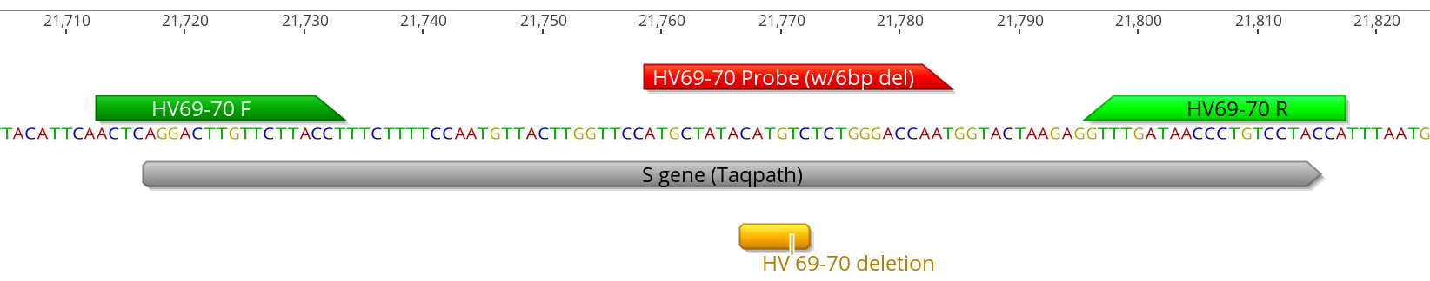

Supplementary Figure 2. Location of Del156-157/R158G primers and probes within the SARS-CoV-2 genome. Probe was designed with the deletion in the center.

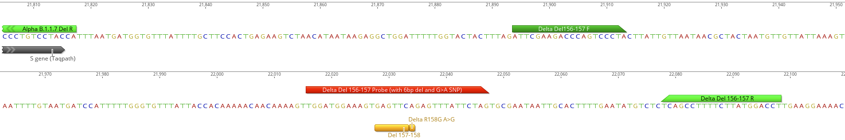

Supplementary Results:

Recovery of BCoV was higher than 10% in all samples suggesting acceptable viral RNA recovery, and absence of substantial inhibition. PMMoV concentrations ranged from 10⁸ to 10⁹ copies per gram at both plants (Figure SZ) on the sampling dates included in this study, within expected ranges previously measured at the POTWs (ref) and indicating consistent recovery of viral RNA from the wastewater solids. Negative controls including extraction and PCR negative controls were negative on all plates and positive controls all amplified. N genes concentrations measured contemporaneously with the mutation targets were similar to those measured immediately after wastewater sample collection (average ratio of the measurements ~ 0.9) indicating RNA stability during -80°C storage.

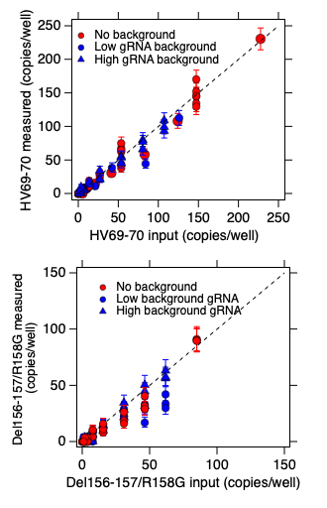
Figure SX. Measured copies of mutation targets versus input copies of mutation targets in no, low, (100 copies/well) and high (10,000 copies/well) background of WT-gRNA from 2019-nCoV/USA-WA1/2020 which does not contain the mutations. Error bars represent standard deviations of the measurements. No background is shown in red; and measurements where background gRNA was included are shown in blue.

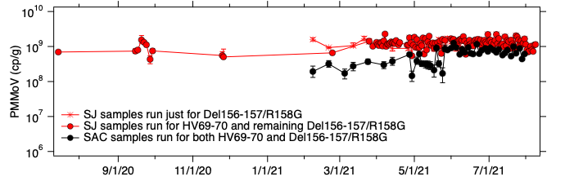
Figure SY. PMMoV RNA target concentrations in wastewater solids used in this study in units of copies per gram dry weight. PMMoV is used as an endogenous control as we expect it in high concentrations and low concentrations would suggest failure in extraction efficiency.
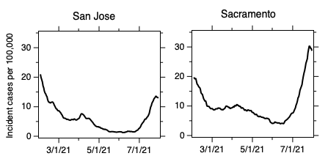
Figure SD. Incident cases of COVID-19 (seven day smoothed) in the sewersheds.

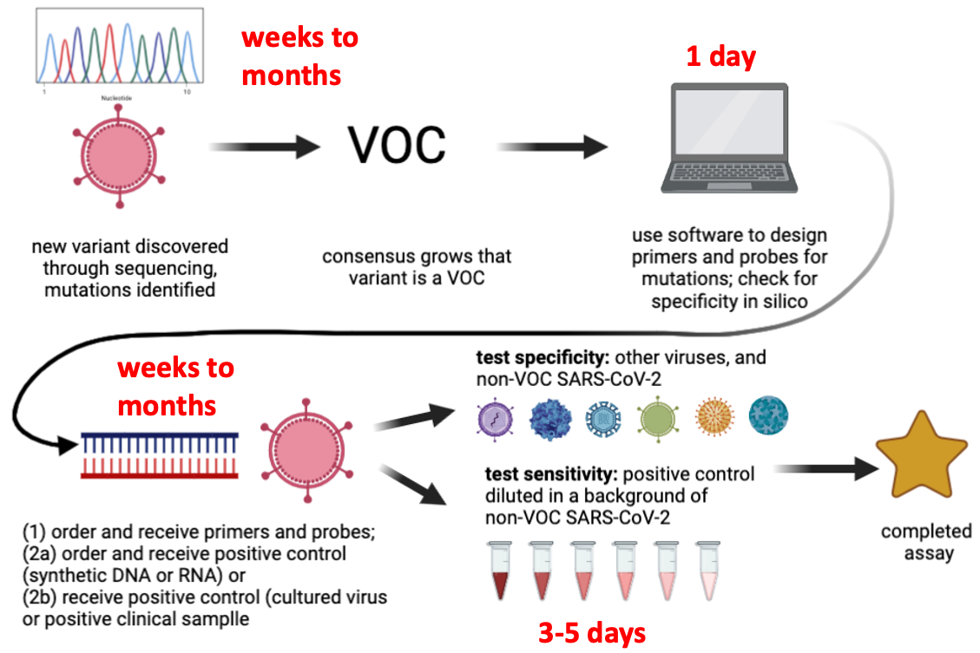
Figure SC. Timeline to develop completed variant mutation assay. The time for variant discovery to consensus that variant is a VOC and time for receiving reagents are obstacles for the rapid development of mutation assays. Figure was created using Biorender.com.

