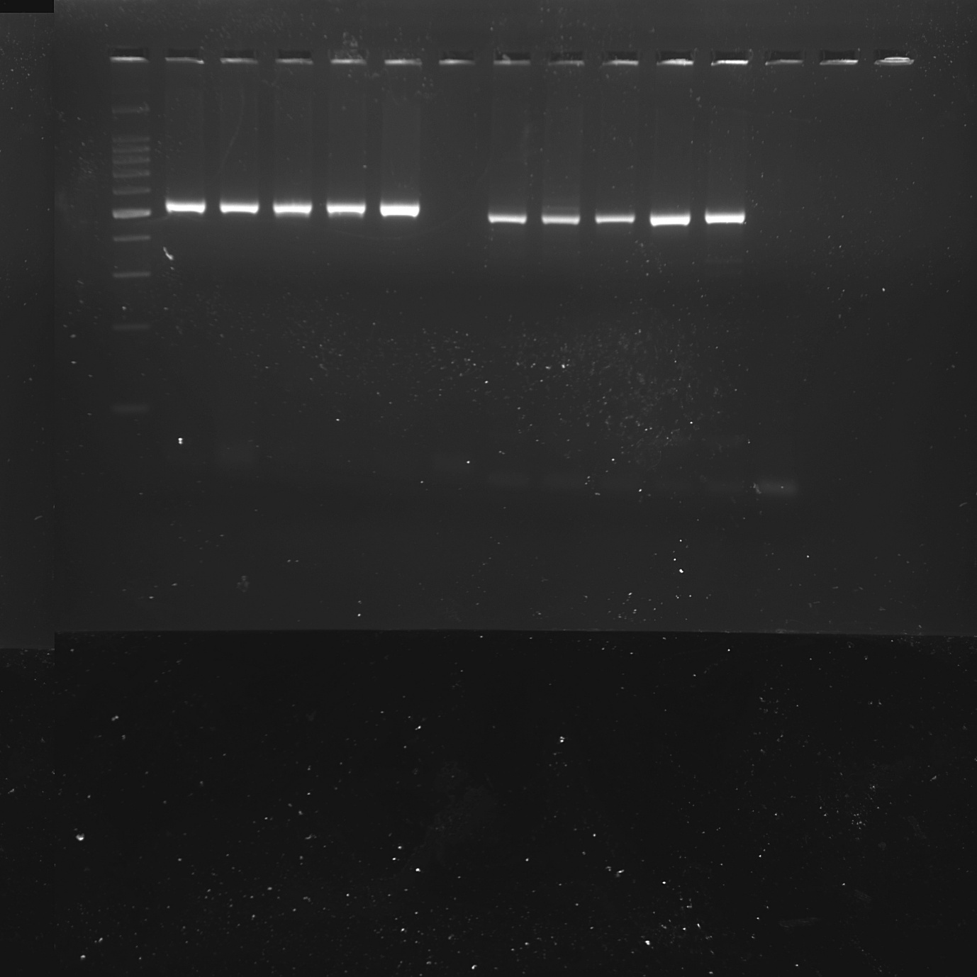
L 1 2 3 4 5 NC 6 7 8 9 10 NC
Figure S1 : Optimization of different annealing temperatures; Lane-L: Ladder (100 bp), Lane-NC: negative; Lane 1: 48°C, Lane 2: 50°C, Lane 3: 52°C, Lane 4: 54°C, Lane 5: 56°C; Lane1-5: EA primer; Lane 6: 48°C, Lane 7: 50°C, Lane 8: 52°C, Lane 9: 54°C, Lane 10: 56°C; Lane 6-10 : seed coat colour primer.
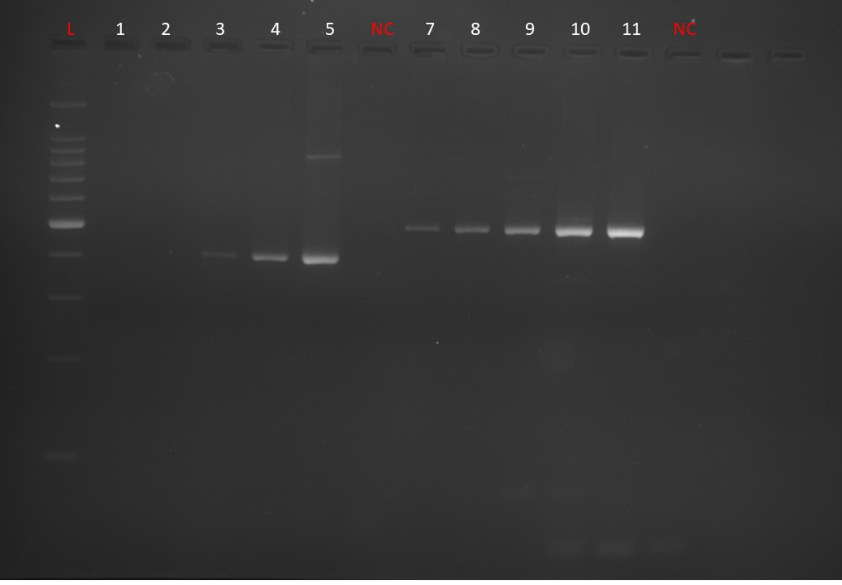

Figure S2: Optimization of different primer concentration; Lane-L: Ladder (100 bp); NC: negative, Lane (1-5) EA; Lane (7-11) seed coat colour; Lane (1&7), 0.1 µl, Lane (2&8) 0.3µl, Lane (3&9) 0.5 µl, Lane (4&10) 1µl, Lane (5&11) 1.5 µl.

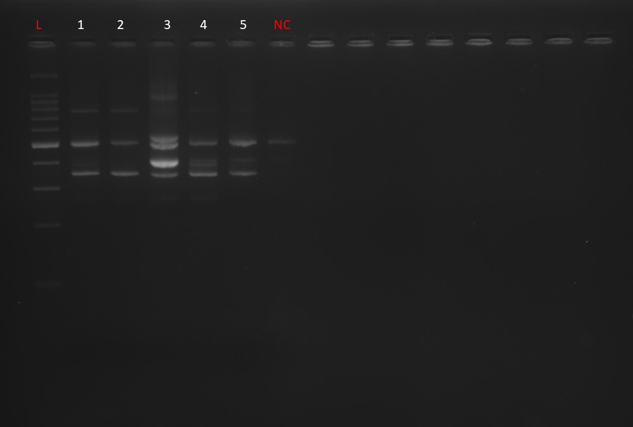
Figure S3: Optimization of different template concentrations for sensitivity, L: Ladder (100 bp), NC: negative, Lane-1; 100% concentration, lane-2; 10⁻¹ dilution, lane-3; 10⁻² dilution, lane-4; 10⁻³ dilution, lane-5; 10⁻⁴ dilution.

