Carbon stock recovery lags far behind area expansion in China’s mangroves over five decades
Xinzhi Wang^{1, 2}, Mingming Jia¹*, Chuanpeng Zhao¹, Rong Zhang¹, Panpan Chen¹, Lina Cheng¹, Haihang Zeng^{1, 2}, Zhijun Feng^{1, 3}, Zongming Wang¹

¹ Key Laboratory of Marsh Wetland Ecosystem Conservation and Restoration, National Forestry and Grassland Administration, Northeast Institute of Geography and Agroecology, Chinese Academy of Sciences, Changchun 130102, China;
² College of Resources and Environment, University of Chinese Academy of Sciences, Beijing 100049, China;
³ School of Geographical Sciences, Northeast Normal University, Changchun 130024, China;
* Corresponding author. E-mail address: jiamingming@iga.ac.cn.

Supplementary Information：
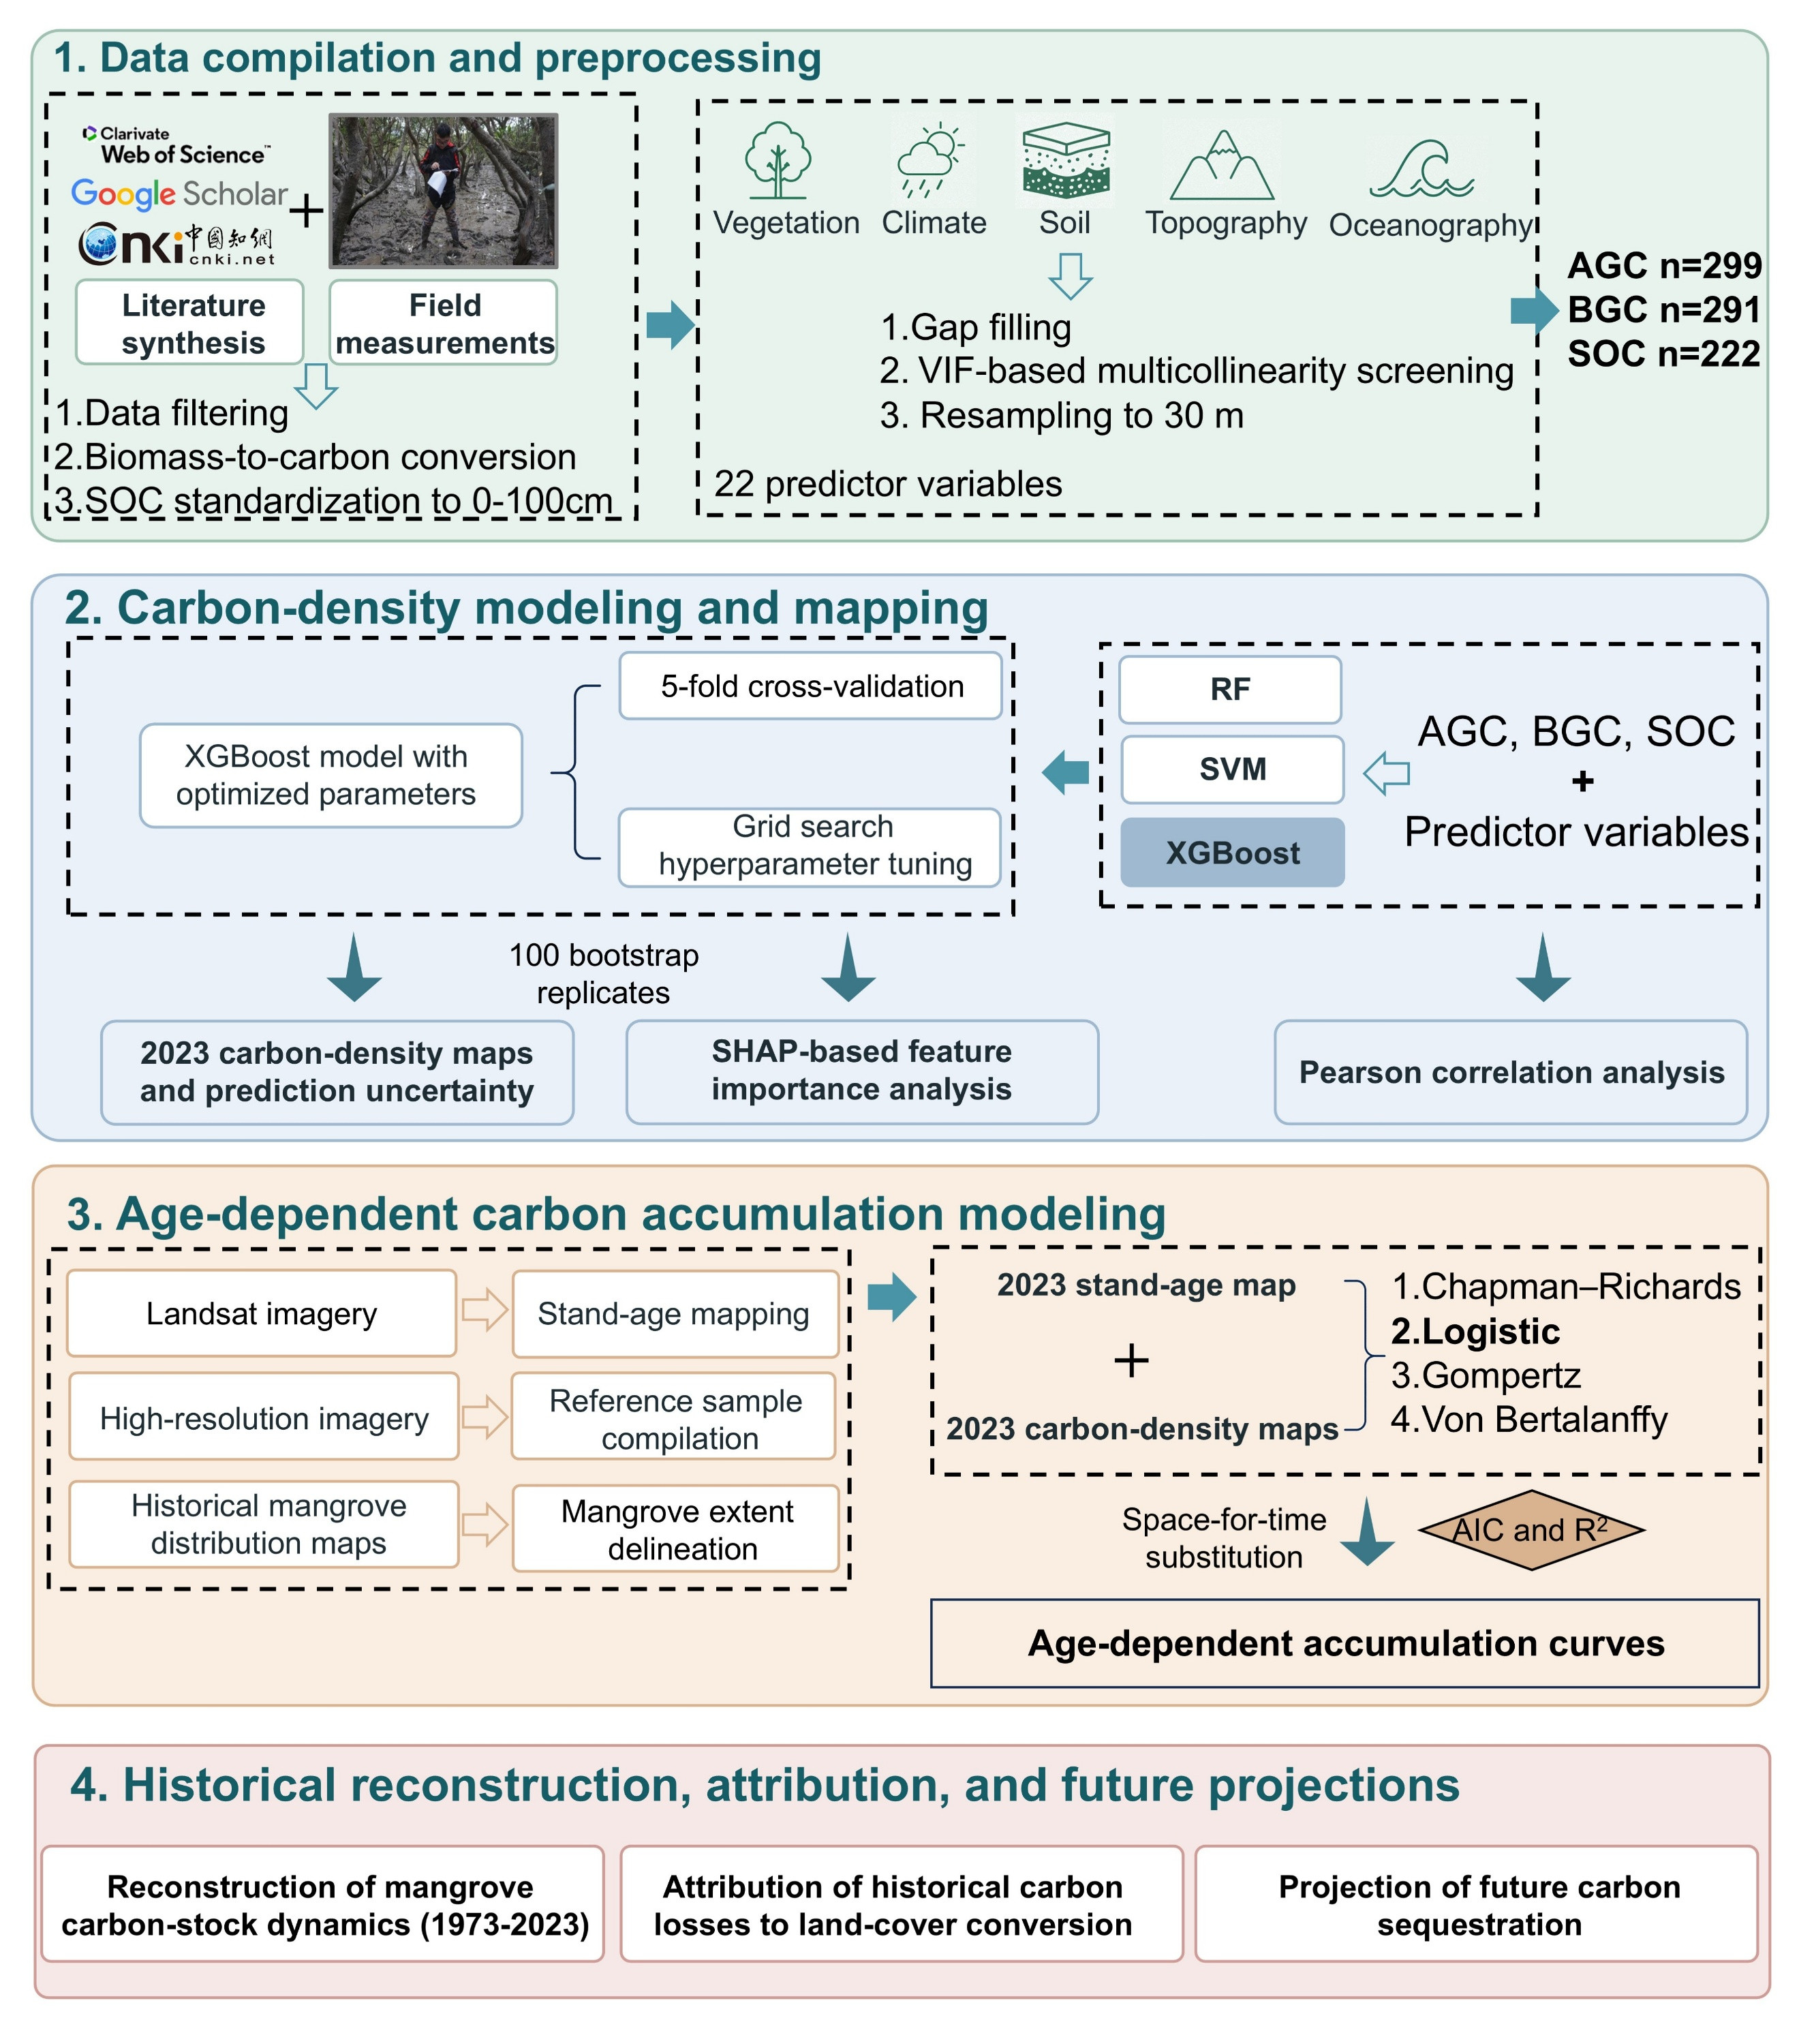
Supplementary Figure 1. Conceptual framework and analytical workflow for reconstructing historical and future mangrove carbon dynamics.

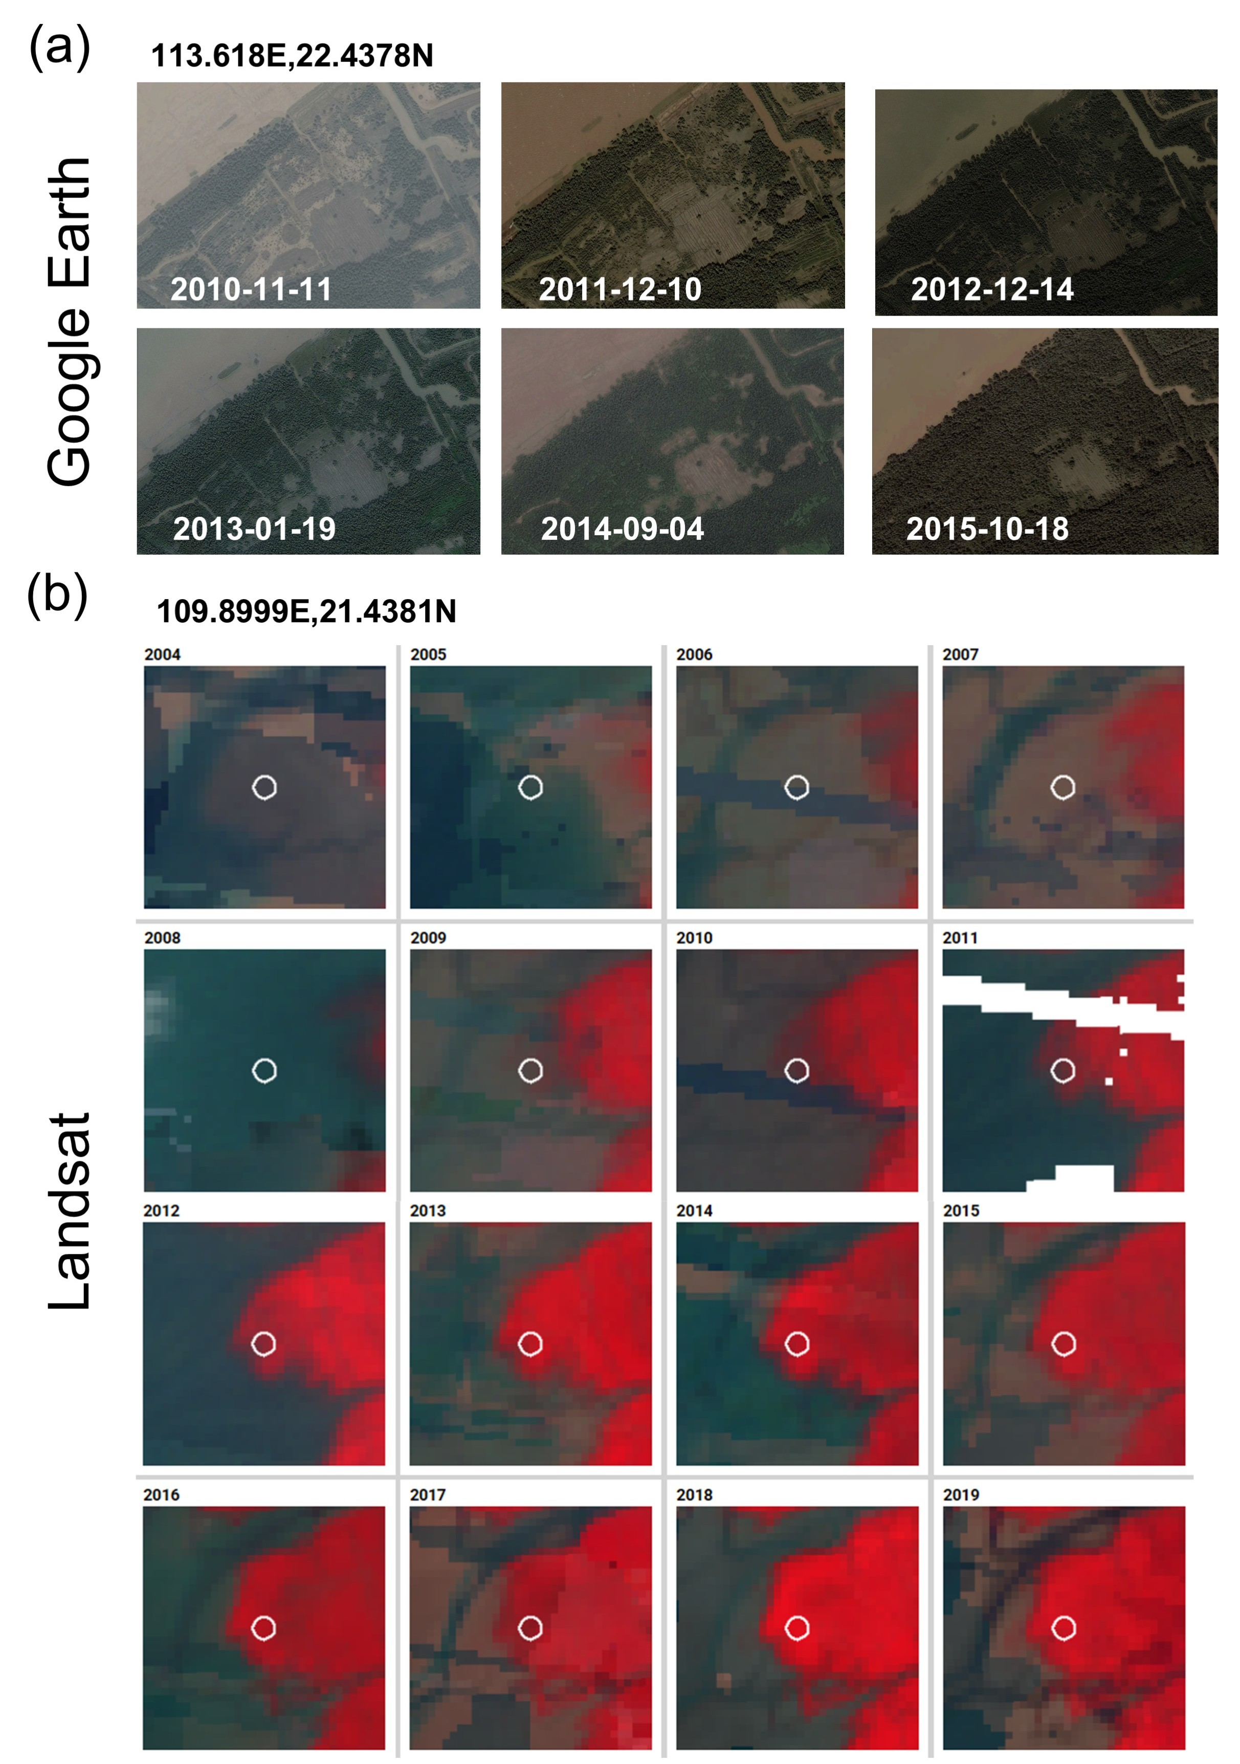
Supplementary Figure 2. Determination of mangrove stand age through visual interpretation of historical Google Earth and Landsat time-series imagery. For example, the time-series in panel (b) reveals that continuous mangrove vegetation cover emerged in 2010. Consequently, for a field sample collected at this location in 2019, the stand age was calculated as 9 years.

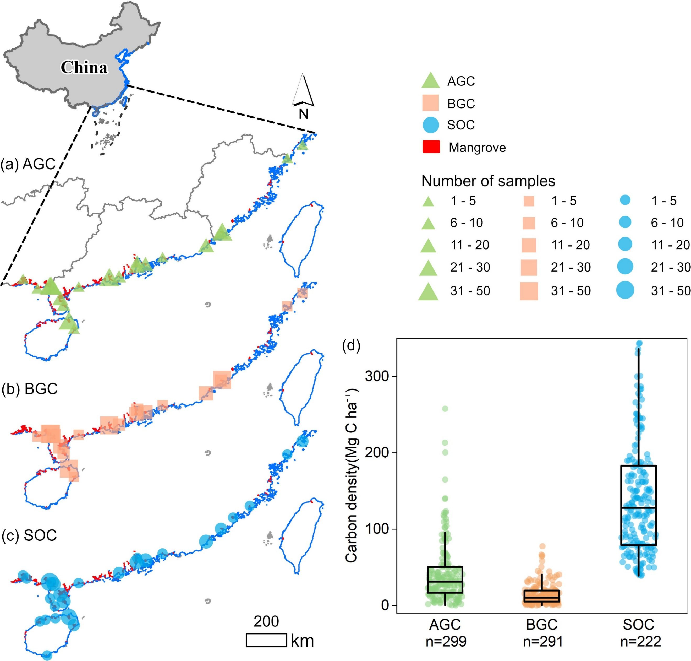
Supplementary Figure 3. Spatial distribution and statistical characteristics of the compiled mangrove carbon dataset. (a–c) Geographic locations and sampling intensity for aboveground biomass carbon (AGC), belowground biomass carbon (BGC), and soil organic carbon (SOC) observations. (d) Statistical distribution of carbon density (Mg C ha⁻¹) for AGC, BGC, and SOC. For each box plot, individual data points are shown as circles. The center line and the top and bottom of the box represent the median and the interquartile range (25th percentile and 75th percentile). The sample size (n) of each group is shown at the bottom of each box plot.

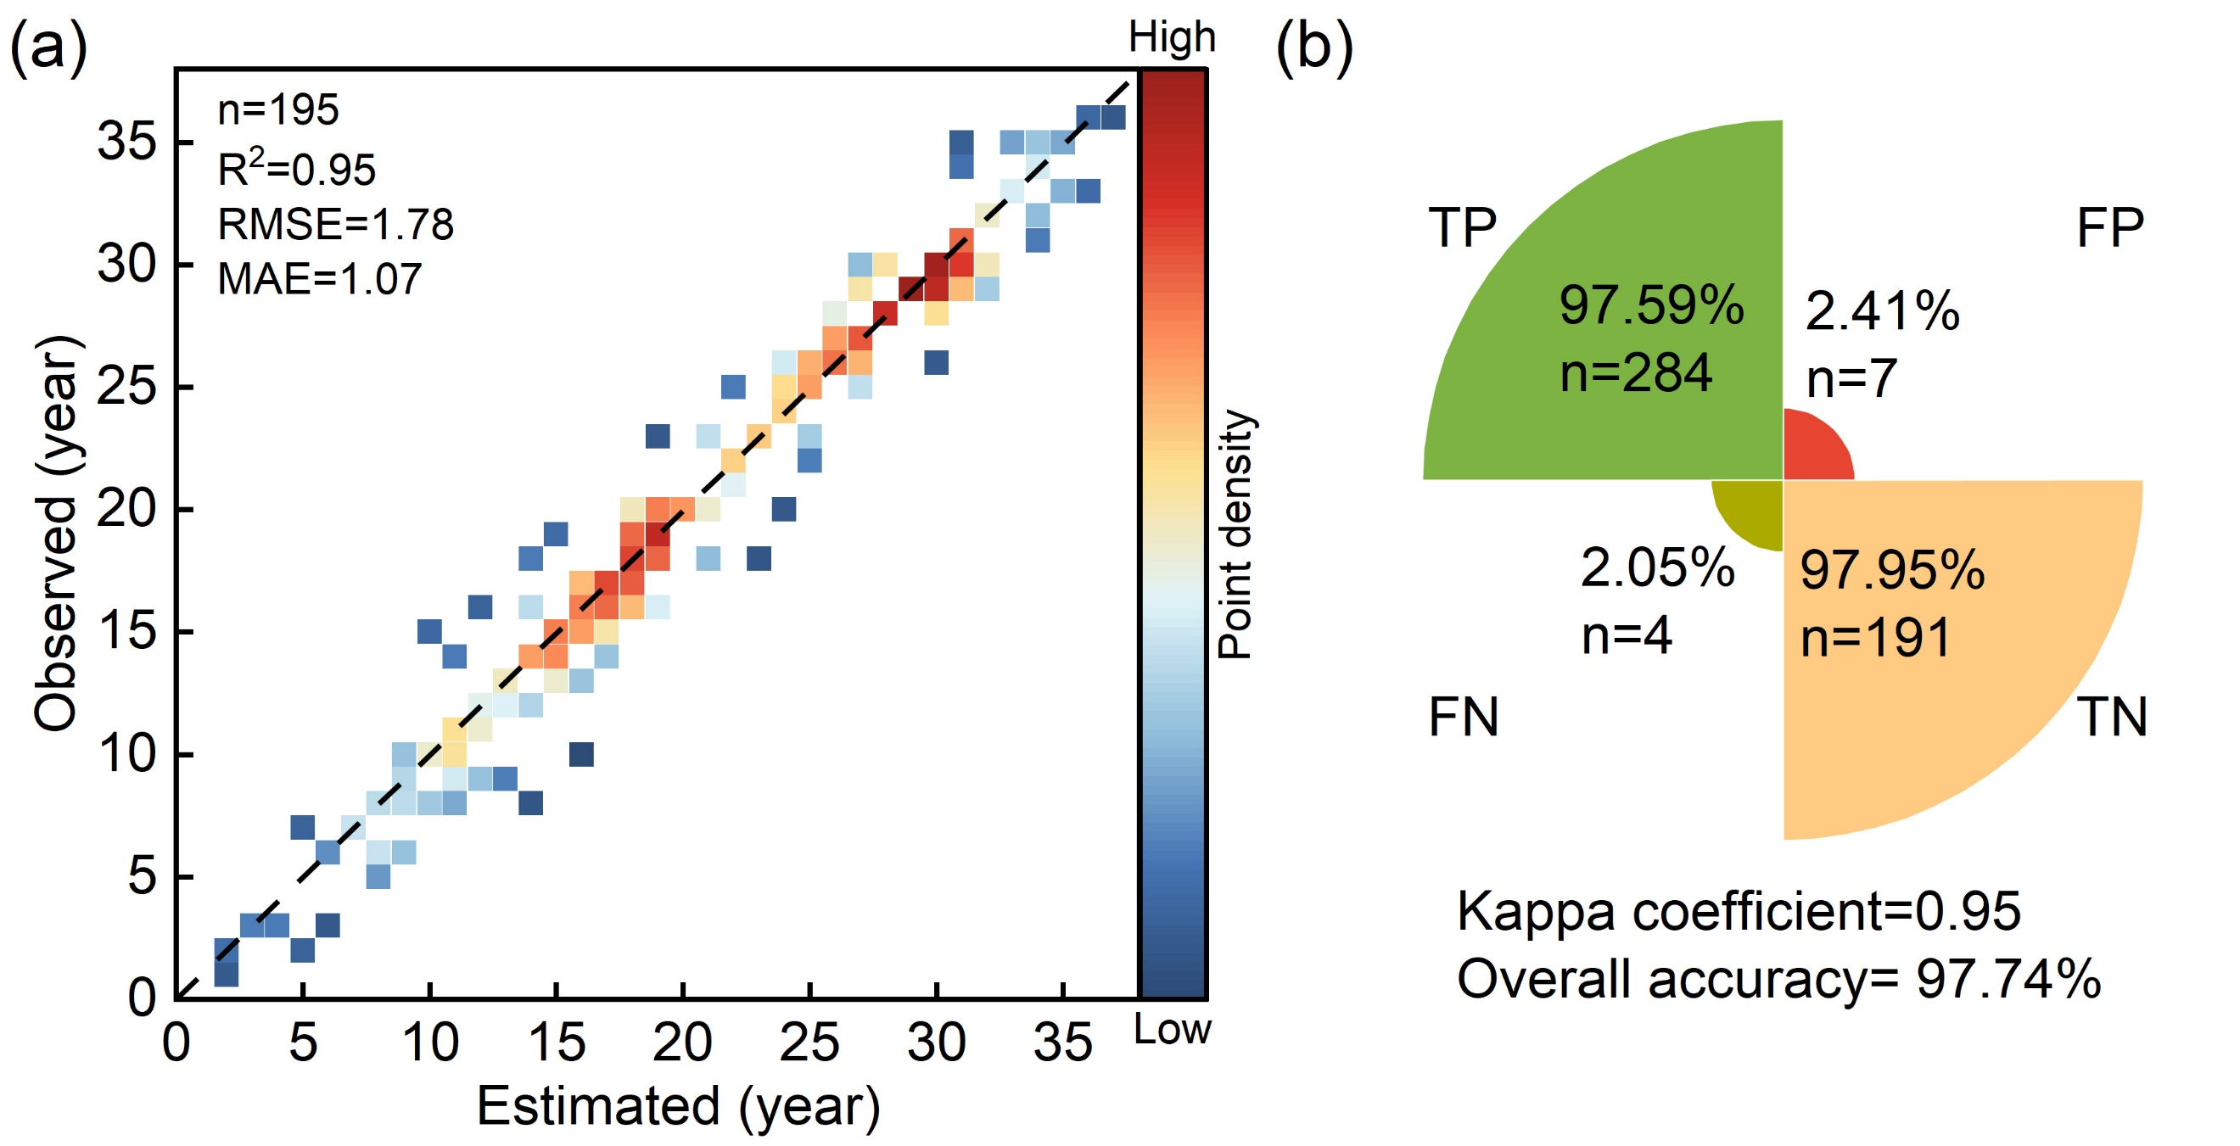
Supplementary Figure 4. Accuracy assessment of the Landsat-derived mangrove stand age products. (a) Comparison between the estimated mangrove stand ages and observed reference data. (b) Evaluation of the binary classification distinguishing old-growth mangroves (OGM, Positive class) from non-OGM stands (Negative class). True Positives (TP) and True Negatives (TN) denote correctly classified OGM and non-OGM samples, respectively, whereas False Positives (FP) and False Negatives (FN) represent misclassifications.

Species | Allometric equations | References
Avicennia marina | W_{AGB}=0.308*DBH^{2.11}  W_{BGB}=1.28*DBH^{1.17} | (Comley et al., 2005)
Kandelia obovata | W_{AGB}=0.187*DBH^{1.855}+0.267*DBH^{1.906}  W_{BGB}=4.6*DBH^{1.136} | (Jin et al., 2012)
Aegiceras corniculatum | W_{AGB} = 0.4326* (DBH²*H)^{0.465}  W_{BGB} = 0.5726* (DBH²*H)^{0.303} | (Tam et al., 1995)
Bruguiera gymnorhiza  (L.) Lam. | W_{AGB}=0.186*DBH^{2.31}  W_{BGB} = 0.4697*DBH^{1.5543} | (Clough and Scott, 1989;  Zheng et al., 1991)
Rhizophora stylosa | W_{AGB}= 0.2206*DBH^{2.4292}  W_{BGB}= 0.261*DBH^{1.86} | (Clough et al., 1997;  Comley et al., 2005)
Sonneratia apetala | W_{AGB} = 0.258*DBH^{2.287}  W_{BGB} = 0.045*DBH^{2.320} | (Kusmana et al., 2018)
Supplementary Table 1. Species-specific allometric equations used to estimate aboveground and belowground biomass.
Note: W_{AGB} and W_{BGB} denote aboveground and belowground biomass (kg), respectively; DBH denotes diameter at breast height (cm); and H denotes tree height (m).

Supplementary Table 2. Detailed information on the 30 predictor variables.
Group | Name | Description | Resolution | Period | Source
Vegetation | Height | Canopy height | 10 m | 2022 | Jia et al. (2025)
 | Species | Dominant species | 10 m | 2021 | Zhao et al. (2024)
 | Age | Stand age | 30 m | 2023 | This study
 | NDVI | Normalized Difference Vegetation Index | 30 m | 2023 | This study
 | EVI | Enhanced Vegetation Index | 30 m | 2023 | This study
 | kNDVI | Kernel Normalized Difference Vegetation Index | 30 m | 2023 | This study
Climate | MAT | Mean annual temperature | 1 km | 1990–2023 | Peng et al. (2019)
 | MAP | Mean annual precipitation | 1 km | 1990–2023 | Peng et al. (2019)
Topography | DEM | Digital elevation model | 90 m | - | MERIT DEM
 | Slope | Slope derived from DEM | 90 m | - | This study
 | Aspect | Aspect derived from DEM | 90 m | - | This study
Soil | BD | Bulk density (0–100 cm) | 250 m | - | Liu et al. (2022)
 | Clay | Clay content (0–100 cm) | 250 m | - | Liu et al. (2022)
 | Silt | Silt content (0–100 cm) | 250 m | - | Liu et al. (2022)
 | Sand | Sand content (0–100 cm) | 250 m | - | Liu et al. (2022)
 | CF | Coarse fragments (0–100 cm) | 250 m | - | Liu et al. (2022)
 | pH_Soil | Soil pH (0–100 cm) | 250 m | - | Liu et al. (2022)
 | TK | Total potassium (0–100 cm) | 250 m | - | Liu et al. (2022)
 | TN | Total nitrogen (0–100 cm) | 250 m | - | Liu et al. (2022)
 | TP | Total phosphorus (0–100 cm) | 250 m | - | Liu et al. (2022)
Oceanographic | SST | Sea surface temperature | 0.05° | 2010–2020 | Bio-ORACLE
 | Salinity | Sea surface salinity | 0.05° | 2010–2020 | Bio-ORACLE
 | Nitrate | Nitrate | 0.05° | 2010–2020 | Bio-ORACLE
 | Phosphate | Phosphate | 0.05° | 2010–2020 | Bio-ORACLE
 | pH_Sea | Sea water pH | 0.05° | 2010–2020 | Bio-ORACLE
 | SeaDir | Sea water direction | 0.05° | 2010–2020 | Bio-ORACLE
 | SeaSpeed | Sea water speed | 0.05° | 2010–2020 | Bio-ORACLE
 | TidalRange | Tidal amplitude | 0.125° | - | EOT20 global ocean tide model
 | NDWI | Normalized Difference Water Index | 30 m | 2023 | This study
 | MNDWI | Modified Normalized Difference Water Index | 30 m | 2023 | This study

Supplementary Table 3. Variance inflation factor (VIF) values for the final set of 22 predictor variables.
Predictor variable | VIF |  | Predictor variable | VIF
Aspect | 1.35 |  | Clay | 4.09
Age | 1.54 |  | CF | 4.30
Silt | 2.26 |  | Phosphate | 4.47
Species | 2.32 |  | NDWI | 4.61
Height | 2.36 |  | MAP | 4.63
DEM | 2.40 |  | EVI | 5.97
SeaDir | 3.05 |  | TP | 6.40
BD | 3.57 |  | pH_Sea | 7.03
pH_Soil | 3.63 |  | NDVI | 7.24
MNDWI | 3.98 |  | MAT | 7.53
SeaSpeed | 4.04 |  | TidalRange | 7.76

Supplementary Table 4. Prediction performance of different models for aboveground biomass carbon (AGC), belowground biomass carbon (BGC), and soil organic carbon (SOC) density.
 | AGC (Mg C ha⁻¹) |  |  | BGC (Mg C ha⁻¹) |  |  | SOC (Mg C ha⁻¹)
 | R² | RMSE | MAE | R² | RMSE | MAE | R² | RMSE | MAE
RF | 0.67 | 26.72 | 19.38 | 0.49 | 9.39 | 6.40 | 0.59 | 59.72 | 41.71
SVM | 0.63 | 26.78 | 18.18 | 0.52 | 9.05 | 6.83 | 0.58 | 59.56 | 36.16
XGBoost | 0.79 | 21.98 | 15.78 | 0.60 | 8.43 | 6.53 | 0.65 | 49.58 | 36.50

Supplementary Table 5. Fitting performance of four growth models for
mangrove aboveground biomass carbon (AGC), belowground biomass carbon (BGC), and soil organic carbon (SOC).
Model | AGC |  | BGC |  | SOC
Model | R² | AIC | R² | AIC | R² | AIC
Chapman-Richards | 0.86 | 155.21 | 0.85 | 127.91 | 0.87 | 160.20
Logistic | 0.92 | 134.88 | 0.91 | 105.46 | 0.96 | 114.22
Gompertz growth | 0.90 | 141.94 | 0.89 | 115.21 | 0.96 | 114.47
Von Bertalanffy | 0.88 | 149.68 | 0.86 | 125.75 | 0.96 | 114.85

Supplementary Table 6. Fitted parameters of age-carbon accumulation models for aboveground biomass carbon (AGC), belowground biomass carbon (BGC), and soil organic carbon (SOC).
Carbon pool | Quantile | Asym | b | c | R²
AGC | P2.5 | 51.58 | 209.6961 | 0.3883 | 0.973
AGC | P50 | 61.11 | 21.6683 | 0.2468 | 0.939
AGC | P97.5 | 70.73 | 6.9516 | 0.1817 | 0.830
BGC | P2.5 | 22.00 | 289.1333 | 0.3438 | 0.976
BGC | P50 | 27.12 | 61.2399 | 0.2521 | 0.961
BGC | P97.5 | 33.38 | 17.8820 | 0.1954 | 0.854
SOC | P2.5 | 194.47 | 4.1574 | 0.0938 | 0.973
SOC | P50 | 237.75 | 2.9437 | 0.0693 | 0.954
SOC | P97.5 | 493.64 | 4.9023 | 0.0394 | 0.876

Supplementary Table 7. Overview of the three future mangrove restoration scenarios.
Scenario | Annual expansion rate | Cumulative restored area by 2060 | Data source
Ecological Potential Scenario | 5,312 ha yr⁻¹ | 196,566 ha | Hu et al. (2020b)
National Target Scenario | 1,810 ha yr⁻¹ | 66,970 ha | MNR & NFGA (2020)
Historical Trend Scenario | 723 ha yr⁻¹ | 26,765 ha | Jia et al. (2021)

Supplementary Table 8. Comparison of published estimates and estimates from this study of mangrove area, carbon stock, and mean carbon density across carbon pools in China.
Carbon pool | Reference year | Published area (ha) | Published carbon stock (Tg C) | Published mean carbon density (Mg C ha⁻¹) | Method | Reference | This study carbon stock (Tg C) | This study area (ha) | This study mean carbon density (Mg C ha⁻¹)
TCS | 2002 | 22,025 | 6.91 | 313.73 | Field/literature-based carbon density × area | Liu et al. (2014) | 2.94 | 19,599 | 149.97
TCS | 2021 | 27,885 | 2.11* | 75.67 | InVEST carbon storage assessment | Li et al. (2024) | 5.52 | 27,813 | 198.64
TCS | 2019 | 25,585 | 5.17 | 202.07 | MaxEnt Model + carbon density accounting | Feng et al. (2024) | 5.07 | 26,347 | 192.45
TCS | 2012 | 5,600 | 0.3 | 53.57 | Carbon-density-based emission accounting | Hamilton and Friess (2018) | 3.65 | 20,968 | 173.99
TCS | 2015 | 22,670 | 4.43 | 195.41 | Machine-learning mapping | Sun et al. (2025) | 4.18 | 22,561 | 185.15
SOC | 2002 | 22,025 | 5.65 | 256.53 | Field/literature-based carbon density × area | Liu et al. (2014) | 2.18 | 19,599 | 111.31
SOC | 2017 | 35,537 | 6.3 | 177.28 | Field/literature-based carbon density × area | Fu et al. (2021) | 3.32 | 24,454 | 135.59
SOC | 2020 | 19,510 | 3.6 | 184.52 | Machine-learning mapping | Fan and Li (2024) | 3.77 | 27,294 | 138.23
SOC | 2000 | 35,896 | 8.97 | 249.89 | Machine-learning mapping | Sanderman et al. (2018) | 2.12 | 19,522 | 108.77
SOC | 2020 | 25,872 | 4.36 | 168.52 | Literature-synthesized carbon density × area | Wang et al. (2025a) | 3.77 | 27,294 | 138.23
SOC | 2015 | 22,670 | 2.73 | 120.42 | Machine-learning mapping | Sun et al. (2025) | 3.01 | 22,561 | 133.46
AGC | 2000 | 15,098 | 0.55 | 36.43 | Remote sensing/LiDAR biomass retrieval | Simard et al. (2019) | 0.48 | 19,522 | 24.62
AGC | 2004 | 53,200 | 2.72 | 51.13 | Remote sensing/LiDAR biomass retrieval | Hu et al. (2020a) | 0.52 | 19,676 | 26.64
AGC | 2015 | 22,670 | 1.2 | 52.93 | Machine-learning mapping | Sun et al. (2025) | 0.78 | 22,561 | 34.72
BGC | 2015 | 22,670 | 0.55 | 24.26 | Machine-learning mapping | Sun et al. (2025) | 0.30 | 22,561 | 13.30

References
Clough, B. & Scott, K. (1989). Allometric relationships for estimating above-ground biomass in six mangrove species. For. Ecol. Manage. 27, 117–127.
Clough, B. F., Dixon, P. & Dalhaus, O. (1997). Allometric Relationships for Estimating Biomass in Multi-stemmed Mangrove Trees. Aust. J. Bot. 45, 1023–1031.
Comley, B. W. T. & McGuinness, K. A. (2005). Above- and below-ground biomass, and allometry, of four common northern Australian mangroves. Aust. J. Bot. 53, 431–436.
Fan, B. & Li, Y. (2024). China's conservation and restoration of coastal wetlands offset much of the reclamation‐induced blue carbon losses. Glob. Change Biol. 30, e17039.
Feng, B. et al. (2024). Identification of Suitable Mangrove Distribution Areas and Estimation of Carbon Stocks for Mangrove Protection and Restoration Action Plan in China. J. Mar. Sci. Eng. 12, 445.
Fu, C. et al. (2021). Stocks and losses of soil organic carbon from Chinese vegetated coastal habitats. Glob. Change Biol. 27, 202–214.
Hamilton, S. E. & Friess, D. A. (2018). Global carbon stocks and potential emissions due to mangrove deforestation from 2000 to 2012. Nat. Clim. Change 8, 240–244.
Hu, T. et al. (2020a). Mapping the Global Mangrove Forest Aboveground Biomass Using Multisource Remote Sensing Data. Remote Sens. 12, 1690.
Hu, W. et al. (2020b). Mapping the potential of mangrove forest restoration based on species distribution models: A case study in China. Sci. Total Environ. 748, 142321.
Jia, M., Wang, Z., Mao, D., Huang, C. & Lu, C. (2021). Spatial-temporal changes of China’s mangrove forests over the past 50 years: An analysis towards the Sustainable Development Goals (SDGs). Chin. Sci. Bull. 66, 3886–3901.
Jia, M. et al. (2025). Synergistic estimation of mangrove canopy height across coastal China: Integrating SDGSAT-1 multispectral data with Sentinel-1/2 time-series imagery. Remote Sens. Environ. 323, 114719.
Jin, C. et al. (2012). An assessment method of Kandelia obovata population biomass. Acta Ecol. Sin. 32, 3414–3422.
Kusmana, C., Hidayat, T., Tiryana, T., Rusdiana, O. & Istomo. (2018). Allometric models for above- and below-ground biomass of Sonneratia spp. Glob. Ecol. Conserv. 15, e00417.
Li, C. et al. (2024). Mangrove wetlands distribution status identification, changing trend analyzation and carbon storage assessment of China. China Geol. 7, 1–11.
Liu, H. et al. (2014). Carbon stocks and potential carbon storage in the mangrove forests of China. J. Environ. Manage. 133, 86–93.
Liu, F. et al. (2022). Mapping high resolution National Soil Information Grids of China. Sci. Bull. 67, 328–340.
Ministry of Natural Resources & National Forestry and Grassland Administration. (2020). Special Action Plan for Mangrove Conservation and Restoration (2020–2025). Beijing.
Peng, S., Ding, Y., Liu, W. & Li, Z. (2019). 1 km monthly temperature and precipitation dataset for China from 1901 to 2017. Earth Syst. Sci. Data 11, 1931–1946.
Sanderman, J. et al. (2018). A global map of mangrove forest soil carbon at 30 m spatial resolution. Environ. Res. Lett. 13, 055002.
Simard, M. et al. (2019). Mangrove canopy height globally related to precipitation, temperature and cyclone frequency. Nat. Geosci. 12, 40–45.
Sun, S. et al. (2025). A Spatial Baseline of China's Blue Carbon Stocks for Improved Monitoring, Management, and Protection. Earth's Future 13, e2024EF005380.
Tam, N. F. Y., Wong, Y. S., Lan, C. Y. & Chen, G. Z. (1995). Community structure and standing crop biomass of a mangrove forest in Futian Nature Reserve, Shenzhen, China. Hydrobiologia 295, 193–201.
Wang, J. et al. (2025). Unveiling distribution and drivers of soil organic carbon in coastal China: Salt marshes and tidal flats as major carbon storage contributors. Ecol. Indic. 178, 114132.
Zhao, C. et al. (2024). Mangrove species mapping in coastal China using synthesized Sentinel-2 high-separability images. Remote Sens. Environ. 307, 114151.
Zheng, S., Liao, B. & Zheng, D. (1991). Biomass and productivity of Bruguiera gymnorrhiza stand. For. Res. 4, 22–29.

