Supplementary material
The farmwork of MDT
Patients with suspected gastric cancer at their first visit to our hospital are scheduled to endoscopy, those with endoscopy biopsy-based pathology proved gastric adenocarcinomas will be referred to a multidisciplinary tumor board (MDT) when imaging scans and laboratory tests were completed. The MDT consisted of specialists in gastrointestinal surgery, digestive oncology, radiotherapy oncology, radiology, pathology and endoscopy. Clinical staging of each tumor was determined by the panel review of baseline imaging data and the treatment pathway was optimized after careful and comprehensive assessment of patient history, imaging, laboratory information, and patient status (eg. if active bleeding or obstruction, or severe anemia was presented). Following the NCCN guidelines, GC staged ≥T2 with any node stag and M0 are eligible to NAC; consequently, GC in clinical phase Ⅱ and Ⅲ (cT2~4a, N0~3, M0) were diagnosed as locally advanced gastric cancer (LAGC) and referred to NAC.
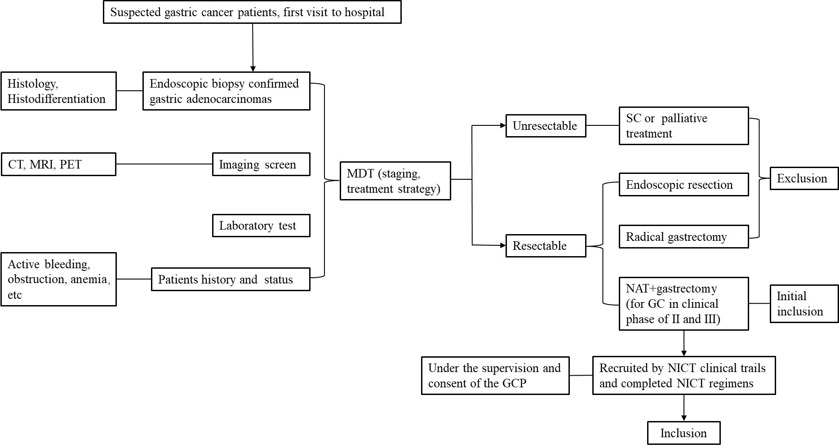
Figure S1. The framework of MDT workflow for patients with gastric cancer. Abbreviations: SC=Systematic chemotherapy; NAT=Neoadjuvant therapy; GC=Gastric cancer; NICT=Neoadjuvant immuno-chemotherapy.
NICT regimens
Patients received standard NICT treatment in real world clinical trials (NCT: 04341857, 03950271, 04891016, 03939962, 05149807, 05177068, 05583383). The anti-PD-1 monoclonal antibody included Sintilimab in 62 patients and Toripalimab in 31 patients. The specific chemotherapy regimens included SOX (S-1, oxaliplatin) regimen performed in 38 patients, FLOT (5-fluorouracil, folinic acid, oxaliplatin, and docetaxel) in 32 patients, mFOLFOX6 (modified infusional fluorouracil, leucovorin, and oxaliplatin) in 8 patients, XELOX (CapeOX, oxaliplatin, capecitabine) in 15 patients.
Pathological response evaluation
Tumor regression grade were classified as follows in accordance to the 8th AJCC TRG criteria: TRG 0 (pathologic complete response, pCR): no viable cancer cells; TRG 1 (near complete response): single cells or rare small groups of cancer cells; TRG 2 (partial response): residual cancer with evident tumor regression, but more than single cells or rare small groups of cancer cells; TRG 3 (poor or no response): massive cancer cells are observed with no evident tumor regression.
Inter-observer agreement between readers’ score for image quality
The inter-observer agreement between the readers’ assessment was excellent, with corresponding kappa value being 0.813 (95%CI: 0.708-0.917) for imaging quality score, 0.786 (95%CI: 0.671-0.900) for cT, 0.795 (95%CI: 0.650-0.940) for cN, 0.936 (95%CI: 0.874-0.999) for MRI-based Borrmann classification, respectively (Table S1-S4).
Five‑fold Cross‑Validation Performance of the Combined Parameter
To internally validate the predictive robustness of the combined parameter (derived from ADC, D, and f) for identifying non‑responders to NICT, a five‑fold cross‑validation procedure was performed on the entire cohort (n = 93). The cohort was randomly partitioned into five equal‑sized subsets, with each fold sequentially held out as the validation set while the remaining four folds served as the training set.
Table S5 summarizes the performance metrics across the five validation folds. The combined parameter achieved a mean area under the receiver operating characteristic curve (AUC) of 0.726 ± 0.130 (range: 0.569–0.917), with a mean accuracy of 0.731 ± 0.111. Sensitivity and specificity averaged 0.708 ± 0.173 and 0.776 ± 0.072, respectively. The positive predictive value (PPV) was consistently high across folds (mean 0.859 ± 0.043), whereas the negative predictive value (NPV) showed greater variability (mean 0.606 ± 0.139). The corresponding receiver operating characteristic curves for each fold, along with the per‑fold performance metrics, are illustrated in Figure S3.

Table S1. Scores of readers for assessing image quality
Reader 2 | Reader 1 |  |  | Sum
Reader 2 | 3 | 4 | 5 | Sum
3 | 6 | 3 | 0 | 9 (9.7%)
4 | 0 | 25 | 5 | 30 (32.3%)
5 | 0 | 3 | 51 | 54 (58.0%)
Sum | 6 (6.5%) | 31 (33.3%) | 56 (60.2%) | 93

Table S2. Readers’ assessment for clinical T staging
Reader 2 | Reader 1 |  |  | Sum
Reader 2 | cT2 | cT3 | cT4a | Sum
cT2 | 4 | 0 | 0 | 4 (4.3%)
cT3 | 2 | 36 | 3 | 41 (44.1%)
cT4a | 0 | 7 | 41 | 48 (51.6%)
Sum | 6 (6.5%) | 43 (46.2%) | 44 (47.3%)

Table S3. Readers’ assessment for clinical N staging
Reader 2 | Reader 1 |  | Sum
 | Negative | Positive
Negative | 19 | 3 | 22 (23.7%)
Positive | 4 | 67 | 71 (76.3%)
Sum | 23 (24.7%) | 70 (75.3%) | 93
Table S4. Readers’ assessment for Borrmann classification
Reader 2 | Reader 1 |  |  | Sum
Reader 2 | Ⅰ | Ⅱ | Ⅲ | Sum
Ⅰ | 9 | 0 | 0 | 9 (9.7%)
Ⅱ | 0 | 36 | 3 | 39 (41.9%)
Ⅲ | 0 | 1 | 44 | 45 (48.4%)
Sum | 9 (9.7%) | 37 (39.8%) | 47 (50.5%)

Table S5. Five‑fold Cross‑Validation Performance of the Combined Parameter
Fold | AUC | Accuracy | Sensitivity | Specificity | PPV | NPV
1 | 0.833 | 0.789 | 0.846 | 0.667 | 0.846 | 0.667
2 | 0.692 | 0.737 | 0.692 | 0.833 | 0.900 | 0.556
3 | 0.619 | 0.684 | 0.667 | 0.714 | 0.800 | 0.556
4 | 0.917 | 0.889 | 0.917 | 0.833 | 0.917 | 0.833
5 | 0.569 | 0.556 | 0.417 | 0.833 | 0.833 | 0.417
Mean ± SD | 0.726 ± 0.130 | 0.731 ± 0.111 | 0.708 ± 0.173 | 0.776 ± 0.072 | 0.859 ± 0.043 | 0.606± 0.139
Abbreviations: AUC, area under the receiver operating characteristic curve; PPV, positive predictive value; NPV, negative predictive value; SD, standard deviation.

Figure S2. Bland-Altman plot diagrams for the interobserver agreements of quantitative parameters measurements between the two readers. (A) ICC for ADC measurements; (B) ICC for D measurements; (C) ICC for D* measurements; (D) ICC for f measurements

Figure S3. Five‑fold cross‑validation results. (A) ROC curves for each fold. (B) Per‑fold performance metrics shown as bars for folds 1 to 5.

