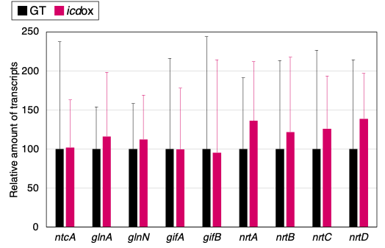
Supplementary Figure 1 Relative expression level of ntcA and NtcA-regulon genes in the GT and icdox strains. Data are presented as the mean ± SD of four to six independent experiments.

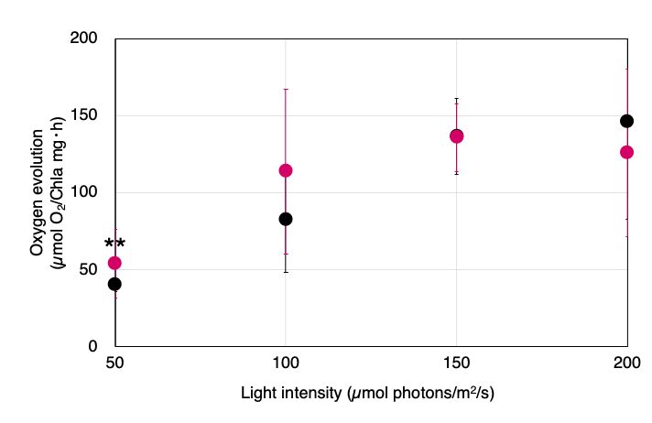
Supplementary Figure 2 Oxygen evolution rates under 50, 100, 150, and 250 µmol photons m⁻² s⁻¹ for the GT and icdox strains. The data are presented as the mean ± SD of five to nine independent experiments. Asterisks indicate statistically significant differences between the two strains (*P < 0.05, two-tailed Welch’s t-test).

