Additional file 1. Supplementary methods, tables, figures, and STROBE checklist
This file provides supplementary methods, analyses, figures, and the STROBE checklist for the main manuscript. It contains no patient-level records, database credentials, or restricted database extracts.

Supplementary methods

eICU-CRD cirrhosis sensitivity definitions
The primary eICU-CRD cirrhosis definition used information from the patient, diagnosis, or admission-diagnosis records. The stricter sensitivity definition required admission-level or primary/major diagnostic evidence of cirrhosis. Higher-coverage hospitals had at least 10 cirrhosis landmark stays, reference-creatinine availability of at least 70%, evaluable urine data in both study windows for at least 50% of landmark stays, and at least five eligible study patients.

eICU-CRD admission selection
The first ICU unit stay within each hospital admission was selected. When a patient had more than one eligible hospital admission, one admission was retained using the earliest recorded discharge year and then the hospital-stay and ICU-stay identifiers. Because eICU-CRD records discharge year rather than a complete admission date, separate admissions within the same year could not always be ordered chronologically.

Urine-output ascertainment
Urine-output staging used time-resolved ICU output records. In eICU-CRD, a 6-h window required at least two records spanning at least 300 min, a 12-h window at least three records spanning at least 660 min, and a 24-h window at least four records spanning at least 1320 min. Urine-output stage was not assigned before a 6-h window could be evaluated.

Sepsis timing sensitivity
In MIMIC-IV, the index-admission ICD diagnosis did not provide a reliable onset time for sepsis. In eICU-CRD, diagnosis records could include entries documented after the 24-h landmark. Sepsis was therefore omitted from the primary adjustment set. Sensitivity analyses incorporated either the available sepsis definition or a database-specific pre-landmark proxy.

Multiple imputation
Covariates were imputed separately within each database using chained equations with predictive mean matching, 40 imputations, and 20 iterations. Exposure, outcomes, patient identifiers, and hospital identifiers were not imputed. Model coefficients and variances were combined using Rubin's rules.

Actual-weight analyses
Urine-output staging was repeated using actual weight. One analysis retained the primary ideal-body-weight-defined risk set, whereas a second analysis reapplied 24-h eligibility after actual-weight staging. This allowed the influence of the weight denominator on both kidney classification and cohort eligibility to be examined.

Assessment of proportional subdistribution hazards
The proportional subdistribution-hazard assumption was assessed across the multiply imputed datasets using weighted Cox models fitted to Fine–Gray expanded data. Because the criterion-count term showed evidence of non-proportionality in MIMIC-IV, a piecewise Fine–Gray analysis estimated associations separately for 24–48 h and 48–72 h and directly compared the two intervals.
Table S1. Adjusted four-phenotype associations in MIMIC-IV
Comparison with no AKI | sHR | 95% CI | P value
Creatinine-only stage 1 AKI | 1.56 | 1.10–2.22 | 0.014
Urine-output-only stage 1 AKI | 1.97 | 1.43–2.72 | <0.001
Both-criteria stage 1 AKI | 2.86 | 1.85–4.42 | <0.001
No AKI was the reference. The model used the primary covariate set, 40 imputations, and patient-level robust variance. An adjusted four-phenotype model was not fitted in eICU-CRD because only 10 patients had both criteria positive.
Table S2. Piecewise MIMIC-IV association after the landmark
Interval or contrast | sHR or ratio | 95% CI | P value
24–48 h: per additional positive criterion | 1.90 | 1.52–2.38 | <0.001
48–72 h: per additional positive criterion | 1.39 | 0.98–1.97 | 0.063
Late-versus-early sHR ratio | 0.73 | 0.49–1.10 | 0.135
The late-versus-early row reports the direct ratio of the interval-specific sHRs.
Table S3. Sepsis timing and sensitivity models
Database | Variable/source | Timing finding | Model | sHR (95% CI)
MIMIC-IV | Index-admission ICD diagnosis | 249/999 positive; diagnosis records did not provide a reliable onset time | Sepsis-adjusted sensitivity | 1.71 (1.41–2.07)
MIMIC-IV | Database-specific pre-landmark proxy | Database-specific pre-landmark definition | Pre-landmark sepsis sensitivity | 1.71 (1.41–2.08)
eICU-CRD | Diagnosis and admission-diagnosis tables | 176/674 positive; 117 had evidence recorded after 24 h and 13 were first positive after 24 h | Sepsis-adjusted sensitivity | 2.21 (1.44–3.40)
eICU-CRD | Database-specific pre-landmark proxy | Database-specific pre-landmark definition | Pre-landmark sepsis sensitivity | 2.23 (1.45–3.41)
Sepsis was omitted from the primary model because its timing relative to the 24-h landmark could not be defined consistently across databases. Sensitivity analyses used the available sepsis definition and database-specific pre-landmark proxies.
Table S4. Actual-weight sensitivity analyses
Database | Analysis | N/events | sHR (95% CI) | Key classification finding
MIMIC-IV | Ideal-body-weight primary | 999/251 | 1.72 (1.42–2.08) | Reference analysis
MIMIC-IV | Actual weight; original risk set | 995/365 | 1.63 (1.41–1.89) | 215/995 (21.6%) changed criterion count
MIMIC-IV | Actual weight; re-eligible risk set | 763/240 | 1.45 (1.19–1.76) | 232 excluded with actual-weight stage 2/3 at 24 h
eICU-CRD | Ideal-body-weight primary | 674/83 | 2.28 (1.49–3.48) | Reference analysis
eICU-CRD | Actual weight; original risk set | 661/115 | 2.81 (2.01–3.93) | 55/661 (8.3%) changed criterion count
eICU-CRD | Actual weight; re-eligible risk set | 616/98 | 2.82 (1.92–4.15) | 45 excluded with actual-weight stage 2/3 at 24 h
Actual weight was unavailable for 4 MIMIC-IV and 13 eICU-CRD patients. Median actual weight was 79.9 kg and 81.0 kg, respectively; median actual-to-ideal body-weight ratios were 1.263 and 1.251. One analysis retained the primary risk set, whereas the second reassessed 24-h eligibility using actual-weight urine-output staging.

Table S5. Covariate missingness
Database | Variable | Missing n (%)
MIMIC-IV | Early mean arterial pressure | 17 (1.7%)
MIMIC-IV | International normalised ratio | 58 (5.8%)
MIMIC-IV | Total bilirubin | 184 (18.4%)
MIMIC-IV | Glasgow Coma Scale | 26 (2.6%)
MIMIC-IV | Platelet count | 2 (0.2%)
MIMIC-IV | Serum sodium | 0 (0.0%)
eICU-CRD | Early mean arterial pressure | 17 (2.5%)
eICU-CRD | International normalised ratio | 133 (19.7%)
eICU-CRD | Total bilirubin | 100 (14.8%)
eICU-CRD | Glasgow Coma Scale | 26 (3.9%)
eICU-CRD | Platelet count | 15 (2.2%)
eICU-CRD | Serum sodium | 0 (0.0%)
Multiple imputation was used for the main analyses. Exposure, outcomes, and clustering variables were complete and were not imputed.
Table S6. Model implementation summary
Database | Analysis set | Imputations | Variance specification | Clustering level | Notes
MIMIC-IV | Primary, extended, four-phenotype, and actual-weight analyses | 40 | Robust | Patient | Fine–Gray models
eICU-CRD | Primary, extended, cirrhosis-definition, hospital-coverage, and actual-weight analyses | 40 | Robust | Hospital | Fine–Gray models
Variance estimation was prespecified by database: patient-level robust variance in MIMIC-IV and hospital-clustered robust variance in eICU-CRD. Multiple imputation used 40 datasets for the imputed analyses.
Table S7. Assessment of proportional subdistribution hazards
Database | Term | Median screening P | Imputations with P<0.05 | Interpretation
MIMIC-IV | Criterion count | 0.0018 | 40/40 | Evidence against proportionality; piecewise analysis reported
MIMIC-IV | Global | 0.0045 | 40/40 | Evidence against proportionality
eICU-CRD | Criterion count | 0.134 | 0/40 | No evidence against proportionality
eICU-CRD | Global | 0.700 | 0/40 | No evidence against proportionality
The table summarises the proportionality assessment across 40 imputations. Piecewise MIMIC-IV results are provided in Table S2.
Table S8. Diagnostic codes used for cirrhosis identification
Database | Code system | Codes
MIMIC-IV | ICD-9-CM | 5712, 5715, 5716
MIMIC-IV | ICD-10-CM | K703, K7030, K7031, K743, K744, K745, K746, K7460, K7469

Supplementary figures
Figure S1. Four-phenotype kidney progression in MIMIC-IV
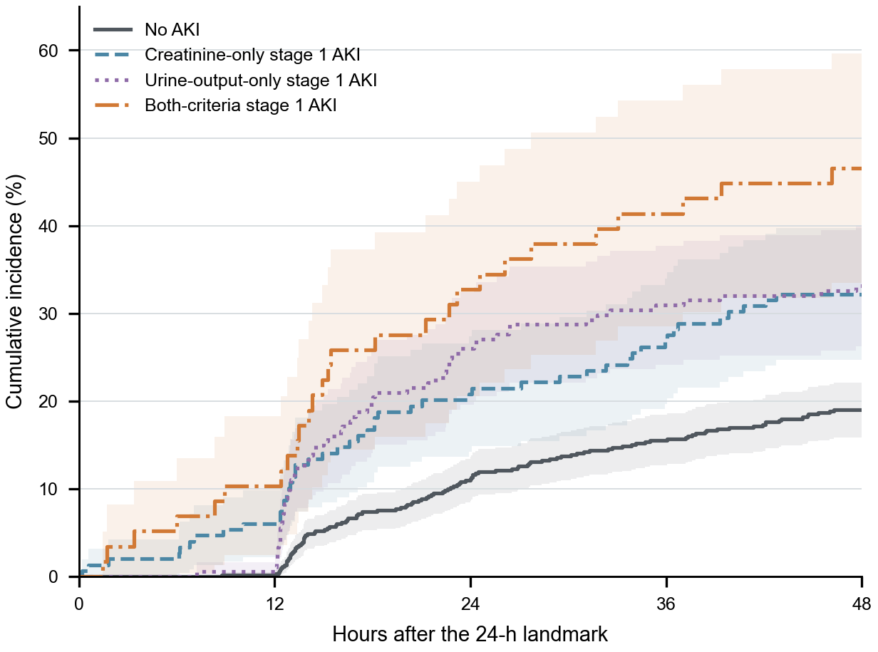
Aalen–Johansen cumulative incidence of stage 2/3 AKI or KRT from 24 to 72 h, with ICU death and live discharge as competing events. Full clinical phenotype names are used; bands show pointwise 95% confidence intervals.
Figure S2. Actual-weight sensitivity
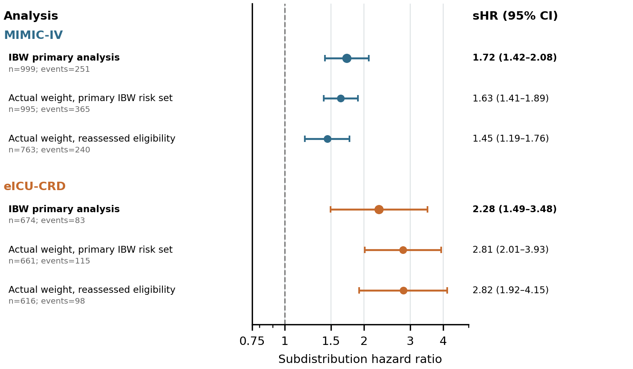
Adjusted sHRs per additional positive AKI criterion for the ideal-body-weight primary analysis, the actual-weight analysis retaining the primary risk set, and the actual-weight analysis after reassessing landmark eligibility.

STROBE checklist
Item | Topic | Recommendation | Location
1 | Title and abstract | Indicate the study design and provide an informative summary | Title; Abstract
2 | Background | Explain the scientific background and rationale | Background
3 | Objectives | State specific objectives and hypotheses | Background, final paragraph
4 | Study design | Present key elements early | Methods: Study design and data sources
5 | Setting | Describe setting, locations, dates, and data collection | Methods: Study design and data sources
6 | Participants | Eligibility and selection methods | Methods: Study population; Figure 1
7 | Variables | Define outcomes, exposures, predictors, confounders | Methods: Creatinine and urine-output criteria through Covariates
8 | Data sources/measurement | Give sources and comparability | Methods: Data sources; Creatinine and urine-output criteria
9 | Bias | Describe efforts to address bias | Methods: landmark design, competing events, sensitivities; Discussion: Limitations
10 | Study size | Explain study size | Methods: Study population; all eligible records used
11 | Quantitative variables | Explain handling of quantitative variables | Methods: Covariates; Statistical analysis
12 | Statistical methods | Describe confounding, missingness, sensitivities, and losses | Methods: Statistical analysis
13 | Participants | Report numbers at each stage and reasons | Results: Study cohorts; Figure 1
14 | Descriptive data | Report participant characteristics and missingness | Results: Baseline characteristics; Table 1; Table S5
15 | Outcome data | Report outcome events | Results: Kidney progression and cumulative incidence
16 | Main results | Give unadjusted and adjusted estimates with precision | Results; Tables 2 and S1–S4; Figures 2–3
17 | Other analyses | Report subgroup and sensitivity analyses | Results: Sensitivity and secondary analyses
18 | Key results | Summarise key results with reference to objectives | Discussion, first paragraph
19 | Limitations | Discuss limitations and direction/magnitude of bias | Discussion, limitations paragraph
20 | Interpretation | Provide cautious overall interpretation | Discussion; Conclusions
21 | Generalisability | Discuss external validity | Discussion, cross-database interpretation and limitations
22 | Funding | Give source and role of funders | Declarations: Funding

