Supplementary Materials:
Auditory Induced Vection and Motion Sickness and Their Effects on Electrocardiography
Carson C Smith, Kate Pellegrino & Sarah M Haigh

Section 1: Vection and Motion Sickness Across the Experiment
The protocol was designed so that the same condition was repeated 5 times over the course of a single block. This was due to the concern that it may take time for percepts of vection and motion sickness to accumulate. Because of the time the study took to complete, blocks could not be repeated. While the order of the blocks was randomized across participants, within participants, there may have been order effects that could have caused vection and/or motion sickness to accumulate over the course of the study regardless of the experimental condition. Therefore, we assessed if there were any effects of trial and block order on vection and motion sickness.
First, to assess if vection or motion sickness increased over the course of one block, trial order (Trials 1-5) was included as a fixed effect in separate logistic regression models for vection frequency and motion sickness frequency, and LMEs for vection intensity and motion sickness intensity.
Within block, there was a marginally significant increase in vection frequency with trial number (χ²(4)=9.25, p=.055), and increased vection intensity over trials (F(4,523.49)=2.56, p=.038), particularly between trial 3 and 5 (p=.042). Motion sickness, however, did not change in number of experiences reported (χ²(4)=1.13, p=.889) or in its intensity (F(1,100.95)=1.06, p=.379; see Fig S1).
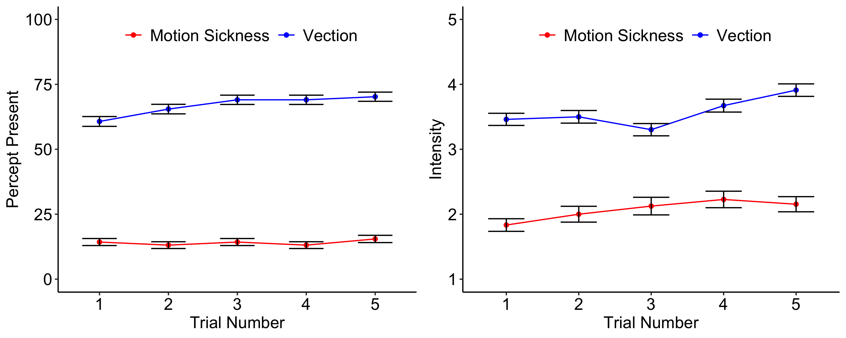
Fig S1 Within each condition vection frequency and intensity increased across the trials while motion sickness remained consistent. Vection (blue) and motion sickness (red) frequency (left) and intensity (right) shown over the five trials collapsed across conditions. Error bars show one standard error.
Across blocks, there was no significant effect on vection frequency (χ²(3)=2.32, p=.509), but motion sickness frequency did increase across blocks (χ²(3)=19.81, p<.001) due to frequency of motion sickness occurring significantly increasing after the first block (ps<.011).
Vection intensity also did not increase across blocks (F(3,106.25)=1.81, p=.151) and neither did motion sickness intensity (F(3,20.43)=1.40, p=.271; see Fig S2).
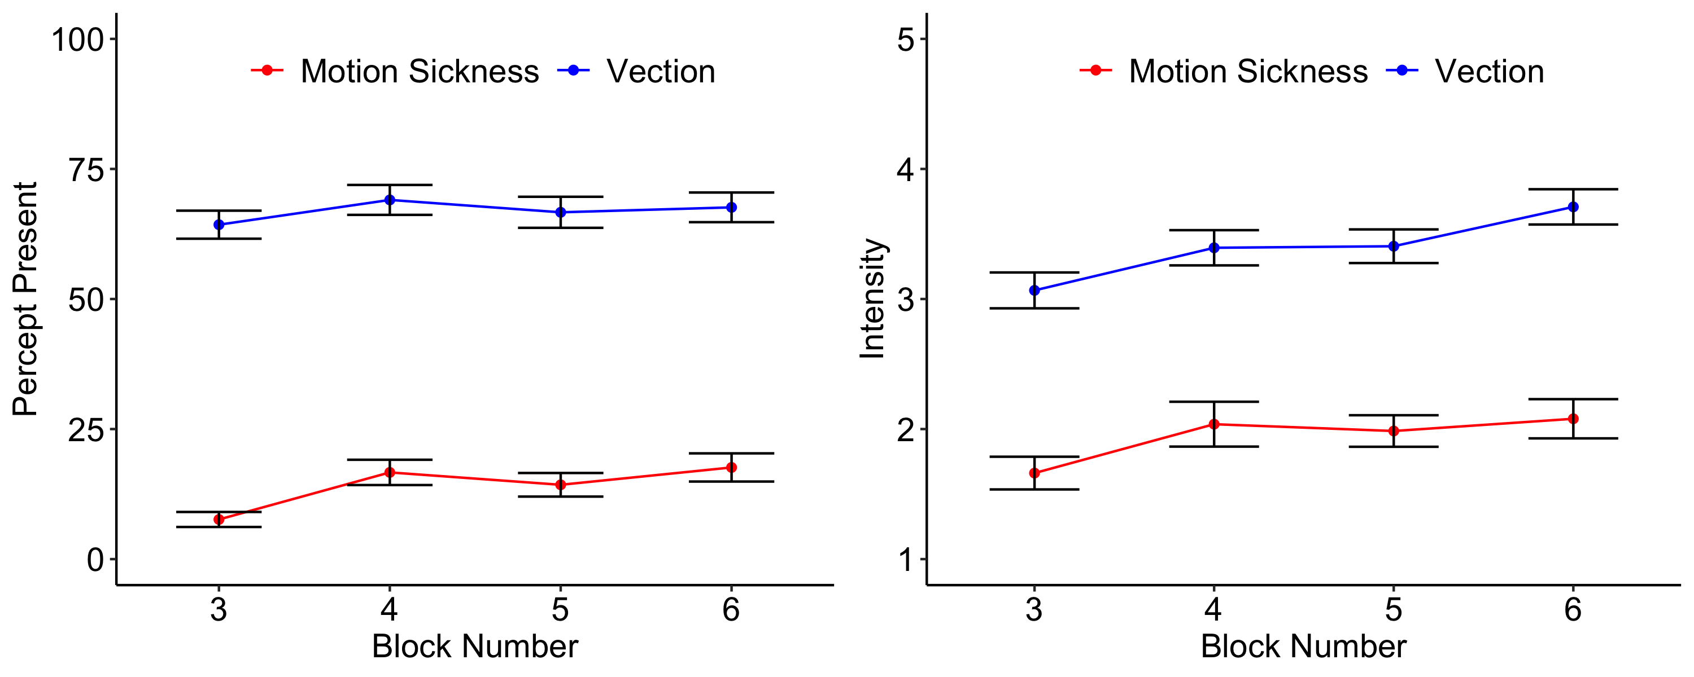
Fig S2 Across the blocks of conditions, vection frequency remained stable while motion sickness increased. However, there was no significant change in intensity over the blocks. Vection (blue) and motion sickness (red) frequency (left) and intensity (right) shown over the four blocks collapsed across trials. Error bars show one standard error.
Together, this suggests that the frequency of experiencing vection and the intensity of the percept accumulated over trials, but not over the course of the study. Interestingly, only the frequency of motion sickness increased over the course of the study (blocks), but not within a block, dissociating the percepts of vection and motion sickness.

Section 2: Perceived Vection Direction as a Function Vibrations
The presence of vibrations provided stimulation independent of our auditory manipulation. We examined if the presence of vibrations influenced the vection percepts by providing direction cues themselves. Chi-square analyses were used to first determine if the distribution of direction reports differed between vibration and no-vibration conditions and, second, to assess the distribution of direction responses. Analyses were restricted to trials that contained reports of vection in one of the seven possible directions (forward, backward, left, right, up, down, and other). Note, that our direction data do not contain the resolution to differentiate between percepts of moving vs falling in a specific direction such as falling forward and moving forward. Independent tests were conducted on conditions that contained vibrations and conditions without vibrations, regardless of tone sweep speed.
The distribution of reported vection direction did not significantly differ between conditions with vibrations and conditions without vibrations (χ²(6)=6.06, p=.416), suggesting that the presence of vibration did not influence the direction of the perceived motion.
We further examined directions to assess whether reports were non-uniform. Direction percepts were non-uniform in both the no vibration conditions (χ²(6)=171.74, p<.001) and the vibration conditions (χ²(6)=228.29, p<.001 see Fig S3), suggesting that reports were biased towards certain motion directions. In the absence of vibrations, downward motion was reported most often (33.5% of trials), followed by forward (26.3%) and backward (19.9%) motion. Left (9.0%), other (6.8%), right (3.8%), and up (0.8%) motion directions were reported less frequently. A similar pattern across direction reports was observed during vibrations, with downward motion reported most often (34.7%), followed by forward (27.6%) and backward (21.8%) motion. Left (8.5%), other (5.1%), up (1.4%), and right (1.0%) motion directions were again less common.

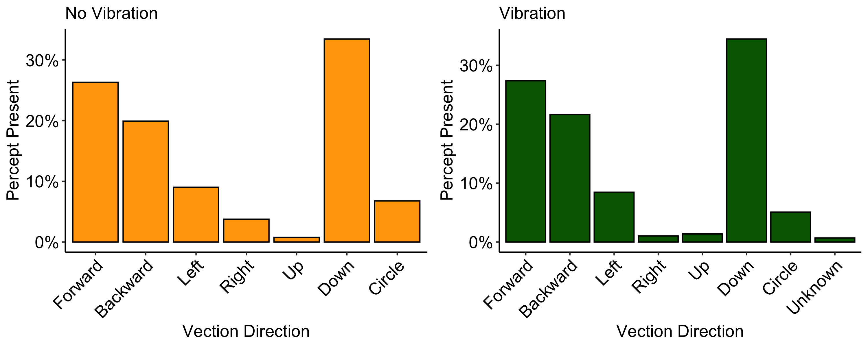
Fig S3 Reported vection direction in the absence of neck vibrations (left) and during neck vibrations (right).
There was a significant tendency to report vection as a falling percept during both the presence and absence of vibrations.

Section 3: Effects of Experimental Conditions on Electrocardiography
The average response from the 5 trials within each block was calculated for each heart response metric and used for analysis. To assess the effect of auditory tone sweeps on ECG measures, we ran separate LMEs on each of the ECG metrics where tone speed (baseline, slow, fast) and vibration (absent, present) were included as main effects. The effect of the auditory tones significantly increased heart rate (F(2,190)=13.60, p<.001) compared to baseline, but there was no significant effect of the vibration (F(1,190)=3.35, p=.069) and no interaction (F(2,190)=0.59, p=.556). pNN50 was significantly lower when the tones were presented (F(2,190)=11.13, p<.001) compared to baseline, but there was no effect of the vibration (F(1,190)=1.25, p=.265) or an interaction (F(2,190)=0.14, p=.868). The same was the case for increased LF/HF ratio with tones compared to baseline (F(2,190)=5.63, p<.001), but no effect of vibration (F(1,190)=1.22, p=.270) or interaction F(2,190)=1.19, p=.308). All post-hoc pairwise comparisons for the effect of tone speed on ECG measures were not significant (Fig S4).
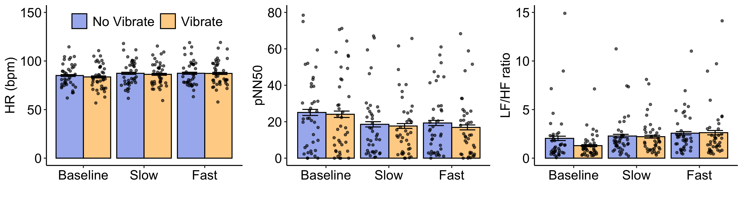
Fig S4 ECG metrics during the baseline, slow sweep, and fast sweep presentations in the absence of neck vibrations (blue) and during neck vibrations (orange). Tone sweep speed significantly increased (A) heart rate (beats per minute), decreased the pNN50 measure of heart rate variability, and increased the low frequency/high frequency ratio measure of heart rate variability. Error bars show one standard error.

