Additional file 1
Supplementary methods, tables, and figures
Sonographic fatty liver and current gallstones among normal-weight adults at a Chinese health-check center: a cross-sectional study of 162,312 participants

Supplementary methods

Operational ultrasound coding
Reports were first required to have ultrasound-specific language or compatible hepatobiliary project context. Organ sections ended at the next major-organ heading. Positive, negative, uncertain, postoperative, and quality states were retained separately before examination-level aggregation. A report describing only a focal hepatic lesion did not establish that liver parenchyma was assessed for steatosis. A nonvisualized gallbladder was not treated as confirmed cholecystectomy and was not eligible for a current-gallstone negative label. Gallbladder observability was established only from the organ-local gallbladder section, so renal or other-organ terms such as cyst-wall descriptions could not make a nonvisualized gallbladder appear assessable. Historical or postoperative stone terms alone did not establish current gallstones, and tentative wording was retained as uncertain. Quantitative field labels such as B-mode Ratio or an ultrasound-guided attenuation parameter (UGAP) 'fatty liver index' were not interpreted as diagnoses without narrative or characteristic parenchymal evidence.
For examinations with more than one eligible report, liver and gallbladder evidence were aggregated independently. A positive-negative contradiction for the same label, or a post-cholecystectomy statement combined with current gallbladder evidence, produced an unclassifiable conflict. In the absence of conflict, definite positive evidence took precedence over tentative wording, and tentative wording precluded a negative label. The full source distribution of report counts and conflicts was audited, and a sensitivity analysis retained only index examinations with one eligible report.

Data cleaning and physiologic ranges
When a source cell contained multiple pipe-delimited numeric results, the median was used. Values outside the following inclusive physiologic ranges were set to missing: age 18-100 years; height 100-230 cm; weight 25-250 kg; reported or derived BMI 10-80 kg/m²; systolic blood pressure 50-260 mmHg; diastolic blood pressure 30-160 mmHg; HbA1c 3-20%; triglycerides 0.05-100 mmol/L; total cholesterol 0.5-30 mmol/L; HDL-C 0.1-10 mmol/L; LDL-C 0.1-20 mmol/L; uric acid 30-1,500 μmol/L; creatinine 5-2,000 μmol/L; ALT, AST, GGT, and ALP 0-5,000 U/L; total bile acid 0-1,000 μmol/L; white blood cell count 0.5-100 ×10⁹/L; neutrophil percentage 0-100%; absolute neutrophil count 0-100 ×10⁹/L; platelet count 1-2,000 ×10⁹/L; and CRP 0-500 mg/L. Boundary values were retained. These bounds were data-cleaning safeguards rather than clinical reference ranges or diagnostic thresholds.

Index-examination sensitivity
The primary pseudo-random rank was a deterministic Secure Hash Algorithm 256-bit (SHA-256) hash of the privacy-preserving person key and health-check identifier. Ten alternative SHA-256 ranks changed the selected examination while preserving one examination per linked adult. The most-complete sensitivity selected the examination with the greatest count of available metabolic measurements, with the fixed pseudo-random rank breaking ties.
Supplementary Table S1. Operational ultrasound label definitions
State | Required evidence | Conservative safeguard
Assessable liver | Parenchymal echo description, explicit fatty-liver diagnosis, or explicit normal liver parenchyma | Focal lesion alone did not qualify
Fatty liver positive | Non-negated narrative diagnosis or characteristic diffuse/fine dense increased echo pattern | Measurement-field names such as B-mode Ratio/UGAP 'fatty liver index' alone did not qualify
Observable gallbladder | Clear organ-local gallbladder morphology, wall, lumen, or bile description | Postoperative, nonvisualized, and poor-quality negative studies excluded
Current gallstones positive | Current gallbladder-local stone term, mobile or shadowing echogenic focus, or wall-echo-shadow (WES)/packed-stone pattern | Historical/postoperative terms alone and renal or bile-duct stones excluded
Uncertain | Tentative suspected stone, sludge, debris, or conflicting positive and negative reports | Not forced to positive or negative
Negative | Target organ assessable with no positive pattern | Negation and artifact rules applied

WES, wall-echo-shadow.
Supplementary Table S2. Cohort construction and privacy-preserving identity linkage
Stage | N | Definition
Panel A - final analytic cohort
Integrated wide health-check records | 1720871 | Examination-level starting database
Eligible organ-local ultrasound reports | 780622 | Examinations
Valid adult examinations linked to identity | 776586 | Examinations
Unique identity-linked adults | 374443 | One index examination selected
Adults with repeated eligible examinations | 163785 | Maximum 18 examinations
Assessable liver and active gallbladder | 363160 | After one or more ultrasound exclusions
Complete BMI | 300017 | Full-BMI context population
Chinese normal weight | 162312 | Primary population
Panel B - source identity-linkage quality |  | Before final organ-local report matching
Candidate examinations entering linkage audit | 782208 | Source linkage denominator
Validated national identity | 689503 | Examinations assigned by this route
Unique demographic group to validated identity | 36768 | Examinations assigned by this route
Name-sex-date-of-birth fallback | 55901 | Examinations assigned by this route
Ambiguous missing identity retained separately | 36 | Examinations assigned by this route
Checksum-valid identity with birth-date mismatch | 4854 | Not accepted as validated identity
Checksum-valid identity with sex mismatch | 217 | Not accepted as validated identity
Demographic groups containing multiple validated identities | 331 | Missing-identity records were not force-linked
Validated identities spanning multiple demographic groups | 1767 | Groups joined only through validated identity
Conservative person groups before final label matching | 375040 | Privacy-preserving linkage output

The source linkage audit preceded final organ-local report matching. Its four mutually exclusive routing counts sum to 782208 candidate examinations; the final report-linked cohort contained 776586 examinations and 374443 adults. Counts describe linkage quality checks, not external identity ground-truth validation. Demographic fallback may leave residual under- or over-linkage. No plaintext identity number was written to an analytic output. BMI, body mass index.
Supplementary Table S3. Missingness among normal-weight adults
Variable | Available, n | Missing, n | Missing, %
Height | 162312 | 0 | 0.0%
Weight | 162312 | 0 | 0.0%
BMI | 162312 | 0 | 0.0%
Systolic blood pressure | 162219 | 93 | 0.1%
Diastolic blood pressure | 162233 | 79 | <0.1%
HbA1c | 49950 | 112362 | 69.2%
Triglycerides | 61806 | 100506 | 61.9%
Total cholesterol | 45667 | 116645 | 71.9%
HDL-C | 61805 | 100507 | 61.9%
LDL-C | 61806 | 100506 | 61.9%
Uric acid | 63775 | 98537 | 60.7%
Creatinine | 67969 | 94343 | 58.1%
ALT | 67968 | 94344 | 58.1%
AST | 63722 | 98590 | 60.7%
GGT | 63777 | 98535 | 60.7%
ALP | 63778 | 98534 | 60.7%
Total bile acid | 61237 | 101075 | 62.3%
White blood cell count | 49304 | 113008 | 69.6%
Neutrophil percentage | 49280 | 113032 | 69.6%
Neutrophil count | 49280 | 113032 | 69.6%
Platelet count | 49284 | 113028 | 69.6%
CRP | 63733 | 98579 | 60.7%

The primary model used age, sex, BMI, fatty liver, and gallstones, all complete by design in this population. Laboratory missingness reflected variation in health-check packages. ALP, alkaline phosphatase; ALT, alanine aminotransferase; AST, aspartate aminotransferase; BMI, body mass index; CRP, C-reactive protein; GGT, gamma-glutamyl transferase; HDL-C, high-density lipoprotein cholesterol; LDL-C, low-density lipoprotein cholesterol.
Supplementary Table S4. Standardized gallstone prevalence among normal-weight adults
Contrast | Estimate | 95% CI
No fatty liver | 3.93% | 3.82%-4.04%
Fatty liver | 4.70% | 4.50%-4.91%
Absolute difference | 0.77 percentage points | 0.54-1.01
Prevalence ratio | 1.20 | See Table 2 for model-based CI

Model-based marginal predictions standardized to the observed age, sex, and BMI distribution of 162312 normal-weight adults. CI, confidence interval.
Supplementary Table S5. Supporting complete-case models among normal-weight adults
Complete-case sample | Adjustment | N | Gallstones, n | PR (95% CI) | P value
Metabolic complete cases | Age, sex, and BMI adjusted | 38407 | 1079 | 1.38 (1.19-1.61) | <0.001
Metabolic complete cases | + Blood pressure, HbA1c, TG, HDL-C, and uric acid | 38407 | 1079 | 1.41 (1.20-1.65) | <0.001
CRP complete cases | Age, sex, and BMI adjusted | 37071 | 1040 | 1.38 (1.18-1.61) | <0.001
CRP complete cases | + Metabolic indicators | 37071 | 1040 | 1.42 (1.20-1.67) | <0.001
CRP complete cases | + Metabolic indicators and CRP | 37071 | 1040 | 1.39 (1.18-1.64) | <0.001

Metabolic indicators were systolic and diastolic blood pressure, HbA1c, log triglycerides, HDL-C, and uric acid. CRP entered as log(CRP+0.1). Comparisons between the primary-cohort estimate and these selected complete-case estimates should not be interpreted as mediation or attenuation. Nested rows within each named complete-case sample use identical observations; the metabolic and CRP complete-case samples nevertheless differ from the primary cohort and from one another. CI, confidence interval; CRP, C-reactive protein; PR, prevalence ratio.
Supplementary Table S6. Normal-weight sensitivity analyses
Analysis | N | Gallstones, n | Fatty liver, n | Adjusted PR (95% CI) | P value
Primary strict-label deterministic pseudo-random index | 162312 | 6702 | 30458 | 1.20 (1.13-1.26) | <0.001
Most-complete examination index | 167576 | 7105 | 31746 | 1.19 (1.13-1.25) | <0.001
Participants with one eligible examination | 91747 | 3421 | 14908 | 1.15 (1.06-1.24) | <0.001
One extracted ultrasound report | 107913 | 3988 | 23102 | 1.24 (1.16-1.33) | <0.001
Excluding reports flagged as globally poor quality | 162111 | 6679 | 30403 | 1.20 (1.14-1.26) | <0.001
Relaxed liver-assessability labels with current gallbladder rules | 162800 | 6740 | 30459 | 1.20 (1.14-1.26) | <0.001
Reported BMI only | 63200 | 2555 | 15164 | 1.20 (1.10-1.30) | <0.001
BMI recalculated from measured height and weight | 162765 | 6729 | 30800 | 1.20 (1.14-1.26) | <0.001
Asian lean definition (BMI 18.5 to <23.0 kg/m²) | 126747 | 4745 | 17951 | 1.23 (1.15-1.31) | <0.001
WHO normal-weight definition (BMI 18.5 to <25.0 kg/m²) | 194475 | 8510 | 44965 | 1.20 (1.14-1.25) | <0.001

All models adjusted for nonlinear age, sex, and continuous BMI within the analysis-specific normal-weight range. CI, confidence interval; PR, prevalence ratio.
Supplementary Table S7. Alternative pseudo-random index-examination selections
Replicate | N | Gallstones, n | Fatty liver, n | Adjusted PR (95% CI) | P value
1 | 162330 | 6714 | 30388 | 1.179 (1.118-1.244) | <0.001
2 | 162206 | 6662 | 30394 | 1.172 (1.111-1.237) | <0.001
3 | 162215 | 6595 | 30358 | 1.189 (1.126-1.255) | <0.001
4 | 162107 | 6673 | 30300 | 1.192 (1.130-1.258) | <0.001
5 | 162075 | 6662 | 30197 | 1.158 (1.097-1.222) | <0.001
6 | 162318 | 6667 | 30394 | 1.183 (1.121-1.248) | <0.001
7 | 162191 | 6625 | 30227 | 1.148 (1.087-1.212) | <0.001
8 | 162268 | 6652 | 30406 | 1.197 (1.135-1.263) | <0.001
9 | 162208 | 6670 | 30460 | 1.182 (1.120-1.246) | <0.001
10 | 162215 | 6657 | 30413 | 1.161 (1.101-1.226) | <0.001

Across ten alternative rankings, the mean PR was 1.176 and the range was 1.148-1.197. Models adjusted for nonlinear age, sex, and continuous within-range BMI. CI, confidence interval; PR, prevalence ratio.
Supplementary Table S8. Full-BMI contextual association models
Model | Adjustment | N | Gallstones, n | PR (95% CI) | P value
Model 0 | Crude | 363160 | 17735 | 1.70 (1.65-1.75) | <0.001
Model 1 | Age and sex adjusted | 363160 | 17735 | 1.38 (1.34-1.42) | <0.001
Model 2 | Age, sex, and nonlinear BMI adjusted | 300017 | 14638 | 1.14 (1.10-1.18) | <0.001

The full-BMI context population included all assessable adults with BMI. BMI was modeled with a four-degree-of-freedom B-spline in Model 2. BMI, body mass index; CI, confidence interval; PR, prevalence ratio.
Supplementary Table S9. Full-BMI standardization and interaction context
Analysis | Estimate | 95% CI or P value
Standardized prevalence, no fatty liver | 4.60% | 4.50%-4.70%
Standardized prevalence, fatty liver | 5.24% | 5.11%-5.37%
Standardized absolute difference | 0.64 percentage points | 0.47-0.82
Full-distribution BMI interaction | Chi-square 28.39, df=4 | <0.001
BMI 18.5 to <28 interaction | Chi-square 7.60, df=4 | 0.108

Standardized prevalence used the full-BMI Model 2. Interaction tests were joint Wald tests for fatty-liver-by-BMI spline terms. BMI, body mass index; CI, confidence interval.
Supplementary Table S10. Selection and missingness weighting analyses
Domain | Analysis | Weighting | N | Gallstones, n | Adjusted PR (95% CI)
BMI availability | Primary full-BMI model | Unweighted | 300017 | 14638 | 1.14 (1.10-1.18)
BMI availability | BMI-observation IPW | Trimmed at 1st/99th percentiles | 300017 | 14638 | 1.14 (1.10-1.18)
Ultrasound assessability | Primary normal-weight model | Unweighted | 162312 | 6702 | 1.197 (1.135-1.262)
Ultrasound assessability | Assessability IPW | Stabilized, untruncated | 162312 | 6702 | 1.196 (1.134-1.261)
Ultrasound assessability | Assessability IPW | Stabilized, trimmed at 1st/99th percentiles | 162312 | 6702 | 1.196 (1.134-1.261)

The BMI-observation model included fatty liver, gallstones, nonlinear age, and sex; mean modeled observation probability was 0.828. For ultrasound assessability, 162312 of 164579 normal-weight non-post-cholecystectomy adults were selected, leaving 2267 unselected. Selected versus unselected adults had mean age 43.51 versus 58.45 years, mean BMI 21.56 versus 21.78 kg/m², and 44.81% versus 41.95% male sex. The assessability model included nonlinear age, sex, and BMI; stabilized weights ranged from 0.989 to 1.157, and the effective sample size was 162279. Weighting assumes observation conditional on modeled covariates and cannot remove selection through unmeasured health-check-package factors. BMI, body mass index; CI, confidence interval; IPW, inverse-probability weighting; PR, prevalence ratio.
Supplementary Table S11. Evidence basis and examination-level aggregation audit for final ultrasound labels
Panel / population | Evidence basis or audit item | n | Denominator, n | %
A. Sonographic fatty liver | Explicit diagnostic wording | 2 | 363160 | 0.001%
A. Sonographic fatty liver | Characteristic parenchymal echo pattern | 124641 | 363160 | 34.321%
A. Current gallstones | Explicit non-negated stone term | 2 | 363160 | 0.001%
A. Current gallstones | Shadowing or mobile echogenic focus | 16936 | 363160 | 4.664%
A. Current gallstones | WES sign or packed-stone pattern | 797 | 363160 | 0.219%
A. Ultrasound quality | At least one report flagged as globally poor quality | 880 | 374443 | 0.235%
B. Source examinations | One eligible report | 567603 | 780622 | 72.712%
B. Source examinations | At least two eligible reports | 213019 | 780622 | 27.288%
B. Source multi-report examinations | Conflicting fatty-liver evidence | 807 | 213019 | 0.379%
B. Source multi-report examinations | Conflicting gallstone evidence | 148 | 213019 | 0.069%
B. Primary normal-weight cohort | One eligible report | 107913 | 162312 | 66.485%
B. Primary normal-weight cohort | Two or three eligible reports | 54399 | 162312 | 33.515%
Panel A counts participants with at least one retained report supporting each evidence basis in the selected index examination. Fatty-liver evidence categories accounted for all 124643 positive labels and gallstone evidence categories accounted for all 17735 positive labels. Denominators are active-gallbladder adults (n=363160), except ultrasound quality, which uses all index-selected adults (n=374443). Panel B audits report multiplicity and conflicts. The 780622 source examinations represented 997996 eligible report instances; conflict percentages use the 213019 multi-report examinations as denominator. Conflicts were set to unclassifiable before the active cohort was formed. The primary normal-weight report-count rows use n=162312. WES, wall-echo-shadow.
Supplementary Table S12. CRP source-quality audit
Quality-control item | Count
Selected examinations with numeric CRP source | 159752
Source unit mg/L | 159752
High-sensitivity CRP assay | 157571
Conventional CRP assay | 2181
Invalid analyte name | 0
Incompatible source unit | 0

The union of primary and most-complete selected examinations was audited. No selected index examination used the historical false-positive panel row identified during source review. CRP, C-reactive protein.
Supplementary Table S13. Model-form robustness among normal-weight adults
Specification | Effect | PR (95% CI) | Difference, percentage points (95% CI)
Primary | Adjusted PR | 1.197 (1.135-1.262) | 0.77 (0.54-1.01)
Linear age and linear BMI | Adjusted PR | 1.216 (1.154-1.282) | 0.85 (0.61-1.09)
Age spline df=3 and linear BMI | Adjusted PR | 1.197 (1.135-1.262) | 0.77 (0.53-1.01)
Age spline df=4 and linear BMI | Adjusted PR | 1.195 (1.134-1.261) | 0.77 (0.53-1.01)
Age spline df=6 and linear BMI | Adjusted PR | 1.196 (1.135-1.261) | 0.77 (0.53-1.01)
Age spline df=5 and quadratic BMI | Adjusted PR | 1.196 (1.134-1.261) | 0.77 (0.53-1.01)
Age spline df=5 and BMI spline df=3 | Adjusted PR | 1.197 (1.135-1.262) | 0.77 (0.54-1.01)
Age spline df=5 and BMI spline df=4 | Adjusted PR | 1.197 (1.135-1.262) | 0.77 (0.53-1.01)
Two-year age and 0.5-BMI categories | Adjusted PR | 1.196 (1.134-1.261) | 0.77 (0.53-1.01)
Log-binomial | Adjusted PR | 1.194 (1.133-1.259) | 0.76 (0.53-1.00)
Logistic standardization | Standardized PR | 1.200 (1.137-1.266) | 0.78 (0.54-1.03)
Post hoc checks: rows 1-9 are sex-adjusted modified Poisson models with the heteroskedasticity-consistent HC0 sandwich variance estimator, varying age and BMI functions; log-binomial used the primary functions, and logistic standardization reports a marginal PR. The primary design matrix was full rank with condition number 7.43, no predicted probability exceeded 1, and the within-normal-BMI interaction was P=0.422. BMI, body mass index; CI, confidence interval; PR, prevalence ratio.
Supplementary Table S14. Sensitivity analysis including post-cholecystectomy status
Outcome definition | N | Events, n | Post-cholecystectomy, n | Observed prevalence, no fatty liver / fatty liver | Adjusted PR (95% CI)
Current gallstones | 162312 | 6702 | 0 | 3.58% / 6.49% | 1.20 (1.13-1.26)
Current gallstones or unconflicted explicit post-cholecystectomy status | 164229 | 8619 | 1917 | 4.43% / 8.72% | 1.30 (1.24-1.36)
The expanded analysis added only records whose final exclusion state was an explicit, unconflicted post-cholecystectomy statement. Two records with conflicting postoperative and current-gallbladder evidence remained excluded. Models adjusted for nonlinear age, sex, and continuous BMI within 18.5 to <24.0 kg/m². Post-cholecystectomy status was not interpreted as prior gallstone surgery because surgical indication was unavailable. BMI, body mass index; CI, confidence interval; PR, prevalence ratio.

Supplementary figures
Supplementary Figure S1. Fatty liver and gallstones across body mass index.
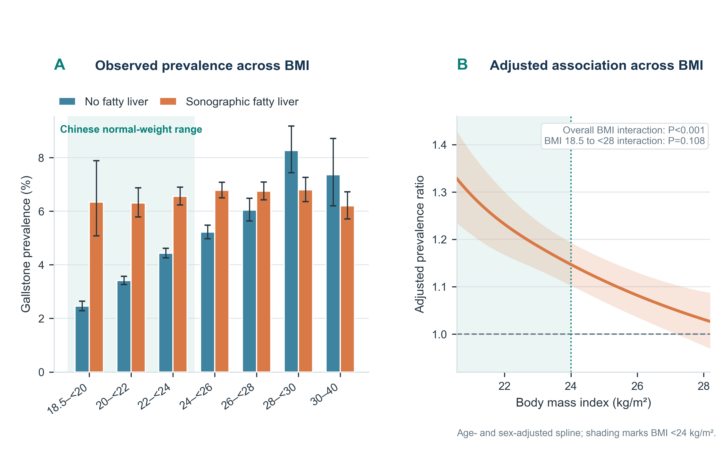
Panel A shows observed gallstone prevalence with Wilson 95% confidence intervals across BMI bands. Panel B shows the age- and sex-adjusted prevalence ratio comparing fatty liver with no fatty liver from a fatty-liver-by-BMI spline model, displayed only over the overlapping central BMI support of both exposure groups. The vertical line marks BMI 24.0 kg/m². The overall interaction used the full BMI-complete sample; the BMI 18.5 to <28.0 test restricted the sample to Chinese nonobese adults. Tail patterns are descriptive and should not be interpreted as a protective effect of obesity.
Supplementary Figure S2. Alternative pseudo-random index selections.
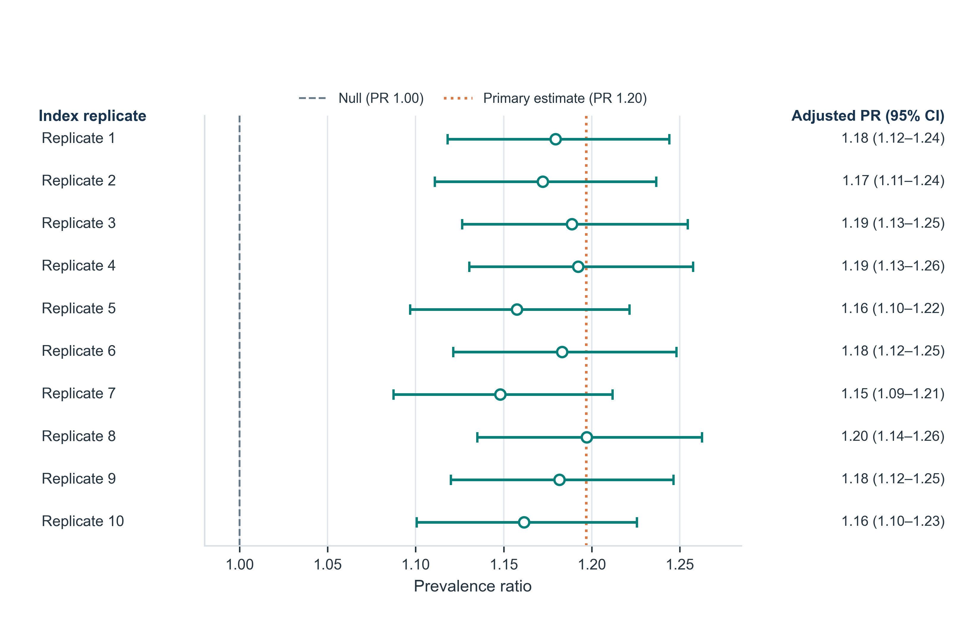
Adjusted prevalence ratios from ten deterministic pseudo-random index-examination rankings. Every analysis retained one examination per linked adult and adjusted for nonlinear age, sex, and continuous within-range BMI. The dashed line marks the null value of 1.0; the dotted orange line marks the primary index estimate.
Supplementary Figure S3. Normal-weight sensitivity analyses.
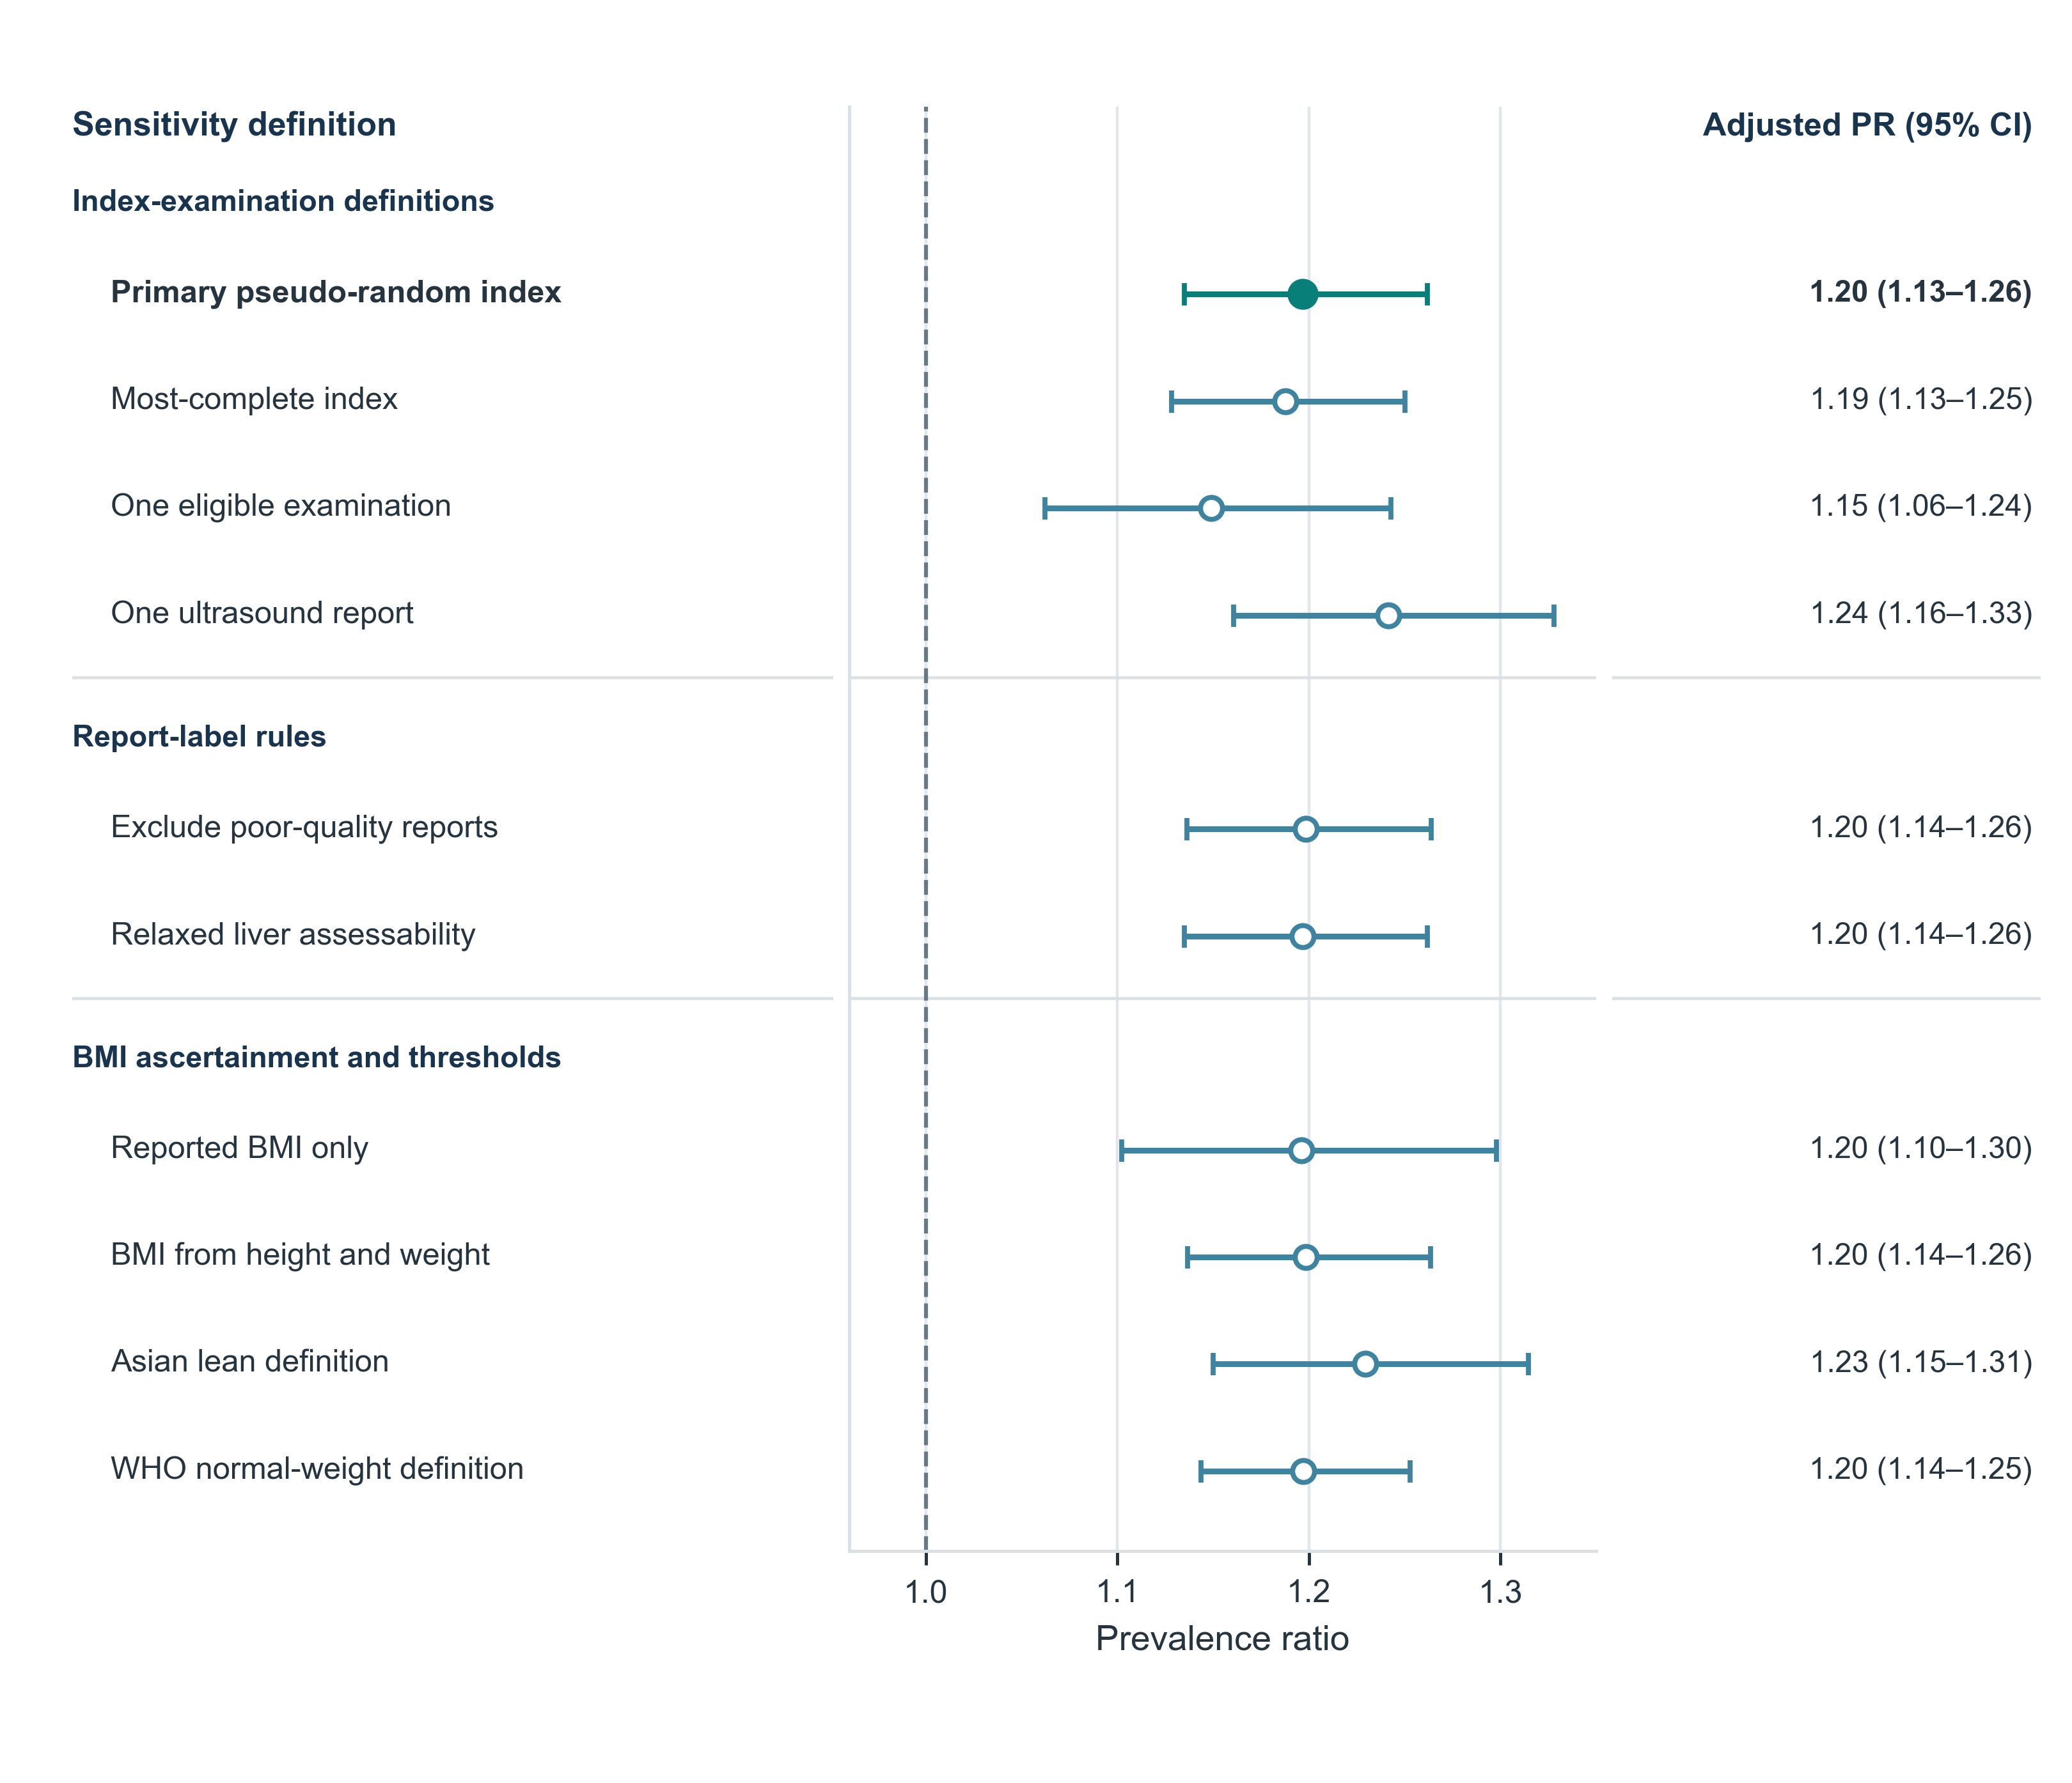
Adjusted prevalence ratios for fatty liver versus no fatty liver across alternative examination selections, ultrasound restrictions, BMI sources, and normal-weight definitions. Models adjusted for nonlinear age, sex, and continuous BMI. The vertical line marks the null value of 1.0.

