Title
Vestibulo-sympathetic Reflex and Pupillary Responses Elicited by Vertical Semicircular Canal Stimulation

Author
Fumihiro Mochizuki, Yoshiyuki Sasano, Alexander Kiderman, Bernat Miro, Madison Hawthorne, Michael Hoffer, and Erin Williams

Supplementary Tables & Figures
Plane | Rotation | Nystagmus | Excited Semicircular Canal
Horizontal | Per (CW) | Right beating | Right Horizontal
Horizontal | Post (CW) | Left beating | Left Horizontal
Horizontal | Per (CCW) | Left beating | Left Horizontal
Horizontal | Post (CCW) | Right beating | Right Horizontal
RALP | Per (CW) | Up beating, torsional (CCW) | Left Posterior
RALP | Post (CW) | Down beating, torsional (CW) | Right Anterior
RALP | Per (CCW) | Down beating, torsional (CW) | Right Anterior
RALP | Post (CCW) | Up beating, torsional (CCW) | Left Posterior
LARP | Per (CW) | Down beating, torsional (CCW) | Left Anterior
LARP | Post (CW) | Up beating, torsional (CW) | Right Posterior
LARP | Per (CCW) | Up beating, torsional (CW) | Right Posterior
LARP | Post (CCW) | Down beating, torsional (CCW) | Left Anterior

Supplementary Table S1. Induced nystagmus direction and primarily excited semicircular canal for each velocity step test (VST) condition. Nystagmus direction and the excited canal are shown for per-rotation (during constant-velocity chair rotation) and post-rotation (after abrupt deceleration) phases in the horizontal, LARP, and RALP canal planes. Excited canals were determined by Ewald’s first law based on the direction of endolymph flow relative to each canal’s ampulla. CW = clockwise; CCW = counterclockwise; LARP = left anterior-right posterior; RALP = right anterior-left posterior.

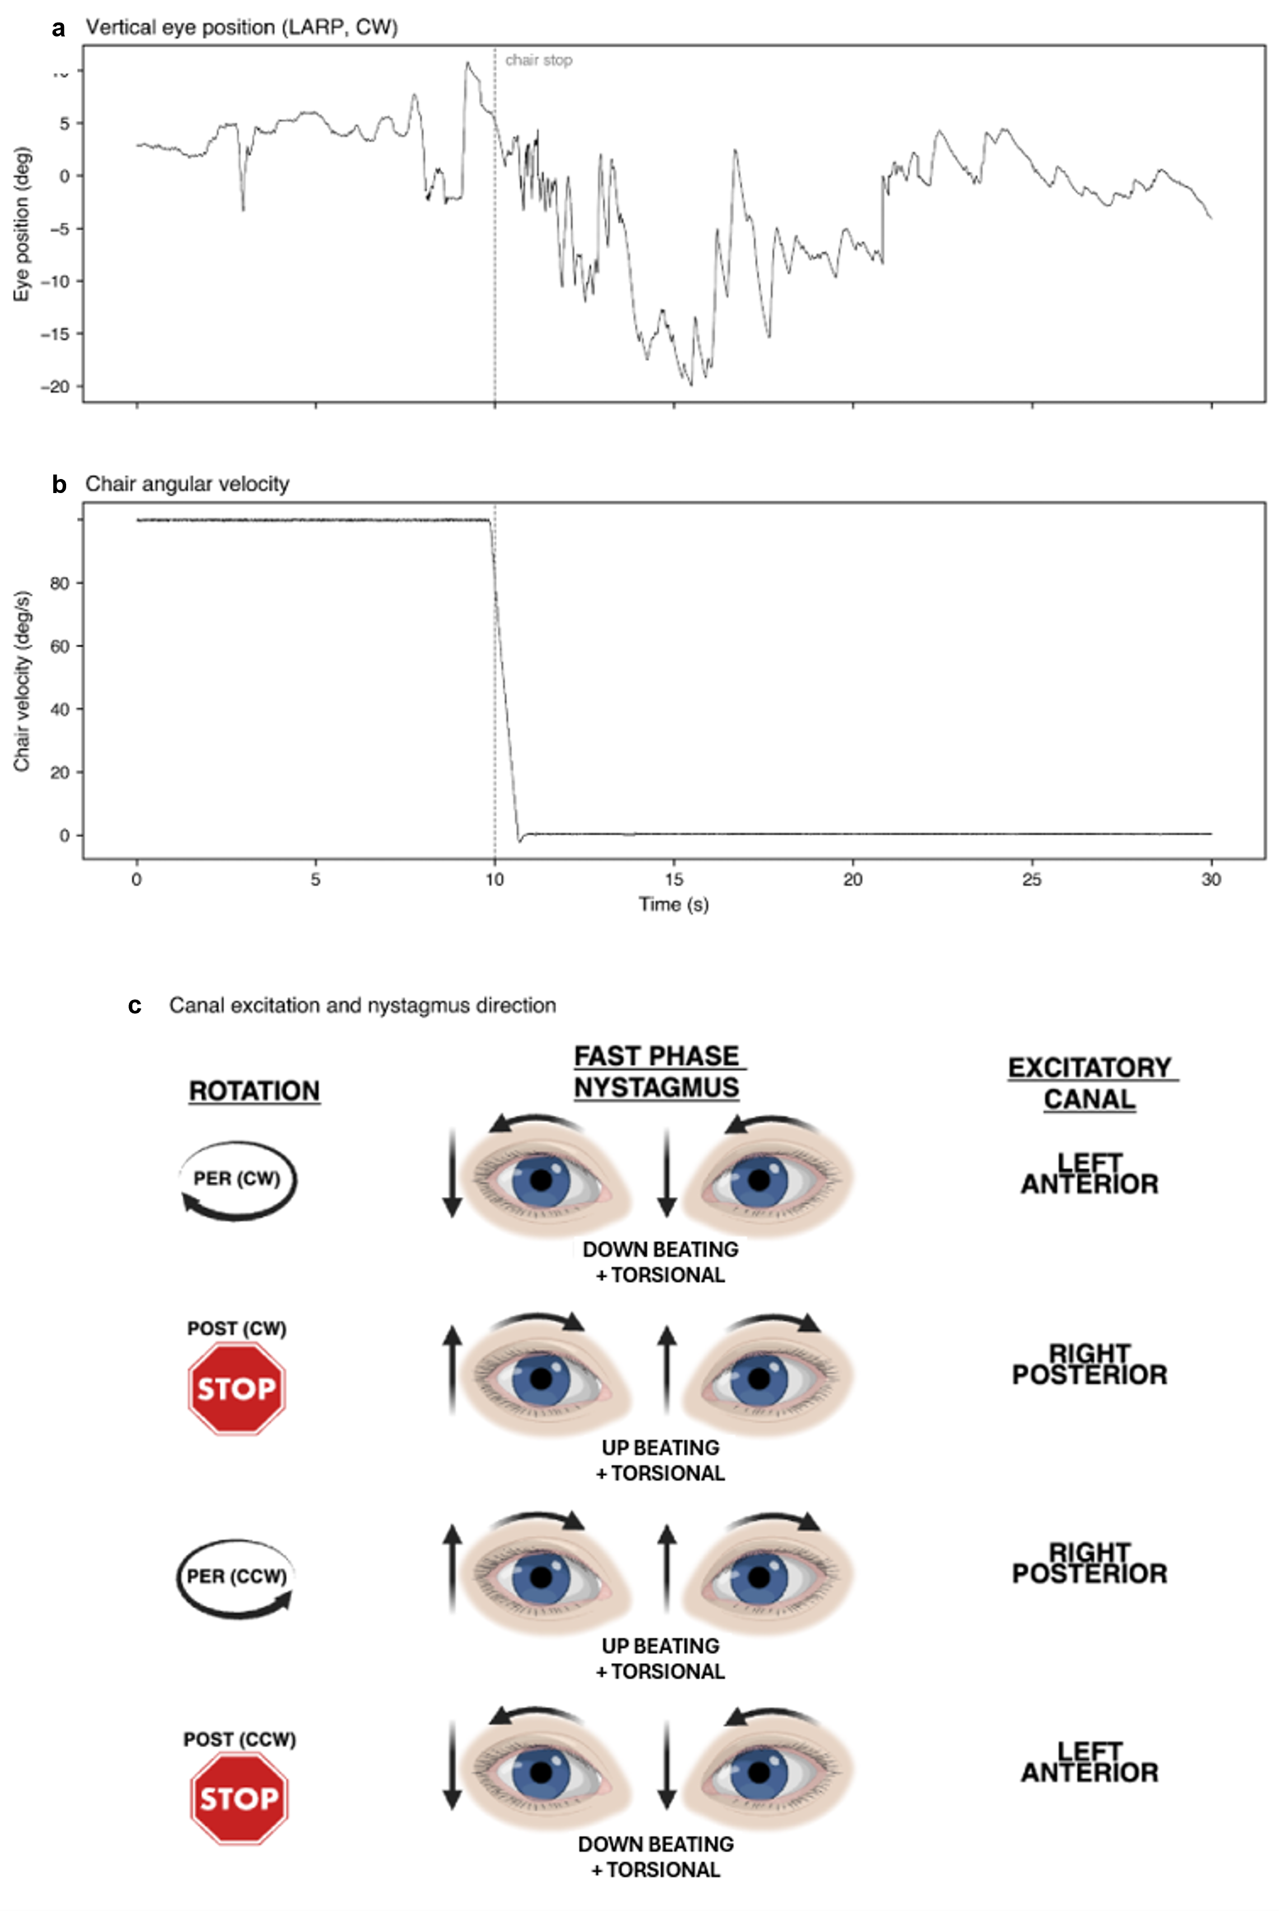
Supplementary Figure S1. Eye position and rotational chair velocity during and after clockwise (CW) rotation with the subject in the left anterior-right posterior (LARP) position during the vertical velocity step test (vVST).
(a) Vertical eye position (degrees; positive values = upward) over the course of the vVST stimulus, showing per-rotation nystagmus during constant-velocity rotation and post-rotation nystagmus following abrupt deceleration. (b) Chair angular velocity (degrees/second) during the per-rotation and post-rotation phases. (c) Canal excitation and nystagmus direction for all four vVST conditions in the LARP plane: per-rotation CW (left anterior canal excited, down-beating + torsional nystagmus), post-rotation CW (right posterior canal excited, up-beating + torsional), per-rotation CCW (right posterior canal excited, up-beating + torsional), and post-rotation CCW (left anterior canal excited, down-beating + torsional). CW = clockwise; CCW = counterclockwise.

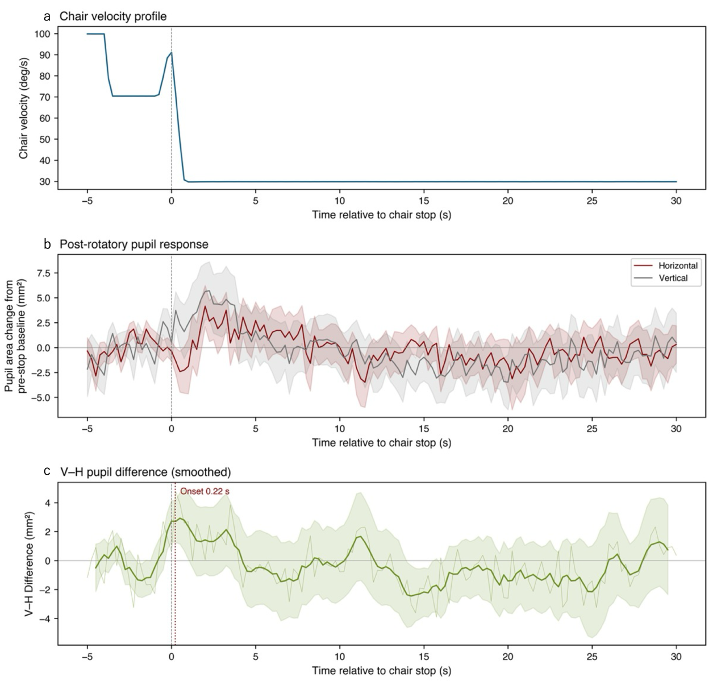
Supplementary Figure S2. Post-rotatory pupil response and exploratory VSR release latency estimation.
(a) Chair velocity profile aligned to chair stop (t = 0). (b) Baseline-normalized pupil area change (mean ± 1 SE) for vertical and horizontal conditions during the post-rotatory period. Baseline = mean of the 5 s pre-stop epoch during constant-velocity rotation. (c) Smoothed (1 s running mean) vertical-minus-horizontal pupil difference ± SE, with estimated divergence onset marked (0.22 s after gyro-detected chair stop; both smoothed-threshold and per-bin t-test methods converged on this point estimate).

