ω_{x} | ω_{y} | ω_{z} | BrIC
Back Isometric View
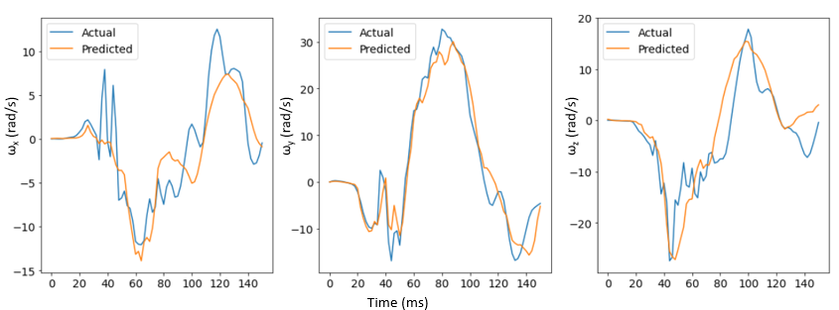  CORA=0.88  CORA=0.62 |  |  | Actual=0.88  Predicted=0.85
Left View
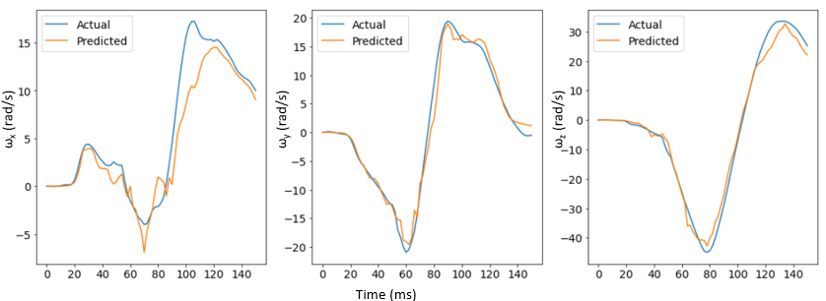  CORA=0.96  CORA=0.93  CORA=0.81  CORA=0.71 |  |  | Actual=1.14  Predicted=1.08
Front Isometric View
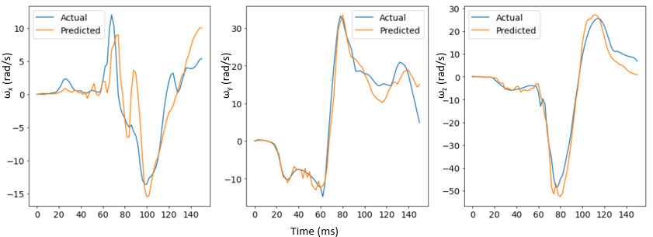  CORA=0.91  CORA=0.92  CORA=0.70 |  |  | Actual=1.29  Predicted=1.38
Table 3. Combined model results

