Supplementary figures for: An eco-friendly, stability-indicating RP-HPLC method for the determination of azilsartan medoxomil in tablets using an ethanol-based mobile phase and a phenyl stationary phase
General chromatographic conditions
Unless stated otherwise in the individual legend, all separations were performed on an XBridge Phenyl column (250 × 4.6 mm, 5 µm) at a flow rate of 1.0 mL min⁻¹, a column temperature of 25 °C and a detection wavelength of 250 nm, with an injection volume of 2 µL. The aqueous component of the mobile phase was 0.02 mol L⁻¹ ammonium acetate, the pH of which was adjusted with acetic acid and measured before mixing with ethanol. Ethanol contents are expressed as the volume fraction of 96 % (v/v) ethanol; the working mobile phase is prepared from 35 volumes of buffer and 65 volumes of 96 % ethanol, measured separately before mixing. Sample and standard solutions were prepared in 96 % ethanol and kept at 5 °C. Figures S3–S14 were recorded on a Nexera LC-30 system (Shimadzu) and are displayed in µV; all remaining chromatograms were recorded on an Agilent liquid chromatograph equipped with a G1315A diode-array detector and are displayed in mAU.
Contents
Figures S1–S2 – Chromatograms obtained under the final method conditions.
Figures S3–S14 – Screening design: mobile-phase pH and ethanol content.
Figures S15–S21 – Effect of mobile-phase pH at a constant ethanol content of 60 % (v/v).
Figures S22–S25 – Effect of ethanol content at pH 3.5.
Figures S26–S33 – Forced degradation and diode–array peak–purity assessment.
Figures S34–S35 – Diagnostics of the response–surface model.
Tables S1–S5 – Greenness assessment of the analytical procedure.

1. Chromatograms obtained under the final method conditions
The final method employs 0.02 mol L⁻¹ ammonium acetate (pH 3.5) and 96 % (v/v) ethanol in the ratio 35:65 (v/v). Azilsartan medoxomil elutes at approximately 8.8 min.
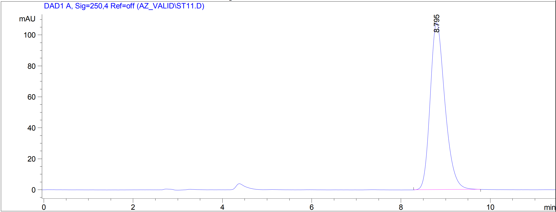
Fig. S1. Chromatogram of a standard solution of azilsartan medoxomil (0.8 mg mL⁻¹) obtained under the final method conditions.
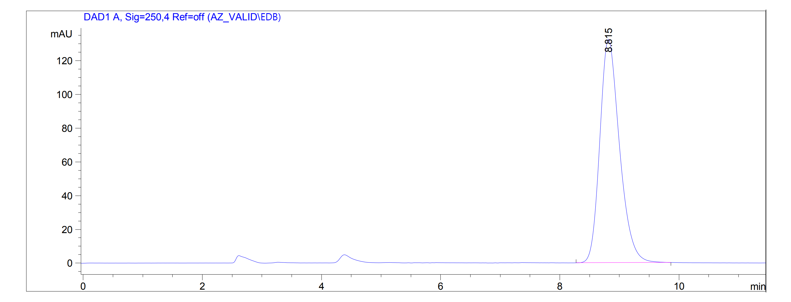
Fig. S2. Chromatogram of a sample solution prepared from azilsartan medoxomil tablets (Edarbi®, 40 mg) obtained under the final method conditions.
2. Screening design: mobile-phase pH and ethanol content
Chromatograms recorded at the twelve points of the 3 × 4 experimental design used to model the resolution between azilsartan medoxomil and its hydrolysis product azilsartan. The buffer pH was set at 2.0, 4.0 and 7.0 and the ethanol content at 50, 60, 70 and 80 % (v/v). Recorded on the Shimadzu system; the ordinate is given in µV.
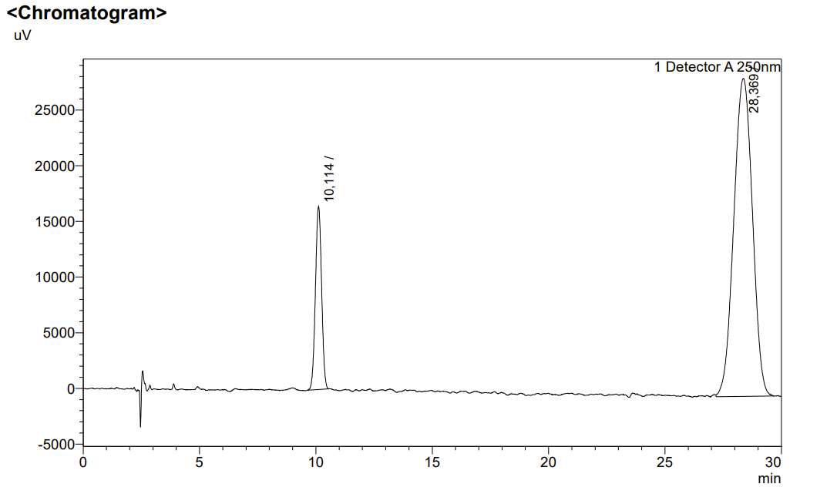
Fig. S3. Design point at buffer pH 2.0 and 50 % (v/v) ethanol.
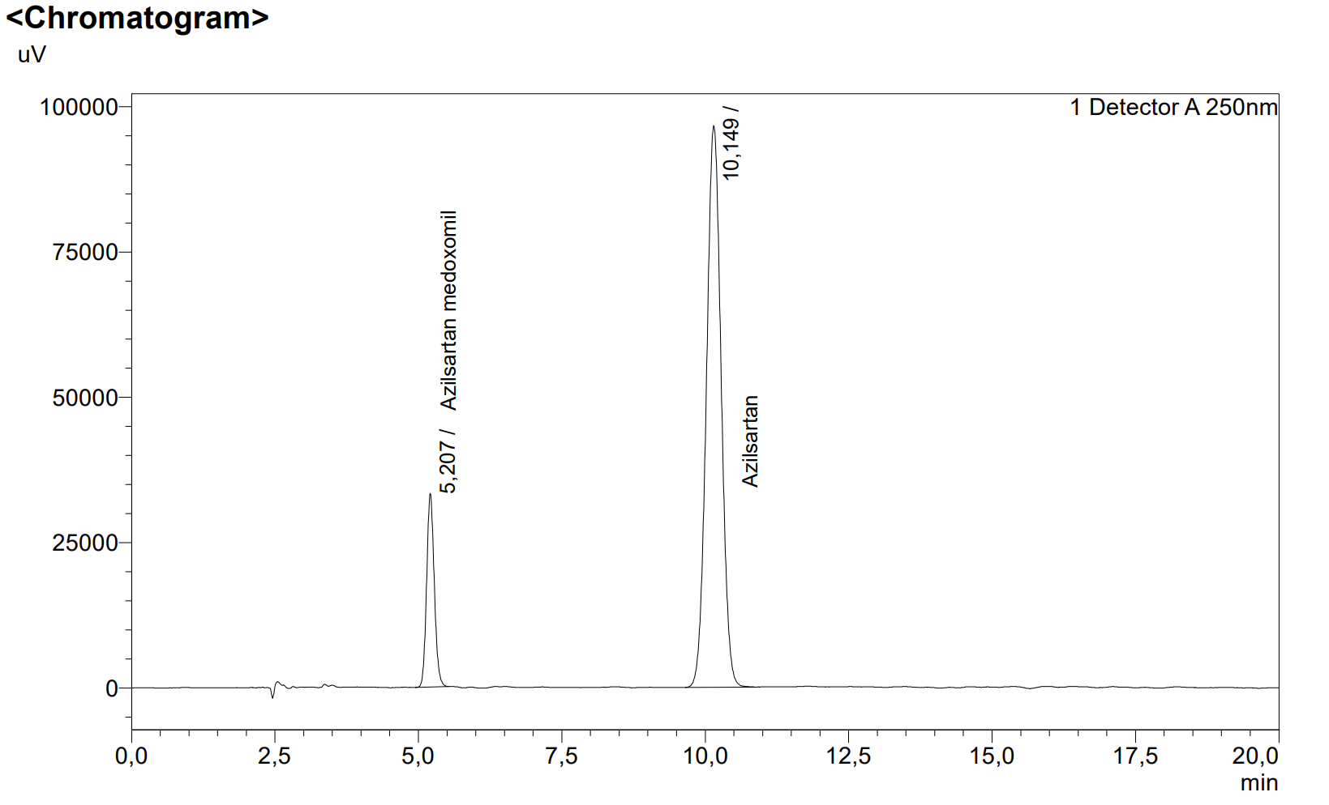
Fig. S4. Design point at buffer pH 2.0 and 60 % (v/v) ethanol.
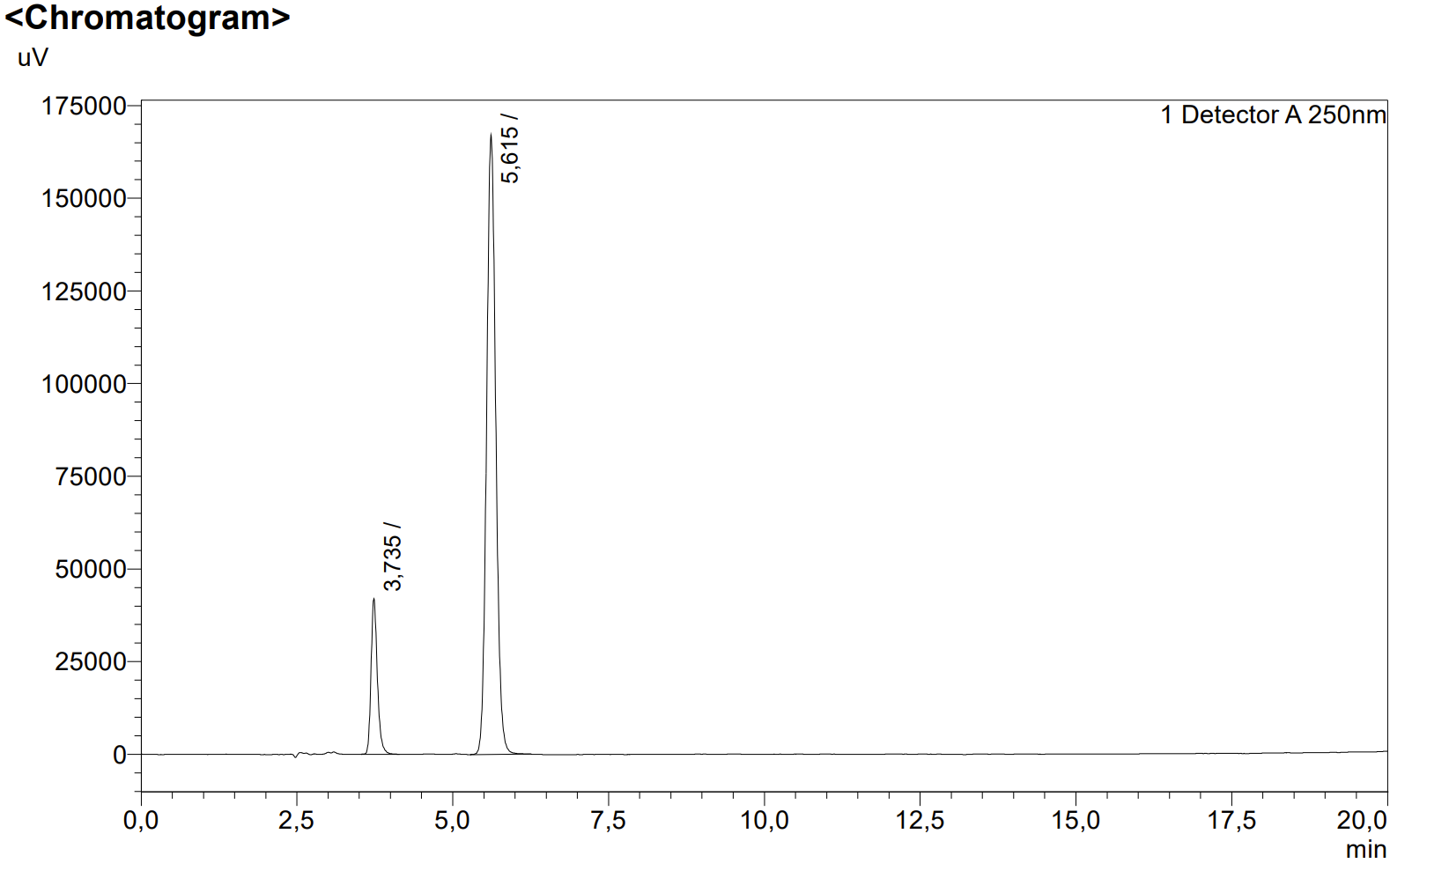
Fig. S5. Design point at buffer pH 2.0 and 70 % (v/v) ethanol.
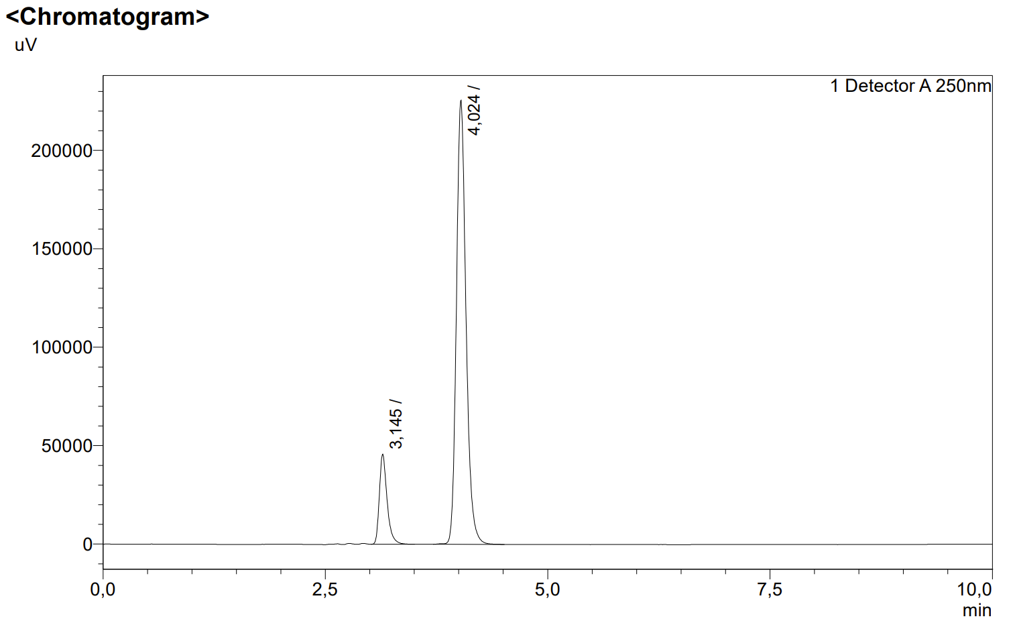
Fig. S6. Design point at buffer pH 2.0 and 80 % (v/v) ethanol.
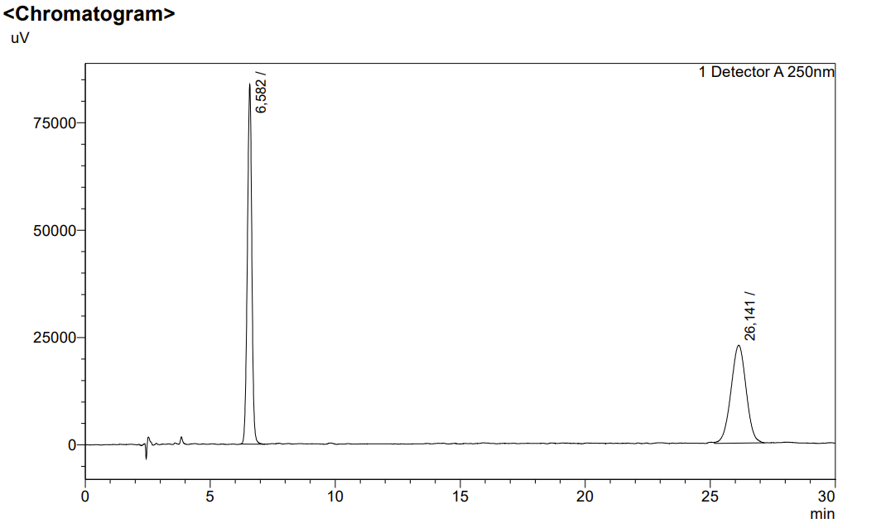
Fig. S7. Design point at buffer pH 4.0 and 50 % (v/v) ethanol.
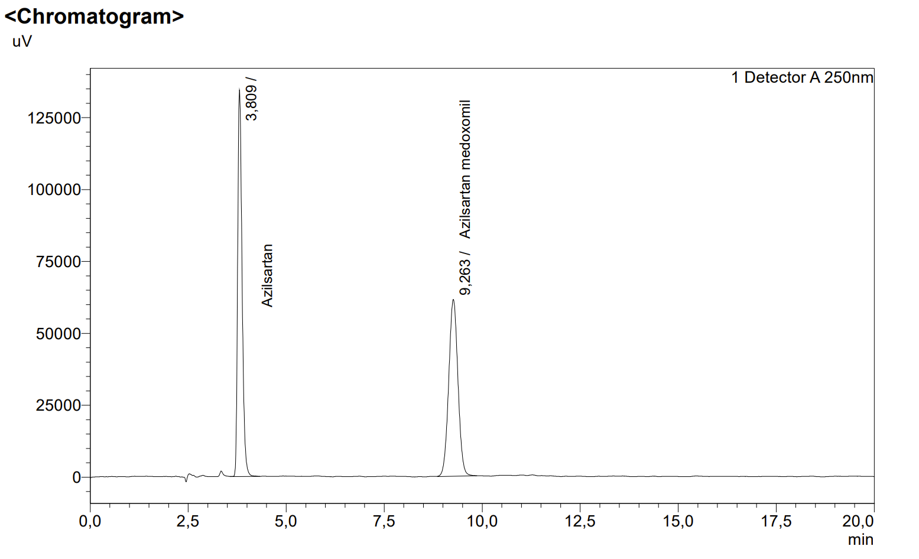
Fig. S8. Design point at buffer pH 4.0 and 60 % (v/v) ethanol.
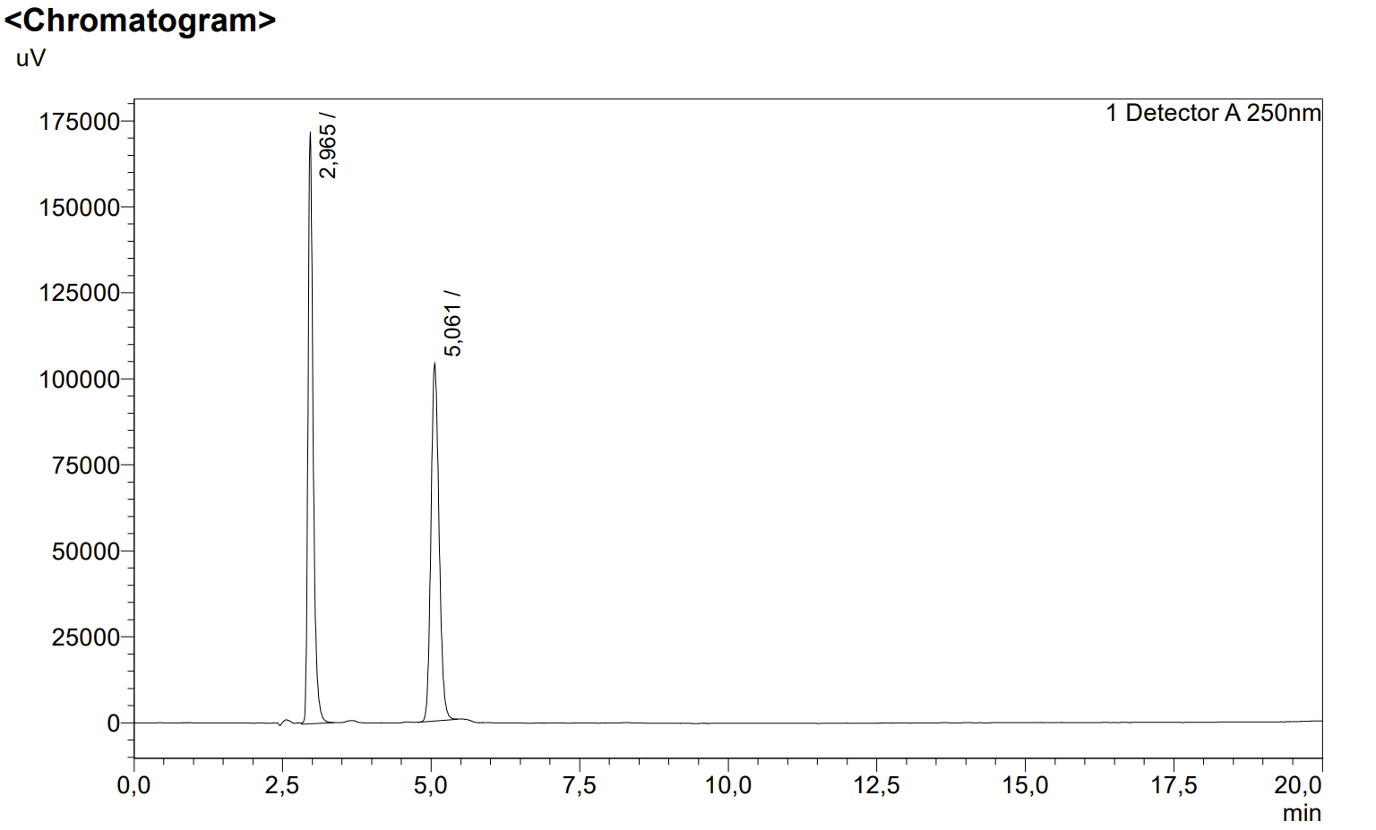
Fig. S9. Design point at buffer pH 4.0 and 70 % (v/v) ethanol.
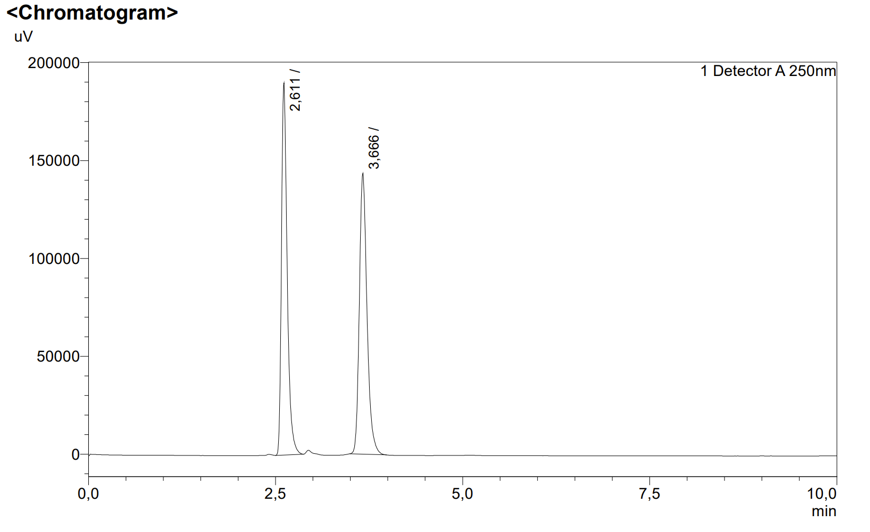
Fig. S10. Design point at buffer pH 4.0 and 80 % (v/v) ethanol.
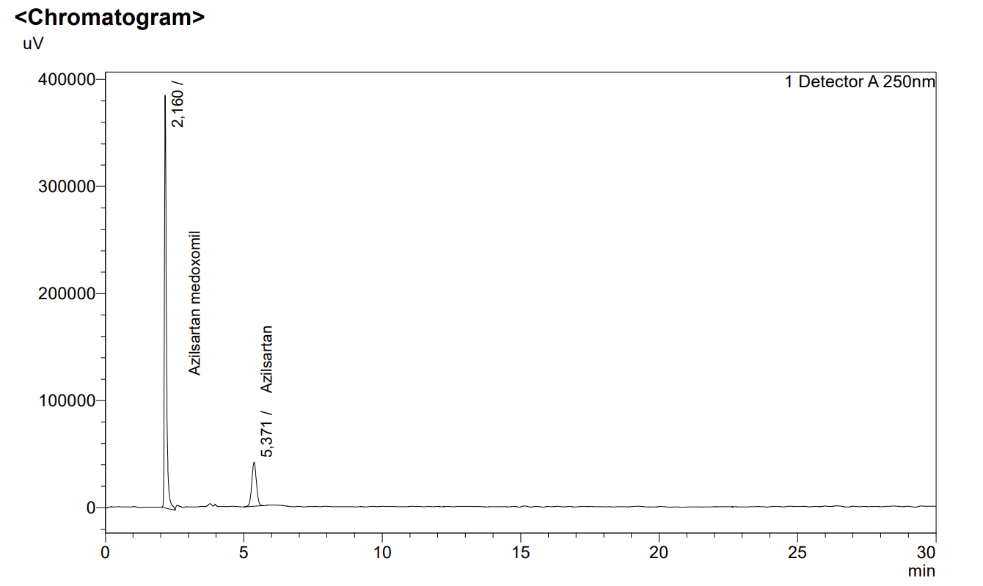
Fig. S11. Design point at buffer pH 7.0 and 50 % (v/v) ethanol.
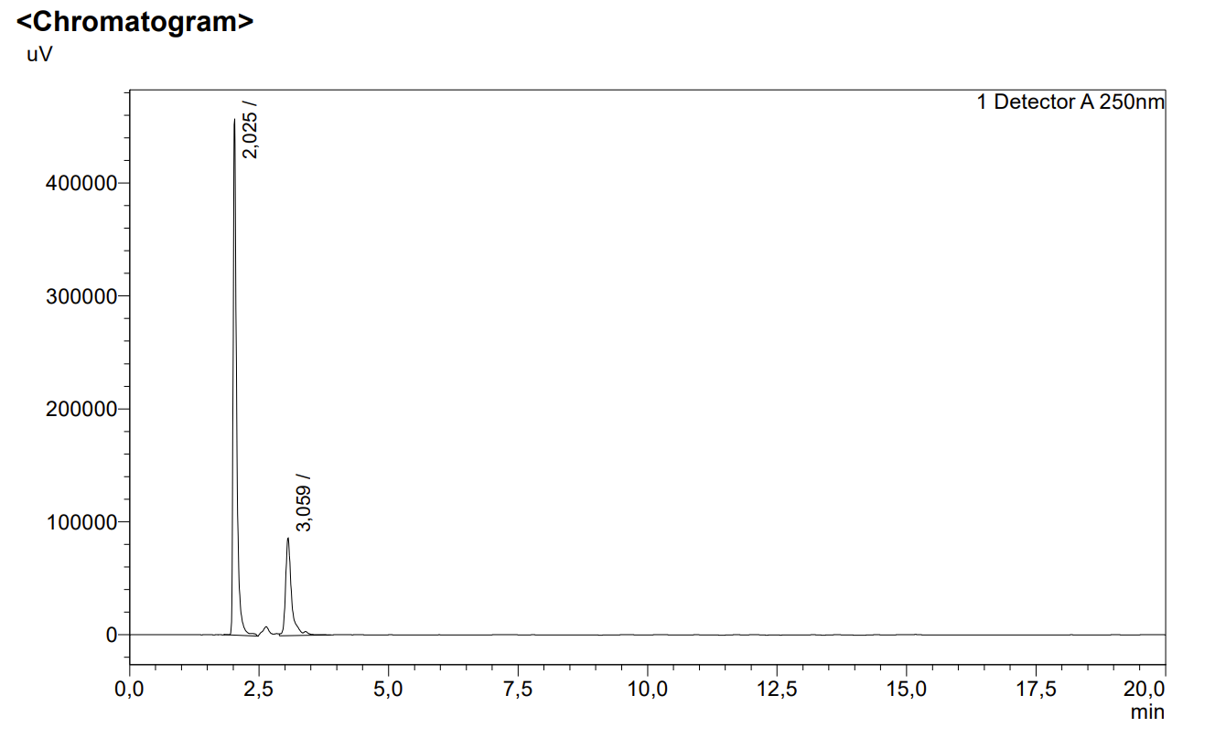
Fig. S12. Design point at buffer pH 7.0 and 60 % (v/v) ethanol.
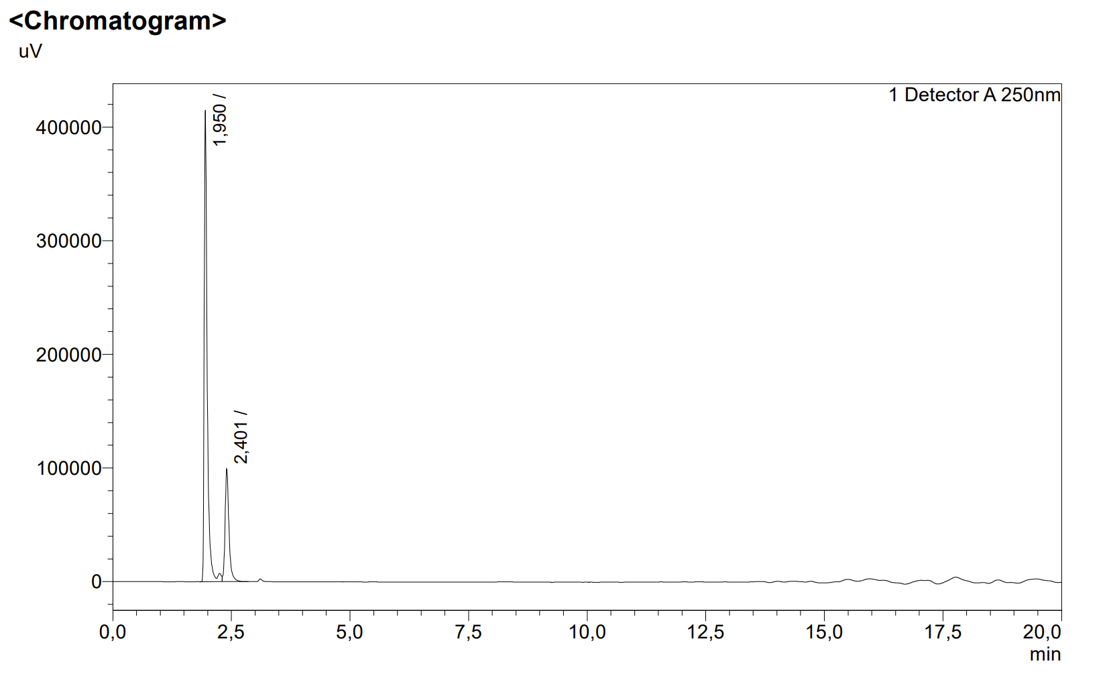
Fig. S13. Design point at buffer pH 7.0 and 70 % (v/v) ethanol.
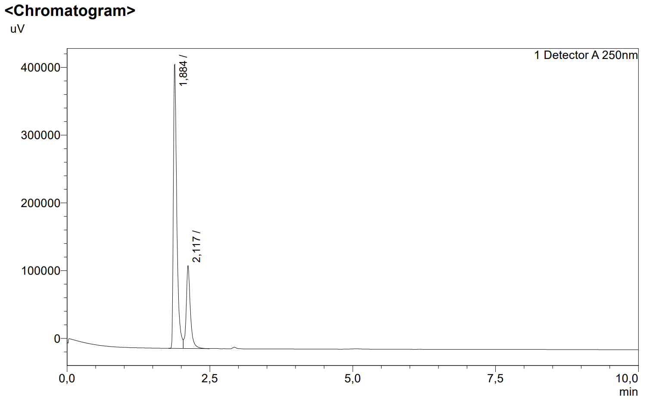
Fig. S14. Design point at buffer pH 7.0 and 80 % (v/v) ethanol.

3. Effect of mobile-phase pH at a constant ethanol content of 60 % (v/v)
Retention times from this series were used to fit the retention–pH sigmoid and to derive the apparent chromatographic dissociation constant of azilsartan medoxomil. The number of theoretical plates (N) determined for the main peak is given in each legend.
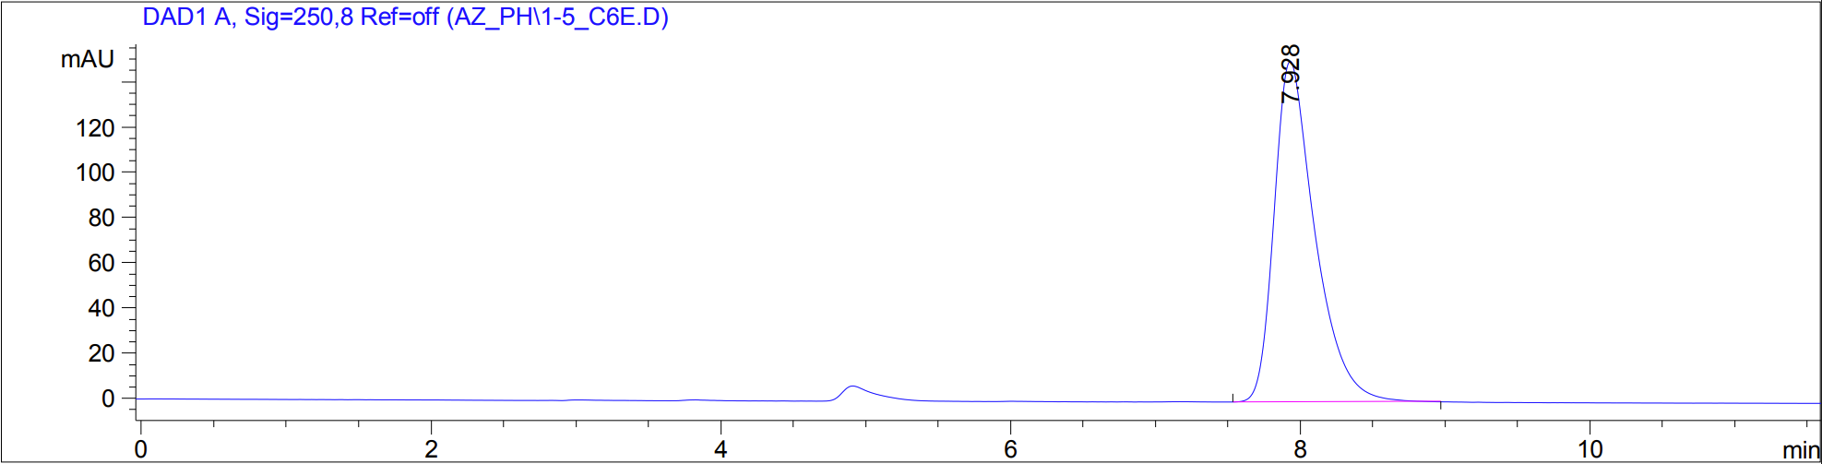
Fig. S15. Separation at buffer pH 1.5; N = 4237.
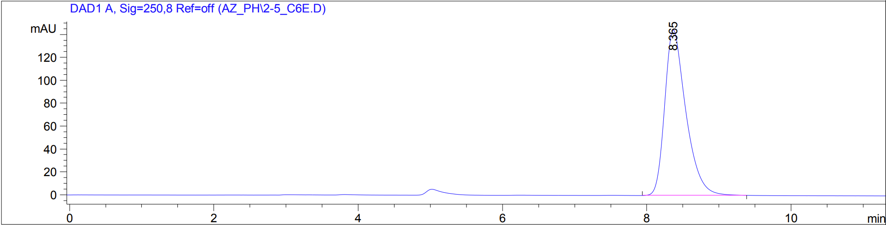
Fig. S16. Separation at buffer pH 2.5; N = 4307.
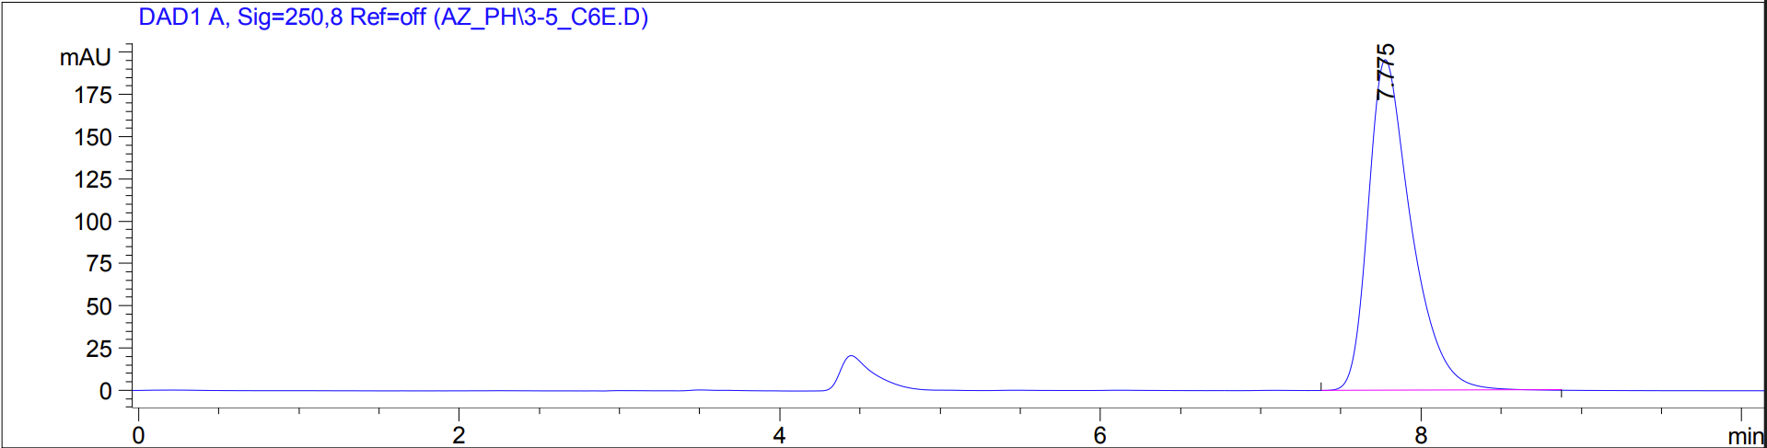
Fig. S17. Separation at buffer pH 3.5; N = 4487.
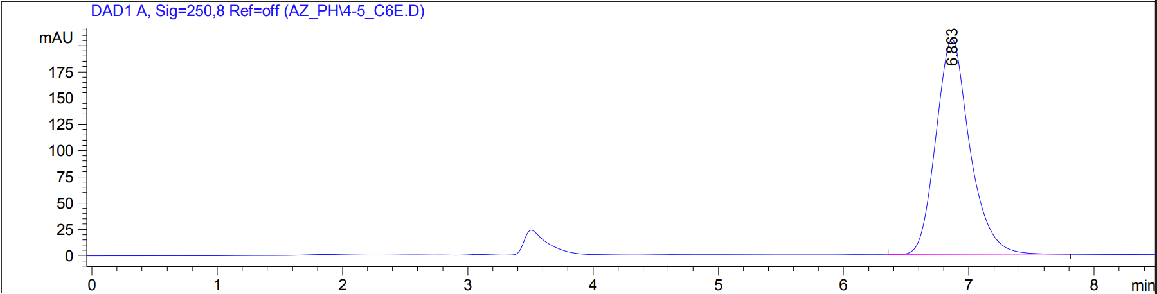
Fig. S18. Separation at buffer pH 4.5; N = 3409.
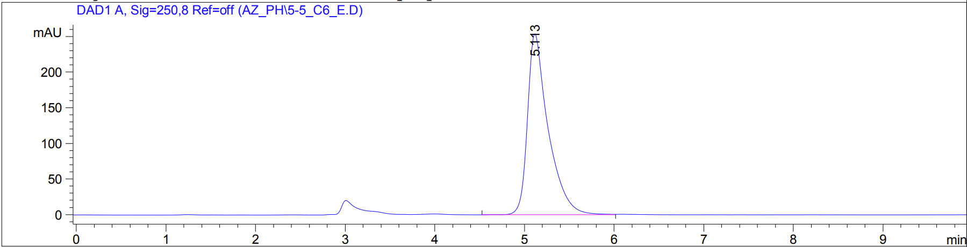
Fig. S19. Separation at buffer pH 5.5; N = 2904.
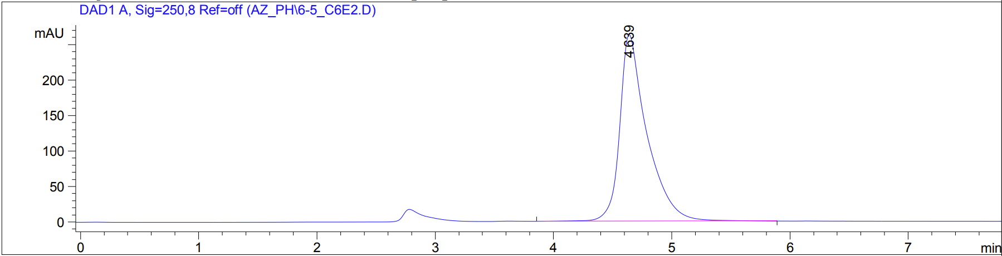
Fig. S20. Separation at buffer pH 6.5; N = 2619.
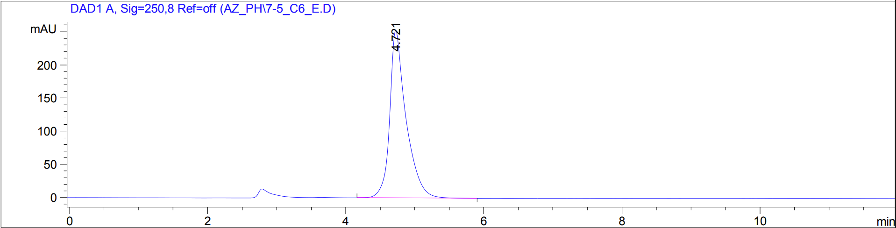
Fig. S21. Separation at buffer pH 7.5; N = 2476.

4. Effect of ethanol content at pH 3.5
Chromatograms recorded at the working pH with increasing proportions of ethanol, illustrating the loss of retention as eluent strength increases. The composition used in the final method is shown in Fig. S23.
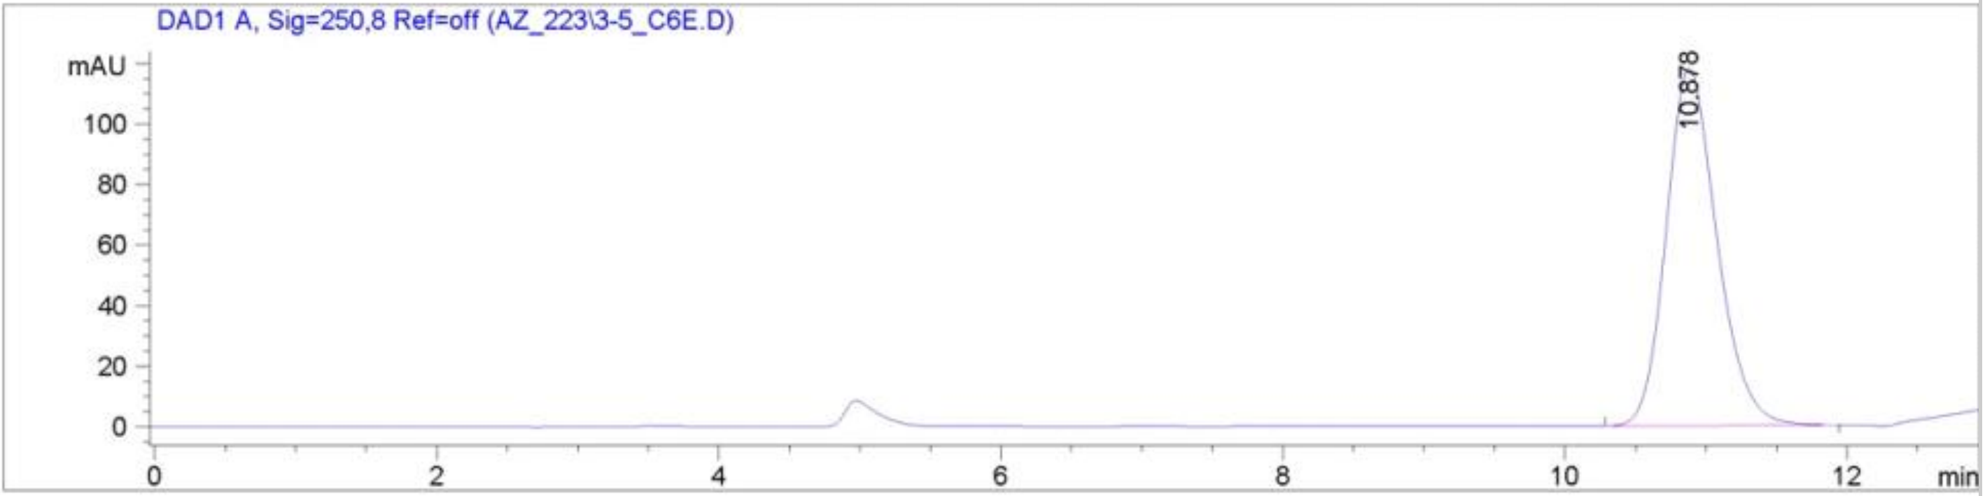
Fig. S22. Separation at 60 % (v/v) ethanol.
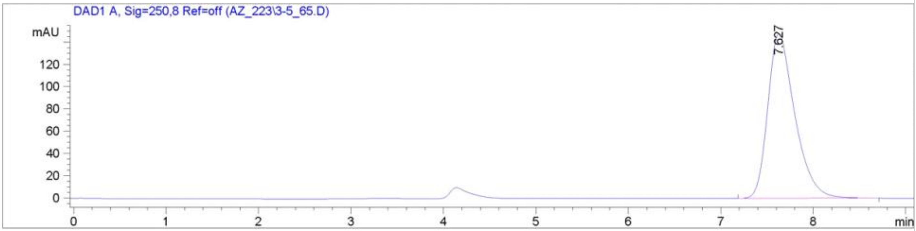
Fig. S23. Separation at 65 % (v/v) ethanol. This composition corresponds to the final method.
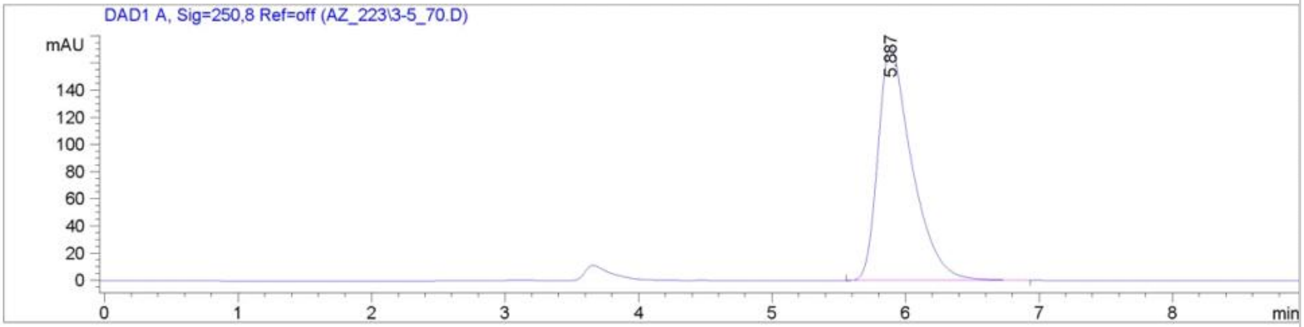
Fig. S24. Separation at 70 % (v/v) ethanol.
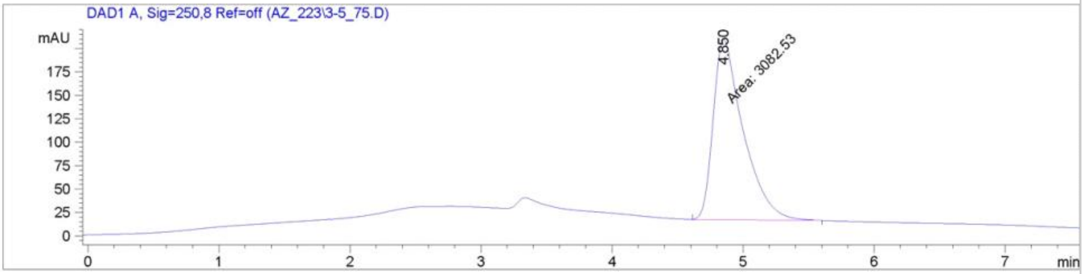
Fig. S25. Separation at 75 % (v/v) ethanol.

5. Forced degradation and diode-array peak-purity assessment
Chromatograms of stressed sample solutions, each followed by the corresponding peak-purity assessment of the azilsartan medoxomil peak. Purity plots show the spectra recorded across the peak together with the purity curve; the purity factor is reported by the software on a scale of 0 to 1000.
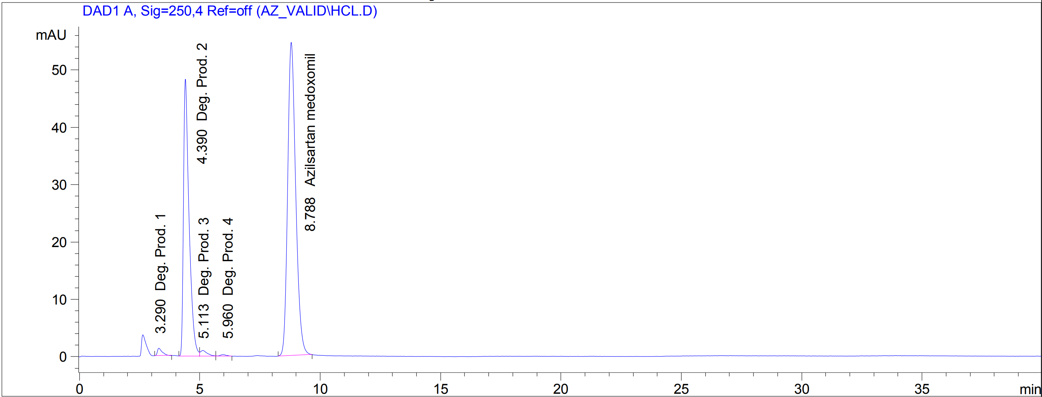
Fig. S26. Sample solution after acid stress (0.1 mol L⁻¹ hydrochloric acid, 2 h, 25 °C).
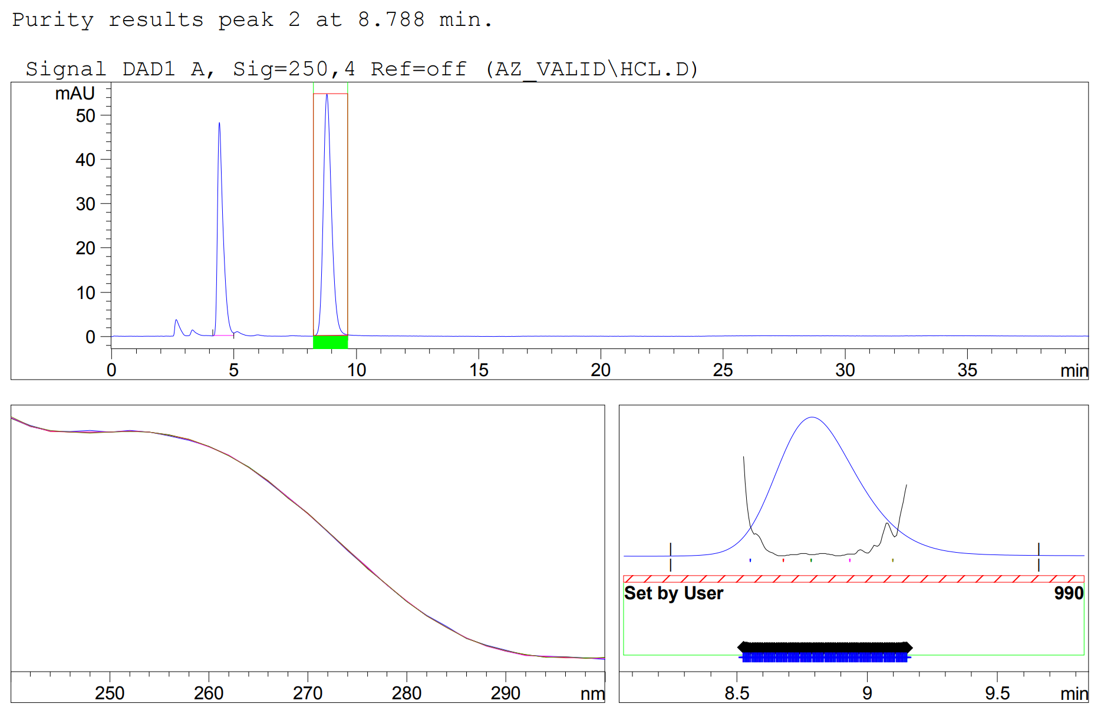
Fig. S27. Peak-purity assessment of the azilsartan medoxomil peak in the acid-stressed solution shown in Fig. S26.
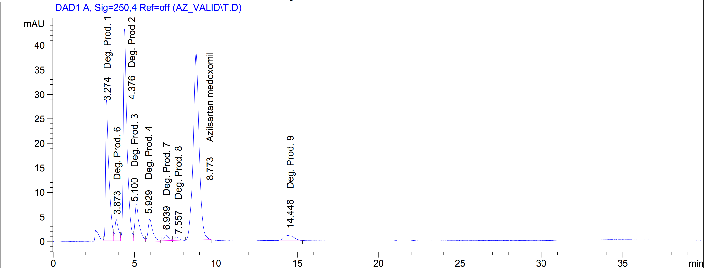
Fig. S28. Sample solution after thermal stress (170 °C, 10 min).
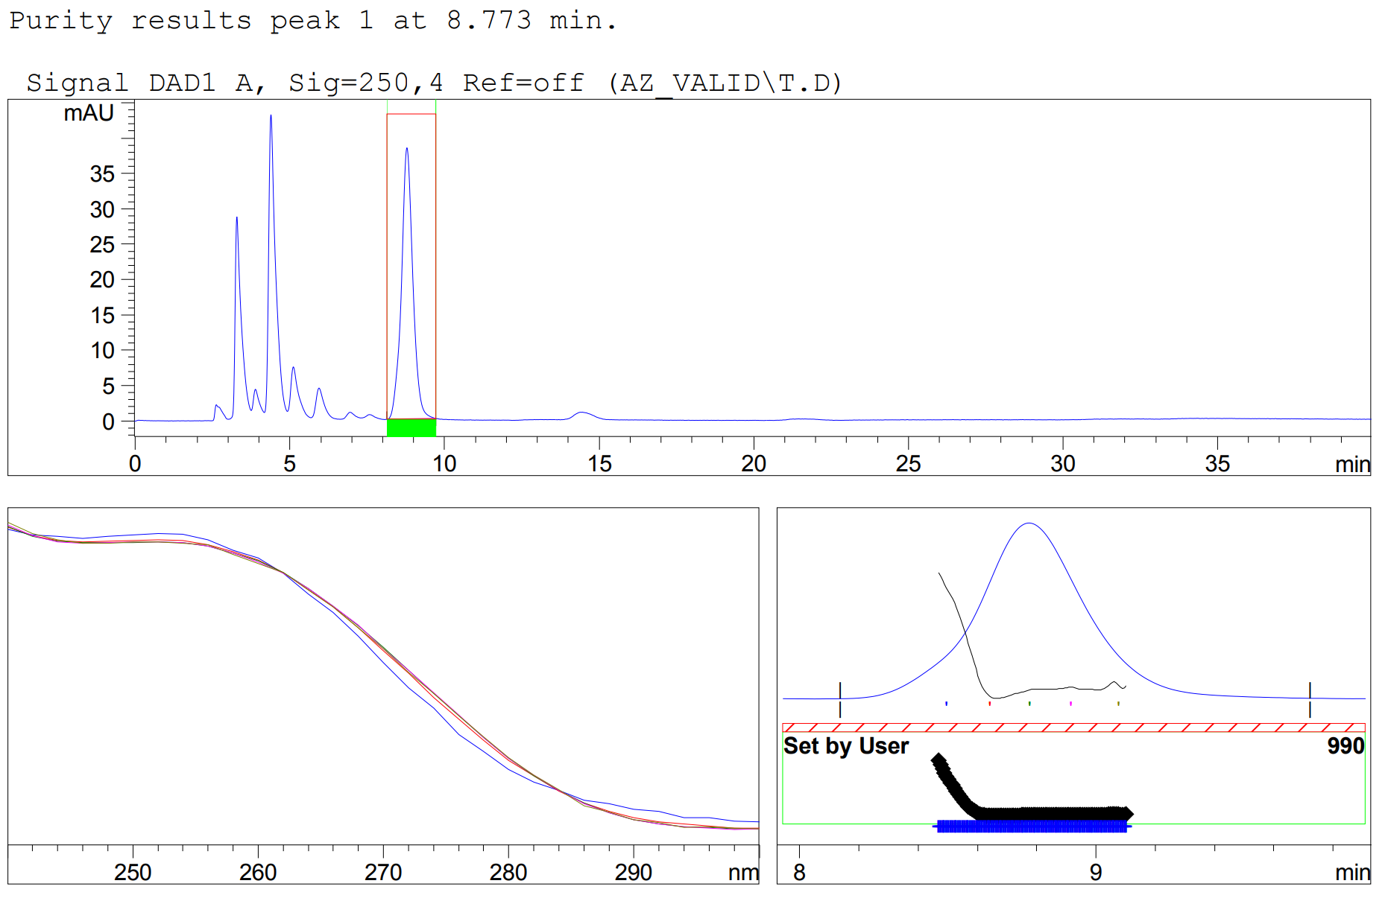
Fig. S29. Peak-purity assessment of the azilsartan medoxomil peak in the thermally stressed solution shown in Fig. S28.
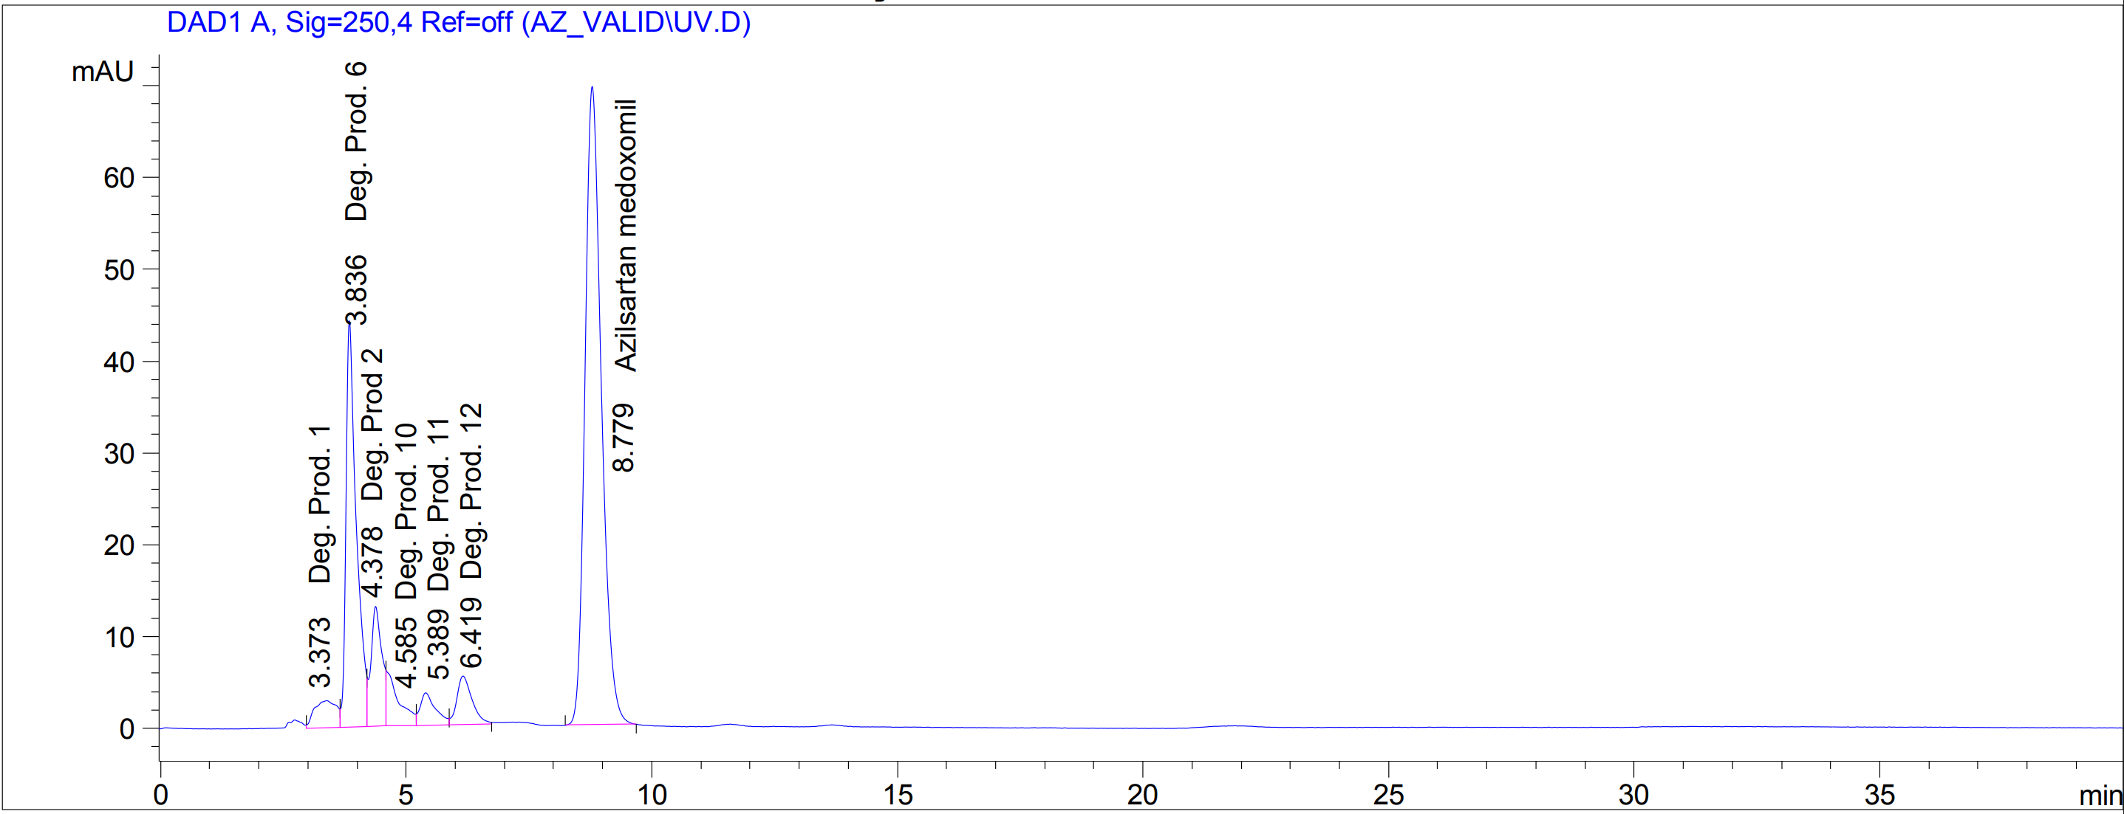
Fig. S30. Sample solution after photolytic stress (ultraviolet irradiation, 2 h).
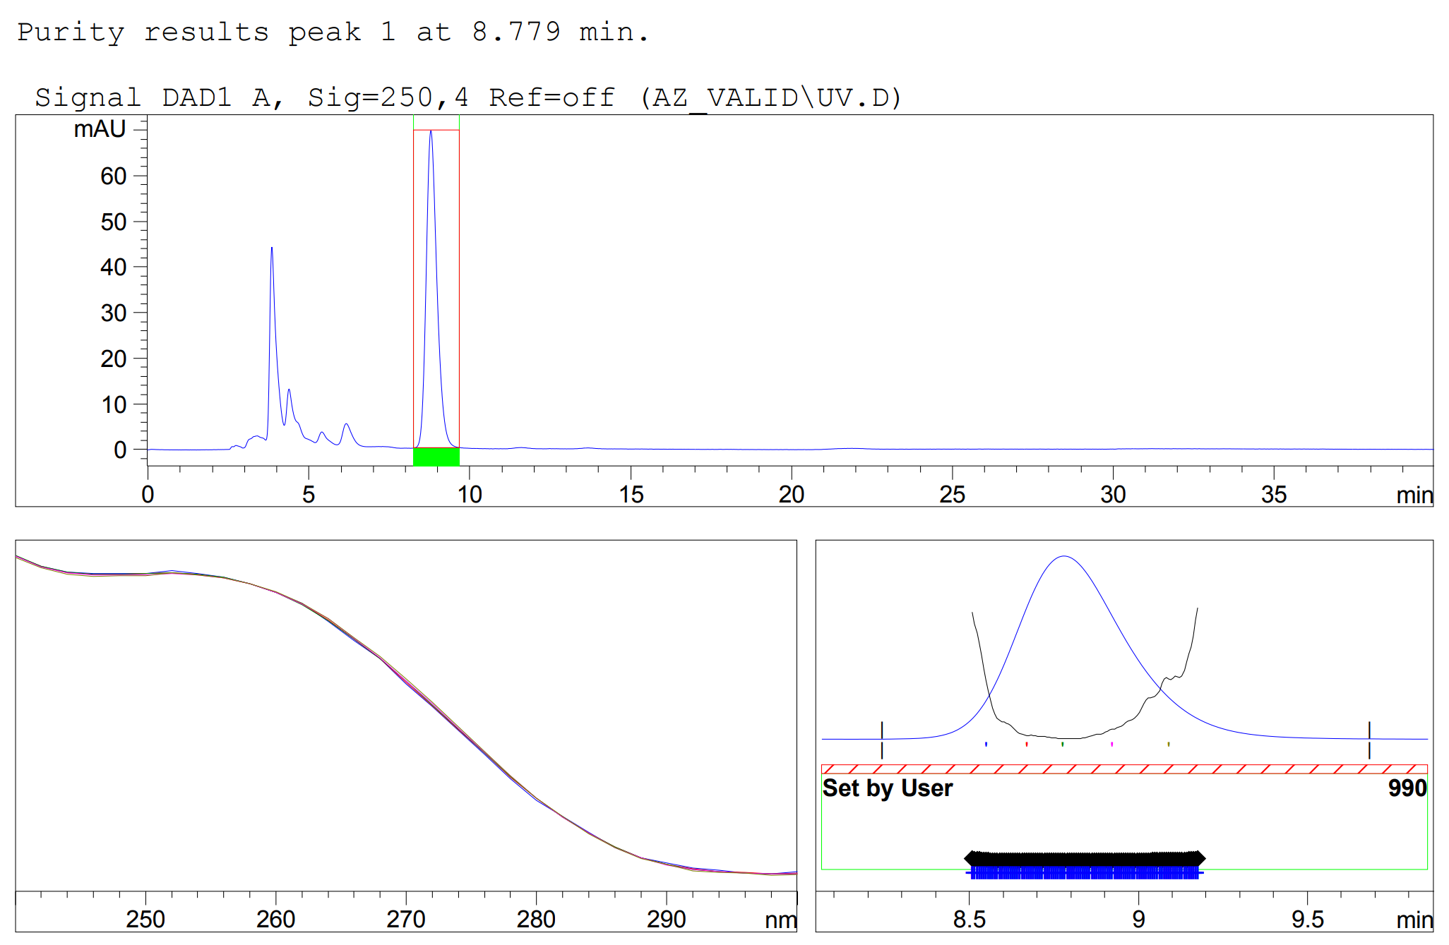
Fig. S31. Peak-purity assessment of the azilsartan medoxomil peak in the photolytically stressed solution shown in Fig. S30.
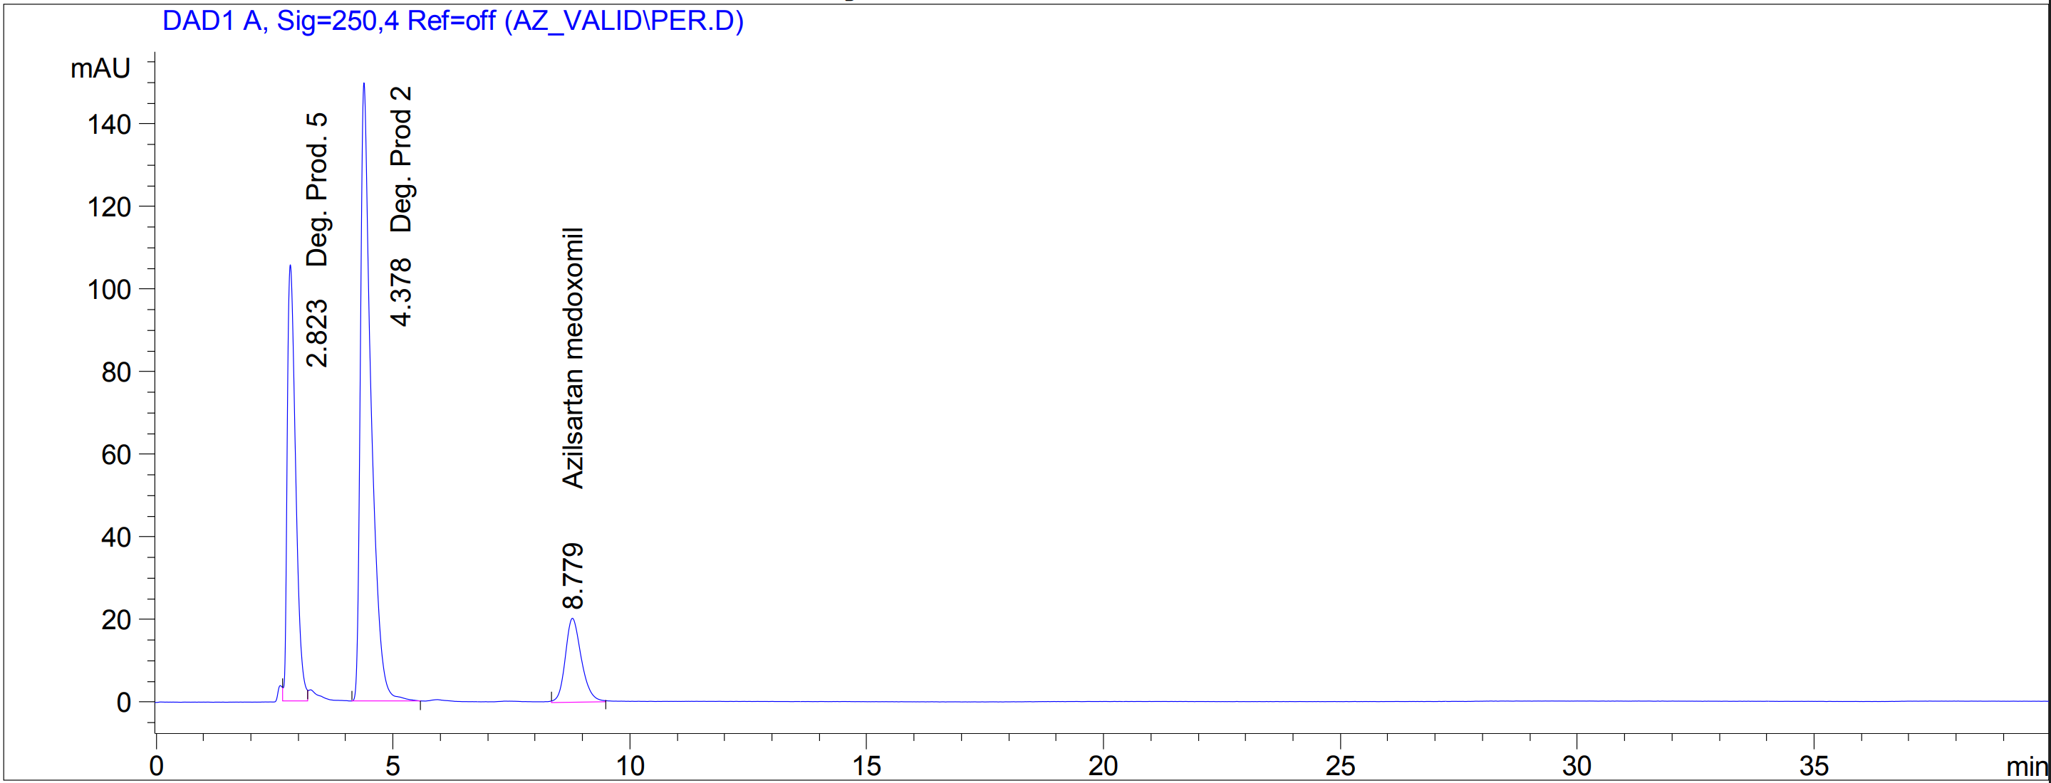
Fig. S32. Sample solution after oxidative stress under neutral conditions (hydrogen peroxide, 2 h, 25 °C).
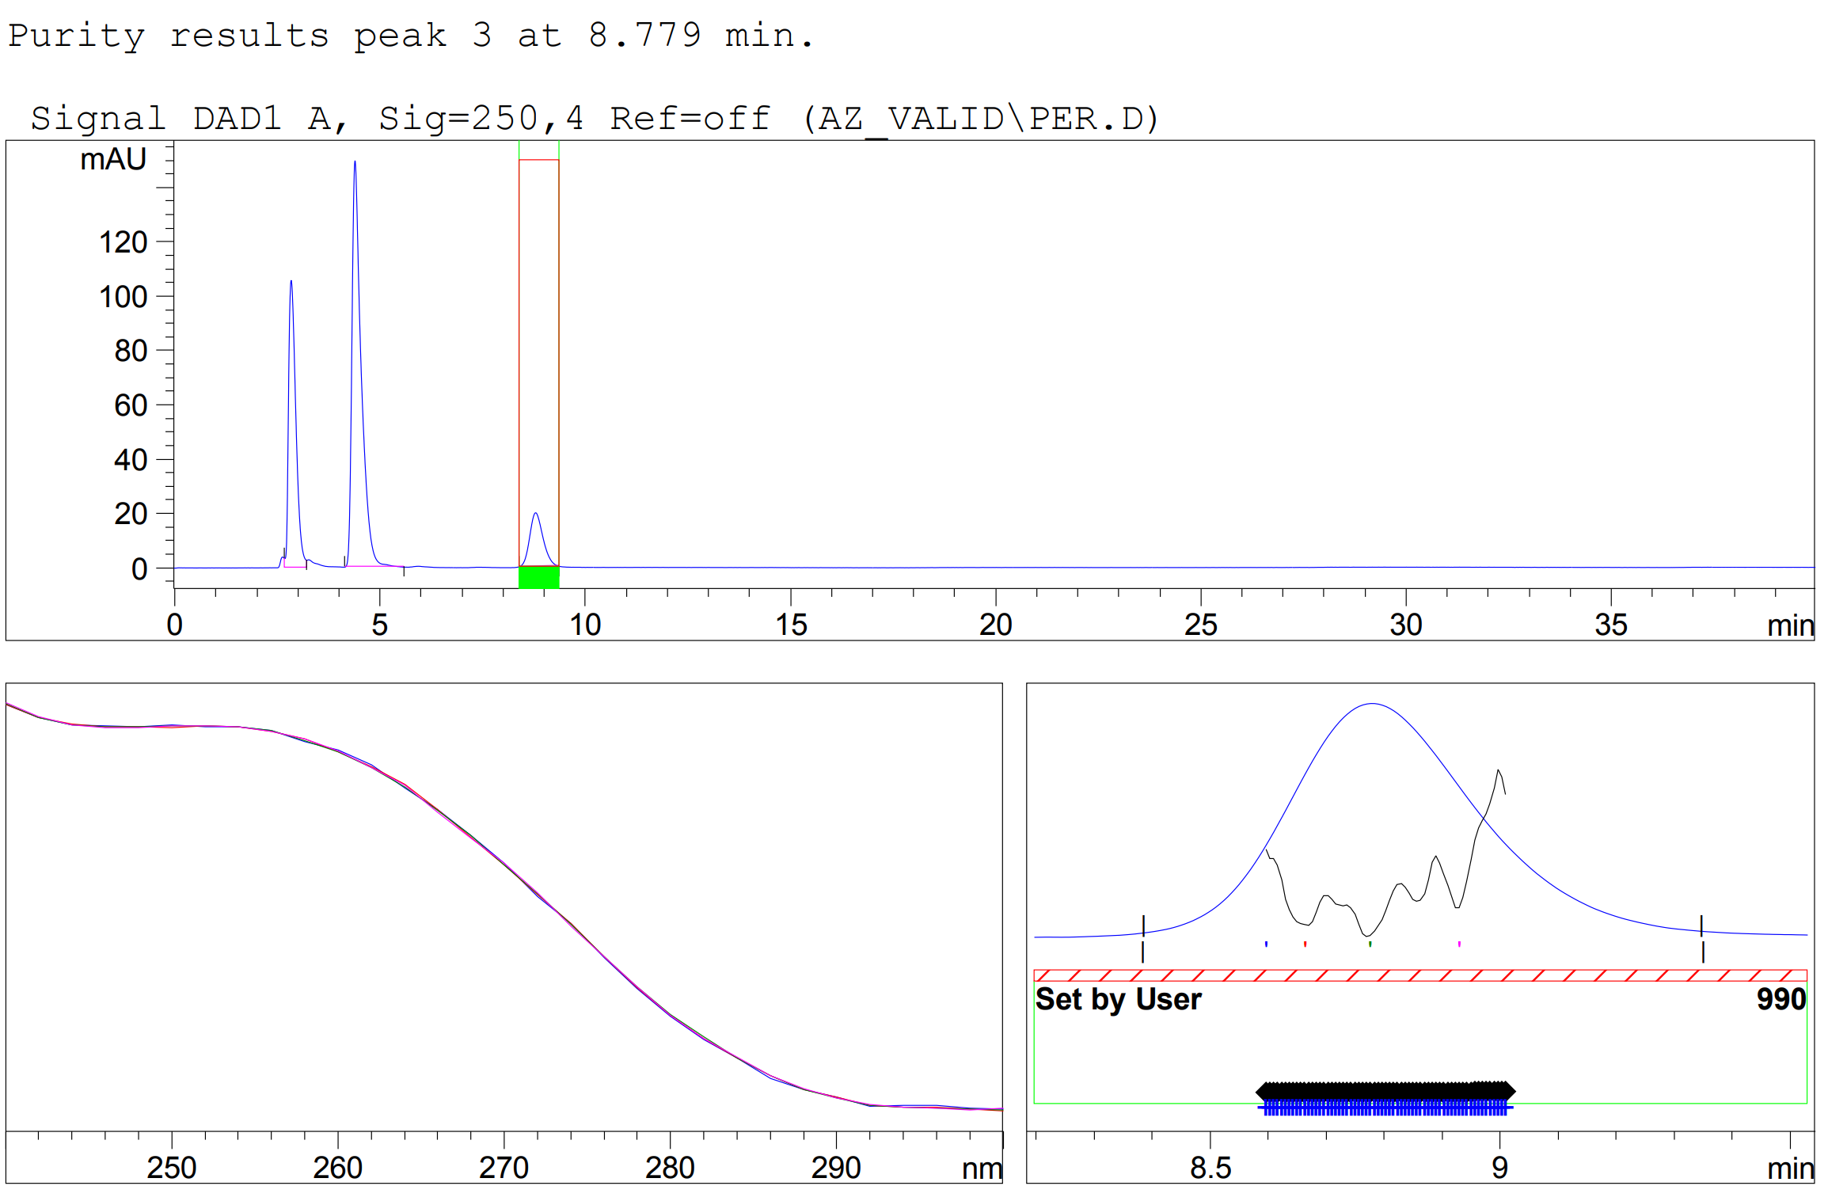
Fig. S33. Peak-purity assessment of the azilsartan medoxomil peak in the oxidatively stressed solution shown in Fig. S32.
6. Diagnostics of the response-surface model
Diagnostic plots generated by Design-Expert® 13 for the second-order model of the critical resolution.
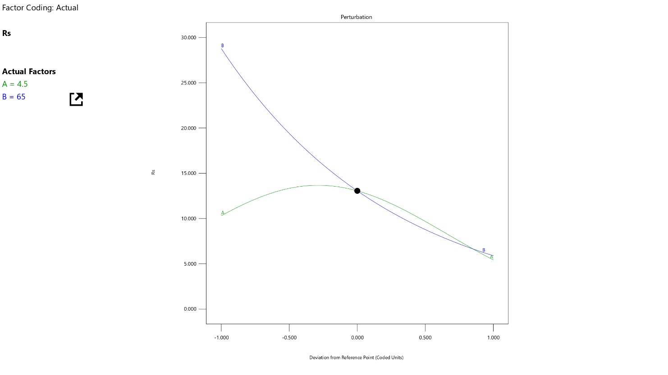
Fig. S34. Perturbation plot showing the sensitivity of the modelled resolution to each factor about the working point (A, mobile-phase pH; B, ethanol content). The steeper the curve, the more sensitive the response is to a deviation in that factor.
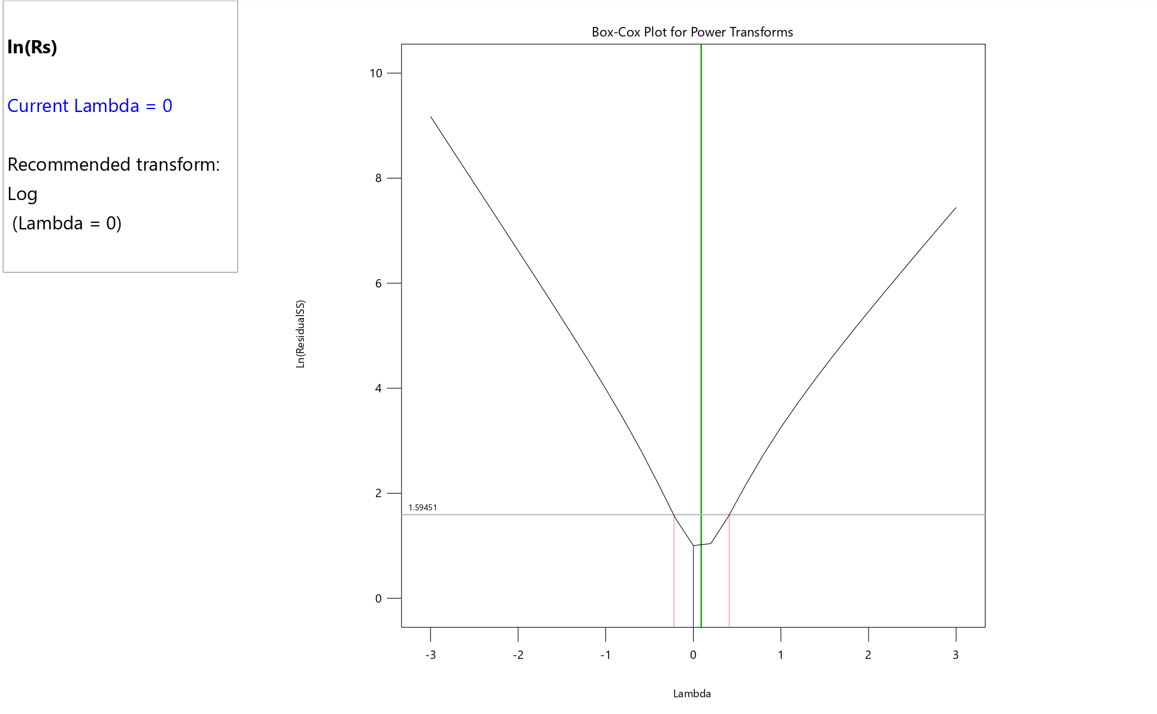
Fig. S35. Box-Cox plot for power transforms. The optimal value of the transformation parameter is λ = 0, which corresponds to the natural-logarithm transform applied to the resolution data.
7. Greenness assessment of the analytical procedure
Table S1. Penalty points (PPs) used to calculate the Analytical Eco-Scale.
Parameter | Category | Sub-total PP | Total PP
Reagents
Amount | <10 mL (g) | 1 | Amount PP × Hazard PP
Amount | 10-100 mL (g) | 2 | Amount PP × Hazard PP
Amount | >100 mL (g) | 3 | Amount PP × Hazard PP
Hazard (physical, environmental, health) | None | 0 | Amount PP × Hazard PP
Hazard (physical, environmental, health) | Less severe hazard | 1 | Amount PP × Hazard PP
Hazard (physical, environmental, health) | More severe hazard | 2 | Amount PP × Hazard PP
Instruments
Energy | ≤0.1 kWh per sample | – | 0
Energy | ≤1.5 kWh per sample | – | 1
Energy | >1.5 kWh per sample | – | 2
Occupational hazard | Analytical process hermetization | – | 0
Occupational hazard | Emission of vapors and gases to the air | – | 3
Waste | None | – | 0
Waste | <1 mL (g) | – | 1
Waste | 1–10 mL (g) | – | 3
Waste | >10 mL (g) | – | 5
Waste | Recycling | – | 0
Waste | Degradation | – | 1
Waste | Passivation | – | 2
Waste | No treatment | – | 3
Adapted from the Analytical Eco-Scale of Gałuszka et al. Hazard categories were assigned from the highest GHS signal word associated with each reagent.
Table S2. Penalty points assigned to the proposed RP-HPLC procedure and the resulting Analytical Eco-Scale score.
Item | Sub-total PP | Total PP
Reagents
Ethanol 96 %; 10-100 mL; more severe hazard | 2 × 2 | 4
Acetic acid (glacial); <10 mL; more severe hazard | 1 × 2 | 2
Ammonium acetate; <10 g; no hazard | 1 × 0 | 0
Instruments
Energy: HPLC, ≤1.5 kWh per sample | – | 1
Occupational hazard: analytical process hermetization | – | 0
Waste
Amount: >10 mL per sample | – | 5
Treatment: recycling | – | 0
Total penalty points |  | 12
Analytical Eco-Scale score (100 − ΣPP) |  | 88
Table S3. Input parameters entered into the AGREE software for the assessment of the proposed RP-HPLC procedure; resulting index: 0.56.
Principle | Input parameter entered | Weight
1. Direct analytical techniques should be applied to avoid sample treatment | Sampling procedure: external sample pre- and treatment and batch analysis (reduced number of steps) | 1
2. Minimal sample size and minimal number of samples are goals | Amount of sample: 0.18 g ª | 1
3. If possible, measurements should be performed in situ | Positioning of the analytical device: off-line | 1
4. Integration of analytical processes and operations saves energy and reduces the use of reagents | Number of major, distinct sample-preparation steps: 3 ^{b} | 1
5. Automated and miniaturized methods should be selected | Degree of automation: semi-automatic; sample preparation: not miniaturized | 1
6. Derivatization should be avoided | Derivatization agents: none | 1
7. Generation of a large volume of analytical waste should be avoided | Amount of waste: 15 mL ^{c} | 1
8. Multi-analyte or multi-parameter methods are preferred | Number of analytes determined in a single run: 1; sample throughput: 4 samples h⁻¹ ^{d} | 1
9. The use of energy should be minimized | Most energy-intensive technique: LC | 1
10. Reagents obtained from renewable sources should be preferred | Type of reagents: some reagents are bio-based ^{e} | 1
11. Toxic reagents should be eliminated or replaced | Use of toxic reagents or solvents: no ^{f} | 1
12. Operator’s safety should be increased | Threats not avoided: highly flammable; corrosive ^{f} | 1
ª Analytical intake of tablet powder equivalent to 40 mg of azilsartan medoxomil; the mass of the composite sample from which the aliquot was withdrawn was not included.
^{b} Comminution, ultrasonication and filtration. Weighing, quantitative transfer, dispersion and dilution to volume were treated as elementary volumetric operations, and cooling of the diluent as a condition parameter, rather than as discrete steps.
^{c} Eluate generated during one isocratic run at 1.0 mL min⁻¹; the unused portion of the working solution was not included.
^{d} Reciprocal of the chromatographic cycle; sample preparation is performed in parallel with the analysis of preceding samples in batch mode.
^{e} Ethanol of fermentation origin constitutes 65 % (v/v) of the mobile phase; ammonium acetate and acetic acid are of synthetic origin.
^{f} Toxicity was defined as the presence of acute, chronic or organ-specific toxicity classes under GHS, whereas physicochemical hazards and corrosivity were assessed separately under principle 12.
Table S4. Input parameters entered into the MoGAPI software for the assessment of the proposed RP-HPLC procedure; resulting index: 77.
Field | Selection entered
Sample preparation
1. Collection | Off-line
2. Preservation | Chemical or physical ª
3. Transport | None
4. Storage | Under normal conditions
5. Type of method | Simple procedures, e.g., filtration, decantation
6. Scale of extraction | Not applicable ^{b}
7. Solvents/reagents used | Green solvents/reagents used
8. Additional treatment | None
Reagents and solvents
9. Amount | 10-100 mL (10-100 g) ^{c}
10. Health hazard | Slightly toxic, slight irritant; NFPA health hazard score = 0 or 1
11. Safety hazard | Highest NFPA flammability or instability score of 2 or 3, or a special hazard is used
Instrumentation
12. Energy | ≤1.5 kWh per sample
13. Occupational hazard | Hermetic sealing of analytical process
14. Waste | >10 mL (>10 g) ^{d}
15. Waste treatment | Recycling ^{e}
16. Quantification | Yes
ª Preparation and storage of all solutions in pre-cooled ethanol at 5 °C, ultrasonication in an ice-water bath and autosampler thermostatting at 5 °C were treated as physical preservation of the analyte, required to suppress hydrolysis of the medoxomil ester.
^{b} No separation or preconcentration step is involved; the sample is dissolved directly in the final diluent.
^{c} Total volume of reagents consumed per determination, comprising the diluent used for solution preparation and the mobile phase delivered during the chromatographic run. This field refers to reagent consumption, whereas field 14 refers to the eluate discarded as waste.
^{d} Eluate generated during one chromatographic run at 1.0 mL min⁻¹; the unused portion of the working solution was not included.
^{e} The volatile ammonium acetate–ethanol eluate is amenable to distillative recovery of the organic modifier, in contrast to non-volatile phosphate-based mobile phases.
Table S5. Input parameters entered into the CaFRI software for the assessment of the proposed RP-HPLC procedure; resulting score: 77.
Field | Selection entered
Energy
1. An energy reduction program or clean energy sources are adapted throughout the procedures | No
2. Total electrical power use of analytical instruments | 0.1-1.5 kW
3. Energy-intensive non-analytical equipment is essential | No
4. Number of samples analyzed per hour | <10 samples per hour
CO₂ emission
5. The carbon footprint of the electrical power of analytical instruments is known | Yes
6. Emission factor | 0.1–0.3 kg CO₂ per kWh
Storage
7. Sample storage | Storage under normal conditions
Transportation
8. The sample has to be transported to an analytical laboratory | No
9. Distance between the sample field and the laboratory | Not applicable
10. Number of samples transported in one shipment | Not applicable
11. An ecofriendly vehicle is used in transportation | Not applicable
Personnel
12. Number of personnel required for one sample analysis | 1 person
13. Automation | Semiautomatic
Waste
14. Waste amount | 10-100 mL or g per sample
15. Waste disposal | Waste disposal by the analyst
Recycling
16. Recycling | The method employs recycled reagents/solvents from the same method
Reagents/solvents
17. Total number of pictograms | ≤3
18. Total amount of organic solvents per sample | >10 mL
19. Total amount of reagents per sample | <1 g or mL

