Model Architecture Details
For reproducibility, we used a two-stage training protocol (pretrain and finetune) on 8-channel EMG windows (1 s, 5 s, and 10 s). In all supervised runs (classification and prediction), we used Adam with a learning rate of 1e-3, batch size 64, and a maximum of 200 epochs (pretrain stage) and 1000 epochs (finetune stage). Inputs were min-max scaled per channel using statistics from the corresponding training split, then clipped to ([0,1]) for validation/test. The supervised objective was the average of three one-vs-rest binary cross-entropy losses (labels: ‘Rest’, ‘Tic’, ‘Move’). Early stopping was applied every 5 epochs based on validation performance: we computed class-wise AUROC and used the sum of AUROCs as the selection score; training stopped when no improvement was observed for more than 7 validation checks (patience = 7), and the best checkpoint was restored.
For optional unsupervised representation pretraining, the training objective was to reconstruct the input EMG sequence with MSE loss. This stage used Adam (lr = 1e-3), batch size = 64, up to 200 epochs, and early stopping with a patience of 15 based on the validation reconstruction loss (evaluated every 5 epochs), retaining the best validation-loss checkpoint.

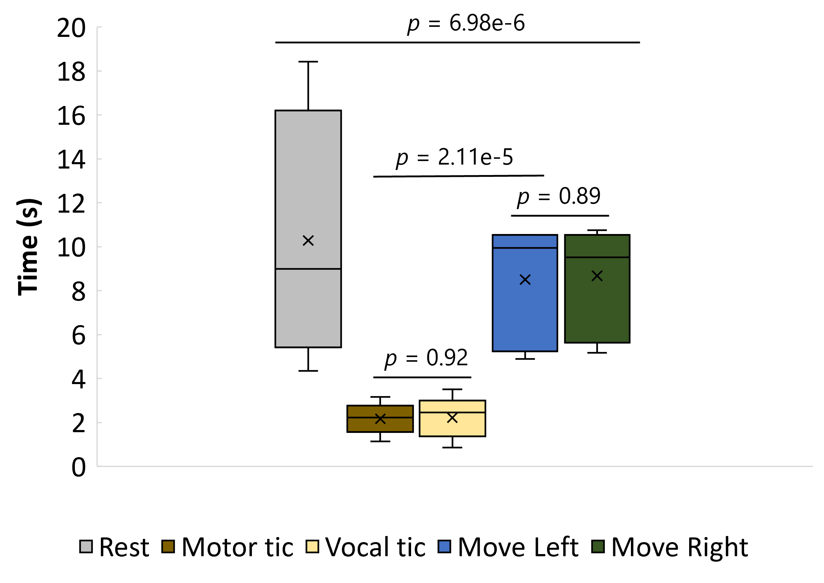
Supplementary Fig. 1. Class distribution of video annotation durations extracted from Label Studio. Significance was tested with a traditional Student's t-test at 5%, assuming unequal variances

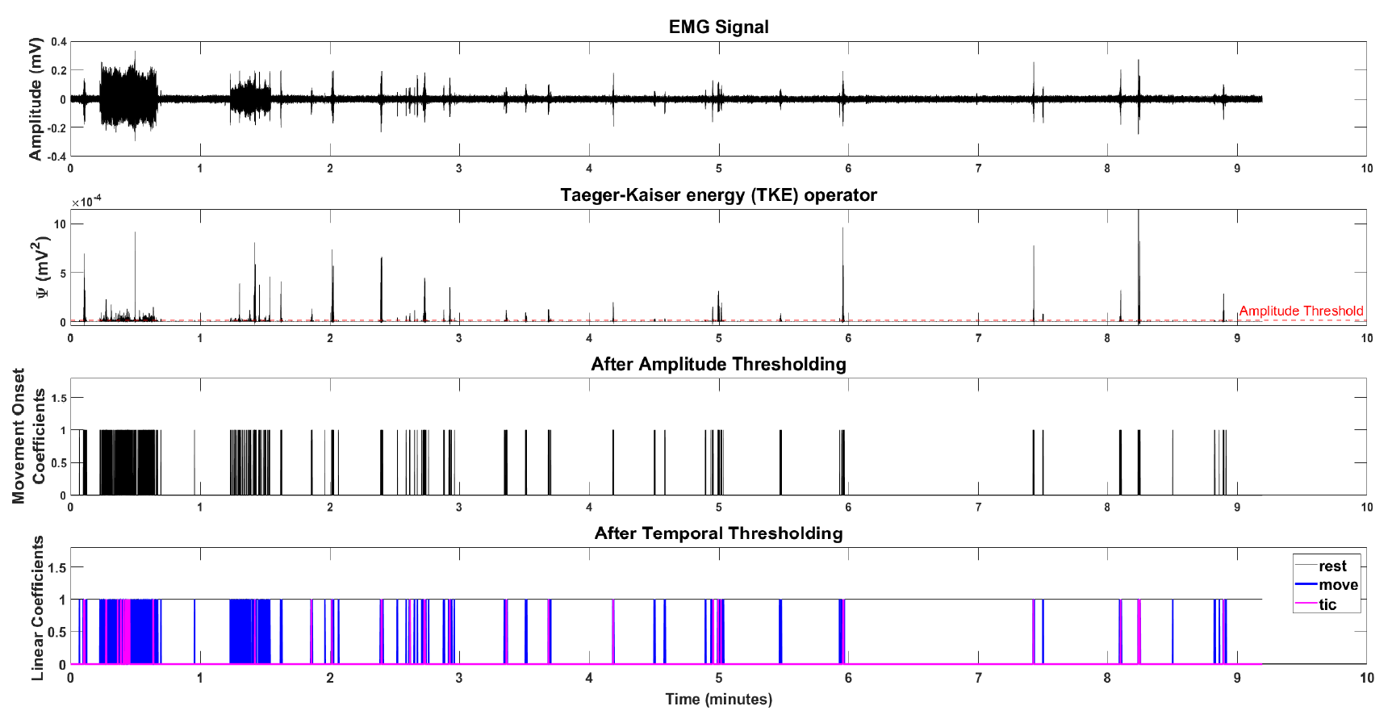
Supplementary Fig. 2. EMG data processing. Movement onset is detected using a double-threshold approach: a Teager-Kaiser computed amplitude threshold and a defined temporal threshold for ‘rest’, ‘move’, and ‘tic’. Abbreviations: EMG, electromyography

Supplementary Table 1: Participant selection for model training and evaluation
[detection][pretrain][train] | TS02, TS03, TS04, TS05, TS06, TS08, TS09, TS10, TS11
[detection][pretrain][val] | S5, S6
[detection][finetune][train] | S1, S2, S3, S4, S5, S6, S7
[detection][finetune][val] | S5, S6
[detection][finetune][test] | S2, S7
[prediction][pretrain][train] | TS02, TS03, TS04, TS05, TS06, TS08, TS09, TS10, TS11
[prediction][pretrain][val] | S5, S6
[prediction][finetune][train] | S1, S2, S3, S4, S5, S6, S7
[prediction][finetune][val] | S5, S6
[prediction][finetune][test] | S2, S7

Val, validation; S# and TS# represents participant ID.

