SUPPLEMENTAL MATERIALS
Supplemental Figure 1. Gradient maps for causes of death statewide, represented as 1) incidence of each grouped cause (left) and 2) SaTScan significant clusters, with a p-value of <0.01 (right). Clusters identified after the 10th significant cluster are grouped with it to conserve and simplify levels for each display.
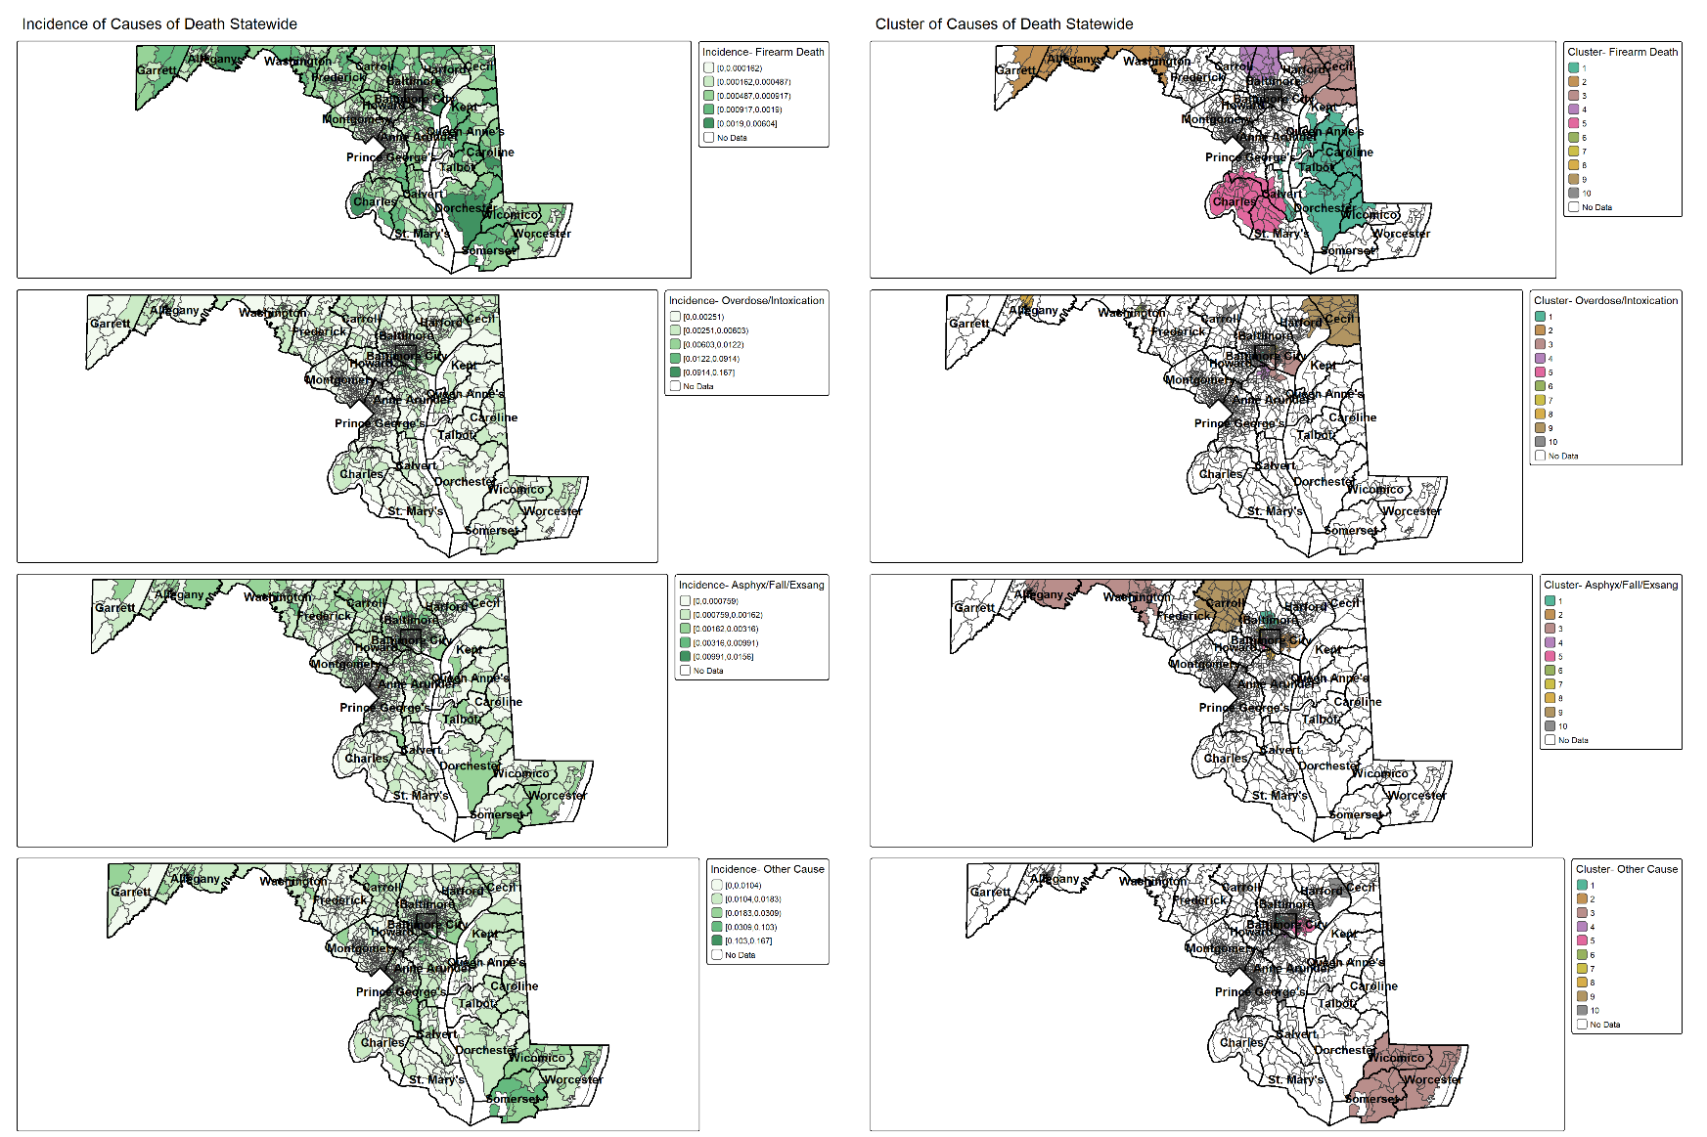

Supplemental Figure 2. Gradient maps for causes of death within Baltimore City, represented as 1) incidence of each grouped cause (left) and 2) SaTScan significant clusters, with a p-value of <0.01 (right). Clusters identified after the 10th significant cluster are grouped with it to conserve and simplify levels for each display.
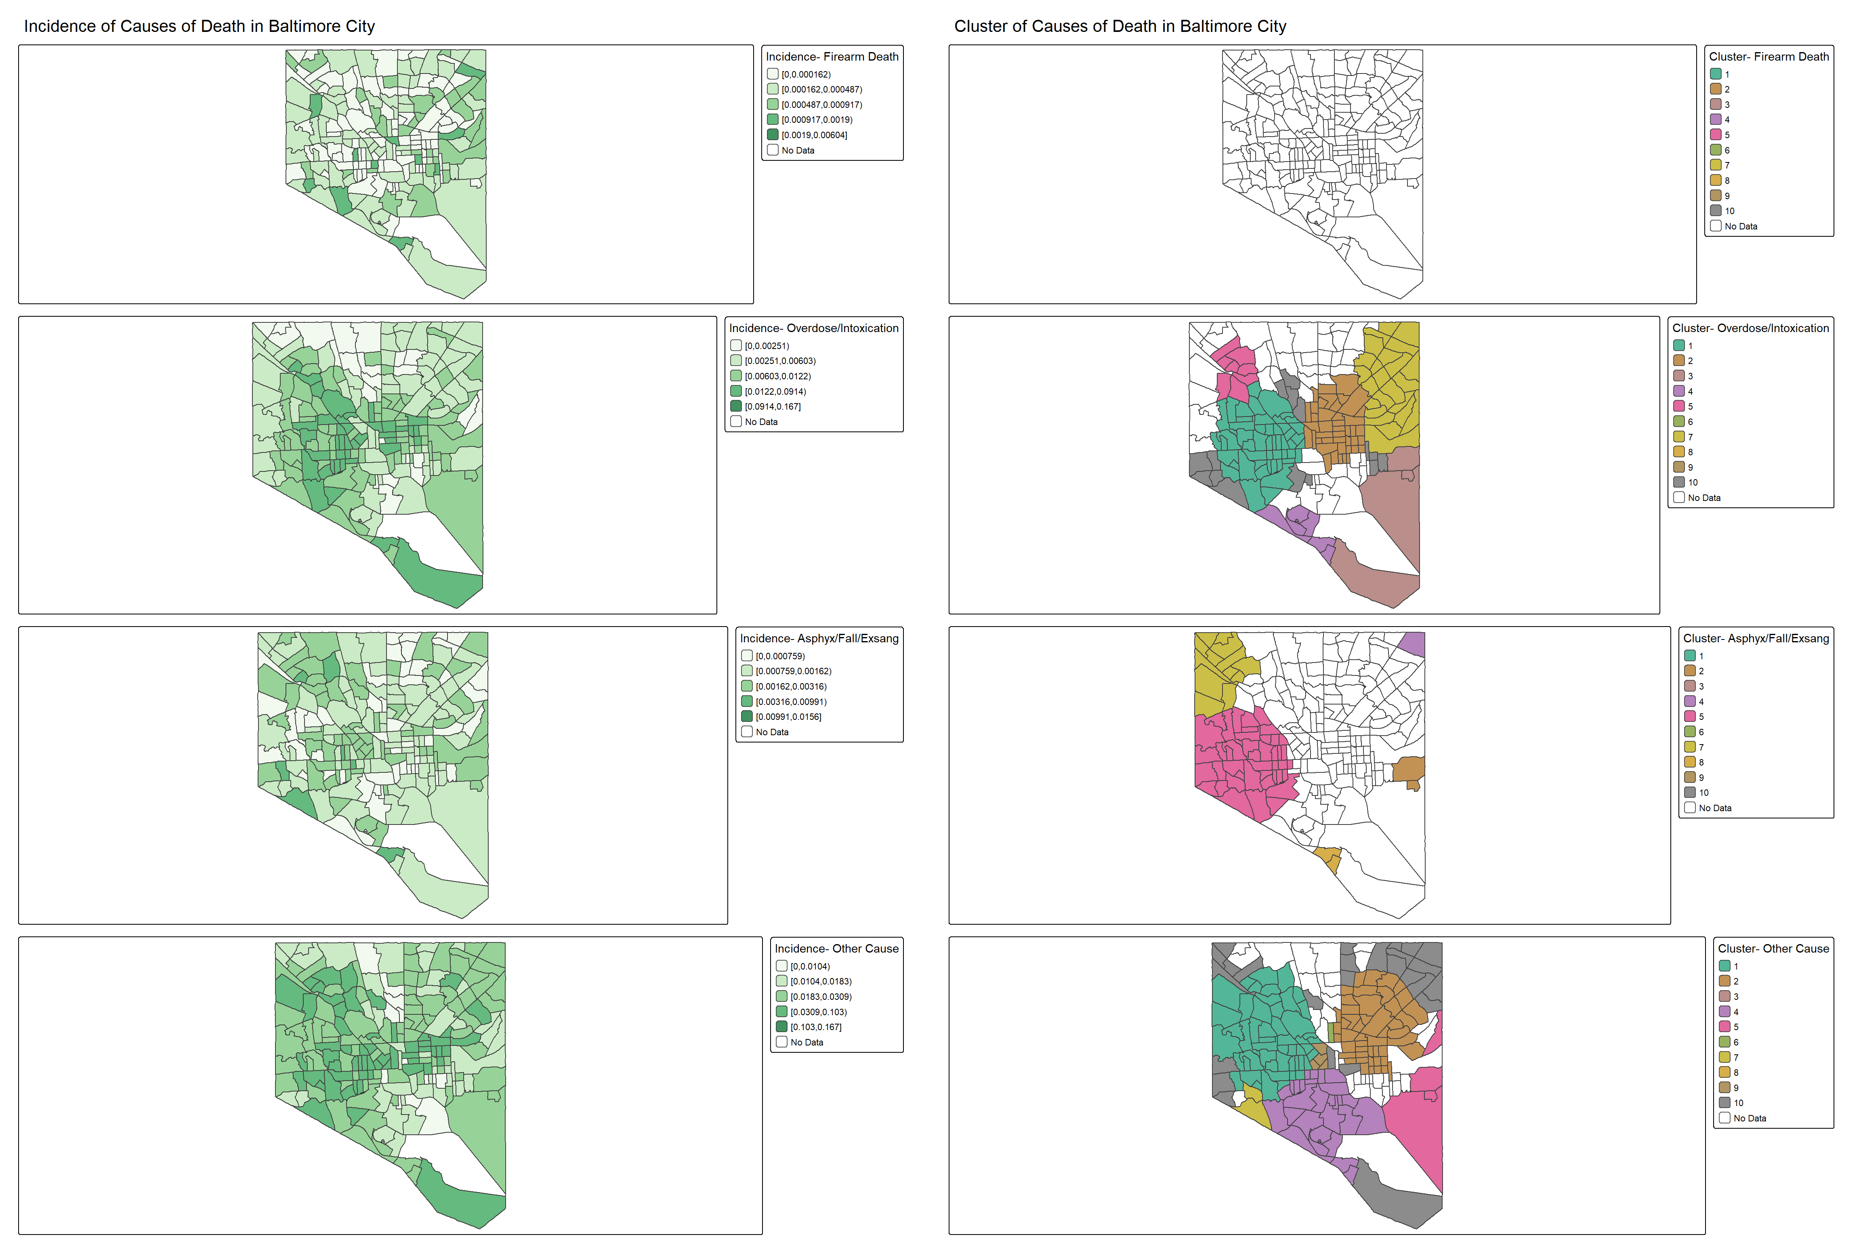
Supplemental Table 1. Demographic feature and jurisdiction of residence by evaluated manner of death in the selected medical examiner’s sample.
Feature | Suicide | Undetermined
Total | 4,824 | 10,616
Demographics
Avg age (std) | 48.5 (19.0) | 41.6 (15.5)
Female | 1,046 (21.7%) | 3,117 (29.4%)
Male | 3,780 (78.3%) | 7,476 (70.6%)
African American | 766 (15.9%) | 3,597 (33.9%)
Caucasian | 3,715 (77%) | 6,614 (62.4%)
Hispanic/Latinx | 135 (2.8%) | 216 (2%)
Other/Unknown | 210 (4.4%) | 169 (1.6%)
County of residence
Allegany | 91 (1.9%) | 201 (1.9%)
Anne Arundel | 545 (11.3%) | 1,078 (10.2%)
Baltimore | 1,205 (25%) | 4,934 (46.6%)
Calvert | 102 (2.1%) | 154 (1.5%)
Caroline | 42 (0.9%) | 74 (0.7%)
Carroll | 183 (3.8%) | 288 (2.7%)
Cecil | 136 (2.8%) | 262 (2.5%)
Charles | 137 (2.8%) | 189 (1.8%)
Dorchester | 42 (0.9%) | 53 (0.5%)
Frederick | 232 (4.8%) | 347 (3.3%)
Garrett | 34 (0.7%) | 23 (0.2%)
Harford | 255 (5.3%) | 476 (4.5%)
Howard | 212 (4.4%) | 271 (2.6%)
Kent | 23 (0.5%) | 26 (0.2%)
Montgomery | 612 (12.7%) | 586 (5.5%)
Prince George’s | 414 (8.6%) | 646 (6.1%)
Queen Anne’s | 58 (1.2%) | 70 (0.7%)
Somerset | 25 (0.5%) | 47 (0.4%)
St. Mary’s | 112 (2.3%) | 139 (1.3%)
Talbot | 36 (0.7%) | 58 (0.5%)
Washington | 188 (3.9%) | 405 (3.8%)
Wicomico | 91 (1.9%) | 178 (1.7%)
Worcester | 51 (1.1%) | 91 (0.9%)

Supplemental Table 2. SaTScan cluster statistics obtained in the main analysis for each outcome. Cluster numbers correspond to regions illustrated in Figures 1 & 2 of the manuscript. Clusters corresponding to a p-value < 0.01 are considered significant.
Outcome | Cluster | LLR statistic | p-value | Cases | Expected | Relative risk
Suicide | 1 | 26.6 | <0.001 | 269 | 168.2 | 1.600
 | 2 | 22.9 | <0.001 | 259 | 166.4 | 1.557
 | 3 | 21.8 | <0.001 | 247 | 158.7 | 1.557
 | 4 | 12.8 | 0.005 | 236 | 167.8 | 1.407
 | 5 | 12.5 | 0.006 | 245 | 176.2 | 1.390
Undetermined | 1 | 875.0 | <0.001 | 1120 | 242.3 | 4.622
 | 2 | 375.4 | <0.001 | 679 | 194.6 | 3.488
 | 3 | 312.1 | <0.001 | 865 | 330.3 | 2.619
 | 4 | 191.3 | <0.001 | 404 | 128.3 | 3.148
 | 5 | 130.3 | <0.001 | 191 | 45.3 | 4.219
 | 6 | 70.1 | <0.001 | 407 | 214.4 | 1.898
 | 7 | 43.8 | <0.001 | 110 | 38.8 | 2.839
 | 8 | 39.6 | <0.001 | 225 | 117.1 | 1.921
 | 9 | 28.1 | <0.001 | 93 | 38.2 | 2.436
 | 10 | 27.9 | <0.001 | 396 | 267.1 | 1.483
 | 11 | 27.4 | <0.001 | 38 | 8.5 | 4.457
 | 12 | 23.2 | <0.001 | 30 | 6.3 | 4.771
 | 13 | 21.2 | <0.001 | 74 | 31.2 | 2.375
 | 14 | 17.7 | <0.001 | 129 | 72.9 | 1.769
 | 15 | 16.6 | <0.001 | 23 | 5.1 | 4.474
 | 16 | 16.3 | <0.001 | 22 | 4.8 | 4.575
 | 17 | 15.0 | <0.001 | 92 | 49.0 | 1.876
 | 18 | 14.3 | <0.001 | 48 | 19.8 | 2.419

Supplemental Table 3. Tract-level average incidence per 100,000 of each grouped cause of death, across binned model response and SaTScan clusters for groupings of each manner of death (top: suicide; bottom: undetermined). Clusters are identified as follows: a) C1, the primary cluster associated with the highest likelihood ratio, b) C2, the cluster associated with the second highest likelihood ratio, c) C3+ all remaining clusters identified as having a significant statistic where p<0.01, and d) all regions not grouped in SaTScan clusters, and therefore not significantly elevated for undetermined death incidence

 | Suicide groupings
 | Model response |  |  |  | SaTScan clusters
Feature | ≤50th %tile | 50th-74th %tile | 75th-89th %tile | ≥90th %tile | Not Clustered | C3+ | C2 | C1
Average gun fatality incidence | 26.3 (39.3) | 42.3 (42.4) | 51.4 (40.8) | 54.6 (34.3) | 30.6 (34.0) | 69.7 (63.8) | 63.2 (46.8) | 72.0 (51.2)
Average overdose/intoxication incidence | 318.8 (407.2) | 295.8 (277.1) | 318.7 (255.7) | 262.1 (156.2) | 311.7 (590.8) | 245.7 (138.8) | 543.1 (344.7) | 474.8 (411.8)
Average incidence of asphyxiation, falls and exsanguination | 98.6 (108.6) | 115.8 (87.3) | 121.3 (86.0) | 96.1 (66.1) | 102.2 (98.4) | 100.2 (71.1) | 142.5 (79.1) | 179.0 (104.1)
Average incidence of other causes | 1,495.1 (1,032.1) | 1,285.4 (817.4) | 1,322.0 (711.4) | 1,180.7 (485.7) | 1,403.4 (1,044.4) | 1,116.5 (472.7) | 1,729.8 (642.6) | 1,619.8 (707.2)
 | Undetermined groupings
 | Model response |  |  |  | SaTScan clusters
Feature | ≤50th %tile | 50th-74th %tile | 75th-89th %tile | ≥90th %tile | Not Clustered | C3+ | C2 | C1
Average gun fatality incidence | 29.1 (34.8) | 43.8 (49.8) | 47.9 (44.4) | 41.8 (36.4) | 35.2 (41.1) | 51.5 (43.2) | 22.8 (35.8) | 22.8 (28.5)
Average overdose/intoxication incidence | 151.5 (122.9) | 295.1 (215.5) | 481.2 (368.7) | 853.9 (532.7) | 198.2 (516.5) | 606.0 (319.7) | 948.9 (517.4) | 1,209.9 (529.2)
Average incidence of asphyxiation, falls and exsanguination | 91.2 (106.2) | 106.9 (75.1) | 125.0 (89.4) | 149.8 (91.2) | 93.5 (93.2) | 152.5 (95.8) | 125.8 (72.0) | 171.3 (116.5)
Average incidence of other causes | 1,074.2 (648.8) | 1,338.9 (736.1) | 1,789.8 (1,014.3) | 2,443.2 (1,123.8) | 1,148.2 (794.8) | 1,963.3 (805.1) | 2,586.1 (1,375.3) | 3,384.0 (1,152.1)

