Supplemental Material
White shark (Carcharodon carcharias) predation on an adult Atlantic sturgeon (Acipenser oxyrinchus): first direct evidence from Gulf of Maine
Environmental Biology of Fishes, Brief Communication
Michael Nguyen (contact author)¹
John Mohan¹

Email address for contact author: Michael.nguyen@myfwc.com
¹Florida Fish and Wildlife Research Institute, Florida Fish and Wildlife Conservation Commission, 100 8th Ave SE, St. Petersburg, FL 33701, USA

²North Carolina Division of Marine Fisheries, 943 Washington Square Mall, Washington NC 27889, USA

Necropsy

Upon closer examination of the specimen, we noted that the sturgeon had extensive external damage heavily concentrated on the left rear flank (Fig. S1). During necropsy, we measured the total and fork length at 224 cm and 199 cm respectively (Fig. S2a). Interorbital width was 14.9 cm and mouth width was 5.10 cm (Fig. S2bc). Head length was measured at 49 cm (Fig. S2d).

We made an initial incision ventrally exposing ovaries indicating maturity. There were no indications of any internal abnormalities or visible damage. All organs appeared usual and the specimen showed normal amounts of subcutaneous fat reserves precluding any predispositions (Fig. S3). Exclusive of recent injuries, skin and scute conditions appeared typical. The left pectoral was absent, clean scarring indicated a successfully healed preexisting injury (Fig. S4).

Right side

A deep scratch along the base of the dorsal fin, scrape along the mid-dorsal fin. Small puncture on flank between the pelvic and anal fin (Fig. S5). Scratch present on lateral scute. There was a deep laceration on the right ventral side with more puncture marks present behind termination of pelvic fin (Fig. S6). The right pelvic fin was missing large portions (Fig. S7). Surface scratches began on flank 1/3 distance from the pelvic and pectoral fin (Fig. S8).

Left side

Injury to upper caudal lobe (Fig. S9). Broken scute by left lateral caudal peduncle (Fig. S10). Scratch on left side of anal fin (Fig. S11). Large avulsion of scutes with trailing laceration (Fig. S12). Slight abrasion can be seen under trail on the ventral portion. Large portion of flank and dorsal region missing skin, visceral fat, and musculature (Fig. S13). Edges of injury are jagged. Surrounding areas show trailing laceration similar to injury located farther back on the body (Fig. S14).

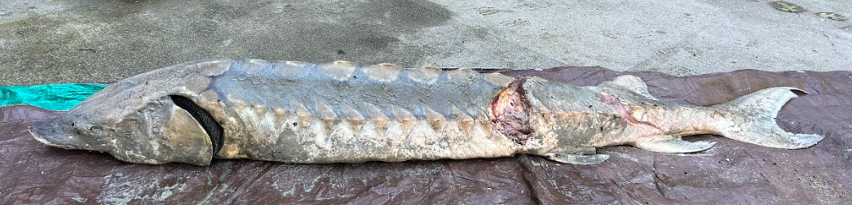

Fig. S1 Full body image of both large, inflicted areas

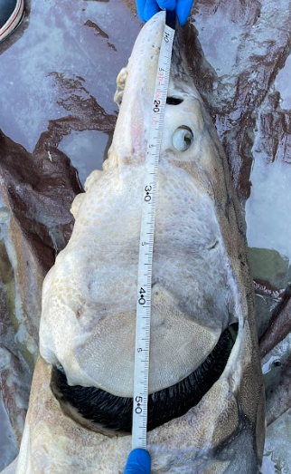
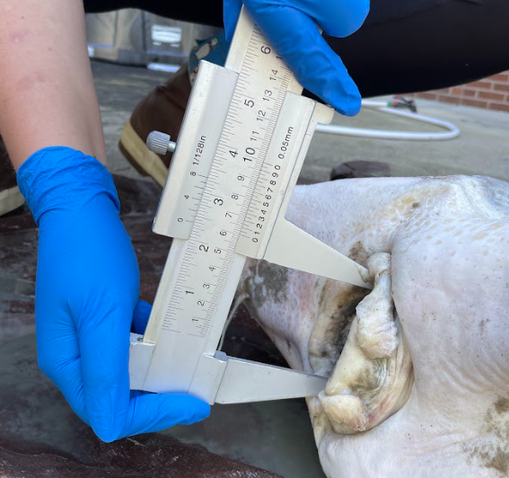
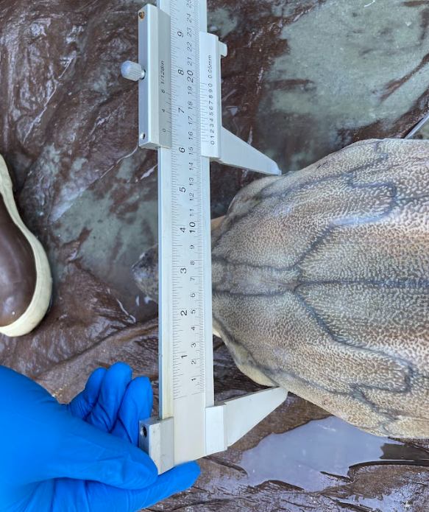
D
C
B
A
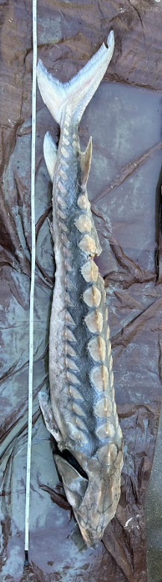
Fig. S2 (A) Atlantic sturgeon specimen lying on ventral side next to tape measure (B) specimen interorbital width (C) specimen mouth width (D) specimen head length

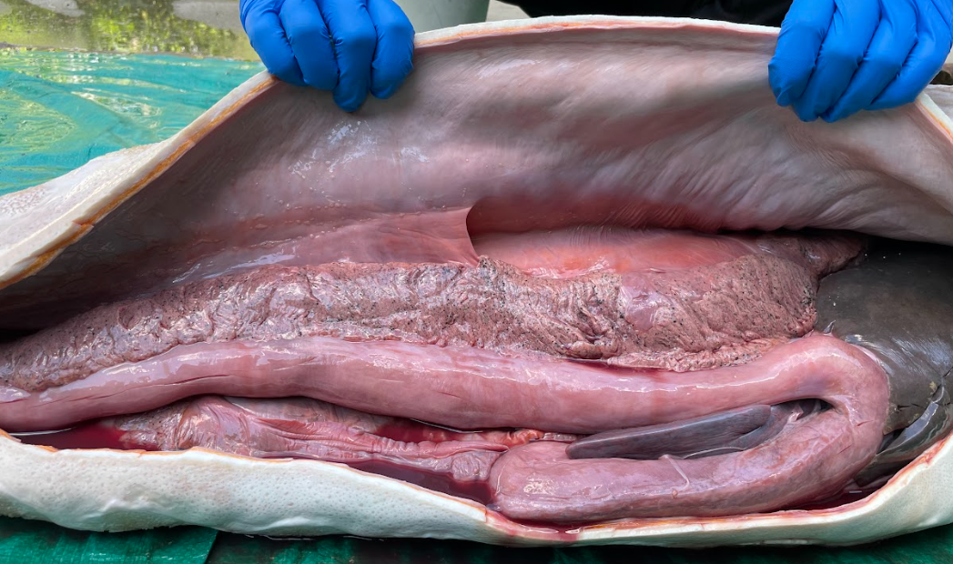
Fig. S3 Atlantic sturgeon specimen mature ovaries (freckled) and fat (orange) exposed

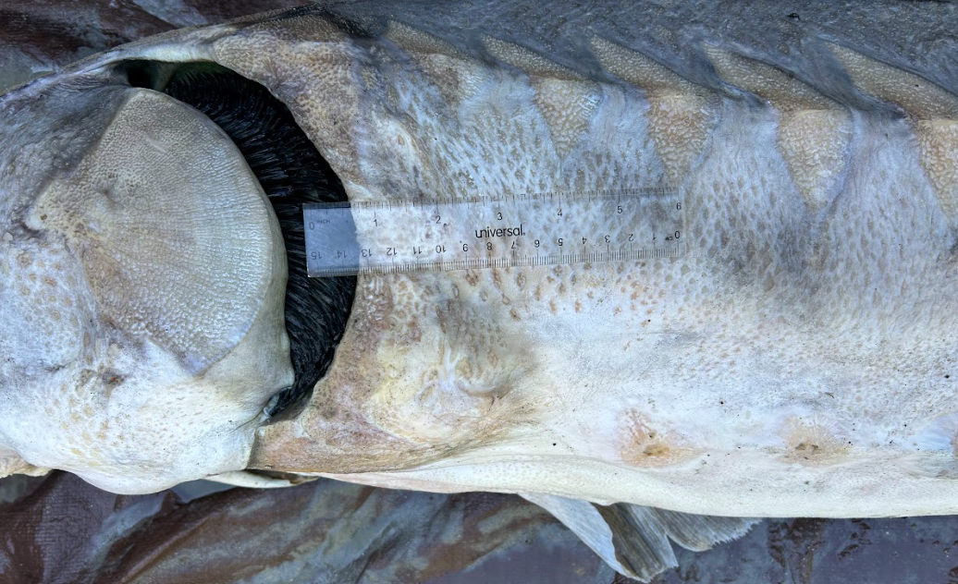
Fig. S4 Left pectoral fin missing, clean healed area

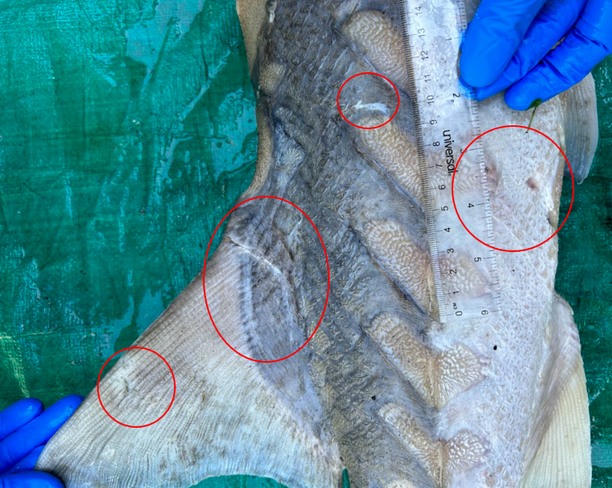

Fig. S5 Deep scratch along base of dorsal fin, scrape along mid-dorsal fin. Small puncture on flank between pelvic and anal fin. Scratch on scute

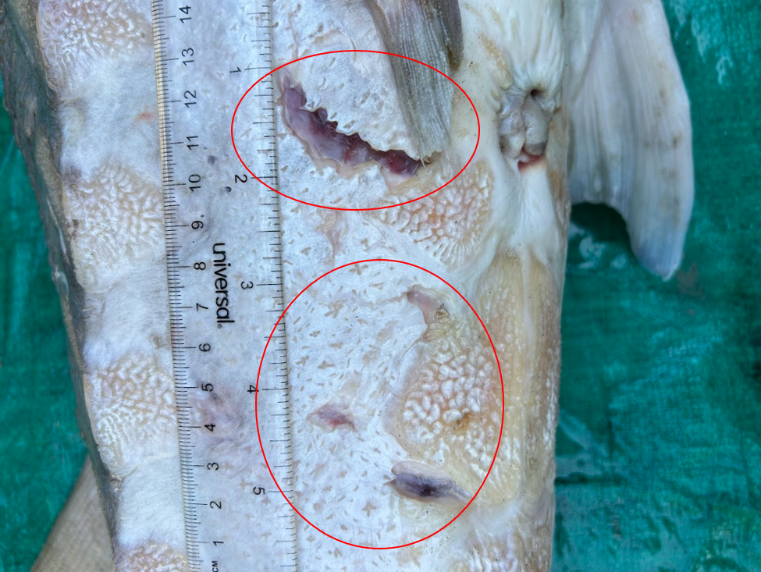
Fig. S6 Deep laceration on right ventral. Puncture marks present. Right pelvic missing large portions

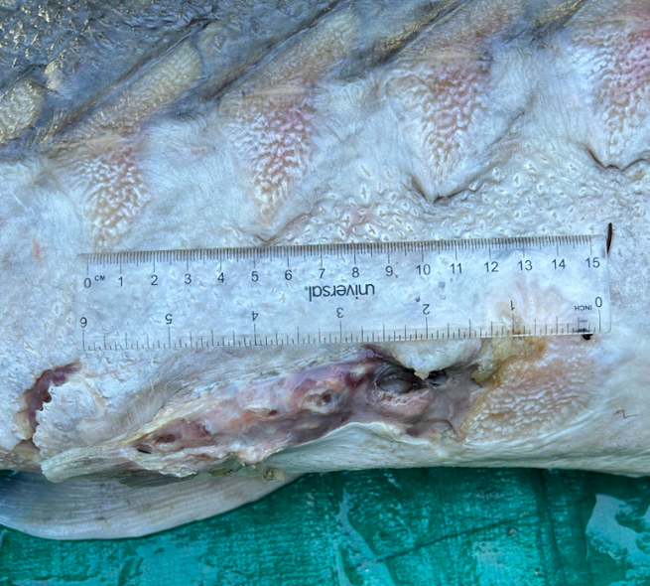
Fig. S7 Damaged right pelvic fin, deep laceration behind termination of fin

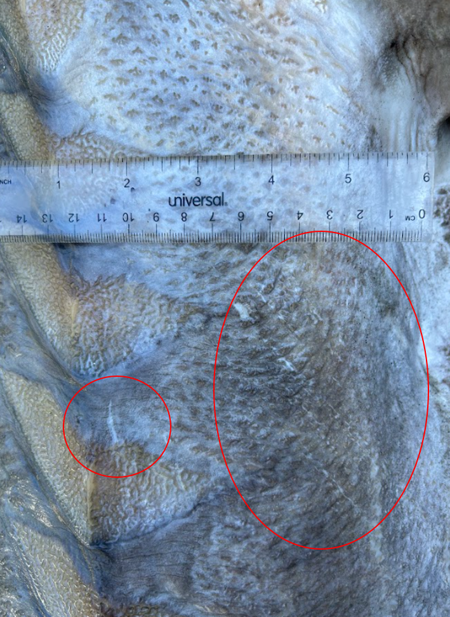
Fig. S8 Scratch on skin of right flank 1/3 distance from pelvic and pectoral fin

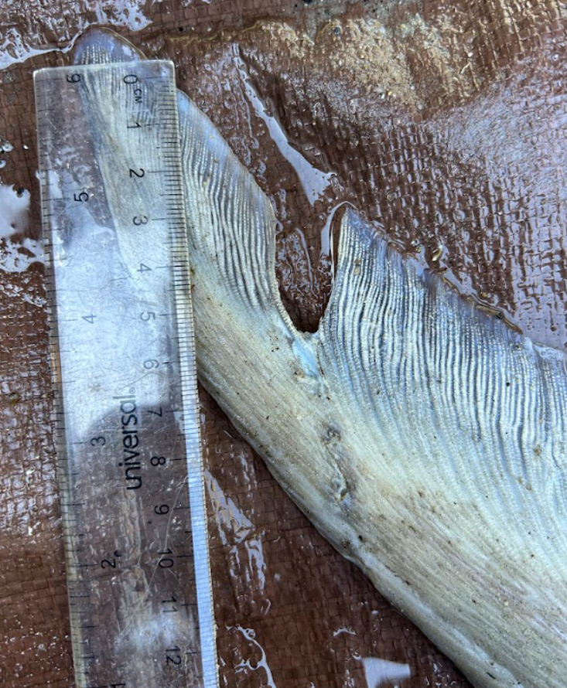
Fig. S9 Injury to upper caudal lobe
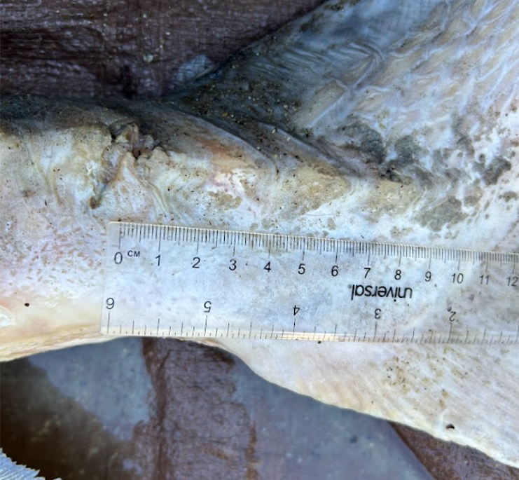
Fig. S10 Broken scute by left caudal peduncle

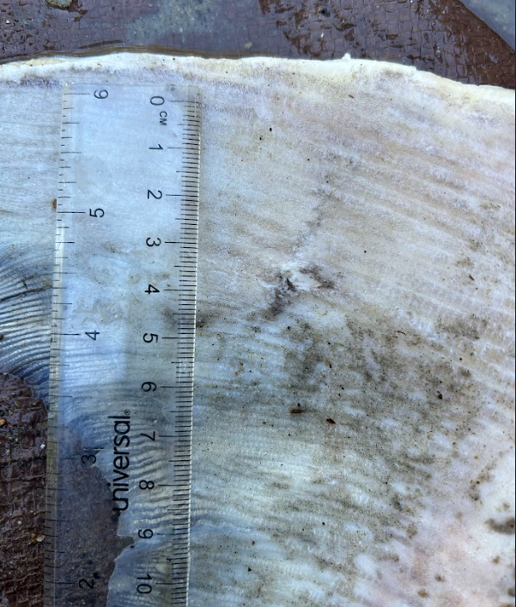
Fig. S11 Scratch on left side of anal fin
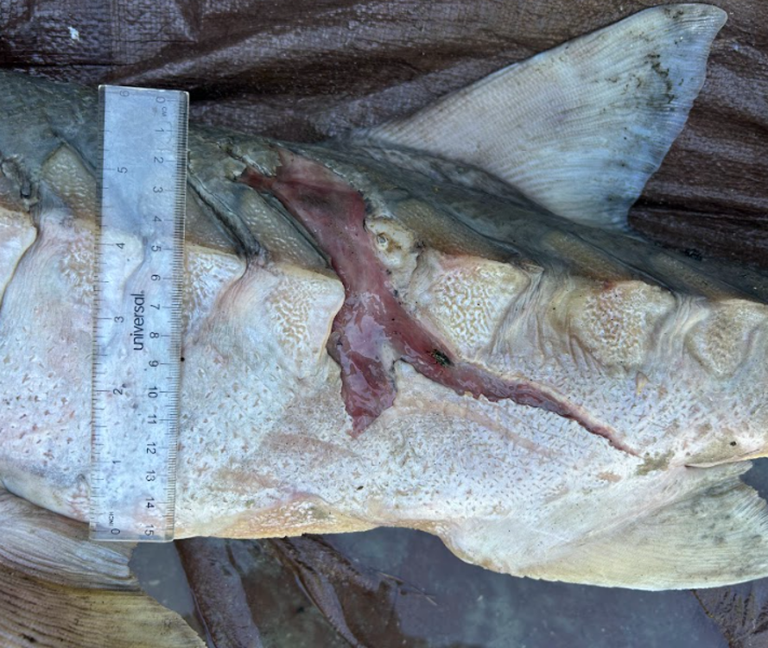
Fig. S12 Avulsion of scutes with a trailing laceration. Abrasion can be seen under the trail on the ventral portion

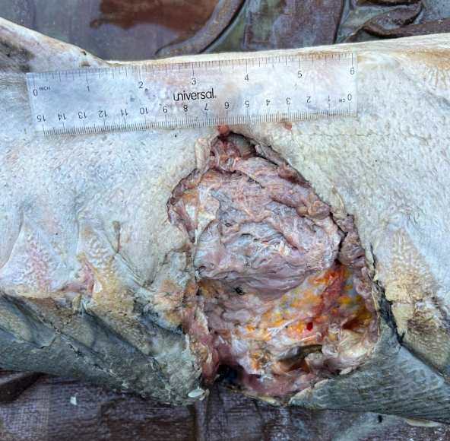

Fig. S13 Large portion of flank and dorsal region missing skin, visceral fat, and musculature. Edges of injury are jagged. Surrounding areas show trailing laceration similar to the injury located further back on the body

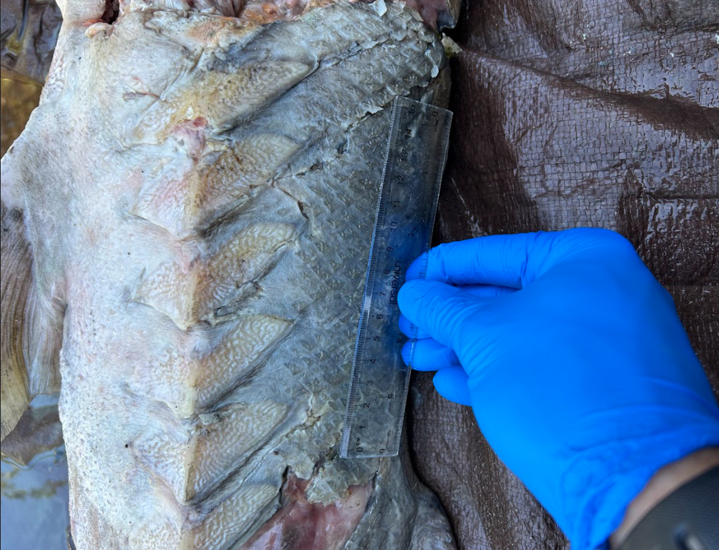
Fig. S14 Left view of both wounds, special notice to the trailing lacerations at the back of the large missing region

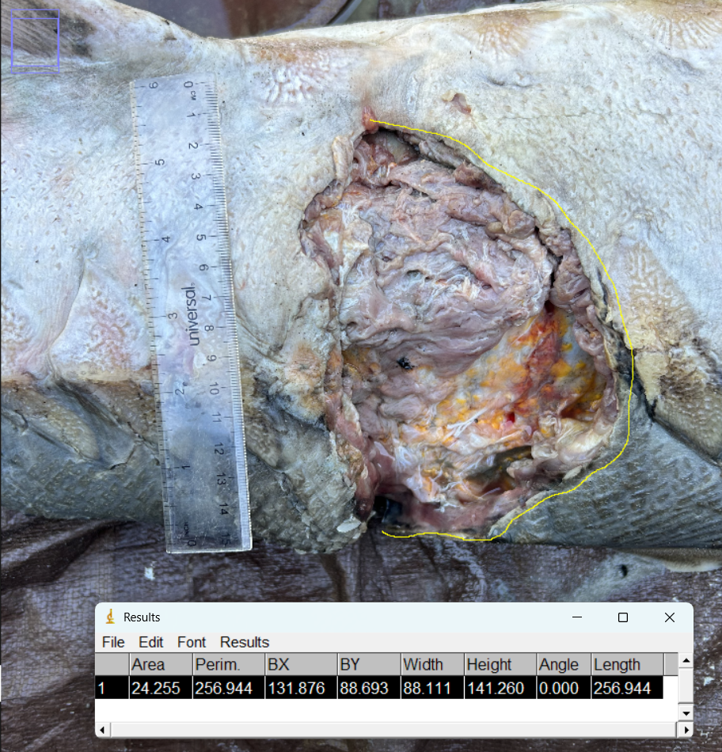
Interdental Distance (IDD) and Bite Circumference (BC) Calculations Using Lowry et al. 2009

Image was imported to Imagej. Pixel was calibrated to known scale, and a freeform line (yellow) was drawn around the margin of the bite circumference. BC = 256.944 mm. BC is specific to upper and lower jaw;
TL estimate (mm):
Upper jaw = 1540
Lower jaw = 1836
*BC is the distance along the arc of the bite on the object, in mm, and will likely underestimate the shark size unless the entire tooth-bearing portion of the jaw was used. (Lowry et al., 2009)*
Estimated white shark total length (x̄ jaw) = 1.68-m

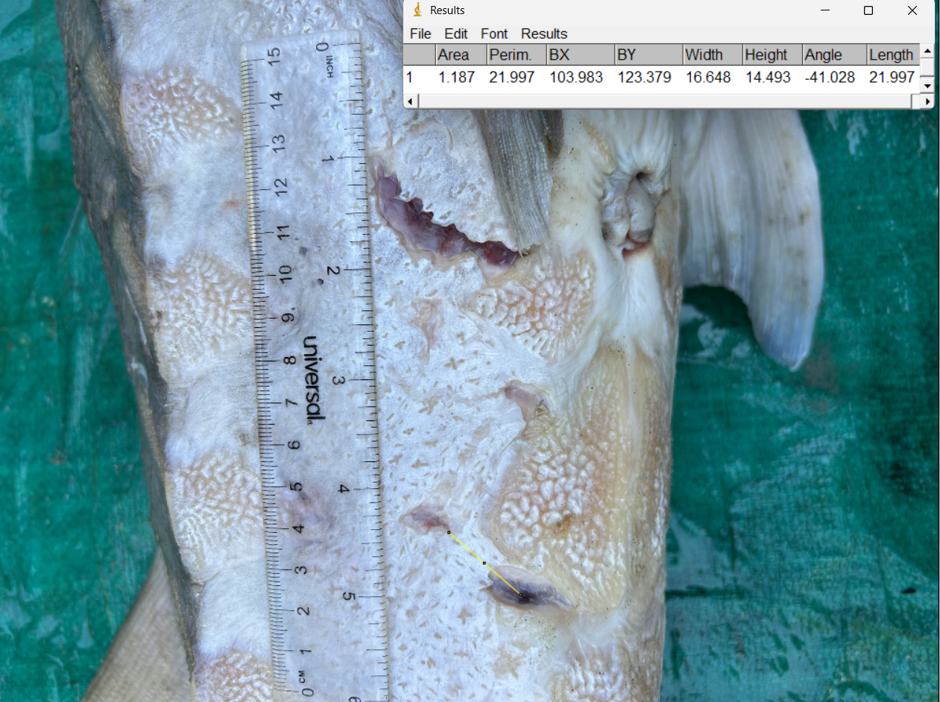
Image was imported to Imagej. Pixel was calibrated to known scale, and a line (yellow) was drawn from the wound bed to the closest wound edge (tooth tip to tooth tip i.e. IDD). IDD = 21.997 mm. IDD is specific to upper and lower jaw;
TL estimate (mm):
Upper jaw = 2681
Lower jaw = 2518
Estimated white shark total length (x̄ jaw) = 2.59-m

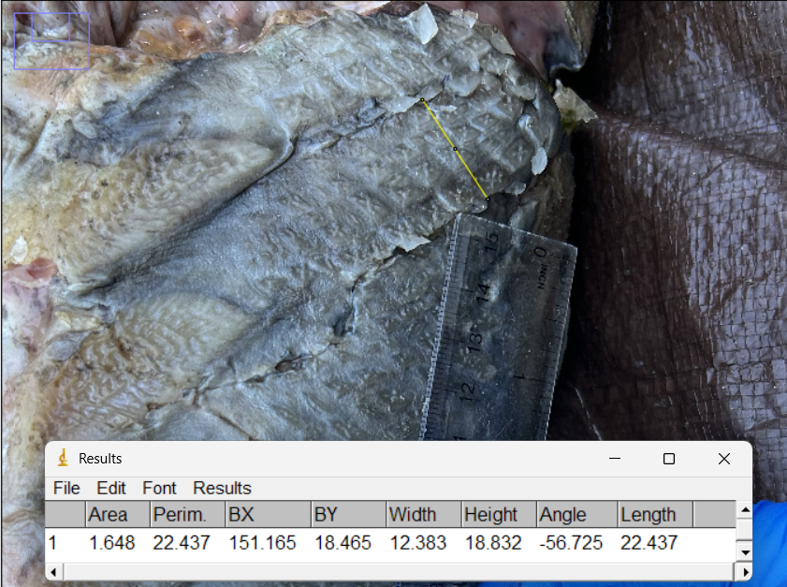
Image was imported to Imagej. Pixel was calibrated to known scale, and a line (yellow) was drawn from the wound bed to the closest wound edge (tooth tip to tooth tip i.e. IDD). IDD = 22.437 mm. IDD is specific to upper and lower jaw;
TL estimate (mm):
Upper jaw = 2735
Lower jaw = 2573
Estimated white shark total length (x̄ jaw) = 2.65-m

Lowry D, Castro ALF, Mara K, Whitenack LB, Delius B, Burgess GH, Motta P (2009) Determining shark size from forensic analysis of bite damage. Mar Biol 156:2483–2492. https://doi.org/10.1007/s00227-009-1273-3

Shark ID | Date | Sex | TL (m) | Life Stage
WS_01† | 8/21/2024 | M | 2.45 | Juvenile
WS_02† | 8/21/2024 | F | 2.79 | Juvenile
WS_03 | 8/25/2024 | M | 2.43 | Juvenile
WS_04 | 8/25/2024 | M | 2.63 | Juvenile
WS_05 | 8/25/2024 | M | 2.75 | Juvenile
WS_06 | 8/26/2024 | M | 2.10 | Juvenile
WS_07 | 8/26/2025 | M | 2.54 | Juvenile
WS_08 | 8/26/2025 | F | 2.48 | Juvenile
WS_09 | 9/20/2025 | M | 2.08 | Juvenile
WS_10 | 9/21/2025 | M | 2.54 | Juvenile
WS_11 | 9/22/2025 | M | 2.08 | Juvenile
WS_12 | 9/22/2025 | F | 2.32 | Juvenile
WS_13 | 7/21/2026 | U | 2.60 | Juvenile
WS_14 | 8/2/2026 | F | 2.38 | Juvenile
WS_15 | 8/2/2026 | F | 2.50 | Juvenile
WS_16 | 8/2/2026 | M | 2.66 | Juvenile
WS_17 | 8/3/2026 | F | 2.71 | Juvenile
WS_18 | 8/3/2026 | M | 2.35 | Juvenile
WS_19 | 8/3/2026 | M | 2.23 | Juvenile
WS_20 | 8/3/2026 | F | 2.23 | Juvenile
WS_21 | 8/5/2026 | M | 2.49 | Juvenile
WS_22 | 8/5/2026 | F | 2.49 | Juvenile
† Individuals measured under Maine Department of Marine Resources Special License # 2024-23-00
Table S1 Date, sex, and total length (m) of white sharks measured in Saco Bay, ME, from 2024-2026. Two individuals (marked †) were measured under Maine Department of Marine Resources Special License # 2024-23-00, issued to Dr. Charles Tilburg; The remaining 20 were measured opportunistically from catch events and did not require a permit. Unpublished data, courtesy of Michael Nguyen, 2026; not for reproduction without permission of the author.

