SUPPORTING INFO
Table S1. Source data for Figure 4 and S5. Mean object total Cy5 intensity per microvessel (×10⁵ AU, mean ± SD, n = 4 microvessels) for anti-hICAM-1- and isotype-conjugated CP26 and CP26-M1 at 1 h and 6 h incubation, in fixed conditions (15° perfusion angle; 4 pmol NP); single HUVEC donor, single experimental run. Values are reported to three decimal places to permit closer verification of Table 1 and the fold-differences and background-subtracted net specific binding reported in Table 2.
1 h incubation | TNF-α 0 ng/mL | TNF-α 1 ng/mL | TNF-α 10 ng/mL
ICAM-1 CP26 | 4.765 ± 0.773 | 83.496 ± 5.383 | 191.533 ± 9.956
ICAM-1 CP26-M1 | 0.954 ± 0.099 | 45.902 ± 12.712 | 81.515 ± 8.477
Isotype CP26 | 1.486 ± 0.634 | 0.987 ± 0.322 | 2.123 ± 0.910
Isotype CP26-M1 | 0.392 ± 0.175 | 0.613 ± 0.298 | 1.470 ± 0.288

6 h incubation | TNF-α 0 ng/mL | TNF-α 1 ng/mL | TNF-α 10 ng/mL
ICAM-1 CP26 | 16.059 ± 2.202 | 93.940 ± 8.445 | 162.119 ± 8.534
ICAM-1 CP26-M1 | 5.188 ± 0.738 | 53.848 ± 3.422 | 61.352 ± 5.301
Isotype CP26 | 1.793 ± 0.447 | 2.406 ± 0.742 | 4.036 ± 1.366
Isotype CP26-M1 | 0.813 ± 0.244 | 1.971 ± 0.367 | 1.337 ± 0.158

Figure S1. Native agarose gel electrophoresis of CP26 and CP26-M1 at each production stage. Scaffold and assembled nanostructures were analyzed at successive stages of production under native conditions. Lane assignments and observed migration behavior are summarized in the accompanying table. 2% agarose, 0.5× TBE with 6 mM MgCl₂.
Lane | Sample | CP26 | CP26-M1
1 | 1 kb ladder | Size reference | Size reference
2 | p8064 scaffold | Slow migration (ssDNA flexibility) | Slow migration (ssDNA flexibility)
3 | Assembled monomer | Strong leading band; excess staples at bottom; upper smear (multimers/aggregates) | Strong leading band; excess staples at bottom; upper smear (multimers/aggregates)
4 | Post-PEG purification | Strong leading band; staples removed; upper smear remains | Strong leading band; staples removed; upper smear remains
5 | Post-streptavidin | Sharp leading band; slight upward shift confirms binding; upper smear remains | Sharp leading band; slight upward shift confirms binding; upper smear remains
6 | PEG-polylysine coated (1× PBS) | Band near well; charge neutralization | Band near well; charge neutralization

Figure S2. Transmission electron microscopy of CP26 and CP26-M1 monomers. Representative TEM images of (A) PEG-polylysine-coated CP26 and (B) Coated CP26-M1 monomers at 5 nM in 1× PBS. (C) pre-PEG coating, where streptavidin is visible as a globular density at protrusion tip for CP26 (see red arrows). The majority of imaged structures show correct L-shaped monomer assembly. Scale bar = 100 nm.
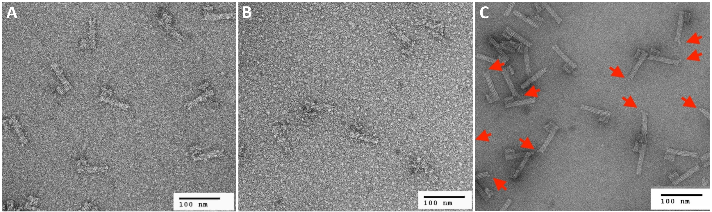

Figure S3. HUVEC cell viability following TNF-α treatment and nanoparticle exposure (15° perfusion angle). Hoechst 33342-derived cell counts per microvessel at 1 h (left column) and 6 h (right column). Top row: Phase 1 conditions (7.5 pmol; TNF-α: 0, 10, 100 ng/mL); bottom row: Phase 2 conditions (4 pmol; TNF-α: 0, 1, 10 ng/mL). n = 4 microvessels; n = 2 for empty vehicle controls; error bars represent SD.
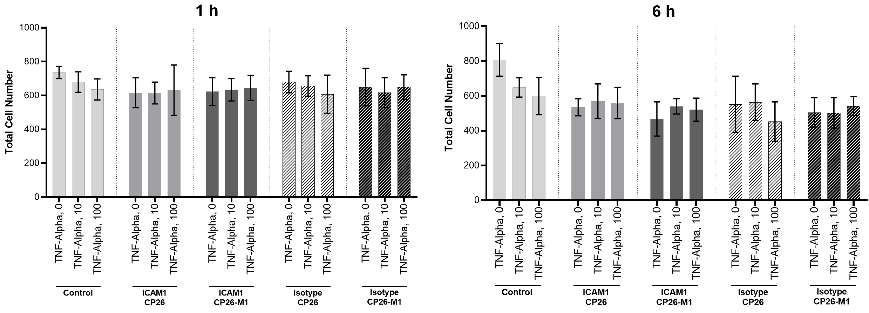
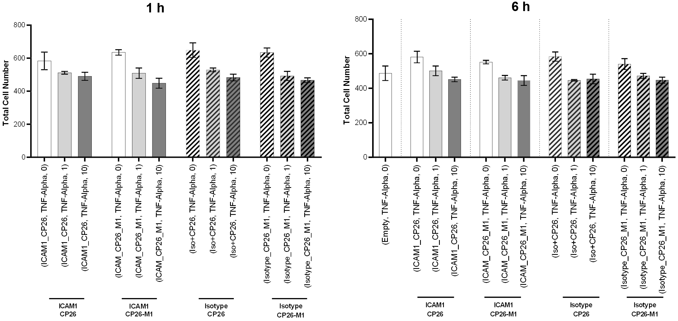

Figure S4. Cellular association of anti-hICAM-1-functionalized CP26 and CP26-M1 at 7.5 pmol. Microvessels were incubated with NPs for 1 or 6 h at 0, 10, or 100 ng/mL TNF-α under fixed conditions (15° perfusion angle). See Results for interpretation and rationale for the 4 pmol primary dataset. n = 4 microvessels; n = 2 for empty vehicle controls; error bars represent standard deviation. SSMD as in Figure 4.
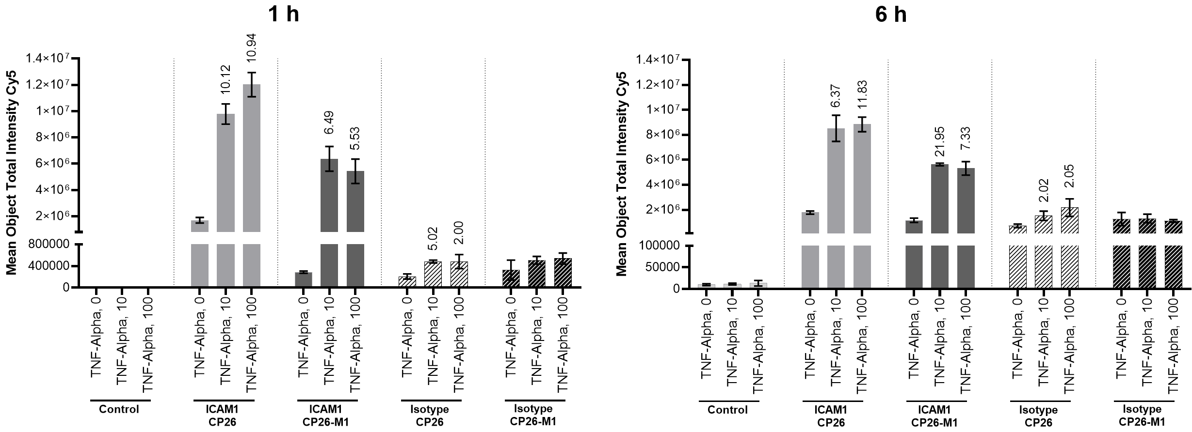

Figure S5. ICAM-1-specific nanoparticle binding at 6 h incubation. As in Figure 4, but following 6 h incubation. SSMD values (Table 1, 6 h). Source data in Table S1.
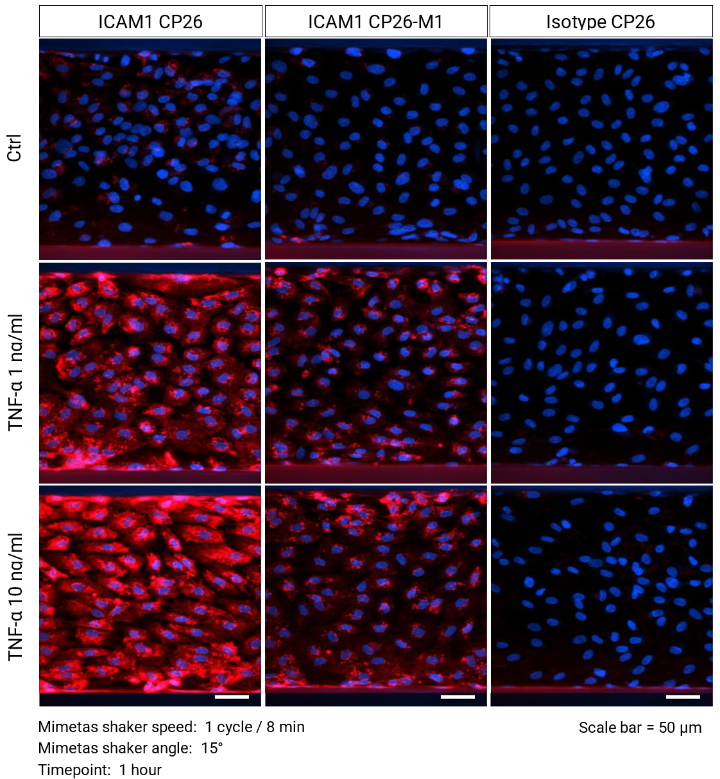
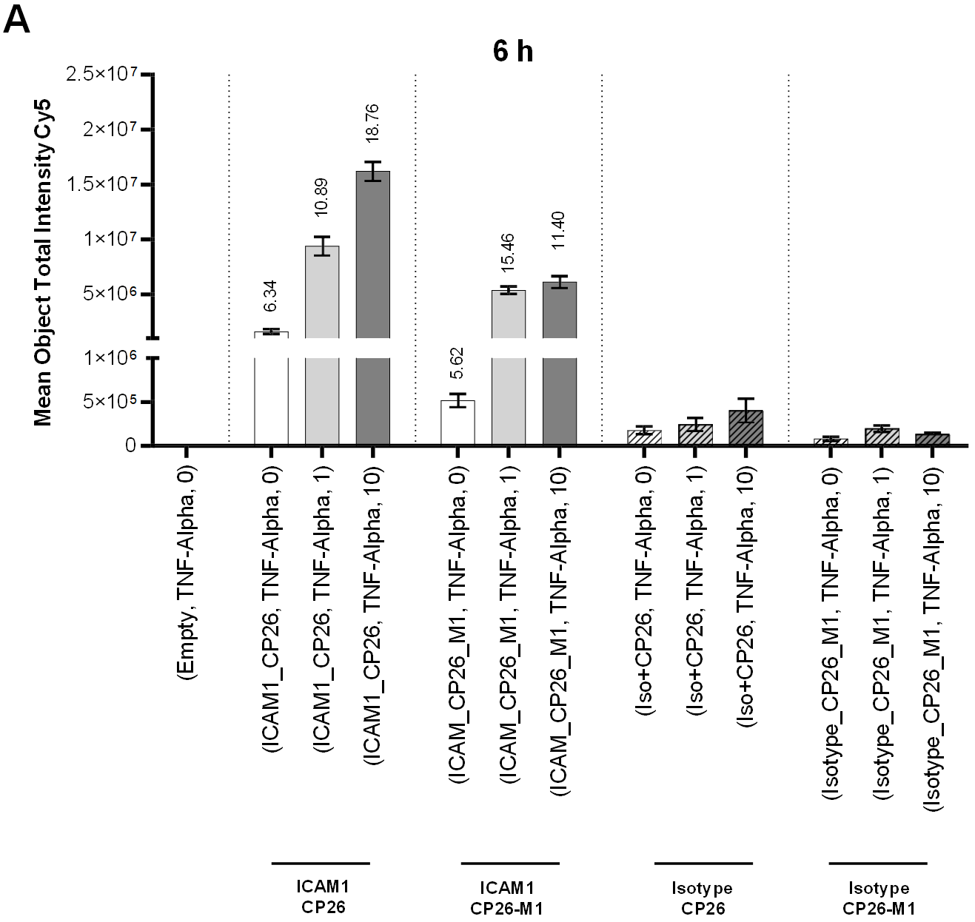
B

Figure S6. Hoechst spectral bleedthrough artifact and algorithm-based correction. (Top Row: A–C) Representative fluorescence micrographs: Hoechst 33342 droplets in Hoechst channel (A, blue; yellow arrows), corresponding spurious signal in Cy5 channel (B, red; yellow arrows), and A/B composite overlay confirming co-localization (C). (Bottom Row: D–F) Object-filtering algorithm (see Methods). (D) Hoechst-channel objects prior to filtering. (E) Objects classified as valid (blue) or rejected (yellow). (F) Final filtered output: valid Cy5 spots (green) and rejected objects (orange).
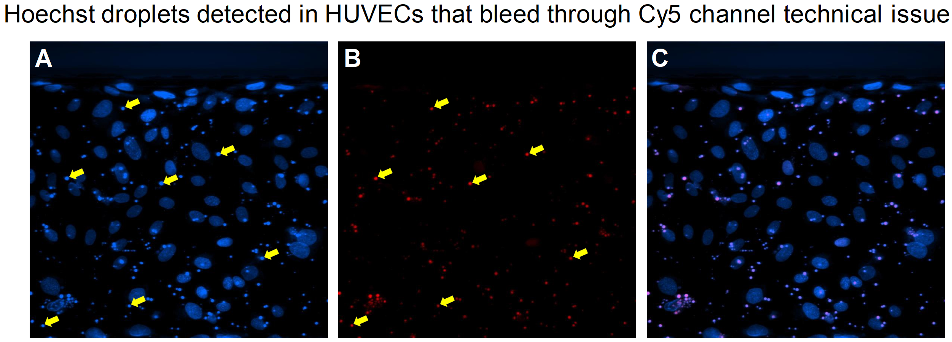
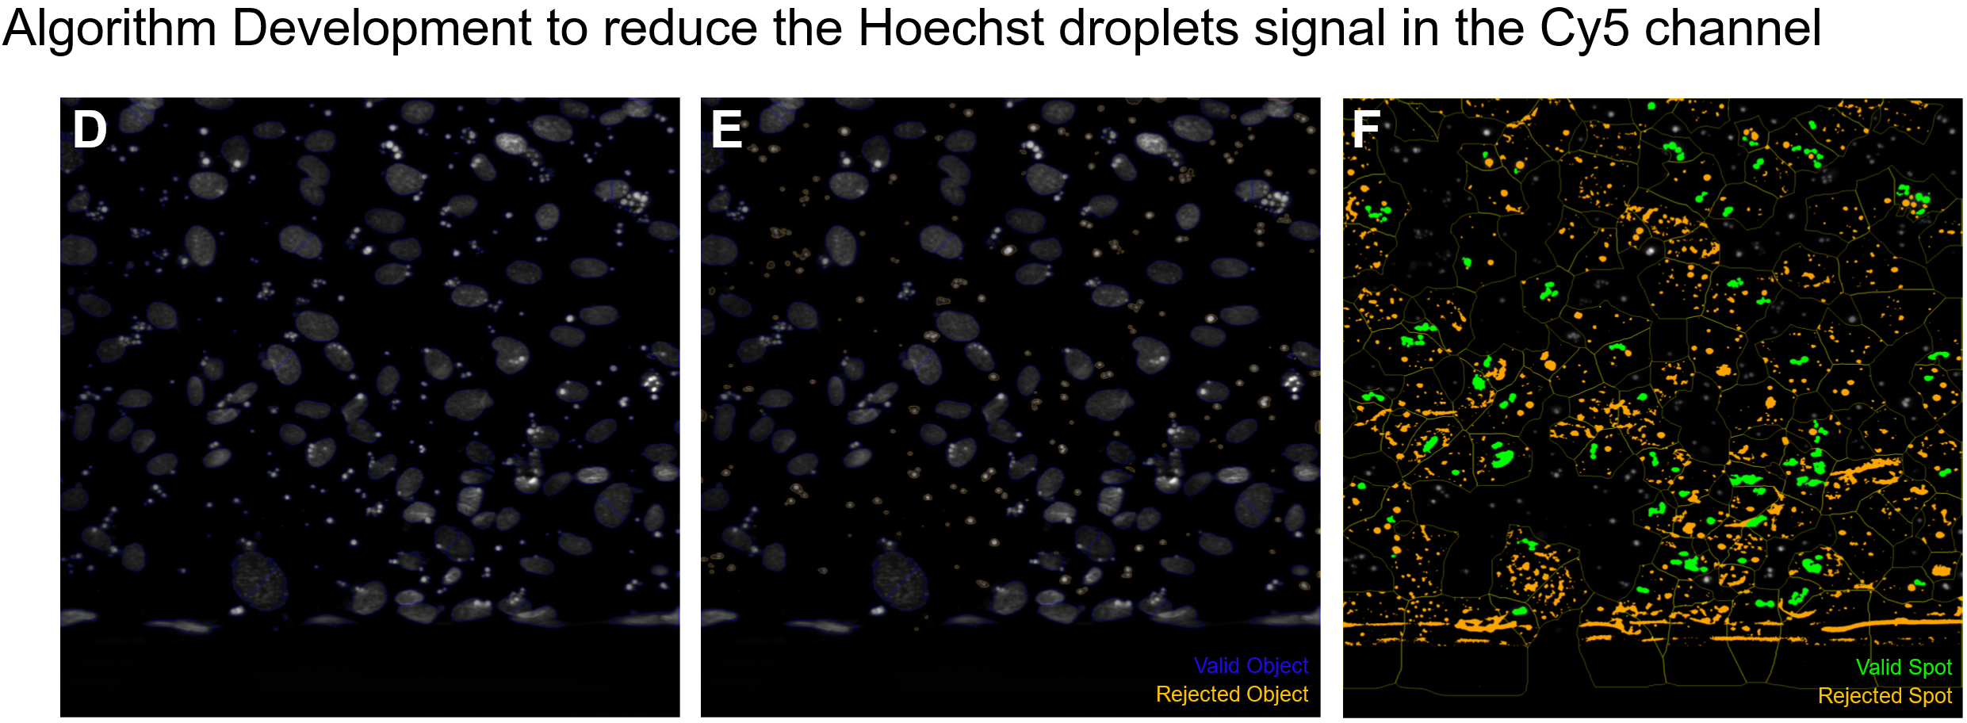

Figure S7. Cy5 fluorescence intensity at 10° and 20° perfusion angles (1 h and 6 h incubation). Data after algorithm-based correction (see Figure S6). Excluded from primary quantitative analysis (see Methods); shown for transparency. SSMD values annotated where calculable. n = 4 microvessels; n = 2 for empty vehicle controls; error bars represent SD.
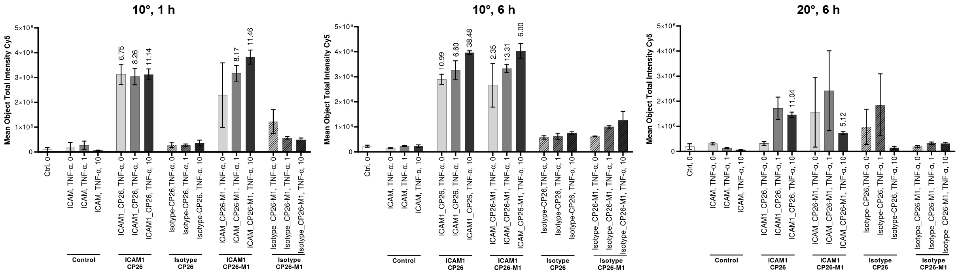

Supplementary Note S1. Design history of the Mivatana™ platform.
The DNA nanoparticle construct evaluated in this study was designed and optimized by the tilibit nanosystems team through an iterative development process between 2016 and 2020. This note documents the design decisions that determined the architecture, conjugation chemistry, optical label, surface coating, and targeting reagent of the nanoparticle reported here. It is provided for reproducibility and to make explicit the empirical basis for parameters stated in the Methods. No functional or comparative performance claims are made beyond those reported in the main text; the studies described here were structural and preparative in nature, and several were conducted at small scale or with descriptive readouts.
S1.1 Architectural lineage: 6-helix to 24-helix protrusions. The initial platform design (Prototype I, 2016) was a single-piece DNA origami object bearing three 6-helix-bundle (6HB) protrusions, with a biotinylated oligonucleotide staple positioned at each protrusion tip for streptavidin capture and subsequent antibody attachment. Native agarose electrophoresis of Prototype I following streptavidin addition consistently resolved two species rather than one. Negative-stain TEM of streptavidin-treated material showed a mixed population of associated and independently extended protrusions (Figure S8B). These observations were interpreted by the originating laboratory as intra-particle bridging, in which a single streptavidin tetramer engages biotin moieties on two protrusions of the same particle, and the two electrophoretic species were attributed to this conformational difference.
Because the 6HB protrusion was judged insufficiently rigid to maintain independent protrusion positioning, the protrusion was redesigned as a 24-helix bundle (24HB) for Prototype II. The monomeric, non-assembling variant used throughout the present study bears a single protrusion and therefore a single streptavidin attachment site, and is structurally incapable of the intra-particle bridging described above — a consideration that informed the selection of the monopod configuration for the reported experiments.
S1.2 Conjugation chemistry. Site-specific oligonucleotide–antibody conjugation was the preferred approach at the outset, since sequence-addressable handles permit independent targeting of defined structural positions, whereas a biotin handle is captured by any accessible streptavidin. No commercial source for custom oligonucleotide–antibody conjugation was identified at the time of design; such services became available subsequently, but at cost and antibody-recovery yields incompatible with the scale required for this work. Streptavidin–biotin capture was therefore adopted as the accessible route to deterministic positional attachment. Transition to oligonucleotide-conjugated antibodies remains the intended path (see Study Limitations, main text). A subsequently identified, lot-dependent variation in commercial antibody biotinylation chemistry is described in S1.8; that observation postdates the experiments reported here.
S1.3 Optical label. Quantum dots were initially evaluated as the optical reporter. Commercially sourced oligonucleotide-conjugated quantum dots failed to attach to the origami structure across two independently supplied lots, and the cause was not established; this product was consequently abandoned. Attachment was demonstrated as proof of concept using streptavidin-conjugated quantum dots, but this route was not pursued: quantum dots of this type present multiple streptavidin molecules, so combining quantum dot and antibody attachment on the same particle would require a sequential blocking and purification scheme of impractical complexity. In addition, the size of the quantum dot dominated electrophoretic migration of the assembled construct and prevented the intermediate purification steps required for conjugation analysis. Cyanine-5 incorporation via dye-labelled staple strands was adopted instead. Successful incorporation of ten Cy5 dyes per monomer was confirmed by Cy5-channel gel imaging, with no dye-induced aggregation detected across a 10–100 nM dilution series; the smear observed at the highest loading was attributed to gel-pocket overloading and was absent on dilution.
S1.4 Surface coating. Oligolysine–PEG (K10-PEG5000) coating conditions were optimised by titration against both monomeric and trimeric structures, monitored by charge-dependent electrophoretic migration, following the published oligolysine–PEG protocol.^{SR1} A 0.5:1 oligolysine–PEG:structure ratio corresponded to approximate charge neutralisation and was adopted for production of the constructs used in this study; transmission electron microscopy at this ratio showed intact, non-aggregated structures. Because the antibody attachment site in the final construct lies beneath this coating, streptavidin accessibility after coating was validated (Figure S10). This assessment was performed at the protrusion-tip position; equivalent accessibility at the platform-body position was not independently tested, and is inferred from the dimensional argument given in Study Limitations (main text).
S1.5 Colloidal and buffer stability. Coated structures were incubated for 24 h at 37 °C in buffers spanning 0.5–5 mM MgCl₂, in PBS, and in MV2 endothelial growth medium, and subsequently analysed by gel electrophoresis and transmission electron microscopy. Monomeric and trimeric structures remained intact under all conditions tested, with no evidence of degradation. Nanoparticles were stored and supplied in PBS. We note that the endothelial medium used in this assessment (MV2) is not the medium used in the MPS experiments reported here (EGM-2), and that the assessment did not include the shear conditions of the perfused system.
A separate constraint was identified during trimer production: addition of streptavidin to structures at high concentration produced inter-particle aggregation that was not reversed by subsequent dilution. This behaviour was insensitive to streptavidin excess (4:1 versus 100:1), to substitution of neutravidin for streptavidin, and to substitution of NaCl for MgCl₂, but was governed by the structure concentration at which streptavidin was introduced. Adding streptavidin at approximately 1 nM structure concentration and subsequently concentrating by ultrafiltration avoided the aggregation and yielded structures with streptavidin at all attachment sites. This order of addition was used for the constructs reported here.
S1.6 Targeting reagent selection. An anti-hICAM-1 VHH single-domain antibody was the original targeting reagent, selected for its small size relative to a full immunoglobulin. Early attempts to demonstrate antibody–antigen engagement on-particle using native gel band-shift against recombinant ICAM-1 did not produce a detectable migration difference, and a subsequent Western blot was negative. The antibody supplier confirmed that the reagent had been validated for flow cytometry applications only; as ICAM-1 D1-domain epitopes are conformational, a negative result under denaturing blot conditions is expected and is not informative regarding binding to native cell-surface antigen. The native-gel result is separately attributable to the limited sensitivity of band-shift detection for a 15 kDa binder on a megadalton-scale structure, and to uncertainty in the presentation of the recombinant antigen preparation used.
Binding was therefore re-assessed in a cell-based format. An isogenic ICAM-1 (CD54) knockout HeLa line was generated by CRISPR/Cas9 and validated by flow cytometry against the parental line. Both candidate reagents were then evaluated on parental and knockout cells by flow cytometry using biotinylated primary antibodies and fluorophore-conjugated streptavidin. The anti-hICAM-1 monoclonal antibody clone HA58 (Invitrogen 13-0549-82, Lot 1995369) stained 88.3% and 88.8% of parental cells at 0.02 and 0.04 mg/mL respectively, versus 1.7% and 2.15% on knockout cells. The anti-hICAM-1 VHH (NAB‐1937‐VHH, Creative Biolabs), with custom C-terminus biotinylation by Creative Biolabs, stained 47.4% and 51.7% of parental cells versus 2.3% and 2.4% on knockout cells. An irrelevant-target VHH (anti-RSV DS-Cav1), included as a format-matched specificity control, remained at background on both lines.
Clone HA58 was selected for the study reported here. Attempts to confirm the biotin:antibody stoichiometry of the VHH preparation by native-gel Western analysis were inconclusive: incubation with streptavidin produced no significant migration shift, with only a faint higher-molecular-weight streptavidin-positive species detected in the presence of the VHH, and analysis of nanoparticle–VHH–streptavidin mixtures was precluded by high background attributed to streptavidin release during blot processing. Given unresolved uncertainty regarding biotin incorporation efficiency and possible free-biotin carryover in the VHH preparation, the cost of further optimisation at proof-of-concept stage, and the availability of a commercially validated monoclonal clone with an isotype-matched control, the monoclonal reagent was adopted for the placement study. This decision was made on grounds of validation status and project scope, and does not constitute evidence of a deficiency in the single-domain reagent, whose ICAM-1 specificity was confirmed as described above. Return to single-domain reagents remains the intended direction (main text).
S1.7 Antibody–nanoparticle conjugation ratio. Two conjugation formats — pre-mix and sequential addition — were compared by flow cytometry on HeLa cells using the monomeric construct (Figure S12). The ratio dependence observed in the pre-mix format is consistent with competition for cell-surface ICAM-1 by antibody not associated with a nanoparticle, which increases with antibody excess; sequential addition, in which unbound antibody is washed away before nanoparticle exposure, removes this competition and is correspondingly ratio-independent.
We note that the single-domain reagent was evaluated in the pre-mix format only at ratios subsequently found to be suboptimal for the monoclonal reagent, and was not tested at 1:1; the pre-mix result obtained with the single-domain reagent is therefore not independent of the ratio effect described above.
S1.8 Reagent sourcing: lot-dependent antibody biotinylation chemistry. [This subsection describes an observation postdating the reported study. It is a reproducibility note, not a design decision, and is dated explicitly for that reason. The observation described here was made in 2025, after completion of the experiments reported in the main text, and did not inform the design decisions described above. It is included because it bears on reproducibility of this work.]
In the course of separate, later development work using a biotinylated anti-CD105 antibody (Cat. No. 13-1051-82, Invitrogen/Thermo Fisher; Lot 302099), nanoparticles conjugated with this material at a 1:1 nanoparticle:antibody ratio did not produce detectable target binding after overnight incubation @ 4°C in 4T1 cell culture, fixed with paraformaldehyde, in both pre-mixed and sequentially mixed formats. However, Cy5.5-labelling of the same antibody, to serve as control, produced clear signal under matched conditions. Because the directly labelled antibody retained antigen recognition, the failure is attributable to the biotin–streptavidin linkage rather than to loss of antibody binding activity. Comparison of supplier internal documentation across lots indicated that earlier material from this product had been biotinylated using amine-reactive NHS-ester chemistry, whereas the lot in question had been prepared using thiol-reactive maleimide chemistry (biotin-BMCC). The basis for the functional difference has not been established — possible contributions include altered biotin positioning or accessibility — and it is reported here as an empirical observation rather than a characterised mechanism. Manufacturer’s QC validated removal of unreacted biotin capable of occupying streptavidin sites
To evaluate whether the conjugation chemistry accounted for this behaviour, an unconjugated anti-CD105 antibody of the same clone was subsequently biotinylated by Thermo Fisher using standard NHS-ester chemistry. Nanoparticles prepared with this custom NHS-biotinylated antibody restored the expected target-binding behaviour and did not exhibit the loss of binding observed with the commercially supplied maleimide-biotinylated lot. Although this result does not establish the underlying mechanism, it is consistent with the conclusion that the observed functional difference arose from the antibody biotinylation strategy rather than from the antibody clone itself.
This observation was made with an anti-CD105 reagent and not with the anti-ICAM-1 clone used in the present study. Nanoparticles conjugated with anti-hICAM-1 antibody (Cat. No. 13-0549-82, Lot 2293327) performed as reported in the main text. We note the CD105 observation here because the two products belong to the same supplier biotin-conjugate product line, and because catalogue number alone does not appear to specify biotinylation chemistry; lot-dependent substitution of maleimide for NHS-ester conjugation cannot be excluded for other products in this line. Investigators seeking to reproduce this work are therefore advised to confirm the biotinylation chemistry of the specific antibody lot obtained.
S1.9 Scale-up of multimeric architectures (observation postdating the reported study).
[The following was established in 2025, after completion of the experiments reported in the main text, and describes the current status of the multimeric architectures rather than a constraint bearing on the monomeric construct evaluated here.]
Production of the self-assembling dimeric and trimeric architectures at preparative scale has not yet been achieved. The individual assemblies form correctly during folding — gel electrophoresis and transmission electron microscopy of the freshly folded material resolved the expected multimeric species — but the inter-monomer interface did not survive the subsequent oligolysine–PEG coating step. Coated preparations could not be resolved into discrete species by native gel electrophoresis: oligolysine–PEG neutralises the DNA backbone charge, so coated material shows markedly altered migration and remains close to the loading pocket (Figure S13D, lane 7). The dissociation was instead identified by transmission electron microscopy of coated material, in which individual 24HB protrusions appear detached from the platform domains (Figure S13B), indicating that the shape-complementary contacts holding the monomers together dissociate under coating conditions at scale. This mechanism is distinct from the intra-particle streptavidin bridging described for the 6HB Prototype I architecture (S1.1) and from the streptavidin-addition aggregation described in S1.5; it reflects the stability of the monomer–monomer interface itself rather than any streptavidin-mediated interaction. Several stabilization strategies were pursued or considered in an effort to retain the assembled trimer through coating: alternative scaffold routing across the monomer–monomer interface, strengthened and additional shape-complementary interaction motifs to increase inter-monomer contact area, and UV point-welding of the assembled structure,^{S2} and modification of the coating chemistry itself (mixtures of oligolysine–PEG with polyethylenimine). The strengthened-interface design measurably increased the proportion of correctly assembled structures recovered after coating, and UV irradiation produced a dose-dependent increase in covalently stabilised species (Figure S13C); neither was sufficient to preserve the full population. Irradiation above 6.4 J/cm² produced high-molecular-weight smearing consistent with structural damage, and the UV experiments were performed on the existing design, whose sequences were not optimised for proximal-thymidine crosslinking, using dilution into water rather than coating as the destabilising challenge; a crosslink-optimised design was proposed but not built. UV crosslinking is additionally expected to bleach fluorophores, so a crosslinked embodiment would require dye conjugation after stabilisation. None of these approaches yielded a coating-stable trimer at preparative scale. A two-piece dimer was then pursued as an intermediate, on the reasoning that a smaller assembly is less complex and might survive coating where the trimer had not. Two complementary monomers (A and B) were designed to break the three-fold symmetry; after correction of an initial interaction-design error that caused one monomer to oligomerise, both folded cleanly and dimerised efficiently, but this architecture retained the same non-covalent inter-monomer interface. The architecture was therefore redesigned as a monomeric dipod (CP-101): a single origami object of dimensions equivalent to the assembled dimer, folded in one reaction from two orthogonal scaffold strands (p7560 and CS4), which eliminates the post-folding multimerisation step and with it the inter-monomer interface as a point of failure (Figure S13D,E). This route was enabled by advances in multi-scaffold origami design and production since the original 2018 tripod, which permit objects of trimer scale to be folded without a multimerisation step; assembly of a trimer by the same one-pot route is the intended next step. This structural solution is independent of the antibody-attachment chemistry: the planned transition to site-specific oligonucleotide-conjugated antibodies (S1.2; Study Limitations, main text) is pursued for stoichiometric control and to remove streptavidin as an intermediary, and is not required to stabilise the multimer.
Oligolysine–PEG was dosed such that the number of cationic nitrogens approximately matched the number of DNA backbone phosphates (N:P ≈ 1:1); the same ratio was maintained for oligolysine–PEG/polyethylenimine mixtures. Native agarose gels were run at 1.5% in 0.5× TBE supplemented with 6 mM MgCl₂ and stained with GelRed, with scans acquired in both GelRed and Cy5 channels; co-localisation of the Cy5 and GelRed signals confirmed dye incorporation. Negative-stain transmission electron microscopy was performed in 1× FoB20 buffer (5 mM Tris, 1 mM EDTA, 5 mM NaCl, 20 mM MgCl₂).

Figure S8. Prototype I architecture and streptavidin-mediated protrusion association. (A) Design schematic of Prototype I, a single-piece DNA origami object bearing three 6-helix-bundle protrusions; cross-sections shown. Scale bar = 20 nm. (B) Negative-stain transmission electron micrograph of Prototype I following biotin and streptavidin addition (PEG-purified). Mixed morphologies are present within a single field: particles in which protrusions are associated with one another (red circles) and particles with independently extended protrusions (green circles). Circled examples reproduce the annotation of the originating analysis (tilibit nanosystems GmbH). Scale bar = 100 nm. See Supplementary Note S1.1 and Figure S9.
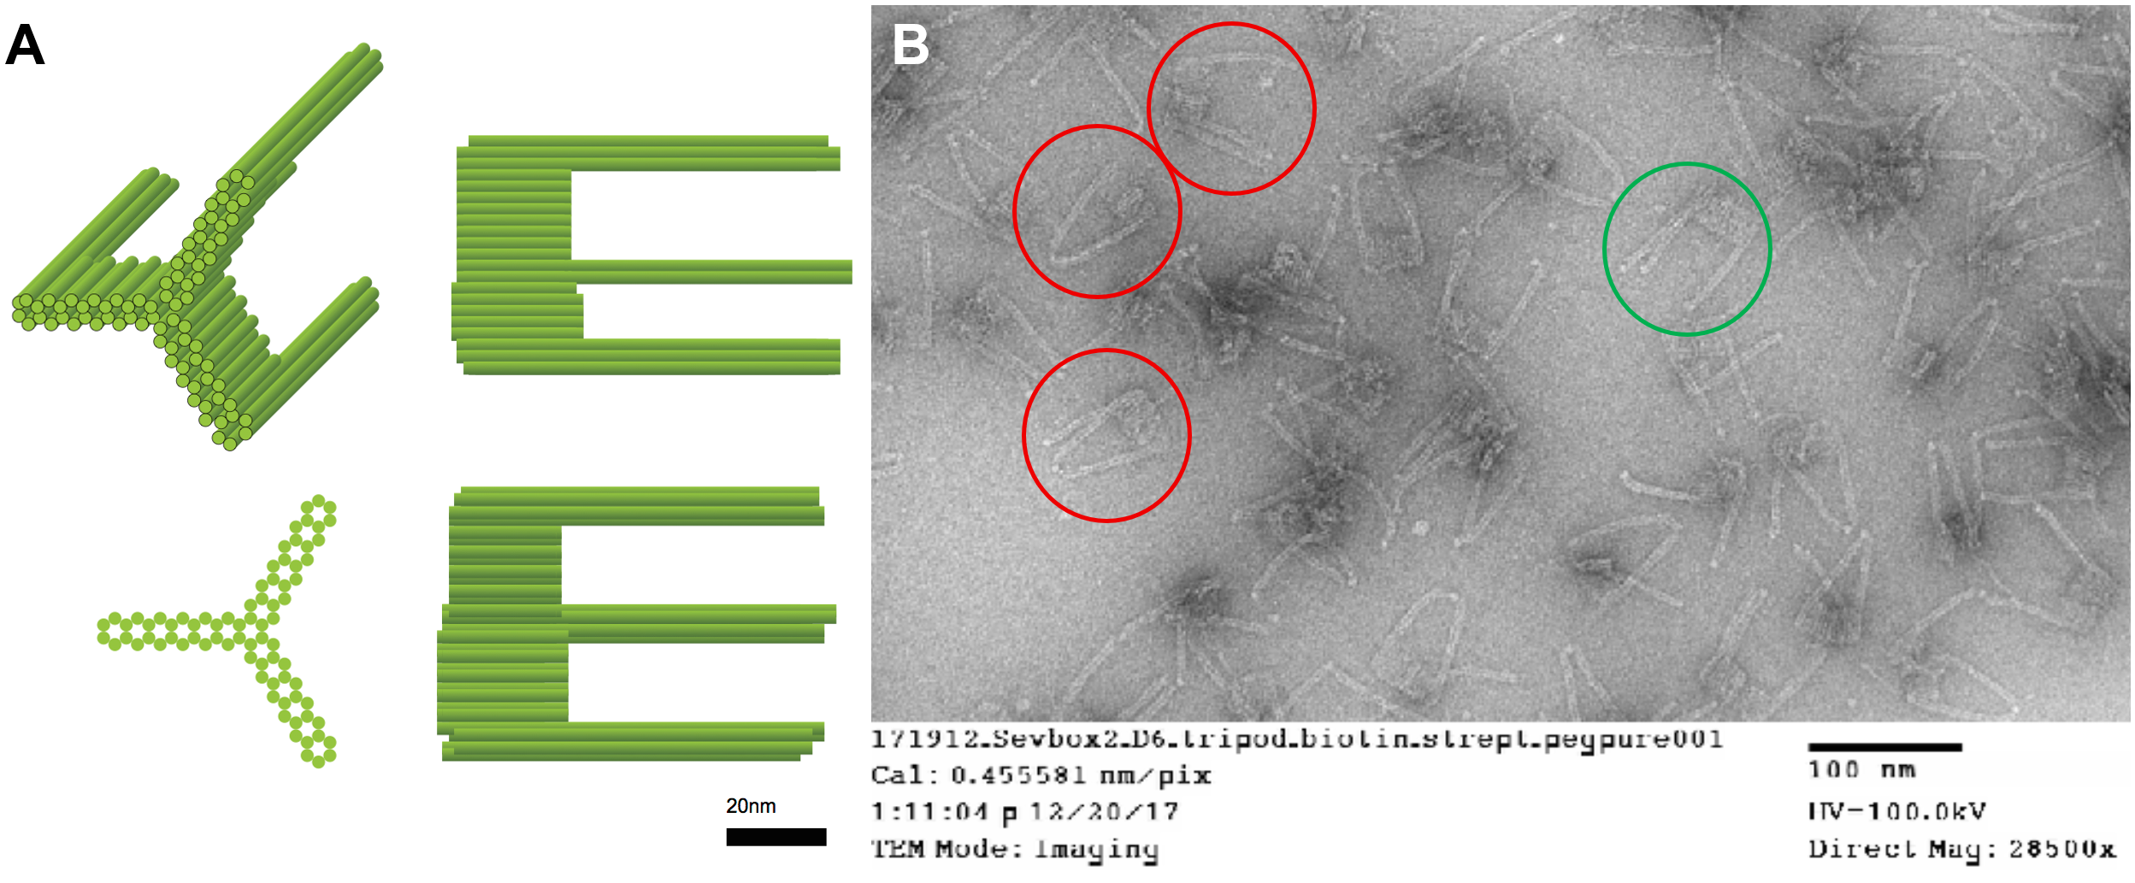

Figure S9. Streptavidin decoration of the 6HB (Prototype I) protrusion architecture resolves two particle species. (A) Native agarose electrophoresis of Prototype I with 1.5% agarose, 6 mM MgCl₂, 90 V, 2 h, ethidium bromide. Lanes include 1 kb ladder; tripod; tripod + biotin; tripod + biotin + streptavidin; and lanes 1-8, an antibody/ICAM titration series from a separate experiment, not analysed here. Boxed regions enhanced for improved visualization. The unmodified and biotinylated tripod each migrate as a single dominant band; addition of streptavidin resolves two closely spaced species (marked C and D). (B-D) Negative-stain transmission electron micrographs of Prototype I. (B) No streptavidin added. (C) Lower species bearing two resolvable streptavidins per particle. (D) Upper species bearing three resolvable streptavidins. The two-density form is attributed to intra-particle streptavidin bridging (Figure S8, Note S1.1). The relative abundance of the two species was not determined by densitometry or particle counting.
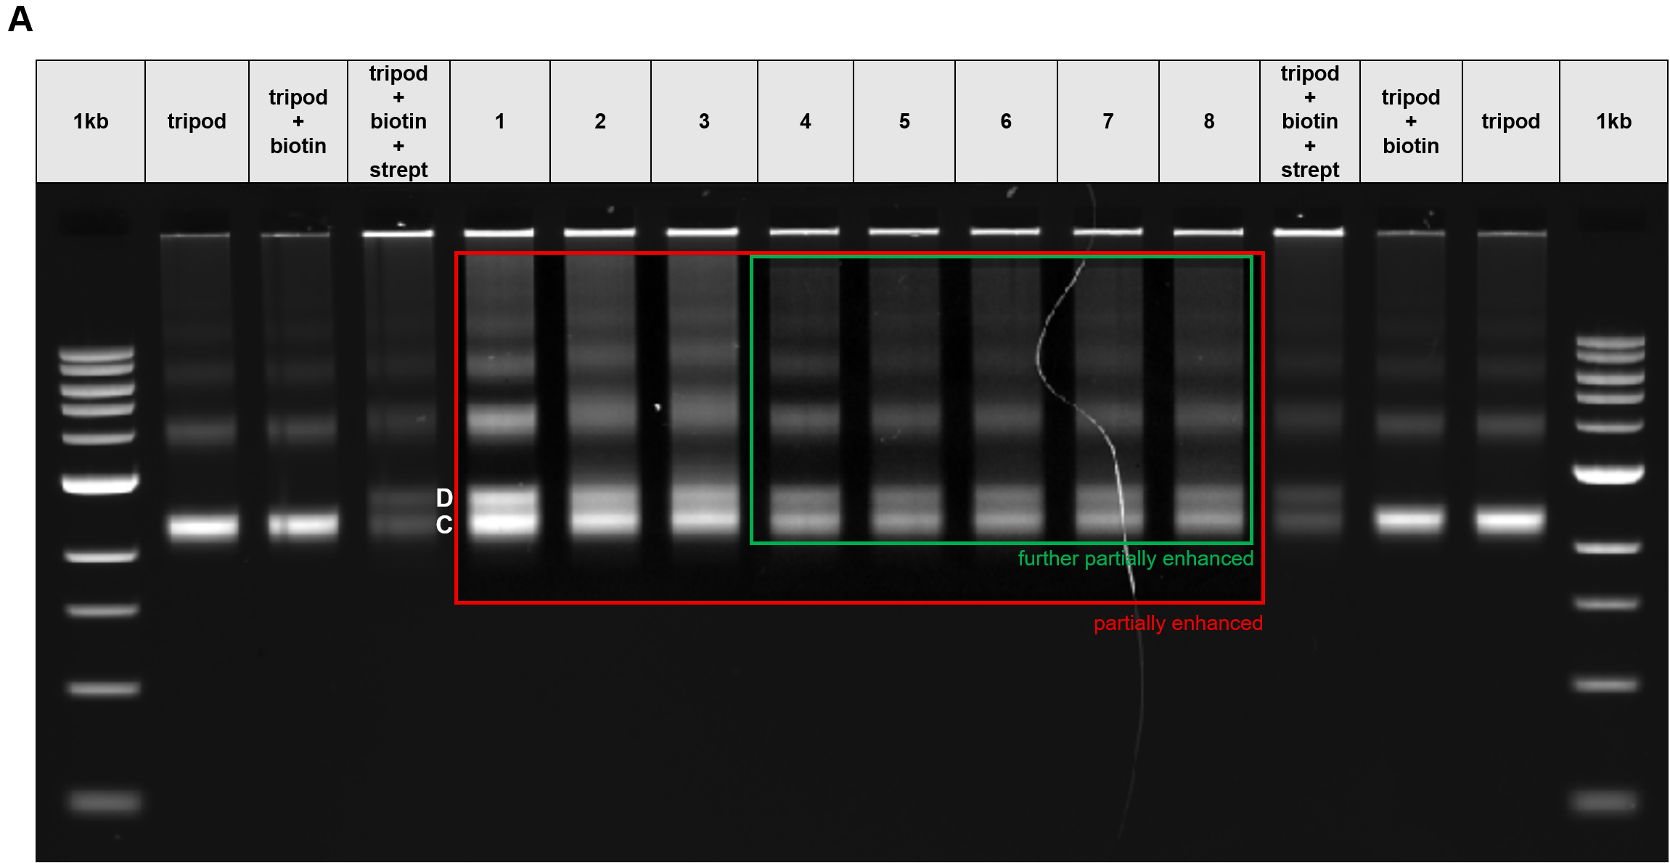
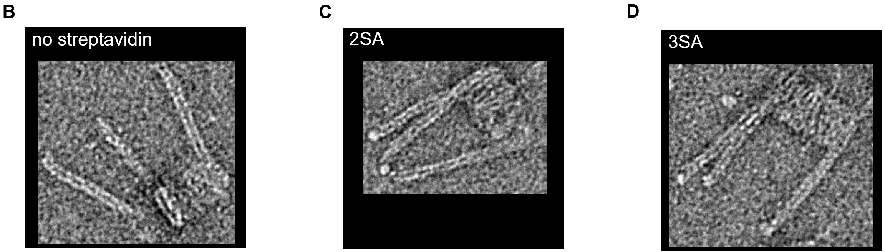

Figure S10. Native agarose electrophoresis of tripods challenged with biotin- and Cy5-modified oligonucleotide before and after coating. Ethidium bromide, EtBr channel (blue, DNA) and Cy5 channel (red, oligonucleotide) superimposed. Four sample types were prepared (1) tripod trimer without streptavidin; (2) tripod monomer with streptavidin; (3) tripod trimer with streptavidin; (4) Cy5-labelled tripod trimer with excess streptavidin — and each analysed uncoated and after coating, with and without added biotin–Cy5 oligonucleotide (16 samples). Structure concentration 10 nM; biotin–Cy5 oligonucleotide 300 nM. 0.5× TBE, 5.5 mM MgCl₂, ethidium bromide. M, 1 kb ladder. Samples 2 and 3 acquire Cy5 signal co-migrating with the EtBr structure band both before and after coating, whereas the streptavidin-free control (sample 1) does not, indicating that the coating does not occlude the streptavidin site; unbound oligonucleotide migrates as the fast front. Sample 4 carries Cy5 on the structure itself and therefore reports capture of the oligonucleotide by streptavidin free in solution rather than site accessibility. Coated structure bands are visibly dimmer in the Cy5 channel than their uncoated counterparts; the assay was read qualitatively and band intensities were not quantified by densitometry.

Figure S11. Knockout-verified ICAM-1 specificity of the candidate targeting reagents. (A) Characterization of the isogenic HeLa ICAM-1 (CD54) knockout line by flow cytometry (PE anti-CD54, clone HA58; Guava easyCyte). Parental HeLa stained with PE anti-CD54 and its isotype control are overlaid with eight CRISPR/Cas9-edited candidate clones. (B) No-primary control: parental and knockout cells incubated with streptavidin–AF647 alone. (C) Parental HeLa and the ICAM-1 knockout line stained with the indicated biotinylated primary antibody at 0.02 or 0.04 mg/mL, followed by streptavidin–Alexa Fluor 647 (Beckman CytoFlex). Rows: mouse IgG1κ isotype control; anti-hICAM-1 monoclonal antibody clone HA58; anti-RSV DS-Cav1 single-domain antibody (VHH), an irrelevant-target control format-matched to the VHH; anti-hICAM-1 VHH. Values are the percentage of cells within gate P4 (AF647-positive), reproduced from the originating analysis; see Note S1.6.
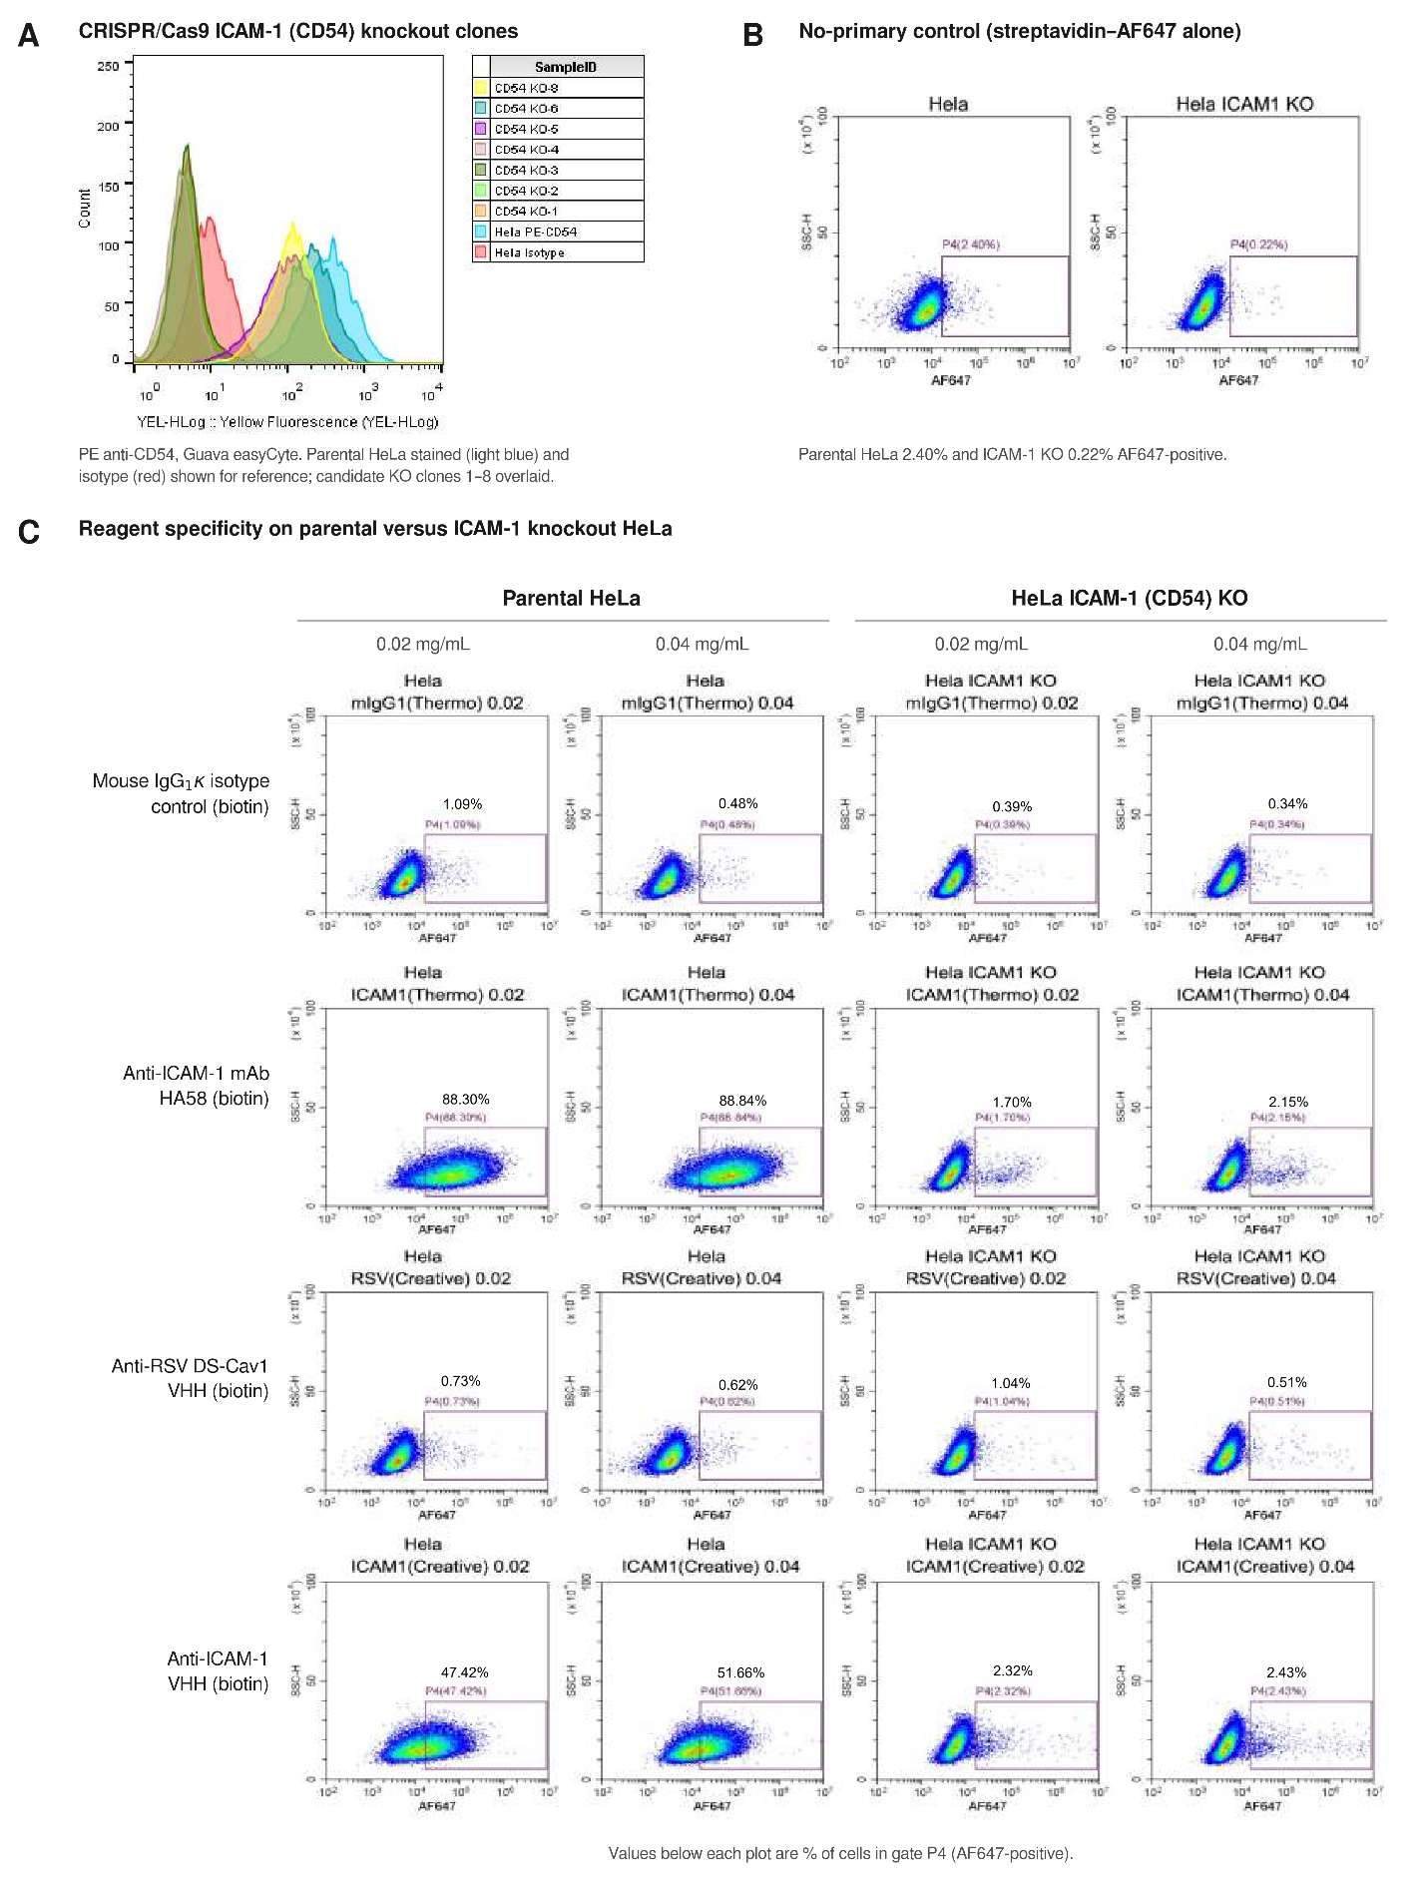
Figure S12. Nanoparticle staining in pre-mix format depends on antibody:nanoparticle feed ratio, whereas sequential addition does not. Flow cytometry of cultured HeLa cells exposed to Cy5-labelled monomeric nanoparticles, gated on live singlet cells (Fixable Viability Dye eFluor 506); values are Cy5 geometric mean fluorescence intensity (GMFI). (A) Monoclonal reagent. Nanoparticles were combined with biotinylated anti-hICAM-1 antibody (clone HA58) at 1:1, 3:1 and 9:1 antibody:nanoparticle molar feed ratios, either pre-mixed for 30 min at room temperature before addition to cells (pre-mix) or added to cells that had first been stained with antibody and washed (sequential). A biotinylated mouse IgG1κ isotype control at 1:1 is shown for each format. In the pre-mix format, GMFI was highest at 1:1 (2,030) and fell progressively with antibody excess (761 at 3:1; 471 at 9:1), the 9:1 value approaching the isotype control (497). In the sequential format, staining was both higher in absolute terms and independent of feed ratio (4,403, 3,479 and 4,403 at 1:1, 3:1 and 9:1 respectively; isotype 427). (B) Single-domain reagent. Nanoparticles were combined with biotinylated anti-hICAM-1 VHH or an irrelevant-target anti-RSV DS-Cav1 VHH at a 3:1 antibody:nanoparticle molar ratio, in the pre-mix format (90 pmol antibody + 30 pmol nanoparticle) or the sequential format at two input amounts (22 pmol + 7.4 pmol; 52 pmol + 17.3 pmol). Sequential addition gave target-specific staining (9,501 and 10,436 for anti-hICAM-1 VHH versus 1,311 and 1,931 for the irrelevant control), whereas the pre-mix format at 3:1 gave no separation from the irrelevant control (1,314 versus 1,165). Single determination per condition; no replicates. Attune NxT flow cytometer. See Supplementary Note S1.7.
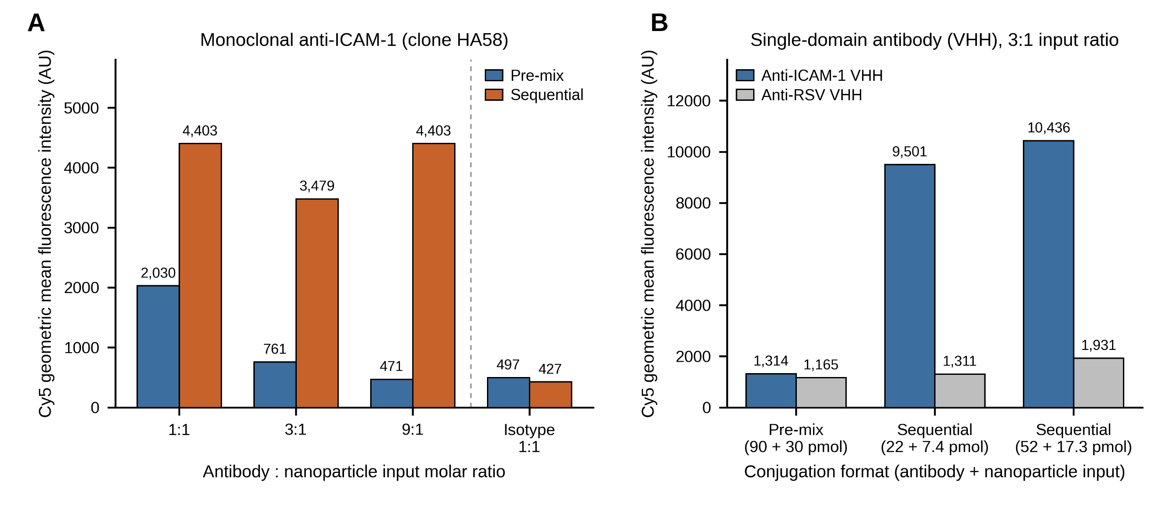

Figure S13. Failure of self-assembling trimer under oligolysine–PEG coating and adoption of a monomeric dipod architecture. (A) Negative-stain TEM of the freshly folded, uncoated Mivatana™ trimer, showing three 24HB protrusions joined at the platform domains. (B) TEM of the same architecture, incorporating strengthened inter-monomer interaction motifs, after oligolysine–PEG coating. (C) Native agarose gel of a UV point-welding dose series (0–12.8 J/cm², left to right), assessing covalent stabilization of the inter-monomer interface. (D) Production quality-control gel (1.5% agarose, 0.5× TBE, 6 mM MgCl₂, GelRed) of the redesigned CP-101 v1.0 M-1 construct: lanes 2–3, the two orthogonal scaffolds (p7560, CS4); lane 4, monomeric assembly; lane 5, after PEG precipitation; lane 6, after streptavidin addition; lane 7, after oligolysine–PEG coating. (E) TEM of coated CP-101, showing intact dimeric particles. Scale bars, 100 nm. See Supplementary Note S1.9.
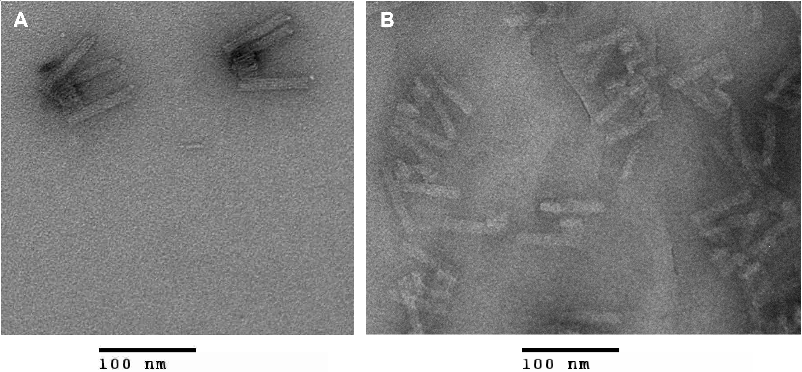
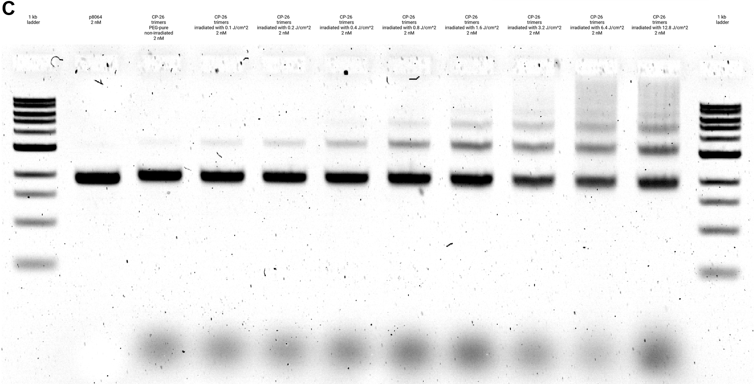
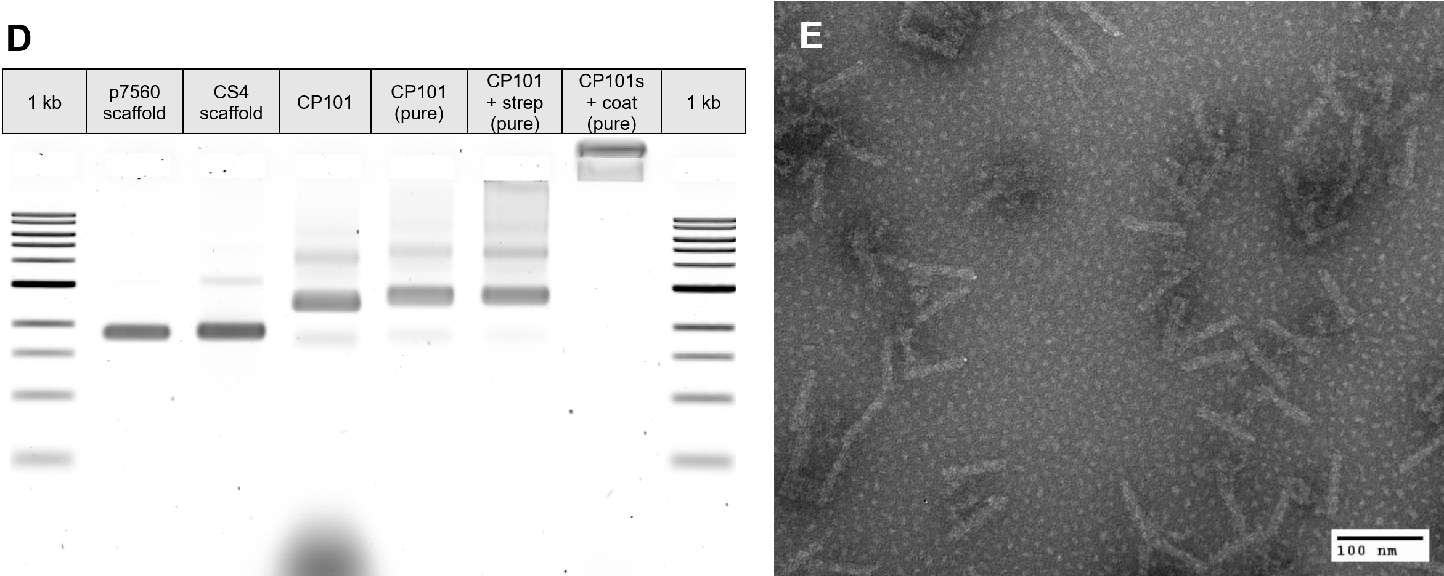

Supporting Information References
S1. Ponnuswamy N, Bastings MMC, Nathwani B, Ryu JH, Chou LYT, Vinther M, et al. Oligolysine-based coating protects DNA nanostructures from low-salt denaturation and nuclease degradation. Nat Commun. 2017;8:15654.
S2. Gerling T, Kube M, Kick B, Dietz H. Sequence-programmable covalent bonding of designed DNA assemblies. Sci Adv. 2018;4(8):eaau1157.

