Supplementary Materials:
Figure S1
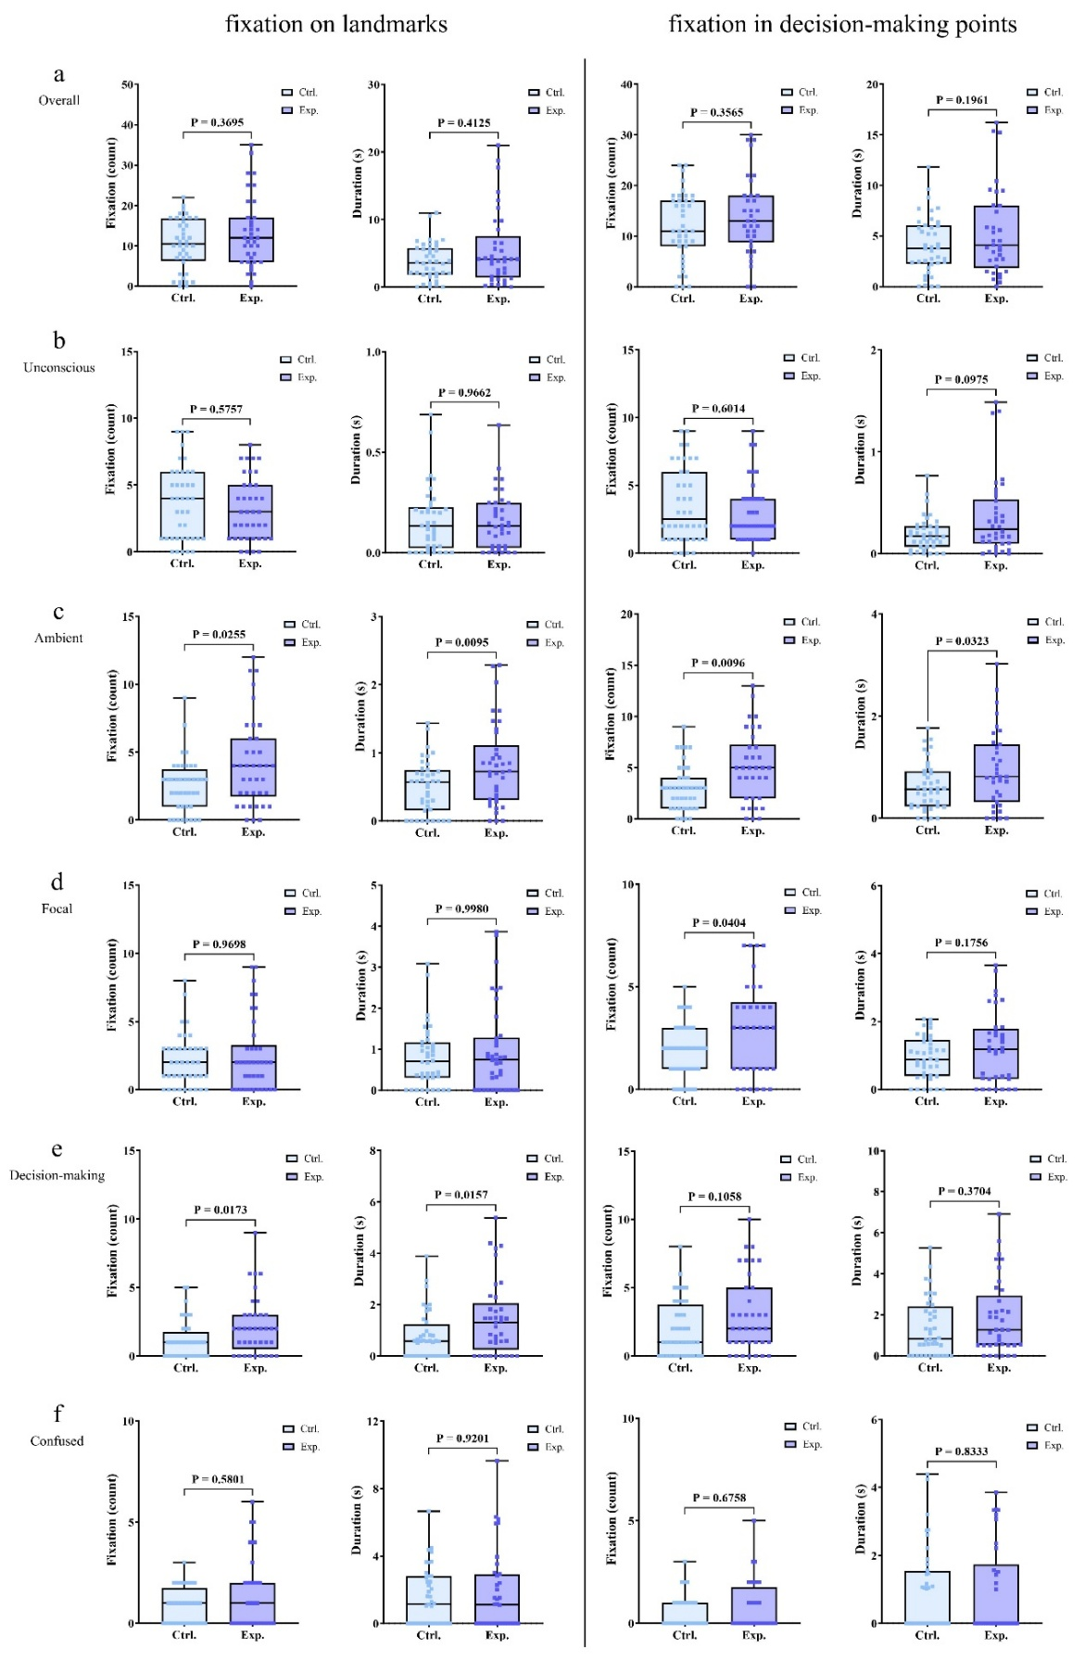
Figure S1: Distribution of fixation and fixation durations on landmarks and decision-making points during spatial navigation. a: Overall Fixations (OF); b: Unconscious Fixations (DF); c: Ambient Fixations (AF); d: Focal Fixations (FF); e: Decision-making Fixations (DF); f: Confused Fixations (CF). *p<0.05

Figure S2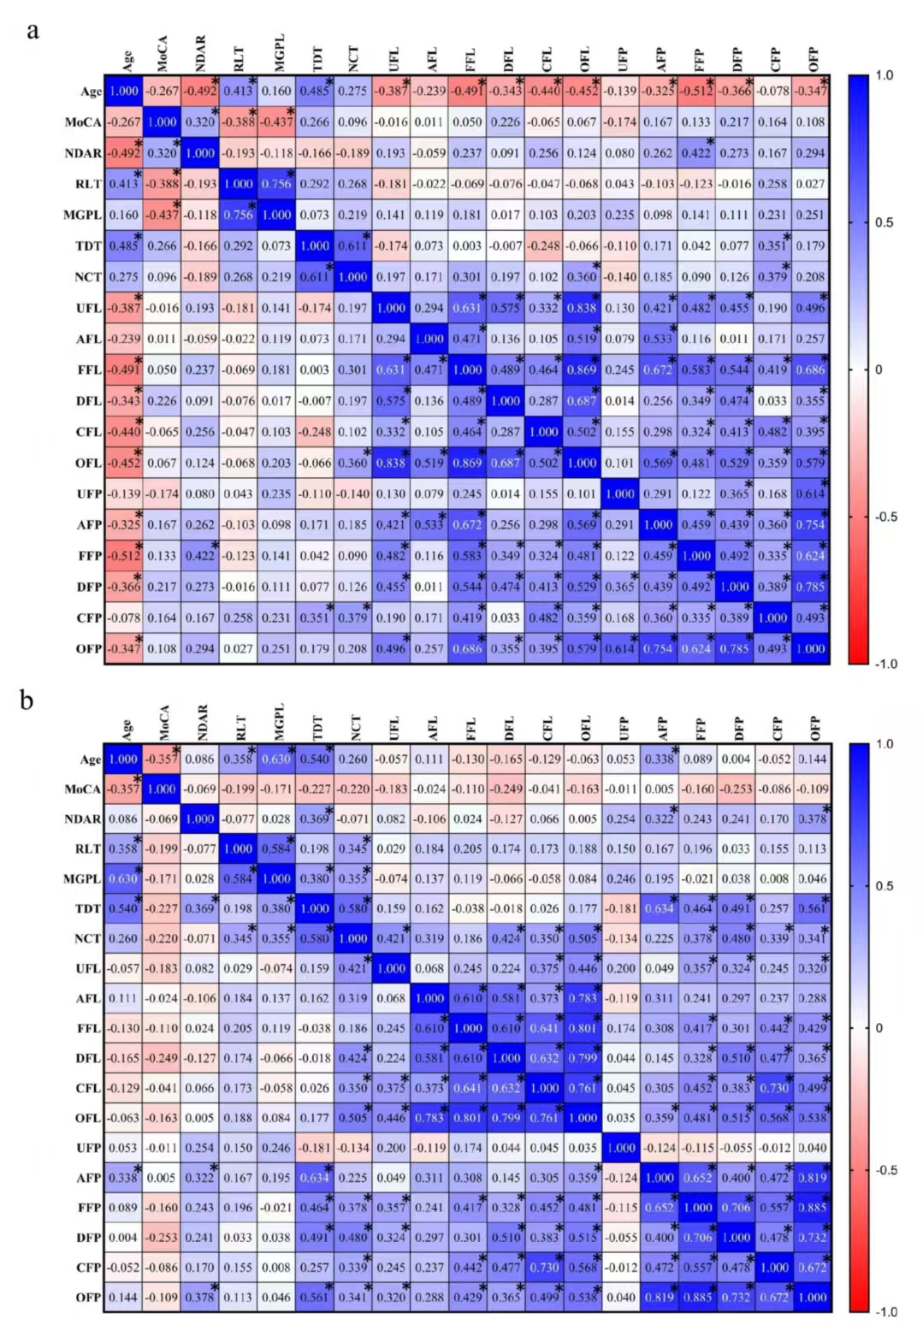
Figure S2. Correlation matrices of parameters of control (a) and experimental (b) groups. Matrix elements with blue and red colors represent positive and negative correlations. Numbers in elements denote Spearman's r values, and * denotes a statistical significance of the correlation (p < 0.05).

