Supplementary File

Safe-by-design algal EPS based ZnO/zeolite bio-nanocomposite for the removal of BPA
Bikramjit Bhattacharyaª, Akshada Nairª, Abisha Christy Christudossª, Kushal Mukherjeeª, Krishna Rao Eswar Neerugattiª, Amitava Mukherjee^{a*}
ª Centre for Nanobiotechnology, Vellore Institute of Technology, Vellore, Tamil Nadu, 632014, India

* Corresponding Author

Amitava Mukherjee
Dean of Academic Research,
Senior Professor at Centre for Nanobiotechnology,
Vellore Institute of Technology, Vellore 632014, India
Email: amitav@vit.ac.in, amit.mookerjea@gmail.com
Tables
Table S1: Composition of Artificial Sea Water per 1000 ml (1)
S. No. | Chemical | Amount (g)
1 | Sodium chloride | 26.29
2 | Potassium chloride | 0.74
3 | Calcium chloride | 0.99
4 | Magnesium chloride | 6.09
5 | Magnesium sulphate heptahydrate | 3.94

Table S2: Composition of Hoagland Nutrient Solution (2)
S. No. | Reagent | Stock (C₁) | Working (C₂) | Required Volume (V₁) (mL/L)
1 | Ca(NO₃)₂ | 2 M | 2.0 mM | 1.00
2 | KH₂PO₄ | 1 M | 0.5 mM | 0.50
3 | K₂SO₄ | 1 M | 0.7 mM | 0.75
4 | KCl | 1 M | 0.01 mM | 0.10
5 | MgSO₄ | 1 M | 0.65 mM | 0.65
6 | MnSO₄·2H₂O | 9.67 mM | 1.0 µM | 0.10
7 | ZnSO₄ | 7.60 mM | 1.00 µM | 1.31
8 | CuSO₄ | 0.14 mM | 0.20 µM | 1.42
9 | H₃BO₃ | 46 mM | 2.00 µM | 0.04
10 | (NH₄)₆MoO₂₄ | 0.05 mM | 0.02 µM | 0.40
11 | FeEDTA | 666 mM | 20.0 µM | 0.03

Figures
Figure S1: FTIR Spectra for BPA

Figure S2: Degradation Kinetics (First Order [A] and Second Order [B])
A
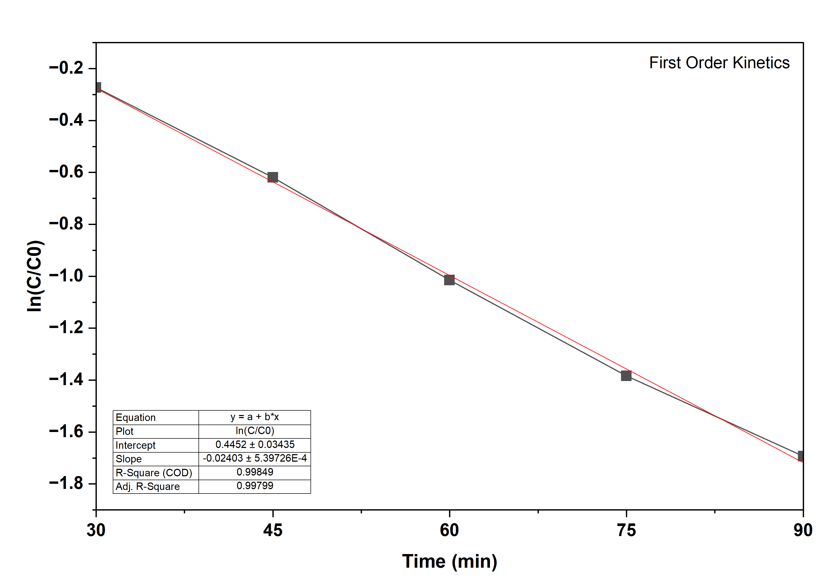

B
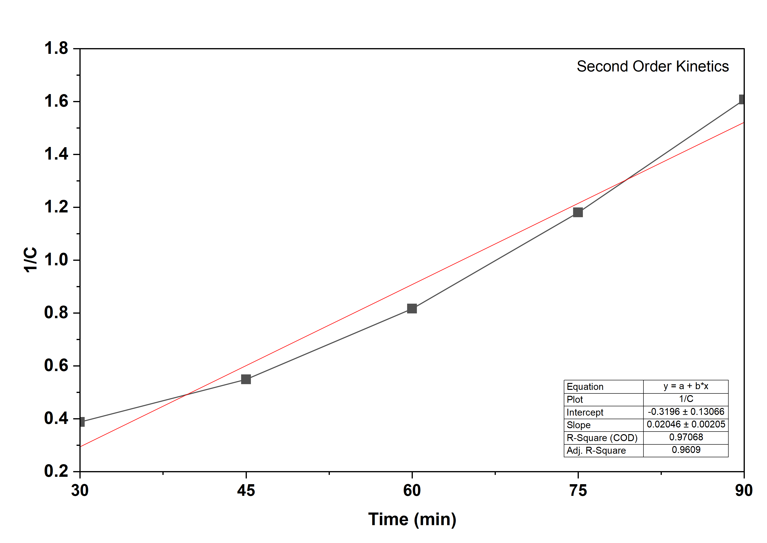
References
1. Rex M C, Mukherjee A. The comparative effects of visible light and UV-A radiation on the combined toxicity of P25 TiO2 nanoparticles and polystyrene microplastics on Chlorella sp. Environ Sci Pollut Res. 2023 Nov 17;30(58):122700–16. doi:10.1007/s11356-023-30910-0
2. Viswanathan D, Christudoss AC, Seenivasan R, Mukherjee A. Decoding Plant Hormesis: Cerium Oxide Nanoparticles and the Role of Soil EPS in the Growth Dynamics of Allium sativum L. ACS Agric Sci Technol. 2025 Jan 20;5(1):61–74. doi:10.1021/acsagscitech.4c00562

