Supporting Information

A Facile Green Synthesis of Polyethyleneimine-Functionalized Graphene Oxide Frameworks with Enhanced CO₂ Capture and Selectivity
Mohamed Hammad Elsayed^{1*}, Emtenan Almukhtar Alshanqiti¹, Mohamed M. Elsenety¹, Islam M. A. Mekhemer¹, Mahmoud Kamal Hussien¹, Rahaf H. H. Al-Otaibi², Ahmed F. Saber¹, Ho-Hsiu Chou³, Mahmoud M. Abdelnaby^{1*}.

¹Interdisciplinary Research Center for Hydrogen Technologies and Carbon Management, King Fahd University of Petroleum & Minerals, Dhahran 31261, Saudi Arabia
²Chemistry Department, King Fahd University of Petroleum & Minerals, Dhahran 31261, Saudi Arabia
³Department of Chemical Engineering, National Tsing Hua University, Hsinchu, 30013, Taiwan

Corresponding Authors: Mohamed Hammad Elsayed, Mohamed.ahmed.2@kfupm.edu.sa
Mahmoud Abdelnaby, mahmoudm@kfupm.edu.sa

  - Synthesis
  - Graphene Oxide (GO)
Graphene oxide (GO) was synthesized from graphite powder using a modified Hummers method (Scheme S1). Initially, graphite powder (1.0 g) was thoroughly ground in a mortar to ensure good dispersion. A mixed acid solution was prepared by combining concentrated sulfuric acid (H₂SO₄, 120 mL) and phosphoric acid (H₃PO₄, 17 mL) in a 300 m glass beaker under stirring in an ice bath. The ground graphite was then slowly added to the acid mixture while maintaining the temperature at 0 °C. While keeping the suspension in the ice bath under continuous stirring, potassium permanganate (KMnO₄, 6.0 g) was added gradually in small portions to avoid a rapid temperature rise. After the complete addition of KMnO₄, the reaction mixture was heated to 50 °C and stirred overnight. The resulting viscous mixture was subsequently cooled to room temperature and carefully poured onto 400 mL of ice containing 3 mL of 30% hydrogen peroxide (H₂O₂), resulting in a bright yellow dispersion. The suspension was divided into capped centrifuge tubes and centrifuged at 9300 rpm for 5 min, and the supernatant was discarded. The obtained solid was washed successively with deionized water (5 × 500 mL) and ethanol (5 × 500 mL). After each washing step, the material was centrifuged and the supernatant was removed as described above. Finally, the purified solid was dried in an oven at 70 °C overnight to obtain graphene oxide.
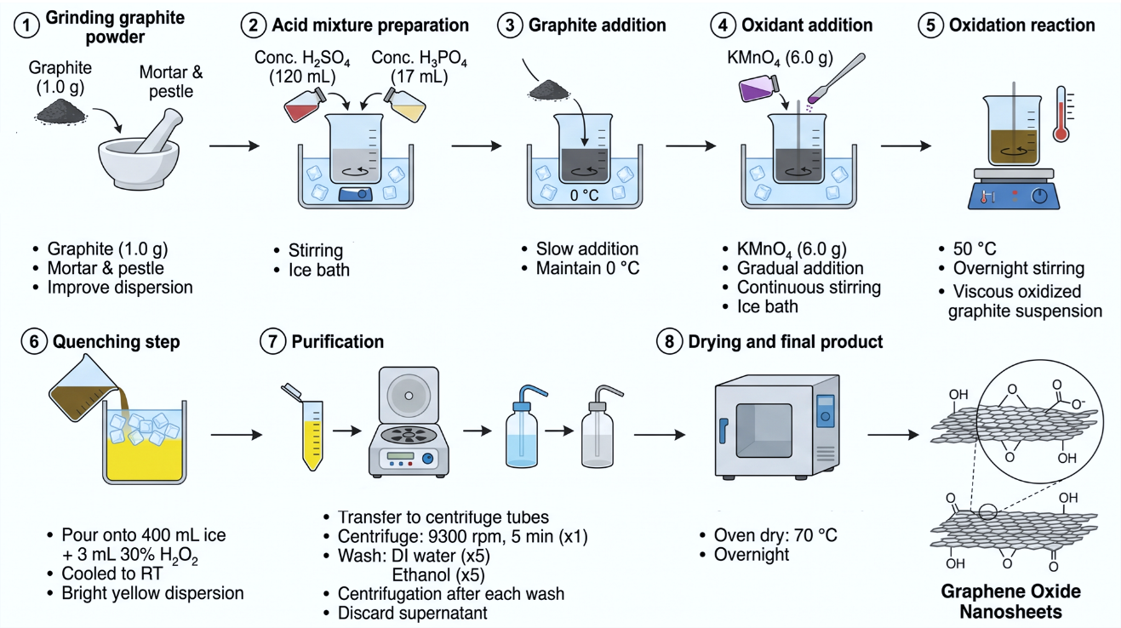
Scheme S1: Synthesis procedure of GO
  - GO-COCl
A sample of graphene oxide (GO, 0.20 g) was transferred into a 100 mL round-bottom flask, and thionyl chloride (SOCl₂, 40 mL) was added to the flask under ambient conditions (Scheme S2). The mixture was subjected to ultrasonic agitation for 30 min to ensure thorough dispersion of GO in the reagent. Subsequently, the resulting suspension was heated to reflux at 80 °C and maintained under these conditions for 24 h with continuous stirring. After cooling to room temperature, the solid product was collected by filtration and washed repeatedly with anhydrous tetrahydrofuran to remove excess SOCl₂ and soluble by-products. Finally, the material was dried at room temperature to afford the thionyl chloride-treated GO, which was used directly in subsequent functionalization steps.
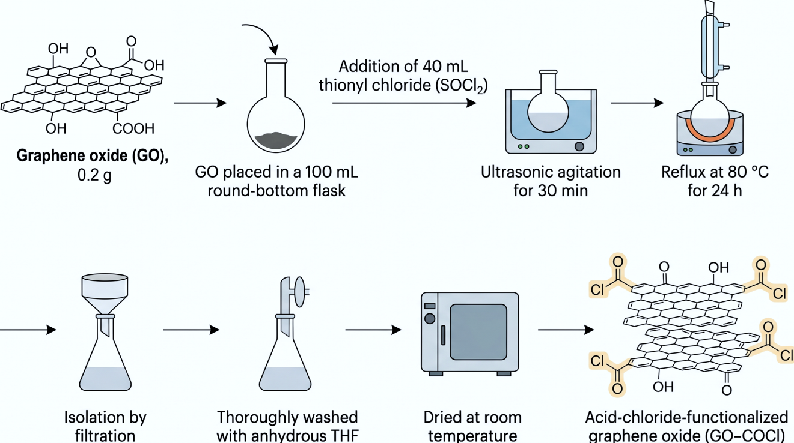
Scheme S2: Synthesis procedure of GO (COCl)
  - CO₂ Adsorption Measurements
CO₂ and N₂ adsorption isotherms were obtained volumetrically using a Quantachrome Instrument (Quadrasorb SI) (Scheme S3). Measurements were performed at 273 K, with temperature regulation achieved using water baths, over a pressure range of 0-1 bar. Prior to data collection, the sample was degassed under dynamic vacuum at 100 °C for 3 hours to ensure the complete removal of guest molecules and residual solvent species. The quantity of adsorbed gas was determined from pressure–volume–temperature (PVT) data following dead-volume calibration and systematic correction, employing the volumetric gas expansion method. Based on the obtained isotherms, CO₂/N₂ selectivity was computed using ideal adsorbed solution theory (IAST, S1/2) for a standard post-combustion flue gas system composed of 15% CO₂ and 85% N₂, following the next equation.
S_{1/2} =(n₁/n₂) × (p₂/p₁) (1)
In this expression, n₁ and n₂ denote the adsorption capacities (mmol g⁻¹) of components 1 and 2 at their respective partial pressures, p₁ and p₂, in the feed gas.
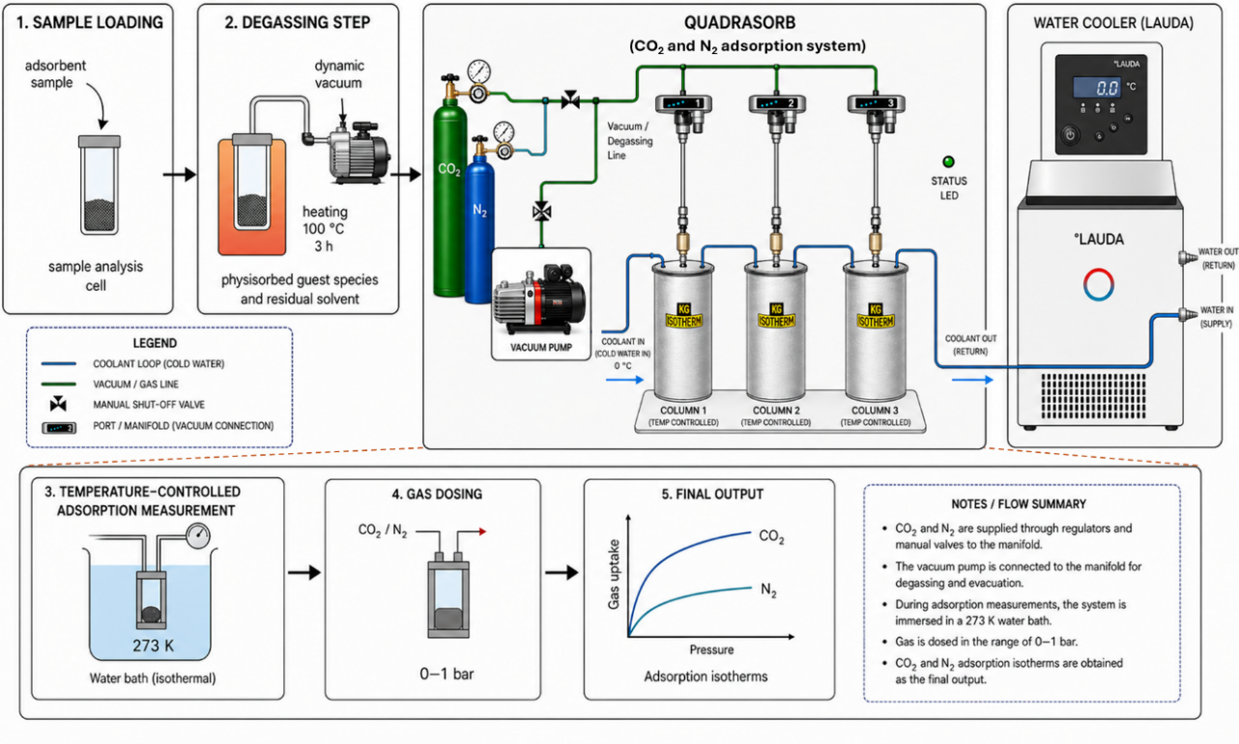
Scheme S3: Schematic diagram of CO₂ and N₂ adsorption measurements

  - Computational Methods
All quantum chemical calculations in this study were performed to elucidate the molecular-level interactions between CO₂ molecules and the representative adsorption sites within the bPEI-GO framework in different environments (Gas phase, EtOH, DMF, and H₂O). bPEI-GO model corresponding to the branched Polyethyleneimine (bPEI) on the surface of graphene oxide (GO). For simplicity, bPEI-GO was designed using repeating units containing amines groups and two-carbon aliphatic active site of the polymer and chemically bonded with carboxylate and epoxy groups on the GO surface. Geometry optimizations of the isolated framework of bPEI-GO, CO₂ molecules, and adsorption CO₂@bPEI-GO were carried out using Gaussian 16 using the long-range corrected ωB97X-D exchange-correlation functional combined with the Def2-SVP basis set.[1]
The adsorption energy (E_{ads}) of CO₂ was calculated according to:
E_{ads}= E_{(CO₂@bPEI-GO)} − E_{(bPEI-GO)} − E_{(CO₂)}
where E_{(CO₂@bPEI-GO} ₎, E_{(bPEI-GO)}, and E_{(CO₂)} represent the total electronic energies of the adsorption complex, isolated framework fragment, and free CO₂ molecule, respectively.[1]
To further characterize the nature of the host–guest interactions, non-covalent interaction (NCI) analyses were performed using Multiwfn.[2] Reduced density gradient (RDG) analyses were conducted based on the optimized wavefunctions, and the resulting RDG isosurfaces were visualized using VMD. The sign(λ₂)ρ versus RDG scatter plots were generated to distinguish attractive, van der Waals, and repulsive interaction regions. The NCI isosurfaces were colored according to sign(λ₂)ρ, where blue, green, and red regions correspond to strong attractive interactions, weak dispersive interactions, and steric repulsion, respectively.[3]

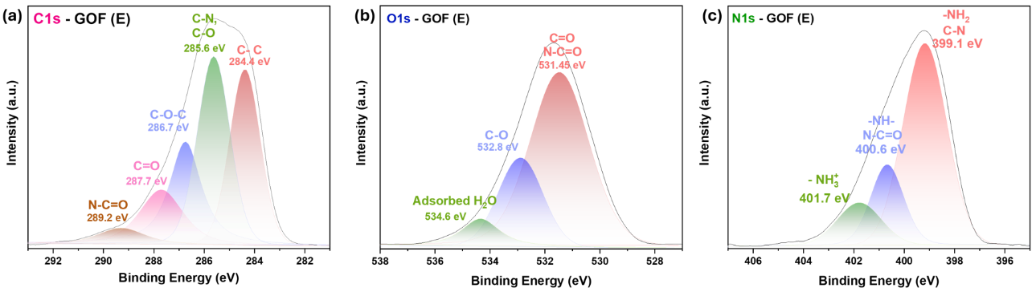
Figure S1: High-resolution XPS spectra of the (a) C 1s, (b) O 1s, and (c) N 1s regions of the GOF (E) adsorbent, showing the deconvoluted peaks corresponding to the surface chemical functionalities.

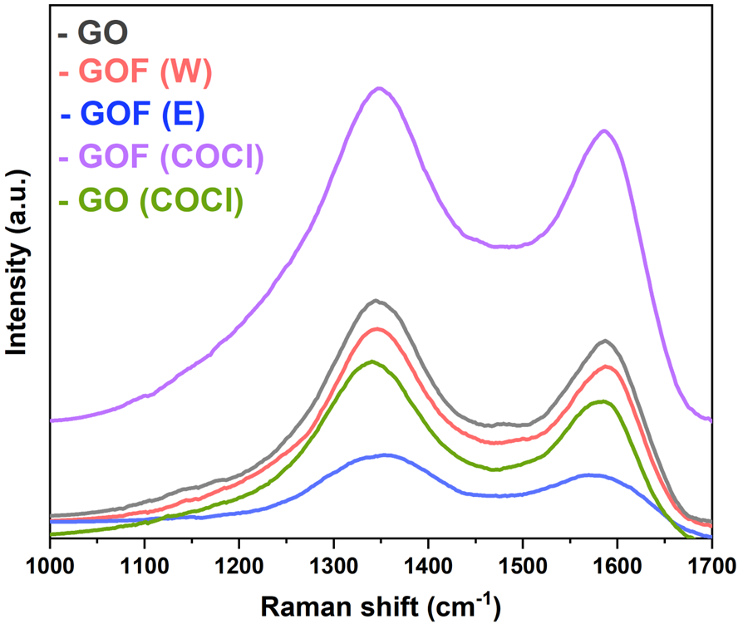
Figure S2: Raman spectra of pristine GO, GO (COCl), and PEI-functionalized graphene oxide composites GOF (W), GOF (E), and GOF (COCl).

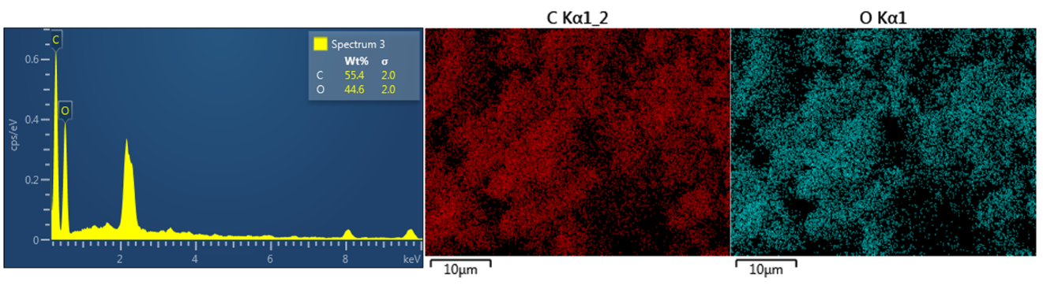
Figure S3: EDS spectrum and elemental mapping of the GO sample, showing the distribution of carbon (C) and oxygen (O). The elemental maps indicate a homogeneous distribution of both elements across the sample surface.

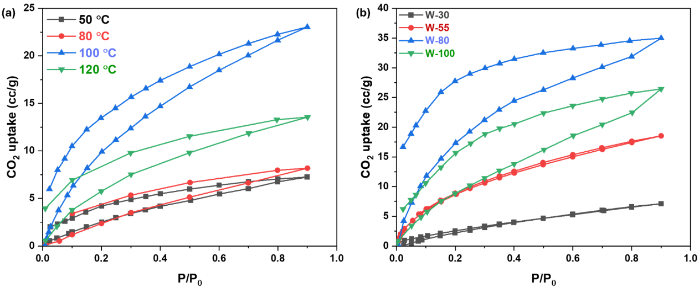
Figure S4. Effect of (a) reaction temperature and (b) PEI loading on the CO₂ adsorption performance of GOF (W).
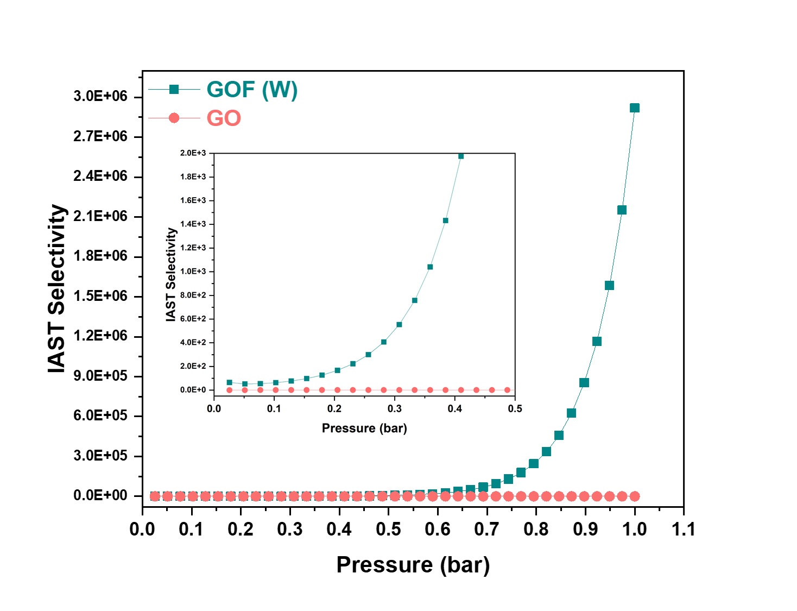
Figure S5. CO₂/N₂ selectivity of pristine GO and GOF (W) as a function of pressure, demonstrating the significantly enhanced selectivity of GOF (W) toward CO₂ adsorption.
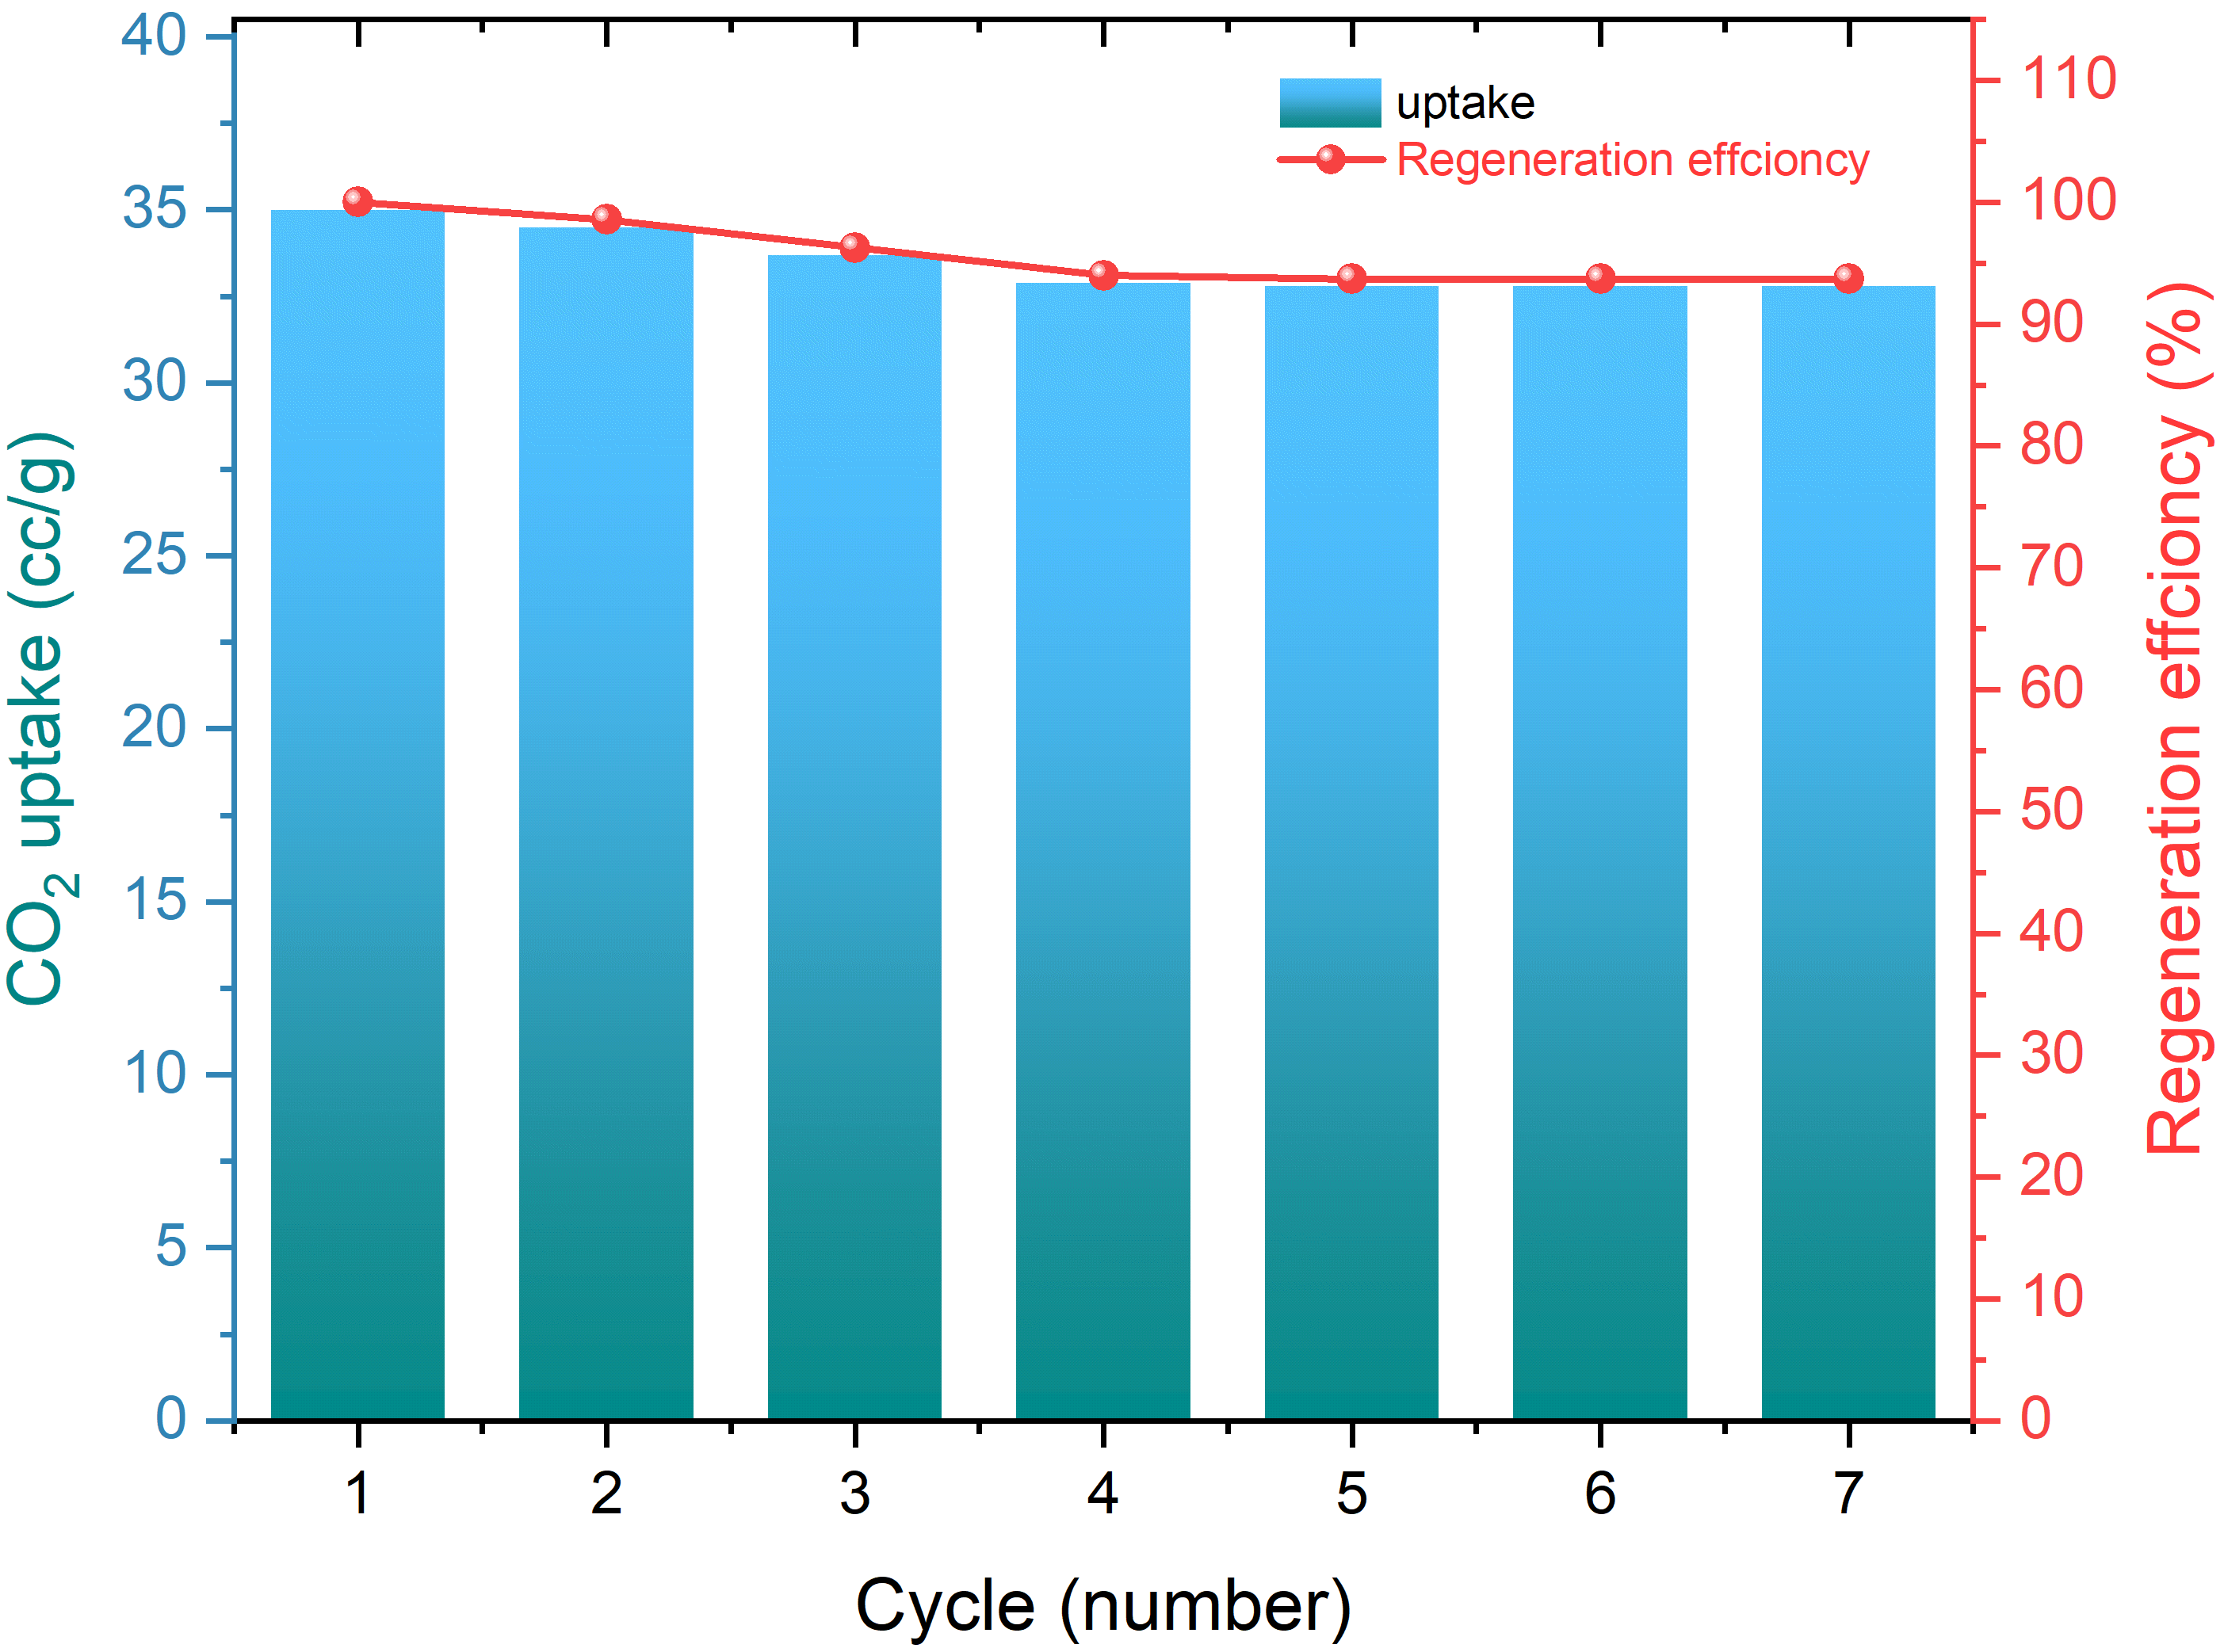
Figure S6. Cyclic CO₂ adsorption capacity (bars) and regeneration efficiency (line) of the GOF (W) adsorbent over seven consecutive adsorption–desorption cycles, demonstrating stable CO₂ uptake and high regeneration efficiency.

Table S1. Atomic percentages of surface elements determined from XPS survey spectra for the GOF-based samples
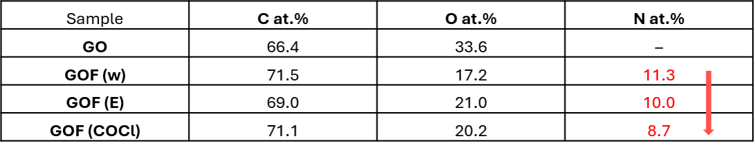

Table S2. Surface Area and Porosity Analysis of GO, GOF (W), GOF (E), GOF (COCl) Composites
 | Surface Area  (m²/g) | Pore Volume  (cm³/g) | Average pore diameter  (nm)
GO | 110.1 | 0.0402 | 3.5663
GOF (W) | 14.2 | 0.0558 | 20.3683
GOF (E) | 30.2 | 0.1041 | 13.6070
GOF (COCl) | 29.6 | 0.0834 | 44.4984

Table S3. Weight percentages (wt.%) of the constituent elements in the GOF-based samples determined from EDS analysis.
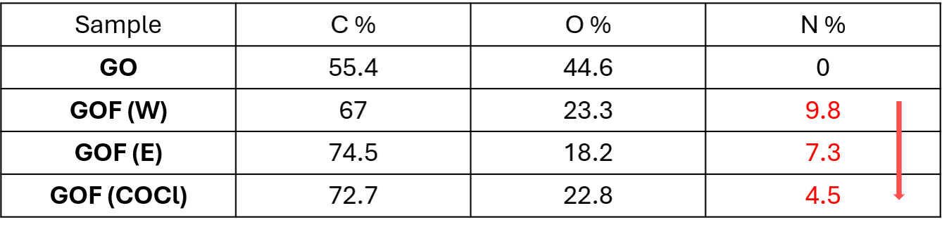

Table S4. DFT results of GO/PEI and CO₂@GO/PEI composites in different environments (Gas phase, EtOH, DMF, and H₂O).
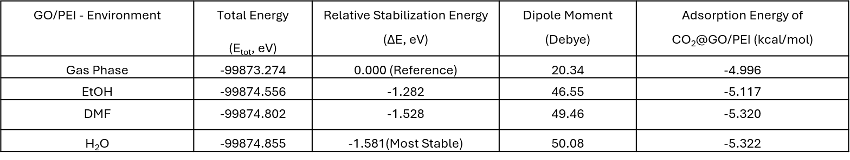

Table S5. Comparison of CO₂ capture Performance: This Work vs. State-of-the-Art GO Materials.
Material | CO₂ uptake (mmol/g) | Selectivity with N₂ | Temperature  (k) | Pressure  (bar) | reference
GO-CH₄N₂O | 1.70 | 28.0 | 273 | 1 | [4]
Diamino-functionalized silsesquioxane pillared GO | 1.7 | - | 273 | 1 (atm) | [5]
Diamino-functionalized silsesquioxane pillared GO | 1.5 | - | 298 | 1 (atm) | [5]
GOF-1 | 1.10 | 25.1 | 273 | 1 | [6]
PEI(60%)-GO | 0.74 | 37.17 | 298 | 1 | [7]
GO-MPD | 0.91 | 21.21 | 298 | 1 | [7]
MOF-200/GO | 1.34 | 18.37 | 298 | 1 | [7]
GO-PEI1 | 0.69 | - | 298 | 1 (atm) | [8]
GO-APTMS1 | 1.71 | - | 298 | 1 (atm) | [8]
Graphite oxide/EDA | 1.22 | - | 303 |  | [9]
CGO | 0.5 | 11 | 298 | 1 | [10]
CGO-1.5APTES | 1.3 | 159.2 | 298 | 1 | [11]
GO-TEHA | 0.74 | 16.37 | 298 | 1 | [12]
GO-EDA | 1.18 | - | 298 | 1 | [13]
GO | 0.26 | - | 273 | 1 | This work
GOF (COCl) | 0.56 | - | 273 | 1 | This work
GOF (E) | 1.00 | - | 273 | 1 | This work
GOF (W) | 1.56 | >10⁶ | 273 | 1 | This work

References
1. Gong, Z., et al., Mechanistic insights into the role of alkali metal activation in CO2 adsorption by nitrogen-doped coal-based carbon materials. RSC Advances, 2025. 15(52): p. 44883-44892.
2. Lu, T. and F. Chen, Multiwfn: A multifunctional wavefunction analyzer. Journal of Computational Chemistry, 2012. 33(5): p. 580-592.
3. Pastorczak, E. and C. Corminboeuf, Perspective: Found in translation: Quantum chemical tools for grasping non-covalent interactions. The Journal of Chemical Physics, 2017. 146(12).
4. Deng, H., et al., Amine-modified graphene oxide: Reaction mechanism with functional groups and enhanced CO2 adsorption-separation performance. Journal of Solid State Chemistry, 2025. 352: p. 125617.
5. Thomou, E., et al., A diamino-functionalized silsesquioxane pillared graphene oxide for CO2 capture. RSC Advances, 2021. 11(23): p. 13743-13750.
6. Chen, L., et al., Selective CO2 adsorption and H2 storage in two porous amine-pillared graphene oxide frameworks. Journal of Solid State Chemistry, 2019. 279: p. 120980.
7. Hosseini, Y., et al., Assembly of amine-functionalized graphene oxide for efficient and selective adsorption of CO2. Materials Chemistry and Physics, 2021. 270: p. 124788.
8. González Barriuso, M., et al., CO2 capture by amino-functionalized graphene oxide. 2019.
9. Yunxia, Z., D. Huiling, and Z. Qin, Preparation and characterization of aminated graphite oxide for CO2 capture. 2012.
10. Jerome, M.P., et al., Upcycling paper waste into aminosilane-functionalized cellulose-graphene oxide composite aerogel adsorbents for low-pressure CO2 capture. Separation and Purification Technology, 2025. 360: p. 131089.
11. Jerome, M.P., et al., Upcycling paper waste into aminosilane-functionalized cellulose-graphene oxide composite aerogel adsorbents for low-pressure CO2 capture. 2025. 360: p. 131089.
12. Hosseini, Y., et al., Assembly of amine-functionalized graphene oxide for efficient and selective adsorption of CO2. 2021. 270: p. 124788.
13. Pruna, A., et al., Effect of synthesis conditions on CO2 capture of ethylenediamine-modified graphene aerogels. 2019. 487: p. 228-235.

