Supplementary Table 3. LASSO Regression Coefficients for Candidate Variables

Abbreviations: LASSO, least absolute shrinkage and selection operator; NA, coefficient shrunk to zero (variable not selected).

Variable | Coefficient (lambda.min) | Coefficient (lambda.1se)
ASA classification | NA | NA
BMI | 0.007 | NA
Age | 0.016 | 0.007
Duration from surgery to discharge, day | 0.031 | 0.016
Comorbidity | 0.291 | 0.025
Anesthesia type | -0.060 | NA
Duration of surgery, min | NA | NA
Anesthesia time, min | NA | NA
Bleeding, mL | 0 | 0
Blood transfusion | 0.253 | 0.086
Crystalloid, mL | NA | NA
Colloid (>1000 mg) | NA | NA
Sufentanil, ug | 0.030 | 0.026
Remifentanil, ug | 0 | 0
Propofol, mg | 0.001 | 0.001
Etomidate, mg | NA | NA

Note: The optimal tuning parameter lambda was selected via 10-fold cross-validation. lambda.min = 0.025 (minimum cross-validated error), lambda.1se = 0.064 (one standard error within the minimum). Variables with NA coefficients were excluded at the corresponding lambda value. Variables with zero coefficients were retained but contributed negligibly to the model.

Supplementary Table 4. Multivariable Logistic Regression Analysis for Postoperative Constipation
Abbreviations: SE, standard error; CI, confidence interval.

Variable | Estimate | SE | Z value | P value | OR | 95% CI
(Intercept) | -3.387 | 0.843 | -4.020 | <0.001 | 0.034 | 0.007–0.178
Duration from surgery to discharge, day | 0.071 | 0.034 | 2.074 | 0.038 | 1.074 | 1.004–1.148
Age, year | 0.013 | 0.013 | 1.013 | 0.311 | 1.013 | 0.988–1.039
Comorbidity (present) | 0.759 | 0.405 | 1.877 | 0.061 | 2.136 | 0.967–4.720
Bleeding, mL | 0.000 | 0.001 | -0.275 | 0.784 | 1.000 | 0.999–1.001
Blood transfusion (yes) | 0.795 | 0.704 | 1.130 | 0.259 | 2.215 | 0.560–8.808
Sufentanil, ug | 0.011 | 0.021 | 0.490 | 0.624 | 1.011 | 0.969–1.054
Remifentanil, ug | 0.001 | 0.000 | 2.218 | 0.027 | 1.001 | 1.000–1.002
Propofol, mg | 0.002 | 0.001 | 2.257 | 0.024 | 1.002 | 1.000–1.004

Note: Odds ratios (OR) and 95% confidence intervals (CI) were calculated from the logistic regression coefficients. Variables were selected via LASSO regression at lambda.min = 0.025. P values were derived from the Wald test. The logistic regression formula is: Logit(P) = -3.387 + 0.071 &times; (Duration from surgery to discharge) + 0.013 x (Age) + 0.759 &times; (Comorbidity) + 0.000 &times; (Bleeding) + 0.795 &times; (Blood transfusion) + 0.011 &times; (Sufentanil) + 0.001 &times; (Remifentanil) + 0.002 &times; (Propofol).
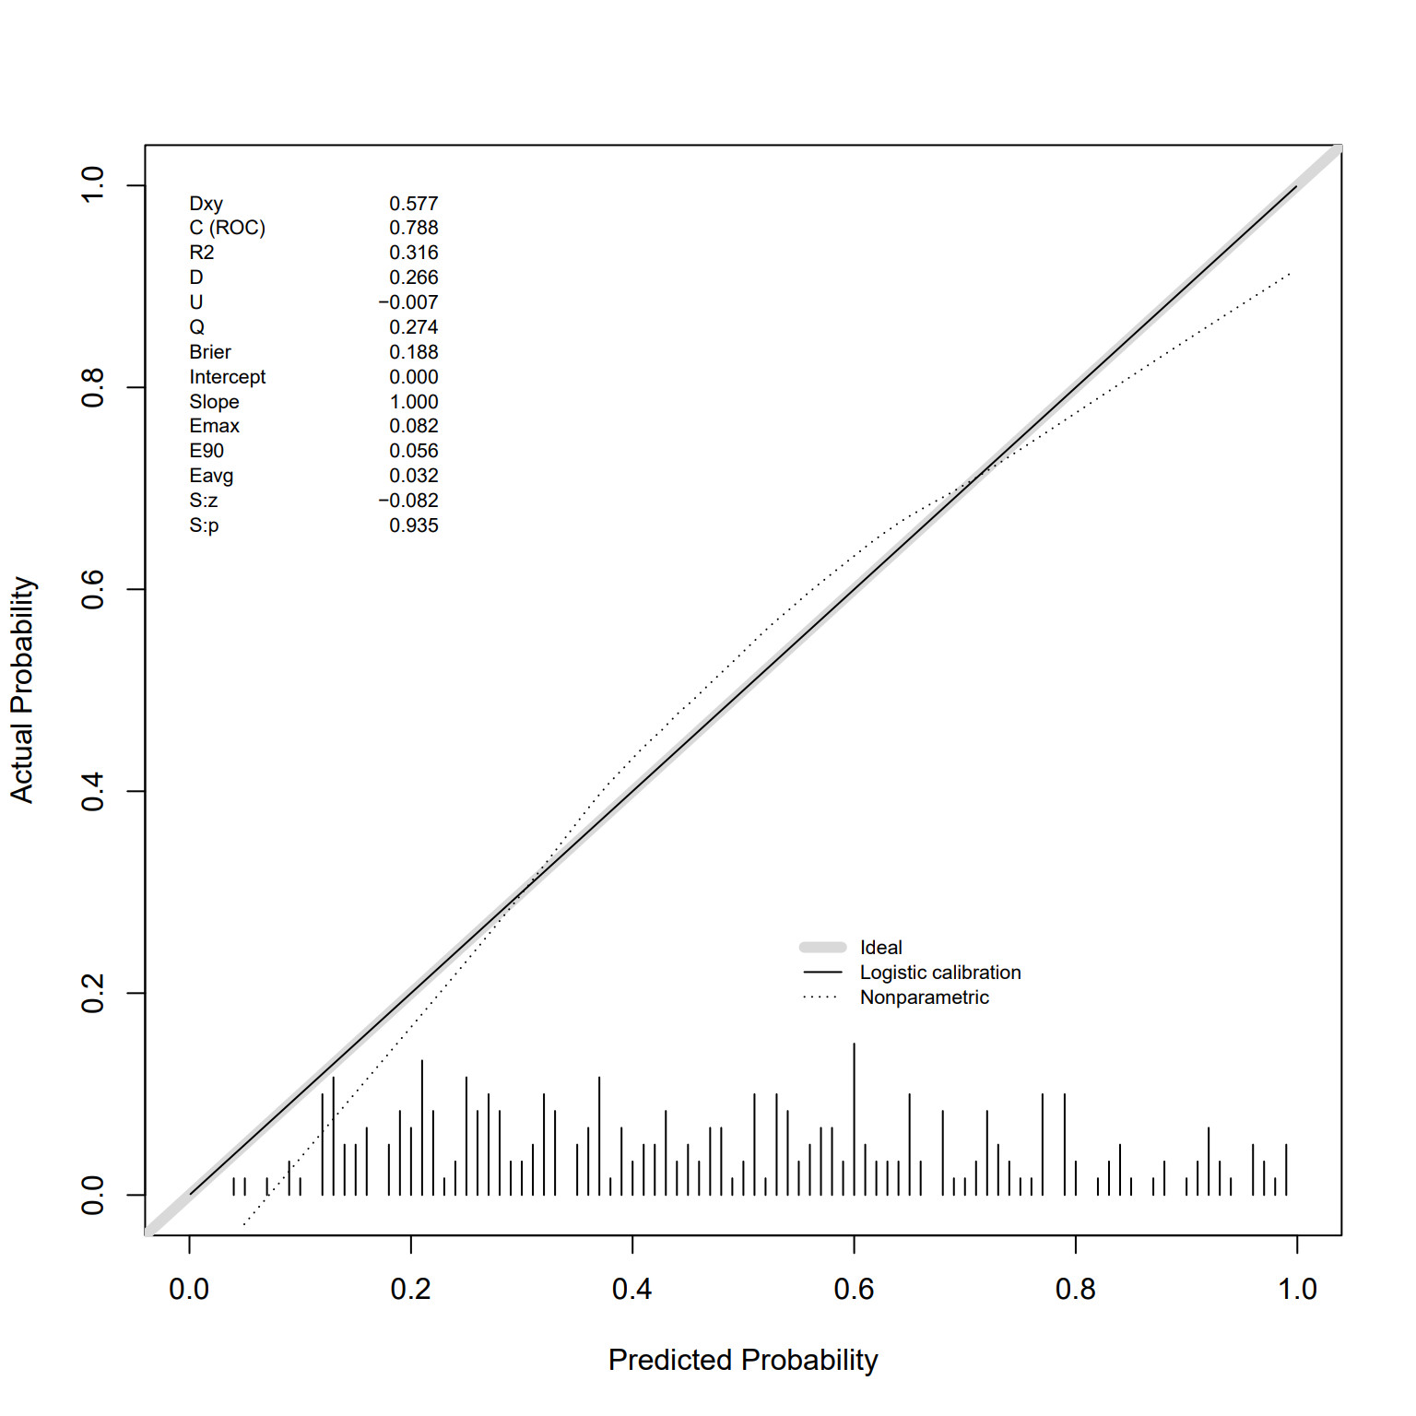
Figure 7 Calibration curve for the nomogram to predict the the probability of Orthopedic postoperative constipation with leave-one-out cross-validation.

