Supplementary material

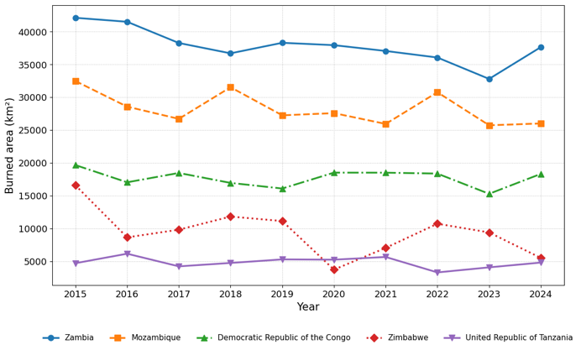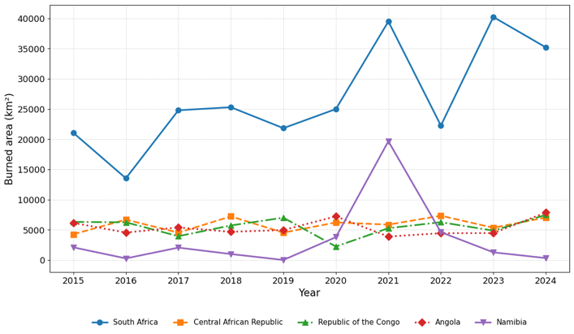
a b
Figure S1: a) countries showing a decreasing pattern in annual total burned area and b) countries showing an increasing tend in annual burned area.

