Supporting document

Zhihui Qiu, Liwen Zhang, Yihong Ding*, Tianbiao Zeng*

College of Chemistry and Materials Engineering, Wenzhou University, Wenzhou Zhejiang 325035, China.
*: Corresponding authors. Email: yhdd@wzu.edu.cn

Text S1:
By plotting the natural logarithm of the peak current density against the natural logarithm of the scan rate derived from CV curves recorded at various sweep rates, the rate-determining step of the electrode reaction can be quantitatively identified—specifically, whether the electrochemical process is dominated by surface-capacitive behavior, ion diffusion, or a mixed contribution from both. The core analytical relationship is expressed as i = ab^{v}, where i is the current (A), v is the scan rate (V s⁻¹), and a and b are adjustable constants. The key diagnostic parameter is the b-value:
b≈0.5: the current is governed by ion diffusion;
b≈1.0: the current is governed by surface capacitance;
0.5<b<1.0: a mixed regime involving both diffusion- and capacitance-controlled contributions.

Text S2:
When the diffusion of lithium ions within the material approaches a quasi-equilibrium state, the Li⁺ diffusion coefficient can be determined by measuring the transient potential response, as described by the following equation:
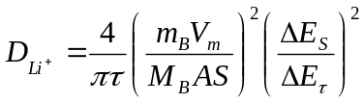
where τ is the duration of the current pulse; m_{B}, M_{B}, and V_{M} denote the mass, molar mass, and molar volume of the active material, respectively; SS is the contact area between the electrode and the electrolyte; and ΔE_{τ} and ΔE_{S} represent the potential change during the current pulse and the steady-state potential change during the subsequent relaxation period, respectively.

，,
Figure S1 XRD of 1Mn/SnS-G,SnS-G and SnS.

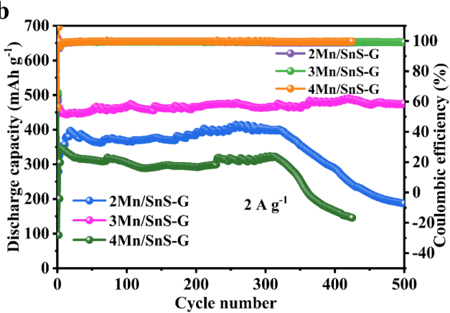
Figure S 2. Cycling stability of 2Mn/SnS-G, 3Mn/SnS-G, and 4Mn/SnS-G at a current density of 2 A g⁻¹

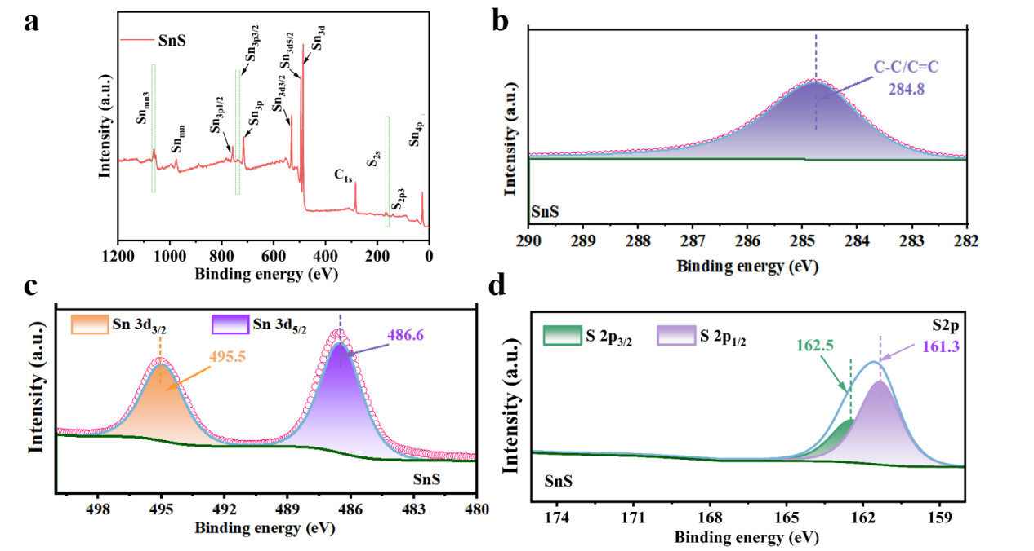
Figure S3. (a) Survey spectrum of SnS; (b) C 1s spectrum of SnS; (c) Sn 3d spectrum of SnS; (d) S2p spectrum of SnS.

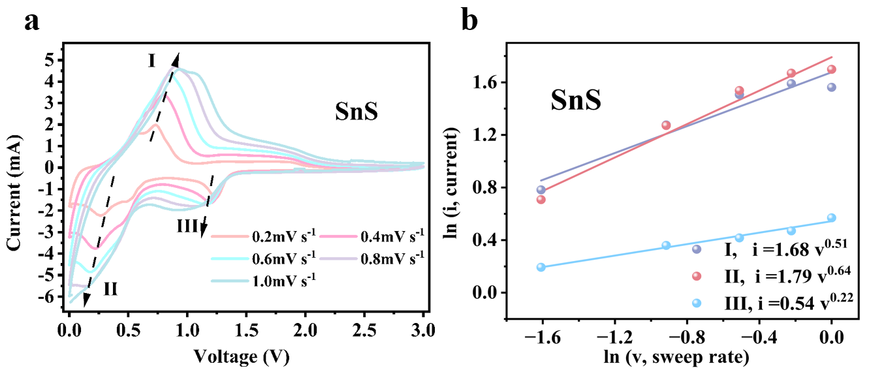
Figure S4. (a) CV curves of SnS at different scan rates; (b) b-values determined from the prominent peaks in the CV curves of SnS at different scan rates.

