Supplementary Information:
Waste-to-Performance Thermoplastic Composites through Valorization of Residual Hemp Noil via Micronization and Interfacial Engineering

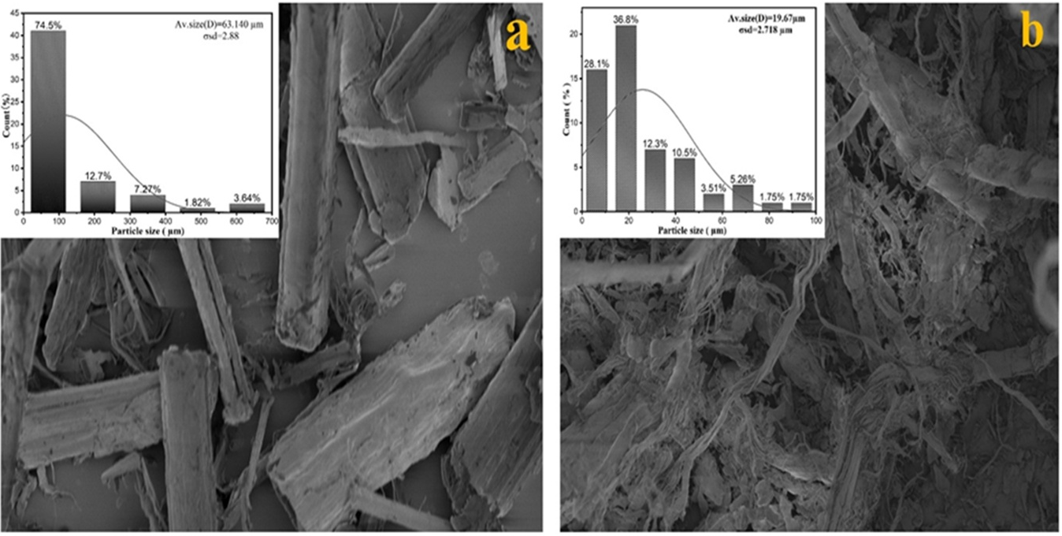
Figure S1. Hemp fiber (a) untreated hemp powder, (b) Treated hemp powder

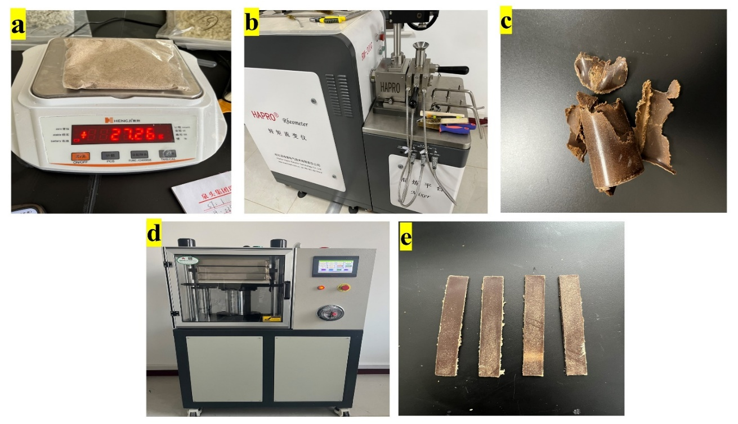
Figure S2. Makle a composite processing

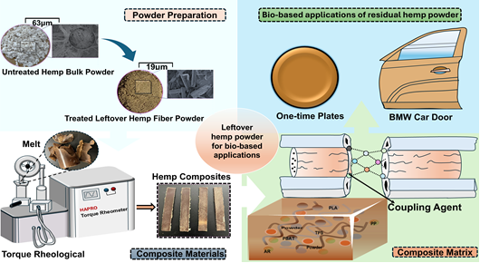
Figure S3. Hemp fiber was chemically processed to obtain fine powder.
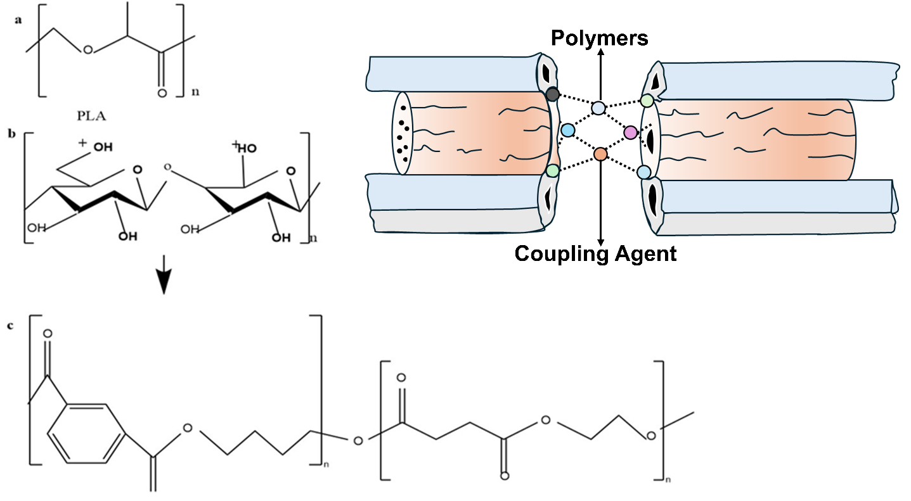
Figure S4. (a) PLA chemical repeating unit (b) Hemp cellulose chemical structure (C) PBAT chemical structure

