Supporting Information

Dual-Function Molecularly Imprinted Polypyrrole Enables Adhesion-Layer-Free Gold Nanostructures for Selective, Antifouling Dopamine Monitoring during Neuronal Differentiation
Joon-Ha Park^{1,#}, Yeon-Woo Cho^{1,#}, Min-ji Kang¹, Eun-Cheol Kwak¹, Tae-Hyung Kim^{1,2,*}
1. Department of Intelligent Precision Healthcare Convergence, Institute for Cross-disciplinary Studies (ICS), Sungkyunkwan University (SKKU), Suwon, Gyeonggi, 16419, Republic of Korea
2. Department of Biomedical Engineering, ICS, SKKU, Suwon, Gyeonggi, 16419, Republic of Korea

# These authors contributed equally to this work

*Corresponding author: Tae-Hyung Kim
Tel.: +82-10-3049-8847, E-mail: thkim0512@skku.edu

Fig. S1 Performance comparison for DA detection of polymer groups with control platform………………………...2
Fig. S2 Surface characterization by fabrication steps…………………………………………………………………..3
Fig. S3 DPV responses of the MIP electrode with PBS solution before and after template extraction………………..4
Fig. S4 AFM topographic images of the artificial boundary on the sensor surface……………………………………5
Fig. S5 Roughness comparison of each two groups……………………………………………………………………6
Fig. S6 TOF-SIMS depth profiles of characteristic secondary ions for the AuNS group……………………………...7
Fig. S7 Characterization of PDA fabrication on surface of AuNS electrode…………………………………………..8
Fig. S8 Optimization of the potential window for the electropolymerization of Py…………………………………...9
Fig. S9 SEM images of the electropolymerized surfaces at different potential windows…………………………….10
Fig. S10 Determination of the potential range for the DA imprinting in 3 groups……………………………………11
Fig. S11 Optimization of the DA template concentration for MIP electrode fabrication investigated by CV………..12
Fig. S12 Optimization of the Py concentration and cycle number of CV for MIP electrode fabrication investigated by CV……………………………………………………………………………………………………………………..13
Fig. S13 DA sensing performance on a control group prepared by CV in blank PBS solution………………………14
Fig. S14 DA sensing performance in AuNS-NIP group………………………………………………………………15
Fig. S15 Chemical detection property of AuNS electrode……………………………………………………………16
Fig. S16 Investigation of DA and interferent adsorption of AuNS and MIP groups using TOF-SIMS………………17
Fig. S17 Elucidating the exclusion mechanism of structural analogues via TOF-SIMS surface analysis……………18
Fig. S18 Optical images of DAergic neurons during differentiation………………………………………………….19
Fig. S19 Evaluation of pH-dependent DA sensing stability…………………………………………………………..20
Fig. S20 Negative control groups for stimulus-evoked DA release from differentiated SH-SY5Y cells……………..21
Fig. S21 Standard calibration of DA using HPLC for cross-validation……………………………………………….22
Fig. S22 HPLC cross-validation of SH-SY5Y cell-secreted DA during differentiation………………………………23
Fig. S23 ELISA cross-validation of SH-SY5Y cell-secreted DA during differentiation……………………………...24
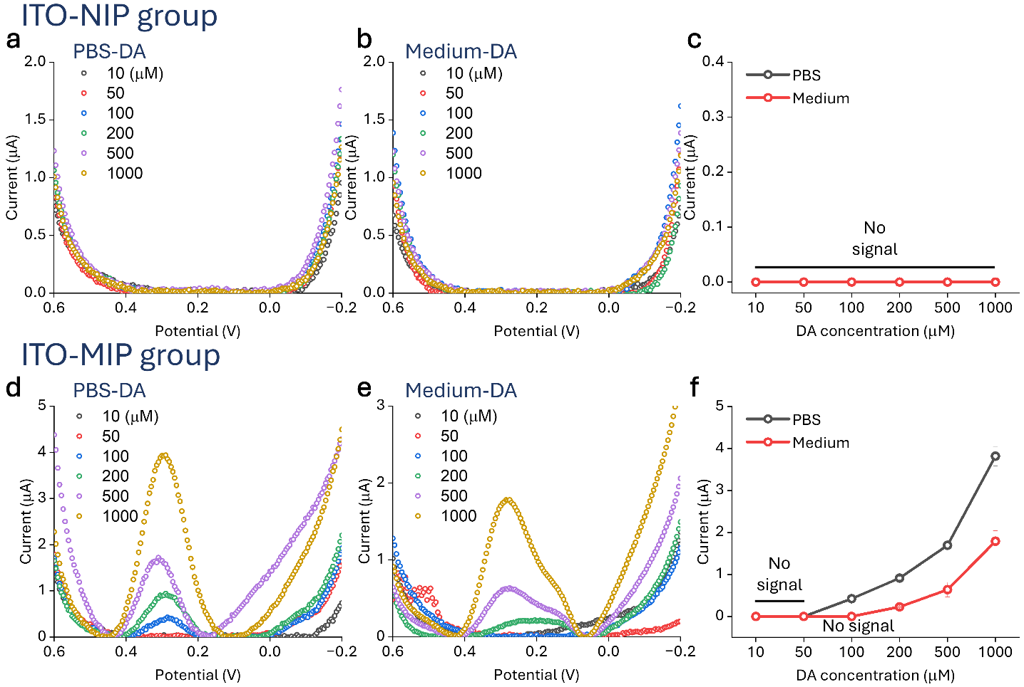
Fig. S1 Performance comparison for DA detection of polymer groups with control platform. a DPV plot of the ITO-NIP group in PBS at various DA concentrations. b DPV plot of the ITO-NIP group in 10% FBS-supplemented medium at various DA concentration. c Quantitative evaluation of a and b. d DPV plot of the ITO-MIP group in PBS at various DA concentrations. e DPV plot of the ITO-NIP group in 10% FBS-supplemented medium at various DA concentration. f Quantitative evaluation of d and e. All potentials are reported versus an Ag/AgCl reference electrode. Data are presented as mean ± SD (n = 3).
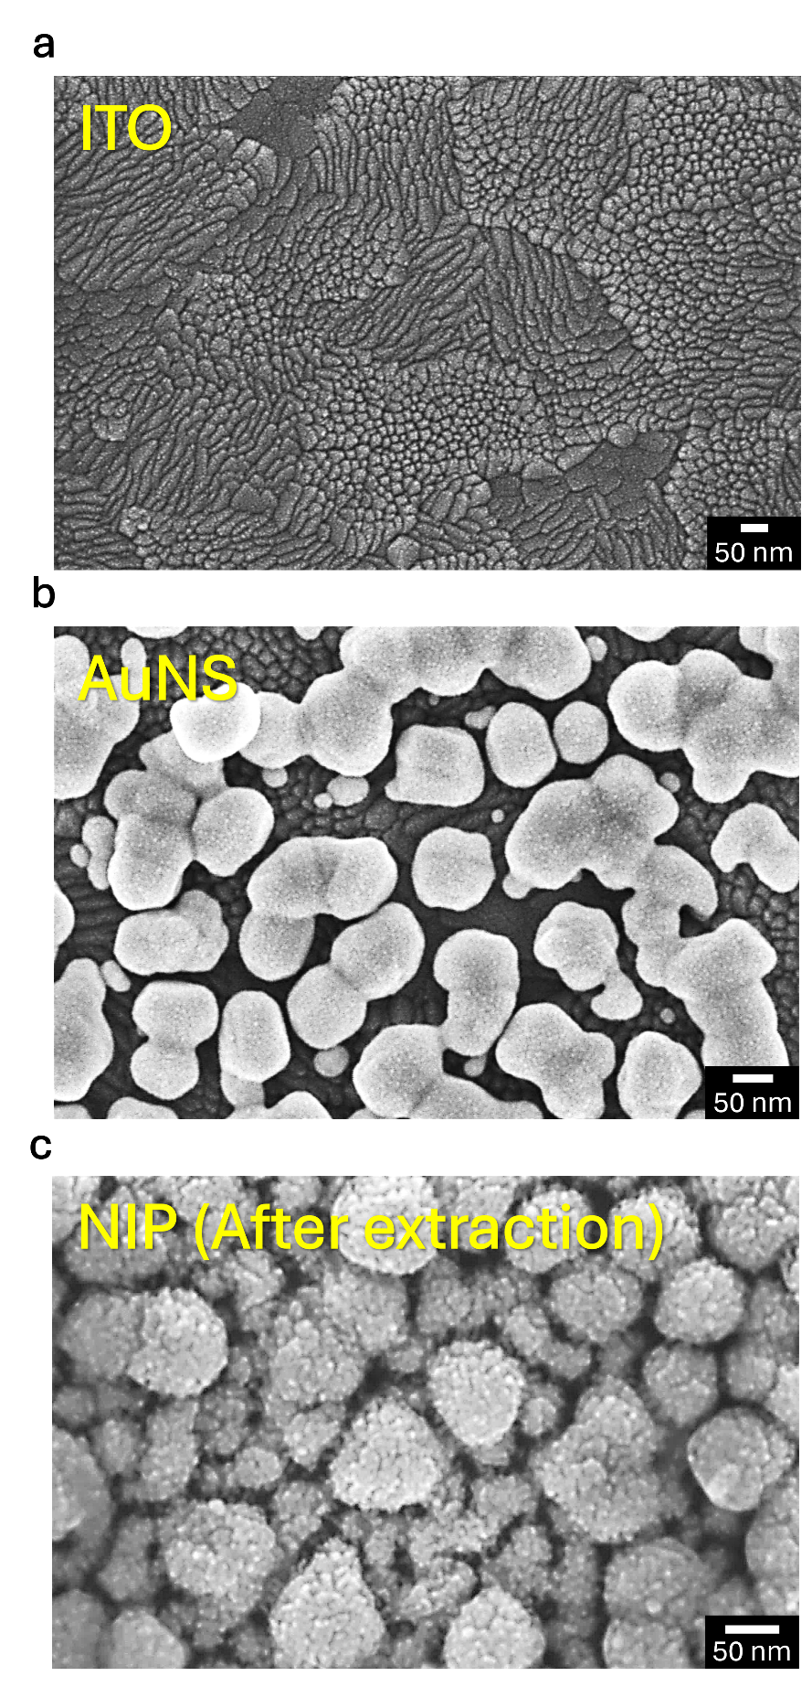
Fig. S2 Surface characterization by fabrication steps. a SEM image of the ITO electrode surface. b SEM image of AuNS electrode surface. c SEM image of NIP electrode surface after extraction step.
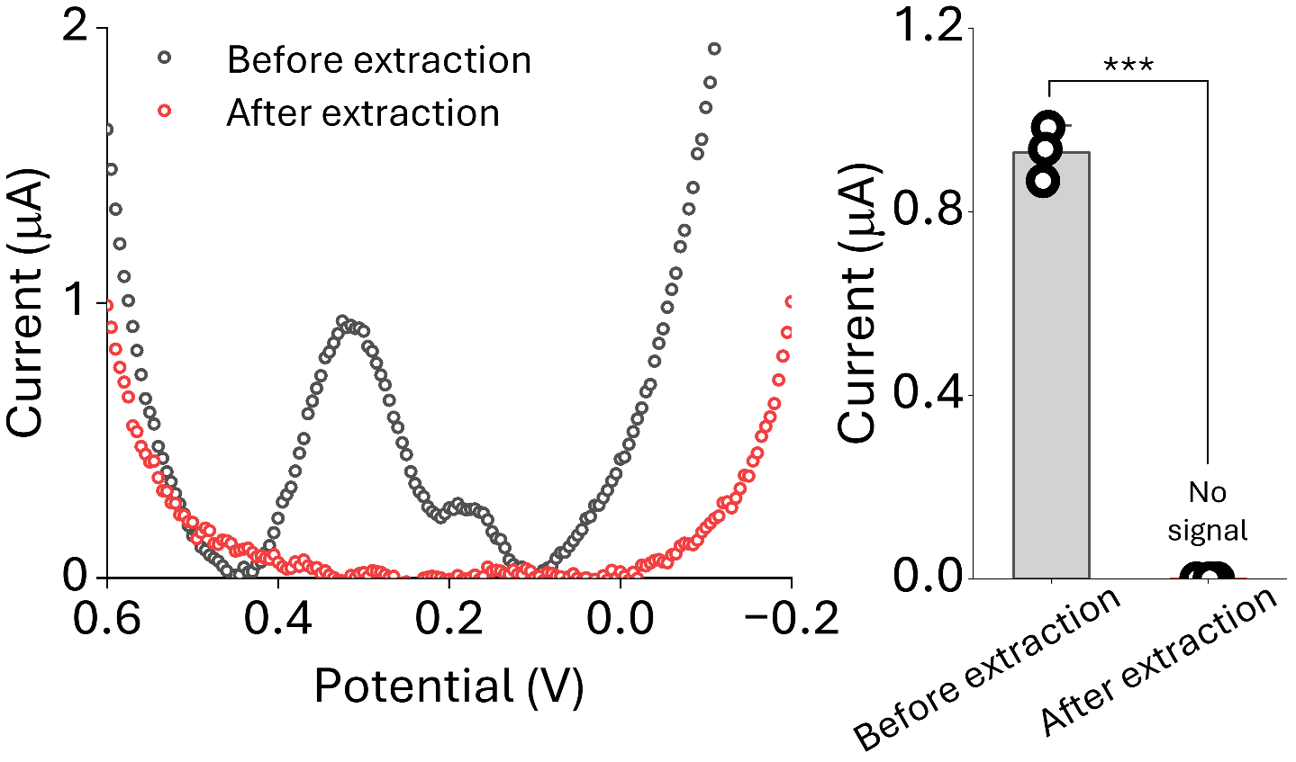
Fig. S3 DPV responses of the MIP electrode with PBS solution before and after template extraction. All potentials are reported versus an Ag/AgCl reference electrode. Data are presented as mean ± SD (n = 3). Statistical significance was determined using an unpaired Student’s t-test. (***: p < 0.001).
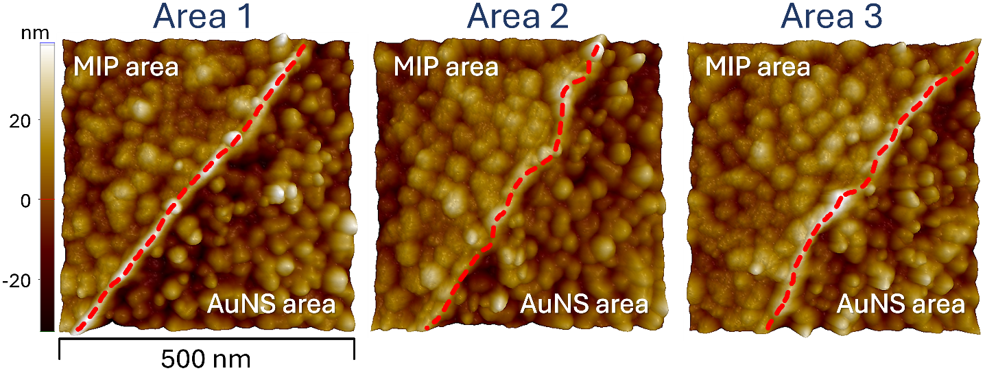
Fig. S4 AFM topographic images of the artificial boundary on the sensor surface. The images (Areas 1-3) concurrently display the MIP modified region and the AuNS region. The red dashed lines indicate the interface between the two distinct morphological areas.
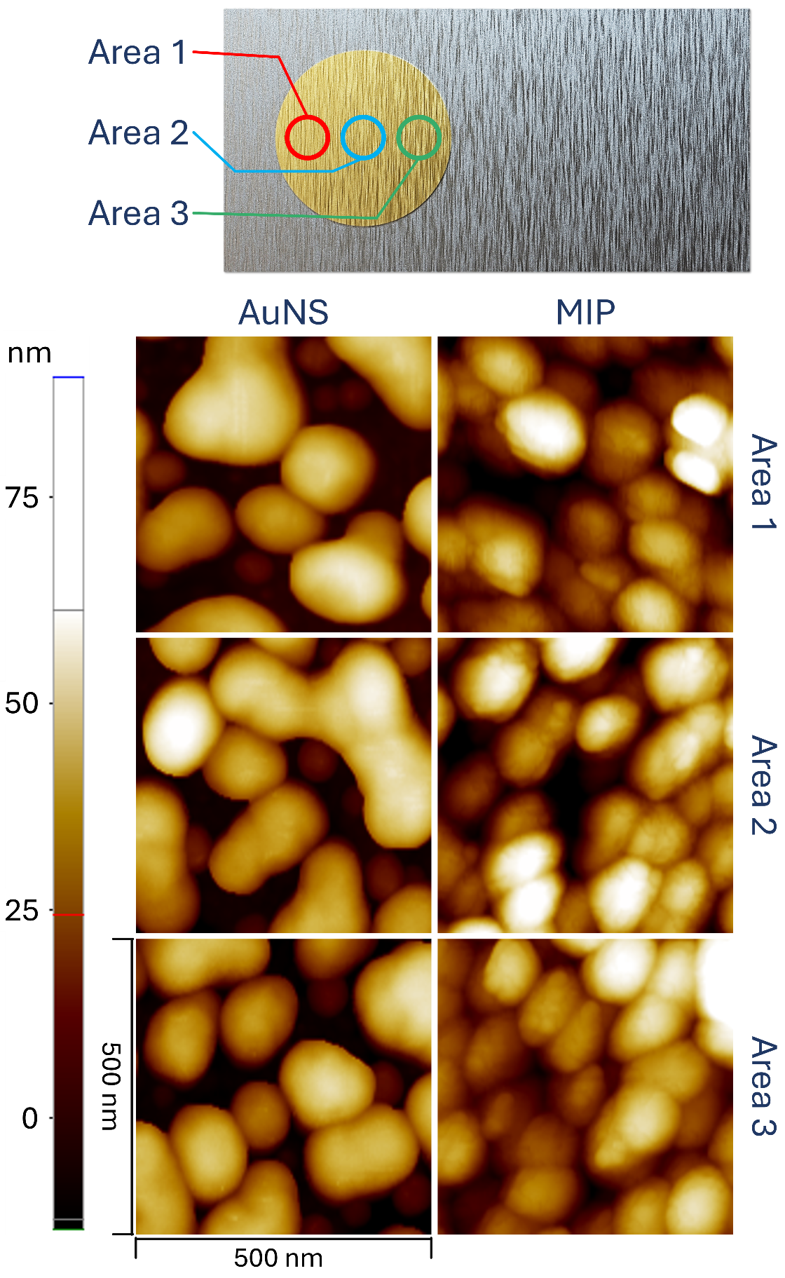
Fig. S5 Roughness comparison of each two groups.
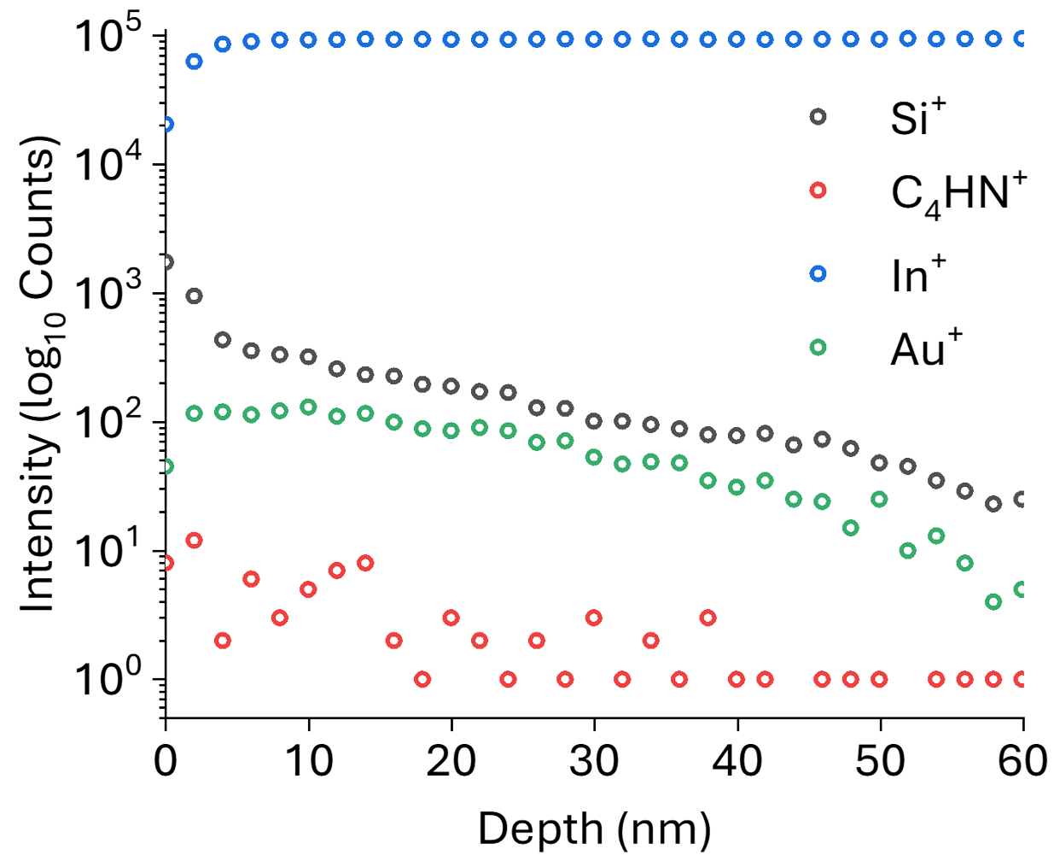
Fig. S6 TOF-SIMS depth profiles of characteristic secondary ions for the AuNS group.
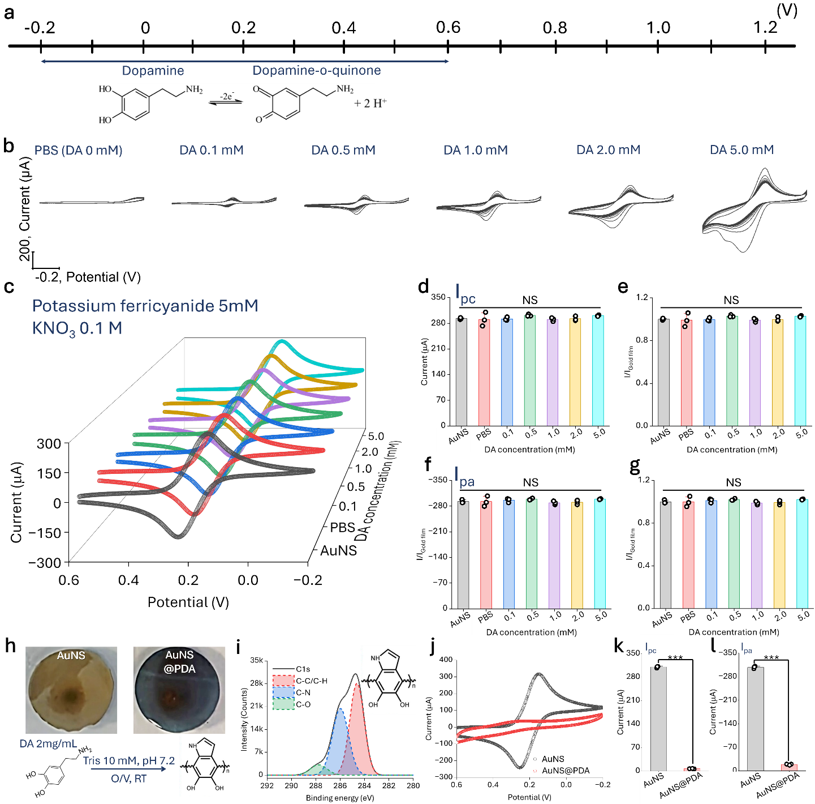
Fig. S7 Characterization of PDA fabrication on surface of AuNS electrode. a Potential scale and schematic illustration showing the electrochemical redox transition of dopamine to dopamine-o-quinone. b CV profiles of DA electropolymerization at various concentrations (0-5.0 mM) in PBS. c Electrochemical characterization for electrodes treated with different DA concentrations. d Cathodic peak current (I_{pc}) comparison with various DA concentrations. e Normalized I_{pc} values relative to the AuNS. f Anodic peak current (I_{pa}) comparison with various DA concentration. g Normalized I_{pa} values with various DA concentration. h Optical images and reaction scheme for PDA formation. i XPS C1s spectrum of the PDA film with deconvolution into C-C/C-H, C-N, and C-O components. j Comparison of CV responses between the AuNS and AuNS@PDA. k Quantitative analysis of I_{pc}. l Quantitative analysis of I_{pa}. All potentials are reported versus an Ag/AgCl reference electrode. Data are presented as mean ± SD (n = 3). Statistical significance was determined using a one-way ANOVA followed by Tukey’s test for (d-g), and an unpaired Student’s t-test for (k, l) (NS: not significant, ***: p < 0.001).
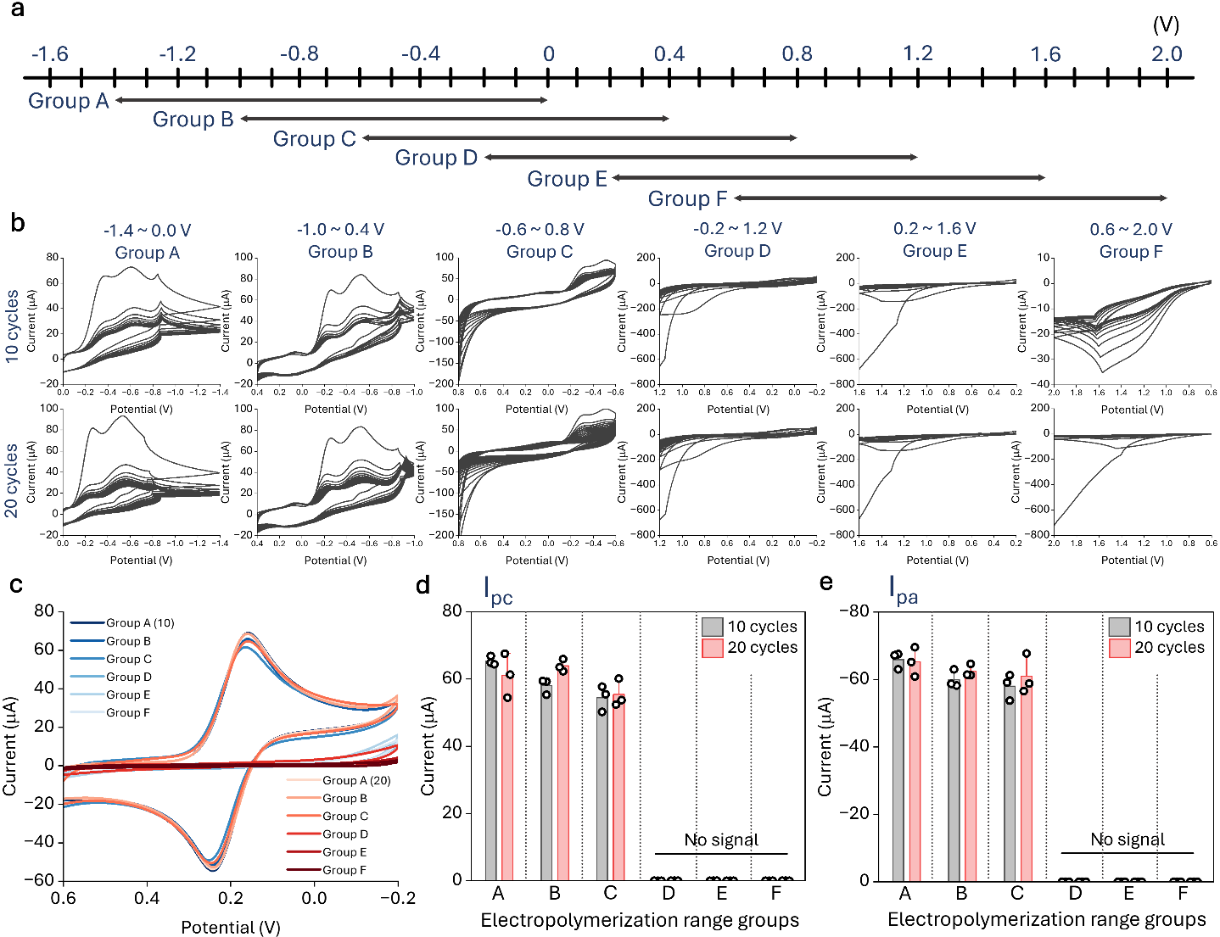
Fig. S8 Optimization of the potential window for the electropolymerization of Py. a Graphical illustration of fabrication phases. b CV profiles recorded during Py electropolymerization for each groups. c Electrochemical properties of each groups. d Comparison of I_{pc} values across differential potential window groups. e Comparison of I_{pa} values across differentia potential window groups. All potentials are reported versus an Ag/AgCl reference electrode. Statistical significance was determined using a one-way ANOVA followed by Tukey’s test. Data are presented as mean ± SD (n = 3).
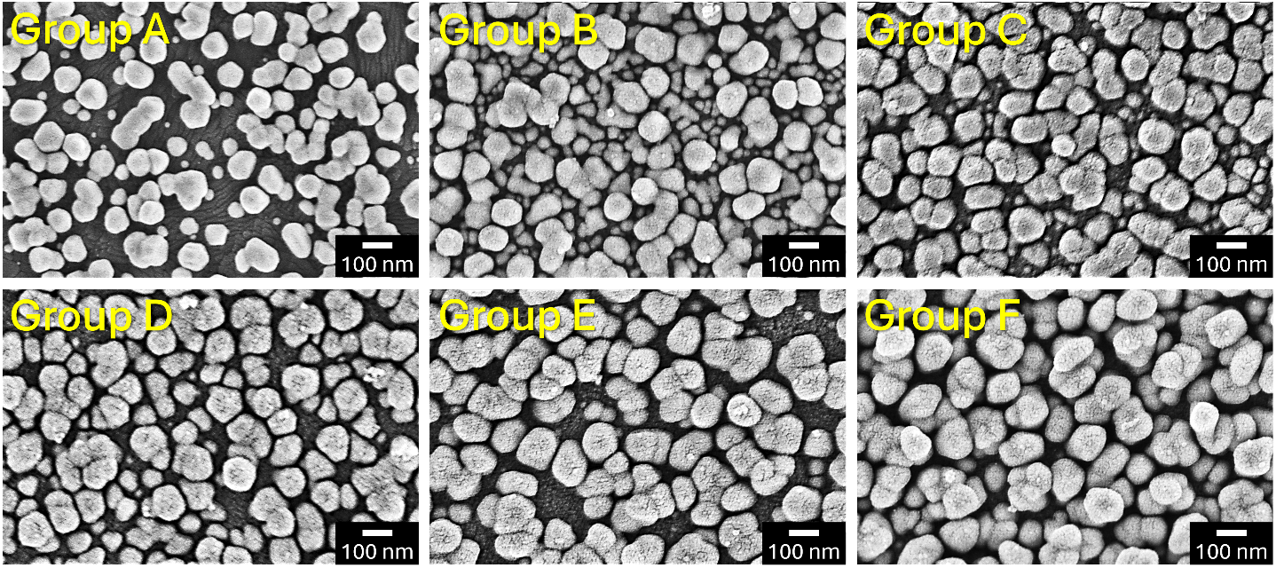
Fig. S9 SEM images of the electropolymerized surfaces at different potential windows.
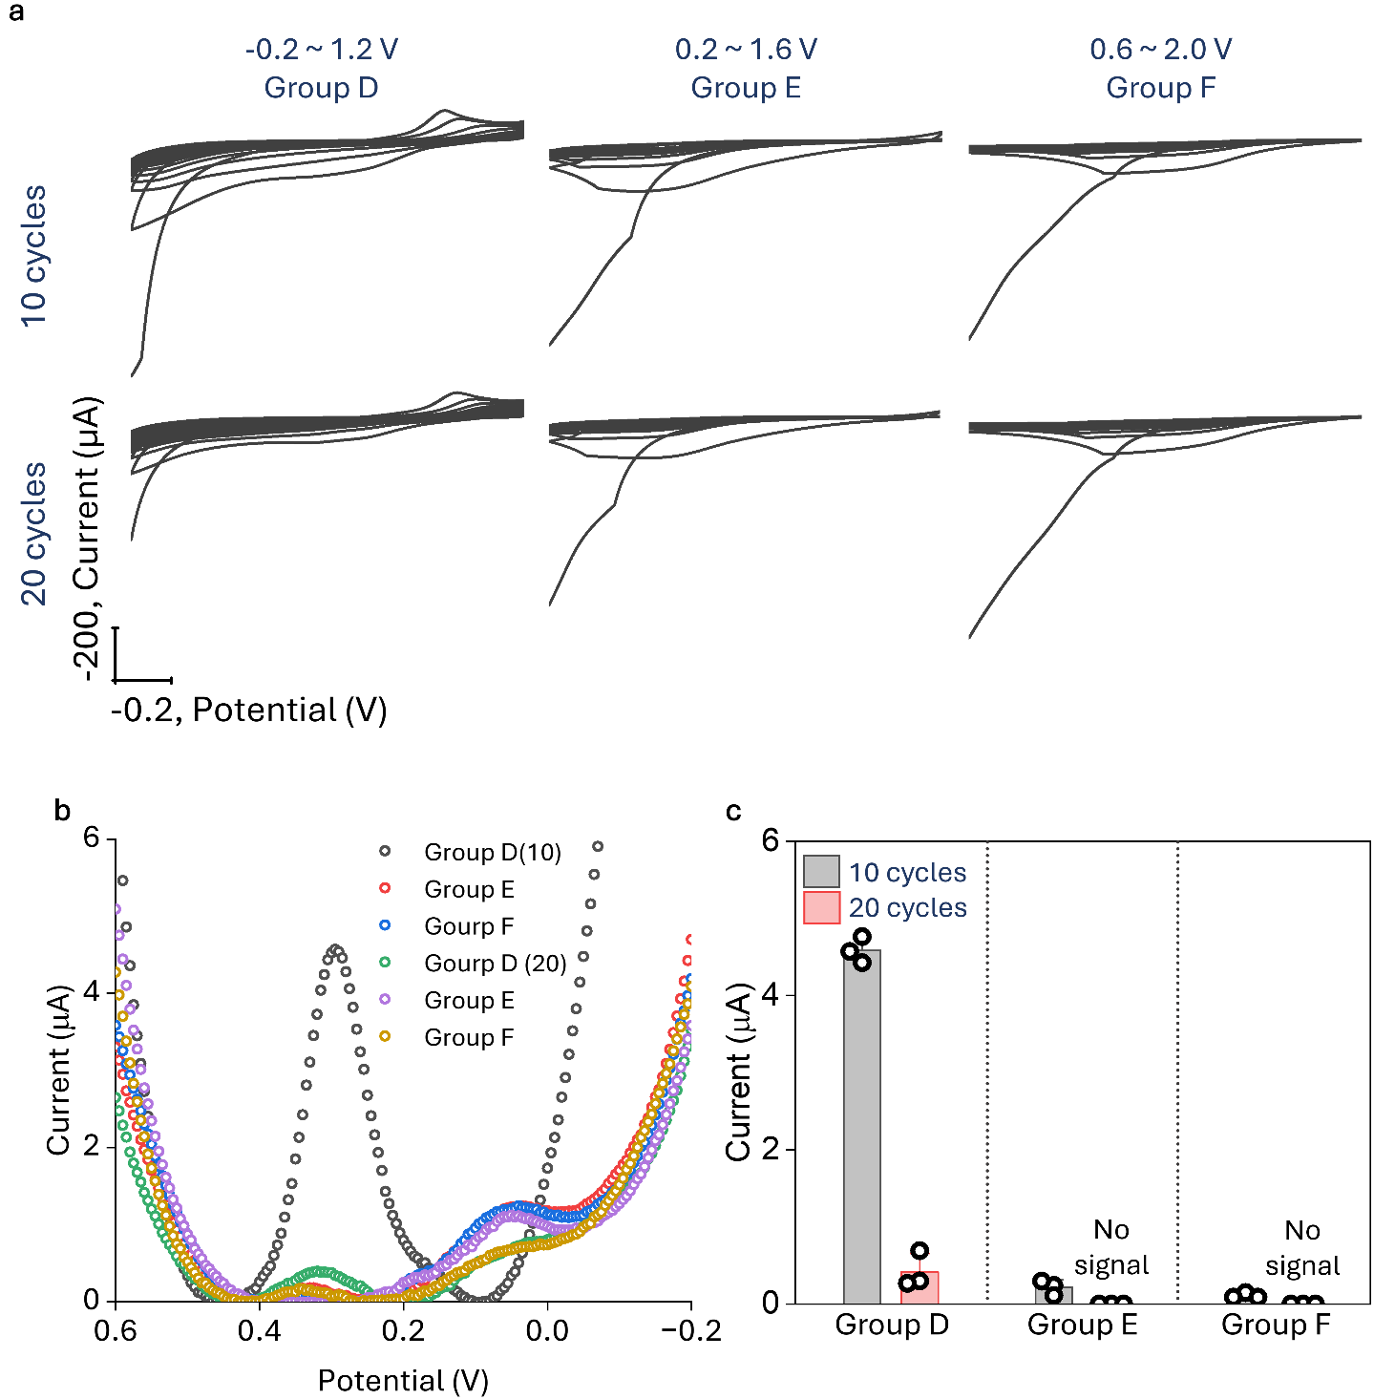
Fig. S10 Determination of the potential range for the DA imprinting in 3 groups. a CV profiles during Py electropolymerization for Group D, E and F at 10 and 20 cycles. b DPV profiles for Group D, E, and F at 10 and 20 cycles. c Quantitative evaluation of b. All potentials are reported versus an Ag/AgCl reference electrode. Data are presented as mean ± SD (n = 3).
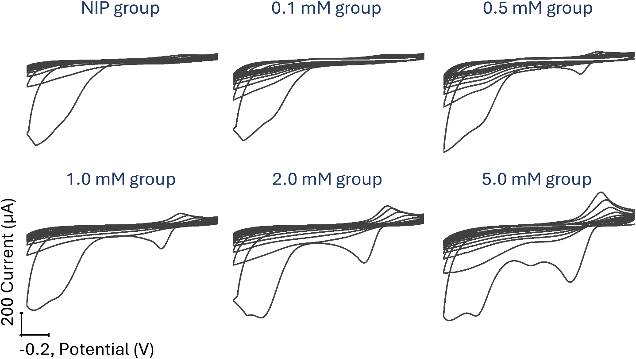
Fig. S11 Optimization of the DA template concentration for MIP electrode fabrication investigated by CV. All potentials are reported versus an Ag/AgCl reference electrode.
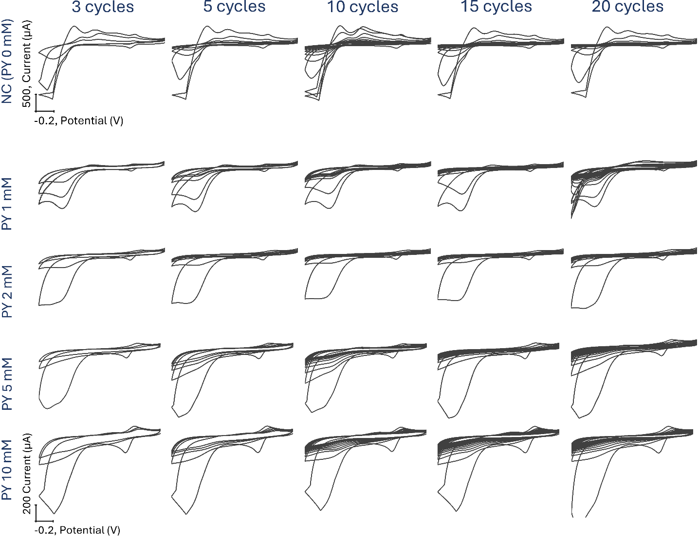
Fig. S12 Optimization of the Py concentration and cycle number of CV for MIP electrode fabrication investigated by CV. All potentials are reported versus an Ag/AgCl reference electrode.
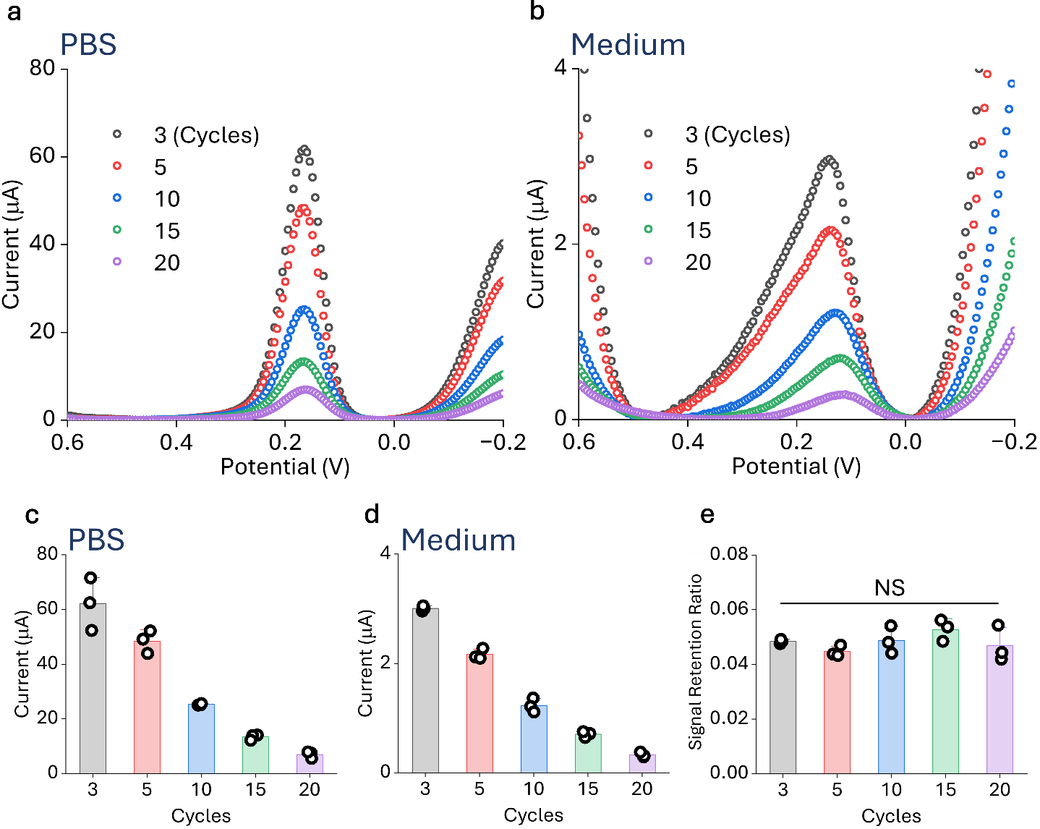
Fig. S13 DA sensing performance on a control group prepared by CV in blank PBS solution. a DPV profiles in PBS of control group across different cycles numbers. b DPV profiles in 10% FBS-supplemented medium across different cycles numbers. c Quantitative evaluation of a. d Quantitative evaluation of b. e Signal Retention Ratio analysis of c and d. All potentials are reported versus an Ag/AgCl reference electrode. Data are presented as mean ± SD (n = 3). Statistical significance was determined using a one-way ANOVA followed by Tukey’s test. (NS: not significant).
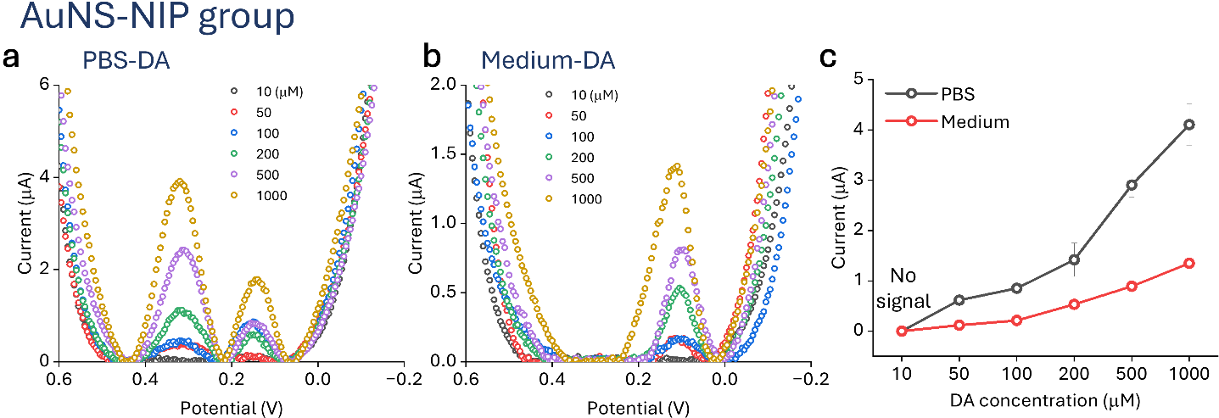
Fig. S14 DA sensing performance in AuNS-NIP group. a DPV plot of the AuNS-NIP group in PBS at various DA concentrations. b DPV plot of the AuNS-NIP group in 10% FBS-supplemented medium at various DA concentration. c Quantitative evaluation of a and b. All potentials are reported versus an Ag/AgCl reference electrode. Data are presented as mean ± SD (n = 3).
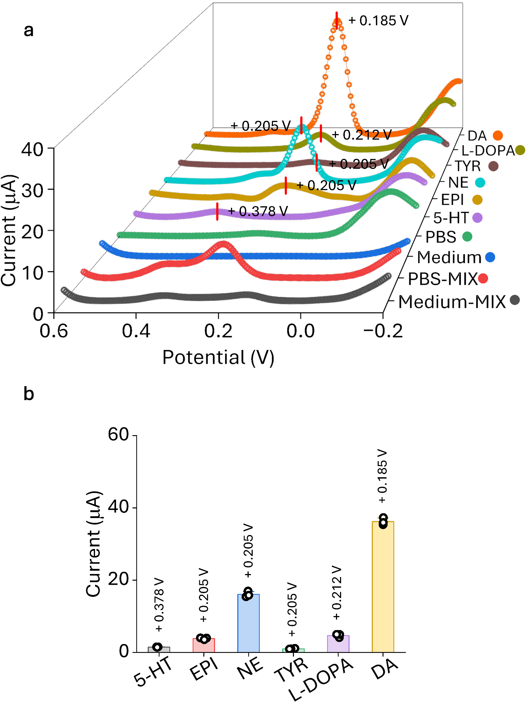
Fig. S15 Chemical detection property of AuNS electrode. a DPV plot of electrochemical responses of various neurotransmitters and precursors. b Quantitative evaluation of a. All potentials are reported versus an Ag/AgCl reference electrode. Data are presented as mean ± SD (n = 3).
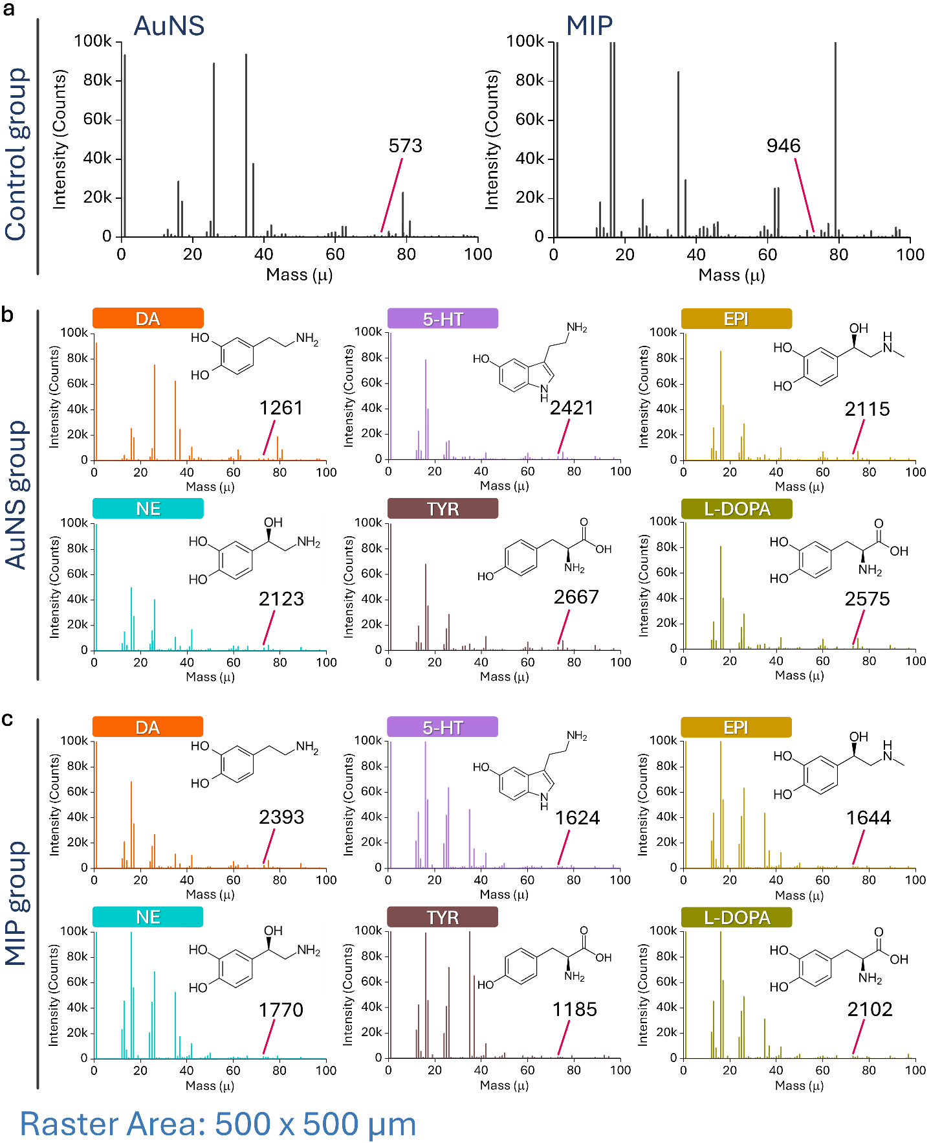
Fig. S16 Investigation of DA and interferent adsorption of AuNS and MIP groups using TOF-SIMS. a TOF-SIMS spectra of the control groups without analyte incubation, showing the baseline ion counts for the C₆ aromatic structure. b TOF-SIMS spectra of the AuNS group after incubation with 10 μM of neurotransmitters and precursors. c TOF-SIMS spectra of the MIP group after incubation with 10 μM of neurotransmitters and precursors. (Raster Area: 500×500 μm).
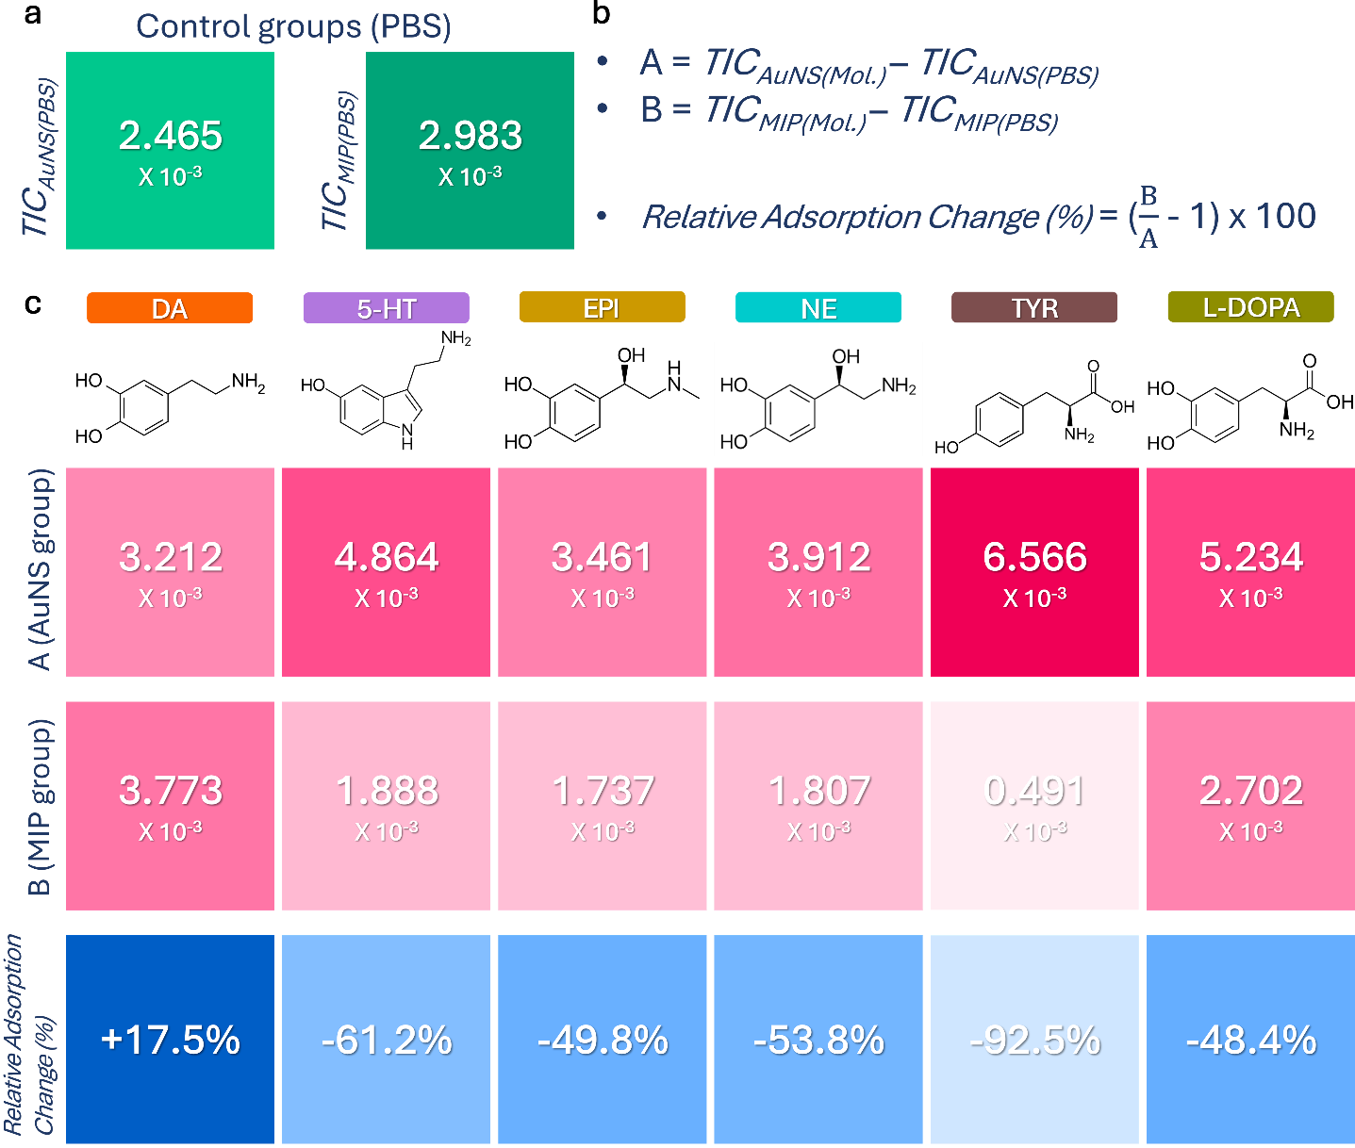
Fig. S17 Elucidating the exclusion mechanism of structural analogues via TOF-SIMS surface analysis. a Baseline Total Ion Count (TIC) values measured in PBS for the AuNS and MIP control groups. b Mathematical definitions for calculating net analyte ion counts (A and B) and the formula for Relative Adsorption Change (%). c Data table presenting TIC-based adsorption values and calculated Relative Adsorption Change (%) for DA and its structural analogues.
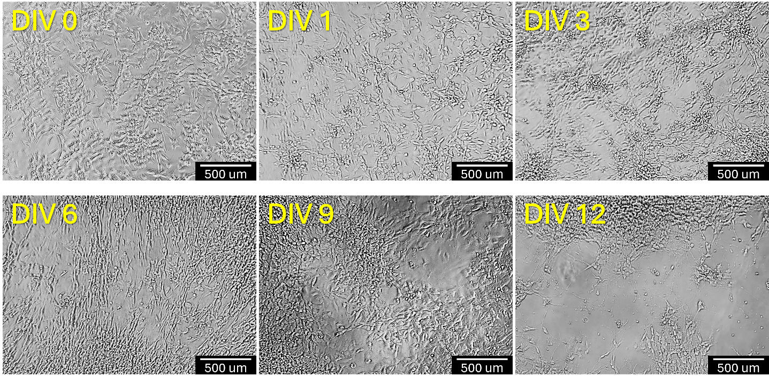
Fig. S18 Optical images of DAergic neurons during differentiation.
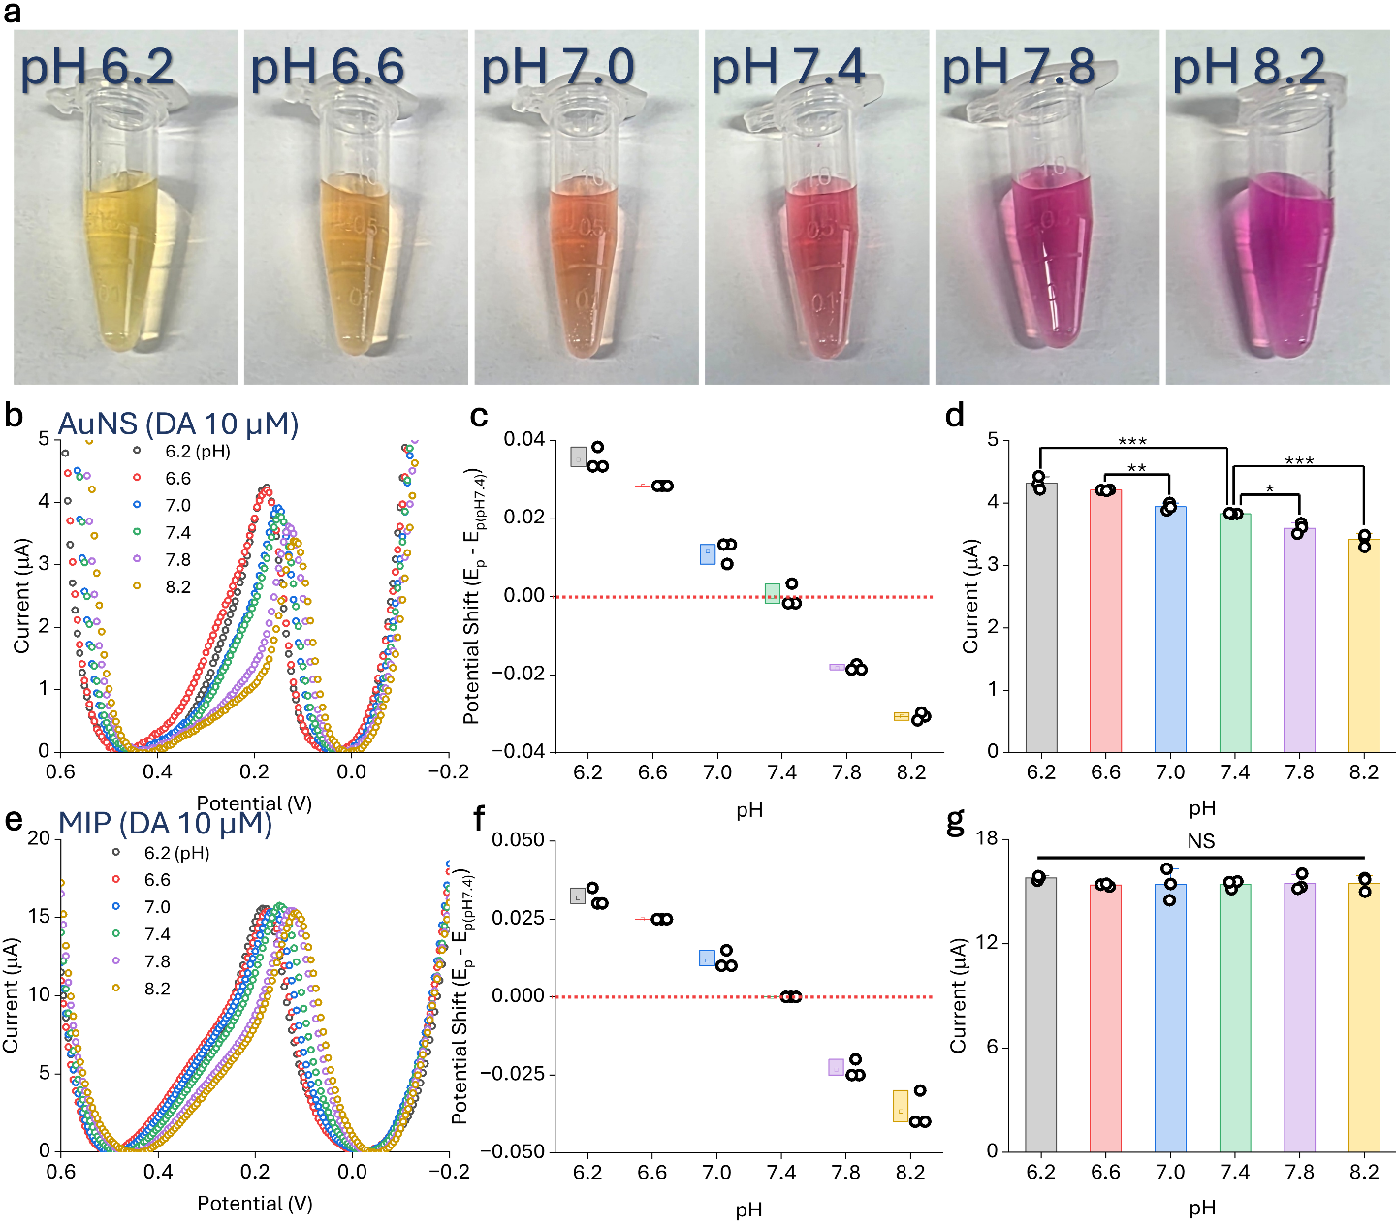
Fig. S19 Evaluation of pH-dependent DA sensing stability. a Optical images of medium adjusted to pH ranges from 6.2 to 8.2. b DPV profiles display the 10 μM DA response on the AuNS electrode. c Potential shifts of DA current signal on AuNS electrode. d Quantitative evaluation of b. e DPV profiles display the 10 μM DA response on the MIP. f Potential shifts of DA current signal on MIP. g Quantitative evaluation of e. All potentials are reported versus an Ag/AgCl reference electrode. Data are presented as mean ± SD (n = 3). Statistical significance was determined using a one-way ANOVA followed by Tukey’s test (NS: not significant, * < 0.05, ** < 0.01, ***: p < 0.001).
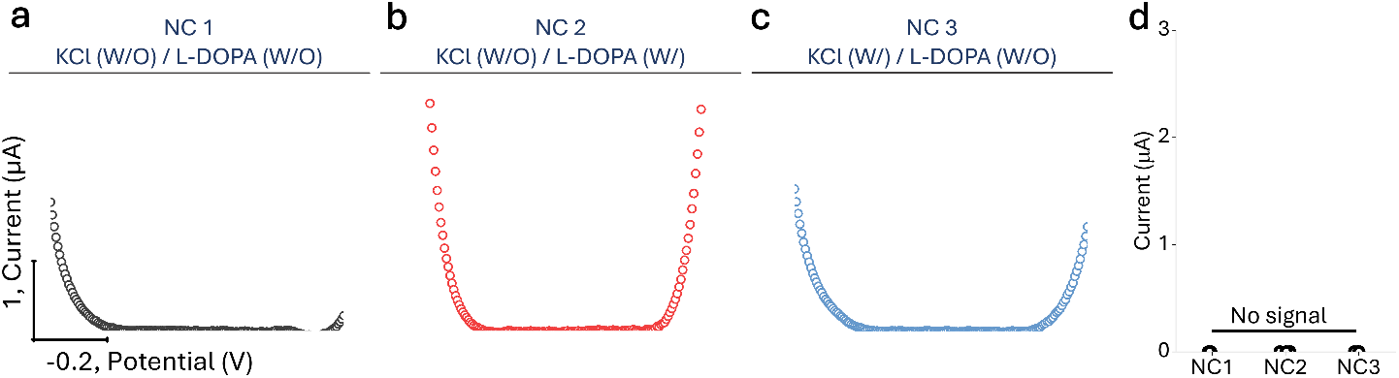
Fig. S20 Negative control groups for stimulus-evoked DA release from differentiated SH-SY5Y cells. a DPV profile of NC 1 group without KCl stimulation and L-DOPA pretreatment. b DPV profile of NC 2 group L-DOPA pretreatment only. c DPV profile of NC 3 group with KCl stimulation only. d Quantitative evaluation of (a-c). All potentials are reported versus an Ag/AgCl reference electrode. Data are presented as mean ± SD (n = 3). Statistical significance was determined using a one-way ANOVA followed by Tukey’s test (NS: not significant).
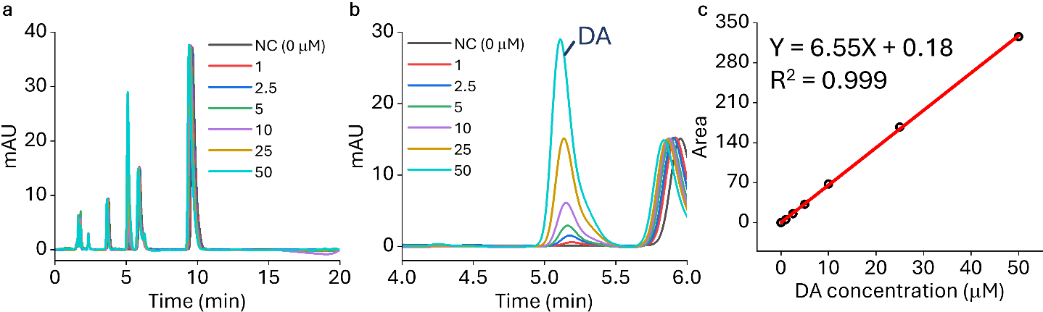
Fig. S21 Standard calibration of DA using HPLC for cross-validation. a Full HPLC chromatograms of standard DA solution at various concentrations in medium (0-50 μM). b Magnified view of the chromatograms from 4 to 6 min, highlighting the concentration-dependent specific peaks for DA. c The corresponding linear calibration curve plotting the peak area against DA concentration.
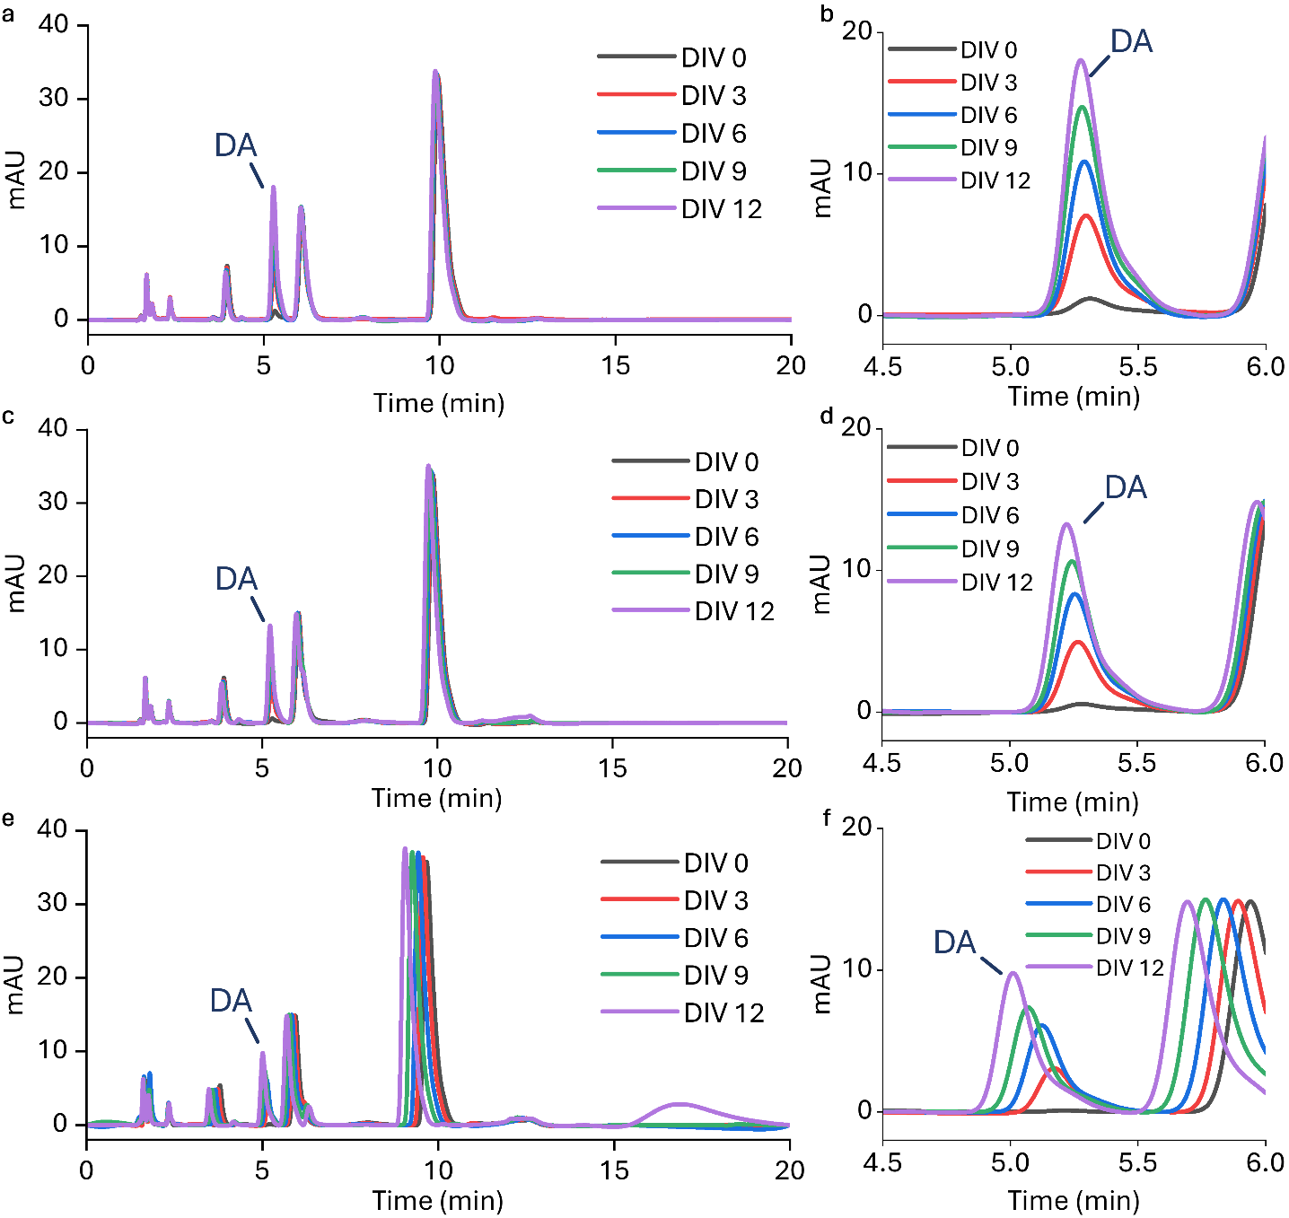
Fig. S22 HPLC cross-validation of SH-SY5Y cell-secreted DA during differentiation. a Full-scale HPLC chromatogram (0-20 min) of culture media from replicate 1, monitored at different days in vitro (DIV 0-12). b Magnified chromatogram (3-6 min) of replicate 1, isolating the distinct DA peak at a retention time of 5.2-5.3 min. c Full-scale HPLC chromatogram (0-20 min) of culture media from replicate 2, monitored at different days in vitro (DIV 0-12). d Magnified chromatogram (3-6 min) of replicate 2, isolating the distinct DA peak at a retention time of 5.2-5.3 min. e Full-scale HPLC chromatogram (0-20 min) of culture media from replicate 3, monitored at different days in vitro (DIV 0-12). f Magnified chromatogram (3-6 min) of replicate 3, isolating the distinct DA peak at a retention time of 5.0-5.2 min.
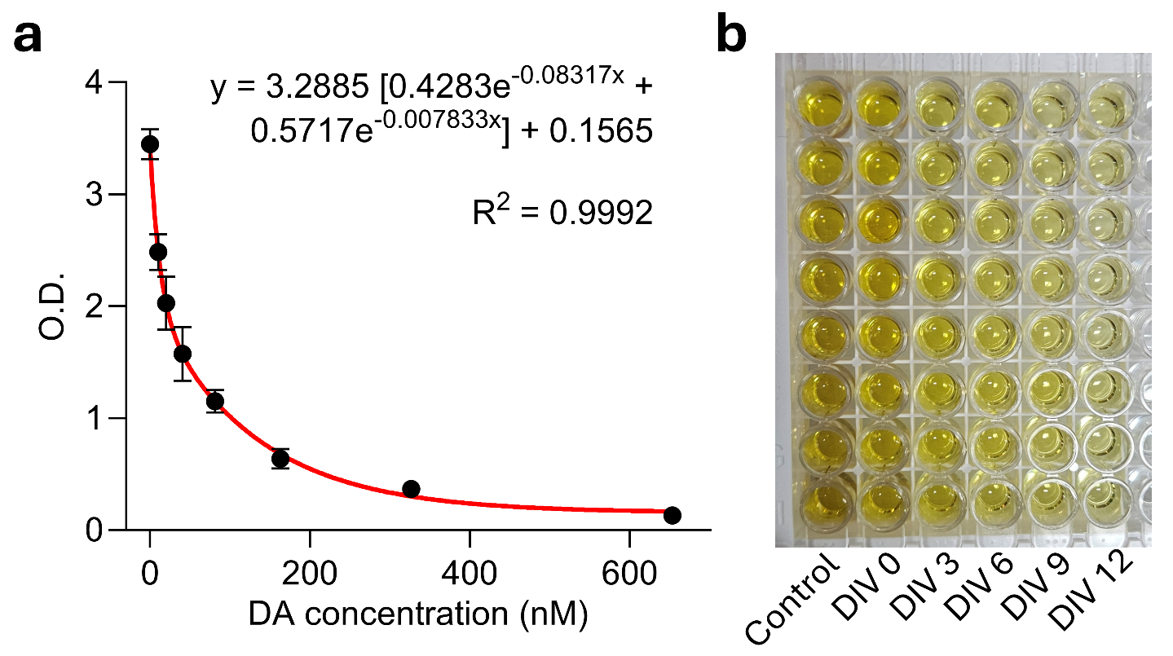
Fig. S23 ELISA cross-validation of SH-SY5Y cell-secreted DA during differentiation. a Calibration curve of DA concentration obtained with ELISA. b A real photo of the ELISA plate, where lighter color intensity corresponds to higher DA concentrations. The control refers to the group in which ELISA was performed without the addition of any test substance.

